Effective Practice:

Managing homes in the community following transition from congregated settings

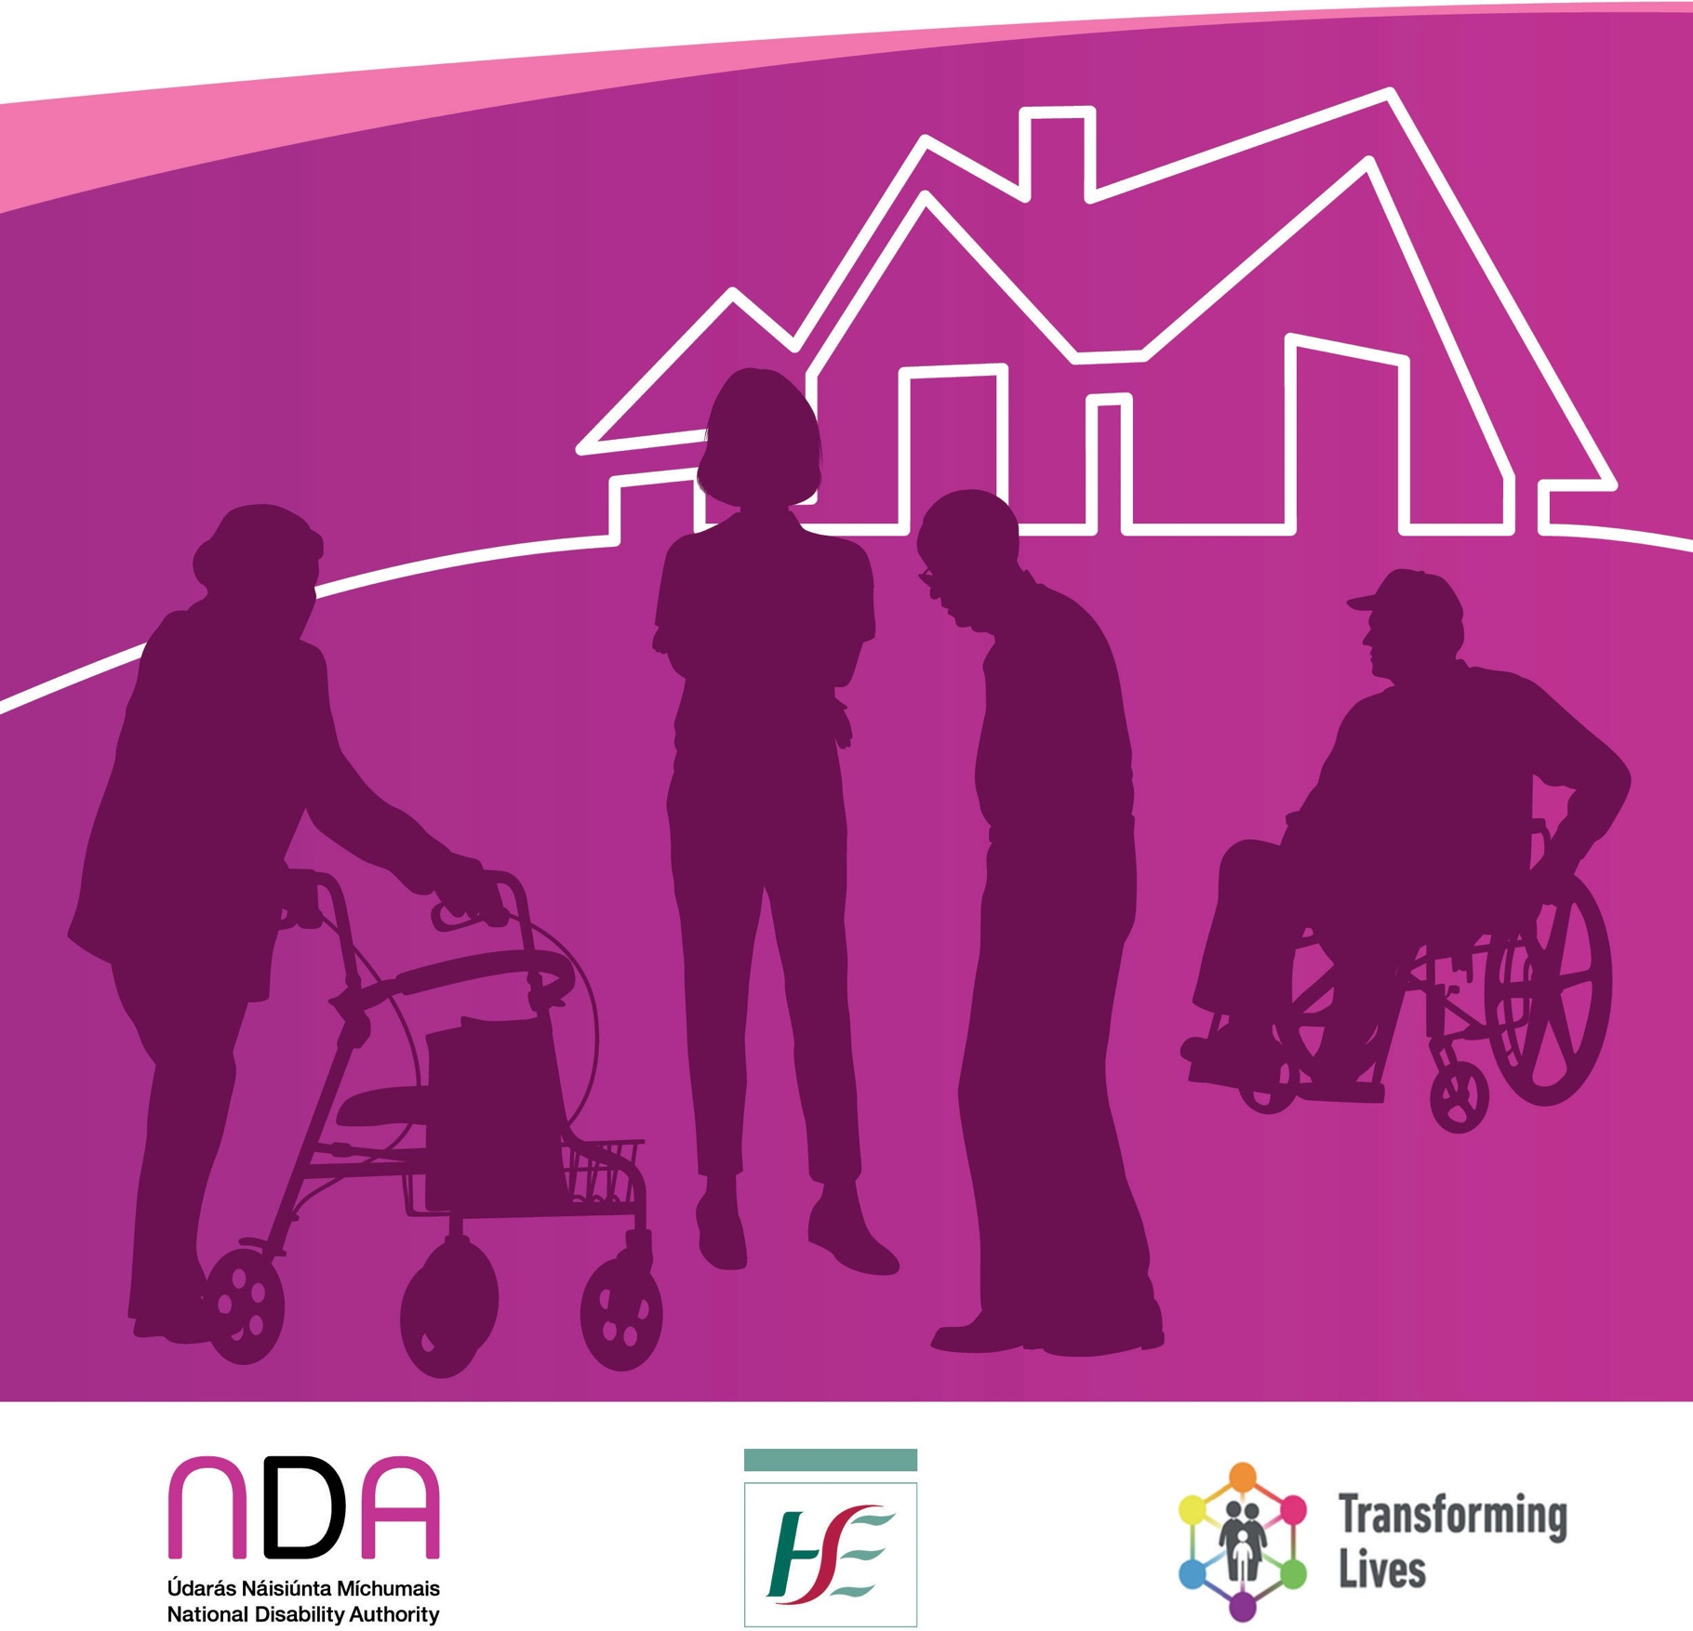

Contents

Supporting staff | 5
Lesson 1- Foster teamwork and good communication | 5
Lesson 2 - Adjust support to staff as needed | 6
Lesson 3 - Find ways to make the transition easier for staff | 7
Lesson 4 - Be available and lead by example. | 8
Managing rosters | 9
Lesson 5 - Balance the needs of residents and staff in rostering arrangements | 9
Preventing mini-institutions | 11
Lesson 6 - Embrace a person-centred model of care | 11
Lesson 7 - Rotate staff periodically | 13
Lesson 8 - Anticipate ‘Institutional creep’ | 13
Lesson 9 - Decouple the community house with the congregated setting | 14
Lesson 10 - Look for opportunities to widen the skill mix of staff | 15
Conclusion | 16
Additional Resources | 17

Published 2024

The Health Service Executive’s (HSE’s) Transforming Lives Programme is a national reform programme of disability services. Part of the Programme involves enabling persons with disabilities to transition from larger congregated settings1 to dispersed homes in the community where
they will have more choice and control over their lives.The Time to Move on from Congregated Settings – A Strategy for Community Inclusion is the strategy that underpins these transitions.

The National Disability Authority conducted a qualitative research study entitled Staff and Change Management, Good Practice in the Transition to Community Residential Disability Services published in 2021.This study examined how disability services have managed the transition process, particularly focusing on the management and experiences of staff. The experiences and learnings from this study have been condensed into two Effective Practices documents, published in 2024, as follows;

- Managing homes in the community following transition from congregated settings
- Managing the transition of staff from congregated to community settings

Drafts of the documents were shared with senior service managers with experience in transitioning services to the community and their insights have also been included to enhance the document.

The staff and managers in the study acknowledged that a lot of what they did in relation to transition to the community was through trial and error and that it was a huge learning curve from them.The key learning from the staff and managers in relation to managing homes in the community following transition from congregated settings is presented in this document using quotes where relevant to highlight particular points and linking to key HSE supporting documentation.

These documents are primarily intended for residential services managers who are coordinating or overseeing the transition of residential services to the community. Frontline staff may also

- Larger congregated settings are defined as living arrangements where 10 or more people share a single living unit or where the living arrangements are campus-based.

find them useful in reflecting on their own practices or in offering suggestions to their managers to improve the transition process. Similarly, the leadership of disability organisations may use them to help support their managers and enhance the change management process within their organisations.

This document takes a practical approach to supporting managers with transition. However, it is also acknowledged that practice needs to be focused on the residents and their will and
preferences with the underlying assumption that they have capacity to make decisions about their own lives in line with the Assisted Decision Making (Capacity) Act 2015 (as amended).Therefore, the approach to transition should reflect the rights of the residents, with a primary focus on the rights included the United Nations Convention on the Rights of Persons with Disabilities and in particular Article 19, Living independently and being included in the community.2

Ten lessons across three themes (supporting staff, managing rosters, and preventing mini- institutions) are outlined below.

- https://www.un.org/development/desa/disabilities/convention-on-the-rights-of-persons-with-disabilities/article-19- living-independently-and-being-included-in-the-community.html

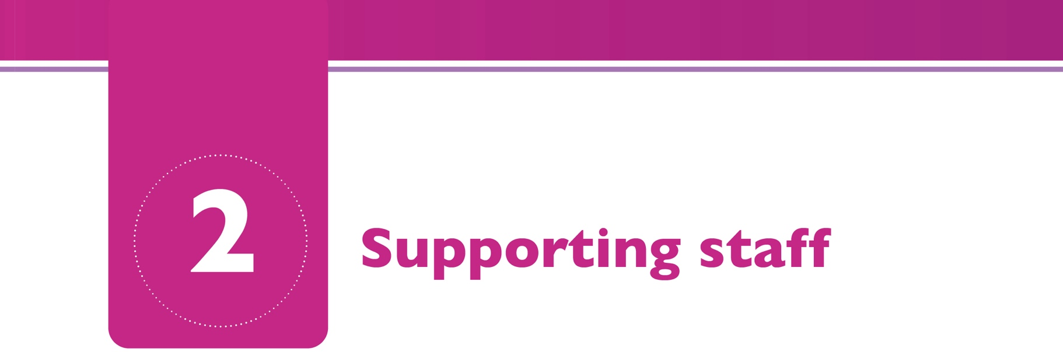

A transition can be defined as the process of moving from one state or stage to another3. Moving from working in a setting where more than 10 people live (a congregated setting) to working in a community house where four or less people live is significant and requires a period of adjustment for staff. For a person coming out of a congregated setting, moving to a new home in the community often provides the opportunity to live a very different life with more independence, choice, and control. Staff need to be supported to change their work practices, where required, to facilitate the increased independence, choice, and control of residents.

Lesson 1- Foster teamwork and good communication
Some staff felt that communication between each other and with management suffered following transition as some saw their manager less often and they were working in smaller teams. Some people reported challenges in ensuring that staff got timely updates during shift changeovers and as a consequence some things such as ordering medication or following up on an incident fell through the cracks. One way of combatting this was to hold regular team meetings and arrange for meetings between the different shifts to take place periodically. Managers also reported involving staff in decision making through the staff meetings or through one-on-one meetings.They also emphasised listening to staff so that problems could be sorted out early on and encouraging staff to resolve any conflicts at local level before escalating them.

And we do have Friday handovers between both shifts so I do think that’s great for being able to kind of sit down and it’s easier then because we’ve less staff it’s not as ‘You did this, you did this’, it’s more of a chat. Because you do have to address things when it’s a small house like that... (Hannah, Frontline Staff)

- Collins English Dictionary Essential Edition 2006

Managers also reported encouraging a team approach.There were many examples of how staff worked more as a team in the community and there was less of a hierarchy defined by roles.

…now in the community I am the nurse and there’s care assistants, but you know we work as much more of a team.There’s definitely less of a division but then there might be less of a focus on roles as well. (Ella, Frontline Staff)
One senior manager reported needing to set up an IT infrastructure to support the dissemination of information such as handover reports, daily notes and as conduit for information flow back and forth.This was an unseen cost to the service at the outset of decongregation.

Resources
  - Section 1.2.6 (page 25) of the People’s Needs Defining Change – Health Services Change Guide relates to investing in people and teams and gives guidance on fostering a team culture of taking responsibility to address issues and problems. In Section 1.2 on People and Culture there is a section on engaging and communicating (page 17 and in Section 2 starting page 38).

Lesson 2 - Adjust support to staff as needed
Managers reported that some staff found the move to the community challenging, particularly if they have taken on additional roles and responsibilities, and it took time for them to adjust to the new ways of working. Others struggled with the blurring of their roles and the lack of boundaries. Some managers cautioned against assuming that staff will automatically adapt as this was not always the case without support. One senior manager emphasised the importance of a supportive culture and empowering staff to feel confident in a new environment and ensure that they are valued.
Some staff required additional support and many managers found that this was best done through on the job mentoring.

I think that sometimes we just, expected too much, without, you know, giving them the support that I think they needed. (Emma, Manager)

The organisation made a great leap in assuming that somebody has the skills to cook. [ ] We also made a great leap in assuming that people have the skillset to teach people to do things in their own home and that change for care support workers has been huge.The majority of the people that redeployed out into community services took it on the chin and made a success of it and there was a couple of people who just were not able for it at all. (Grace, Manager)
One senior manager talked about the importance of good governance and providing support and guidance to staff teams post transition particularly in relation to autonomy to make decisions

noting that, in campus locations, frontline staff do not tend to have a huge amount of autonomy. There is therefore sometimes unrealistic expectations that staff will just fall into a new working environment and be able to make decisions.

Many staff embraced the challenge of transition and enjoyed the broadening of their role.

The feeling that you have a new job even though you are working for the same service. The fact that every day is different, the smell of freshly cooked food and sometimes baking depending who is on!! The enjoyment of working in such a nice house that’s so open and roomy, it feels like home away from home. Sometimes it doesn’t feel like you’re going to work. [ ] From a work point of view being able to help the lads live a more fulfilled life, I
think it’s why we all got into this kind of work, and now we have the freedom to do it. (Paul, frontline staff member)

Resources
  - The Project Action Plan Template 2018 version is a template for service providers.The template guides services to set out their current configuration and their future proposed structure to enable them to plan how to transition and from an institutional model of care to a community- based service.The Project Action Plan identifies the eight key work streams that need to be managed in order to drive the change in services and includes a pre-populated work plan
for each of these work streams that services can adapt for their specific project and use as a project management tool.The key work streams covered are: housing, person centred planning, transitioning, staffing, finance, governance, communications, and training.The template also includes a range of practical project management tools.

Lesson 3 – Find ways to make the transition easier for staff
A senior manager emphasised the importance of working with staff and involving them in every step of the process. One senior manager reported setting up a weekly service bulletin to assist in the connectedness of the service.They encouraged people supported to visit each other in their community houses to maintain relationships and this also assisted in team members remaining connected.This service holds two celebratory events annually to bring the people supported and staff teams together and she reported that this has been really welcomed by residents and staff alike.
One staff member gave an example of a house he was moving to that organised a coffee morning before he started so he could meet residents and other staff members. He found this extremely helpful in his own transition.

- Note that this quote was received as part of the review process for these documents and not from the original research.

Lesson 4 - Be available and lead by example
Many managers described leading by example and adopting a partnership approach where they were not expected to have all the answers, but problem solved together with the staff.

…if you want staff to come with you, you really have to practice what you preach, you know.
...if they feel valued they’ll go the extra mile for you. (Amanda, Manager)

Managers reported visiting houses and checking in with staff regularly.This can prevent staff feeling isolated and make them feel more supported.

Our coordinator, she’s brilliant. She kept on saying ‘If you need support on this, is everything okay ring me anytime.’ Anytime you ring her she’ll always return the call. (Amelia, Frontline Staff)

Resources
  - In the HSE’s People’s Needs Defining Change – Health Services Change Guide section 1.2.2 (page 14) on modelling shared values might be useful.

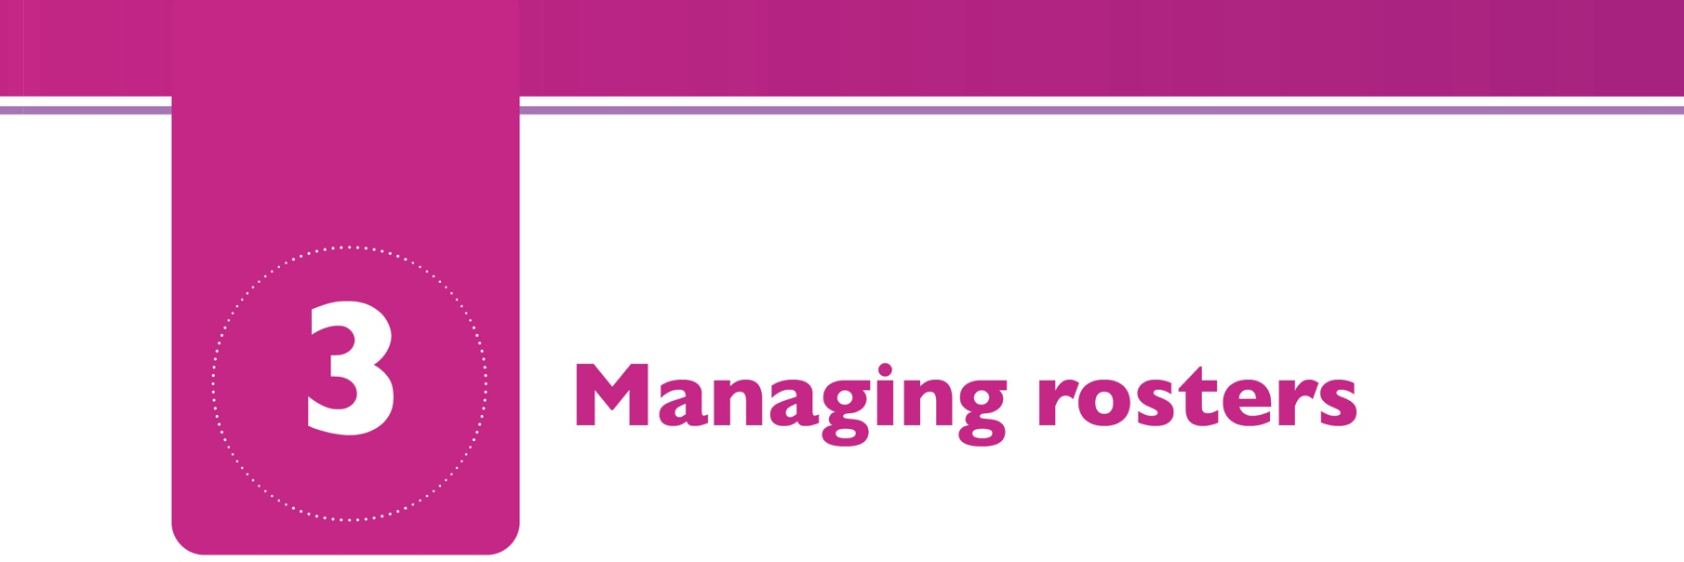

In order to provide person-centred supports in the community some managers reported a need to have a more flexible rostering system. Roster changes may be required at the point of the initial transition to facilitate more person-centred supports and at a later point due to changing dependencies of residents. Some managers found it very challenging to change rosters due to contractual limitations and recruitment and retention of staff was an issue for some.

Some of the staff felt that rosters were not managed well, that there was no consideration of their work life balance and that this was a reason for difficulties in recruitment and retention of staff. Many staff reported not liking split shifts, all weekend working including sleepovers, and short notice of their shifts.

Rosters are a mess! Oh my God, they’re a car, where I am, they’re a car crash (Conor, Frontline Staff)
Lesson 5 – Balance the needs of residents and staff in rostering arrangements
Although it is challenging to develop rosters that balance the needs of residents and the needs of staff, some services have successfully changed rosters to meet both sets of needs.They did this by;

  - Making staff aware of the rosters and flexibility required before they are recruited or transitioned
  - Where possible facilitating staff roster and location requests
  - Continuing to promote person-centred practice which helped staff see the need for more flexible working patterns.
  - Allowing staff to self-roster if possible. Not only did this reduce administration for the manager but it also gave some autonomy to staff. It also allowed staff to see the requirements for flexibility in order to meet the needs of those they support. Some managers found this worked well and staff liked that autonomy. One service co-produced a roster toolkit with the unions to assist managers.

  - Developing a clear staff retention policy to minimise staff turnover which can often be as a result of the uncertainty around shifts.
  - Making provisions for staff cover for when staff are sick, on holidays or a house is understaffed. Ensuring that staff are familiar with residents in one or two of the other houses by rostering them to work there occasionally so they can provide cover if necessary.
  - Having an on-call system particularly for emergencies and to support staff who are working alone.
  - Being creative in the use of staff resources such as using floating staff or twilight support staff.
  - Where agency staff are used to fill gaps trying to use staff that know the residents.This can be done by building up and training a number of agency staff for a specific house and then only using these when needed.This can lead to the residents feeling calmer and safer and having trust in those agency staff.

Resources
  - Lone workers are those employees who work by themselves without close or direct supervision.The Health and Safety Authority identify lone workers as “employees who are physically isolated from colleagues and without access to immediate assistance”.
  - The HSE’s Lone Worker’s policy sets out responsibilities for line managers to carry out risk assessments in consultation with employees and the responsibility of employees to protect their own safety, health and welfare and that of others. It also provides a framework to support managers in managing lone working activities in consultation with their employees.

Many staff and managers reported that it was easy for homes in the community to become like mini-institutions following the transition of residents from a congregated setting. One senior manager went so far as to say that ‘transference of institutional practices is a given and therefore, you should plan to address same’.There was a general understanding among participants that a mini-institution meant bringing institutionalised practices into a home in the community so that while the environment had changed, the life of the resident had not. Many managers also reported that staff were quite institutionalised.

It is possible to have a service where the address has changed and even though you walk in and it’s set up like a home, if you have a service user who’s continuing the same behaviours and a staff team who have never changed their approach, basically it’s a small residential service…That can happen and it can happen quite easily. (Grace, Manager)
There were a number of ways that managers and staff worked to prevent this happening.

Lesson 6 – Embrace a person-centred model of care
Embrace a social or person-centred model of care.This can be done by looking at the staffing mix and recruiting more staff with a community orientated approach where possible. It can also be done through staff training and mentoring, for example, in social role valorisation. Examine medicalised practices to see if they are a carry-over from the congregated setting and whether they are person-centred and implement changes where necessary.

The biggest mistake that they made was they never changed the staff. It remained a medical model, okay. So all you were doing was you were moving them from one institution to another institution… (Aoife, Manager)
Adequate staffing numbers are essential to allows for a person-centred way of working. Many managers talked of fighting to have better staff numbers as they were aware of the risk of a mini- institution if staffing was insufficient.

But I think you can’t work those little houses without your numbers because it’s just pointless. It will become a mini-institution if you go down on the staff. (Hannah, Frontline Staff)
The attitude of the staff is very important with managers having a preference for staff that want to work in the community and that are open to change preferred.

Because in some community houses you’d get a house that I’d say if the staff are not motivated…not much will happen no matter where they are, unfortunately…. (Ella, Frontline Staff)
Another important area mentioned was to focus on the transition plan and what would replace day services.This includes community mapping and is a key piece of work that needs to be done prior to the transition.

Resources
  - The HSE’s People’s Needs Defining Change – Health Services Change Guide has a section on modelling shared values that may be of use (Section 1.2.2 page 14).
  - A National Framework for Person-Centred Planning in Services for Persons with a Disability. The process of supporting each person’s transition to their new home should follow the principles of person-centred planning and this work in most cases, will commence well in advance of the moving date.There are many documents, resources and websites that provide guidance on person-centred planning, based on different approaches and theories.The framework for person-centred planning sets out the key stages of the process and what is important at each stage for person-centred planning to be effective and states that the best measure of success is where “the person has experienced a real change for the better in his or her life, as a result of their person-centred plan being implemented.”
  - Other materials related to person centred planning are available on the HSE’s person-centred planning page for example:
    - A Guide to Understanding the Difference Between the Person-Centred Plan and Personalised Care and Support Plans
  - A Quality Framework: Supporting Persons with disabilities to achieve personal outcomes.The focus on outcomes is an essential part of the service delivery framework being progressed
in Ireland for people with disabilities. Following research and consultation by the National Disability Authority, the Department of Health and the HSE have approved nine outcome domains for Irish disability services for adults. A Quality Framework: Supporting Persons with disabilities to achieve personal outcomes (HSE, 2018,Working Group Four report, unpublished) has been developed and captures these domains and identifies the outcome predictors that service providers can use to assess and measure how well they are supporting the achievement of these outcomes.The outcome predictors identified should inform and guide continuous quality improvement, aimed at providing outcomes-focussed services and supports.While this report has not been published the NDA paper on Outcomes for Disability Services is available for download.

Lesson 7 – Rotate staff periodically
Some managers reported rotating staff periodically to prevent a sense of ownership among staff of the residents or the house and to prevent the formation of staff cliques. Managers found new staff working in a house to be beneficial in terms of a fresh set of eyes and challenging the status quo.

Yes very much so yes [agreeing that mini-institutions could easily form].This is why I think it’s good to change around staff… People from another area can spot things straight away that the others just don’t see.They don’t mean bad, they just don’t see it. (Lucy, Manager)

Rotating staff periodically and across houses is something we probably don’t do enough. (Senior manager reviewer)

Lesson 8 - Anticipate ‘Institutional creep’
Anticipate, identify, and stop ‘institutional creep’ (whereby institutional practices or service activities are gradually reintroduced). Managers advised visiting the houses frequently and continually challenge staff and their attitudes and the purpose of their work to remind them that they are now employees in the houses of the residents rather than, as was the case in the congregated setting, there were residents in their place of work.

… you’d be checking up what did they do at the weekend, where did they go. I suppose meeting with staff regularly. I’d like keep promoting out, out, or social things and getting them going… You want staff to be on their toes but it kind of protects the service user. (Olivia, Manager)

Our Persons in Charge deliver lots of coaching and mentoring and on the job training to ensure that the mindset shift is always forefront in our planning and practices. Some staff did not stay in role post transition as the new model did not suit them. (Senior Manager, reviewer)

Resources
  - The HSE’s guide to Making a Home points out that care must be taken to ensure that the “administrative” imprint in the home is kept to a minimum and that the “organisation and service provider” aspect of the support being delivered is respectful and discreet in the person’s home (see ‘Home not a Workplace’ page 72).
  - The People’s Needs Defining Change – Health Services Change Guide in section 4.4 (page 82) has sections around developing an Action Plan and consolidating key changes, actions and
measures that have been taken and identifying enabling and sustaining actions. Section 5.5 (page 96) has further guidance around sustaining improvements that may be useful in sustaining the changes associated with transition to the community.There are other sections on celebrating success (page 96) and measuring progress (page 3) that may be useful to refer to.
  - Some services reported developing a significant number of inhouse guidance documents that underpin the rights-based approach, including ‘ways of working’, quality zoom’s, practice development updates and access to community of practitioners. Many services are open to sharing their internal documentation with others.

Lesson 9 – Decouple the community house with the congregated setting
In some services strong links were maintained with the congregated setting such as residents returning for day services, to use the restaurant/coffee shop, to use the medical or recreational facilities or in sharing staff. While continued use of these facilities was sometimes part of residents’ transition plans to maintain some familiar environments, there was rarely a longer-term plan in place to replace these with community services.There needs to be a planned transition to using more community bases services.

They used to always go to the [name] restaurant [in campus setting] here because they would have done it for years, the staff is lovely they’re comfortable or whatever. (Lily, Frontline Staff)

Lesson 10 - Look for opportunities to widen the skill mix of staff
When a staff member leaves or retires, evaluate the job and the needs of the organisation, and consider whether you need to replace like with like or whether this presents an opportunity to diversify skill mix and bring in other professionals.This may be particularly important in services that are nurse-led where the introduction of social care workers, who are trained in the social model of care could be a great asset to the success of the transition. One senior manager reported that they had dramatically reduced the number of nurses across the service and increased social care workers. She stated that;

Whilst health and wellbeing is a fundamental outcome for people, we increased the potency of a rights-based approach by investing in Social Role Valorisation (SRV), Genio training, SRV champion training and EQT training. (Senior manager, reviewer)

It is hoped that this document will be useful to managers in managing homes in the community following transition. As decongregation progresses more and more organisations are gaining experience and there are more tools, materials, and experiences which are available to share. Managers should make the most of these and continue to network to make the transition as easy, sustainable, and effective as possible.There are other resources that may be of use in managing staff for transition and these are listed in the additional resources section below.
Thanks are due to the staff and managers who took part in the original research and to the senior managers who reviewed the Effective Practice Documents.

- HSE Time To Move On from Congregated Settings website
This site contains newsletters, progress reports and several documents to support service providers to implement change including;
  - HSE (2019) Making a home. A practical guide to creating a home and moving to the community. HSE.
  - HSE (2018) Community Living Transition Planning Toolkit. HSE.
  - HSE.Time to Move On” from Congregated Settings Communication Plan- Stakeholder Mapping Tool.

HSE. SCD/QID Project Tool box for Residential Services for Adults with Intellectual Disabilities
The purpose of the Project Toolbox is to build a range of resources to support the efforts of residential services in implementing good practice and improving the delivery of quality safe services. It includes tools, guides, policies, templates, and signposts to online resources from HIQA, the HSE and other national bodies, where relevant, and is aligned to the 18 Outcomes upon which services are inspected by HIQA against regulations and standards.

