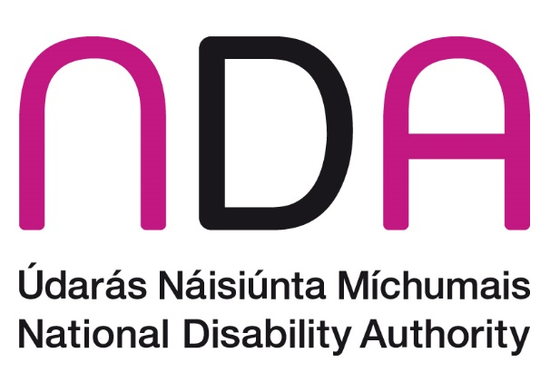

**Annual Conference 2025**

**Parenting, Relationships, and Sexual & Reproductive Rights in the context of Article 23 UNCRPD**

**Meet the Speakers**

Introduction and Opening Addresses

Dr Aideen Hartney – Director, National Disability Authority (NDA)

Dr Aideen Hartney became Director (Chief Executive) of the National Disability Authority (NDA) in mid-2020, having joined the organisation in 2016 as its Head of Policy, Research and Public Affairs.

Aideen has a long career in overseeing research for the public good, having managed several major funded research programmes in University College Dublin, before coming to the NDA. She also has private sector experience following 7 years as a market research consultant. Aideen holds a doctorate in Ancient History and lectured for a time at the University of Bristol.

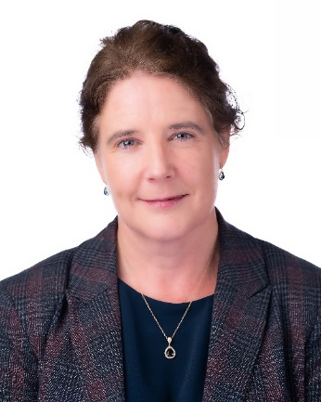

Kathryn O’Donoghue – Chairperson, National Disability Authority (NDA)

Kathryn was appointed as the Chair of the board of the National Disability Authority (NDA) in 2022. A member of the board since 2018, Kathryn was the Chair of the Finance Committee and a member of the Audit & Risk Committee.

Kathryn also served as the Chair of the Science Gallery Dublin Board from 2019 until 2022 having previously held roles as the Interim Director of Science Gallery Dublin during 2018 and as a Science Gallery Board member for 3 years until 2017.

Kathryn graduated from Trinity College Dublin in 1987 and completed a post-graduate course in Information Systems. Kathryn then started her career as a Management Consultant and spent 10 years between PriceWaterhouseCoopers and Ernst & Young specialising in Information Technology predominantly defining IT Strategies and designing, developing and implementing systems for Financial Services and Government organisations many of which were highly innovative and ground-breaking.

Kathryn joined General Electric in 1997 and working in the Financial Services division that became known as GE Money she successfully led several IT programs including the Y2K and Euro projects for 6 countries. She then moved to Italy to lead a project to fully replace the organisation’s systems there and once this was concluded she moved to the bank in Switzerland where she became the first female CIO for GE in Europe and the first female CIO of a bank in Switzerland. After 5 years she moved to Paris to become the Western Europe CIO for GE Money responsible for 10 countries.

Kathryn then moved back to Ireland and joined Google in 2009 and was a Director leading a number of multinational, multi-lingual teams across the sales and operations functions including being responsible for 44 countries in EMEA. She also led a global team responsible for data analytics & insights and spent 3 years as the EMEA Director of Trust & Safety for advertiser and publisher products.

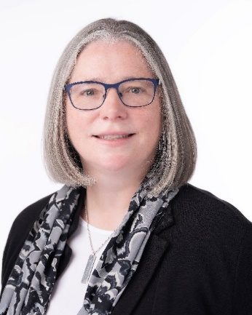

Norma Foley T.D. – Minister for Children, Disability and Equality

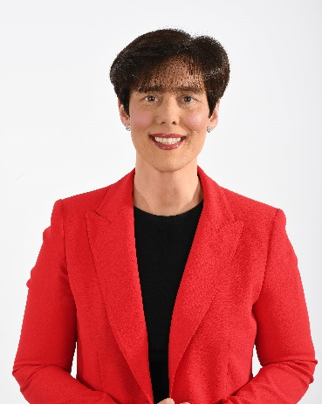Norma previously served as Minister for Education (2020-2025). Born and reared in Tralee, Norma is married to Denis Maguire, also a teacher.  
  
A passion for politics blossomed at an early age and she was a regular on the campaign trail, canvassing for her father Denis, a TD for Kerry North for over 18 years.   
  
Since 2004, Norma Foley has represented the people of Tralee Municipal District on Kerry County Council.  She has also served on Tralee Town Council, and held the position of Mayor of Tralee on three occasions as well as being elected Mayor of Kerry.  
  
She was appointed Minister for Education in June 2020 following the formation of the Government when she became the first Kerry woman to sit at the Cabinet table. She was appointed as Minister for Children, Disability and Equality in January this year.

Session 1: Parenting with a Disability

Chair: Gerard Brophy, Chief Social Worker, Tusla

Information forthcoming.

Speaker TBC  
Information forthcoming.

Professor Niamh Stack, Head of Department – Psychology, Mary Immaculate College

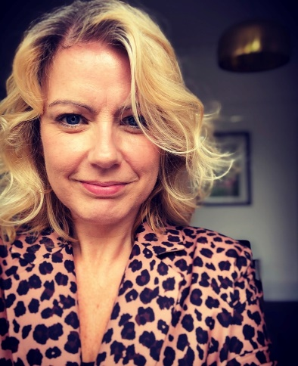Professor Niamh Stack is a developmental psychologist and the Head of the Department of Psychology, Mary Immaculate College, Limerick. She has a particular interest in development, difference and diversity across the lifespan.

Professor Eilionóir Flynn, Established Professor at the School of Law and Director, Centre for Disability Law and Policy, University of Galway

Eilionóir Flynn is an Established Chair in Law and Director of the Centre for Disability Law and Policy at the University of Galway. Her research focuses on disability and social justice, with a particular emphasis on legal capacity, access to justice and the intersection of disability, gender and ageing. Her first book, “From Rhetoric to Action: Implementing the UN Convention on the Rights of Persons with Disabilities” was published by Cambridge University Press in 2011 and since then she has gone on to publish extensively in the domain of disability rights.

Eilionóir is the Scientific Co-ordinator of the PREPARED Marie Curie Sklowdoska Cofund, a European network of postdoctoral researchers developing disability-inclusive solutions to the most urgent global challenges. Her work has attracted significant research funding, including a Starting Grant from the European Research Council, and an Investigator Award from Wellcome Trust. She has acted as a board member and advisor in a range of local, national and international bodies working on the rights of disabled people, and regularly advises policy-makers at national and international levels, including providing support to the Secretariat of the UN Committee on the Rights of Persons with Disabilities, and in particular the working group which developed General Comment 1.

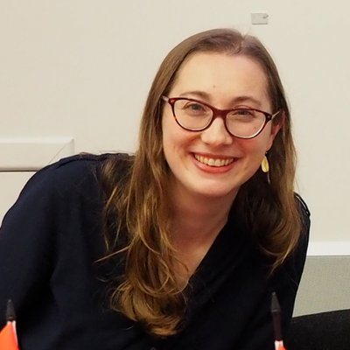

Louise Milicevic, Learning and Development Administrator, Rehab Group, and Volunteer Parent Advocate and Member, Disabled Women of Ireland

Louise Milicevic is a disabled woman with lived experience of disabled parenting. A mother of three, Louise is a self-advocate and through her own journey has highlighted the barriers experienced by disabled parents. Over the years, Louise has contributed to research relating to disabled parenting including the Real Productive Justice project and has addressed the Oireachtas on issues relating to reproductive justice in the context of the Assisted Human Reproductive Act.

Louise has worked for over 20 years for the Rehab Group in a corporate function capacity. She is a member of Disabled Women Ireland, a national representative organisation of disabled women, girls and non-binary people in Ireland.

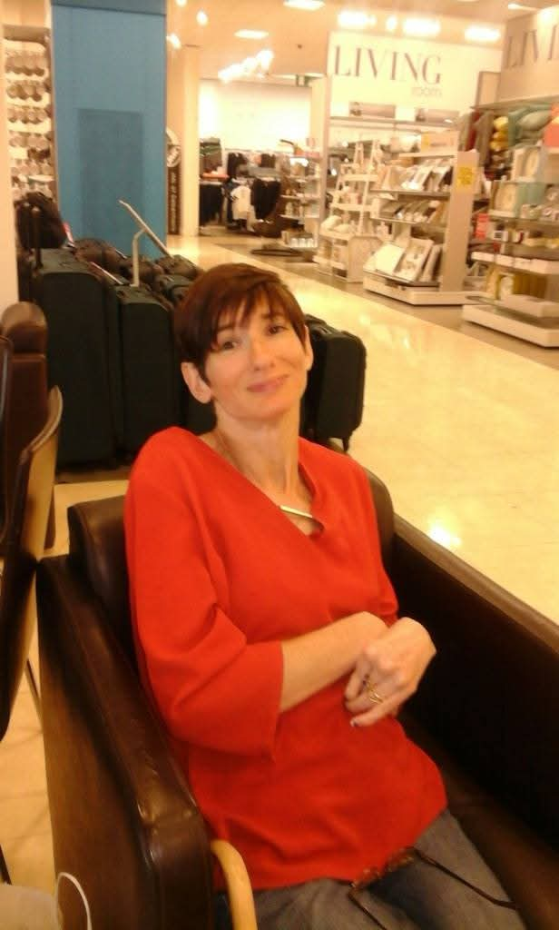

Midday Address

Hildegarde Naughton T.D., Minister of State with responsibility for Disability, Department of Children, Disability and Equality

Hildegarde Naughton is Minister of State attending Cabinet at the Department of Children, Disability and Equality with responsibility for Disability. She was appointed to this role in January 2025.

Minister Naughton previously served as Minister of State at the Department of the Taoiseach as Government Chief Whip; and the Department of Education with special responsibility for Special Education and Inclusion. She has also served as Minister of State in the Departments of Transport, Health and Justice in the last Government.

Hildegarde was a primary school teacher and was elected to Galway City Council in 2009. She was mayor of the city in 2011/2012.

Having served in Seanad Éireann, Hildegarde was first elected to represent the constituency of Galway West in the 2020 general election. She has served on a number of Oireachtas committees including the Future of Healthcare, and Budgetary Scrutiny. She was appointed as the chair of the Communications, Climate Action and Environment committee in 2016.

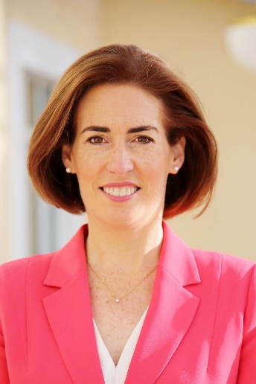

Session 2: Relationships and Sexuality

Chair: Suzy Byrne, Greater Dublin Regional Manager, National Advocacy Service for People with Disabilities

Suzy Byrne is a Regional Manager for the National Advocacy Service for People with Disabilities in Greater Dublin and previously worked as a Senior Advocate for the service. Suzy is currently a Director of Iarnród Eireann and is a former board member and chairperson of the Irish Council of Civil Liberties and has a background in community and voluntary sector for over 35 years. She has a particular interest in family law, reproductive and LGBT rights and has advised on national policy and research projects in these fields for many years.

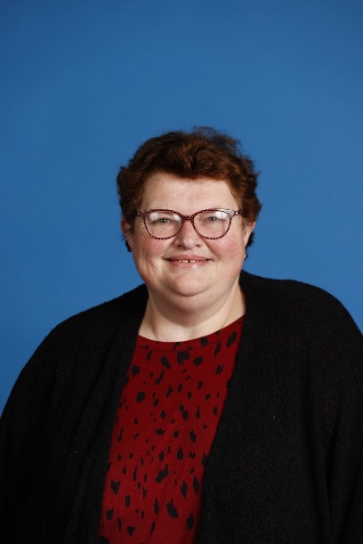

Jennie Williams, Founder and Chief Executive Officer, Enhance the UK

Jennie Williams is the founder and CEO of Enhance the UK (ETUK), a user-led charity which helps people with physical and sensory disabilities to live a full life. She set it up after working in the care sector and becoming frustrated with the lack of practical information and support available for people who wanted to know more about communicating with disabled people both professionally and personally.  
  
Jennie, who has degenerative hearing loss, an auto-immune condition and is neuro diverse, also wanted to encourage open conversation and education around sex and disability. The charity’s Undressing Disability campaign focuses on the sexual rights and responsibilities of disabled people. It includes the ‘Love Lounge’, podcasts, videos and books alongside an online forum for advice and answers regarding sex, dating and relationships for those with impairments. Jennie speaks freely around her experiences and identifies as pansexual.

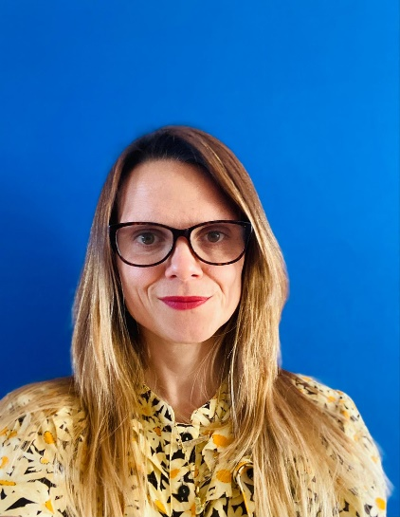

Nicole Lam, Guidance Development and Research Lead, National Disability Quality Improvement Team, Access & Integration, Disability Services, Health Service Executive

Nicole Lam (she/they) is the Guidance and Research Lead in the HSE National Disability Quality Improvement Team. Nicole has a background in Sociology & Social Policy (BA), Intercultural Communication and Education (MA). She has been working in the HSE since 2019 and is committed to a human-rights and intersectional approach to disability justice.

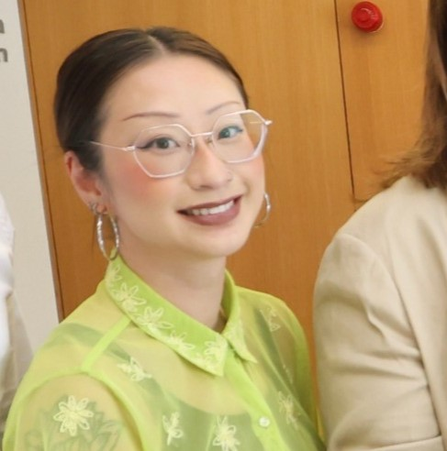

Jack Kavanagh, Pharmacist, Speaker and Non-Executive Director

In 2012, Jack Kavanagh’s life changed forever when he sustained a spinal cord injury, leaving him with just 15% muscle function. Rather than letting this define his limits, Jack has since redefined what’s possible, proving that resilience, ambition, and courage can push boundaries beyond expectation.  
  
Jack has taken the stage at TEDx with his powerful talk, "Fearless Like a Child: Overcoming Adversity." His impact has been widely recognized—he was honored as one of the Ten Outstanding Young People of the Year in 2019 and has received multiple international awards for his groundbreaking documentary Breaking Boundaries. He is the host of the Only Human Podcast, where he explores the depths of human experience and resilience.  
  
A pharmacist, speaker, and non-executive director, Jack is a force for change. He runs Move The Needle, a consultancy focused on high-impact projects. He also serves on the board of the National Disability Authority and leadership development organization Common Purpose Ireland. His expertise has led him to collaborate with the World Health Organization on digital and assistive technologies, and he is currently pioneering accessibility advancements in aviation through the AeroFix Project.  
  
Yet, through it all, one thing has remained a constant—Jack’s passion for adventure. Whether hand-cycling, sailing, or mastering the art of sit-skiing, he refuses to let limitations stand in his way. Last summer, he set himself a formidable challenge—a *misogi*—cycling 100 km in a single day to mark the anniversary of his injury. Completing this goal stands as one of his proudest personal achievements in recent years.

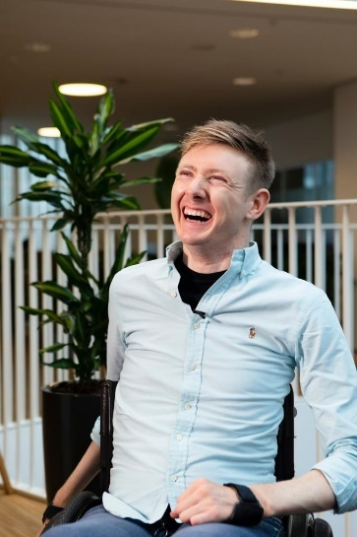

Derval McDonagh, Chief Executive, Inclusion Ireland

Derval is the Chief Executive of Inclusion Ireland and a lifelong ally to people with an intellectual disability and their families. Having trained originally as a speech and language therapist, Derval has a particular interest in accessible information and communication as a human right. She has campaigned extensively for inclusive education, deinstitutionalisation and justice for non-speaking people.

Derval is also chairperson of the Irish Penal Reform Trust, a civil society organisation working for a fairer justice system. She is also a proud director of LINQ Ireland. She works consistently through an intersectional, rights-based lens for a more equitable Ireland for us all.

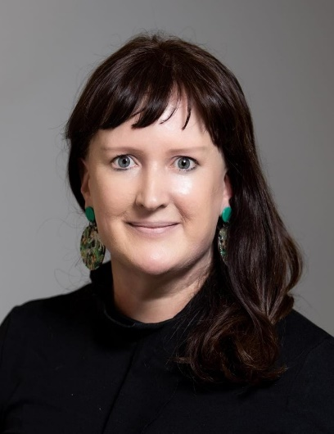

**Session 3: Sexual and Reproductive Health and Rights**

Chair: Rosie Gowran, Clinical Lead, National Clinical Programme for People with Disability, Clinical Design and Innovation, Health Service Executive

Professor Rosemary (Rosie) Joan Gowran, Clinical Design and Innovation as Clinical Lead – National Clinical Programme for People with Disability, with the Health Service Executive; Associate Professor in Occupational Therapy, School of Allied Health, University of Limerick; Honorary Professor with Department of Computer Sciences at the Global Disability Innovation (GDI) Hub, University College London and hold a visiting position at the Assisting Living and Learning (ALL) Institute, Maynooth University.

As a human rights activist, Rosie adopts a human security approach to support persons with disability, to address service system challenges and erosion of personhood. Rosie is a powerful advocate, who inspires, motivates, and engages with diverse audiences to facilitate and build strong relationships and create lasting partnerships. By collaborating to achieve goals and manage change, she successfully directs solution focused programme operations and has a proven track record of stakeholder centred co-design using mixed methods, engaging people using services, providers, and policy makers. Rosie believes that building sustainable communities of practice in health and social care and advocating for appropriate person-centred, rights-based service provision is a responsibility of the whole community.

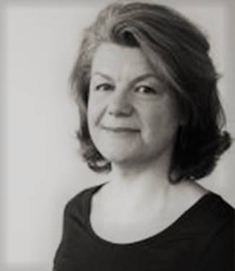

Professor Margaret McGrath, Head of Department of Occupational Science and Occupational Therapy, University College Cork

Information forthcoming.

Fiona Weldon, Disabled Persons Organisations (DPO) Capacity Development Officer, Independent Living Movement Ireland

Fiona Weldon is a disabled activist and academic who joined the ILMI staff team in November 2021. She has over 30 years of experience in working in the Disability Sector. All of her work is motivated by the reality of the effects of segregation, exclusion and non-disabled professionalism on the lives of Disabled People.

Fiona believes passionately in promoting the need for a Rights Based Model of Support to people that are labelled disabled (as opposed to our current resource based model of support that is dominated by both the Medical Model of Disability and the Charity Model of Disability) that is driven by both the Social Model of Disability and the Philosophy of Independent Living as professed by the Disabled People’s Movement.

Fiona holds an MA in Disability Studies, Diploma’s in Community Development, Information Communication Technology (ICT) and Counselling Skills. She also holds Certificates in other subjects including Advanced Facilitation, Equality Studies, Social Care, Reality Therapy, Assistive Technology and Supported Self-Directed Living.

As Capacity Development Officer with ILMI, Fiona provides collective training to disabled activists in Ireland to engage in local Disabled Persons Organisations. She resources the ILMI Women's Healthcare Working Group and led the development of ILMI's ground-breaking "Strategies for Change" training programme. This programme was about building the collective capacity of emerging Disabled Activists in Ireland through the provision of online training. These were cross-impairment spaces for disabled adults.

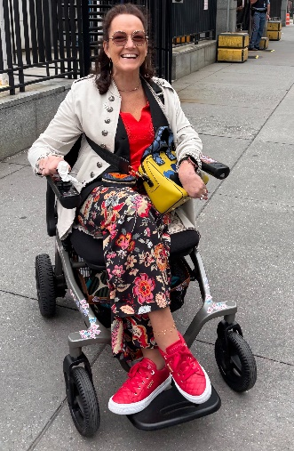

Sara Rocha, Vice-Chair, Women’s Committee, European Disability Forum and Vice-President, European Council of Autistic People

Sara Rocha is a Portuguese autistic and disabled advocate working as a Data Manager for the Public Health and Primary Care department of the University of Cambridge. She is Vice-chair of the Women’s Committee of the European Disability Forum (EDF), Vice-President of the European Council of Autistic People (EUCAP) and co-founder and President of Associação Portuguesa Voz do Autista, the first autistic-led organisation in Portugal. Sara has been an advocate on sexual and reproductive rights of women and girls with disabilities and for the criminalisation of forced sterilisation.

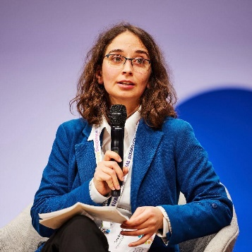

Professor Michael Brown, Deputy Head School of Nursing and Midwifery, Queens University Belfast

Professor Brown is Professor of Nursing and Deputy Head of School of Nursing and Midwifery, Queen’s University Belfast. A Registered Nurse Intellectual Disabilities and Registered General Nurse, he has worked extensively in specialist health services for people with intellectual disabilities. An educator and researcher, he has published over 150 papers, chapters and reports in the academic literature. He led the research team who undertook the study across the UK and Ireland about the relationships and sexuality education needs of children and young people with intellectual disabilities. He is a Principal Fellow of the Higher Education Academy and a Fellow of the Royal College of Nursing.

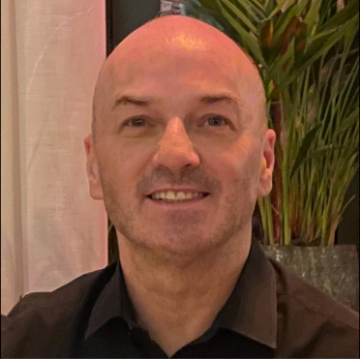

Speaker TBC

Information forthcoming.

**Session 4: Maternity Care**

Chair: Linda O'Connor, Principal Officer, Maternity and Gynaecology Policy, Department of Health

Linda O’Connor is head of Maternity and Gynaecology Policy at the Department of Health, where she leads on driving the implementation of the National Maternity Strategy 2016-2026 and oversight and governance of Maternity and Gynaecology Policy in acute hospitals. Linda has previously worked in the Department of Social Protection, the Department of Justice, the Office of the Houses of the Oireachtas, the Central Statistics Office and the Irish Permanent Representation in Brussels. Linda holds a BSc in Chemistry from Coventry University and an MSc in Strategy and Innovation from the National University of Ireland, Maynooth.

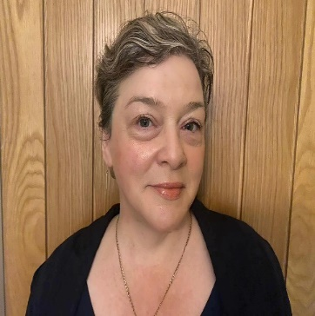

Dr Deirdre Daly, Professor in Midwifery in the School of Nursing and Midwifery, Trinity College Dublin

Deirdre Daly, Professor in Midwifery and Director of the Trinity Centre for Maternity Care Research (TCMCR), Trinity College Dublin (https://peoplefinder.tcd.ie/DALYDE).

Deirdre is the Principal Investigator on the Maternal Health and Maternal Morbidity in Ireland (MAMMI) study (https://www.tcd.ie/mammi/), a longitudinal study exploring the health of and health problems experienced by first-time mothers giving birth in Ireland.

Deirdre also leads/co-leads several related studies on maternal health and, together with other MAMMI study team members, has published several papers on various aspects of maternal health.

She is the Director of the Trinity Centre for Maternity Care Research (TCMCR), a member of the national severe maternal morbidity and maternal death in Ireland groups.

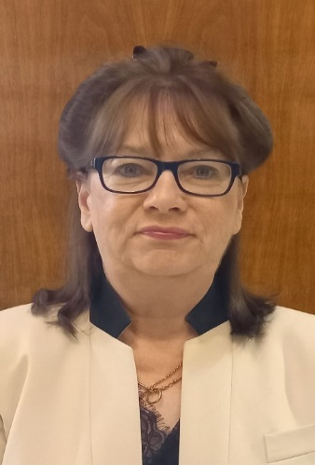

Karen Henry, Midwife and Lecturer, University of Suffolk

Karen is a midwife and lecturer in midwifery at the University of Suffolk. Karen leads modules in anatomy and physiology, plus care of the newborn and infant feeding. Whilst in practice, Karen worked with The Florence Nightingale Foundation to create a series of support plans to support autistic women accessing maternity care which led to her undertaking an MA in autism to further her knowledge and design an ethos for staff training.

Since then, Karen has written several articles, and book chapters, plus she has cowritten a book called ‘Supporting Autistic People Through Pregnancy and Childbirth’. Karen is a founding member of the Maternity Autism Research Group which is a collective of autistic researchers who wish to support meaningful and accessible maternity care for autistic women. Karen has worked with various organisations to improve maternity care for autistic people which includes Suffolk and North Essex (SNEE) ICB, the Royal College of Midwives, and All4Maternity. Karen has consulted on several expert panels for Toronto University, Cambridge University, Swansea University, and is currently a member of the Maternity Inclusivity Taskforce led by MP Marie Tidball to review maternity care for disabled women.

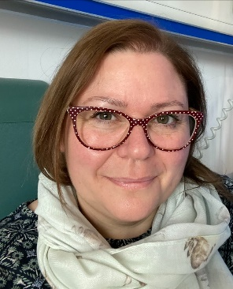

Dr Carly Cheevers, Senior Research Officer, National Disability Authority

Dr Carly Cheevers is a Senior Researcher at the National Disability Authority, where she leads projects on the rights and lived experiences of children and adults with disabilities. She is currently leading a study on families and children in crisis as part of the Autism Innovation Strategy. Carly has previously worked on a wide range of projects on child and maternal health, development, and wellbeing, with a consistent focus on evidence that informs policy and improves outcomes for children and families.

Headshot of Dr Carly Cheevers. Carly has short dark hair and is wearing a yellow, floral jacket.


Dr Alison Harnett, Chief Executive Officer, National Federation of Voluntary Service Providers

Information forthcoming.