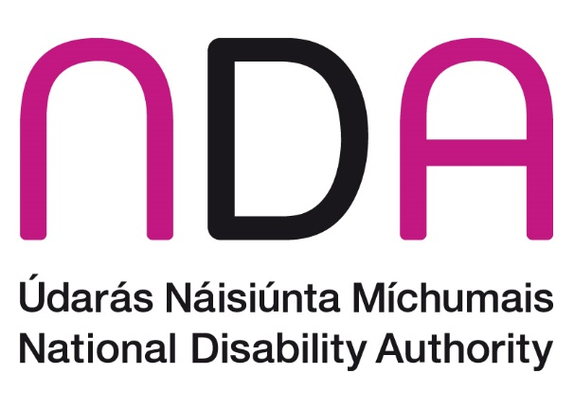

**Annual Conference 2025**

**Parenting, Relationships and Sexual & Reproductive Rights in the context of Article 23 UNCRPD**

**Conference Programme**

**Thursday, 16 October 2025, Aviva Stadium and online.**

**Welcome and Registration**

**9:30** Tea and coffee.

**Introduction and Opening Addresses**

**10:00** Dr Aideen Hartney, Director, National Disability Authority.

**10:05 Welcome Address**  
Kathryn O’Donoghue,Chairperson, National Disability Authority.

**10:15** **Ministerial Address**

Norma Foley T.D., Minister for Children, Disability and Equality.

**Session 1: Parenting with a Disability**

**10:30** **Chair:** Gerard Brophy, Chief Social Worker, Tusla

* Professor Niamh Stack, Head of Department – Psychology, Mary Immaculate College
* Professor Eilionóir Flynn, Established Professor at the School of Law and Director, Centre for Disability Law and Policy, University of Galway
* Louise Milicevic, Learning and Development Administrator, Rehab Group, and Volunteer Parent Advocate and Member, Disabled Women of Ireland
* Speaker TBC

**11:10 Q&A**

**11:30 Break**

**Midday Address**

**12:00 Ministerial Address**

Hildegarde Naughton T.D., Minister of State with responsibility for Disability, Department of Children, Disability and Equality.

**Session 2: Relationships and Sexuality**

**12:10** **Chair:** Suzy Byrne, Greater Dublin Regional Manager, National Advocacy Service for People with Disabilities

* Jennie Williams, Founder and Chief Executive Officer, Enhance the UK
* Nicole Lam, Guidance Development and Research Lead, National Disability Quality Improvement Team, Access & Integration, Disability Services, Health Service Executive
* Jack Kavanagh, Pharmacist, Speaker and Non-Executive Director
* Derval McDonagh, Chief Executive, Inclusion Ireland

**12:50 Q&A**

**13:10 Lunch**

**Session 3: Sexual and Reproductive Health and Rights**

**14:00** **Chair:** Professor Rosie Gowran, Clinical Lead, National Clinical Programme for People with Disability, Clinical Design and Innovation, Health Service Executive

* Professor Margaret McGrath, Head of Department of Occupational Science and Occupational Therapy, University College Cork
* Sara Rocha, Vice-Chair, Women’s Committee, European Disability Forum and Vice-President, European Council of Autistic People
* Professor Michael Brown, Deputy Head of School of Nursing & Midwifery, Queen's University Belfast
* Fiona Weldon, Disabled Persons Organisations (DPO) Capacity Development Officer, Independent Living Movement Ireland (ILMI)
* Speaker TBC

**14:55 Q&A**

**15:10 Comfort Break**

**Session 4: Maternity Care**

**15:15** **Chair:** Linda O'Connor, Principal Officer, Maternity and Gynaecology Policy, Department of Health

* Dr Deirdre Daly, Professor in Midwifery in the School of Nursing and Midwifery, Trinity College Dublin
* Karen Henry, Midwife and Lecturer, University of Suffolk
* Dr Carly Cheevers, Senior Research Officer, National Disability Authority
* Dr Alison Harnett, Chief Executive Officer, National Federation of Voluntary Service Providers

**15:55 Q&A**

**Closing Address**

**16:15 Conference Close**

Dr Aideen Hartney, Director, National Disability Authority.