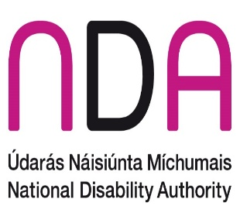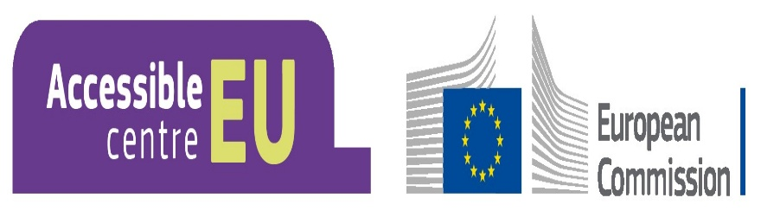

Seminar

Accessibility in Action - Models of Good Practice

Seminar Programme
Friday 13 March 2025, Pavilion Room, NDA and online.

Welcome and Registration
9:30am Tea and coffee

Introduction and Opening Address
10:00am Introduction
Dr Aideen Hartney, Director,
National Disability Authority

10:05am Welcome Address
Kathryn O’Donoghue, Chairperson,
National Disability Authority

10.15am Opening Address
Kevin McMahon, Secretary General,
Department of Children, Disability and Equality

Session 1. Models of Good Practice
10.30am Introduction - NDA’s e-learning module on disability equality
Niamh Fawl, Senior Standards and Monitoring Officer,
National Disability Authority

10.40am Panel Discussion: Lived experience of universally designed and accessible public services
Chair: Niamh Fawl
Panellists:
      - Caitlin Cruise, Training Officer, AsIAm
      - Brian Dalton, Senior Accessibility Test Lead
      - Heylove Robert Mark Senior,
Community Development Worker,
Independent Living Movement Ireland (ILMI)
      - Caroline McGrotty, Access Officer,
Electricity Supply Board (ESB)
      - Liam McMunn, Environmental Health and Safety Manager,
Central Bank of Ireland
11.20am Questions and Answers Session

11.35am Tea and coffee break

Session 2. Monitoring Models of Good Practice
11.50am Overview of NDA’s monitoring functions and our advisory role on the European Accessibility Act (EEA) (2025)
Dr Donal Fitzptarick,
Senior Advisor for the European Accessibility Act (EAA) (2025),
National Disability Authority
12.00pm Panel discussion: Monitoring progress in providing universally designed and accessible public services
Chair: Dr Donal Fitzptarick
Panellists:
- Mary Tallant, Senior Standards and Monitoring Officer,
Part 3 of the Disability Act (2005) and the Irish Sign Language - ISL Act (2017),
National Disability Authority
- Niamh Fawl, Senior Standards and Monitoring Officer
Part 5 of the Disability Act (2005),
National Disability Authority
- Aislinn Conway, Senior Standards and Monitoring Officer,
EU Web Accessibility Directive (WAD) (2020),
National Disability Authority
12.40pm Questions and Answers Session

Session 3. New NDA guidance for future progress

Session Chair: Robert Murtagh, Senior Policy and Public Affairs Advisor,
National Disability Authority

12.55 pm Introduction - NDA’s Guidance to Support Non-Speaking and Minimally Speaking People to Access Public Services
April Parker, Policy and Public Affairs Advisor,
National Disability Authority

13.05pm Introduction – NDA’s Guidance for Commissioning of Disability Training
Edward Crean, Policy and Public Affairs Advisor,
National Disability Authority

13.15pm Questions and Answers Session

13.30pm Closing Remarks
Dr Aideen Hartney, Director,
National Disability Authority
13.40pm Lunch and optional tour of the NDA’s renovated building

