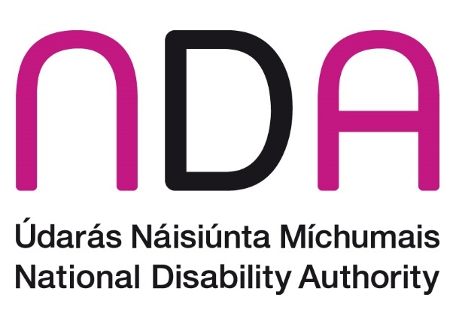

Annual Conference 2023: Public and political participation of disabled people.

Meet the speakers

Introduction to Conference 2023 3

Dr Aideen Hartney, Director, National Disability Authority (NDA) 3

Kathryn O’Donoghue, Chairperson, National Disability Authority (NDA) 3

Anne Rabbitte T.D., Minister of State with responsibility for Disabilities, Department of Health and Department of Children, Disability, Equality, Integration and Youth 4

Session 1: International innovations for accessible voting 5

Annette Costello, Member, Disability Stakeholders Group (DSG) 5

Armin Rabitsch, Democracy & Election Expert, Election Watch EU 6

Nellika Valder, Deputy Head of the State Electoral Office of Estonia 7

Cahir Hughes, Head of Electoral Commission Northern Ireland 8

Session 2: Accessibility of voting in Ireland 8

Christabelle Feeney, Director of Employers for Change, at the Open Doors Initiative 8

Dr Robert Sinnott, Coordinator of Voice of Vision Impairment 9

Dr Vivian Rath, Disability Equality & Human Rights Advocate 9

Art O’Leary, Chief Executive, An Coimisiún Toghcháin (The Electoral Commission) 10

Session 3: Participation in public life 11

Siobhán McKenna, Head of Equality, Diversity & Inclusion at the Public Appointments Service (publicjobs.ie) 11

Suzy Byrne, Regional Manager, National Advocacy Service for People with Disabilities 12

Majella O’Keefe, County Kildare Access Network 12

Sinéad Friel, Chairperson, National Advisory Council of Down Syndrome Ireland 13

Session 4: Political participation of disabled people in Ireland 14

Dr Tom Clonan, Senator to Seanad Éireann 14

John Dolan, CEO, Disability Federation Ireland (DFI) 15

Dr James Casey, Policy officer, Independent Living Movement Ireland (ILMI) 15

Brian Sheehan, CEO, Women for Election 16

Lorraine Lally, Barrister at Law 16

Session 5: Political representation of disabled people: International context and initiatives 17

Noelle O’Connell, CEO, European Movement Ireland 17

Alejandro Moledo del Río, Deputy Director & Head of Policy, European Disability Forum (EDF) 18

Ethan Young, Access to Elected Office Fund, Inclusion Scotland 19

Florian Sanden, Policy Coordinator, European Network on Independent Living 20

Wrap-up: Reflections from elected representatives 20

Ivana Bacik, TD, Labour Party 20

Pauline Tully, TD, Sinn Féin 21

Martin Conway, Senator, Fine Gael 22

Conference close 23

# Introduction to Conference 2023

## Dr Aideen Hartney, Director, National Disability Authority (NDA)

Dr Aideen Hartney became Director (Chief Executive) of the National Disability Authority (NDA) in mid-2020, having joined the organisation in 2016 as its Head of Policy, Research and Public Affairs.

Aideen has had a long career in overseeing research for the public good, having managed several major funded research programmes in University College Dublin, before coming to the NDA. She also has private sector experience following 7 years as a market research consultant. Aideen holds a doctorate in Ancient History and lectured for a time at the University of Bristol.

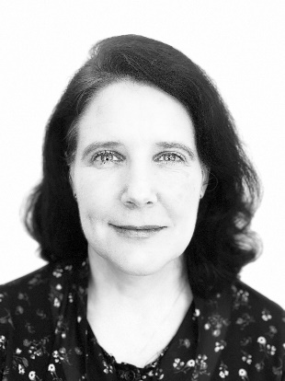

## Kathryn O’Donoghue, Chairperson, National Disability Authority (NDA)

Kathryn was appointed as the Chair of the board of the National Disability Authority (NDA) in 2022. A member of the board since 2018, Kathryn was the Chair of the Finance Committee and a member of the Audit & Risk Committee.

Kathryn also served as the Chair of the Science Gallery Dublin Board From 2019 until 2022 having previously held roles as the Interim Director of Science Gallery Dublin during 2018 and as a Science Gallery Board member for 3 years until 2017.

Kathryn graduated from Trinity College Dublin in 1987 and completed a post-graduate course in information systems. Kathryn then started her career as a Management Consultant and spent 10 years between PriceWaterhouseCoopers and Ernst & Young specialising in Information Technology predominantly defining IT Strategies and designing, developing and implementing systems for Financial Services and Government organisations many of which were highly innovative and ground-breaking.

Kathryn joined General Electric in 1997 and working in the Financial Services division that became known as GE Money she successfully led a number of IT programs including the Y2K and Euro projects for 6 countries. She then moved to Italy to lead a project to fully replace the organisation’s systems there and once this was concluded she moved to the Bank in Switzerland where she became the first female CIO for GE in Europe and the first female CIO of a bank in Switzerland. After 5 years she moved to Paris to become the Western Europe CIO for GE Money responsible for 10 countries.

Kathryn then moved back to Ireland and joined Google in 2009 and was a Director leading a number of multinational, multi-lingual teams across the sales and operations functions including being responsible for 44 countries in EMEA. She also led a global team responsible for data analytics & insights and spent 3 years as the EMEA Director of Trust & Safety for advertiser and publisher products.

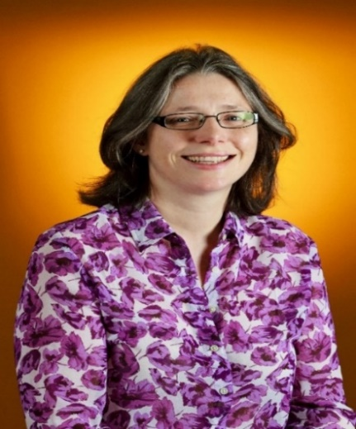

## Anne Rabbitte T.D., Minister of State with responsibility for Disabilities, Department of Health and Department of Children, Disability, Equality, Integration and Youth

Appointed to this role in July 2020, Anne Rabbitte hails from a small town in the west of Ireland, Portumna, Co Galway. A widowed mother to three children in second and third level education, she has been a TD for the Galway East constituency since the 2016 general election.

She was a member of Galway County Council from 2014 to 2016. In May 2016, she was appointed to the Fianna Fáil front bench as Spokesperson for Children and Youth Affairs.

Anne worked for 25 years for a financial institution and is a qualified financial adviser. For 3 years, Anne ran a community childcare facility.

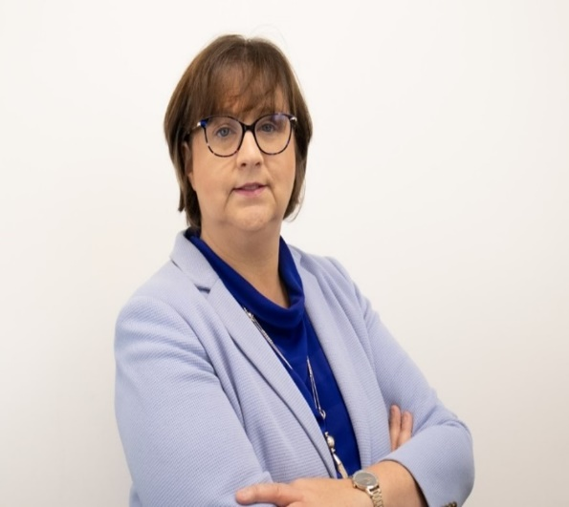

# Session 1: International innovations for accessible voting

## Annette Costello, Member, Disability Stakeholders Group (DSG)

Annette was appointed to the Disability Stakeholders Group (“DSG”) 5 in August 2018 and appointed to DSG 6 in December 2021. She was a member of the Disability Consultative Committee at the Department of Justice (one term), Department of Transport (two terms) and Department of Tourism, Culture, Arts, Gaeltacht, Sport and Media (one term)

Annette has appeared as a witness with members of the DSG before the Joint Oireachtas Committee on Disability Matters regarding Public and Political Participation of Disabled People on 23 September 2021 and 1 December 2022

Annette has over 28 years’ experience in corporate governance and was a Fellow of the Chartered Governance Institute prior to her retirement on health grounds from a Top 5 law firm in June 2018. She also has volunteer experience of working with young people. Annette has lived experience of disability since 2006.

Annette Costello smiling at camera


## Armin Rabitsch, Democracy & Election Expert, Election Watch EU

Armin Rabitsch is an elections and democracy expert and has worked with the UN, the EU, IFES, and OSCE/ODIHR. He has managed electoral assistance programmes and participated in various functions in election observation activities. Armin Rabitsch is the chairperson and co-founder of [Election-Watch.EU](http://https/www.wahlbeobachtung.org/en/) (wahlbeobachtung.org), a non-partisan civil society organisation advocating for participatory electoral reforms and young voter education within the EU and its Member States. Together with 70 colleagues of the Election-Watch.EU network he conducted the first comprehensive Election Assessment Mission to the 2019 European Parliament elections and presented its [recommendations](http://https/www.wahlbeobachtung.org/wp-content/uploads/2019/09/election-watch-eu-eam-ep-2019-final-report-160919.pdf) to the Constitutional Committee of the European Parliament. Armin coordinated the comparative research on persons with disabilities’ suffrage and accessibility rights in European elections across 27 EU Member States for the [European Disability Forum’s annual Human Rights Handbook](https://www.edf-feph.org/content/uploads/2022/10/edf_hr_report_issue_6_2022_accessible.pdf).

With Election-Watch.EU Armin recently co-authored and co-published the S[EEEDS Policy Paper on European Parliament Elections](https://www.wahlbeobachtung.org/en/policy-paper-to-the-european-parliament-elections-calls-for-eu-and-member-state-actions/) together with EPD, DRI and EPDE, and chaired a [High-Level Event on Enhancing the Integrity of the European Parliament Elections](https://www.wahlbeobachtung.org/en/great-exchange-among-european-decision-makers-and-civil-society-on-ensuring-the-integrity-of-the-2024-european-elections/) in the European Parliament.

He holds a PhD in international relations and an LL.M. in international Human Rights Law. Armin Rabitsch co-authored the [UNESCO Practitioners Handbook on Elections in Digital Times](http://https/unesdoc.unesco.org/ark:/48223/pf0000382102), the [OSCE RFoM policy paper on AI's impact on freedom of expression in political competition and elections](https://www.wahlbeobachtung.org/en/policy-paper-on-ai-and-freedom-of-expression-in-elections/#:~:text=The%20Policy%20Paper%20captures%20the%20current%20impact%20of,to%20data%20for%20an%20independent%20social%20media%20monitoring.), as well as the [UNDP elicitive peace and conflict monitoring research study in Iraq](https://www.undp.org/iraq/publications/elicitive-peace-and-conflict-monitoring-pilot-study-iraq)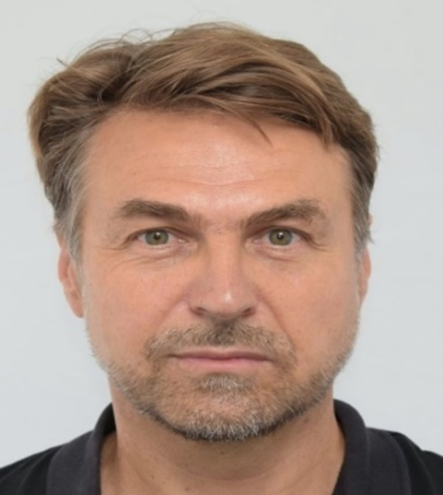

## Nellika Valder, Deputy Head of the State Electoral Office of Estonia

Nellika Valder is the Deputy Head of the State Electoral Office of Estonia. At just 21 after finishing her studies, Nellika organized elections in local government. After several years of working in the local government, it was a logical continuation to move to the national election organization. Although her specialty is the field of Law, she is passionately ensuring the accessibility of elections in Estonia by working closely with the Estonian Chamber of People with Disabilities.

One of her tasks as a Deputy Head of the State Electoral Office of Estonia is to think and implement universal smart solutions to improve the accessibility of elections. One solution was instructional videos by disabled persons themselves in the form of tips on how to make their voting in the polling station more convenient and smoother. These videos were used as part of polling station staff training. Estonia is one of the few countries in the world where voting can also be done via the internet, which has greatly facilitated the independent and secret voting opportunities of voters with disabilities.

Photograph of Nellika Valder wearing glasses and a blue jacket



## Cahir Hughes, Head of Electoral Commission Northern Ireland

Cahir is Head of the Electoral Commission Northern Ireland. He graduated from Queen’s University Belfast with a BA Joint Hons Modern History and Politics and MA in Irish Politics. Cahir joined the Electoral Commission in 2006 as a Participation Officer and then a Senior Communications and Electoral Administration Officer before taking up the position of Head in 2019.

He has been the lead author of numerous reports on elections and electoral registration which have led to significant improvements in the delivery of electoral services in Northern Ireland. He has overseen the delivery of large scale public awareness campaigns and partnership work targeted amongst the wider public and groups less likely to be engaged in the democratic process. This has contributed to Northern Ireland currently having the highest ever number of people on the electoral register.

As a member of the Commission’s Senior Leadership team, he also plays an active role in setting and delivering the Commission’s strategic objectives and goals across the UK. Cahir lives in Belfast with his wife and two children and is a member of the Board of Governors of Forge Integrated Primary School, Belfast.

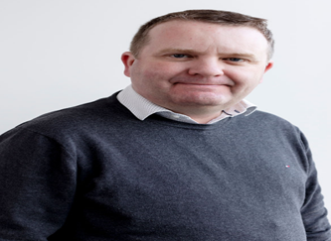

# Session 2: Accessibility of voting in Ireland

## Christabelle Feeney, Director of Employers for Change, at the Open Doors Initiative

Christabelle Feeney (she/her) is the Director of Employers for Change, at the Open Doors Initiative. Employers for Change is an employer disability information service, funded by the Department of Children, Equality, Disability, Integration and Youth. Christabelle has over ten years of experience in Diversity & Inclusion, Politics, Advocacy, Campaigns and Strategic Communications. She has a Masters in Political & Public Communications, a Degree in Economics, Politics & Law, a Professional Diploma in Diversity, Equity, Belonging & Inclusion (DEIB) and a Certificate in Sustainable Business Strategy. She has worked on numerous campaigns, initiatives and referenda including the Marriage Equality Referendum. She has created training programmes to support women on their political journey and grassroots networks to drive DEI within politics.

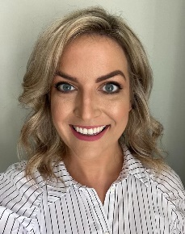

## Dr Robert Sinnott, Coordinator of Voice of Vision Impairment

Dr Robert Sinnott won a landmark High Court case against the State regarding the right of visually impaired people (blind or partially sighted) to vote in secret (i.e., without assistance).

Robert, as he is also known to his friends, is, himself, blind and neurodiverse. In July 2019, he founded Voice of Vision Impairment (VVI), which is Ireland’s Disabled Persons’ Representative Organisation (DPRO), as defined by the Convention on the Rights of Persons with Disabilities (CRPD), specialising in the Human Rights and needs of visually impaired people.

Robert represents VVI on the Disability Voting Working Group of the Franchise Unit (Dept. of Housing & Local Government – DHLG), as well as representing VVI on many other committees and groups. As well as ongoing Human Rights campaigning, as part of VVI, Robert also works in the building, organisation and management of VVI, as well as on policy-building and article-writing for <https://www.vvi.ie>

While his BA degree (in University College Dublin) was in Politics and Sociology, Robert’s doctorate is a PhD in Irish, from Trinity College Dublin, and he specialises in extinct dialects of Modern Irish, and in his remaining spare time, he works on publishing academic material related to that area of research.

## Dr Vivian Rath, Disability Equality & Human Rights Advocate

Dr Vivian Rath is an academic and human and disability rights advocate. He is an Adjunct Teaching Fellow in Trinity College Dublin (TCD) and a Research Officer on the Reasonable Accommodations and Professional Placement project with AHEAD. His Ph.D, titled the “social engagement experiences of disabled students in higher education in Ireland”, focused on the areas of disabled student social engagement, transitions, voice and belonging. He obtained a Master's in Management from Smurfit Business School where he focused on the employment of graduates with disabilities. A TCD Equality Champion and a Disabled Leader awardee he has focused on ensuring the voice of disabled people is represented at the decision-making table.

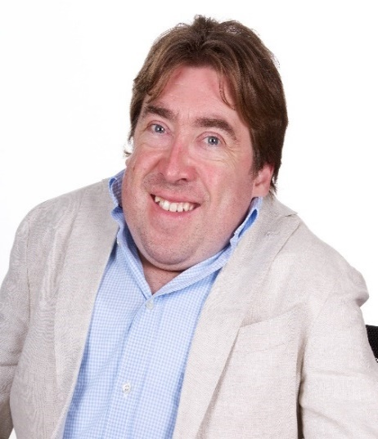

## Art O’Leary, Chief Executive, An Coimisiún Toghcháin (The Electoral Commission)

Art O'Leary is Chief Executive at An Coimisiún Toghcháin, The Electoral Commission, a new management and oversight organisation for electoral and wider democracy matters.

In 2021 he was Secretary to 2 national Citizens' Assemblies - deliberative democracy initiatives set up to advise the government on the crisis on Biodiversity Loss and local government structures in Ireland’s capital city. Art also designed and ran Ireland's first Citizens' Assembly in 2012, the recommendations from which resulted in a number of successful constitutional referendums.

From 2014 - 2021, Art was Secretary General to the President of Ireland, acting as Chief of Staff and Chief Adviser to President Michael D. Higgins.

Prior to that, Art also worked in the Irish Parliament for over 20 years, primarily as a member of the senior management team as Director of Parliamentary Committees, Information & Communications, Human Resources and as head of a number of parliamentary functions.

He is an Adjunct Professor at the School of Politics and Government at University College Cork and has an MBA from Henley Business School.

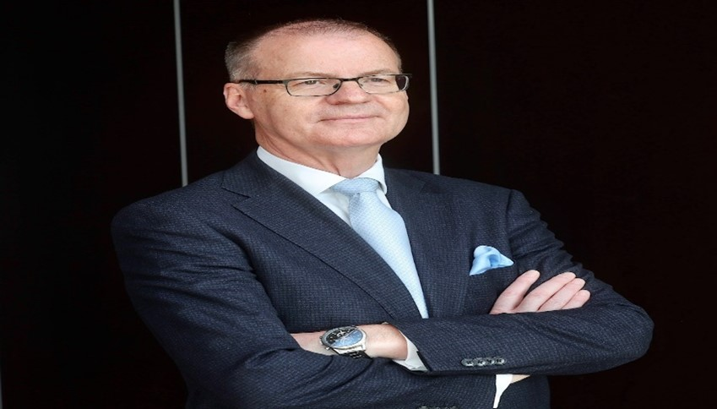

# Session 3: Participation in public life

## Siobhán McKenna, Head of Equality, Diversity & Inclusion at the Public Appointments Service (publicjobs.ie)

Siobhán is the Head of Equality, Diversity & Inclusion at the Public Appointments Service (publicjobs.ie), Ireland’s centralised provider of recruitment services across the civil and public service.

Siobhán returned to Dublin in 2021 having spent 20 years in the non-profit and public sectors in London. She worked for 5 years in international development at the Open Society Foundation where she supported the global fight against HIV/AIDS.

In 2009, Siobhán joined City Hall, where she held several roles including youth programme manager, senior social policy advisor to the Mayor of London and education programme manager at London’s Violence Reduction Unit. Siobhán also developed and delivered the workplace equality, diversity and inclusion priorities for the Mayor of London and key front-line public sector organisations within the Mayor’s remit.

Siobhán holds a Bachelors degree in Social Science (International), from UCD and an MPhil in Ethnic and Racial Studies from Trinity College Dublin.

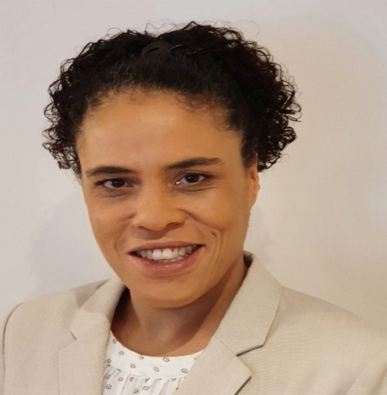

## Suzy Byrne, Regional Manager, National Advocacy Service for People with Disabilities

Suzy Byrne is a disabled woman who has been involved in community work and campaigning on disability and equality issues for over 30 years. She works as a regional manager for the National Advocacy Service for People with Disabilities which provides professional independent representative advocacy for disabled individuals who may need support in decision making. Suzy is also a Director of the board of Iarnród Eireann as one of the first disabled people to be specifically recruited to a state public transport board. She also currently chairs the board of Irish Council of Civil Liberties.

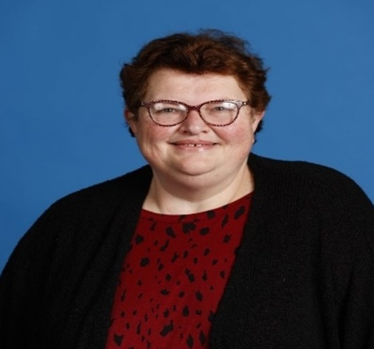

## Majella O’Keefe, County Kildare Access Network

My name us Majella O Keefe. I had a successful retail business for 20 years and my life suddenly changed with the diagnosis of a brain tumour. I lost most of my sight and my ability to work full time. Because of my lack of independence, my husband and I made the decision to sell our home and business and move into Naas. My sight loss had created new challenges, dangers and lots of frustrations. I encountered difficulty with obstacles in shops, broken paths, and walking into glass doors. I decided to meet other people with disabilities and discovered what an Access Group was. I learned that Kildare Co. Council recently had employed a part time Access Officer and 2014 I started the Naas Disability Access Group.

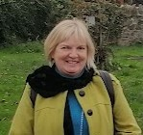

## Sinéad Friel, Chairperson, National Advisory Council of Down Syndrome Ireland

My name is Sinéad Friel and I am the Chairperson of the NAC – the National Advisory Council of Down Syndrome Ireland.

The NAC is the voice of adults with Down syndrome in Down Syndrome Ireland. We represent people with Down syndrome.

I have been a member of the NAC for 4 years. I have been the chairperson for 1 year. It has been an amazing experience.

Before joining the NAC, I studied MOTE. MOTE stands for My Opinion My Vote. I learned how important advocacy is. I learned how important it is to vote.

There are 7 adults on the NAC – Orla, Chrissie, Una, Eric, Ross, Conor and me.

We are interested in self-advocacy, adult education, employment and much more.

Adults with Down syndrome want to lead full lives. We want to reach our full potential, and this is what we want for all people with Down syndrome.

We believe that it is important for people with Down syndrome to vote and to be represented.

I am happy to represent Down Syndrome Ireland at the NDA Annual Conference.

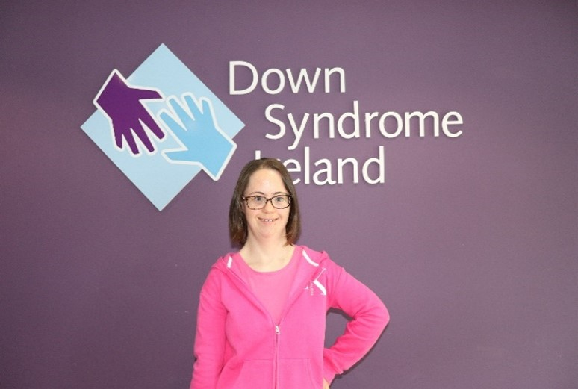

# Session 4: Political participation of disabled people in Ireland

## Dr Tom Clonan, Senator to Seanad Éireann

Dr Tom Clonan is a retired army officer, university lecturer and recently elected Senator to Seanad Éireann. Tom has campaigned to end gender-based discrimination and gender-based violence in the Irish armed forces and was a member of the HEA Expert Group on ending bullying, sexual violence, and sexual harassment in Irish universities. Tom has written two best-selling books about his experiences in the army in the Middle East and former Yugoslavia. Unusual fact:  Tom has also performed as a lead dancer in the award winning ‘Soldier Still’ – an exploration of trauma and grief written and choreographed by the dance theatre company Junk Ensemble. He has four adult and teenage children and is an advocate for children and young adults with disabilities.

A photograph of Dr Tom Clonan in a suit



## John Dolan, CEO, Disability Federation Ireland (DFI)

John Dolan has had polio since childhood and has worked all his life in the disability movement. He has been Chief Executive of the Disability Federation of Ireland since 2000. Prior to that he worked for 20 years with the Irish Wheelchair Association (IWA), and during that time gained a comprehensive understanding of issues across the movement. John has been active in developing governance, management capacity and collaborative working to increase organisational capacity across the voluntary disability movement. He has been at the forefront of many innovative developments seeking equality for people with disabilities in Irish society.

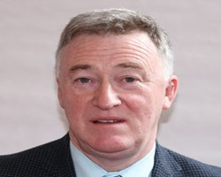

## Dr James Casey, Policy officer, Independent Living Movement Ireland (ILMI)

Dr James Casey currently works for ILMI as the policy officer, he previously worked on the Onside Project. He holds a PhD in Critical Disability Studies from the University of Galway where he was the recipient of a Doctoral Teaching Fellowship. He is a disabled person and has worked as a teacher, disability equality consultant and communications worker in addition to his continued role as a peer reviewer with several international journals and his tenuous forays as a writer.

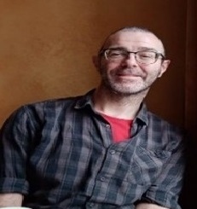

## Brian Sheehan, CEO, Women for Election

Brian has a wide background in social justice advocacy, campaigning and politics. He was the co-director of the Yes campaign in the 2015 same-sex marriage referendum and for a decade was the executive director of GLEN, one of the leading Irish LGBTI equality and advocacy organisations.

He is a former co-chair of ILGA-Europe, the Brussels-based advocacy organisation of 700 LGBTI+ member bodies in Europe and Central Asia. More recently, Brian was the general secretary of a political party in Ireland before joining Women for Election to encourage and support more women to enter Irish politics.

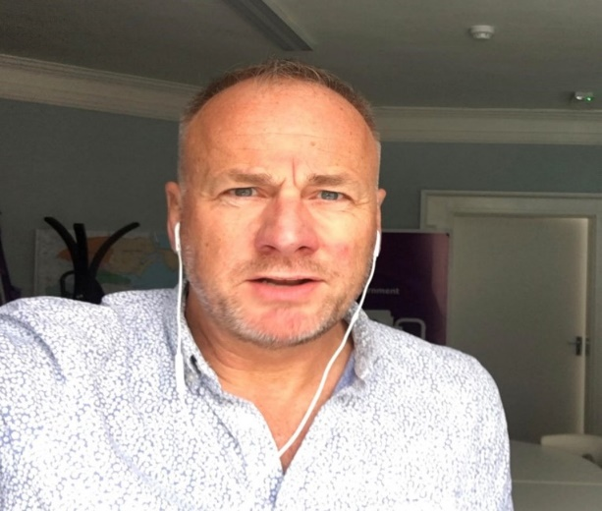

## Lorraine Lally, Barrister at Law

Lorraine Lally is from Galway. She holds an LLM in International Human Rights Law from the Irish Centre for Human Rights in the University of Galway and an LLM in International Financial Services Law from University College Dublin. Lorraine is a practising barrister in Ireland since October 2010.

She is a qualified mediator practising in online and face to face mediation for more than 10 years.

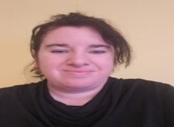

# Session 5: Political representation of disabled people: International context and initiatives

## Noelle O’Connell, CEO, European Movement Ireland

Noelle O Connell was appointed CEO of European Movement Ireland in April 2011. European Movement Ireland is Ireland’s longest established Not for Profit membership organisation dedicated to developing the connection between Ireland and Europe founded in 1954. As the organisation’s CEO, Noelle is the public spokesperson for the organisation and she regularly makes appearances on national and international media to give commentary on the ongoing Brexit negotiations, as well as the latest developments across the EU and in Ireland.

Noelle is Vice President of European Movement International which encompasses European Movement councils in 34 countries in addition to 38 international associations representing civil society, business, trade unions, NGOs, political groups and academics.

Prior to leading European Movement Ireland, Noelle provided business development training, education, and public affairs consultancy to a wide variety of both private and public sector clients. She also has extensive experience of working in the third level sector and has managed and led on significant national and international funding projects (e.g., Interreg, Skillnets, Erasmus+, Europe for Citizens etc.).

Noelle is a voluntary Director of the board of Alliance Française Irlande, and in 2017 was awarded the French Chévalier de l’Ordre National du Mérite. In 2019, she was appointed an International Leadership Fellow of Society of Leadership Fellows, St. George’s House, Windsor. She is also a member of the Institute of Directors, the CIPD, and is a Fellow of the Irish Institute of Training and Development (IITD). In July 2021, she was appointed by the Irish government to act as Ireland’s National Citizen Representative to the Conference on the Future of Europe. She was selected as one of the Taoiseach’s independent nominees to serve in the National Economic and Social Council.

She holds a BA Hons in European Studies, French and Spanish from University College Cork, Ireland, a DEUF Diploma from Université de Jean Moulin, Lyon III, France and a MSc in International Relations from the University of Edinburgh, Scotland, Executive Diplomas in Finance, Strategy and Innovation from the Irish Management Institute (IMI) and speaks Irish, French and Spanish.

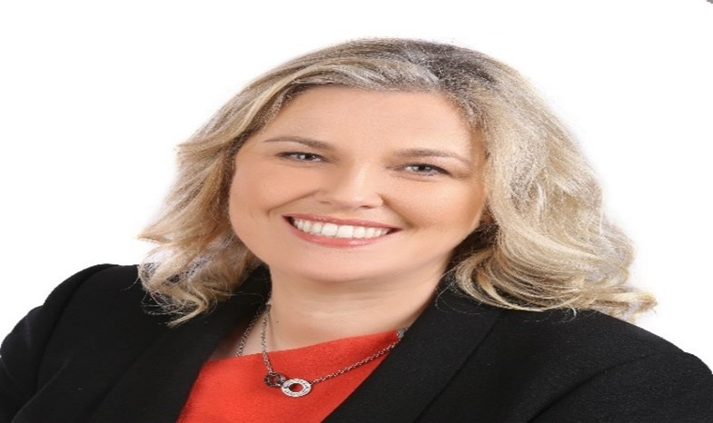

## Alejandro Moledo del Río, Deputy Director & Head of Policy, European Disability Forum (EDF)

Mr. Moledo leads and coordinates EDF’s advocacy and policy work at EU level and supports the work of the European Parliament Disability Intergroup.

Among other areas, Mr. Moledo has developed policy positions and recommendations regarding political participation of persons with disabilities, accessible Information and Communication Technologies, Assistive Technologies and different standardisation activities.

Mr. Moledo holds a Bachelor's degree with honours in Journalism from University of Valencia (Spain, 2005-2010), including one year at York University (Canada), as well as a Master's degree in political and corporate communication from University of Navarra and George Washington University (Spain and US, 2011-2012). During his bachelor’s studies he worked as communication officer for a political group within the parliament of the Valencia Region (2009 and 2010). After working as a journalist in digital media and a communication agency in Andorra, he started working in a European public affairs company (Madrid) in 2012, before joining the European Disability Forum in 2013.

Mr Moledo is also member of the Spanish Blind Organisation (ONCE), for which he worked as a journalist and regional representative of young visually impaired people inside the organisation (2008-2011).

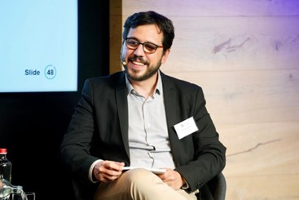

## Ethan Young, Access to Elected Office Fund, Inclusion Scotland

Civic Participation Manager at Inclusion Scotland.Ethan leads the Access to Politics work at Inclusion Scotland which includes the Access to Elected Office Fund Scotland. The projects aim to reduce barriers that disabled people face to fully participate in politics at all levels. He works with disabled people, political parties, and other key stakeholders to achieve this. He has previously worked in International and Community Development, Peace and Reconciliation and finance.

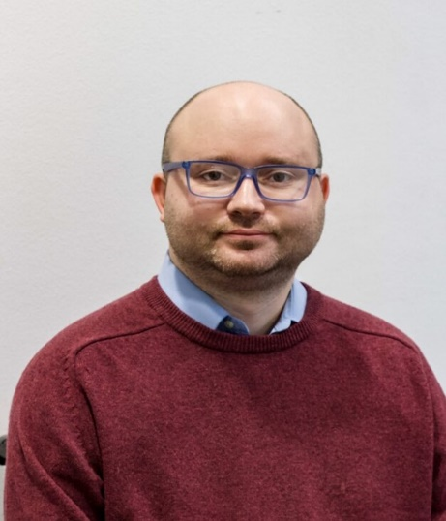

## Florian Sanden, Policy Coordinator, European Network on Independent Living

After graduating with a Master of Science degree in European Studies from Maastricht University (NL), Florian Sanden started working for EU-level NGOs in 2016. By doing advocacy work in the field of social policy for BAGFW e.V., a German association of social service providers and youth and education policy for AKSB e.V., an association of providers of non-formal youth and adult education, Florian developed a passion for disability rights. After discovering he is on the autistic spectrum and also bipolar, he started working as policy coordinator at the European Network on Independent Living (ENIL) which he also entered as individual member. Alongside his work Florian Sanden contributes to the activities of ADHD, ASC & LD Belgium, a small entirely volunteer based organisation focused on self-help and peer support of neurodivergent people.

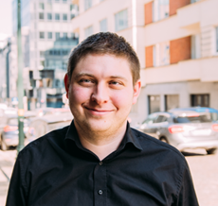

# Wrap-up: Reflections from elected representatives

## Ivana Bacik, TD, Labour Party

Ivana Bacik is the Leader of the Labour Party and TD for Dublin Bay South. She was first elected as a Senator on the Dublin University panel in 2007 and was re-elected at each subsequent Seanad election before being elected to the Dáil in July 2021.

A lifelong feminist, Ivana has a long track record of campaigning on human rights issues. In 2018 she was Chairperson of the Oireachtas Vótáil100 Programme, the series of events run to celebrate the centenary of women’s suffrage in Ireland. In 2022, she chaired the Special Oireachtas Committee on Gender Equality, which reported on the recommendations in the Report of the Citizens’ Assembly on Gender Equality. For many years, Ivana was the Reid Professor of Criminal Law, Criminology and Penology at Trinity College Dublin, and has published extensively on criminal law, criminology, human rights, constitutional law and related matters.

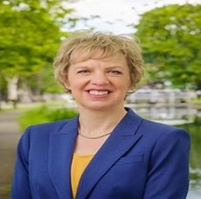

## Pauline Tully, TD, Sinn Féin

Pauline Tully is the Sinn Féin Spokesperson on Disability and Carers and TD for Cavan-Monaghan. Pauline is a member of the Oireachtas Committee of Disability Matters. A single parent to Pearse, 12, and Eoghan, 9, Pauline lives in rural Cavan near the villages of Ballinagh and Kilnaleck where she grew up on a small farm.

Pauline taught Maths and History in Breifne College in Cavan Town where she was Year Head to the Second Years and was Chairperson of the outgoing Board of Management.

Elected to Cavan County Council in 1999 for the Ballyjamesduff Electoral Area, Pauline retained the seat until 2012 when she resigned to meet the then care needs of her children.

She is passionate about her community and is a strong voice in the Dáil for the people of Cavan, Monaghan and North Meath.

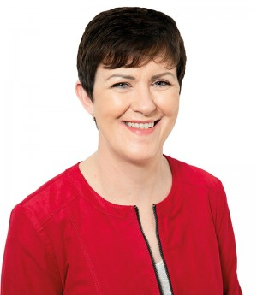

## Senator Martin Conway, Fine Gael

Martin Conway is a member of the 26th Seanad and previously served in the 24th Seanad on the Administrative Panel, having been elected in 2011. He is the Seanad spokesperson on Justice and Equality and is the first visually impaired member of the Oireachtas.

He was first elected to Clare County Council in June 2004 representing North Clare and was re-elected in 2009, topping the poll.

Martin is the third generation of his family to be born with congenital cataracts. When he was just six months old, he was taken to London for a series of ground-breaking eye operations, which left him with 16% vision. Rather than going to a school especially for the blind and visually impaired, Martin attended local schools with his brother.

Martin first joined Fine Gael whilst at school in Ennistymon and his interest in politics continued throughout his college career. In 1998 he graduated with a Degree in Economics and Politics from University College Dublin.

One of his proudest moments was to receive the prestigious University College Dublin President’s Award for Excellence, in recognition of his commitment for campaigning and advocacy for people with disabilities.

Martin campaigns tirelessly on behalf of people with disabilities for the provision of adequate housing, improved education and employment opportunities, and proper sport facilities.

Martin is a founding member of AHEAD-The Association of Higher Education Access and Disability- which endeavours to make education accessible to all. He is particularly proud of the Willing Able Mentoring (WAM) programme which has successfully placed over 150 graduates with disabilities in employment over the last seven years.

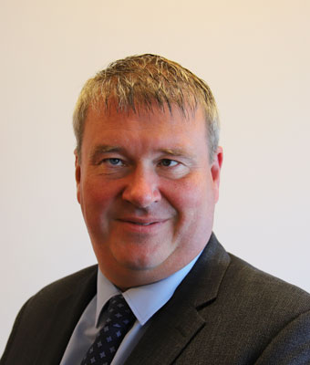

# Conference close

Conference Close and video message from Roderic O’Gorman, TD, Minister for Children, Equality, Disability, Integration and Youth and Dr Aideen Hartney, Director, National Disability Authority.