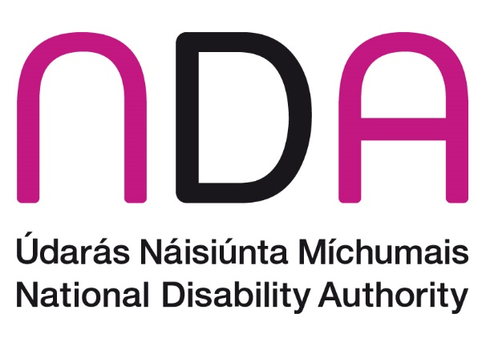

Annual Conference 2023: Public and political participation of disabled people

Conference Programme
Thursday, 26 October 2023, Aviva Stadium and online.

Welcome and registration
9.30 Tea and Coffee

Introduction to Annual Conference 2023
10:00 Dr Aideen Hartney, Director, National Disability Authority.
10.05 Welcome Address
Kathryn O’Donoghue, Chairperson, National Disability Authority.

10.10 Ministerial Address
Anne Rabbitte T.D., Minister of State with responsibility for Disability, Department of Children, Equality, Disability, Integration and Youth.

Session 1: International innovations for accessible voting
10.20 Chair: Annette Costello, Member, Disability Stakeholder Group (DSG).
- Armin Rabitsch, Election Watch EU,
- Nellika Valder, Deputy Head of the State Electoral Office of Estonia,
- Cahir Hughes, Head of Electoral Commission Northern Ireland.
10.55 Q&A

11:05 Break

Session 2: Accessibility of voting in Ireland
11.20 Chair: Christabelle Feeney, Director of Employers for Change, at the Open Doors Initiative
- Dr Robert Sinnott, Coordinator of Voice of Vision Impairment,
- Dr Vivian Rath, Disability Equality & Human Rights Advocate,
- Art O’Leary, Chief Executive, An Coimisiún Toghcháin (The Electoral Commission).
12.05 Q&A

Session 3: Participation in public life
12.15 Chair: Siobhán McKenna, Head of Equality, Diversity & Inclusion at the Public Appointments Service (publicjobs.ie).
- Suzy Byrne, Regional Manager, National Advocacy Service for People with Disabilities,
- Majella O’Keefe, County Kildare Access Network,
- Sinéad Friel, Chairperson, National Advisory Council of Down Syndrome Ireland.
12:50 Q&A

13:00 Lunch

Session 4: Political participation of disabled people in Ireland
13.40 Chair: Senator Dr Tom Clonan, Independent
- John Dolan, CEO, Disability Federation Ireland (DFI),
- Dr James Casey, Policy Officer, Independent Living Movement Ireland (ILMI),
- Brian Sheehan, CEO, Women for Election
- Lorraine Lally, Barrister at Law
14:25 Q&A

14.35 Break

Session 5: Political representation of disabled people: International context and initiatives
14.40 Chair: Noelle O’Connell, CEO, European Movement Ireland.
- Alejandro Moledo, Deputy Director & Head of Policy, European Disability Forum (EDF),
- Ethan Young, Access to Elected Office Fund, Inclusion Scotland,
- Florian Sanden, Policy Coordinator, European Network on Independent Living.
15:25 Q&A

Wrap-up: Reflections from elected representatives
15.35 Chair: Dr James Casey, Policy Officer, Independent Living Movement Ireland (ILMI)
- Ivana Bacik, TD, Labour Party,
- Pauline Tully, TD, Sinn Féin,
- Senator Martin Conway, Fine Gael.
16:05 Conference Close and video message from Roderic O’Gorman, TD, Minister for Children, Equality, Disability, Integration and Youth
Dr Aideen Hartney, Director, National Disability Authority.

