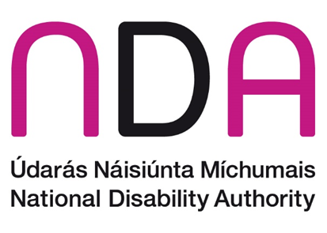

NDA Research Promotion Scheme:

Frequently Asked Questions
- Question: Are PhD/research students eligible to apply for this scheme?
Answer: No, this scheme is not a scholarship scheme.
- Question: Our organisation is based outside Ireland; can we apply to the Scheme?
Answer: The scheme is open to researchers based throughout Europe but the research findings must have application in Ireland.
- Question: ‘Only organisations which can deliver a satisfactory final draft report on the research by stated date will be eligible for consideration.’ Does this mean that the entire research project needs to be completed by stated date?
Answer: Yes. It is expected that the entire research project, including delivery of a satisfactory final draft report, is completed within the specified timeframe.
- Question: Are the referees to be selected on behalf of the principle
investigator or on behalf of the entire research team?
Answer: References are required on behalf of the principal investigator.
- Question: Can the reference provided on behalf of the Principal Investigator be written by another member of the team who they have worked closely with?
Answer: The reference provided should be written from outside of the team, as it needs to be independent from the team.
- Question: Does the RPS grant cover costs associated with dissemination?
Answer: Yes. Dissemination costs can be included as part of the proposal.
- Question: What level of supervision (Research Advisory committee) is required?
Answer: While the NDA will review the final report as a condition of payment, we are not in a position to provide ongoing supervision of the research report. The final research report must meet the NDA Quality Guidelines for Research.
- Question: Is the Grant amount payable, a VAT-able amount?
Answer: For an Educational Institution – No. See Revenue.ie for further information.

