The National Disability Authority

20 years of Disability Policy in Ireland
December 2020
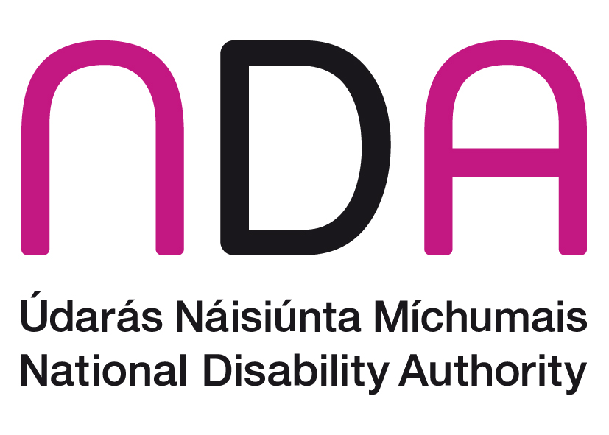

Table of Contents
What is this document about? 2
The National Disability Authority 3
Research and Policy 3
Standards and Monitoring 4
The Centre for Excellence in Universal Design 5
Disability Developments in Ireland 7
Commission on the Status of People with Disabilities 7
The National Disability Authority Act 1999 8
National Disability Strategy, 2004 8
The Disability Act 2005 8
The United Nations Conventions on the Rights of Persons with Disabilities 2006 10
20 Years of Disability Policy and Developments in Ireland 11
Conclusion 18

What is this document about?
The National Disability Authority is 20 years old. The National Disability Authority is sometimes called the NDA.
This document is about the work the NDA does.
This document is also about disability policy in Ireland over the last 20 years.

The National Disability Authority
The NDA is an independent organisation. It gives information and advice about disability issues to the Irish Government and promotes the uptake of Universal Design.
The three main roles of the NDA are described below

Research and Policy
The NDA carries out research about disability.
The NDA supports other people and organisations to also carry out research about disability.
Research is used to inform new policies and strategies that the government writes.
Policies are the government’s plans of action.
Strategies are the actions that the government takes to achieve long-term goals.
The NDA advises government departments on policies about:
- employment
- transport
- independent living
- adult day services
- education
- children
- attitudes
- access
- where people live
The main job of the NDA is to give information and advice informed by research to the Minister for Children, Equality, Disability, Integration and Youth.
The NDA organises a conference every year so that people can learn about disability policy and research in Ireland and around the world.

Standards and Monitoring
Monitoring means checking
The NDA helps to make sure policies and strategies are carried out.
It also checks that the policies helped the lives of persons with disabilities.
The NDA checks the number of persons with disabilities that are working in the public sector. There is a rule that says the public sector must employ persons with disabilities.
The NDA writes standards.
Standards are a level of quality for programmes and services for persons with disabilities.
The NDA develops codes of practice. Codes of practice help services aim for good standards and quality in their work.
The NDA prepared a code of practice about the accessibility of:
- public buildings
- services
- information and
- heritage sites
Accessibility means that places and services can be used by persons with disabilities.

The Centre for Excellence in Universal Design
The NDA opened the Centre for Excellence in Universal Design in 2007.
Universal design means that things are set up in a way that all people can access, use and understand.
The Centre for Excellence in Universal Design says that:
- information
- services
- information technology
- places and
- products
should be made so that all people can use them.
The Centre for Excellence in Universal Design has done good work with:
- energy companies
- colleges
- the tourism sector
- housing and building professionals
In 2019 the Centre for Excellence in Universal Design won awards in Ireland and Europe for its work.

Disability Developments in Ireland
Some big changes led to the development of the NDA as it is today:

Commission on the Status of People with Disabilities
A report was written in 1996 by the Commission of the Status of People with Disabilities.
This report was called A Strategy for Equality.
This report is important because it talked about the barriers that persons with disabilities face.
Barriers make it difficult for persons with disabilities to access:
- education
- employment
- independent living
- relationships
This report talked about moving away from the medical model of disability to a social model of disability.
The medical model of disability focuses on the person’s disability. This model says that a person’s disability is the reason they cannot:
- Access some goods and services
- Fully take part in society
- The social model of disability looks at the barriers in society that make it too difficult for persons with disabilities to take part in day-to-day life.
The social model also says that attitudes towards persons with disability create barriers to inclusion.
The social model looks at what can be done to take away barriers to inclusion.
The Commission said to set-up an organization like the NDA.

The National Disability Authority Act 1999
In 1999 the National Disability Authority Act 1999 became a law.
It says what work NDA will do. The NDA was set up in 2000.

National Disability Strategy, 2004
The first ever National Disability Strategy was brought out in 2004.
The National Disability Strategy talks about how to:
- plan disability policies and services
- make sure disability policies and services are carried out.

The Disability Act 2005
The Disability Act 2005 is a law in Ireland.
The Disability Act, 2005 gave more work to the NDA.
The Disability Act 2005 was put together to support persons with disabilities to take part in society.
The Disability Act 2005 talks about:
- supporting disability services.
- setting up the Centre for Excellence in Universal Design.
- improving access to mainstream public services. Mainstream services are the usual services that everybody uses.
The Disability Act says that:
- services and public service buildings must be accessible.
- public services must employ persons with disabilities.
The Disability Act says that sectoral plans must be made by government departments.
Sectoral plans talk about how each government department will provide services to persons with disabilities.
The NDA helped the government departments to put important information about disability in the sectoral plans.
These sectoral plans were published in 2006:
- Health and Children
- Social and Family Affairs
- Transport
- Communications, Marine and Natural Resources
Environment, Heritage and Local Government
Enterprise, Trade and Employment

The United Nations Conventions on the Rights of Persons with Disabilities 2006
The United Nations Conventions on the Rights of Persons with Disabilities is called the UNCRPD for short.
The UNCRPD is a legal document about human rights for persons with disabilities.
The UNCRPD tells us that persons with disabilities have the same rights as all other people.
Ireland signed the UNCRPD in 2007.
The government ratified the UNCRPD in 2018. Ratified means it became part of the law in Ireland.
The NDA helped departments and agencies to work on their policies so they would be ready for the UNCRPD.
The NDA still gives advice to agencies and the government about the UNCRPD.
The NDA will work with the Irish Human Rights and Equality Commission to check how Ireland is carrying out the UNCRPD.

20 Years of Disability Policy and Developments in Ireland
This is a summary of some of the main disability policies and developments in Ireland since the NDA was set up 20 years ago.
2000 – 2003
The NDA was set up in 2000. It first worked on important topics like education and disability law.
In a 2002 report, the NDA advised the government to make a National Disability Strategy.
In 2003, Ireland hosted the Special Olympics.
This led to greater awareness of disability in the general public.
This was also the European Year of People with Disabilities.
The European Union did a survey about attitudes towards disability.
The survey said that Ireland had the most positive attitudes towards persons with disabilities in the European Union.
2004 - 2007:
In 2004, the Disability Bill 2004 was published.
In 2004, the first National Disability Strategy was launched.
In 2004, the Education for Persons with Special Educational Needs Act 2004 became part of the law.
This led to the set-up of the National Council for Special Education.
In 2004, the Employment Equality Act 2004 became part of the law.
In 2004, the Equal Status Act 2004 became part of the law.
In 2005, the NDA published guidelines on person-centered disability services.
Person- centered means that disability services focus on the needs and wishes of the person with a disability.
In 2005, the Disability Act 2005 became part of the law.
In 2006, the 6 sectoral plans were published by the different government departments.
In 2006, A Vision for Change was published.
It talks about a way of:
- promoting mental health at all levels of society and
- giving specialist care to everyone who needs it.
In 2007, the Centre for Excellence in Universal Design was set-up.
In 2007, Ireland signed the United Nations Convention on the Rights of Persons with Disabilities.
2008 – 2016:
The Department of Health published the important report on ‘Value for Money and Policy Review of Disability Services’.
The NDA gave advice about policy and research for this report.
This report looked at the costs of disability and disability supports in different countries.
The report set out a plan for reforming disability services in Ireland.
Reforming means to change things for the better.
The Value for Money and Policy Review for Disability Services was renamed ‘Transforming Lives’.
Transforming Lives is about supporting persons with disabilities to live the lives they choose in the community.
In 2010, Progressing Disability Services for Children and Young People was set up.
This aims to change the way disability services for children are provided in Ireland.
In 2011, the National Housing Strategy for People with Disabilities was launched.
The Centre for Excellence in Universal Design worked with the government to make guidelines about using universal design for new housing to make it easy for persons for disabilities to live in.
In 2012, New Directions – a review of Adult Day Services was published.
The NDA gave information and advice to the HSE about this.
New Directions is about a new way to run disability day services so that persons with disabilities can take part in mainstream community activities.
In 2014 and 2015, a set of standards were put together to carry out New Directions.
In 2012 the Time to Move on From Congregated Settings report was published.
The report said that persons with disabilities living in institutional settings should be supported to move to homes in the community.
In 2012 the Centre for Excellence in Universal Design gave us Building for Everyone: A Universal Design Approach. This is a set of books that shows people how to design buildings and the places outside where we walk and move around so that everyone can use them.
In 2014 and 2016, the HSE and the NDA published guidelines about:
- planning accessible health and social care services
- delivering accessible health and social care services
In 2015, the Comprehensive Employment Strategy for People with Disabilities was brought out.
This was a plan for the whole government to work together to improve employment for persons with disabilities.
In 2015, The NDA put together a ‘Programme of Actions for Autism’.
This was about:
- the justice system
- housing
- employment
In 2015, The Assisted Decision-Making (Capacity) Act 2015 was signed into law. It talks about supports for adults who have difficulties with decision-making.
In 2015 the Centre for Excellence in Universal Design gave us “Universal Design Guidelines for Homes in Ireland”. This book shows us how to build houses that everyone can live in whether they have a disability or not.
In 2016, the Programme for Partnership Government agreed to make a way for personalised budgets to be available to persons with disabilities.
2017 – 2020:
In 2017, The Government brought out the National Disability Inclusion Strategy 2017 – 2021.
This is about the whole government working to make the lives of persons with disabilities better.
The Strategy is about:
- Equality and Choice
- Policies and public services
- Education
- Employment
- Health and Wellbeing
- Person centered disability services
- Living in the Community and
- Transport and access to places
In 2017, the NDA did their 4th survey about attitudes to disability. This survey showed positive attitudes towards every kind of disability.
In 2018, Ireland ratified the United Nations Convention on the Rights of Persons with Disabilities and it became law in Ireland.
In 2019, the Centre for Excellence in Universal Design published Universal Design Guidelines for Early Learning and Care Settings.
It supports the Access and Inclusion Model for children with disabilities in Ireland.
The Centre for Excellence in Universal Design wrote a new standard with the National Standards Authority of Ireland on how to include persons with disabilities in decisions in an organisation.
In 2020, Mr. Roderic O’ Gorman was named as the Minister for Children, Equality, Disability, Integration and Youth.
This is the first time that there has been a senior government minister for disability.
Image 1: Mr. Roderic O’ Gorman is the current Minister for Children, Equality, Disability, Integration and Youth

Conclusion
Over the last 20 years the job of the NDA has changed.
The NDA has contributed to many very important policy documents over the last 20 years and is a trusted source of research and advice.
The NDA gives information and advice to the government to help them write policies.
This information includes what we have heard from people with disabilities and their families.
The NDA helps make sure that the policies are used to make the lives of persons with disabilities better.
COVID-19 presents us all with a new challenge. The NDA is working to ensure that persons with disabilities are not left behind in the COVID-19 response.
The UNCRPD means that the NDA will work more with persons with disabilities to prepare advice. This will make sure persons with disabilities take part in Irish society in a full and equal way.
The NDA looks forward to the next 20 years of work to improve the lives of persons with disabilities.

