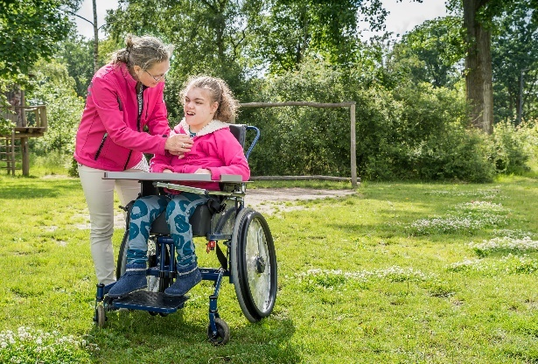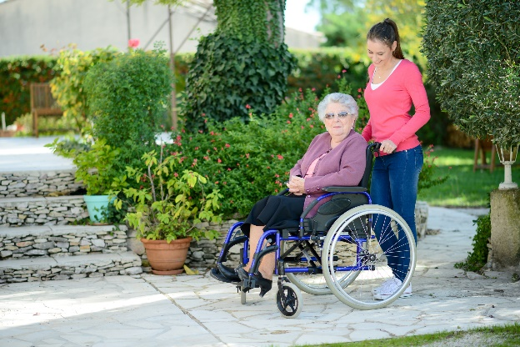

**National Survey of**

**Public Attitudes to**

**Disability in Ireland**

**2017**

Executive Summary

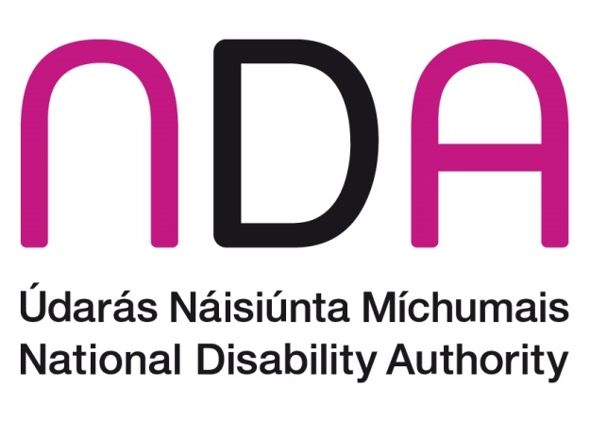

**Executive Summary**

The National Disability Authority (NDA) commissioned Behaviour & Attitudes (B&A) to conduct a nationally representative survey on public attitudes to disability in Ireland in 2017. The NDA previously conducted national surveys on attitudes to disability in 2001, 2006 and 2011.

The survey used quota sampling and was conducted via face-to-face interviews during January and February 2017. Data were weighted on gender, age, region, socio-economic status and disability status. Data from 2017 were compared to 2011 and 2006 data and these datasets were also weighted to their respective census year. Multivariate analysis was carried out to determine what factors influenced the key findings.

It is important to note that in surveys, some small fluctuations in results can be due to sampling variation and chance rather than reflecting a true change in attitudes. However, differences between groups cited in the report are statistically significant (that is, are not as a result of chance). If differences are not mentioned, it can be assumed that they are not statistically significant.

The survey covered a range of topics on attitudes relating to disability. These included awareness of disability and attitudes towards particular types of disability. Survey questions explored attitudes towards children with disabilities in mainstream education, the employment of people with disabilities as well as relationships, neighbourhood, and the social wellbeing of people with and without disabilities.

**Description of the sample**

A total sample of 1294 respondents aged 18 years and older participated in the survey. The sample was comprised of an initial sample of 1,021 respondents, of whom 166 had a disability, and a booster sample of 273 people with disabilities, giving a total of 439 people with a disability and 855 without.

People with disabilities were more likely than people without disabilities to be: older; to be from lower socioeconomic groups; to be either unemployed, retired, or a fulltime homemaker; to be single; to have only primary or secondary education; and to have no children.

**Awareness of and familiarity with disability**

In 2017, physical disability received the highest unprompted association with the term ‘people with disabilities’ (82%), followed by mental health difficulties (54%) and intellectual disability (47%). When compared with the 2011 survey results, unprompted association with intellectual disability (54% in 2011 versus 47% in 2017), vision difficulties (33% in 2011 versus 28% in 2017), and addiction (13% in 2011 versus 9% in2017) had declined among respondents. Unprompted association of the term ‘disability’ with mental health difficulty was slightly higher in 2017 at 54% compared to 50% in 2011 and also higher for long-term illness at 25% compared to 22% in 2011.

Almost three in every four respondents knew someone with a disability**.** On average, they knew two people with a disability and 78% of those who knew someone with a disability had daily or weekly contact with them.

More women than men had daily contact with someone with a disability (44% versus 29%) while respondents living in Dublin were less likely to have daily contact (28%) with someone who has a disability compared to respondents living elsewhere in the country (for example, 43% of respondents living in Munster had daily contact).

**Prevalence of disability**

The overall prevalence among respondents of having a ‘long-lasting condition’ increased from 12% in 2006 to 14% in 2011 to 16% in 2017. The 16% disability prevalence of this survey corresponds to that of Census 2016 where the prevalence of disability in the 20 to 85+ year category was 16.1%.[1]

The most common disability reported in the 2017 survey was a condition that substantially limits one or more basic physical activities (57%, up from 45% in 2011), followed by a chronic illness (37%, up from 11% in 2011).[2] There were minimal differences in the distribution of conditions among respondents in the booster sample and among respondents with disabilities in the main sample. The prevalence of disability, as expected, increased with age. Those who were 18-35 years had a prevalence of 7% compared to a 33% prevalence among those aged over 65 years. Those aged 55+ and those in the lower socio-economic group were most likely to have a condition that substantially limits one or more basic physical activities. Chronic illness and deafness were more common amongst those aged over 65 years.

**General attitudes to people with a disability**

Over one-third (36%) of respondents agreed that ‘people with disabilities are treated fairly in Irish society.’ This is a decrease from 44% in 2011 and 40% in 2006. Levels of agreement were higher among people living in urban areas and were also higher both among people who knew someone with a disability and, somewhat contradictory, among people who never or rarely interacted with a person with a disability.

There has been a significant increase in the level of agreement with the statements that people with all types of disability can participate fully in life compared to the 2011 and 2006 data. For example, agreement that people with physical disabilities can participate fully in life increased to 46% in 2017 from 31% in 2011 and 30% in 2006. Although not directly comparable, it would appear that more respondents thought that people with both autism and intellectual disability were able to participate fully in life when compared to the combined autism and intellectual disability category in 2011 and 2006. Further analysis found that the levels of agreement that people with disabilities could participate fully in life was higher among younger people (all disability categories except physical disability) and people living in urban areas (all disability categories except intellectual disability). People who were more satisfied with life were more likely to agree that those with mental health difficulties and physical disabilities can participate fully in life.

Three in four respondents (76%) believed that there are circumstances when it is all right to treat people with disabilities more favourably than others. This was an increase from 68% in 2011 but still lower than the 2006 level of 81%. There was a similar level of agreement regarding people with a disability having priority over others concerning social housing (78% agree), hospital waiting lists (78% agree) and receiving increases in welfare payments (77% agree).

**Disability and education**

Almost two in five people (38%) agreed that, in general, people with disabilities receive equal opportunities in terms of education. This is a non-significant increase from 34% in 2011 and 33% in 2006.

The number of respondents agreeing that children with various disabilities should attend the same schools as children without disabilities increased for all disability types. For example, for children with vision or hearing disabilities 61% of respondents agreed that they should attend the same school as children without disabilities an increase from 46% in 2011 and 57% in 2006. Respondents continue to be most supportive in relation to children with physical disabilities attending the same schools as those without disabilities (75%) and least supportive in relation to children with mental health difficulties (49%).

In further analysis, for all disability categories, people from Leinster (excluding Dublin) had higher agreement levels with the statement that children with disabilities should attend mainstream schools. For three of the five disability categories (intellectual disability, autism and vision or hearing disabilities) people from Connaught/Ulster had higher agreement levels when compared to people from Munster. People who were younger had higher agreement levels with the statement for children with mental health difficulties, autism and vision or hearing disabilities.

**Disability and employment**

Overall, only 18% of respondents believed that people with disabilities receive equal opportunities in terms of employment (20% in 2011, 15% in 2016).

When asked about their level of comfort working with people with disabilities, respondents reported highest comfort levels for working with people with physical disabilities (8.9 out of 10), and the lowest comfort levels for working with people with mental health difficulties (8.2 out of 10). Nevertheless, positive attitudes towards all, including people with mental health difficulties, have increased when compared to previous years. Comfort levels working with people with disabilities were slightly lower compared to other minority groups apart from members of the travelling community.

**Disability and relationships**

Agreement that adults with disabilities have the same right to fulfilment through sexual relationships as everyone else increased for people with vision or hearing disabilities (77% to 90%) and physical disabilities (76% to 88%) when compared to 2011. For people with mental health difficulties agreement that they had the same right to fulfilment through sexual relationships increased to 78% in 2017 from 54% in 2011 and 61% in 2006. Although not directly comparable, the proportion of respondents agreeing that people with autism and intellectual disabilities have the same right to fulfilment through sexual relationships also increased substantially.

In further analysis, living in Connaught/Ulster increased the odds of agreeing with the statement that people with intellectual disability, autism and physical disabilities have the same right to fulfilment through sexual relationships as everyone else.

Having a higher satisfaction with life score increased the odds of agreeing with the statement that people with intellectual disability, autism and mental health difficulties have the same right to fulfilment through sexual relationships as everyone else.

Similarly, support for people with disabilities having children if they wish was highest for adults with vision or hearing disabilities (85%) and physical disabilities (80%) and lowest support was for adults with mental health difficulties (56%). The proportion of respondents agreeing that adults with vision or hearing disabilities (85%), physical disabilities (80%), or mental health difficulties (56%) should have children if they wish increased significantly on 2011 levels (68%, 65%, and 36% respectively) and are back in line with those recorded in 2006. Similar increases were seen for autism and intellectual disability although these were not directly comparable to previous years.

Further analysis found that in four of the five disability types (all except mental health difficulties) people from Leinster (excluding Dublin) and people from Connaught/Ulster had higher levels of agreement with the statements that people with disabilities should have children if they wished compared to Munster. Younger people had higher agreement levels for three of the five disability groups (people with mental health difficulties, intellectual disability and physical disabilities). Having a higher satisfaction with life score were associated with higher agreement scores for people with mental health difficulties and autism.

**Disability and neighbourhood**

Overall almost nine in ten respondents (87%) agreed that people with disabilities should live in houses like everyone else.

Respondents were asked about their level of comfort if people with disabilities were living in their neighbourhood. Highest comfort levels were for living close to people with physical disabilities or vision and hearing disabilities (9.3 out of 10), and lowest comfort levels were for living close to people with mental health difficulties (8.8 out of 10). Although comfort levels increased since 2011 this was not significant. Comfort levels with living close to people with disabilities were similar to comfort levels with living close to other minority groups such as migrant workers with the exception of members of the travelling community for whom people expressed lower levels of comfort (7.5 out of 10).

In further analysis, people from Leinster (excluding Dublin) had consistently higher levels of comfort with having neighbours with all types of disability when compared to Munster. People at risk of social isolation, and who rarely or never had contact with someone with a disability, had lower levels of comfort with having neighbours with a disability. For four of the five disability types (all except mental health difficulties) people who knew someone with a disability had higher comfort levels.

**Disability, social participation and social isolation**

Respondents who had a disability were significantly less likely than those without a disability to have taken a holiday at home (36% vs. 53%) or abroad (28% vs. 50%) in the past 12 months, gone on a day trip (55% vs. 75%) or had a hobby (67% vs. 82%). They were also significantly less likely to access the internet (66% vs. 88%) or own a mobile phone (85% vs. 96%) although mobile phone ownership was high overall. Further analysis found that for most activities being younger, living in an urban area, being from the higher socio-economic group and having a higher satisfaction with life score increased the odds of participating in these activities. Having a disability is the most common factor associated with not participating in these activities. Being at risk of social isolation was also a significant factor in not participating in some of the activities. Disability remained a significant factor in lower mobile phone ownership and less internet access even after controlling for age, socio-economic group and other relevant variables.

People with a disability were significantly more likely to be at high risk of social isolation as measured on the Lubben Social Network Scale-6. Thirty-two percent of people with a disability are at risk of being socially isolated versus 22% of people without a disability.

Respondents were asked to rate their level of satisfaction with life and their level of happiness on a scale of one to 10, where 10 was the highest score. People with disabilities reported a significantly lower level of satisfaction with life (7.3 versus 8.0 out of 10) and were less happy (7.4 versus 8.2 out of 10) than those without disabilities. Further analysis on the satisfaction scale found that those living in Leinster, including Dublin, and those in higher socio-economic groups had a higher satisfaction with life score. People who are younger, who have a disability and who are at risk of social isolation had lower levels of satisfaction with life. Further analysis of the happiness scale found that those living in Leinster, Dublin, or in Connaught/Ulster and those in higher socio-economic groups had higher levels of happiness. Respondents who were younger had lower levels of happiness. A higher proportion of people with a disability compared to people without a disability felt tense (19% vs 4%), lonely (16% vs 4%), and downhearted and depressed (18% vs 4%). There was no variation in the levels of trust expressed between those with and without a disability.

**Conclusion**

The 2017 NDA national survey data suggests that positive attitudes towards every kind of disability including mental health difficulties are increasing when compared to the 2011 findings, which have largely returned to, or exceeded the 2006 findings. There is a statistically significant increase in the number of respondents agreeing with the statement that people with physical disabilities, vision or hearing disabilities or mental health difficulties can participate fully in life. In further analysis that controlled for demographic and other factors, this increase remained consistent for all disability types across the 2006 and 2011 surveys years.

The findings of this survey need to be considered in relation to a number of contextual factors over the past six years. It is possible that a recession effect may have contributed to the more negative attitudes expressed in 2011 and this is consistent with research findings from other countries. There have been a number of mental health campaigns and campaigns around other disabilities over the last number of years. An evaluation of the largest of these, the See Change Green Ribbon campaign, showed an increase in awareness of mental health issues. The impact of some public policies are now being seen with more accessible buildings and public transport and more access to mainstream schools for people with disability. With the commencement of inspection of residential services for people with disabilities by HIQA in 2014, there has been substantial media coverage of the reports, particularly where problems have been identified.

All of these factors and others may influence attitudes of the general population to people with disability. However, as attitudes form through complex interactions of a multiplicity of factors, it is difficult to pinpoint particular issues or events as drivers of changes in attitude.

It is important to stress that while increasing positive attitudes facilitates the inclusion of people with disabilities, the converse is also true. That is, ensuring inclusion and participation improves attitudes. In this regard, the United Nations Convention on the Rights of People with Disabilities (UNCRPD) with its focus on full inclusion of people into every aspect of life is an important international instrument for advancing policy and practice and, in so doing, improving attitudes. The UNCRPD insists that people with disabilities must have the support and accommodations they need to exercise their rights. It also includes people with disabilities as equal partners with the government in negotiating each of the principles and articles. Ireland is currently amending its legislation so that, when it ratifies the UNCRPD, it will be in a position to implement it. This will be an important step towards improving attitudes as it highlights the adaptations required so that people with disabilities are fully included in Irish society. By ratifying the Convention, the Irish government will enter into a commitment to translate the UNCRPD principles into policy and practice. The Convention includes both national and international monitoring mechanisms. It is anticipated that the UNCRPD will be ratified by Ireland by the end of 2017 and the NDA urges the government to meet this target.

In conclusion, despite an apparent increase in positive attitudes in 2017, it is essential to continue increasing employment opportunities, promoting inclusive education and reducing stigma associated with mental illness. Well-designed interventions can improve knowledge about, attitudes towards, and acceptance of people with a disability.[3] Interventions that address the rights of people with disabilities such as education, employment and health policies can influence attitudes. Legislation and supporting mechanisms such as standards and monitoring strategies can also influence attitudes as can interventions that increase contact with people with disabilities on an equal footing and positively portray people with disabilities in the media and the arts. Ireland is at an early stage in transformational programmes for people with disabilities. The implementation of policies and strategies such as the Comprehensive Employment Strategy,[4] Time to Move on From Congregated Settings,[5] the Review of Vision for Change,[6] New Directions,[7] the Task Force on Personalized Budgets,[8] and the National Disability Inclusion Strategy, are at an early stage of implementation.[9] The full implementation of these strategies and policies should result in further increases in positive attitudes.

**Key Facts**

* The proportion of adults with a disability in the sample was 16% (14% in 2011 and 12% in 2006). The disability prevalence of 16% is the same as the Census 2016 figure for adults aged 20 - 85+
* Almost 3 in every 4 respondents knew someone with a disability
* On average they knew 2 people with a disability
* 78% of those who knew someone with a disability had daily or weekly contact with them
* There was an overall improvement in attitudes towards people with disabilities when compared to 2011 data, with 2017 attitudes generally returning to 2006 levels. For example, there was increased agreement that:
* Children with disabilities should be in the same school as those without disabilities
* People with disabilities should have fulfilment through sexual relationships and have children if they wish
* While attitudes to people with mental health difficulties are more positive, mental illness continues to invite more negative attitudes than other disabilities and this is in keeping with international surveys. For example:
* Only 49% of respondents agreed that children with mental health difficulties should attend the same schools as children without disabilities compared to 75% for physical disability.
* Only 56% of respondents agreed that adults with mental health difficulties should have children if they wish compared to 85% for vision or hearing disabilities.
* Only 36% of respondents believed people with disabilities are treated fairly in Irishsociety compared to 44% in 2011 and 40% in 2006.
* More respondents thought that people with disabilities receive equal educational opportunities (38%) compared to employment opportunities (18%).
* Over 3 in 4 respondents agreed that people with a disability should have priority over othersin certain circumstances (for example, waiting for social housing, hospital waiting lists and increases in welfare payments)
* People with disabilities reported more social isolation (32% versus 22%) and less participation in social activities than those without a disability (for example, 28% versus 50% took a holiday abroad in the last 12 months).
* People with disabilities reported a lower level of satisfaction with life (7.3 versus 8.0 out of 10) and lower levels of happiness (7.4 versus 8.2 out of 10) compared to people without disabilities.
* 



Údarás Náisiúnta Míchumais

25 Bóthar Chluaidh, Baile Átha Cliath 4

Teileafón (01) 608 0400

Facs (01) 660 9935

www.nda.ie

**National Disability Authority**  
25 Clyde Road, Dublin 4  
**Telephone**: (01) 608 0400  
**Fax**: (01) 660 9935

Is í NDA an t-eagraíocht stáit neamhspleách NDA is the independent state body

a chuireann saineolas ar fáíl chuig an Aire providing expert advice on disability

maidir le polasaí agus cleachtas i Leith policy and practice to the Minister,

míchumais, agus a chuireann Dearach and promoting Universal Design in

Uilíoch chun cinn in Éirinn. Ireland.

1. CSO 2016, <http://www.cso.ie/px/pxeirestat/Statire/SelectVarVal/Define.asp?maintable=EZ042&PLanguage=0> (last accessed October 2017). It was not possible to directly compare adults age 18+ as the census age bands include 15-19 years and 20-24 years.
2. This change may reflect a change in the way respondents classified disability this year due to a definition of chronic illness that was included after the pilot study.
3. Fisher KR, Purcal C (2017) Policies to change attitudes to people with disabilities. Scandinavian Journal of Disability Research, 19 (2), 161-164
4. Comprehensive Employment Strategy for People with Disabilities. 2015-2024. Government of Ireland. <http://www.justice.ie/en/JELR/Comprehensive%20Employment%20Strategy%20for%20People%20with%20Disabilities%20-%20FINAL.pdf/Files/Comprehensive%20Employment%20Strategy%20for%20People%20with%20Disabilities%20-%20FINAL.pdf> (last accessed October 2017)
5. Health Service Executive (2011). Time to Move on from Congregated Settings: A Strategy for Community Inclusion. Report of the Working Group on Congregated Settings. Dublin, Health Service Executive
6. A Vision for Change. Report of the Expert Group on Mental Health Policy (2006) The Stationary Office. Dublin.
7. Health Services Executive (2012) New Directions. Review of HSE Day Services and Implementation Plan 2012 – 2016. Working group report. HSE
8. <http://health.gov.ie/disabilities/task-force-on-personalised-budgets/> (last accessed October 2017)
9. National Disability Inclusion Strategy. 2017-2021. Department of Justice. <http://www.justice.ie/en/JELR/Pages/WP17000244> (last accessed October 2017)