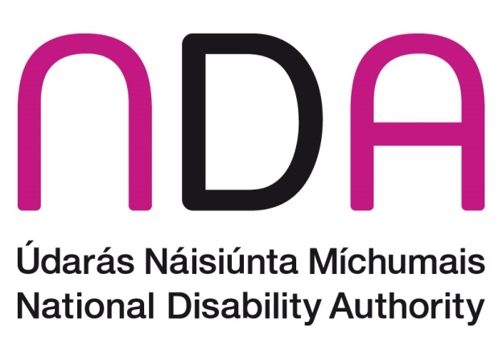
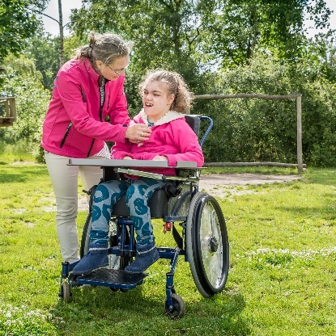
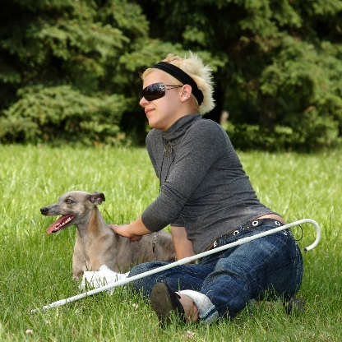
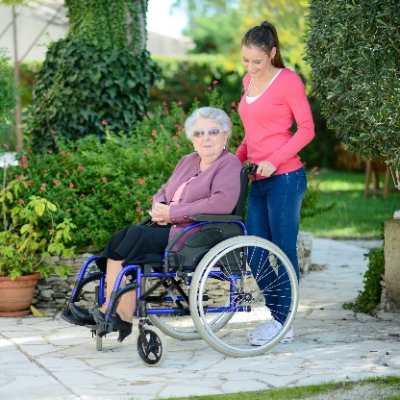
What is in this Report?
This is a Plain English Report
National Survey of Public Attitudes to Disability in Ireland 2017

- Information about the Survey
- What the researchers found out about disability
- What the researchers found out about attitudes to disability
- What should happen next

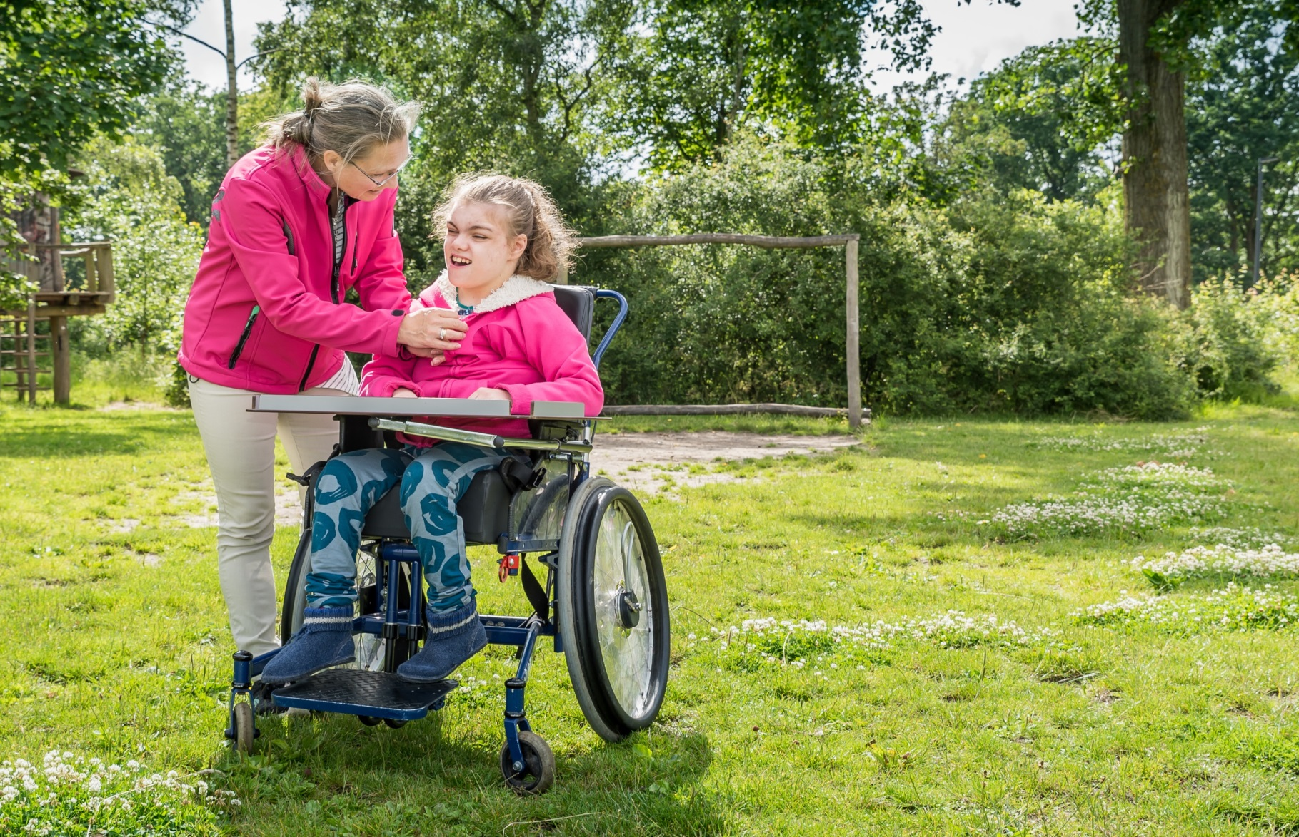

Information about the Survey

What is this survey about?
The National Disability Authority (NDA) carried out a survey on public attitudes to disability in Ireland in 2017.
Attitude is the way someone thinks or feels about something. This survey looked at the way people in Ireland think or feel about disability.
The NDA also did surveys on attitudes to disability in Ireland in 2001, 2006 and 2011.
The researchers looked at the information from the survey in 2017. They looked back at the information from 2006 and 2011 to see if attitudes have changed.

Who took part in the survey?
- 1294 adults took part in the survey
- Men and women of different ages took part
- People from different parts of Ireland took part
- Some people had disabilities and some did not
- Interviews were carried out in January and February 2017

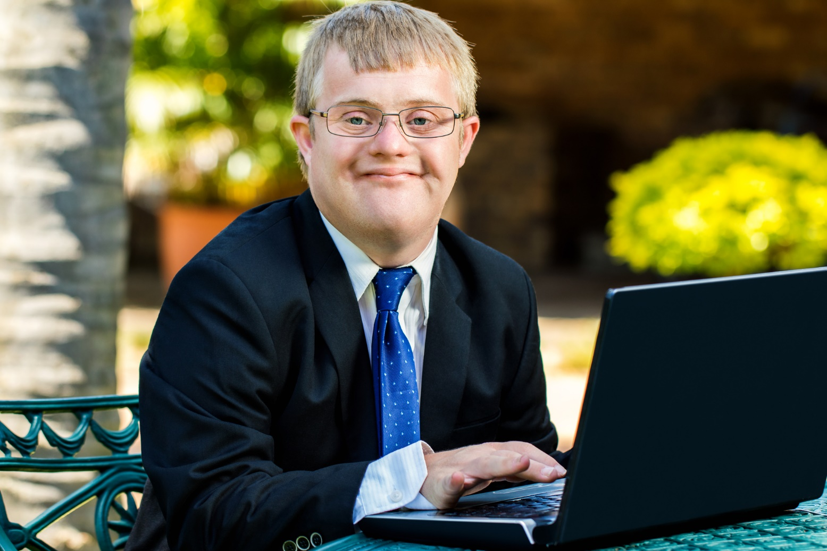

What the researchers found out about disability

Knowing about disability
When people hear the words ‘people with disabilities’, they think mostly about people with physical disabilities, mental health difficulties and intellectual disabilities.
Most people taking part in the survey knew someone with a disability. Most people had contact with that person every day or week.
More women than men had contact with a person with a disability every day.
People living in Dublin had less contact with a person with a disability.

How many people have a disability?
The survey found that 16 out of every 100 people have a long lasting disability. This number is up from 2006 and 2011.
The number from the 2017 survey matches the numbers collected in the Census in 2016. The Census is a survey of everyone in Ireland.
The most common disability reported in the 2017 survey was:
- A disability making physical activities hard
- An illness that lasts a long time
The number of people with a disability goes up as people get older.

Types of Disability
When asking people about attitudes, the researchers asked about five different types of disability. These were:
- Physical disabilities
- Vision or hearing disabilities
- Intellectual disabilities
- Autism
- Mental health difficulties

What the researchers found out about attitudes to disability

Attitudes to people with a disability
In the 2017 survey, 3 out of every 10 people agreed that people with disabilities are treated fairly in Irish society. The number of people that agreed is down from 2006 and 2011.
In 2017, more people agreed that people with all types of disabilities can take part fully in life than in 2006 or 2011.
Most people agreed that there are times when it is all right to put people with disabilities before others.
Most people agreed that people with disabilities are more important than others when it comes to social housing, hospital waiting lists and better welfare payments.

Disability and Education
Only some people agreed that people with disabilities get an equal chance when it comes to education.
Many people agreed that children with different disabilities should go to the same schools as children without disabilities.
Only half of the people taking part in the survey said children with mental health difficulties should go to the same schools as children without disabilities.

Disability and Work
A small number of people believed that people with disabilities get an equal chance when it comes to work.
Most people said they would feel comfortable working with a person with a physical disability.
A few people said they would not feel comfortable working with people with disabilities, especially people with mental health difficulties.

Disability and Relationships
Many people said that adults with disabilities have the same right to sexual relationships as everyone else.
In the 2017 survey, the number of people that agreed with this was up from 2011.
Most people agreed that people with disabilities can have children if they wish. In 2017, more people agreed with this than in 2011.
Some people worried that people with disabilities might not be able to give their consent to relationships.
Some worried that if a person with a disability had a child, they might not be able to cope or care for the child properly.

Disability and Neighbourhood
Most people agreed that people with disabilities should live in houses like everyone else.
Most people felt comfortable living close to people with physical disabilities or vision and hearing disabilities.
More people said they did not feel comfortable living close to people with mental health difficulties.

Disability and taking part in society
People with a disability were less likely to have:
- taken a holiday at home or abroad in the past year
- gone on a day trip in the past year
- had a hobby
- used the internet
- used a mobile phone
If you are young, live in a town or city, have money, and are happy with your life, then you are more likely to take part in these activities.
People with a disability are at risk of feeling lonely or cut off from society. If you are lonely or cut off from other people, then you are less likely to take part in activities.
In the 2017 survey, most people with and without disabilities were happy with their lives. More people with a disability felt lonely, sad and depressed.

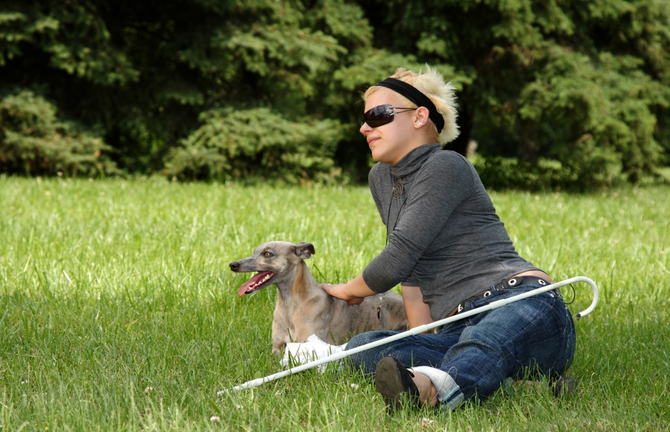
What should happen next

Why do attitudes change?
The 2017 survey found that attitudes are more positive towards every kind of disability.
It is hard to explain why attitudes to disability can change. Things like the recession or HIQA reports can change the way people think.
Information on disability or mental health and Government policies can get the public’s attention. They can change people’s understanding of disability and their views.
Positive attitudes support people with disabilities to take part in society. When people with disabilities do the same things as everyone else, public attitudes can change.

The United Nations Convention on the Rights of People with Disabilities
This Convention on the Rights of People with Disabilities is very important when it comes to changing policies and attitudes.
The Convention says that all people with disabilities must enjoy all human rights and be supported to use their rights.
Ireland is changing its laws so that it can put the Convention into practice. The Convention shows the changes needed so people with disabilities can take part fully in Irish society.
The NDA encourages the government to agree the Convention by the end of 2017.

The Future
Attitudes to disability are more positive in 2017 but:
- It is very important that we keep working on education and work opportunities for people with disabilities
- It is important that we keep working on health policies
- It is important to help the public understand more about mental health difficulties
- The media and the arts should show people with disabilities in a good way, for example by showing their skills and talents. The media means television and radio stations, newspapers, magazines, and the Internet
Strategies can help change attitudes. A Strategy is a plan. The Government has many Strategies to improve the lives of people with a disability.
Putting these Strategies in place will be very important:
- New Directions
- Comprehensive Employment Strategy
- Review of Vision for Change
- National Disability Inclusion Strategy
- Time to Move on from Congregated Settings
Laws, standards and other ways of checking services and supports, can also improve attitudes.

This survey was carried out by Behaviour & Attitudes and the National Disability Authority.

This Easy to Read Report was put together by ACE Communication with the help of Experts by Experience.

National Disability Authority
25 Clyde Road
Dublin 4
01 6080400
www.nda.ie

