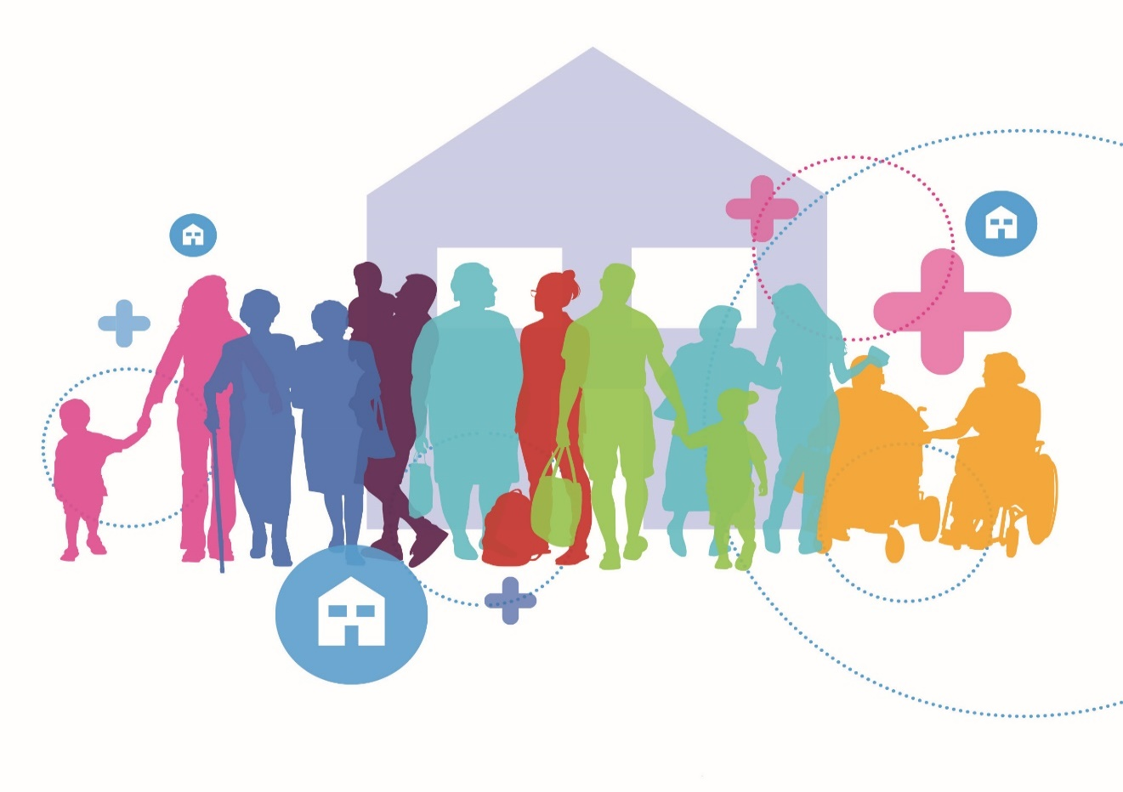

NATIONAL DISABILITY INCLUSION STRATEGY 2017-2021

Action 97: Policy Advice Paper on Achieving Universal Design in new housing
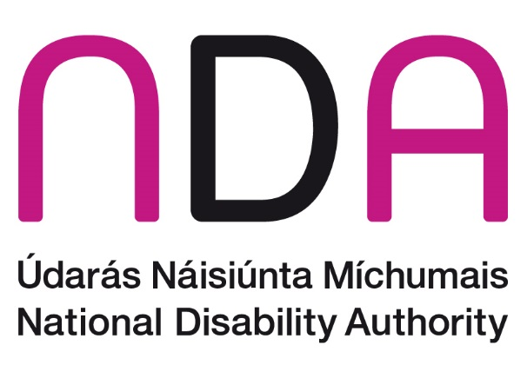
December 2019

Contents
Executive Summary 7
Context 7
What is covered? 7
What is Universal Design? 7
Universal Design approach to housing 8
The need for Universal Design homes 17
Costs associated with Universal Design homes 17
Good practice in Universal Design 18
Universal Design’s place in current housing policy 18
International policy 20
Regulating for a Universal Design approach 20
Incentivising a Universal Design approach 21
Recommendations 22
Regulatory 23
Recommendation 1: Update and Revise Part M of the Building Regulations 24
Policy 24
Recommendation 2: Insert targets for Universal Design homes into county development plans 24
Recommendation 3: Increase minimum apartment sizes 25
Recommendation 4: Link current Government policies to produce Sustainable Homes and communities 25
Recommendation 5: Review functions of relevant public bodies 26
Recommendation 6: Technical skills – housing design 26
Funding/incentives 27
Recommendation 7: Explore options for home adaptations 27
Recommendation 8: Universal Design Grants 27
Recommendation 9: Universal Design mortgages 28
Recommendation 10: VAT reduction for a Universal Design approach to building new homes 28
Recommendation 11: Waive development contributions for Universal Design homes 29
Other 30
Recommendation 12: Accessible communications 30
Context 31
Why Universal Design? 32
Comparison of dimensions 37
Smart Technologies and Assistive Products 38
Who will benefit from Universal Design Homes? 39
Connection to place 39
The need for new Universal Design homes 40
An ageing population 40
Good practice in Universal Design: Ireland 42
Wexford County Council 42
Fingal County Council 43
Louth County Council 44
Westmeath County Council 44
Broome Lodge 45
Colivet Court, Limerick 45
Ava Housing 45
Good practice in Universal Design: International 47
Norway 47
Japan 48
New Zealand 49
International comparisons 49
United Kingdom 50
United States of America 50
Australia 51
Universal Design’s place in current housing policy 51
National Housing Strategy for Persons with a Disability 2011-2016 52
Social Housing Strategy 2020 54
Rebuilding Ireland 55
Project Ireland 2040 55
Universal Design interaction with other government policies 56
Regulating for a Universal Design approach 59
Part M of the Building Regulations 59
Minimum apartment sizes 60
Bringing Back Homes – Manual for the reuse of existing buildings 61
New Public Bodies 62
Incentivising Universal Design approach 65
Universal Design Grants 65
Universal Design Mortgages 66
VAT reduction for the building industry 66
Development contribution waivers 66
International policy 67
The right to housing 67
Sustainable Development Goals 68
Recommendations 71
Regulatory 71
Recommendation 1: Update and Revise Part M of the Building Regulations 71
Policy 73
Recommendation 2: Insert targets for Universal Design homes into county development plans 73
Recommendation 3: Increase minimum apartment sizes 74
Recommendation 4: Link current Government policies to produce Sustainable Homes and communities 74
Recommendation 5: Review functions of relevant public bodies 75
Recommendation 6: Technical skills – housing design 76
Funding/incentives 78
Recommendation 7: Explore options for home adaptations 78
Recommendation 8: Universal Design Grants 79
Recommendation 9: Universal Design mortgages 80
Recommendation 10: VAT reduction for a Universal Design approach to building new homes 81
Recommendation 11: Waive development contributions for Universal Design homes 82
Other 83
Recommendation 12: Accessible communications 83
APPENDIX A 85
UK Part M Building Regulations 85
APPENDIX B 86
Norwegian State Housing Bank 86
APPENDIX C 87
Extracts from Norway’s State Party Report to the UNCRPD Monitoring Committee 87
Universal design and accessibility 87
APPENDIX D 89
Article 19 – Living independently and being included in the community 89
Article 28 – Adequate standard of living and social protection 89

Executive Summary

Context
The National Disability Authority (NDA) is producing this advice paper under Action 97 of the National Disability Inclusion Strategy 2017-21. The paper sets out the NDA’s advice on ways of achieving Universal Design solutions for new housing so that homes can be made accessible to all regardless of their age, size, ability or disability.

What is covered?
This paper aims to set out a practical set of recommendations for consideration by Government on how to apply a Universal Design approach to the design and building of new homes in Ireland. The focus of the paper incorporates both social and private housing, and all housing types, e.g. apartments as well as traditional housing units.

What is Universal Design?
Universal Design is the design and composition of an environment so that it can be accessed, understood and used to the greatest extent possible by all people regardless of their age, size, ability or disability. An environment (or any building, product, or service in that environment) should be designed to meet the needs of all people who wish to use it. This is not a special requirement, for the benefit of a part of the population. It is a fundamental condition of good design. If an environment is accessible, understandable, usable, convenient and a pleasure to use, everyone benefits. By considering the diverse needs and abilities of all throughout the design process, Universal Design creates products, services and environments that are easy to use by everyone. Universal Design is a design philosophy that aims to create an inclusive, sustainable society, where every person can participate to the greatest extent possible.
The statutory Centre for Excellence in Universal Design (CEUD) is an integral part of the NDA. The main functions of the CEUD include contributing to the development and promulgation of standards and design guidance; promoting Universal Design in education courses and curriculum for the relevant professions and occupations; and raising awareness of Universal Design. The Universal Design role extends beyond disability to consider design issues for everyone and entails engagement with standards bodies, industry, professional bodies and educational institutions.

Universal Design approach to housing
Finding suitable and appropriate homes that can accommodate changing needs over time can be difficult – whether for families with young children, a person with a temporary or permanent injury, someone with a disability or an older person. Universal Design can meet everyone’s needs through flexible homes designed to adapt to a person’s lifecycle and lifestyle patterns of people over time.
Informed by research, the NDA’s Centre for Excellence in Universal Design has published Universal Design Guidelines for Homes in Ireland which sets out a Universal Design approach to building new homes involving two levels of Universal Design to making a home more accessible, understandable and usable at each stage with a third level for very individual needs that require extra space in the home. The NDA has conducted research and engaged with the relevant professions and other stakeholders to inform the Universal Design Home guidelines, as well as the Dementia Friendly Dwellings for People with Dementia, their Families and Carers guidelines.
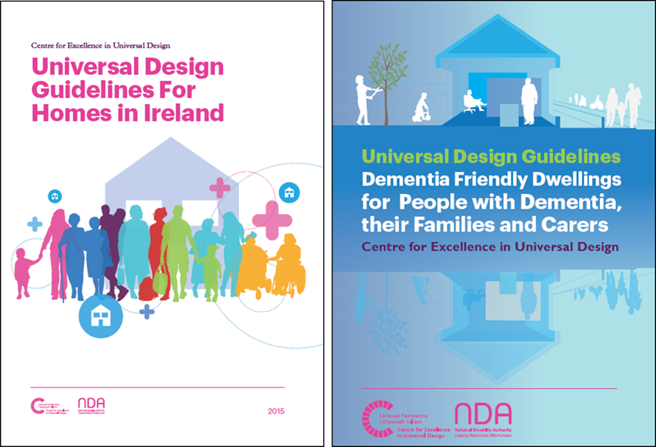

The Universal Design Home Guidelines are informed by research of national and international best practice guidance including an extensive consultation process with key stakeholders. Universal Design Homes build upon social and technological advancements in Ireland and internationally. The guidelines are also informed by national policies developed by the former Department of the Environment such as the National Housing Strategy for People with a Disability 2011-2016 and the Quality Housing for Sustainable Communities 2007, the Department of Health’s National Positive Ageing Strategy and their National Dementia Strategy 2014.
The guidance is provided in a two-tiered system described as:
UD Home optimising flexibility, adaptability and usability for everyone;
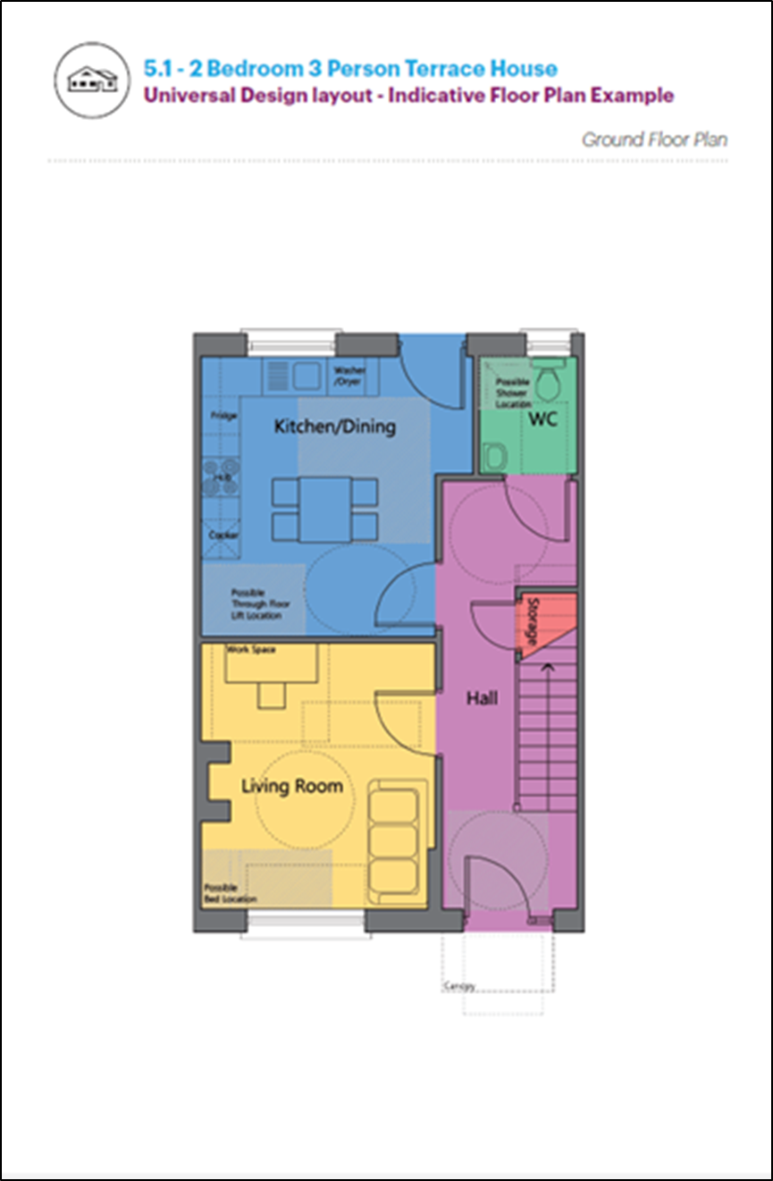
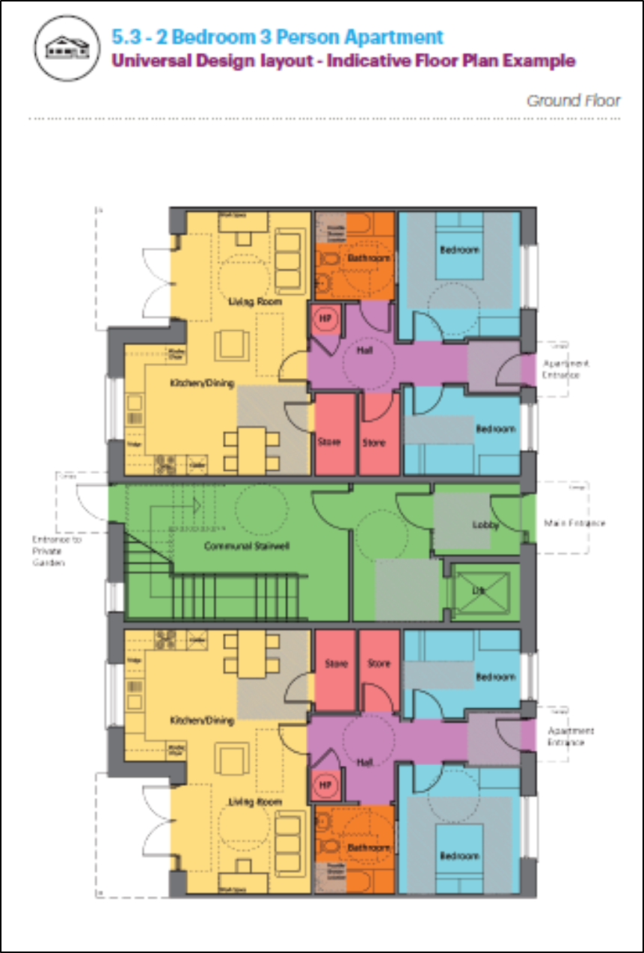
UD Home + providing for greater accommodation of people’s changing needs over time.
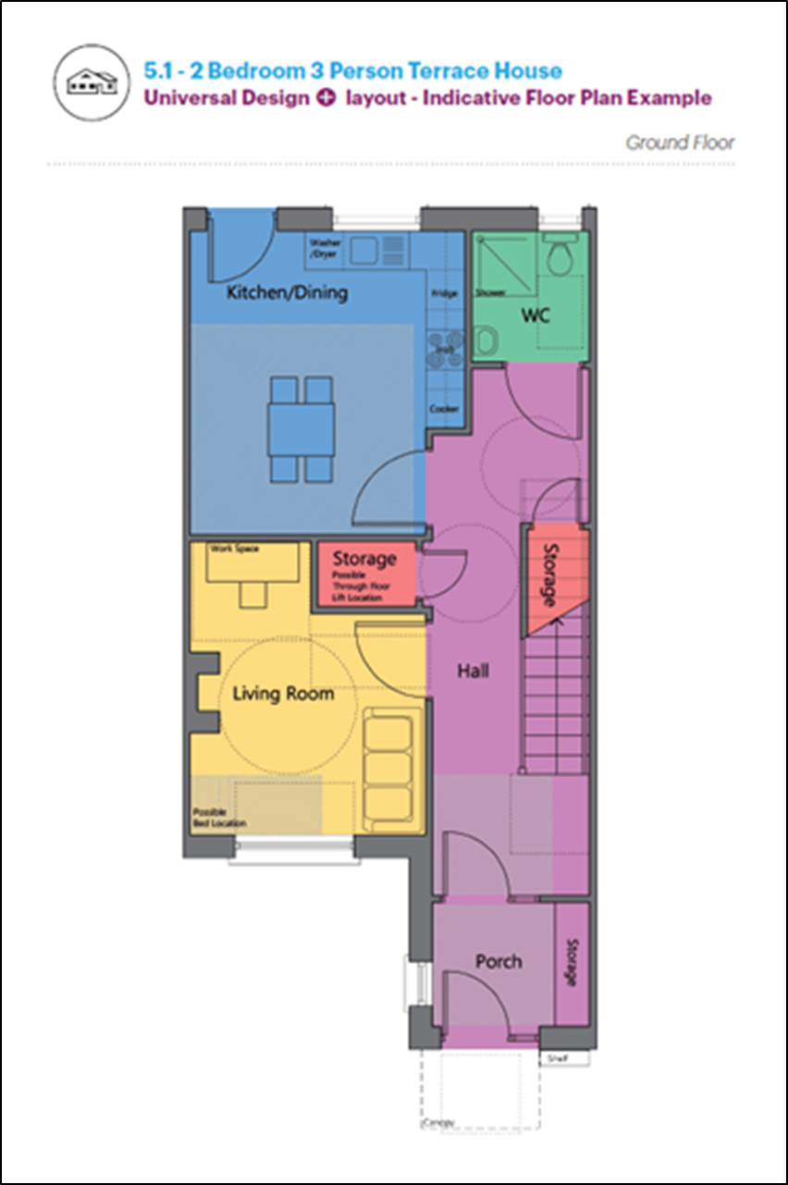
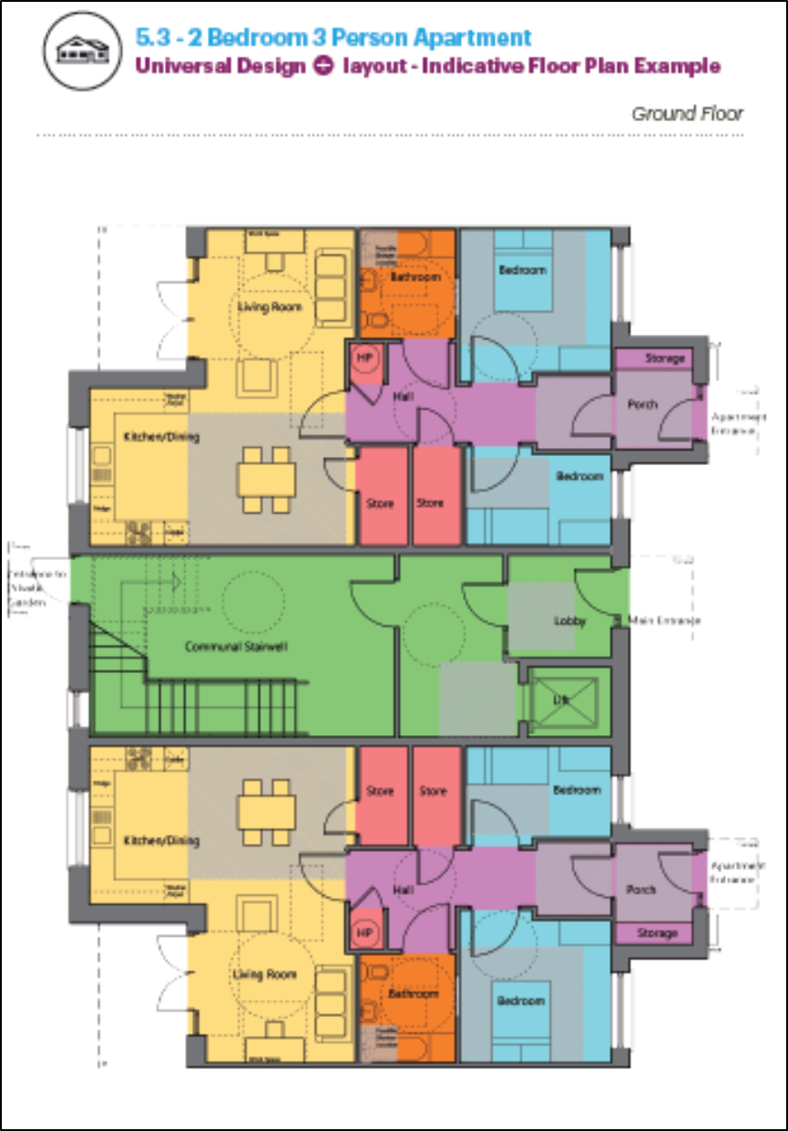

It also provides guidance on a UD Home ++ to raise awareness and assist in person-centred design for specific needs beyond the UD home + specifications.
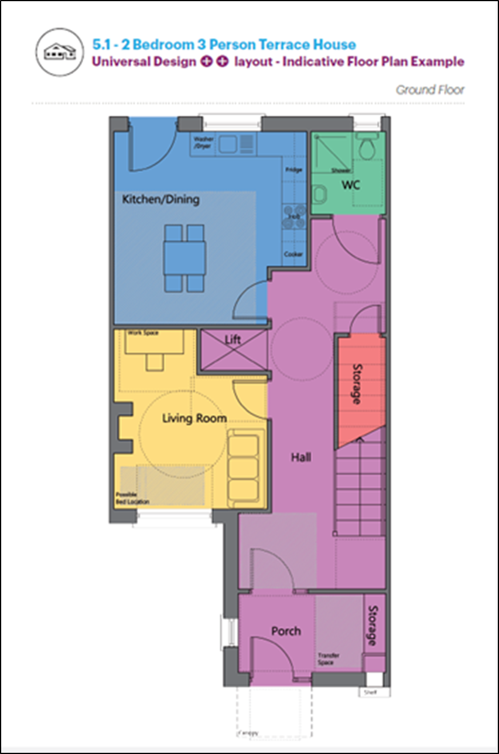

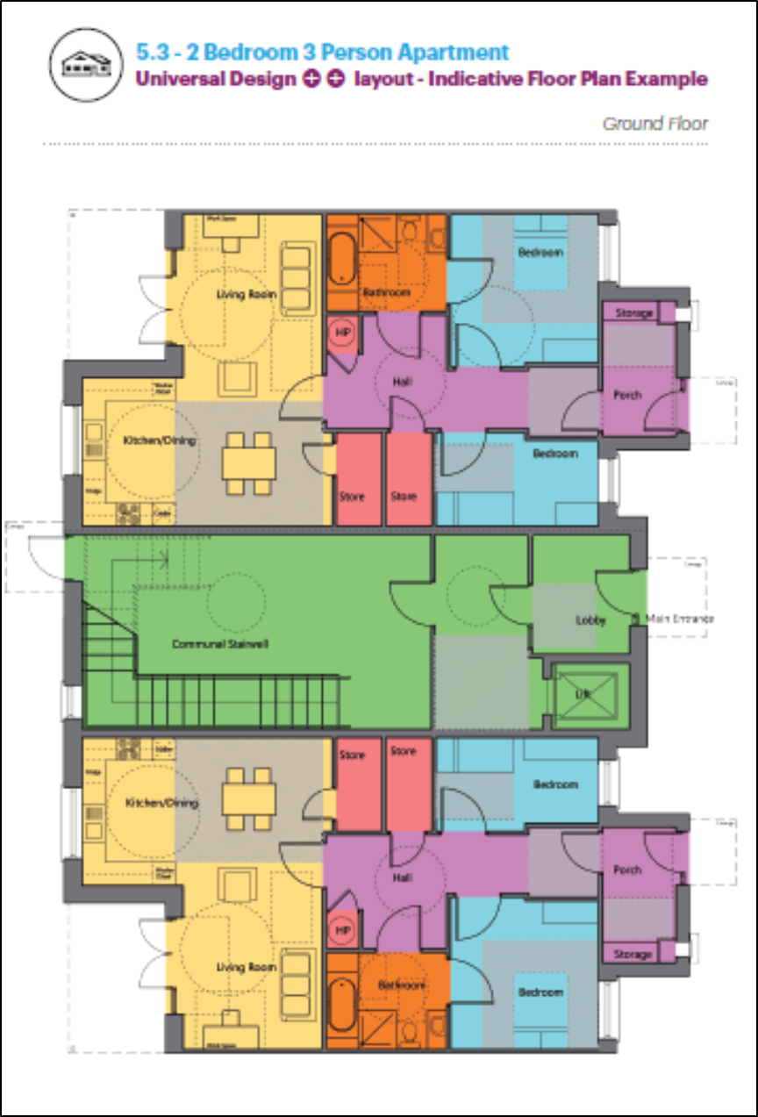
These guidelines show how Universal Design can be implemented in practice, with clear helpful diagrams and drawings showing how this can work in practice in standard homes. Universal Design homes can create an enabling home environment for the widest range of people that can be easily and readily adaptable.
UD Home Design Quality Features
The following are core features of a Universal Design Home across all three levels. Many of these features will be relevant to all of us, which is the essence of Universal Design:
- Providing wider external and internal doors
- Providing capped electrical points for future installation of a stair lift, front door illumination, adjacent to internal doors, above and beside window heads and at skirting level (for future automatic devices such as assisted door openings, ceiling hoists and automatic curtain/blind opening)
- Inserting sockets at the top and bottom of stairs and including two-way or three-way switching. In addition, ensuring sockets and switching (and window sills) are further than 500mm from an internal corner and are at levels that are within easy reach and view for everyone, should be allowed
- Providing cabling which future proofs all dwellings to enable various existing or new technologies to be integrated easily into the home
- Considering easy control and use of systems and the capability to integrate smart technology, energy efficiency and security systems or assistive technology
- In the entry level toilet, ensuring that it is sufficient for the future installation of a walk-in shower including walls of adequate wall strength to take future fittings. Below floor drainage, level access, moisture resistant plasterboard and light fittings and tanking of floor and walls up to a height of 2000mm will also be necessary.
- Locating the main bathroom immediately adjacent to the main bedroom with a “soft spot” for future installation of a door between them. Ensuring that provision is made for future adaptation to a shower room including the features listed for the entry level toilet
- In the main bedroom, located beside the bathroom, it is important to provide for “hard spots” in the ceiling to allow for a hoist track to be installed supported by ceiling construction
- Providing for fittings like lever door handles and taps that are easier to use for everyone
- Providing a beam at ceiling level ground floor as part of the rear wall to allow for future extension in exceptional cases where design layouts cannot incorporate a future downstairs walk-in shower and/or a future room for conversion to bedroom.
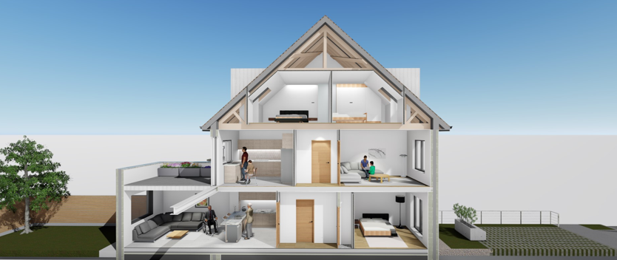
Multi-Generational Home design, Westmeath County Council Capital Housing Design Team

The NDA notes based on feedback from Wexford County Council, that it is not necessarily the case that a Universal Design home will have a larger footprint than a standard home. In fact, estate agents in Wexford have been getting feedback from potential buyers that they are more impressed by the design of the layout and the use of space in the homes that contain accessible and adaptable elements and features. This is due in large part to the initiative that Wexford County Council took in its County Development Plan to ensure that a minimum of 20% of dwellings in all new housing estates of five dwellings or more must be suitable to accommodate, or are adaptable to provide accommodation, for persons with disabilities, their families and carers, based on Universal Design guidelines.
Designs for various housing types in a new development in north County Dublin, obtained via Fingal County Council, show a range of sizes that are in line with the normal range of 90m²-110m² that cover a standard 3-bed semi-detached home. They applied the 10 Ways to Construct a More Lifetime Adaptable and Age Friendly Home guidelines that were developed in collaboration with Fingal County Council, Age Friendly Ireland and the NDA’s Centre for Excellence in Universal Design (CEUD). These 10 features are based on the Universal Design Home Guidelines developed by the CEUD.

The need for Universal Design homes
The 2016 Census indicates that 643,131 people in Ireland had a disability. That is 13.5%, or 1 in 7 of the population in Ireland that has a disability. This represented an increase of 47,796 persons (8%) on the 2011 figure of 595,335.
Like other countries, our population is living longer and the number of older persons is growing. It is expected that the numbers of persons with disabilities will increase by approximately 20% by 2026. This has particular implications for housing and supported living in the community, and the need to ensure a sustainable housing model in Ireland. While Universal Design particularly addresses the needs of persons with disabilities and older persons its broader reach across the wider population e.g. families with children, shared homes etc., make sense to adopt this approach to Irish home design.

Costs associated with Universal Design homes
Figures provided by Clúid (an Approved Housing Body), whilst building Broome Lodge apartments in Cabra, Dublin 7, in 2017, show that their experience of the extra construction cost for building to Universal Design Homes standards was approximately €4,150 (incl. of VAT, On-Costs, finance costs and legal costs) per apartment which equated to a 2.5% uplift. This equated to 2.1% increase in the overall project development costs. As these features and elements become the norm the price differential between a Universal Design home and a standard home should be minimal in the future.
Estimated figures, obtained via Fingal County Council, relating to accommodation for older persons including Universal Design features in a new build costing approx. an extra €12,000 compared to the costs of retro-fitting an existing dwelling amounting to an extra €32,000.
The CEUD are working with members of the Society of Chartered Surveyors Ireland to produce a comprehensive cost comparison for home construction following a Universal Design approach that will show analysis around the potential long-term savings to homeowners – and to the State – that accrue from following a Universal Design approach.

Good practice in Universal Design
There are a number of examples of a Universal Design approach to developing new homes being put in to practice. There are homes already built in Dublin, Limerick and Wexford that combine Universal Design features with high levels of energy efficiency.
Wexford County Council has taken a lead and specified a minimum number of accessible homes be built in developments of a certain size. This is something that other local authorities have the statutory powers to achieve and could study and try to replicate this example in their own development plans. Clúid’s work is also set out in this paper. It is one of many Approved Housing Bodies (AHBs) building new homes for persons with disabilities and older persons. These AHBs would benefit from the policy and regulatory changes discussed elsewhere in this paper.
The paper also sets out examples from other countries that may be relevant to how a Universal Design approach to new homes could be implemented in Ireland. In addition, there are examples of cost comparisons and costs benefit analyses carried out in other jurisdictions. It should be noted that these analyses are some years old, and that different regulatory circumstances apply in each of the relevant jurisdictions.

Universal Design’s place in current housing policy
There are a number of commitments regarding housing for persons with disabilities under the current Programme for Government, the National Housing Strategy for People with a Disability 2011-2016, the Social Housing Strategy 2020, Rebuilding Ireland, DHPLG’s Statement of Strategy 2017-2020, the National Disability Inclusion Strategy 2017-2021(NDIS) and in Project Ireland 2040.
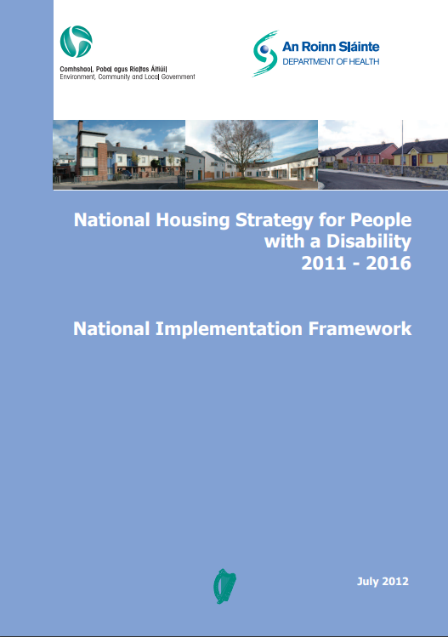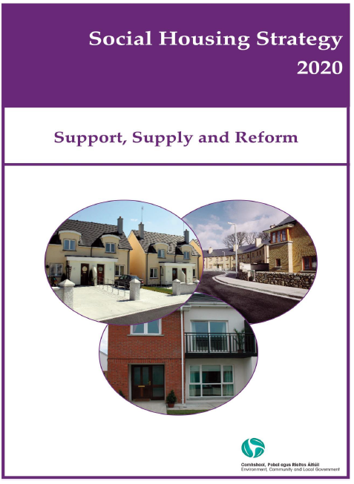
The National Housing Strategy for People with a Disability 2011-2016 (NHSPWD) is connected to, and supported by, the Social Housing Strategy 2020, has been incorporated into Rebuilding Ireland, and extended to 2020.
The full effect of these policies has not yet been felt as they are still in the implementation phase. The NDA advises that there are opportunities now to review how they can better support implementation of Universal Design, particularly in light of wider Government policy commitments to persons with disabilities and older persons, considerations regarding sustainability and to ensure better use of funding. We highlight the following in particular:
- The ratification of the UN Convention on the Rights of Persons with Disabilities (UNCRPD) requires that Ireland report on what actions it is taking to realise the economic, social and cultural rights set out in the Convention. This report is due to be presented to the UNCRPD Committee, in Geneva, two years after formal ratification has taken place (April 2020);
- DHPLG is due to carry out a review of the NHSPWD in 2020;
- The current mid-term review of the NDIS which is being led out by the Dept of Justice and Equality, comprising the housing strategy and potential follow on from this advice paper;
- The acknowledgement, in the National Planning Framework, of the significant role that Universal Design of buildings to deliver greater accessibility for all has to play in relation to social inclusion and translation of same into specific actions.
It is the NDA’s view that realisable actions to support a Universal Design approach to new homes, set out in this paper, need to be considered and put into action now.
A Universal Design approach to new homes also has potentially positive implications for a series of Government policies relating to health and well-being, positive ageing and climate action.

International policy
The right of access to adequate housing for persons with disabilities is recognised in international treaties. This right has been further developed under Articles 19 and 28 of the recently ratified UNCRPD (Appendix D). Under Article 19, Ireland recognises the rights of persons with disabilities to choose their place of residence while Article 28 recognises the right of persons with disabilities to adequate housing. The Convention, under Article 4, also places an emphasis on Universal Design in practice. Ireland is fortunate to have a statutory Centre for Excellence in Universal Design which has already undertaken research and developed practical guidelines to support national policy. The UN’s Sustainable Development Goals are now embedded in Government policy and provide a vehicle for linking a Universal Design approach to sustainable homes and communities.
This paper also sets out different approaches to implementing Universal Design in other jurisdictions. For example, Norway has made Universal Design a central criterion for funding from its national housing bank; Japan offered lower mortgage interest rates or higher loan amounts based on adaptations.

Regulating for a Universal Design approach
Progress in Universal Design housing policy needs to be assisted by an examination of how legislation, regulations and policy can support its delivery,
In the first instance, consideration should be given to examining the feasibility of recognising a Universal Design approach to housing in building control legislation.
Part M of the Building Regulations sets out minimum provisions for the access and use of buildings. The Technical Guidance Document to Part M (TGD M) sets out guidance on the minimum level of provision that meets the requirements of the regulations. The minimum standard required in the current TGD M for dwellings is that new dwellings are visitable by people with disabilities.
In contrast, Universal Design Homes are about reflecting homes that people can live in, over their lifetime, as their needs change. A reference to Universal Design was added to the TGD M in 2010, however it only asks designers and builders to consider making additional provisions where practicable and appropriate while having regard to Universal Design,
This is the only current mention of Universal Design in any primary, or secondary, legal/regulatory instrument that covers planning, building control or design. Currently there is no general, statutory obligation on builders/developers to plan, build or design following a Universal Design approach. There are no penalties or incentives in planning law, building control law or tax law to encourage a Universal Design approach. There are no housing funding programmes that contain measures requiring a Universal Design approach. There are no statutory minimum targets or quotas for Universal Design dwellings in housing developments. However many of the local authorities are keen to implement the universal design guidelines developed by the NDA if the proper structures were in place nationally.
A positive route for supporting change could come via the three new public bodies that have been created to implement housing policy namely:
- Land Development Agency: could include Universal Design as a criterion for building on land owned by them
- Office of the Planning Regulator: could consider Universal Design as a topic for research, training and education as well as monitoring its consistent application in planning across all local authorities
- Home Building Finance Ireland: could include Universal Design as a criterion for financing developments
The NDA is working with the Housing Agency to engage with these new bodies on a Universal Design approach to new homes.
The knowledge and experience of the local authorities in relation to planning, design costs, etc., supported by the Local Government Management Agency and the County and City Management Association, can assist the DHPLG in working to drive the national adoption of a Universal Design approach to home building.
Various financial incentives could also be considered, as well as the possible redirection of expenditure from one area, e.g. housing adaptations grants, to another, social housing construction in the long-term.

Incentivising a Universal Design approach
This paper proposes the exploration of a number of financial incentives to encourage those involved in planning, design and construction to follow a Universal Design approach to home building. They would, not be required if new home building were to be underpinned by any new minimum UD Home standard set out in a revised Part M of the Building Regulations. This process will, however, take time. In the meantime, the measures listed below could be made available on the basis of a non-statutory agreed set of standards promoted by DHPLG; using the 10 Ways to Construct a More Lifetime Adaptable and Age Friendly Homes promoted by Fingal County Council, for example. In summary, the proposals cover the following:
- DHPLG explore options for national funding schemes to allow older people to remain in their own home and community, maintain some form of financial security and provide accommodation for others.
- In the interest of linking energy efficiency and Universal Design a grant scheme modelled along the lines of the Home Energy Grants administered by the Sustainable Energy Authority of Ireland
- Similar to Green mortgages offered by financial institutions that depend on a minimum BER rating, the development of Universal Design mortgages
- A time-limited VAT reduction for developers who opt to follow a Universal Design approach to help offset any possible higher costs
- The extension of existing local authority waivers from Development Contributions - that already exist for developments in receipt of Housing Adaptation Grant and for developments to be used as accommodation for persons with disabilities – to developments that follow a Universal Design approach

Recommendations
The National Disability Authority (NDA) advises that progressing new home design and construction from a Universal Design approach needs to be established policy, recognising in particular that the general population is getting older, persons with disabilities are living longer and are, in some cases, out-living their traditional care-givers, e.g. their parents/siblings. This trend will continue to put pressure on traditional housing solutions when someone can no longer live independently e.g. nursing homes. In tandem with the necessary health and social care support packages, homes built using a Universal Design approach offer a solution that gives people the option to remain in their homes and communities for longer, thus reducing their need for long-term and expensive care homes; keeping them connected to family, friends and place, thus helping their mental health and well-being.
Finding suitable and appropriate homes that can accommodate our changing needs over time can be difficult – whether for families with young children, a person with a temporary or permanent injury, someone with a disability, or an older person living independently. Universal Design can meet everyone’s needs through flexible homes designed to adapt to lifecycle and lifestyle patterns of people over time.
The NDA acknowledges that adopting a Universal Design approach to new housing will involve a more coordinated and integrated approach across government departments such as Housing, Health, Finance and Transport as well as inter-departmental cooperation and coordination. We have set out our reasoning and recommendations. As we engage with a range of stakeholders to support the adoption of Universal Design in Ireland, we would be happy to support further collaborative work in relation to universal design homes.
This paper concludes with a series of recommendations that seek to tackle the issue from a combined regulatory, policy and financial viewpoint. If some of the recommendations are taken on board it will not be necessary to implement others.
All the recommendations are set out in summary below. They are explained, in detail, later on this paper. The NDA looks forward to engaging with the Department and its agencies in guiding further on how the recommendations can be advanced and implemented, and to play our role as appropriate.

Regulatory

Recommendation 1: Update and Revise Part M of the Building Regulations | Responsible for this Action
Part M for dwellings should be reviewed and the minimum standard for new dwellings should move from new dwellings being required to be visitable to new dwellings being suitable for people to live in over their lifetime, based on a the first level of Universal Design guidance. This should be included as an action after the mid-term review of the National Disability Inclusion Strategy 2017-21 | Department of Housing, Planning and Local Government

Policy
Recommendation 2: Insert targets for Universal Design homes into county development plans | Responsible for this Action
In advance of Recommendation 1 above being achieved it is recommended that DHPLG introduces a new minimum percentage target of all new housing developments to be planned, designed and constructed following a Universal Design approach. This also complements Action 4.6 in the Government’s Policy Statement on Housing Options for our Ageing Population 2019 which states that: “In partnership with industry, introduce measures to ensure that over a five year period delivery is increased to ensure that 30% of all new dwellings are built to incorporate universal design principles to accommodate our ageing population. | Department of Housing, Planning and Local Government  Local Authorities  Local Government Management Agency  Housing Agency  County and City Management Association  Construction Industry Federation

Recommendation 3: Increase minimum apartment sizes | Responsible for this Action
Review the current apartment sizes in the Apartment Guidelines from 2018 to address size issues and comply with universal design guidelines. This can also be supported by revising Part M to achieve universal design standards as well as insuring that monitoring systems are in place to ensure its application. | Department of Housing, Planning and Local Government  Local Authorities

Recommendation 4: Link current Government policies to produce Sustainable Homes and communities | Responsible for this Action
In the context of current Government policies on housing and climate change explore practical solutions to link energy efficiency, sustainability and Universal Design as a holistic approach to designing and building new homes. This directly links to Action 3.4 in the Housing Options for ageing population that, states: Develop a Design for Life rating mechanism for homes that will measure the energy-efficiency and age-friendliness of homes to enable them to be truly sustainable. | Department of Housing, Planning and Local Government  Department of Communications, Climate Action and Environment  Local Authorities  Housing Agency  National Disability Authority  Irish Green Building Council  Sustainable Energy Authority of Ireland

Recommendation 5: Review functions of relevant public bodies | Responsible for this Action
The Land Development Agency, the Office of the Planning Regulator and Home Building Finance Ireland should review how they approach the planning, design and build of new homes in order for them to change course from their current approach to following a Universal Design approach.  The Department should review the statutory functions of these agencies to see how they can be strengthened to have a Universal Design focus. | Department of Housing, Planning and Local Government  Department of Finance  Land Development Agency  Office of the Planning Regulator  Home Building Finance Ireland  National Disability Authority

Recommendation 6: Technical skills – housing design | Responsible for this Action
In order to ensure that the knowledge and resources are in place the Department of Housing, Planning and Local Government should work with the stakeholders listed opposite to support the advancement of CPD for all professional staff who are involved in the planning, design and construction of new homes following a Universal Design approach. | Department of Housing, Planning and Local Government  Department of Education and Skills  Higher Education Authority  Solas  Local Authorities  Royal Institute of Architects of Ireland  Construction Industry Federation  Engineers Ireland  Society of Chartered Surveyors Ireland  National Disability Authority

Funding/incentives

Recommendation 7: Explore options for home adaptations | Responsible for this Action
In the context of the current review of other grant schemes – e.g. Housing Adaptation Grants - DHPLG to explore options for national funding schemes - on either an administrative, or statutory, basis – to allow older people to remain in their own home and community and at the same time maintain some form of financial security, as well as providing much needed accommodation for others. This would entail liaising with the relevant stakeholders, listed on the right, regarding the amount of money involved and how such a scheme would be administered. | Department of Housing, Planning and Local Government  Local authorities  Local Government Management Agency  Housing Agency  City and County Managers Association

Recommendation 8: Universal Design Grants | Responsible for this Action
In the interest of linking energy efficiency, sustainability and Universal Design, DHPLG and the relevant public bodies could introduce and promote a grant scheme, modelled along the lines of the Home Energy Grants administered by the Sustainable Energy Authority of Ireland. | Department of Finance  Department of Public Expenditure and Reform  Construction Industry Federation  Society of Chartered Surveyors Ireland

Recommendation 9: Universal Design mortgages | Responsible for this Action
Similar to Green mortgages offered by financial institutions that depend on a minimum BER rating, consideration should be given, by the relevant Departments, to exploring the potential for Universal Design mortgages for new homes where more favourable terms could be offered when Universal Design features are included in new homes. This could be a temporary measure introduced pending the revision of Part M. | Department of Finance  Department of Public Expenditure and Reform  Construction Industry Federation  Society of Chartered Surveyors Ireland  Central Bank  Financial institutions

Recommendation 10: VAT reduction for a Universal Design approach to building new homes | Responsible for this Action
Consideration should be given to introducing a time-limited VAT reduction in order to encourage builders to build Universal Design Homes. This could be a temporary measure introduced pending the revision of Part M. | Department of Finance  Department of Public Expenditure and Reform  Construction Industry Federation  Society of Chartered Surveyors Ireland

Recommendation 11: Waive development contributions for Universal Design homes | Responsible for this Action
Explore potential and feasibility of extending the existing practice of waivers from local authority development contributions to developments – or part of developments – that are planned, designed and built following a Universal Design approach. This could be a temporary measure introduced pending the revision of Part M. | Department of Housing, Planning and Local Government  Local Authorities

Other
Recommendation 12: Accessible communications | Responsible for this Action
Ensure the processes and services around housing applications and information, and all communications with public in this regard, are universally designed so that all relevant Departments and public bodies should follow the guidance set out in the NDA’s - Customer Communications Toolkit for the Public Service for the Public Service.  This toolkit provides guidance for public servants on how to communicate with the public using the simplest and clearest language possible and to ensure that all services are accessible, and meets the diverse needs of all our customers.  The toolkit contains advice on general writing style principles, verbal and non-verbal communications, design of forms and documents, web and social media content and how to display signage.  The toolkit aligns with a key objective of the government’s reform agenda, which is to enhance how the public service engages with service users with a view to improving the quality of their interaction with the public service. | Department of Housing, Planning and Local Government  Local Authorities  Home Building Finance Ireland  Office of the Planning Regulator  Land Development Agency  Department of Public Expenditure and Reform  Department of Finance

Context
The National Disability Inclusion Strategy 2017–2021(NDIS), which was launched on 14 July 2017, takes a whole of Government approach to improving the lives of persons with disabilities. It is intended that it will make a significant difference over its lifetime to the position of persons with disabilities in Irish society. One of the eight themes of the NDIS is ‘Living in the Community’, incorporating Action 97, in which the National Disability Authority (NDA) commits to:
… prepare policy advice on ways of achieving Universal Design solutions for new housing so that new homes can be accessed and used by all persons, irrespective of size, age, ability or disability. We will advise on any implications of same for stakeholders including designers, builders, homeowners and tenants.
The NDA is the independent statutory advisory body to the Government on disability matters and has a duty to assist the adoption of Universal Design through its Centre for Excellence in Universal Design (CEUD). In practice, Universal Design benefits everyone – regardless of age, size, ability or disability - as defined in the Disability Act 2005. As such, when implemented, it can enable everyone to interact as independently as possible with the built environment, products, services and ICT. While relevant to everyone, it is especially important to persons with disabilities and older persons.
The statutory Centre for Excellence in Universal Design (CEUD) is an integral part of the NDA. The main functions of the CEUD include contributing to the development and promulgation of standards; promoting Universal Design in education courses and curriculum for the relevant professions and occupations; and raising awareness of Universal Design. The Universal Design role extends beyond disability to consider design issues for everyone and entails engagement with standards bodies, industry, professional bodies and educational institutions.
Ireland is unique in having a statutory Centre for Excellence in Universal Design. The CEUD has produced two sets of technical guidance on the Universal Design of homes and the retro-fitting of existing homes and these have been recognised as best practice both nationally and internationally. They have also been applied in practice in some local projects, which will be discussed later in the paper.
We believe there is also an opportunity to encourage adoption and implementation of a Universal Design approach by building it in as a requirement to housing funding programmes, including those for adaptations, therefore, creating more sustainable accommodation for those with ever changing needs. Living in a UD Home helps to avoid the need for re-location or costly building works as one’s family needs change over time. Integration of smart infrastructure and energy efficient systems at the outset of home design avoids costly re-fits which benefits everyone in terms of comfort, efficiency and quality of services.
It is not about a ‘one-size-fits-all’ model – the UD Home enables the widest possible number of people to live at home independently and in their community. For a housing provider, builder or developer, a UD Home thereby provides a competitive advantage as the home offers a more attractive market proposition for the widest range of potential residents. UD Homes are fundamentally about better design, efficiency and a creating more sustainable homes and communities.
This paper sets out the value of Universal Design as part of the solution to Ireland’s long-term housing needs and the facilitation of inclusive communities for all citizens. It is widely understood that housing is not, by its very nature, a quick-fix solution, and that a variety of measures will be required to address current shortages, but Universal Design can offer a sustainable and flexible solution to Ireland’s housing need that could have long-term economic and societal benefits.

Why Universal Design?
The type of housing we build, how it is designed and where it is located impacts all of us and the overall costs to the State. Traditionally, this has meant the need for adaptations or renovations to allow the individual to remain within their homes, or re-location to alternative premises.
The NDA advises that through the application of the CEUD’s Universal Design Homes Guidelines customised features would be easy to apply cost effectively if needed, thereby improving the whole home design and development process for everyone in the future.
A Universal Design Home is in line with the standard range for the most common house types e.g. a 3-bed semi-detached home between 90m²-110m². It is the internal layout and design of the property that sets it apart from the standard home. The house will be easier to circulate around for everybody. There will be level entry to the house. Internal fixtures and fittings are installed in such a way that they can be modified to suit the needs of the occupants at any given time.
The following are core features of a Universal Design Home across all three levels. Many of these features will be relevant to all of us, which is the essence of Universal Design:
- Providing wider external and internal doors
- Providing capped electrical points for future installation of a stair lift, front door illumination, adjacent to internal doors, above and beside window heads and at skirting level (for future automatic devices such as assisted door openings, ceiling hoists and automatic curtain/blind opening)
- Inserting sockets at the top and bottom of stairs and including two-way or three-way switching. In addition, ensuring sockets and switching (and window sills) are further than 500mm from an internal corner and are at levels that are within easy reach and view for everyone should be allowed
- Providing cabling which future proofs all dwellings to enable various existing or new technologies to be integrated easily into the home
- Considering easy control and use of systems and the capability to integrate smart technology, energy efficiency and security systems or assistive technology
- In the entry level toilet, ensuring that it is sufficient for the future installation of a walk-in shower including walls of adequate wall strength to take future fittings. Below floor drainage, level access, moisture resistant plasterboard and light fittings and tanking of floor and walls up to a height of 2000mm will also be necessary.
- Locating the main bathroom immediately adjacent to the main bedroom with a “soft spot” for future installation of a door between them. Ensuring that provision is made for future adaptation to a shower room including the features listed for the entry level toilet
- In the main bedroom, located beside the bathroom, it is important to check for “hard spots” in the ceiling to allow for a hoist track to be installed supported by ceiling construction
- Checking for fittings like lever door handles and taps that are easier to use for everyone
- Providing a beam at ceiling level ground floor as part of the rear wall to allow for future extension in exceptional cases where design layouts cannot incorporate a future downstairs walk-in shower and/or a future room for conversion to bedroom.
The Universal Design Guidelines developed by CEUD are not intended to be overly prescriptive, but provide a flexible framework for designers to apply the guidelines creatively to all new home types through the different levels described as UD Homes and UD Homes +.
Although the guidelines enhance quality of life for everyone in their homes, they would not necessarily meet every need to accommodate an individual’s personal factors, circumstance or choice. Therefore UD Home ++ Guidance and design tips are also provided for those persons who need a much higher level of support to remain in their homes.
UD Home optimises flexibility, adaptability and usability for everyone. This level is about planning & designing new homes (and retrofitting existing homes) within and beyond current Building Regulations. A Universal Design Home from the design stage shows attention to detail and high quality materials that are essential to ensure longevity of use. Universal Design Homes are accessible to all people regardless of age, size, ability or disability. A home designed from a Universal Design approach allows ease of access and use for people with mobility issues, persons using wheelchairs, for children in strollers and buggies and to allow easy access for the delivery of furniture and appliances. They are homes that demonstrate good, practical design quality that is affordable.
UD Home + provides for greater accommodation of a person’s changing needs over time. For example, providing additional flexibility to the layout of the home, i.e., wider entrance gates to the home, deeper canopy to the entrance door, wider entrance doorways and hallways, level access to the rear garden space, moveable partitions to allow flexibility of spaces, dropped counter tops with powered controls. UD Home + builds on the practical design of a Universal Design Homes to provide greater flexibility for the persons living in the home
UD Home ++ is a more person-focused approach to home design and construction. A UD ++ home may be provided for a person with a long-term illness or disability. The home would be planned and designed with the end user’s needs in mind as well as taking on board their family and carers needs, however the home is to look and feel no different to other homes. Through good design and consultation with the end user(s), the home should be easy to use and future-proofed. A UD Home ++ provides greater use of space and provides more elements and features to ensure the home is fit for purpose.
There is a preference for persons as they get older to be able to continue to live in a familiar environment close to family and friends, retaining independence and wellbeing. Homes should be designed and built with ease of use as a core feature to ensure this is possible.
This is also an opportunity for other strategic areas such as energy efficient home design, smart cities and sustainable communities to benefit from a Universal Design approach.
When home environments are person-centred in design and convenient everyone benefits, including national programmes with reduced demand for funding housing adaptations. Simply put, Universal Design is better design. The application of Universal Design thinking to our homes recognises our differences and accommodates them through the integration at the outset of the design and construction stages of:
- Flexibility and ease of adaptability to meet a person’s changing needs over time in a cost effective way;
- Sustainable design to improve comfort and energy efficiency;
- Smart technologies to enable ease of living independently for longer;
- Effective use of space. Practical considerations built in, e.g. to facilitate installation of hoists at later stage etc.
Living in a Universal Design Home helps to avoid the need for re-location or costly building works as a person or family’s needs change over time. Integration of smart infrastructure and energy efficient systems at the outset of home design avoids costly re-fits and also benefits everyone in terms of comfort, efficiency and quality of services. Evidence emerging from Wexford indicates that a Universal Design approach also delivers more appealing homes for buyers.
The table below gives a rough comparison of similar features under UD Homes, UD Homes + , Irish Wheelchair Association Guidelines for Lifetime Adaptable Homes and the Category 2 and 3 Regulations in the UK; the UK Regulations are set out in Appendix A.
The dimensions are taken from the publications listed above. This table is included in order to demonstrate that Universal Design offers the most comprehensive design solution across a range of features that re common to every home. These dimensions also demonstrate that the CEUD’s guidance matches and exceeds what has been included in the UK Regulations since 2015.

Comparison of dimensions

Feature | UD Homes | UD Homes + | Irish Wheelchair Association Access Guidelines Lifetime Adaptable Housing | UK M4(2) Category 2 | UK M4(3) Category 3 Wheelchair Users
Entrance gate | 900mm | 1000mm | 900mm | 900mm | Minimum 850mm
Entrance door | Between 800mm and 900mm | Between 850mm and 1000mm. | 900mm | 850mm | Minimum 850mm
Hallway | 1000mm-1200mm | 1800mm x1800mm | Minimum1200mm | 900mm-1200mm | Minimum 1050mm
Space between kitchen units/work surfaces | 1200mm -1500mm | 1500-1800mm | 1800mm | 1200mm | Minimum 1500mm
Size of bathroom | 1800mm x 2000mm | 2500mm x 2500mm | 2500mm x 2500mm | 1450mm x 1800mm | 1650mm x 2200mm
Switches | 450mm-1200mm above floor level | 450-1200mm above floor level | 400mm-1000mm above floor level | 450mm-1200mm above floor level | 450mm-1200mm above floor level

Smart Technologies and Assistive Products
The Universal Design Homes Guidelines state that
Home services, and management of resources such as water, waste and energy will, in future, be transformed by enabling technologies.
New models of care and welfare are also being transformed, with innovation in assistive products and services driving change towards non-institutional, community-oriented, home-based care services. Universal Design Homes can create an enabling home environment for the widest possible number of persons by providing opportunities for lifetime living as well as easy adaptations to the existing structure. By “designing-in” ease of use and the possibilities for smart technologies, taking a Universal Design approach at the outset, the home can provide a supportive environment to optimise participation and activity throughout a person’s lifetime.
As a means of demonstrating the application of smart and assistive technologies in homes, the CEUD collaborated with DHPLG on the successful Homes for Smart Ageing Universal Design Challenge in 2017. This was an initiative under Rebuilding Ireland (Action 2.19) and the Department of the Taoiseach’s Programme of Actions for Smart Ageing. The winners of the Challenge – the Abhaile Project (now Ava Housing) – have completed their pilot development in Clondalkin and have been funded by DHPLG to commence five more projects in 2019. The overarching objective of the Challenge was to improve the quality of life for older persons in Ireland. The learning from the Challenge can also be applied to the wider population as the solutions demonstrated in the pilot could be implemented in any home if the occupants should require them.
The Challenge also brought together important stakeholders to consider the practical application of a Universal Design approach to housing:
- Department of Housing, Planning and Local Government
- Dublin City Council
- Construction Industry Federation
- Royal Institute of the Architects of Ireland
- Enterprise Ireland
It will be important to draw on these already successful collaborations to try and advance a case for the adoption of a Universal Design approach to housing by Government

Who will benefit from Universal Design Homes?
Universal Design Homes are about better design, efficiency, sustainability and catering for a broader market need. In the first instance, society as a whole will benefit from the development of diverse communities; where persons with disabilities can remain and be a part of their local community.
Universal Design Homes are suitable for both the rental and home buying market. The following scenarios based on the four principles of Universal Design emphasise the flexibility of Universal Design Homes:
- Easy, safe, access from the immediate neighbourhood to the entrance to the home works for everyone whether those carrying shopping, with small children, or for an older person living alone.
- Providing homes with a flexible lay-out with more easily adaptable internal walls allows the home to expand or contract as the family grows; this works for ‘empty-nesters’ and works for persons living alone or independently with particular needs.
- Ease of movement and simple control of the home environment and systems works for everyone, but also improves quality of life for persons with temporary injuries, those with a disability who need to move safely around their home, and works for older persons who are vulnerable to accidents in their homes.
- Clever use of limited space designed for multi-purposes with wider entrances works for young families who need ease of movement for strollers, for children’s play areas, or for extra storage or shelving space, and it also works for wheelchairs and double buggies.
- Smart home services and entertainment enjoyed by everyone in their homes can also work for the integration of assistive technologies for persons with a disability, or for older persons living alone

Connection to place
Housing policy needs to facilitate proximity to existing urban facilities such as community medical facilities, public transport, libraries and entertainment that can encourage as many persons as possible to be independent for longer and hence delay their reliance on health and personal social services. Well-designed dwellings within existing communities allow for more frequent interaction with family and friends while also maintaining independence and privacy. Getting involved in the community not only gives persons a sense of purpose and contribution that is vital for maintaining a sense of dignity but also promotes socialising and mental exercise that helps to delay the onset of mental health difficulties and age-related illnesses such as dementia.
Having engaged with home providers and home designers the CEUD has produced housing research and design guidance resources that looks at Universal Design Homes and Dementia Friendly Dwellings for Persons with Dementia, their Families and Carers. If new dwellings or alterations to existing dwellings are built in line with a Universal Design approach, then they will help persons to remain living at home and in their community independently and safely for as long as possible.
There is an opportunity to increase awareness of Universal Design approach across all care and housing related professions and services.

The need for new Universal Design homes

An ageing population
The general statistical trends tell us that life expectancy has increased. This is equally true for persons with disabilities and older persons. There are already examples of older persons living in homes that no longer suit their needs. Understandably they are reluctant to leave a place that they have been connected to for decades. Their choices are further limited by a lack of suitable right-sizing options in their neighbourhoods.
Persons with disabilities can often encounter barriers at the other end of market, where it can be difficult to source suitable accommodation, regardless of what stage in life they have reached. There are more persons with disabilities who are living longer – due to advances in medicine and health care – who out-live their traditional support structures e.g. parents, siblings, relatives, where housing solutions are required rather than institutional arrangements.
All of us will age. Some of us will acquire a disability as we age. There is an obligation on all parties involved in planning, design and construction to take the opportunity to begin a move towards a sustainable long-term housing model in Ireland. Homes and apartments built following a Universal Design approach should adapt around the persons who live in them as their needs change. The house should adapt smoothly and at minimum cost rather than there being the need to engage in a series of expensive one-off retro-fits.
The 2016 Census tells us that 643,131 persons had a disability. That is, 13.5 per cent, or 1 in 7 of the population in Ireland has a disability. This was a small increase on 2011, where 13 per cent of the population self-reported as having a disability.
The Irish population was 4.7 million in 2016, but the CSO expects this to grow to 5.8 million by 2036. CSO projections show a rise in the number of over 65s from around 630,000 in 2016 to anywhere between 1.5m-1.6m by 2051 (an increase of up to 54%). In addition, the numbers over 80 are expected to rise
Source: Census 2016
from the 2016 level of 148,000 to anywhere from 536,000-550,000 (an increase of up to 170%).
Therefore over one in four households will contain a person over 65 and one in ten houses will have someone aged over 80. In addition to this sizeable groups is the number of people with a disability (disability numbers but don’t double count older people).

The current average age of a first-time buyer in Ireland is now 34. At this age the average man can expect to live to 80 and woman to 83.
These projections are based on a number of assumptions, however, current housing and health policy could not cope with such increases. What follows is an examination good practice in Universal Design and of where housing policy currently is and what considerations would be relevant to allow it to address the projected increases in the number of older persons and the associated increase in the number of persons with disabilities.

Good practice in Universal Design: Ireland
The CEUD has developed design guidance based on a Universal Design approach and works with stakeholders to promote designing from a Universal Design approach in the context of the built environment, in line with its statutory functions.
A Universal Design approach has also been recognised and adopted in a number of local authorities across the country.

Wexford County Council
Wexford County Council’s Development Plan 2013-19 promotes Universal Design and Lifetime Housing in accordance with best practice and the policies and principles contained in Building for Everyone: A Universal Design Approach (National Disability Authority, 2012) and Sustainable Residential Development in Urban Areas: Guidelines for Planning Authorities and its companion document Urban Design Manual (DEHLG, 2008) They require an Access Statement to be completed for significant developments in accordance with Appendix 6 of Booklet 9 ‘Planning and policy’ from the series Buildings for Everyone: A Universal Design Approach.
One of Wexford Co. Council’s objectives – in its current County Development Plan - is to ensure that a minimum of 20% of dwellings in all new housing estates of five dwellings or more are suitable to accommodate or are adaptable to provide accommodation for persons with disabilities, based on a Universal Design approach. Developers are also required to show an accessible route to the residential units from the boundary of the property. Proximity and access to local services must also be considered relative to the units which are accessible. Because this Plan was developed prior to the publication of the Universal Design Home Guidelines, it contains a number of references to the relevant sections of a previous NDA publication, Building for Everyone: A Universal Design Approach, from 2012. As stated elsewhere, there is nothing to compel the adoption of a Universal Design approach to planning, design and construction, however, Wexford’s success at following through on this Objective sets a good example for other local authorities to follow.

Fingal County Council
Fingal County Council’s Development Plan 2017-23 commits to building homes for persons with disabilities based on a Universal Design approach. In addition Fingal also promotes a Universal Design approach in its Strategic Plan for Housing People with a Disability 2016-2021. In this document Fingal state as follows:
“Universal Design is considered to be the minimum specification for some or all of new build and newly acquired housing.”
Universal Design is to be combined with advancement in assisted living technology in the provisions of homes for persons with disabilities.
In order to illustrate the Universal Design approach Fingal County Council have also developed a list of 10 recommendations on features to be included in a Universal Design home. These 10 feature are listed elsewhere in this paper (pp 8 and 25-26). These features have also been independently costed by quantity surveyors. They have found that the cost of including these 10 features in a new home is estimated to be €11,200 ex VAT; this compares to a cost of €31,150 ex VAT to retro-fit these features into an existing home.

Louth County Council
Louth County Council’s Development Plan 2015-21 contains a commitment to designing for lifetime needs. The Council demonstrates an awareness of the need for flexible, adaptable and accessible housing types that will be designed and built based on the requirements and characteristics of the households to be accommodated.

Westmeath County Council
Westmeath County Council’s current development plan is due to be replaced by a new six-year plan in 2020. As it stands, the current development plan (2014-2020) contains an objective to follow recommended standards in the NDA’s 2012 publication, Building for Everyone: A Universal Design Approach, which refers to Universal Design of all buildings and their approaches, covering internal and external public environments. A team of architects and planners from Westmeath entered the 2017 Rebuilding Ireland Homes for Smart Ageing Universal Design Challenge. The NDA is hopeful that Westmeath County Council will follow up on this entry by including commitments to following a Universal Design approach to housing in its new development plan.
NDA advises that there should be scope for all the other local authorities to consider adopting the objective and the follow-up work that has been pursued, in Wexford, in their own development plans. Dublin City Council’s current plan makes numerous references to Universal Design for streets, the public realm and the built environment, but not specifically about new homes. There is an opportunity for Dublin City Council to adopt a similar approach to Wexford.
Local authorities could consider introducing a target percentage for each development and support this by building awareness of the Universal Design approach across all its functions.
A comprehensive, nationwide approach to planning and building control would create consistency and certainty and make building, based on a Universal Design approach, more attractive to developers. What follows are some examples of where a Universal Design approach has been followed in actual developments.

Broome Lodge
During 2017, Clúid Housing constructed 43 one and two bedroom apartments at Broome Lodge, Cabra, Dublin 7. The development now houses 51 older persons. The development is designed to keep pace with residents’ changing needs. The occupants will be facilitated to ‘age in place’, which will allow them to stay in their home for as long as they wish. In this way Clúid’s design standard follows the guidance set out in CEUD’s Universal Design Guidelines for Homes in Ireland and embraces Universal Design approach in its approach to delivering sustainable housing.
The entire complex runs on an energy efficient heating system and the BER of each apartment is A3. Combined with an affordable rent, this helps combat fuel poverty and supports residents to minimise their living costs, as well as being relevant to achieving a number of the UN’s sustainable development goals.

Colivet Court, Limerick
This is one of a number of examples in Limerick City and County where age-friendly accommodation has been purpose built following a Universal Design approach. The development is managed by Clúid Housing. The development is located in such a way that it has allowed the residents to stay in their Southill community while having the benefit of accommodation that has been purpose-built to keep them as active and involved with other residents – and the wider community – for as long as possible. The residents also benefit from the availability of a caretaker.
As with Broome Lodge, sustainability and energy saving elements can be combined with a Universal Design approach to building, each apartment has a BER rating of B1.

Ava Housing
The Abhaile Project (now Ava Housing) developed out of the winning entry to a competition called the Homes for Smart Ageing Universal Design Challenge 2017. The Challenge was an initiative under the Rebuilding Ireland programme (Action 2.19), and aimed to stimulate and encourage the design and construction industries to be innovative in designing and delivering housing solutions for older persons. It was overseen by DHPLG in partnership with the CEUD, which coordinated the design and delivery of the Challenge.
The winning entry provides project management and support services to older homeowners who wish to adapt their home to provide space for a rental capacity, following a Universal Design approach. The service is a continuous relationship from the initial adaption works, to finding a suitable renter to managing and collecting of rent on behalf of the homeowner.
The ground floor of the home is remodelled to create a self-sufficient unit for the homeowner. A new accessible toilet with shower is provided and the front reception room is converted to a bedroom. The rear reception room becomes the main living space, and the kitchen, by necessity reduced in size, opens off this area. The homeowner retains direct access to the rear garden from the main living space.
A new door creates a single entry point from the shared circulation space to allow the homeowner privacy and security. Existing doors are widened to improve access for persons with limited mobility. A range of Universal Design upgrades are considered depending on the particular needs of the homeowner.
The first floor of the home is also remodelled to create a suite of living spaces. The existing bathroom and rear bedroom remain unchanged. The two bedrooms to the front of the house are converted to a kitchen and living/dining room respectively with a new opening in the wall between the two.
The stairs and hall are space that the homeowner and renter share. A new porch is added to the front of the house to increase the size of the shared space at ground level. The porch also provides a sheltered area immediately outside the door and may include a new seating area to create the opportunity for social interaction between the occupants of the house and connectivity with the outside world.
A current pilot project in Clondalkin involves putting a new kitchen upstairs so that the current homeowner can rent the upstairs space while she will move downstairs. A new comfortable bathroom has been included downstairs, which retains the original fireplace. In addition the garage is being converted to create an extended kitchen/ dining space. A Section 5 Declaration of Exemption from South Dublin County Council was sought and was granted. This means the project can be delivered with minimal regulatory burden on the homeowner.
Since the completion of this first project Ava Housing has received funding from DHPLG to start five more houses to be completed in 2019. These projects should offer DHPLG the chance to study the benefits of these adaptations across a number of indicators, such as applying Universal Design as well as health, finance, etc. On the basis of this experience DHPLG should explore options for national funding schemes to allow older people to remain in their own home and community, maintain some form of financial security and provide accommodation for others.

Good practice in Universal Design: International
Below are some examples of schemes where financial and/or regulatory mechanisms are/were offered to encourage house building using a Universal Design approach, consideration of which might be relevant in an Irish context.

Norway
The Norwegian State Housing Bank (NSHB) is working towards increasing the amount of housing using a Universal Design approach. This work is based on Norwegian government policy set out in Norway universally designed by 2025. This was in the Norwegian government’s first five year action plan for universal design and increased accessibility, running from 2009-2013
The NSHB’s basic housing loan scheme for new building projects promotes universal design. In order to get a loan from the NSHB, the applicant must meet certain quality criteria for Universal Design in housing, formulated through minimum requirements in building regulations and standards.
Their basic loan scheme includes loans for construction of new homes, renewal and reconstruction of existing ones.
The NSHB’s basic loan scheme aims at promoting Universal Design and environmentally sustainable solutions in new and existing dwellings.
In issuing loans, it is important for the NSHB to promote environmental concerns, paying attention to sustainability within the home, housing quality, design and energy efficiency. Increased attention is also given to ensuring physical accessibility and promoting Universal Design.
Basic loans are first priority mortgages in which the amount of the loan is based on the local housing market and the particular public goals attached to the individual project.
Most of the basic loans are given to professional actors in the home construction industry. Individual households building their own home may also apply for the basic loan. The rates are set out in Appendix B.
NDA advises that homes that are to be planned, designed and built following a Universal Design approach could be prioritised for investment by Home Building Finance Ireland as an incentive for builders/developers.

Japan
Japan’s Housing Mortgage Scheme for the Ageing Future ran from 1996 to 2007 and was subsidised by the Japanese government. It entitled those purchasing dwellings meeting requirements on accessibility and usability to lower interest rates or larger mortgage sums. These requirements included level floors, support for handrail installation and specific widths to accommodate wheelchair usage. Because of the scheme, housing with design for ageing features increased considerably.
As a result of research in 1987, draft design guidelines on design for the ageing society were prepared, which guided local governments when they built rental housing. In 1995, the Ministry issued the finalised Design Guidelines of Dwellings for the Ageing Society, which, together with the Act on Accessible and Usable Buildings by the Aged and Physically Disabled Persons of 1994, marked a clear departure from age-specific housing schemes. In 1996, the Housing Loan Corporation introduced the Housing Mortgage Scheme for the Ageing Future, which offered reduced interest rates or larger sums of mortgages where design for ageing was respected in housing construction.
By revealing a clear and direct linkage between disability and ageing, the scheme showed how important accessibility is for all. Through offering an incentive, the scheme encouraged housing manufacturers to construct, and persons to obtain, accessible private housing. As an integral part of the Japanese Government’s Action Plan for Persons with Disabilities, the scheme promoted in particular the goal of living in communities as ordinary citizens.
When the scheme was introduced, all the major housing providers changed their design standards to meet the new requirements. Housing mortgage usage related to design for ageing increased to over 60%. Among the whole housing stock, 5.4% included design for ageing features.
In light of the Japanese experience, the NDA advises that DHPLG could consider working with colleagues in the Department of Finance to explore this approach and its feasibility including looking at the costs of a range of tax incentives, or financial reliefs in order to encourage the adoption of a Universal Design approach across the building industry. This could take the form of specific time-limited VAT reduction or the provision of grants.

New Zealand
Lifemark is a commercial division of CCS Disability Action. CCS Disability Action is a community organisation that has been advocating for disabled persons to be included in the community since 1935. Lifemark has been campaigning for new homes to be built with features that better cater for the elderly and disabled as well as being suitable for the whole family.
Lifemark work alongside designers and builders to offer advice on how to make best use of space in a home, based on the principles of Universal Design. Any new home design and any size home can be Lifemark rated. A new home design is rated against the Lifemark Standards and awarded points based on how adaptable, safe and usable the home is. The better the rating (3, 4 or 5 Stars), the more it will suit your family’s needs throughout life as they change.
The Thames-Coromandel District, north of Auckland, has recognised Lifemark’s certification scheme and amended planning regulations to allow larger dwellings that occupy a greater percentage of a site to be built if the design incorporates the Lifemark standards. Applicants don’t have to pay fees and don’t have to go through a particular planning application process called a resource consent. Under New Zealand law, resource consents are required for any change of land use that may have an impact on the environment. This saves them the equivalent of around €800.
This is one example of a regulatory change that could be made to encourage the adoption of Universal Design. There may be scope to consider a similar change to an equivalent provision in our planning laws to incentivise Universal Design.

International comparisons
To date, in Ireland, there have been no papers published on a cost benefit analysis of the possible long-term benefits of building homes following a Universal Design approach. The NDA is working on a separate cost comparison exercise on a Universal Design approach to home building that will complement and underpin the recommendations in this paper.
There are, however, some examples from other jurisdictions that can be examined. There have been papers published in the UK, USA and Australia on the long-term savings that result from building to Universal Design standards, given that cost will be a significant determinant in convincing the private sector to build on this basis.

United Kingdom
In September 2014, the UK’s Department for Communities and Local Government published a consultant’s report, Housing Standards Review: Cost Impacts. The report focused on the costs of a number of current and considered housing standards. It contains information and costs for incorporating accessible features in a number of different housing types ranging from a 1 bed apartment to a 4 bed detached house. At the time the report was published the UK’s Part M Building Standards were under review. In summary the report highlighted the fact that the build costs to meet the new Part M ranged from £520-£940 (€572-€1,035 at current exchange rates) per property. The design makes it cheaper and easier to adapt if the needs of the household changes, providing better value for money and increased sustainability over time. It creates a level playing field for all housing developers to deliver homes on an equal footing.

United States of America
A 2008 paper, published in the Journal of the American Planning Association, stated that the ageing population would lead to an increase in persons developing disabling conditions. While the figures are based on factors particular to the USA, it is interesting to note their emphasis on the fact that planning accessible features in housing stock – accessible features are an element of Universal Design - from the start is much cheaper than retro-fitting. The paper cites a basic access cost of $100 per unit (€90 at current exchange rates) for at least a half bath on the entry level, adding a level entrance and wide interior doorways. This is weighed against costs of $700 (€630) per unit for widening an interior door in an existing house or $3,300 (€2,990) to remove steps and retrofit a level entrance. The cost of the alternatives, i.e. nursing home care for an individual in the USA, range from €57,000 to €64,000 per annum in 2008 terms.

Australia
A 1999 paper from Australia estimated a total Government saving of around €900m over a 30-year period if housing were to be developed with built-in accessible features. These savings covered:
- Reduced nursing home care
- Reduced spending on retro-fitting and adaptations
This paper highlighted the fact that it could take up to 50 years for new accessible housing stock to filter through as the majority housing stock. The paper also estimated, based on the figures available at the time, an average saving on the above items of around €4,700 per household across five housing types. One final finding was that retro-fitting would cost on average 10%-15% more, across five housing types, than providing accessible features from the start.
Overall the figures from these examples suggest that there are long-term savings to be had in factoring-in adaptive features to new build homes that will realise savings in the form of the reduction – or cessation – of adaptation grants and the reduction in costs for nursing home care, if persons can stay in their homes.

Universal Design’s place in current housing policy
The Government’s vision for housing is set out by DHPLG as follows:
Every household should have access to secure, good quality housing suited to their needs at an affordable price in a sustainable community.
The Government has less direct control over the development of new private housing. When it comes to new social housing the Government has more direct legislative, regulatory and financial control over building standards, housing type and the amount of money that can be made available to meet demand.
The NDA advises that Universal Design can assist the realisation of the Government’s vision including considerations set out below.
Universal Design currently involves extra per unit costs above the rate at which it is cheapest to build, albeit limited in extent. The NDA is recommending that the Government embeds Universal Design requirements into the current policy on social housing. In doing so it will provide long-term economic and societal benefits. There are some current examples of targets for Universal Design Homes: 20% as an objective of the County Development Plan in Wexford; 30% for new homes for older persons agreed by DHPLG and the Dept of Health. These can be used as a starting point to study the costs involved and to develop the professional expertise required in the building industry.
By setting this example, an approach to address the role of builders and getting their support to work with them to introduce Universal Design in private sector developments could follow.
DHPLG has made a number of commitments regarding persons with disabilities under the Programme for Government, the Social Housing Strategy 2020, Rebuilding Ireland, in the Department’s Statement of Strategy 2017-2020, the National Disability Inclusion Strategy 2017-2021(NDIS) and in Project Ireland 2040.
What follows is a summary of the main instruments in current housing policy and the capacity they contain to either help, or hinder, a path towards a Universal Design approach to new housing.

National Housing Strategy for Persons with a Disability 2011-2016
The National Housing Strategy for Persons with a Disability 2011-2016 (NHSPWD) was connected to, and supported by, the Social Housing Strategy 2020, has been incorporated into Rebuilding Ireland, and extended to 2020. The NDA was on the former Department of the Environment, Heritage and Local Government’s Advisory Group on the development of the NHSPWD, as well as the sub-group on mental health and the drafting sub-group.
The NDA is represented on the DHPLG’s Implementation Monitoring Group on the NHSPWD and the Housing Agency’s National Housing Strategy Sub Group. DHPLG affirms the commitment to implementing the National Housing Strategy in the National Disability Inclusion Strategy 2017-21 (NDIS). As the NDIS is undergoing a mid-term review, the NDA suggests that there is an opportunity to strengthen actions therein on housing for persons with disabilities, and to identify specific deliverables and targets.
The NDA advises that within these activities further focus will be required to achieve greater impact on access to housing for persons with disabilities. The NDA has been advising on the various initiatives and will continue to do so within our independent role. This advice includes:
- Using the new Land Development Agency, Home Building Finance Ireland and the Office of the Planning Regulator to progress Universal Design Housing
- Consider introducing a Norway-style Housing Bank (see below for further detail on this)
- Considering a lower VAT rate for builders/developers who sign contracts to build Universal Design homes in order to offset the slightly higher costs of building to Universal Design specifications
DHPLG indicated, during a hearing of the Oireachtas Joint Committee on Housing, Planning and Local Government, on 10 July 2019, that:
“The national housing strategy for persons with a disability is in its eighth year and we are now beginning to look to 2020, when it will be reviewed.”
Despite these policies being in place IHREC’s recently published report with the ESRI on Discrimination and Inequality in Housing in Ireland, states that it is apparent that there is systemic discrimination against persons in receipt of housing social welfare payments. They also indicate that persons with disabilities are more than twice as likely to report discrimination relating to housing and over 1.6 times more likely to live in poor conditions.
The NDA appreciates that resources with regard to housing are currently constrained, and that there is a prioritisation of activity directed towards addressing the needs of those in emergency accommodation and experiencing homelessness. The NDA advises, however, that in light of the evidence that persons with disabilities being more likely to experience housing discrimination, that further focus on Universal Design is required in this regard. There is also a need for further research to understand the interaction of homelessness and disability, including mental health difficulties. The NDA is currently funding research on this theme of homelessness through its Research Promotion Grants Scheme 2019, with research findings due for publication in 2020. We advise, however, that further enhancing the evidence base on this matter would be important in order to inform future policy developments.

Social Housing Strategy 2020
The Social Housing Strategy 2020 committed to:
- Provide 35,000 new social housing units, over a 6 year period, to meet the additional social housing supply requirements as determined by the Housing Agency,
- Support up to 75,000 households through an enhanced private rental sector; and
It leans heavily on the NHSPWD to cater for the needs of persons with disabilities.
On the first priority, when the Government published Rebuilding Ireland in July 2016, it tacitly acknowledged that the figures for new social housing units were too low and needed to be increased. Changes in the structure and delivery of housing benefits cannot alone make it easier for persons with disabilities to secure accommodation. There are difficulties accessing private rental accommodation not only because of the lack of accessible properties, but also because persons with disabilities are priced out of the rental market.
The Social Housing Strategy 2020 has been challenging to implement. However, its measures for persons with disabilities were, in the main, not realised due to the slow progress thus far in progressing access to housing for persons with disabilities under the NHSPWD.
The Housing Agency’s Summary of Social Housing Assessments 2018 brings together information provided by local authorities on households in their functional area that are qualified for social housing support but whose social housing need is not currently being met. It is a point-in-time assessment (11 June 2018) of the identified need for social housing support across the country.
In 2017 there were 7,336 households where persons with disabilities had unmet need. This figure had reduced to 5,095 households in 2018.

Rebuilding Ireland
Current Government housing policy, as constituted under Rebuilding Ireland, incorporates the NHSPWD, and extends it to 2020.
The Rebuilding Ireland social housing building programme aims to deliver over 8,400 houses over the coming years.
Of the 1,416 projects listed in a recent update (21 June 2019), 147 are being funded under Capital Assistance Scheme (CAS). CAS provides essential funding to AHBs for the provision of accommodation for persons with specific categories of housing need such as Homeless and Older Persons, Persons with Disabilities, Returning Emigrants and Victims of Domestic Violence.
This represents 10.4% of the committed projects, however, there is no breakdown for the various categories covered by CAS. When the Department first reported on the social housing building programme in 2016, 21% of the committed projects were CAS funded. Over the 3-year interval it appears that there has been a reduction in the number of projects that are most likely to be available to persons with disabilities.
432 (30.5%) projects are funded under the Capital Advance Leasing Facility (CALF). The Department offers financial support to AHBs in the form of a long-term loan under the CALF to assist with the financing of the construction or acquisition of units that will be provided for social housing use. This loan facility can support up to 30% of the eligible capital cost of the project, where the units will be provided under long-term lease arrangements to local authorities for social housing use. Funding is provided to AHBs through local authorities.

Project Ireland 2040
A core part of this Project is the National Planning Framework (NPF). The NPF is signposted as the overarching policy and planning framework for the social, economic and cultural development of our country. Under the NPF it is claimed that 550,000 homes are needed by 2040. The NPF acknowledges the challenges facing persons with disabilities. It highlights the importance of accessible housing for the purposes of integration in communities and for the ability to gain and maintain employment within a reasonable commuting distance.
National Policy Objective 28 commits to:
Plan for a more diverse and socially inclusive society that targets equality of opportunity and a better quality of life for all citizens, through improved integration and greater accessibility in the delivery of sustainable communities and the provision of associated services.
Significantly the NPF acknowledges the important role that the Universal Design of buildings has in promoting social inclusion via greater accessibility for all. The NPF provides the context for the Government’s Housing Options for Our Ageing Population Policy Statement. As stated elsewhere this is the first explicit commitment by Government to incorporate Universal Design into its housing policy. It is an encouraging start for the NPF if its significance and its support of Universal Design can be reflected in mainstream housing.
Under the theme “Persons, Homes and Communities”, the NPF also states:
“Housing, education, health and transport are four key areas where social inclusion can be improved; for example, through Universal Design of buildings to deliver greater accessibility for all.”
In addition to the references to Universal Design in the NPF National Policy Objective 36 makes the case for building lifetime adaptable homes to cater for changing work patterns, e.g. more people working from home, the change in household sizes and older persons living longer - and independently - they age.

Universal Design interaction with other government policies
Universal Design is relevant to many government policies. Apart from the various policies Government has in place to deal with housing there are other policies being pursued across Departments that need to be considered where a Universal Design approach could have a positive impact.
- The HSE’s ‘Time to Move on from Congregated Settings’ report from 2011, sets out a roadmap for about 4,000 persons with intellectual disabilities to move from institutions to community housing. While the decongregation of persons with disabilities from institutional living arrangements to community living continues under the Time to Move On, the current Programme for Government has acknowledged that the original timeframe of 2019 for decongregation was not going to be met so that the timeframe was extended to 2021. To date just under 2,000 persons with disabilities have left the institutions under that programme. The NDA continues to advise and assist on such matters including conducting an evaluation of decongregation from particular sites. The NDA has also given advice directly to the HSE on building, acquiring and retro-fitting homes in the community, following a Universal Design approach, in order to ease the transition for those persons leaving the institutions.
- The National Positive Ageing Strategy, which aims to ensure that “that persons are enabled to age with confidence, security and dignity in their own homes and communities for as long as possible” and ‘older persons are facilitated to live in well-maintained, affordable, safe and secure homes which are suitable to their physical and social needs”. Universal Design is seen as a key factor in realising these goals.
- Healthy Ireland is a government-led initiative aimed at improving the health and wellbeing of everyone living in Ireland. It recognises that housing is part of a series of social determinants and predictors of health and wellbeing. Universal Design is a key factor in realising these goals.
- Early Learning Centres guidelines set out the key Universal Design considerations and guidance for Early Learning and Care settings in Ireland. The Department of Children and Youth Affairs partnered with the CEUD on this project in order to support its Access and Inclusion Model which is a model of supports designed to ensure that children with disabilities can access the Early Childhood Care and Education Programme. In the context of meetings involving the NDA and that Department where an old Dept of the Environment document called Childcare facilities guidelines for planning authorities was discussed, Children and Youth Affairs are now requesting that any new settings provided in new housing developments must follow these guidelines
- AFFINITY National Falls and bone health project 2018-2023 been set up to bring renewed focus, coordination and clear direction to the spectrum of falls and fracture prevention service improvement initiatives currently underway in the community and within acute services across the country. A paper on fall detection technology, developed under the NDA’s Research Promotion Grant Scheme for 2017, found that while fall detection technology is at an early stage it has the potential to have a positive effect on lifestyle by allowing persons at risk of falling to maintain independence for longer, for example, adults were able to move out of residential care settings back into the community reducing their social isolation. The study considered the Universal Design of these fall detection technologies. It was found that the available technology was generally simple and intuitive to use. Cost was found to be an issue in accessing fall detection technologies. However, where certain technologies were supported, such as the Senior Alert Scheme, access was much more equitable. A 2008 report for the UK’s NHS, covering the issue of bad home design and related domestic injuries, forward a figure of £1.4bn as the first year treatment costs to the NHS of leaving persons in the poorest 15% of the housing stock in England. Poor design leads to more falls and injuries. The raising of housing standards in both the existing and new housing stock will accrue health benefits, which the NHS and society as a whole will benefit from. Universal Design adapts with the resident to increase their comfort and wellbeing in their home.
- The Government’s Climate Action Plan 2019 focuses on upgrading and retro-fitting housing to improve energy ratings. The CEUD is currently engaging with the Sustainable Energy Authority of Ireland and the Irish Green Building Council to help publicise the mutual benefits of improving energy ratings and Universal Design. The Irish Green Building Council already reference Universal Design in their Home Performance Index. According to the Council the Index assures the homeowner that:
their homes have been designed and constructed with care to ensure low running costs, enhance occupant wellbeing and minimise environmental impact
For the developer it:
- Communicates the quality of their housing to homebuyers
- Demonstrates quality of the development to planning authorities, potentially saving time and cost
- Enables design and construction teams to work more effectively together, setting and achieving quality and sustainability targets
- Adds value to their development and investment portfolio

Regulating for a Universal Design approach

Part M of the Building Regulations
Part M of the Building Regulations sets out minimum provisions for the access and use of buildings. The current Part M regulations are Part M 2010. The over-arching regulation in Part M 2010 is Regulation M1 which states that ‘adequate provision shall be made for persons to access and use a building, its facilities and its environs’. There are additional specific requirements relating to extensions to buildings and to dwellings. The Technical Guidance Document to Part M (TGD M) sets out guidance on the minimum level of provision that meets the requirements of the regulations. The guidance covers aspects such as:
- approaches to buildings
- access to buildings
- circulation within buildings
- sanitary facilities
- other facilities
- aids to communication
The most recent revision to Part M in 2010 focused on non-residential buildings with only a limited upgrade to the requirements applying to dwellings, as it was considered premature at that stage to extensively update the guidance on dwellings prior to the development of the NHSPWD. The NHSPWD has lived on longer than originally intended and the NDA advises that it could have benefitted from a stronger wording after the 2010 revision of Part M. One change to the TGD M in 2010 was the inclusion of references to Universal Design. The document asks designers and builders to consider making additional provisions where practicable and appropriate while having regard to Universal Design.
Since 1 October 2015 the UK’s Building Regulations Approved Document M Volume 1 has provided three technical accessibility standards that can be used in new homes (Appendix A). These standards are not mandatory.
The NDA echoes the recommendations of the Habinteg Housing Association in the UK. In a recent report, from June 2019, they called on the UK Government to make M4(2) Category 2 the mandatory baseline for all new housing. The NDA advises that it already has adequate guidelines that would underpin any strengthening of Part M (see reference to Universal Design Guidelines for Homes).
It is clear that designing homes to a Universal Design standard would exceed what is being sought as a mandatory minimum standard in the UK. The UD Homes and UD Homes + figures have been thoroughly researched and tested and provide a solid fact-based body of evidence for DHPLG to consider an update and revision of Part M. They create a range of dimensions catering for a diverse range of persons. What the Irish Wheelchair Association would be seeking should also be catered for.

Minimum apartment sizes
DHPLG’s current policy in relation to building height reinforces the trend towards apartment development as the primary building type in major urban centres. Feedback from the Housing Agency’s recent publication, Thinking Ahead: Independent and Supported Housing Models for an Ageing Population suggests that it is difficult to get a Universal Design apartment or a fully accessible apartment to work within the existing guidelines as set out in the Department’s Sustainable Urban Housing: Design Standards for New Apartments. Guidelines for Planning Authorities 2018; however, in these Guidelines there is a recommendation that where a project involves social housing, or purpose built housing for older persons, it is considered necessary that there should be provision for a two-bedroom apartment to accommodate 3 persons. We advise concern that the updated guidelines for new apartments do not meet the requirements of older persons, their families and carers.
The apartment guidelines recommend that for the majority of all apartments in any proposed scheme of 10 units or more the minimum floor area should exceed the standard for any combination of the relevant 1, 2 or 3 bedroom unit types, by a minimum of 10%. The minimum should match, or hopefully, exceed, any new standard introduced under a revised Part M.

Bringing Back Homes – Manual for the reuse of existing buildings
The Bringing Back Homes manual was produced by a working group chaired by the DHPLG. The working group comprised representatives from the DHPLG, the Department of Culture, Heritage and the Gaeltacht, local authorities, Fire Services, Building Control, Planning, and design professionals in private practice. Publication of the manual was a commitment under Action 5.21 of Rebuilding Ireland and is also referenced in the National Vacant Homes Reuse Strategy 2018-2021.
This document states that:
“Consideration should be given to future proofing homes brought back into reuse by adopting a Universal Design approach.”
The NDA welcomes acknowledgements of the role of Universal Design documents published by DHPLG.
The Manual was launched in April 2019, around six months after the Government announced the establishment of the Land Development Agency (see below). Based on the stated purpose of the new Agency it appears that its work will have a significant impact on the guidance set out in the Manual. The NDA advises that the Land Development Agency getting involved in the acquisition of vacant homes should be written in to its remit when the establishing primary legislation is going through the Oireachtas.
Some of the current vacant properties for both social and private housing are either listed buildings or are older buildings that may not meet Part M of the Building Regulations 2010 requirements nor would they follow Universal Design Guidance.
Planning authorities should have an open-minded view with regards to the renovation of older buildings and perhaps provide a degree of leniency where the circumstances do not allow for exact meeting of Building Regulations - guidance and advice should be provided to ensure, where practicable, that tenants and home owners are provided with the best fire safety and accessibility measures.
The vacant site levy was introduced under the Urban Regeneration and Housing Act 2015, in an attempt to try to bring vacant land in urban areas back into beneficial use at a time when homelessness is at record levels, as is the cost of rent in Ireland. Consideration could be given to directing some of the receipts from the levy towards incentivising the development of Universal Design homes on these sites.

New Public Bodies
DHPLG and the Department of Finance have established three new public bodies to tackle issues that are acting as barriers to the development of housing in Ireland. These public bodies will be charged with taking on tasks that would have formerly been directly carried out by DHPLG. These new agencies are:
- Land Development Agency
- Home Building Finance Ireland
- Office of the Planning Regulator
As these new public bodies are in the process of establishing themselves it is worth assessing whether there are any opportunities to embed a Universal Design approach in their activities. The NDA looks forward to engaging with these public bodies, along with the Housing Agency, to advise on Universal Design matters.

Land Development Agency
The statutory instrument setting up the Land Development Agency states that the services to be provided by the agency include the development and regeneration of land and property, including structures, for the purposes of delivering housing and the achievement of wider physical, social and economic development and regeneration.
The Government is under pressure to get new homes built. This leaves very little space for immediate consideration of long-term solutions. One approach to help resolve this conflict would be to identify ways to embed Universal Design in the approach of local authorities to all new housing developments, and to have this supported with a matching commitment in the work of the Land Development Agency.
In addition to all this, the creation of the Land Development Agency could pave the way for a centralised process for incorporating a Universal Design approach to building new homes and retro-fitting vacant properties. The first activity of the new Agency is the:
“development and regeneration of land and property, including structures, for the purposes of the delivery of housing and the achievement of wider physical, social and economic development and regeneration;”
A Universal Design approach could contribute to the realisation of these goals as it improves the sustainability and use of the housing stock and allows for greater social cohesion via the development of stable communities.

Home Building Finance Ireland
Home Building Finance Ireland (HBFI) is a private company formed under the Companies Act 2014 and the Home Building Finance Ireland Act 2018. It has been established for the purpose of funding the construction of new homes in Ireland. It is a commercial entity, providing finance at market rates for commercially viable residential developments.
HBFI has two connected functions that could be useful for introducing Universal Design as a criterion for home building finance. The first is the aim to:
“contribute to the economic and social development of the State,”
This aim is tied in with the following:
“(3) In complying with its obligation under subsection (2)(b)(i), HBFI shall have regard to the policy of the Government relating to housing.”
HBFI states that the minimum size of development it will fund is 10 units. Its focus will be small and medium-sized developments. In this regard there is potential for it to be more explicit in terms of referencing Universal Design homes based on the UD Homes guidance. As a criterion for funding, it could also set specific targets for housing developments such as those already in place in Wexford.
According to additional, anecdotal, evidence from Wexford certain Universal House designs are proving more attractive to prospective buyers and they are prepared to pay up to €5,000 more for an adaptable home because it has a more attractive internal layout and can change to suit their needs as they get older. Some designs now provide space for internal lifts and benefit from level entry, wider hall ways and doors. This is being done within the same footprint as a current standard home. Universal Design does not automatically lead to a bigger footprint. Achieving such prices means that homes built in this way could be considered commercially viable, thus attracting HBFI funding.
The NDA advises that the HBFI should consider the long-term economic benefits of committing to a Universal Design approach in terms of savings made from the reduced need for retro-fitting, market appeal to potential buyers, enabling people to stay in their homes longer rather than using costly alternatives provided by the State.

Office of the Planning Regulator
The Office of the Planning Regulator (OPR), as established under the Planning and Development (Amendment) Act 2018, has been assigned three major functions:
- Assessment of all local authority and regional assembly forward planning, including development plans, local area plans, regional spatial and economic strategies, etc. The OPR will provide statutory observations during the drafting of statutory plans to ensure consistency with relevant regional or national policies
- Organisational review of the systems and procedures used by any planning authority, including An Bord Pleanála, in the performance of any of their planning functions, including assessing risks of maladministration or corruption.
- Driving national research, training, education and public information programmes. The OPR will establish best practice in planning matters and highlight the role and benefit of proper planning
The NDA advises that the first function could allow the OPR to assess all local authority plans against a Universal Design approach in line with national policies that depend on access to Universal Design homes, e.g. NDIS, housing for older persons, etc. The third function may provide an opportunity to consider actions relevant to promoting Universal Design as a core component of new housing solutions, such as those taken by the Norwegian Building Authority, the main agency for implementing building policy and the Norwegian State Housing Bank, which uses financial measures to facilitate the achievement of housing policy goals. They have devised a programme to develop expertise in Universal Design among municipal employees and politicians, and an information programme for Universal Design for the building sector. Project planning tools, handbooks and competence plans have also been developed for different target groups, as well as information for consumers on how to improve accessibility in existing housing in line with Universal Design principles.
The OPR could also use its statutory powers to promote the rationale for the inclusion of Universal Design in housing planning via education and training programmes; the NDA’s CEUD would be able to collaborate with the OPR in this regard.
Given the extent to which the functions of these three public bodies are interlinked, NDA advises there would be opportunities for cooperation on issues relevant to promoting Universal Design as part of any housing solutions for the State. The CEUD can support this given its statutory remit, its existing research and the work it has undertaken to engage with professional bodies and with third-level institutions regarding the inclusion of Universal Design as a key component of their working and teaching.
In cooperation with the Housing Agency, the NDA is already engaging with these three public bodies in order to promote the economic and social benefits of a Universal Design approach and to set out whether it would be practical to embed it in the planning and development process as it currently exists, or the process that they envisage, going forward.

Incentivising Universal Design approach
This paper proposes exploring a number of financial incentives to encourage those involved in planning, design and construction to follow a Universal Design approach to home building. There are already existing grant schemes that facilitate persons with disabilities and older persons to adapt and retro-fit their homes as required. There are also other grant schemes available to the general population covering other areas, e.g. energy efficiency.

Universal Design Grants
The current Home Energy Grant scheme offers grants for a list of items in order to upgrade the energy efficiency of existing homes. In the interest of incentivising the construction industry to include Universal Design features in their new developments, consideration could be given to using the list of ten Universal Design features, see above, as the starting point of a Universal Design Grant Scheme.

Universal Design Mortgages
Similar to Green mortgages offered by some financial institutions that depend on a minimum BER rating, the development of Universal Design mortgages using the list of ten Universal Design features would follow on from the creation of a Universal Design Grant Scheme.
If builders are including Universal Design features in new homes then there would be eligible properties on the market that could attract the discounted fixed-term rates that currently apply to Green mortgages.
In light of the CEUD’s discussions with the Irish Green Building Council, further consideration could be given to a combined Green/Universal Design mortgage that could even more favourable terms.

VAT reduction for the building industry
Another way of approaching this issue would be to consider the introduction of a time-limited VAT reduction for developers who opt to follow a Universal Design approach in order to offset any possible higher construction costs. Such a reduction was applied to restaurants and the relevant stakeholders were not happy when this reduction was revoked in Budget 2019.
With any new model there are initial start-up cost that will be higher than the standard costs. These costs eventually even themselves out as they become the norm in an industry. A time-limited VAT reduction covering a 2 to 3 year period may act as an incentive to builders. As with the two previous recommendations, using the list of ten Universal Design features would be the starting point.

Development contribution waivers
Waivers from Development Contributions were previously set out in Circular Letter PD 5/2007 issued to local authorities by the former Department of the Environment.
As it stands waivers already exist for developments in receipt of a Housing Adaptation Grant and for developments to be used as accommodation for persons with disabilities. Consideration should be given to extending this waiver to Universal Design homes. Based on figures from Dublin City Council they are charging, from 2020, €92.10 per square metre of residential development. This charge applies to the whole development and is not is per unit charge.
If the waiver could be extended to cover Universal Design then the construction industry may decide to set aside a portion of their development to use the list of ten Universal Design features. This would reduce their start-up costs. It would see a reduction in contributions to local authorities, however, these reductions could –over a period of time - be gradually clawed back via a reduction in the amounts required to be paid out in Housing Adaptation Grants as the housing stock require less retro-fitting and adaptation.

International policy

The right to housing
The right to adequate housing has its origins in the Universal Declaration of Human Rights (1948) and was brought into binding international law through Article 11 of the International Covenant on Economic, Social and Cultural Rights (1976). The UN Convention on the Rights of Persons with Disabilities (UNCRPD) (2006) further elaborates on the meaning of the right to adequate housing as it relates to persons with disabilities. Most directly the UNCRPD creates a new benchmark for the realisation of the right of persons with disabilities to adequate housing through Article 28: Adequate standard of living and social protection. Universal Design in all matters relating to accessibility, including housing, is a general obligation for all signatories to the UNCRPD, under Article 4.
Persons have the right to request reasonable accommodation and support in the home and in the community.
The UN Committee on the UNCRPD has stated previously that:
“The strict application of universal design to all new goods, products, facilities, technologies and services should…contribute to the creation of an unrestricted chain of movement for an individual from one space to another, including movement inside particular spaces, with no barriers.”
The Committee has also commented on the potential costs involved:
“States parties are not allowed to use austerity measures as an excuse to avoid ensuring gradual accessibility for persons with disabilities. The obligation to implement accessibility is unconditional, i.e. the entity obliged to provide accessibility may not excuse the omission to do so by referring to the burden of providing access for persons with disabilities.”
This statement has to be weighed against a decade of austerity that has seen a steep decline in the completion of new housing units in Ireland; from a peak of over 88,000 in 2006, to just over 4,500 new units completed in 2013. There has also been a parallel decline in the numbers employed in the construction sector from 219,000 in 2006 to 81,000 in 2012.
The limited finance to build homes and the shortage of skilled labour means that Ireland is lagging behind in housing solutions for the population as a whole, and as discussed above, the NDA advises that persons with disabilities are additionally disadvantaged in this regard. In addition, while there has been some improvement in gathering data around the housing needs of persons with disabilities, not all persons with disabilities are on local authority social housing waiting lists. It is also the case that part of the reason for delays in implementation of government policy to transition persons with disabilities living in institutions to homes in the community is the low availability of suitable housing stock. . All of these factors hamper Ireland’s ability to meet its obligations under Articles 19 and 28 of the UNCRPD.

Sustainable Development Goals
According to the United Nations sustainable development means meeting the needs of the present without compromising the ability of future generations to meet their own needs. Sustainable development is about making sure that everyone in society enjoys a decent quality of life today, while also making sure that we can pass on that same opportunity to the next generation, and on into the future.
The Government previously acknowledged this in Our Sustainable Future, a Framework for Sustainable Development for Ireland, published by the Department of the Environment, Community and Local Government in 2012. It stated that:
“Sustainable communities are places where persons want to live and work, are environmentally sustainable and contribute to a high quality of life for residents. They are safe and inclusive, well-planned, built and run, and offer equality of opportunity and good services for all.”
The Government has published the Sustainable Development Goals National Implementation Plan 2018-2020 which seeks to mainstream the Goals into national policies and frameworks.
Under Goal 11 (Make cities and human settlements inclusive, safe, resilient and sustainable) the Government has committed, by 2030, via Rebuilding Ireland, to:
ensure access for all to adequate, safe and affordable housing
Under Goal 1(End poverty in all its forms everywhere) the Government has also committed by 2030, via Rebuilding Ireland, to
build the resilience of the poor and those in vulnerable situations
A central foundation for reaching these Goals is the provision of affordable and accessible housing that allows the greatest number of persons to be accommodated and have the choice to remain in their communities,
The Plan sets out a vision to:
. . . provide tailored housing supports and State assistance in ensuring access to good quality, safe homes for its residents
The NDA acknowledges the importance of creating liveable and sustainable neighbourhoods, where everyone can live full and active lives as part of a real community. Universal Design contributes to this by providing for the creation and delivery of the communities that are envisaged in this Plan.

Recommendations
The general population is getting older, persons with disabilities are living longer and are, in some cases, out-living their traditional care-givers, e.g. their parents/siblings. There are also many persons who acquire disabilities as they age. This trend will continue to put pressure on the traditional solutions when someone can no longer live independently. There are a range of Government policies that depend, in part, on the application of Universal Design approach to the development of new homes in the community. Universal Design offers a solution that gives persons the option to remain in their homes and communities for longer, thus reducing their need for long-term and expensive health care; keeping them connected to family, friends and place, thus improving their mental health and well-being.
The NDA acknowledges that adopting a Universal Design approach to new homes requires inter-departmental, inter-agency and public/private cooperation and coordination. It is important that this is recognised in the business plans of all of the relevant Departments and public bodies. It is also important that actions are advanced through planning, processes and systems.
We now set out our recommendations. The NDA remains available to deliver on our statutory remit to further guide and support on the implementation of these recommendations.

Regulatory

Recommendation 1: Update and Revise Part M of the Building Regulations | Responsible for this Action
Part M for dwellings should be reviewed and the minimum standard for new dwellings should move from new dwellings being required to be visitable to new dwellings being suitable for people to live in over their lifetime, based on a the first level of Universal Design guidance. This should be included as an action after the mid-term review of the National Disability Inclusion Strategy 2017-21 | Department of Housing, Planning and Local Government

Applying Universal Design principles is encouraged by the Technical Guidance Document for Part M 2010 of the Building Regulations. It states that it ‘sets out guidance on the minimum level of provision to meet the requirements of M1-M4. However, those involved in the design and construction of buildings should also have regard to the design philosophy of Universal Design and consider making additional provisions where practicable and appropriate.
The NDA echoes the recommendations of the Habinteg Housing Association in the UK. In a recent report, from June 2019, they called on the UK Government to make M4(2) Category 2 the mandatory baseline for all new housing. The NDA advises that its standard UD Homes guidelines go even further in providing maximum flexibility. In addition the Office of the Planning Regulator should be given the powers to challenge those local authorities that don’t meet this standard.
The NDA is recommending revising and updating the Part M and making it a new action under the mid-term review of NDIS. This would represent a natural follow-on from this policy advice paper and the accompanying cost comparison under Action 97 of the current NDIS. Part M needs to move beyond visitability to existing and new homes to be revised and updated accordingly as has happened in the UK.

Policy

Recommendation 2: Insert targets for Universal Design homes into county development plans | Responsible for this Action
In advance of Recommendation 1 above being achieved it is recommended that DHPLG introduces a new minimum percentage target of all new housing developments to be planned, designed and constructed following a Universal Design approach. This also complements Action 4.6 in the Government’s Policy Statement on Housing Options for our Ageing Population 2019 which states that: “In partnership with industry, introduce measures to ensure that over a five year period delivery is increased to ensure that 30% of all new dwellings are built to incorporate universal design principles to accommodate our ageing population | Department of Housing, Planning and Local Government  Local Authorities  Local Government Management Agency  Housing Agency  County and City Management Association  Construction Industry Federation

Wexford County Council has led the way and anecdotal evidence suggests that the design and layout of a Universal Design house is proving to be popular with potential buyers; even though the asking prices are slightly higher than the standard home. The extra costs are due to the internal layout and the built-in, adaptable features that have the potential to allow the house to meet the needs of its occupants, over time. The Universal Design homes are being built on the same footprint as the standard home. Local authorities should examine how Wexford arrived at this decision and how they have implemented it and monitored it. They could then apply this information to their own local circumstances to determine its feasibility as an idea.

Recommendation 3: Increase minimum apartment sizes | Responsible for this Action
Review the current apartment sizes in the Apartment Guidelines from 2018 to address size issues and comply with universal design guidelines. This can also be supported by revising Part M to achieve universal design standards as well as insuring that monitoring systems are in place to ensure its application. | Department of Housing, Planning and Local Government  Local Authorities

The apartment guidelines, mentioned above, recommend that for the majority of all apartments in any proposed scheme of 10 units or more the minimum floor area should exceed the standard for any combination of the relevant 1, 2 or 3 bedroom unit types, by a minimum of 10%. The NDA would suggest that the Department consider making this recommendation the new minimum because it would allow for apartments to be built following a Universal Design approach.

Recommendation 4: Link current Government policies to produce Sustainable Homes and communities | Responsible for this Action
In the context of current Government policies on housing and climate change explore practical solutions to link energy efficiency, sustainability and Universal Design as a holistic approach to designing and building new homes. This directly links to Action 3.4 in the Housing Options for ageing population that, states: Develop a Design for Life rating mechanism for homes that will measure the energy-efficiency and age-friendliness of homes to enable them to be truly sustainable. | Department of Housing, Planning and Local Government  Department of Communications, Climate Action and Environment  Local Authorities  Housing Agency  National Disability Authority  Irish Green Building Council  Sustainable Energy Authority of Ireland

Two of the Government’s current major issues – housing and climate change – would benefit from the application of a Universal Design approach. There is a growing body of evidence at home and abroad (see Irish Green Building Council above) that energy efficiency, sustainability and accessibility together create an inclusive, sustainable home and community for all persons. The NDA would be happy to work with the relevant Departments and public bodies to explore practical solutions that can combine these different concepts in the context of current Government policies on housing and climate change.

Recommendation 5: Review functions of relevant public bodies | Responsible for this Action
The Land Development Agency, the Office of the Planning Regulator and Home Building Finance Ireland should review how they approach the planning, design and build of new homes in order for them to change course from their current approach to following a Universal Design approach.  The Department should review the statutory functions of these agencies to see how they can be strengthened to have a Universal Design focus. | Department of Housing, Planning and Local Government  Department of Finance  Land Development Agency  Office of the Planning Regulator  Home Building Finance Ireland  National Disability Authority

DHPLG and the Department of Finance have established three new public bodies to tackle issues that are acting as barriers to the development of housing in Ireland. These public bodies will be charged with taking on tasks that would have formerly been directly carried out by DHPLG. These new agencies are:
- Land Development Agency
- Home Building Finance Ireland
- Office of the Planning Regulator
As these new public bodies are in the process of establishing themselves it is worth assessing whether there are any opportunities to embed a Universal Design approach in their activities. The National Disability Authority looks forward to engaging with these public bodies, along with the Housing Agency, to advise on Universal Design matters.

Recommendation 6: Technical skills – housing design | Responsible for this Action
In order to ensure that the knowledge and resources are in place the Department of Housing, Planning and Local Government should work with the stakeholders listed opposite to support the advancement of CPD for all professional staff who are involved in the planning, design and construction of new homes following a Universal Design approach. | Department of Housing, Planning and Local Government  Department of Education and Skills  Higher Education Authority  Solas  Local Authorities  Royal Institute of Architects of Ireland  Construction Industry Federation  Engineers Ireland  Society of Chartered Surveyors Ireland  National Disability Authority

It would be important that professional staff who are involved in the design or acquisition of new housing can be skilled up in the area of Universal Design, and its application in the built environment. This goes beyond consideration of ramps and visitable WCs, to consider needs across the spectrum of disability, age, and ability. Technical guidance on Universal Design in the built environment is set out in Building for Everyone: A Universal Design approach. The CEUD has also worked extensively with third-level institutions in developing Universal Design modules for those courses that are relevant to the planning design and construction of dwellings. The CEUD was also involved in advising on a Universal Design approach towards the design of the Grangegorman campus for the new Technological University of Dublin.
There is a need to educate and support staff to develop their skills and experience in Universal Design. This would include architects, engineers, planners, surveyors and landscape architects in local authorities, DHPLG and AHBs who are involved in preparing design briefs, approving housing acquisitions and building control functions. Industry bodies such as the Construction Industry Federation should also be included under this umbrella of Universal Design up-skilling. The CEUD has engaged with the Royal Institute of Architects in Ireland on the creation of CPD training courses on Universal Design, informed by commissioned research specifically looking at CPD for architects in Universal Design.
The Department of Education and Skills, Solas and the Higher Education Authority are already cited under actions related to training and skills in the policy paper Construction 2020. We advise that this strategy be reviewed and renewed alongside the Solas Further Education and Training (FET) Strategy 2014-2019 to establish how these bodies to coordinate the development of education and training that provides the necessary skills to implement Universal Design.

Funding/incentives

Recommendation 7: Explore options for home adaptations | Responsible for this Action
In the context of the current review of other grant schemes – e.g. Housing Adaptation Grants - DHPLG to explore options for national funding schemes - on either an administrative, or statutory, basis – to allow older people to remain in their own home and community and at the same time maintain some form of financial security, as well as providing much needed accommodation for others. This would entail liaising with the relevant stakeholders, listed on the right, regarding the amount of money involved and how such a scheme would be administered. | Department of Housing, Planning and Local Government  Local authorities  Local Government Management Agency  Housing Agency  City and County Managers Association

Older persons living in well-designed accessible home environments have better health and are better able to accomplish everyday tasks and manage living independently than those living in conventional or inaccessible home environments. This is backed by research from the World Health Organisation and the Irish Longitudinal Study on Ageing (TILDA).
Figures from DHPLG show that from 2008-2017 the amount spent on Housing Aid for Older People was approximately €165m. The Scheme of Housing Aid for Older People is available to assist older people to have necessary repairs or improvements carried out to their homes. The effective maximum grant under the scheme is 10,500 euro which may cover up to 100% of the cost of works.
If a Universal Design approach is followed then this expenditure would gradually reduce over a number of years as requests for various items of assistive technology are replaced by a coordinated approach to designing and building new homes that adapt to the needs of the person as they age.
The NDA advises that DHPLG could also look at incorporating elements of the CEUD’s Universal Design Guidelines for homes in Ireland and the Dementia Friendly Dwellings for Persons with Dementia, their Families and Carers into their guidance and circulars to local authorities, etc. If new dwellings or alterations to existing dwellings are built in line with a Universal Design approach, then they will help persons to remain living at home and in their community independently and safely for as long as possible. This approach will also support family members and carers to sustain the caring relationship, particularly if these carers are older persons or a person with a disability.
In the recent DHPLG and Department of Health policy statement, Housing Options for Our Ageing Population, the Departments commit to working with the industry to ensure that 30% of all new dwellings incorporate Universal Design approach. NDA welcomes this commitment and recommends that the target is revisited and revised at regular intervals.
DHPLG could expand on initiatives like the Ava Housing that allows older persons to remain in their own home and community and at the same time maintain some form of financial security.

Recommendation 8: Universal Design Grants | Responsible for this Action
In the interest of linking energy efficiency, sustainability and Universal Design, DHPLG and the relevant public bodies could introduce and promote a grant scheme, modelled along the lines of the Home Energy Grants administered by the Sustainable Energy Authority of Ireland. | Department of Finance  Department of Public Expenditure and Reform  Construction Industry Federation  Society of Chartered Surveyors Ireland

The current Home Energy Grant scheme offers grants for a list of items in order to upgrade the energy efficiency of existing homes. In the interest of incentivising the construction industry to include Universal Design features in their new developments, consideration could be given to using the list of ten Universal Design features (Fingal Co. Co., see above) as the starting point of a Universal Design Grant Scheme.

Recommendation 9: Universal Design mortgages | Responsible for this Action
Similar to Green mortgages offered by financial institutions that depend on a minimum BER rating, consideration should be given, by the relevant Departments, to exploring the potential for Universal Design mortgages for new homes where more favourable terms could be offered when Universal Design features are included in new homes. This could be a temporary measure introduced pending the revision of Part M. | Department of Finance  Department of Public Expenditure and Reform  Construction Industry Federation  Society of Chartered Surveyors Ireland  Central Bank  Financial institutions

Similar to Green mortgages offered by some financial institutions that depend on a minimum BER rating, consideration could be given to the development of Universal Design mortgages that could be based on the ten Universal Design features described elsewhere.
If builders are including Universal Design features in new homes then there would be eligible properties on the market that could attract the discounted fixed-term rates that currently apply to Green mortgages.
In light of the CEUD’s discussions with the Irish Green Building Council, further consideration could be given to a combined Green/Universal Design mortgage that could offer even more favourable terms.

Recommendation 10: VAT reduction for a Universal Design approach to building new homes | Responsible for this Action
Consideration should be given to introducing a time-limited VAT reduction in order to encourage builders to build Universal Design Homes. This could be a temporary measure introduced pending the revision of Part M. | Department of Finance  Department of Public Expenditure and Reform  Construction Industry Federation  Society of Chartered Surveyors Ireland

Another way of approaching this issue would be to consider the introduction of a time-limited VAT reduction for developers who opt to follow a Universal Design approach in order to offset any possible higher construction costs. Such a reduction was applied to restaurants and the relevant stakeholders were not happy when this reduction was revoked in Budget 2019.
With any new model there are initial start-up costs that will be higher than the standard costs. These costs eventually even themselves out as they become the norm in an industry. A time-limited VAT reduction covering a 2 to 3 year period may act as an incentive to builders.

Recommendation 11: Waive development contributions for Universal Design homes | Responsible for this Action
Explore potential and feasibility of extending the existing practice of waivers from local authority development contributions to developments – or part of developments – that are planned, designed and built following a Universal Design approach. This could be a temporary measure introduced pending the revision of Part M. | Department of Housing, Planning and Local Government  Local Authorities

Waivers from Development Contributions were previously set out in Circular Letter PD 5/2007 issued to local authorities by the former Department of the Environment.
As it stands waivers already exist for developments in receipt of a Housing Adaptation Grant and for developments to be used as accommodation for persons with disabilities. Consideration should be given to extending this waiver to Universal Design homes. Based on figures from Dublin City Council they are charging, from 2020, €92.10 per square metre of residential development. This charge applies to the whole development and is not a per unit charge.
If the waiver could be extended to cover Universal Design then the construction industry may decide to set aside a portion of their developments to meet the ten Universal Design features. This would reduce their start-up costs. It would see a reduction in contributions to local authorities, however, these reductions could be gradually clawed via a reduction in the amounts required to be paid out in Housing Adaptation Grants as the housing stock requires less retro-fitting and adaptation.

Other
Recommendation 12: Accessible communications | Responsible for this Action
Ensure the processes and services around housing applications and information, and all communications with public in this regard, are universally designed so that all relevant Departments and public bodies should follow the guidance set out in the NDA’s - Customer Communications Toolkit for the Public Service for the Public Service.  This toolkit provides guidance for public servants on how to communicate with the public using the simplest and clearest language possible and to ensure that all services are accessible, and meets the diverse needs of all our customers.  The toolkit contains advice on general writing style principles, verbal and non-verbal communications, design of forms and documents, web and social media content and how to display signage.  The toolkit aligns with a key objective of the government’s reform agenda, which is to enhance how the public service engages with service users with a view to improving the quality of their interaction with the public service. | Department of Housing, Planning and Local Government  Local Authorities  Home Building Finance Ireland  Office of the Planning Regulator  Land Development Agency  Department of Public Expenditure and Reform  Department of Finance

It is recommended that all aspects of administration and customer engagement around new housing be accessible following a Universal Design approach. The CEUD recently won a Plain English award from the National Adult Literacy Agency for its joint publication with the Dept of Public Expenditure and Reform: Universal Design Toolkit for Customer Engagement in the Public Sector. The NDA has made this publication available to the Department of Housing, Planning and Local Government’s Social Housing Capital Investment Unit. This Unit is currently working on the issues outlined in Actions 98 and 99 of the National Disability Inclusion Strategy. The Unit has consulted with local authorities in order to collate best practice in this area with a view to standardising practice across all local authorities. The Unit is also working with the NDA to improve the accessibility of the application form and the guidance issued with it.

APPENDIX A

UK Part M Building Regulations
- M4(1) Category 1: Visitable dwellings is the mandatory baseline. Whilst it offers some basic accessibility features (i.e. door widths and corridors of a size suitable for a range of persons including wheelchair users), it fails to guarantee the true visitability and adaptability that many households will need over their lifetimes, for example, level access into the dwelling is not always provided.
- M4(2) Category 2: Accessible and adaptable dwellings is very similar to the Lifetime Homes Standard, a flexible and adaptable standard offering enhanced access features and benefits to all households over their lifetime and over the lifetime of the home.
- M4(3) Category 3: Wheelchair user dwellings specifying accommodation to meet the needs of a household that includes a wheelchair user. Within the M4(3) standard two sub-categories are available to specify:
- M4(3)a: wheelchair adaptable (meaning that they meet spacial and layout requirements but may not have been fully fitted and finished to accommodate immediate use by a wheelchair user
- M4(3)b: wheelchair accessible (meaning that the dwelling is fully ready for occupation by a wheelchair user household).

APPENDIX B

Norwegian State Housing Bank
Here is an overview of current interest rates. Please note that most municipalities add some 0.25-0.50 percentage points to our nominal interest rates to cover administration costs and losses on start-up loans.
Nominal interest rates May 2019**:
 | Number of  instalments per year | 3 y fixed | 5 y fixed | 10 y fixed | 20 y fixed | Floating
May | 12 | 1,874 | 2,198 | 2,657 | 2,950 | 1,549
 | 4 | 1,877 | 2,202 | 2,663 | 2,957 | 1,551
 | 2 | 1,881 | 2,208 | 2,672 | 2,968 | 1,554
Apr | 12 | * | * | * | * | 1,549
 | 4 | * | * | * | * | 1,551
 | 2 | * | * | * | * | 1,554
**The effective interest rate is normally 0,1 - 0,2 percentage points higher than the nominal interest rate, depending on the size of the loan and the payment scheme. At present, a start-up fee of NOK 600 (approx. €60 at current exchange rates) and a NOK 30 (approx. €3 at current exchange rates) fee for each payment is included when the effective interest rate is calculated.
Customers who apply for a loan in the Housing Bank must currently at least be able to pay up to 6.25 percent interest annually. Please note that this is only one of several criteria for the assessment of loan applications.

APPENDIX C

Extracts from Norway’s State Party Report to the UNCRPD Monitoring Committee

Universal design and accessibility
24. The overriding objective of policies for persons with disabilities is to achieve full participation and equality. To achieve this objective, Norway has provisions governing universal design set out in the Anti-Discrimination and Accessibility Act and in several other central laws. Universal design is one of the stated objectives of the Planning and Building Act, prescribing the general objectives for planning and building matters. The division of responsibilities in planning and building policy implies that the state prescribes the general objectives and the legal framework for policymaking. Through the Act, it sets the framework for both land use and socio-economic planning and for building and installation design. In regional planning policies, the municipalities may set functional requirements, including universal design, for outdoor areas and the utilisation of housing stock. The regulations pertaining to the Act set requirements for universal design of new buildings for use by the public, work buildings, installations, and outdoor areas. The Act also prescribes accessibility requirements for new dwellings. Overall responsibility for planning, housing and building policy is assigned to the Ministry of Local Government and Modernisation. The Norwegian Building Authority is the central authority for building matters regulated in the Planning and Building Act, while the municipalities act as local planning and building authorities. The Norwegian State Housing Bank is the central government agency for implementing housing policy, granting basic loans and subsidies to promote building quality. Funding for research, information and competence development are other key policy instruments. The collective and economic policy instruments provided under the Act are applied to ensure that persons with disabilities can use new buildings and installations on an equal basis with others, and that accessibility is a key consideration in general renovation, change of use, and rehabilitation of dwellings.
59. The Norwegian Building Authority and the Norwegian State Housing Bank have devised a programme to develop expertise in universal design among municipal employees and politicians, and an information programme for universal design for the building sector. Project planning tools, handbooks and competence plans have also been developed for different target groups, as well as information for consumers on how to improve accessibility in existing housing in line with universal design principles.

APPENDIX D

Article 19 – Living independently and being included in the community
States Parties to the present Convention recognize the equal right of all persons with disabilities to live in the community, with choices equal to others, and shall take effective and appropriate measures to facilitate full enjoyment by persons with disabilities of this right and their full inclusion and participation in the community, including by ensuring that:

a) Persons with disabilities have the opportunity to choose their place of residence and where and with whom they live on an equal basis with others and are not obliged to live in a particular living arrangement;

b) Persons with disabilities have access to a range of in-home, residential and other community support services, including personal assistance necessary to support living and inclusion in the community, and to prevent isolation or segregation from the community;

c) Community services and facilities for the general population are available on an equal basis to persons with disabilities and are responsive to their needs.

Article 28 – Adequate standard of living and social protection

1. States Parties recognize the right of persons with disabilities to an adequate standard of living for themselves and their families, including adequate food, clothing and housing, and to the continuous improvement of living conditions, and shall take appropriate steps to safeguard and promote the realization of this right without discrimination on the basis of disability.

2. States Parties recognize the right of persons with disabilities to social protection and to the enjoyment of that right without discrimination on the basis of disability, and shall take appropriate steps to safeguard and promote the realization of this right, including measures:

a) To ensure equal access by persons with disabilities to clean water services, and to ensure access to appropriate and affordable services, devices and other assistance for disability-related needs;

b) To ensure access by persons with disabilities, in particular women and girls with disabilities and older persons with disabilities, to social protection programmes and poverty reduction programmes;

c) To ensure access by persons with disabilities and their families living in situations of poverty to assistance from the State with disability-related expenses, including adequate training, counselling, financial assistance and respite care;

d) To ensure access by persons with disabilities to public housing programmes;

e) To ensure equal access by persons with disabilities to retirement benefits and programmes.

http://universaldesign.ie/Built-Environment/Housing/
Order of Magnitude Costs No.1 for Fingal County Council, Lawlor Burns & Associates Chartered Quantity Surveyors
https://www.fingal.ie/sites/default/files/2019-04/10_ways_to_create_adaptable_and_age_friendly_home_march_2019.pdf
Figure obtained from Clúid, via the Housing Agency
Order of Magnitude Costs No.1 for Fingal County Council, Lawlor Burns & Associates Chartered Quantity Surveyors
https://www.seai.ie/grants/home-energy-grants/
https://www.dublincity.ie/sites/default/files/content/Planning/Documents/DevelopmentContributionScheme2016-2020.pdf
https://www.gov.ie/en/press-release/51c63c-universal-design-toolkit-customer-engagement-public-sector-launched/
http://www.justice.ie/en/JELR/Pages/WP17000244
http://www.irishstatutebook.ie/eli/2005/act/14/section/52/enacted/en/html#sec52
http://universaldesign.ie/Built-Environment/Housing/ http://universaldesign.ie/Built-Environment/Housing/Dementia-Friendly-Dwellings/
http://universaldesign.ie/News-events/News/Universal-Design-Guidelines-for-Homes-in-Ireland.pdf
Order of Magnitude Costs No.1 for Fingal County Council, Lawlor Burns & Associates Chartered Quantity Surveyors
http://universaldesign.ie/Web-Content-/Homes-for-Smart-Ageing-Universal-Design-Challenge-PDF.pdf
Universal Design Guidelines For Homes in Ireland, page 8
https://stats.oecd.org/index.aspx?queryid=30114
https://www.centralbank.ie/docs/default-source/publications/household-credit-market-report/household-credit-market-report-2019.pdf
https://www.cso.ie/en/releasesandpublications/er/ilt/irishlifetablesno162010-2012/
https://www.wexfordcoco.ie/sites/default/files/content/Planning/WexCoPlan13-19/Volume1.pdf, page 417
https://www.fingal.ie/sites/default/files/2019-03/Disability%20Strategy%20%20Final%20Draft%20Jan%202018.pdf
https://www.fingal.ie/sites/default/files/2019-04/10_ways_to_create_adaptable_and_age_friendly_home_march_2019.pdf
Order of Magnitude Costs No.1 for Fingal County Council, Lawlor Burns & Associates Chartered Quantity Surveyors
https://www.louthcoco.ie/en/publications/development-plans/louth-county-council-development-plans/volume-1-written-statement.pdf, page 125
https://www.westmeathcoco.ie/en/media/CDP%20Volume%201%20Written%20Statement.pdf, page 125
https://www.dublincity.ie/sites/default/files/content/Planning/DublinCityDevelopmentPlan/Written%20Statement%20Volume%201.pdf
http://rebuildingireland.ie/install/wp-content/uploads/2019/03/Q4-2018-Rebuilding-Ireland-Progress-Report.pdf, page 12
https://www.regjeringen.no/globalassets/upload/bld/nedsatt-funksjonsevne/norway-universally-designed-by-2025-web.pdf
http://www.scoop.co.nz/stories/AK1608/S00105/new-initiative-set-to-reduce-cost-of-building-consents.htm
https://assets.publishing.service.gov.uk/government/uploads/system/uploads/attachment_data/file/353387/021c_Cost_Report_11th_Sept_2014_FINAL.pdf
Stanley K. Smith, Stefan Rayer & Eleanor A. Smith (2008) Aging and Disability: Implications for the Housing Industry and Housing Policy in the United States, Journal of the American Planning Association, 74:3, 289-306, DOI: 10.1080/01944360802197132
This is a term used in North America for a room in a private home that contains a toilet and washbasin but no bath or shower.
http://universaldesignaustralia.net.au/economic-arguments-for-ud-in-housing/ Martin Hill, Breaking into adaptable housing: A cost benefit analysis of adaptable homes
https://www.housing.gov.ie/housing/housing-policy
https://www.oireachtas.ie/en/debates/debate/joint_committee_on_housing_planning_and_local_government/2019-07-10/3/
https://www.ihrec.ie/app/uploads/2018/06/Discrimination-and-Inequality-in-Housing-in-Ireland..pdf
https://www.housing.gov.ie/sites/default/files/publications/files/social_strategy_document_20141126.pdf
http://rebuildingireland.ie/wp-content/uploads/2016/07/Rebuilding-Ireland_Action-Plan.pdf
https://www.gov.ie/pdf/?file=https://assets.gov.ie/166/310818095340-Project-Ireland-2040-NPF.pdf#page=1
http://npf.ie/project-ireland-2040-national-planning-framework/
https://aim.gov.ie/universal-design-guidelines-for-elc-settings/
http://nda.ie/Publications/Others/Research-Promotion-Scheme/Investigation-of-the-Universal-Design-of-Fall-Detection-Technologies-in-the-Smart-Home-and-their-Impact-on-Lifetime-Communities1.pdf
https://www.bre.co.uk/filelibrary/pdf/87741-Cost-of-Poor-Housing-Briefing-Paper-v3.pdf
https://www.igbc.ie/certification/hpi/
https://www.housing.gov.ie/housing/building-standards/tgd-part-m-access-and-use/si-513-2010-building-regulations-tgd-part-m
HM Government (2016) Building Regulations 2010 Access to and use of Buildings Volume 1: Dwellings, HM Government https://assets.publishing.service.gov.uk/government/uploads/system/uploads/attachment_data/file/540330/BR_PDF_AD_M1_2015_with_2016_amendments_V3.pdf
https://www.habinteg.org.uk/download.cfm?doc=docm93jijm4n2151.pdf&ver=2575
https://www.housing.gov.ie/sites/default/files/publications/files/bringing_back_homes_print_version_final.pdf
See https://www.housing.gov.ie/sites/default/files/publications/files/housingoptionsforanageingpopulationeng_web.pdf
http://www.irishstatutebook.ie/eli/2018/si/352/made/en/pdf
S.I. No. 352/2018 - Land Development Agency (Establishment) Order 2018, section 5(a)
Home Building Finance Ireland Act 2018, section 7(2)(b)(i)
Home Building Finance Ireland Act 2018, section 7(3)
https://personalbanking.bankofireland.com/borrow/mortgages/green-mortgage/green-mortgage-fixed-interest-rate/
http://www.dublincity.ie/developmentcontributionschemes
https://www.un.org/development/desa/disabilities/convention-on-the-rights-of-persons-with-disabilities/article-4-general-obligations.html
https://www.cso.ie/en/media/csoie/releasespublications/documents/construction/2006/prodbuild_q42006.pdf
https://pdf.cso.ie/www/pdf/20190520091124_Production_in_Building_and_Construction_Index_Quarter_4_2018_full.pdf
https://www.dccae.gov.ie/documents/DCCAE-National-Implement-Plan.pdf
M1-M4 refers to the four Part M building regulations, which are the minimum regulatory requirements that relate to the access and use of buildings
https://www.habinteg.org.uk/download.cfm?doc=docm93jijm4n2151.pdf&ver=2575
www.universaldesign.ie/buildingforeveryone
https://www.housing.gov.ie/housing/construction-2020-strategy/construction-2020-departments-role
http://www.solas.ie/SolasPdfLibrary/FETStrategy2014-2019.pdf
https://www.housing.gov.ie/housing/statistics/social-and-affordble/other-local-authority-housing-scheme-statistics
https://www.housing.gov.ie/housing/special-housing-needs/older-people/housing-options-our-ageing-population-policy-statement
http://abhaileproject.ie/
https://personalbanking.bankofireland.com/borrow/mortgages/green-mortgage/green-mortgage-fixed-interest-rate/
http://www.dublincity.ie/developmentcontributionschemes
https://www.gov.ie/en/press-release/51c63c-universal-design-toolkit-customer-engagement-public-sector-launched/
UN Convention on the Rights of Persons with Disabilities – Norway's Initial Report, p.11
UN Convention on the Rights of Persons with Disabilities – Norway's Initial Report, p.20

