Annual Report
2025
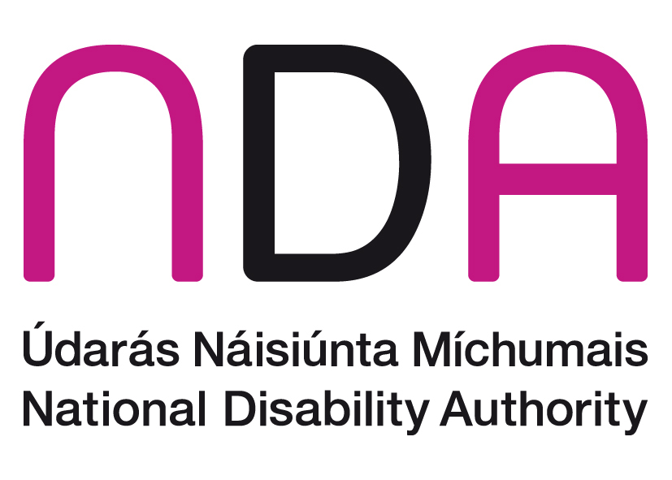
Chairperson’s statement 3
Overview and policy context 7
Strategic Priority 1: 14
Strategic Priority 2: 30
Strategic Priority 3 47
Strategic Priority 4: 69
Strategic Priority 5: 74
Financial statements 2025 87
Financial Statements for Year ended 31 December 2025 88
General Information 89
Appendix 1: Authority and other committees in 2025 90
Appendix 2: Representation on external bodies in 2025 91
Appendix 3: Publications in 2025 95
Appendix 4: Policy advice papers in 2025 97

Chairperson’s statement
I am delighted to present the National Disability Authority’s (NDA) Annual Report for 2025, which was the first year of our current Strategic Plan 2025-2027. It was also the year in which the NDA marked a quarter century of work to provide evidence-informed advice and guidance to government on disability policy and practice.
It was another busy year for the NDA, and I encourage you to read more detail about the various projects and outputs delivered during 2025 in the pages that follow. We particularly welcome the September 2025 launch of the government’s National Human Rights Strategy for Disabled People 2025-2030. This whole-of-government commitment to improving the lives of disabled people offers a road-map for activity in the coming years and was significantly informed by the wide-ranging public consultation with disabled people, their representative organisations, families and carers, led by the NDA during 2024. The report of this consultation was published alongside the new Strategy, and I would like to congratulate the Department of Children, Disability and Equality for their extensive work across Departments and disability stakeholders to finalise the document. In particular, their work with the Disabled Person’s Network and other stakeholders facilitated a co-creation approach to this important document. The NDA looks forward to supporting the implementation of the Strategy across its five pillars and enabling initiatives in the coming years, both through our monitoring activity but also our advice and guidance on several commitments under the various pillars.
Early in 2025 a new Programme for Government was agreed, and we were pleased to see the emphasis and focus on disability within it. This Programme provides further context for the NDA’s activity over the course of the year. I would like to take this opportunity to acknowledge the leadership of Ministers Norma Foley, Hildegarde Naughton, and more latterly, Emer Higgins, in delivering on the commitments within the Programme, as well as their ongoing support for the NDA.
During 2025 the NDA was particularly engaged in projects across key life domains for disabled people. This included a review of the Children’s Disability Network Teams model of service delivery, as well as the associated pilot of enhanced in-school therapies. These project reports were presented to the Department of Children, Disability and Equality and the HSE by the end of the year, and we look forward to their timely publication in 2026, and implementation of the recommendations set out.
I also welcome the ongoing focus on Universal Design and accessibility during the year. The European Accessibility Act (EAA) was scheduled for full implementation from June 2025 and the NDA continued to work closely with Ireland’s market surveillance authorities to provide guidance and information on the requirements of the Act. In doing so we have explored new ways of delivering our guidance, including through eLearning modules and short information videos. We look forward to continuing this work as we move through 2026.
Our support for realisation of the provisions of the United Nations Convention on the Rights of Persons with Disabilities (UNCRPD) also continued during the year, and particularly through our Annual Conference which in 2025 focused on Article 23, Respect for Home & the Family. The event allowed for a spotlight on topics that can often be neglected and appreciation for this focus was very evident in the positive feedback we received.
Finally, I would like to thank my fellow members of the National Disability Authority. As a board, we oversee a wide portfolio of research, monitoring, guidance and advisory activities related to disability and Universal Design. I would like to thank them for their commitment to the mission and vision of the organisation, and their constructive challenge to the NDA team to advance these goals. The staff of the organisation bring expertise and dedication to realising the Authority’s strategic objectives and as you will see from the pages that follow, they have delivered an impressive programme of work during 2025. This work was progressed in spite of some disruption to the organisation’s premises during works to improve the accessibility of our building. I’d like to particularly thank everyone for their patience and flexibility during this time and look forward to welcoming readers of this report to the improved building during the years ahead.
Kathryn O’Donoghue
NDA Chairperson
Kathryn O'Donoghue, NDA Chairperson


Overview and policy context
2025 marked the first year of the NDA’s operations under its Strategic Plan 2025-2027. The work of the organisation is broadly organised in service of five Strategic Priorities:
- SP1: Advise on and support implementation of UNCRPD and national strategies through provision of robust, objective and evidence-informed advice and guidance.
- SP2: Monitor, evaluate and guide performance across government on commitments and obligations to achieve inclusion for all.
- SP3: Continue to promote adoption and application of a Universal Design approach across all sectors.
- SP4: Engage strategically with our wide range of stakeholders, including disabled people through their representative organisations, to inform and enhance our advice and guidance.
- SP5: Clearly communicate the value of our work, while maintaining and enhancing organisational effectiveness.

A renewed focus on disability
The Programme for Government 2025 was agreed by all government parties early in the year, further to the General Election held in late 2024. The programme sets out significant commitments to improve the lives of disabled people over the lifetime of the government, and this emphasis is welcomed by disabled people. The implementation of these commitments offers an opportunity to achieve a step-change in how Irish society addresses the challenges and barriers experienced by many disabled people. Some of the NDA’s 2025 work-plan was configured in this new context, including activity under the Autism Innovation Strategy and a focus on specialist disability services for children. We also had productive engagement with the newly appointed Minister of State with responsibility for Disability Services, Ms Hildegarde Naughton, and congratulate her on her subsequent appointment as Minister for Education. We look forward to working closely with her successor, Ms Emer Higgins, TD, as well as the senior Minister for Children, Disability and Equality, Ms Norma Foley TD.
Following the formation of the Government, the NDA made submissions to each of the Departments to inform their Statements of Strategy, setting out our advice on key points for consideration in relation to inclusion, accessibility and Universal Design. We also reminded departments of the resources and guidance we have available to assist them in delivery of their functions in a manner that recognises the needs of everyone, including disabled people.
We were also pleased to engage with Oireachtas Committees on a number of topics during the year, welcoming the focus these Committees bring to key issues. Our engagements included hearings on Artificial Intelligence, Inclusive Education, and children’s disability services. We appreciate the opportunity to share our research and information about good practice with this audience.
NDA colleagues appear before the Oireachtas Joint Committee on Disability Matters, June 2025
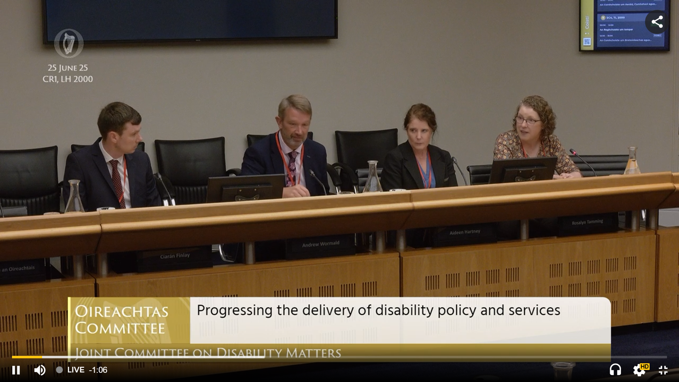

UNCRPD and a new national strategy for disability
In 2025 the Department of Children, Disability and Equality launched its National Human Rights Strategy for Disabled People 2025-2030. This is one of the State’s primary mechanisms for realisation of the vision of the UNCRPD and will be implemented through a series of multi-annual action plans. The NDA welcomes the publication of this Strategy and the impetus it provides for departments and public bodies across government to explore how their services and activities can maximise the inclusion of the full population, including disabled persons. The rights-based focus is also important as part of the ongoing process to move the State away from the medical model of disability.
The first of the action plans under the Strategy was published in December 2025, setting out detailed commitments under each of the 5 pillars within the Strategy. The NDA has continued work with departmental colleagues and other key stakeholders to develop a monitoring framework to allow for progress in relation to these commitments be measured over the lifetime of the Strategy. We particularly welcome the decision to have the Taoiseach chair the group charged with monitoring and delivery of the Strategy’s implementation, as this signals the importance placed on disability by the current government.
We were also pleased to be asked to lead the establishment of a Disability Research Data Advisory Group, which will be established in 2026 to support a strategic approach to providing an evidence base to inform decision making at the policy level.
This focus on coordinated approaches to the gathering and use of data and evidence is very welcome under the auspices of the Strategy. This will also be supported by a new National Disability Survey to follow the 2027 National Census, led by the CSO. The NDA was pleased to take a leading advisory role in the extensive preparatory work for this initiative during 2025, including stakeholder engagement and participation in working groups to establish how data gathering can inform policy decisions. We look forward to the roll-out of this survey in due course and to analysing and using the rich data it will provide in relation to the daily lives of disabled people in Ireland.
Our focus on UNCRPD also continued through our Annual Conference 2025, which centred on Article 23: Respect for home and the family. We note the appreciation our speakers and audience members had for the opportunity to give attention to this essential aspect to living a full and ordinary life. We hope the information and examples of good practice we were able to spotlight can inform decisions about the services and supports relevant to disabled people in this space.
In late 2025 we were happy to sign a Memorandum of Understanding with the Irish Human Rights and Equality Commission (IHREC), setting out the parameters of our work to support them in their role as the Independent Monitoring Mechanism for the UNCRPD. The UN Monitoring Committee has published its list of issues for consideration and response by the State in advance of its first dialogue with the Committee in 2028. We look forward to working with IHREC to provide information, data and statistics to support them in their work to monitor the State’s performance against the provisions of the Convention.

Statutory obligations
The NDA has a range of monitoring, advisory and reporting responsibilities assigned through legislation or at the request of a Minister. During 2025 we completed our 16th annual report on the employment of disabled people in the public sector. This report shows that in 2024 5.4% of public sector employees were people with disabilities, exceeding the statutory minimum target of 4.5% for that year. In 2025 the minimum target increased to 6% and monitoring for this year will commence early in 2026.
In July, the Minister for Children, Disability and Equality formally requested that the NDA prepare a report on the operation of the Irish Sign Language Act of 2017, as per Section 10 of that Act. This is the second such report prepared by the NDA and to inform its contents we carried out extensive consultation and engagement with members of the ISL community and relevant Disabled Persons Organisations. The final report will be presented to the Minister in early 2026.
The date for full implementation of the European Accessibility Act (EAA) in member states was the 25 June 2025. As set out in the transposing legislation (S.I. No. 636), the NDA continued to provide a range of supports for implementation during the year. This included engaging with the appointed market surveillance authorities to provide guidance and information on accessibility, preparing information resources in a variety of formats for ongoing reference, as well as extensive work to support the development of European and national standards that will underpin implementation by market providers.
During the year we also continued our monitoring role in relation to the accessibility of public service websites under the Web Accessibility Directive, and some of the provisions under Part 3 of the Disability Act 2005. These monitoring functions will also be relevant in evaluating progress under the National Human Rights Strategy for Disabled People, given its inclusion of a Capacity Strengthening Initiative on Accessibility, and the NDA will continue to explore ways of gathering and using monitoring data as efficiently as possible as this work continues to expand.

Understanding a rights-based approach to disability
During 2025 the NDA dedicated substantial in-house resources to an evaluation of the Children’s Disability Network Team (CDNT) model of service provision. This interdisciplinary approach to meeting the needs of disabled children was established under the reconfiguration provided for under the Progressing Children’s Disability Services policy. The evaluation was conducted in the context of increasing pressure on services with implications for waiting times for children and families and in some cases limited availability of supports. The evaluation included extensive consultation with families, children, CDNT managers and staff and other relevant stakeholders. We also carried out an exercise to begin the work on establishing the workforce size that would be necessary to meet the principles underpinning the model which can inform decision-making at the policy level. We were also asked to evaluate the pilot of the enhanced in-school therapy model whereby HSE-funded therapists work within special school settings to support the educational outcomes of children. While this is a fast-moving policy space, we look forward to the publication of this work in early 2026 and to it being of use in informing considerations across the HSE and relevant departments.
Work to realise the aims of the UNCRPD also includes implementation of the Assisted Decision Making (Capacity Act) 2015 (amended 2023), and particularly the dismantling of the old system of wardship. The NDA continued its research project to understand the experiences of Wards of Court and the discharge process, with the report finalised in 2025 and scheduled for launch in early 2026. The report will highlight the extent to which the discharge process can restore decision-making powers to people who had previously been considered incapable of managing their own affairs, improving their sense of autonomy and self-worth. The report also details ways in which the provision of information and decision-making supports can be optimised to ensure the discharge of those who currently remain in wardship can proceed as quickly and as possible and in a person-centred way.
We have also completed several pieces of work to offer guidance to public bodies on how best to provide services and supports to all members of the public, including those with disabilities. This has included updates on previous guides for justice professionals on autism, guidance on the role of access officers, and guidance on how to communicate with people who are minimally speaking or non-speaking. We have also concluded work to revise and update our eLearning module on disability equality which we hope will be widely used across the public sector when it is launched in early 2026. We hope that this range of practical information can benefit public services who seek to adopt a more rights-based approach to the delivery of their remit.

Universal Design
Under the NDA’s Strategic Plan for 2025-27, we aim to increase application of Universal Design principles in key realms as well as continuing to raise awareness and understanding of the concept. One of the mechanisms employed is participation in the AccessibleEU hub, one of the flagship initiatives proposed by the European Commission Strategy for the Rights of Persons with Disabilities 2021-2030. The hub is a resource centre on accessibility working on areas such as built environment, transport, information and communication technologies to ensure the participation of persons with disabilities in all areas of life on equal basis with others. The NDA through its Centre for Excellence in Universal Design, is the national contact point for this hub and during 2025 hosted a number of events spotlighting good practice in accessibility and Universal Design.
We are also carrying this work forward in the area of housing, with work to develop a national standard for UD Dwellings well advanced and scheduled for public enquiry stage in early 2026. We have also continued to advance various inputs to support a Cost Benefit Analysis of Universal Design Housing that will inform the Department of Housing in its future decision making.
Both the NDA and the CEUD have also continued to build profile and awareness of the themes underpinning our work through sponsorship of awards and research initiatives, aiming to build capacity and understanding of Universal Design and inclusion across sectors. We hope you enjoy reading more about these initiatives in the pages that follow.

The NDA Premises and staff
In September 2025, the NDA staff were able to reoccupy office space in 24 and 25 Clyde Road that had been extensively refurbished to achieve compliance with fire safety regulations and accessibility requirements. The works included remodelling bathrooms to improve accessibility, as well as the installation of a new Changing Places Toilet facility. The project has provided learning on how accessibility and Universal Design can be achieved even in buildings with protected characteristics, and we hope visitors and staff will experience an improved working and meeting environment as a result. I would also like to take this opportunity to acknowledge the patience and flexibility of the NDA staff throughout the project and the inevitable disruption it brought. Our building now actively supports collaborative working across our teams and we look forward to maximising these opportunities during the lifetime of our Strategic Plan, leveraging the expertise and experience of our staff members in fulfilment of our vision and mission. We also recognise the hard work of those staff who support the day-to-day operations of the organisation and ensure we maintain our high standards of compliance with the various governance obligations incumbent on us as a state agency.
L-R: NDA building entrance and reception area, prior to and post refurbishment.
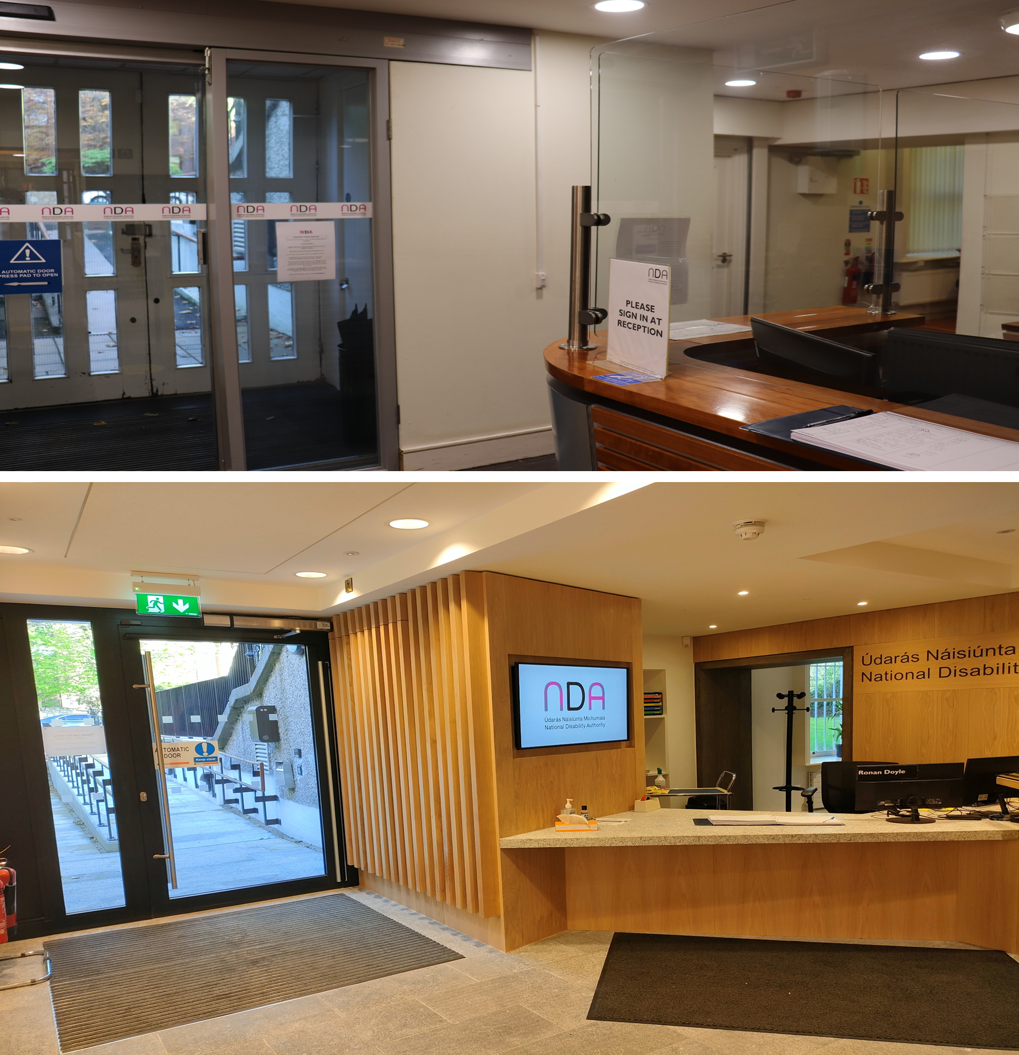

Strategic Priority 1:
“Advise on and support implementation of UNCRPD and national strategies through provision of robust, objective and evidence-informed advice and guidance”

Deliver high quality research and detailed policy analysis to inform decision making across government on implementation of the UNCRPD

Wards of Court Research
The Assisted Decision-Making (Capacity) Act 2015 and amending legislation commenced in April 2023. This legislation triggered the process of dismantling the adult wardship system in Ireland. The new law required all adults that had been made a ward of court to exit wardship within three years. As part of this process, the court determines what, if any, decision-making supports the person requires when leaving the wardship system.
The National Disability Authority undertook research which examined the experiences of people who are in the process of exiting or have exited the system of wardship and who are now living independently or availing of the new supported decision-making system. The research is framed by Article 12 of the UNCRPD which addresses the right to equal recognition before the law.
The research found the transition from wardship has been slower than anticipated. Of the 2,173 people in wardship in April 2023, there were still 1,602 adults in wardship (almost 74%) at the end of November 2025. Two significant barriers to engagement with the discharge process emerged from the study. Firstly, management of the former ward’s funds following discharge appeared to be a significant concern for participants. Secondly, there was a reluctance to embark on a new, unfamiliar system. Some expressed discontent that the same supports would not be available following discharge for both people in wardship and their committees.
There also appeared to be an information vacuum around the process of ending wardship. This was despite substantial information provision by several public bodies. It would appear that some individuals that had been made a ward of court and their committees overlooked or chose not to engage with the information provided.
Participants who had been discharged described how they were in a position to make their own decisions in their day to day lives and live more independently. For some, the responsibility of having to make decisions was met with fear and anxiety. While some people leaving wardship are deemed by the court to have capacity to make their own decisions, many of these same people have not had experience of doing so for many years.
Of those who had been discharged from wardship at the end of November 2025, a decision-making representative was appointed for the majority of them (78%). Decision-making representatives are responsible for making decisions on an individual’s behalf, based on their will and preferences. Over one in seven (13%) of those who exited wardship were discharged with no support arrangements as the court determined that the individual had decision-making capacity. Only 9% of those who left wardship were discharged with the support of a co-decision-maker who jointly makes decisions with the former ward of court.
As part of the study, NDA researchers also observed over 60 court discharge hearings. These observations highlighted significant efforts by the judiciary to make the court process more informal and accessible to individuals that had been made wards of court. The court also considered and gave great weight to the will and preferences of the person exiting wardship.
This report sets out key learnings and recommendations to address the concerns and apprehensions raised by participants in the research. This research was published in February 2026.
Providing wider context to the NDA’s research examining the process and the experiences of people leaving wardship, we published a background paper on Ireland’s journey from wardship to supported-decision-making viewed through the lens of the UN Convention of the Rights of Persons with Disabilities (UNCRPD) in early 2025.
This background paper considers the progress Ireland has made in meeting the requirements of Article 12 of the UNCRPD concerning equal recognition before the law, and the UNCRPD Committee’s guidance on this topic, by comparing the old wardship system and the new supported decision-making framework under the Assisted Decision-Making (Capacity) Act 2015 (as amended). The paper finds that while Ireland’s new statutory framework of supported decision-making constitutes a substantial step forward in terms of compliance with Article 12, and a marked improvement on the wardship system, it does not fully align with the UNCRPD Committee’s interpretation as set out in General Comment No.1.

Research promotion scheme 2023-2024
The NDA runs a Research Promotion Scheme (RPS) approximately every two years, subject to availability of funding.
Two papers were published during 2025 arising from the 2023-2024 Research Funding Scheme. The theme of this scheme was ‘Disability in Marginalised Groups and Communities’. Similar to the 2025-2026 scheme, Disabled Persons’ Organisations were invited to comment on a list of proposed themes and their comments were considered in selecting the final theme and an Expert by Experience was contracted to assist in selection of applicants. The research published as a result of this funding is outlined below

Disability, Diversity and Identity in Ireland’s Local and European Elections
This research explored the experiences of disabled candidates who identified as holding intersecting identities and who stood in the Irish local elections in 2024. It was intended to also include the European elections but no candidate with a disability participated in this election cycle. It was conducted by researchers in University of Galway and Trinity College Dublin.
The research identified systemic barriers including barriers related to inaccessibility of the built environment, information and communication, negative attitudes, fear of violence, insufficient financial resources, and lack of support. Participants reported canvassing as particularly challenging. The research recommended that issues around accessibility and funding for disabled candidates be addressed.

An Exploration of the Scale and Impact of Physical Disability in People Experiencing Homelessness in Ireland
This research conducted by researchers in Trinity College Dublin explored the scale and impact of physical disability in people experiencing homelessness in Ireland.
This study found just over one fifth of people accessing homeless accommodation included in the study were reported to have some kind of mobility limitation. Of those, just under half were sleeping in rooms up at least one set of stairs and just under half of these were staying in a hostel without a lift. In addition, one third of those with impacted or restricted mobility did not have access to an accessible bathroom.
This research is an important contribution to the evidence base on physical disability and homelessness in Ireland and recommendations focused on ensuring more accessible accommodation.
Dr. Julie Broderick, Trinity College Dublin, presents her RPS-funded research on homelessness at a webinar
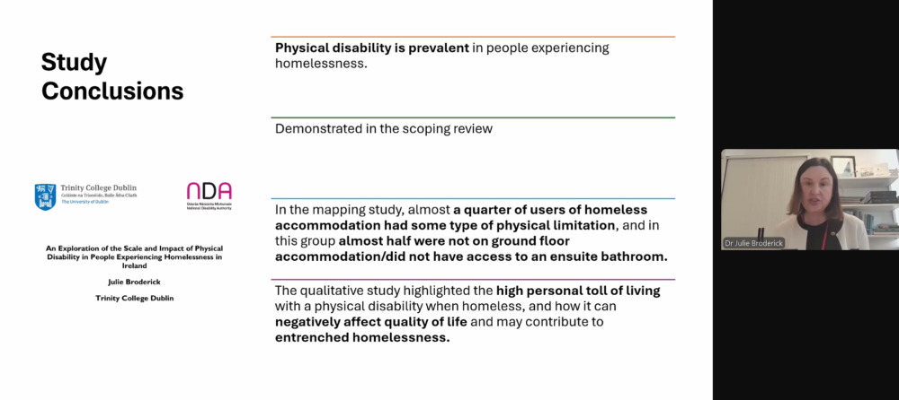

Research Promotion Scheme 2025-2026
The theme for the 2025-2026 Research Promotion Scheme was the same as the theme for our 2023-2024 Scheme, ‘Disability in Marginalised Groups and Communities’ but included a specific stream relating to disabled travellers. Disabled Persons’ Organisations were invited to comment on a list of proposed themes and their comments were considered in selecting the final theme. The aim was to fund research that examines the intersectionality of being a disabled member of marginalised groups.
An Expert by Experience joined the review team in assessing applications with a particular focus on the inclusion of disabled people in the research.
The funded projects under the 2025-2026 scheme are:
- Pavee Point in collaboration with Lucy Michael Research, Training and Consultancy: The research aims to explore the lived experiences of disabled Travellers in accessing disability and related services, and to identify barriers, facilitators, and culturally appropriate solutions that can inform inclusive policy and practice
- Munster Technological University: The research aims to investigate how housing conditions shape the health and wellbeing of disabled Travellers in Ireland, while situating these experiences within the wider Traveller community and to co-create actionable recommendations that ensure inclusive and culturally appropriate housing and health policy
- Simon Communities of Ireland: The research project aims to explore and understand the housing and accessibility needs of older adults with disabilities who are experiencing, or at risk of experiencing, homelessness
The project reports are due to be completed and published by mid-2027.

Translate research findings and policy analysis into practical guidance and advice

Update to Guidance on the Role of Access Officers for Public Bodies.
The NDA has updated its Guidance on the role of Access Officers for Public Bodies. This guidance was developed for Public Bodies in 2022, to help public bodies understand the importance of having an Access Officer; to outline their role and responsibilities; to advise public bodies on how they can support and enable their Access Officers, and to outline NDA monitoring of Access Officers.
Following requests from several government departments and private sector organisations to provide training to their Access Officers, it was decided to update this guidance to provide more detailed information on the role of the Access Officer. Experienced Access Officers were consulted to get their feedback on the guidance and how it could be improved. This has resulted in the updated guidance providing:
- Additional information on the relevant requirements in the Disability Act 2005 and the Ombudsman Act 1980
- Clarification on the difference between an Access Officer and an Inquiry Officer
The new guidance document is now available on the NDA website.
Two video presentations were also produced to complement this guidance. One video focuses on public bodies’ statutory responsibilities to have an Access Officer and also summarises the role of the Access Officer. The other video features a presentation from an Access Officer on their role in the Department of Housing, Local Government and Heritage.
Screenshot of video on the responsibilities for public bodies in relation to Access Officers
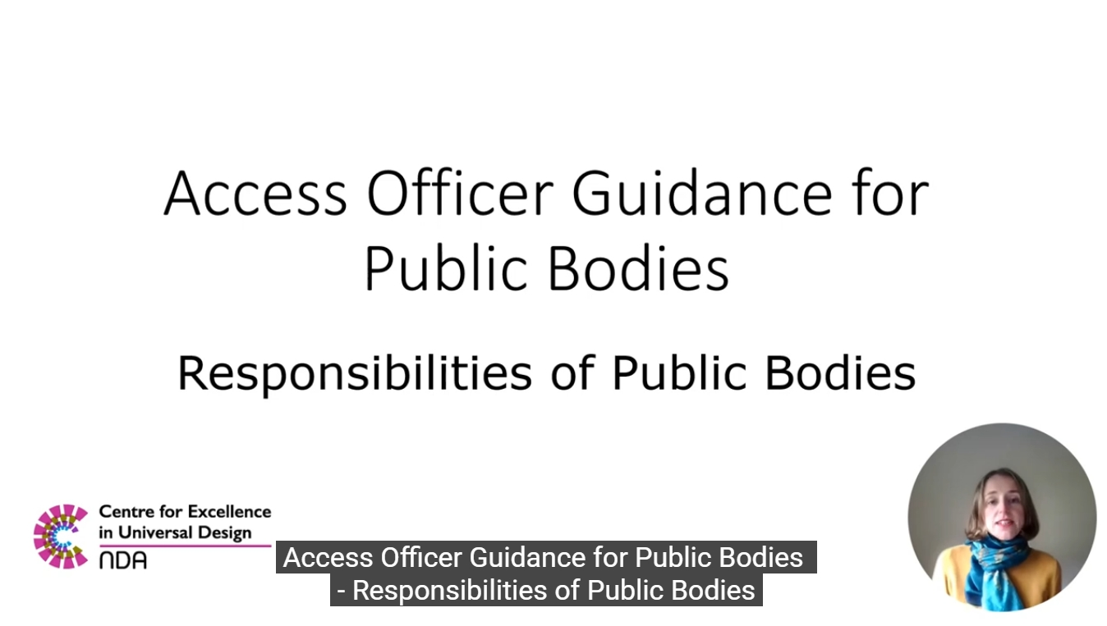
The implementation of this guidance will be evaluated through the monitoring of the Code of Practice on Accessibility of Public Services and Information provided by Public Bodies.

The European Accessibility Act (EAA)
The European Accessibility Act (EAA) is a European Directive that contains accessibility requirements for a range of products and services. The EAA commenced in June 2025.
The EAA is formally known as Directive (EU) 2019/882 on the Accessibility Requirements of Products and Services. In Ireland, the EAA was transposed into Irish Law through Statutory Instrument No. 636 of 2023.
The NDA’s EAA team has developed a comprehensive suite of materials providing information on the EAA Accessibility Requirements, the Functional Performance Criteria and why accessibility matters available on the CEUD website. These materials were launched in June 2025 ahead of the commencement of the Act. The team also provided details of these materials to participants as part of an AccessibleEU webinar ‘The European Accessibility Act is here: What is it and What do I do Now?’.
These webpages will continue to be developed and updated as the Act is implemented.

European Accessibility Summit 2025
The NDA was pleased to be invited to join a panel at the European Accessibility Summit 2025, a hybrid event held in Brussels in October 2025. The panel comprised persons with disabilities, a regulator from the Netherlands, an academic from Germany, and the Senior Advisor for the EAA from the NDA. It was moderated by a representative from Microsoft. The discussion focussed on diverse matters including aspects of regulation, and issues which should be addressed by the Commission in order to ensure effective implementation of the EAA which informed the work here in Ireland.

Minimally speaking and non-speaking people
The NDA developed guidance for public sector staff to support non-speaking and minimally speaking people to access public services. This was in fulfilment of Action 82 in the Autism Innovation Strategy. The purpose of this guidance is to raise awareness around the needs of autistic people and others with disabilities who use Augmentative and Alternative Communication (AAC). This includes information on the different types of AAC and best practice for frontline service providers to engage with these individuals in a respectful way.
The content was informed by two advisory groups, made up of AAC users and those with experience supporting them in a professional or personal capacity. It was also informed by a literature review. The guidance and literature review were published in early 2026.
Call for advisory group members, June 2025
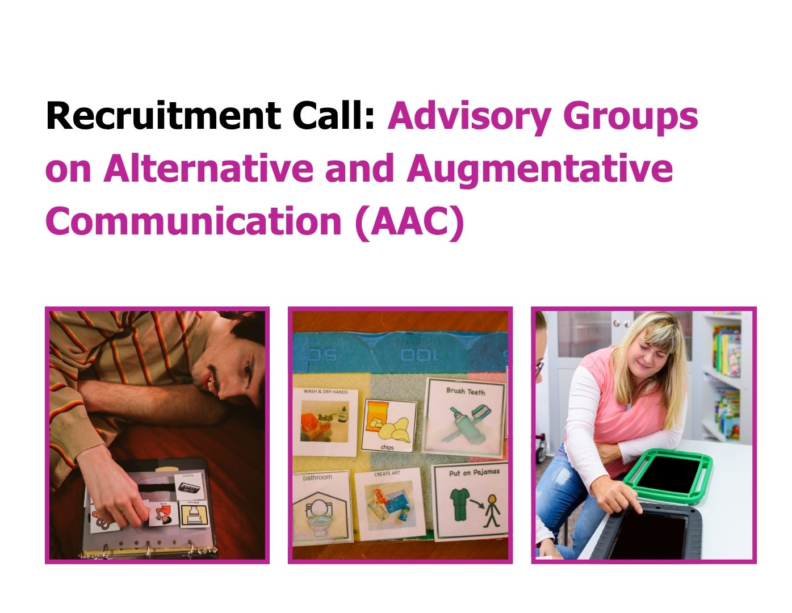

Oireachtas Committee appearances and submissions

Inclusive education
Following a request to make a submission to the Joint Oireachtas Committee on Disability Matters on Inclusive Education the NDA were invited to appear before the committee on 8 October. Our opening statement touched on a range of areas and issues, including Ireland’s progress in meeting the requirements of Article 24 of the UN Convention on the Rights of Persons with Disabilities, which enshrines the right to inclusive education. Other topics covered included Universal Design in Education, assistive technology provision and use in schools, the in-school therapy model and transition planning. Examples from other countries will more advanced inclusive education systems were referenced and the NDA followed up with some additional information following the meeting.

Artificial Intelligence
The NDA was invited to appear before the Joint Oireachtas Committee on Artificial Intelligence on 7 October 2025 as part of their schedule of meetings developed to help members understand the challenges and opportunities of AI for key groups in society. In our inputs the NDA emphasised the importance of building AI systems with a Universal Design approach, adopting co-creation and co-design principles. These points were also summarised in our opening statement. Issues around the affordability of technology and digital literacy were also raised, along with the importance of standards and regulation to support inclusion. At the same time, the NDA recognised the significant benefits that can be experienced by disabled people if AI is rolled out carefully within public services.

Progressing the delivery of disability policy and services
The NDA appeared before the Joint Oireachtas Committee on Disability Matters on June 25. The NDA spoke about the forthcoming National Disability Strategy and the review of the Children’s Disability Network Teams service model, as well as the Optional Protocol to the UNCRPD. These are summarised in our opening statement. The discussion covered a wide range of areas, including the importance of Universal Design in housing and the public realm, Ireland’s disability employment gap, and the need for reform in relation to the Assessment of Need process while also working to enhance interdisciplinary services. The NDA emphasised the importance of ensuring that services could be received by families and children, noting that the focus on accessing Assessment of Need was only one part of the picture. The NDA took the opportunity to forward links to some of our recent research on employment and decongregation to the Committee for their information.

Equality Bill
The NDA appeared before this Oireachtas Committee on 8 July to discuss pre-legislative scrutiny of the general scheme of the Equality (Miscellaneous Provisions) Bill 2024. The NDA outlined the implications of the legislation for disabled people, highlighting both progress and areas requiring further improvement. The opening statement touched on the need for civil legal aid for anti-discrimination cases, the definition of disability, consultation with disabled people requesting reasonable accommodation and other changes to improve reasonable accommodation provision.
NDA colleagues appear before the Oireachtas Joint Committee on Disability Matters and Joint Committee on Artificial Intelligence
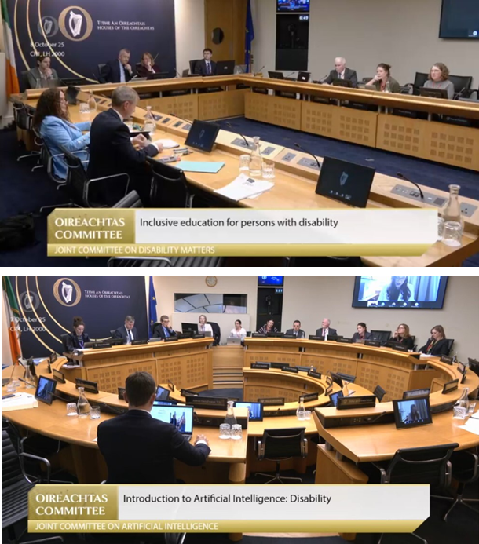

Submissions to equality related consultations
The NDA made submissions during 2025 on the new Strategy for Women and Girls and the LGBTI+ Strategy both led by DCDE and An Garda Síochána’s Human Rights Strategy. We also made submissions to the Department of Health on Protection of Liberty and the Mental Health Bill. The Department of Social Protection had consultations on the Roadmap for Social Inclusion and Pathways to Work to which we also made submissions.
These submissions gave the NDA the opportunity to ensure that the intersectionality of disability with other equality grounds were highlighted. The submissions shared data available on intersectionality drawing on NDA work, data from the CSO and other relevant reports. It also highlighted the new National Human Rights Strategy for Disabled People, its focus on intersectionality and the opportunities to make sure strategies and revised plans are aligned with the Strategy.

Support knowledge-sharing and coordination across the public sector to enhance realisation of goals of UNCRPD and implementation of national strategies and programmes

National Human Rights Strategy for Disabled People 2025–2030
The National Human Rights Strategy for Disabled People 2025-2030 was published in September 2025 by Taoiseach Micheál Martin, Tánaiste Simon Harris, Minister for Children, Disability and Equality, Norma Foley, and Minister of State with Responsibility for Disability, Hildegarde Naughton. The strategy aims to provide a blueprint for further realisation of the UN Convention on the Rights of Persons with Disabilities (UNCRPD) in Ireland.
Centred around five key pillars identified as priorities by people with disabilities and their representative organisations, the new strategy contains a range of ambitious commitments which seek to improve the lives of disabled people across the country. Recognising the need for cross-departmental and agency collaboration, the strategy also sets out a whole-of-government framework and approach, with an emphasis on mainstream-first delivery. The NDA provided ongoing advice to the Department of Children, Disability and Equality in the development of the strategy.
In particular, the NDA played a key role in ensuring that the voices of disabled people featured prominently in the strategy development process. At the request of the Department of Children, Disability and Equality, the NDA carried out a comprehensive national public consultation to inform the development of the strategy in late 2023 and the first half of 2024. The consultation was underpinned by principles of participation and aimed to be a genuine, accessible, and transparent process which meaningfully engaged with disabled people. The National Human Rights Strategy for Disabled People 2025-2030 Consultation Report was published alongside the new strategy in September 2025.
National Human Rights Strategy for Disabled People 2025-2030 Consultation Report
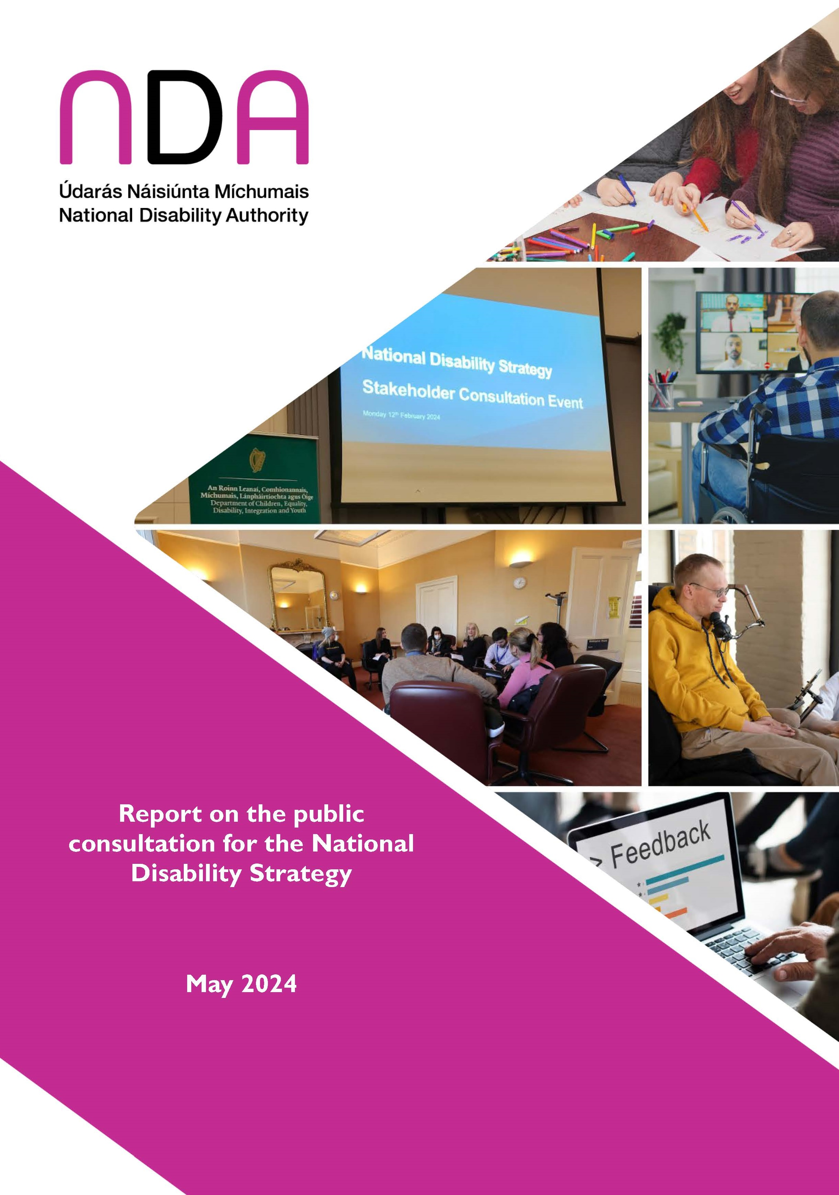
The NDA will play an important role in guiding and monitoring the implementation of the strategy. The NDA will facilitate the establishment of both a Data and Evidence Working Group, to advance the development of indicators for a rights-based approach to monitoring the strategy, and a Disability Research and Data Advisory Group, to foster a more strategic and coordinated approach to disability research and data across the public sector. In addition, the NDA will be represented on the Delivery and Monitoring Committee for the strategy and the five pillar groupings.
The First Programme Plan of Action 2025-2026 to support implementation of the new strategy was published in December 2025, with the NDA providing advice in relation to its development. This document sets out how the key priority actions under each strategy commitment will be delivered, by whom, relevant success indicators and the timeframe for delivery. There are several actions assigned to the NDA relating to accessibility, research and data, and universally designed homes. The first meeting of the Monitoring and Delivery group was also convened in December, chaired by An Taoiseach.

NDA participation in a working group to review and update HIQA’s National Guidance on Good Communication in Health and Social Care: Using Plain Language
HIQA decided in late 2024 to update their 2015 Guidance for providers of health and social care services for children and their Guidance for providers of health and social care services. These guidance documents were designed to support health and social care staff to use plain language in all communication with people using their services.
HIQA established a working group to oversee the work, recruiting several different stakeholders to it, including Adult Literacy for Life, NALA, Solas, HSE, Irish Cancer Society, TUSLA and NDA. They hosted three working group meetings to gather feedback from the working group on how the guidance documents could be improved, best practice examples that they could reference and where terminology needed to be updated or edited. NDA contributed to the revision and following feedback on both documents a decision was made to combine the documents into one document, that could be used by all health and social care services.
HIQA published their updated National guidance on good communication in health and social care: using plain language on 4 December 2025.

Meeting with the National Transport Authority (NTA)
NDA staff attended a meeting with the Technical Working Group on bus stops and cycling infrastructure. At this meeting, NDA provided detailed feedback after reviewing the design of over thirty bus stops and cycle infrastructure in Dublin and its surrounding areas. The NTA will use the NDA’s feedback to develop new design guidance for new bus stops.
The NDA communicated the importance of addressing the design issues of the bus stops. However, a retrofit programme is not the intention of the NTA at this current time. The NDA will continue to engage with the NTA over the coming months at the scheduled Technical Working Group meetings and through other fora to drive improvement in accessible public transport.

HSE HR Conference 2025
In October, the NDA presented at the HSE HR Conference on creating an Equal, Diverse and Inclusive Culture using a Universal Design approach. This conference was attended by over 300 HR Directors and Managers in the HSE.
The NDA also presented to the Le Chéile Network and senior staff of the HSE for the HSE’S celebration of International Day for People with Disabilities (IDPWD) in November. The Le Chéile Network was established by the HSE in 2021 to provide employees with disabilities with:
- Support and visibility and a voice for staff
- Opportunity for employees with disabilities to contribute personal stories and experience into HR policy and practice
- Assist with raising awareness on Diversity, Equality and Inclusion (DEI) issues to the wider workforce

Submission to OGP Consultation on National Public Procurement Strategy
The Office of Government Procurement (OGP) is developing Ireland’s first national public procurement strategy. To inform their work, they hosted an online consultation in 2025 that invited comments on what the priorities of strategy should be, the current challenges in public procurement, and ways in which those challenges could be addressed. The OGP proposed the strategy would be structured under 11 themes, such as ‘Transparency’ and ‘Efficient and effective public procurement’ and invited comments in relation to each of these themes. NDA submitted a response calling for accessibility to be incorporated as a core requirement of public procurement – the process of procurement and content of procurement – and cited the national, European and international legislation that calls for same. Proposals were made on how accessibility could be addressed to ensure that the process and the products/services/works procured are accessible. We will continue to work with the OGP to advance understanding and implementation of accessibility requirements in public procurement. We look forward to the expected completion and launch of the strategy in the first half of 2026.

Advise and guide public bodies on how to implement the principles of engagement in disability policy-making to reflect the goals of UNCRPD and strengthen delivery of objectives

Submissions on Statements of Strategy
The NDA made 11 submissions to various government departments and Offices in response to their consultations on their Statements of Strategy following the formation of the new Government early in 2025. The NDA submissions all highlighted the need for each department to engage with the new National Human Rights Strategy for Disabled People and ensure their department or office was committed to delivering their actions. We also emphasised the need to engage with disabled people through their representative organisations and pointed to NDA resources to support this. The NDA also took the opportunity of the revision of departments’ Statements of Strategies to remind them of their obligations related to the employment of disabled people, having accessible websites, their obligations under the Irish Sign Language Act and other issues in relation to accessibility.

Strategic Priority 2:
“Monitor, evaluate and guide performance across government on commitments and obligations to achieve inclusion for all”.

Monitor and report on implementation of, and compliance with, statutory obligations in relation to accessibility to guide continued improvement

EU Web Accessibility Directive (WAD) Monitoring

Reviews conducted and notable developments
The NDA conducted 233 Simplified Reviews, 22 In-depth Reviews on websites and 12 In-depth Reviews on mobile applications for the 2025 monitoring period. The resulting national report was submitted to the Secretary General of the Department of Culture, Communications and Sport in December and was published on the NDA website. This is the first of three annual reports that will collectively fulfil NDA’s reporting obligations for 2025-2027 under the Directive as per the Commission Implementing Decision 2018/1524.
Ireland’s Annual Monitoring Report 2025
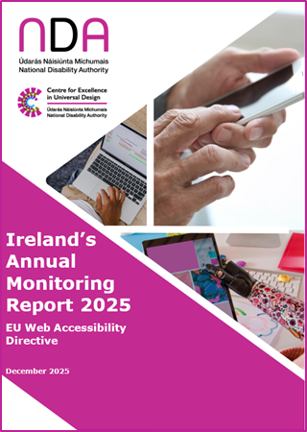
The 2025 report has shown significant improvement in levels of compliance across certain cohorts of public sector bodies. Many public sector bodies have addressed accessibility issues identified by the automated and manual tests. Public bodies subject to In-depth Review, Simplified Review, or both, for the 2025 monitoring period should consider these results as the beginning of their accessibility journey. The NDA advises that engagement with real users including persons with disabilities, and addressing issues identified in automated and manual testing are key to ensuring meaningful accessibility and achieving compliance with the Web Accessibility Directive.
Similar to last year, the NDA observes a consistent and welcome trend by public sector bodies in addressing accessibility in the development of new or existing websites and mobile apps. It continues to be critical that public sector bodies consider accessibility from the early stages and throughout the process when planning, developing and publishing content on their websites and mobile applications. The NDA advises against the routine publishing of inaccessible PDFs and recommends that public sector bodies consider the publication of options that are easier to make accessible such as HTML, Word documents, FormsIE (for online forms) as alternatives, whenever possible.

WAD Webinar in partnership with the Irish Computer Society
The WAD team in partnership with the Irish Computer Society (ICS) held an online training webinar in April titled “PDF Accessibility” and delivered by Jess Cahill, Senior Accessibility and Usability Consultant at AbilityNet. The seminar was attended by 300 online participants and covered topics such as checking PDFs for accessibility, working with tags in PDFs and the accessibility of scanned documents and PDF forms. Participants were enthusiastic about learning more to help them improve the accessibility of existing and future PDFs created by their organisations.

Second report on the operation of the Irish Sign Language Act 2017
The NDA progressed a formal request by the Minister for Children, Disability and Equality to conduct the second review on the operation of the ISL Act, as per Section 10 of the Act, and to report by the end of 2025. The NDA made a number of recommendations in the first report on the operation of the Act in 2021 and the 2025 report is to determine whether these have been implemented and what progress has been made to address the challenges outlined in the first report.
The NDA established an Advisory Group to guide on the proposed information gathering process from various perspectives, interpret consultation findings, and to feedback on the recommendations within the report. The Advisory Group was made up of people from organisations that represent the interests of the members of the ISL community, service organisations and interpreter representatives –the Irish Deaf Society, Chime, Sharing the Journey, Centre of Deaf Studies TCD, Council of Irish Sign Language Interpreters, Community K and Sign Language Interpreting Services. The Advisory Group met with the NDA five times throughout the reporting period.
Video overview of the consultation on the ISL Act 2017 and call for submissions
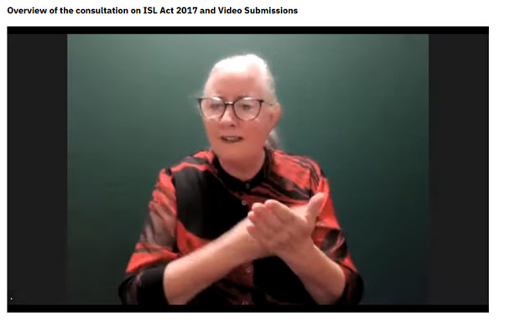
Consultation on the operation of the ISL Act was carried out in Q3/Q4 of 2025 which comprised engagement with both public service providers and the public. Public bodies and government departments were requested to complete a survey requesting information regarding the implementation of their responsibilities under the Act. Members of the ISL community were invited through online public surveys, public meetings and an invitation for written and ISL submissions. Analysis of the data was completed in December 2026.
As part of this project, the Irish Deaf Society was commissioned to carry out consultation with children on their experiences of the operation of the ISL Act.
The project team commenced report writing in December 2025, and. the final report will to be submitted to the Minister of Children, Disability and Equality in early 2026.

Report on Compliance with Part 5 of the Disability Act 2005 for 2024
This report was published to the NDA’s website in December 2025.
In 2024, the minimum statutory employment target increased from 3% to 4.5%. In 2025, this target will increase to a minimum of 6%.
The key findings from this report are:
- In 2024, the percentage of employees reporting a disability increased to 5.4%. This is the first time this percentage has exceeded 5%. The number of employees reporting a disability increased from 11,254 in 2023 (4.1%) to 15,403 (5.4%) in 2024.
- The number of public bodies in the public sector increased from 210 in 2023 to 216 in 2024. At the end of 2024, the total number of employees in the public sector had increased by 10,058 people (+3.7%) going from 273,747 in 2023 to 283,805 in 2024.
- In 2024, 185 public bodies (85.6%) met the 4.5% target compared to 191 (91%) who met 3% target in 2023.
- In 2024, 134 public bodies (62.6%) met the forthcoming minimum 6% target compared to 110 (52.4%) in 2023.
- Overall, the public sector exceeded the minimum statutory employment target for people with disabilities for the fourteenth successive year.
The NDA acknowledges the continued improvement in the public sector’s performance. However, we continue to advise public bodies that they need to meet or exceed the minimum 6% in 2025 by developing and enhancing Equal, Diverse and Inclusive (EDI) work cultures, that focus on increasing the recruitment and retention of persons with disabilities and supporting employees with disabilities to be more comfortable in sharing their disability status.

S.49 requests for 2022 and 2023
In 2022 and 2023, only two public bodies, with over 50 employees, did not make the minimum 3% target for these two consecutive years. These public bodies were:
- Health Service Executive (HSE)
- The Private Security Authority
The NDA did not send a S.49 request to the Private Security Authority because it reported that the main reason it had not met the minimum 3% target in 2022 and 2023 was because it was not responsible for its recruitment and was assigned employees from the Department of Justice. This public body therefore has a limited ability to meet the minimum 3% target. However, this public body demonstrated that it had measures in place to create an EDI work culture, for example, having a formal written commitment to providing universally designed communications that are easy to access, understand and use for everyone and providing employees with training in disability equality.
The NDA monitored this public body’s performance and is pleased to note that it exceeded the 4.5% target in 2024.
The NDA sent a S.49 request to the HSE for 2022 and 2023 for this two-year period. In response to this request the HSE provided evidence that the same mitigating factors that were deemed to apply in 2021 and 2022 continued to be felt in 2022 and the first part of the 2023 period. These mitigating factors are the unprecedented disruption of the COVID-19 pandemic and the cyber-attack. In this context, having reviewed the HSE’s response, the Authority decided that it would not issue a draft determination of non-compliance for this two-year period.
The NDA has noted that the HSE is now back to normal service. We have advised the HSE that the COVID-19 pandemic and the cyber-attack will no longer be considered as mitigating factors that could prevent this public body from meeting the minimum statutory employment target.
Since 2020, the NDA has been in an ongoing engagement with a designated team in the HSE to help this public body improve its performance under Part 5.

S.49 requests for 2023 and 2024
Under Section 49 (S.49) of the Disability Act 2005, the NDA can request further information from public bodies who have not made the minimum statutory employment target for two consecutive years. The NDA reviews this information to determine if a public body is compliant under Part 5.
In 2023 and 2024, the following public bodies did not make the minimum statutory employment target for these two consecutive years:
- Health Service Executive (HSE)
- Irish Aviation Authority
- Rásaíocht Con Éireann
- Údarás na Gaeltachta
In November 2025, the NDA sent these public bodies S.49 requests for this two-year period. Public bodies have three months to respond. The deadline for their responses is quarter one 2026.

Code of Practice on Accessible Heritage Sites
In 2025, the NDA commenced work to review and update Statutory Instrument No. 484 of 2011 – the Code of Practice on Accessible Heritage Sites. To inform this work we met with colleagues from the Office of Public Works (OPW), the Department of Housing, Local Government and Heritage and local authorities, and have visited diverse heritage sites in several counties. Our stakeholder engagement has led us to prioritise awareness-raising and training initiatives above any revision of the code, which we anticipate will coincide with activities in relation to a revision of S.I. No. 163 of 2006/Code of Practice on Accessibility of Public Services and Information Provided by Public Bodies.

Assess and evaluate progress on implementation of national strategies and programmes to guide on how to fully realise the rights of disabled people

Review of Children’s Disability Network Team Service Model
The NDA was commissioned by the HSE to conduct a review of the Children’s Disability Network Team (CDNT) service model as outlined under action 2.17 in the Roadmap for Service Improvement 2023-2026: Disability Services for Children and Young People.
Progressing disability services (PDS) is a programme to reconfigure health and social care services for children who have complex needs arising from a disability or from multiple disabilities in Ireland. This programme of reconfiguration led to the creation of the new CDNT service model.
This was the first in-depth formal nationwide review of the operation of the CDNT service model since its inception. Following planning and preparation work performed in 2024 the review was formally commenced in early 2025. The project plan divided the review into three parts that were to run concurrently as outlined below. The review was supported by an advisory group and a steering group focused on Parts 1 and 2 with a separate steering group for Part 3.

Part 1
The aim of Part 1 was to identify what is working well and what is working less well within the CDNT service model, in particular relating to its 12 principles and an additional principle of Management and Leadership. The principles are:
- Governance and Accountability
- Clinical governance and evidence-based practice
- Family Centred Practice
- Early identification of need
- Evaluation of outcomes
- Equity of access
- Accessibility
- Staff are valued and respected
- Biopsychosocial model
- Cultural competence
- Inclusion
- Interdisciplinary teams
- Management and Leadership
Data were collected through surveys, interviews, focus groups and written submissions from families, children and young people, staff, CDNT managers, other HSE staff and a wide range of other stakeholders. Extensive analysis was conducted with the main report submitted to the HSE and DCDE in late December 2025.
The findings point to a complex system with some legacy issues that impact on service delivery. While a number of improvements have taken place or are underway and staff numbers are increasing there remains dissatisfaction among many families both because they are not receiving a service or they perceive the service to be inadequate. Staff and managers were dedicated to meeting the needs of disabled children and their families but were hampered by workload. The report includes a number of recommendations, and these will be discussed with the HSE and DCDE in early 2026.
A number of supplementary reports are being produced on different stakeholder groups that will be submitted in early 2026.

Part 2
The aim of Part 2 was to identify the optimal workload of staff and the configuration of teams to maximise the efficiency and effectiveness of operations. Two meetings of an expert reference group were held to guide the project. A database has been developed combining CDNT staffing, CDNT monthly metrics, and Health Atlas data that includes population data based on Census 2022 and deprivation data. These data were analysed to examine optimal workload but the extent of analysis possible was constrained by the data available.
A report was submitted to the HSE and DCDE in late 2025 and the NDA anticipates that more analysis will be required to have robust enough data to inform staffing numbers and configuration for CDNTs.

Part 3
The aim of Part 3 was to conduct a brief evaluation of the enhanced in-school therapy supports pilot. One aspect of the reconfiguration of services that occurred under the auspices of PDS was the amalgamation of health and social care professional working in special school with the local community disability teams. This was undertaken with the aim of increasing equity of service access and creating a single streamlined service model nationally. However, some stakeholders, such as parents or teachers attached to some schools were dissatisfied with this change. These stakeholders believed children in these schools received less support under the CDNT service model than they did prior to reconfiguration.
In August 2024, government therefore announced that a pilot of enhanced therapy supports in six special schools in Dublin and Cork would commence in September 2024. We visited five of the six schools taking part in the pilot and interviewed staff from the sixth school online. A school-based therapist, the principle or a teacher, a parent and a staff member from the local CDNT were interviewed for each school.
The evaluation found frustration among all stakeholders that communication about the pilot was limited. They perceived a lack of transparency in decision-making on several aspects of the initiative. There appeared to be a disconnect, at times, between parent and school perceptions of what the pilot aimed to achieve and what therapists and CDNTs were asked to do which created some tensions. A number of recommendations were made to inform next steps in relation to the provision of therapies in schools.
The evaluation report was shared with the HSE and DCDE in July 2025. The NDA are working on some requested amendments. The report has been used to inform the development of a new Education Therapy Scheme that is currently being rolled out by the Department of Education in 45 special schools.

Literature reviews
Seven literature reviews were completed to inform the evaluation project as listed below. Where relevant, the findings were incorporated into the three reports above. A literature review on the configuration of children’s disability services in other jurisdictions is ongoing.
- Literature review on determining appropriate caseloads and workloads for Children’s Disability Network Teams
- Literature review on the calculation of the optimal frequency/intensity of therapeutic intervention within children’s disability services
- Literature review on the prioritisation of referrals in interdisciplinary teams
- Literature review of non-clinical competencies and skill mix required by interdisciplinary teams who support children with disabilities
- Literature review on the evidence for interdisciplinary teams in community-based services
- Literature review on the evidence for task shifting to assistant therapists in healthcare services
- Literature review on the evidence for family-centred practice within children’s disability services

Personalised budgets
The Department of Health published the Task Force on Personalised Budget’s report, Towards Personalised Budgets for People with a Disability in Ireland in July 2018. The Task Force report recommended that the Department of Health and the HSE should establish demonstration projects to test the delivery of personalised budgets in an Irish context with a view to identifying the best approach to the wider roll-out of these models following the initial demonstration phase.
The Task Force Report describes a personalised budget as:
"…an amount of funding which is allocated to an individual by a state body so that the individual can make their own arrangements to meet specified support needs, instead of having their needs met directly for them by the State".
The HSE developed an implementation plan and established the Personalised Budget Demonstration Project in late 2019. The Department of Health established a PB Oversight Group (chaired by the Department of Health and including the HSE and the National Disability Authority in an advisory capacity) for the Demonstration Projects, also in 2019.
The Department of Health requested that the NDA manage an evaluation of the Personalised Budget Demonstration Project. Subsequently specialist disability services were transferred from the Department of Health to the Department of Children, Equality, Disability, Integration and Youth (now the Department of Children, Disability and Equality).
The NDA developed an evaluation plan in 2020. As part of this evaluation, the NDA commissioned ACE Communication to support this evaluation given their expertise in supporting people with different communication needs. In 2024 given that there had been very a significant delay in the evaluation fieldwork commencing, due to the slow rate of people transitioning to a personalised budget, the NDA presented a revised evaluation design which was signed off by DCDE in late 2024. Revised ethical approval was sought and received and data collection commended in mid-2025.
There were 45 budget holders at the time of the evaluation and 18 budget holders and or their families participated in interviews. There was also participation from the Project Office team, other relevant HSE staff and a range of external stakeholders. The HSE sent administrative data relating to the budget holders that included some information on personal plans and details on expenditure.
An advisory group was formed to advise on the evaluation that included members of Disabled Persons Organisations, disability advocacy organisations and individuals with personal experience of receiving a personalised budget (but who were not part of the Demonstration Project).
The evaluation indicated that participants receiving a personalised budget all felt that it gave them more choice and control in their lives. They gave mixed views on the process to receive a personalised budget with some reporting good support from the National Office and a relatively easy process to some who found the process very challenging and reported receiving little support. The final report will be submitted to the HSE and Department of Children, Disability and Equality in early 2026 and will set out a number of recommendations as to how a new system for personalised budgets could be developed.
An international literature review was also conducted focusing on learning from personalised budget programmes and practices across ten jurisdictions. Findings from the review informed the evaluation.

Comprehensive Employment Strategy
The Comprehensive Employment Strategy (CES) for People with Disabilities was a ten-year, whole of government approach to improving employment outcomes for disabled people. In early 2025 the NDA published an end of strategy review.
The review showed that, over the lifetime of the CES, a number of positive developments were realised across a range of areas, including in education and skills development and in relation to some employment supports. However, several gaps and challenges were found to remain, including in relation to the persistent disability employment gap in Ireland and limitations in relation to appropriate career guidance for some learners with disabilities, gaps in supported employment, and issues with strategy coordination and implementation. Learnings for future national strategies that include a focus on the employment of disabled people are included in the report.
The new National Human Rights Strategy for Disabled People has a pillar dedicated to employment which will keep a focus on this important area.

Provide a robust evidence-base to inform implementation and reporting at national and international levels, including identifying data gaps and taking opportunities to gather new information

National Disability Survey
The NDA has been active over the last number of years in building a case for a National Disability Survey. Such a survey was conducted in 2006 by the Central Statistics office following the 2006 Census of Population. The survey provided in-depth information on the lives, needs, and difficulties experienced by individuals with a disability, and it is still used to inform policy.
The National Human Rights Strategy for Disabled People 2025-2030, includes a commitment to conduct a National Disability Survey following the 2027 Census. Planning for the survey is currently underway and is being led by the Central Statistics Office and DCDE. The NDA were requested by DCDE to lead a consultation with DPOs, disabled people and other civil society, academic and other relevant stakeholders on points for consideration in such a survey. This work was conducted in late 2024 and early 2025. NDA received good engagement from the consultation and submitted a consultation report to DCDE which helped informed the parameters of the survey.
The NDA sits on the overall steering group for the survey as well as each of the five sub-groups that were established to inform the development of the survey modules (employment, transport, assistive technology, autism and neurodiversity and a general topics group). The NDA continues to work with the CSO and DCDE providing advice where relevant and looks forward to the survey being piloted in 2026.

Autism prevalence paper
The NDA has had a number of commitments under the Autism Innovation Strategy. Action 80 was to examine the extent to which existing data sources and methods could provide a reliable estimate of the prevalence of autism in Ireland. This review was led by the NDA with the support of DCDE, the Central Statistics Office (CSO) and the Health Research Board (HRB) and incorporated feedback from autism stakeholders and public bodies.
The analysis found that in the Irish context, no data source nor methodological approach to measure the prevalence of autism is ideal. Each has its own strengths and weaknesses. The findings suggest a multi-component approach to estimating the prevalence of autism is warranted.
The planned National Disability Survey and the Irish Health Survey may be an appropriate mechanism by which a national prevalence estimate could be explored. It may also be beneficial to explore the role of the National Ability Supports System to capture more autism data over time. In the long term, the establishment of the Health Data Access Body may provide data to support rich insights into this area. The report was published in September and is available on our website.

Outcomes focused monitoring of New Directions
The NDA is supporting the HSE to design and development an outcomes-focused monitoring system, to support the implementation of New Directions adult day services, underpinned by the Standards for New Directions. The monitoring system is being co-designed with relevant stakeholders through an iterative design process. The first phase of the trial to co-design the monitoring system was conducted across April, May and June of 2025. The trial involves the input of people who attend day services in developing the monitoring system. The first trial focused on information gathering both as part of a desk exercise in advance of a visit and during the visit.
L-R: Clare Walsh, Jack Kenny, Martina Lanigan (HSE), Deirdre Nally (NDA) at the Health Service Executive Patient and Public Partnership Conference 2025
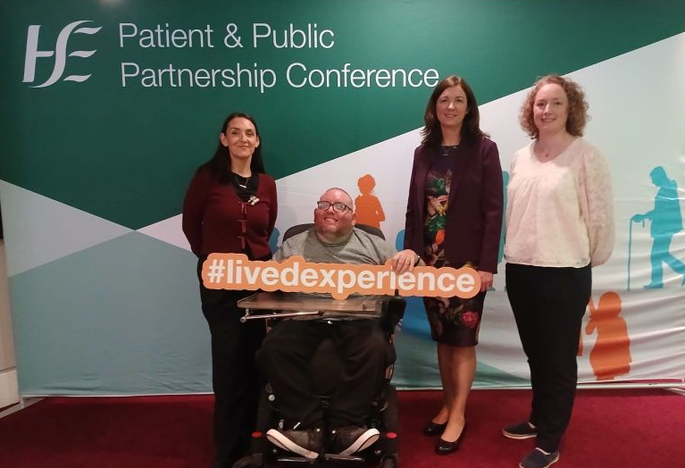
In a novel development for the HSE the NDA has also supported the inclusion of assessors with lived experience on the monitoring teams. This involved recruiting and training people who attend day services to take part in monitoring of other centres. This approach has been shared widely through presentations at conferences and a podcast.
Feedback from the first phase of the trial was gathered from people supported, assessors and service providers and will be used to inform improvements to the second and third phases in 2026. An evaluation report on the third phase will be conducted by the NDA in 2026. The NDA continues to support the HSE to examine approaches that will embed this monitoring system in existing HSE systems in the future.

Provide advice and guidance to engage with public bodies as a critical friend in order to achieve improvements

Commissioning disability and autism training
Action 6 of the Autism Innovation Strategy is the development of a coherent good practice guidance document that provides a neuro-affirmative approach to autism training in the public sector. This action was assigned to the NDA. In discussion with DCDE it was agreed that in addition to a guidance document focused on autism training the NDA would also develop a general disability training guidance document, updating a previous NDA publication from 2005. The aim of these documents is to support public sector commissioners of disability and autism training to procure appropriate training for their staff, based on good practice. DPOs were invited to consult on the content of the documents prior to drafting and to provide feedback on the version approved by the Authority. Feedback was also sought from a selection of public bodies.
A key point highlighted by DPOs was that training be delivered by people with lived experience. These guidance documents outline how this can be done in line with public sector procurement practices, noting that this may not always be possible. They also emphasised the requirement that the training needs to be equality focused and go beyond simple awareness training. The documents reflect the significant legislative and policy changes since 2005 including WAD, EAA, UNCRPD, Public Sector Duty, as well as developments in language around disability and autism.
The documents cover the purpose, type and delivery of training as well as evaluation of the training. The separate disability and autism guidance was published in early 2026. It is intended that they complement a public body’s own internal policies and goals, and that they can be used alongside the NDA’s revised eLearning Module on Disability Awareness Training published in early 2026.

Guidance for Justice Professionals
The NDA published an updated version of its Guidance for justice professionals on effectively communicating with autistic people during 2025. This work updates original guidance from 2018 and implements action 57 in the Autism Innovation Strategy 2024–2026.
The document provides guidance to those working in the civil and criminal justice system on how to effectively communicate with and support autistic people who they may meet or engage with during their work. This includes members of An Garda Síochána and officials working in the Courts Service, the Irish Prison Service and the Probation Service, as well as the judiciary and members of the legal profession such as solicitors and barristers.
The NDA consulted with several organisations, including organisations supporting and advocating on behalf of autistic people, public bodies and experts in the development of the updated guide. It also contains real-life examples and personal accounts by autistic people, family members and justice professionals in Ireland.

Inclusive workplaces for Autistic People
As part of Action 32 of the Autism Innovation Strategy the NDA developed A review of available resources to support employers to create autism-friendly workplaces. It lists existing training, publications, supports, services and other resources, as well as identifying gaps that may exist that are relevant to supporting autistic people and their employers in the workplace. Most of these resources are also relevant to supporting neurodivergent employees.
A review of available resources to support employers to create autism-friendly workplaces
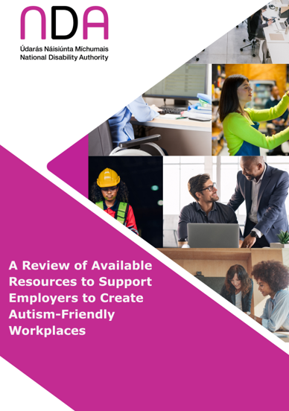
The NDA consulted with several organisations in the development of this review, including DPOs, organisations supporting and advocating on behalf of autistic people, employer groups and experts.

Strategic Priority 3
“Continue to promote adoption and application of a Universal Design approach across all sectors”

Continue to build awareness and understanding of Universal Design and its underpinning principles and guidelines

Age Friendly Ireland training on Age Friendly Housing and Public Realm
The Centre for Excellence in Universal Design (CEUD) which is part of the National Disability Authority partnered with Age Friendly Ireland to provide training to housing practitioners who assist with the delivery of social housing delivery for local government. The training took the form of two workshops with the CEUD contributing training on Universal Design, including the Internal Layout Checklist for Universal Design Homes. These training sessions were to inform local authority professionals on the value of applying Universal Design along with the supporting guidance that was co-developed by CEUD and Age friendly Ireland.

Walkability Audit Reports
In 2025, the CEUD team in collaboration with Age Friendly Ireland (AFI) analysed and synthesised 48 walkability audit reports that were conducted by AFI involving people with disabilities, older people across the country. The Results highlighted the positive experiences as well as the barriers that people encounter in their local communities. The final report was approved by both AFI and the NDA Board and published in March 2025.

AccessibleEU Events
AccessibleEU is one of the flagship initiatives proposed by the European Commission Strategy for the Rights of Persons with Disabilities 2021-2030. It is a resource Centre on accessibility working on areas such as built environment, transport, information and communication technologies to ensure the participation of persons with disabilities in all areas of life on equal basis with others. As part of their obligations as Ireland’s National Expert in the AccessibleEU consortium, CEUD have run three events during 2025 to promote Universal Design and engagement.
AccessibleEU logo
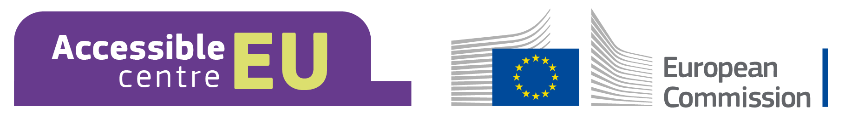

Event One:
In June, CEUD, in association with the University of Galway and the AccessibleEU, ran a workshop which included three interactive panel discussions. This in-person event took place at the University of Galway campus as a pre-conference event of the European Access Network (EAN) Conference. This workshop called for Universal Design as a required leadership competency, embedding UD in research funding criteria, creating fun, empowering, and non-tokenistic experiences and a strong emphasis on shared responsibility and system-level coordination across institutions, government, and civil society. A key part of this event was a ‘student panel’, which captured the lived experiences of students with disabilities, in the course of navigating all aspects of student life.
L-R, Donal Fitzpatrick (NDA), Naomi Oldenburg (QQI), Prof. Ciara Meehan (University of Galway) and Prof. Klaus Miesenberger (University of Linz).
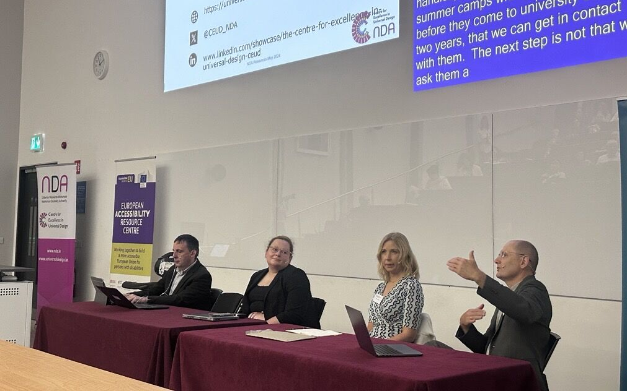
Overall themes and takeaways from the event included:
- Universal Design is people-centred: It benefits everyone and should not be seen as burdensome.
- Meaningful inclusion requires leadership, policy integration, funding, and awareness training.
- Students are experts in their own experience: involving them meaningfully creates better outcomes for all.
- Assessment reform and flexible delivery models support a more diverse student body and reduce anxiety.
- Transition planning to and from university life, especially into employment, remains a major gap.
Over 90 participants from a wide range of educational institutions attended, including participation from students from University of Galway, UCC and TCD, along with national organisations such as QQI.

Event two:
In June, CEUD, in collaboration with AHEAD and AccessibleEU, delivered a two-hour workshop entitled ‘The European Accessibility Act is here: What is it and What do I do Now?’
This event outlined what the European Accessibility Act (EAA) is all about. The workshop was opened by Inmaculada Placencia Porrero from the EU Commission, who had led the development of the legislation. There was also input from Irish government officials, regulators, and a User Experience Panel.
Objectives of the workshop were:
- To bring together diverse stakeholders who offered differing perspectives on the EAA.
- To highlight the barriers faced by persons with disabilities, and to show how the EAA will help to overcome them.
- To showcase information and guidance developed by CEUD which is available to help understand the EAA, including its accessibility requirements.
Webinar ‘The European Accessibility Act is here: What is it and What do I do Now?’
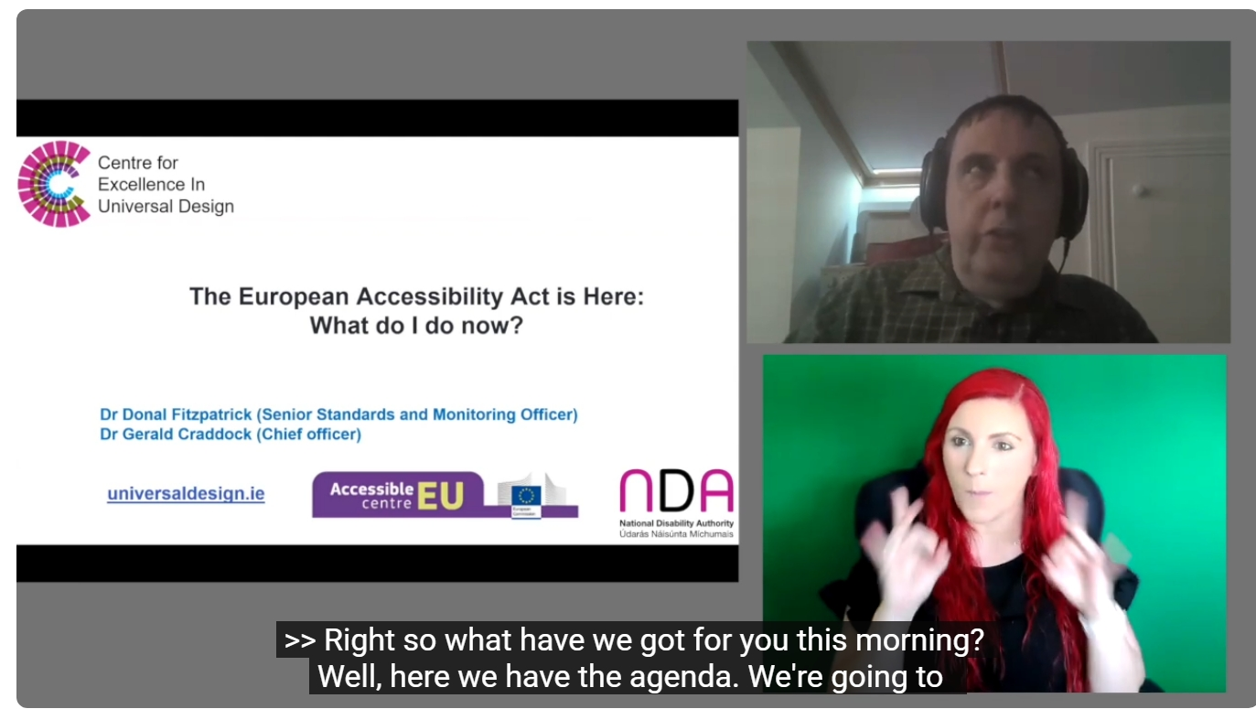
There were approximately 200 participants who attended this hybrid event. Participants were predominantly from Ireland but also many from across the EU.

Event three:
The Universally Designed Homes: Housing for all conference, organised by the Irish Wheelchair Association (IWA), CEUD, Irish Council for Social Housing (ICSH) and Age Friendly Ireland, was held on the 1st of December at the Gibson Hotel in Dublin.
The goals of the conference were to promote greater awareness of the importance of universally designed housing. Key stakeholders and people with lived experience of disability came together to explore and discuss solutions for the enhanced delivery of homes that enable people with disabilities to live independently.
It sought to highlight the importance of Universal Design in creating homes that are accessible, adaptable, safe, and welcoming for people of all ages and abilities.
The goals of the conference included:
- National Awareness and Engagement: Greater public and stakeholder awareness of both the need for and importance of providing Universally Designed homes
- Strengthen collaboration between government departments, local authorities, housing providers and DPOs.
- Enhanced knowledge among professionals (architects, planners, developers) about Universal Design and its practical application.
- Greater recognition of lived experience as central to housing design and policy formulation.
A post conference report will be published and distributed in February 2026.
L-R: Fíonnadh McGonigle (CEUD - NDA), Jean Coleman (IWA), Declan Gaffney (Age Friendly Ireland) and Catherine McGillycuddy (ICSH) at the ‘Universally Designed Homes: Housing for all’ conference
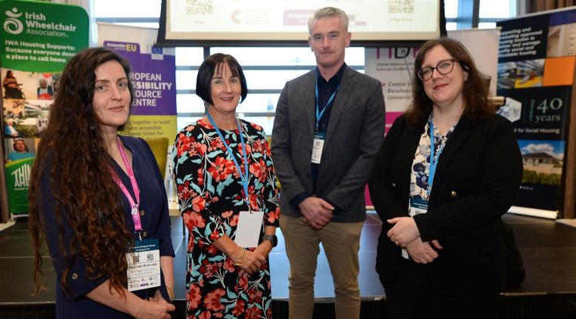

European Access Network (EAN) Conference Galway 10-11th of June 2025
The EAN Conference 2025 was hosted by the University of Galway Access Centre and the Office of the Dean of Students in partnership with CEUD and supported by the Office of the Vice President for Equality Diversity and Inclusion (EDI).
The key aim of the European Access Network (EAN) Conference 2025 was to bring together three highly related communities with shared aims which could benefit from better alignment - the access and widening participation community, the universal design community and the higher education pedagogy and practice community. A further aim was to centre the voices of students from under-represented groups in all aspects of the conference.
The theme of the EAN Conference 2025 was Inclusion by Design, with three inter-related sub-themes:
- Universal Design in Education
- Collaboration and partnerships in widening participation
- Identity and belonging in higher education
L-R: Larry McNutt and Gerald Craddock (CEUD-NDA) at the European Access Network (EAN) Conference
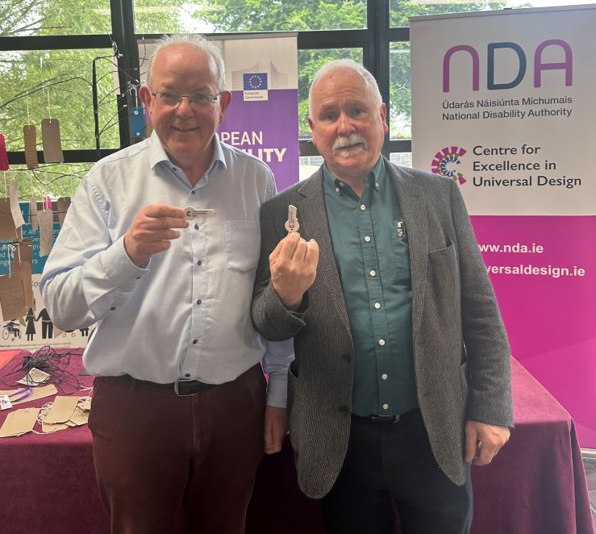
There were over 250 participants at the two-day conference. CEUD also had an exhibition stand over the two days.

Encourage application of Universal Design and build capacity for innovation and creativity in key sectors through engagement with professional bodies and in particular inclusion across the various levels of education

Cost Benefit Analysis of Universal Design Homes
In 2025, the NDA appointed Indecon Economic and Strategic Consultants to complete a cost benefit analysis of Universal Design Homes, following a competitive tender process. This work is being carried out under Action 1.5.5 of the National Housing Strategy for Disabled People 2022-2027 Implementation Plan.
The NDA continued work on a number of inputs into the cost benefit analysis including a cost review of Universal Design Homes in partnership with the SCSI and a series of site density case studies assessing the impact of incorporating Universal Design Homes as a percentage of dwellings in new housing developments.
Two meetings of the project Technical Advisory Group were held in 2025. The NDA also engaged with the Department of Housing, Local Government and Heritage in response to its request for revisions to the methodology proposed for the cost benefit analysis. This work is due for completion in Q3 of 2026.

Embed Universal Design concepts in practice guidance documents and technical standards to support implementation of obligations regarding accessibility and inclusion

EAA Harmonized Standards
Harmonised standards are European standards created by recognised European Standards Organisations such as CEN, CENELEC, or ETSI, following a request from the European Commission. They serve as practical guidelines or “blueprints” that manufacturers and other economic operators can use to show that their products, services, or processes meet the essential requirements of EU directives or regulations. When a product complies with the relevant harmonised standards, it is presumed to conform to the applicable EU legislation, simplifying regulatory compliance. Harmonised standards help reduce trade barriers, ensure product safety and quality, and provide a common framework for compliance across the EU. They also facilitate market access by giving manufacturers a clear, recognised path to demonstrate conformity with EU law.
NDA staff members are working on the Non-digital Information Standard and Support Service Standard, both of which will be harmonised under the EAA as a compliance pathway for select accessibility requirements. The EAA team have been engaging with committee members to provide comments on both these standards in 2025 and will continue this work in 2026.

Update on new NSAI standard, Universal Design Dwellings, requirements and recommendations
CEUD chairs the NSAI Working group to develop the new Irish standard “Universal Design: Dwellings, requirements and recommendations”.
The Department of Housing, Local Government and Heritage (DHLGH) suggested a need to carry out a “gap analysis” against all Technical Guidance documents. Comments are currently being resolved and reviewed with DHLGH. It is intended to issue a revised draft document to the working group at the end of Q1 2026 to seek approval from the Working group to issue the draft document for public enquiry. The aim is for the standard to be completed and published in Q3/4 2026.

Guide and advise on Universal Design of technological solutions to foster inclusive and sustainable communities

NDA submission to National Council for Curriculum and Assessment (NCCA) on the Background Paper and brief for the Leaving Certificate in Design and Communication Graphics
NCCA held a consultation in quarter one 2025 on the background paper and brief they developed ahead of the work on curriculum development for the Leaving Certificate in Design and Communications Graphics (DCG). The brief contained high level considerations for the Development Group to consider when they undertake work on the curriculum, including models of similar curricula in other countries.
NDA completed a submission that emphasized the essential nature of Universal Design (UD) in design education and in the design field, as a key point in the background paper was that the curriculum for the DCG Leaving Certificate should distinguish essential and non-essential components. The submission also advocated for the incorporation of Universal Design in Education (UDE) and Universal Design Learning (UDL) in the administration of the curriculum.

BT Young Scientist and Technology Exhibition 2025
The Centre for Excellence in Universal Design (CEUD) hosted a stand at the BT Young Scientist and Technology Exhibition in January 2025 at the RDS in Dublin.
Over the three days CEUD ran a game at the stand called the Connected Game. This game challenged students to connect a USC, a USB and headphone jack into a device while not being able to view the device or the cables as they were in a closed box. Before playing this game staff explained to students the importance of designing devices/ cables that can be accessed, understood and used regardless of a person's age, size, ability or disability.
Students get involved at the CEUD stand at BTYSE
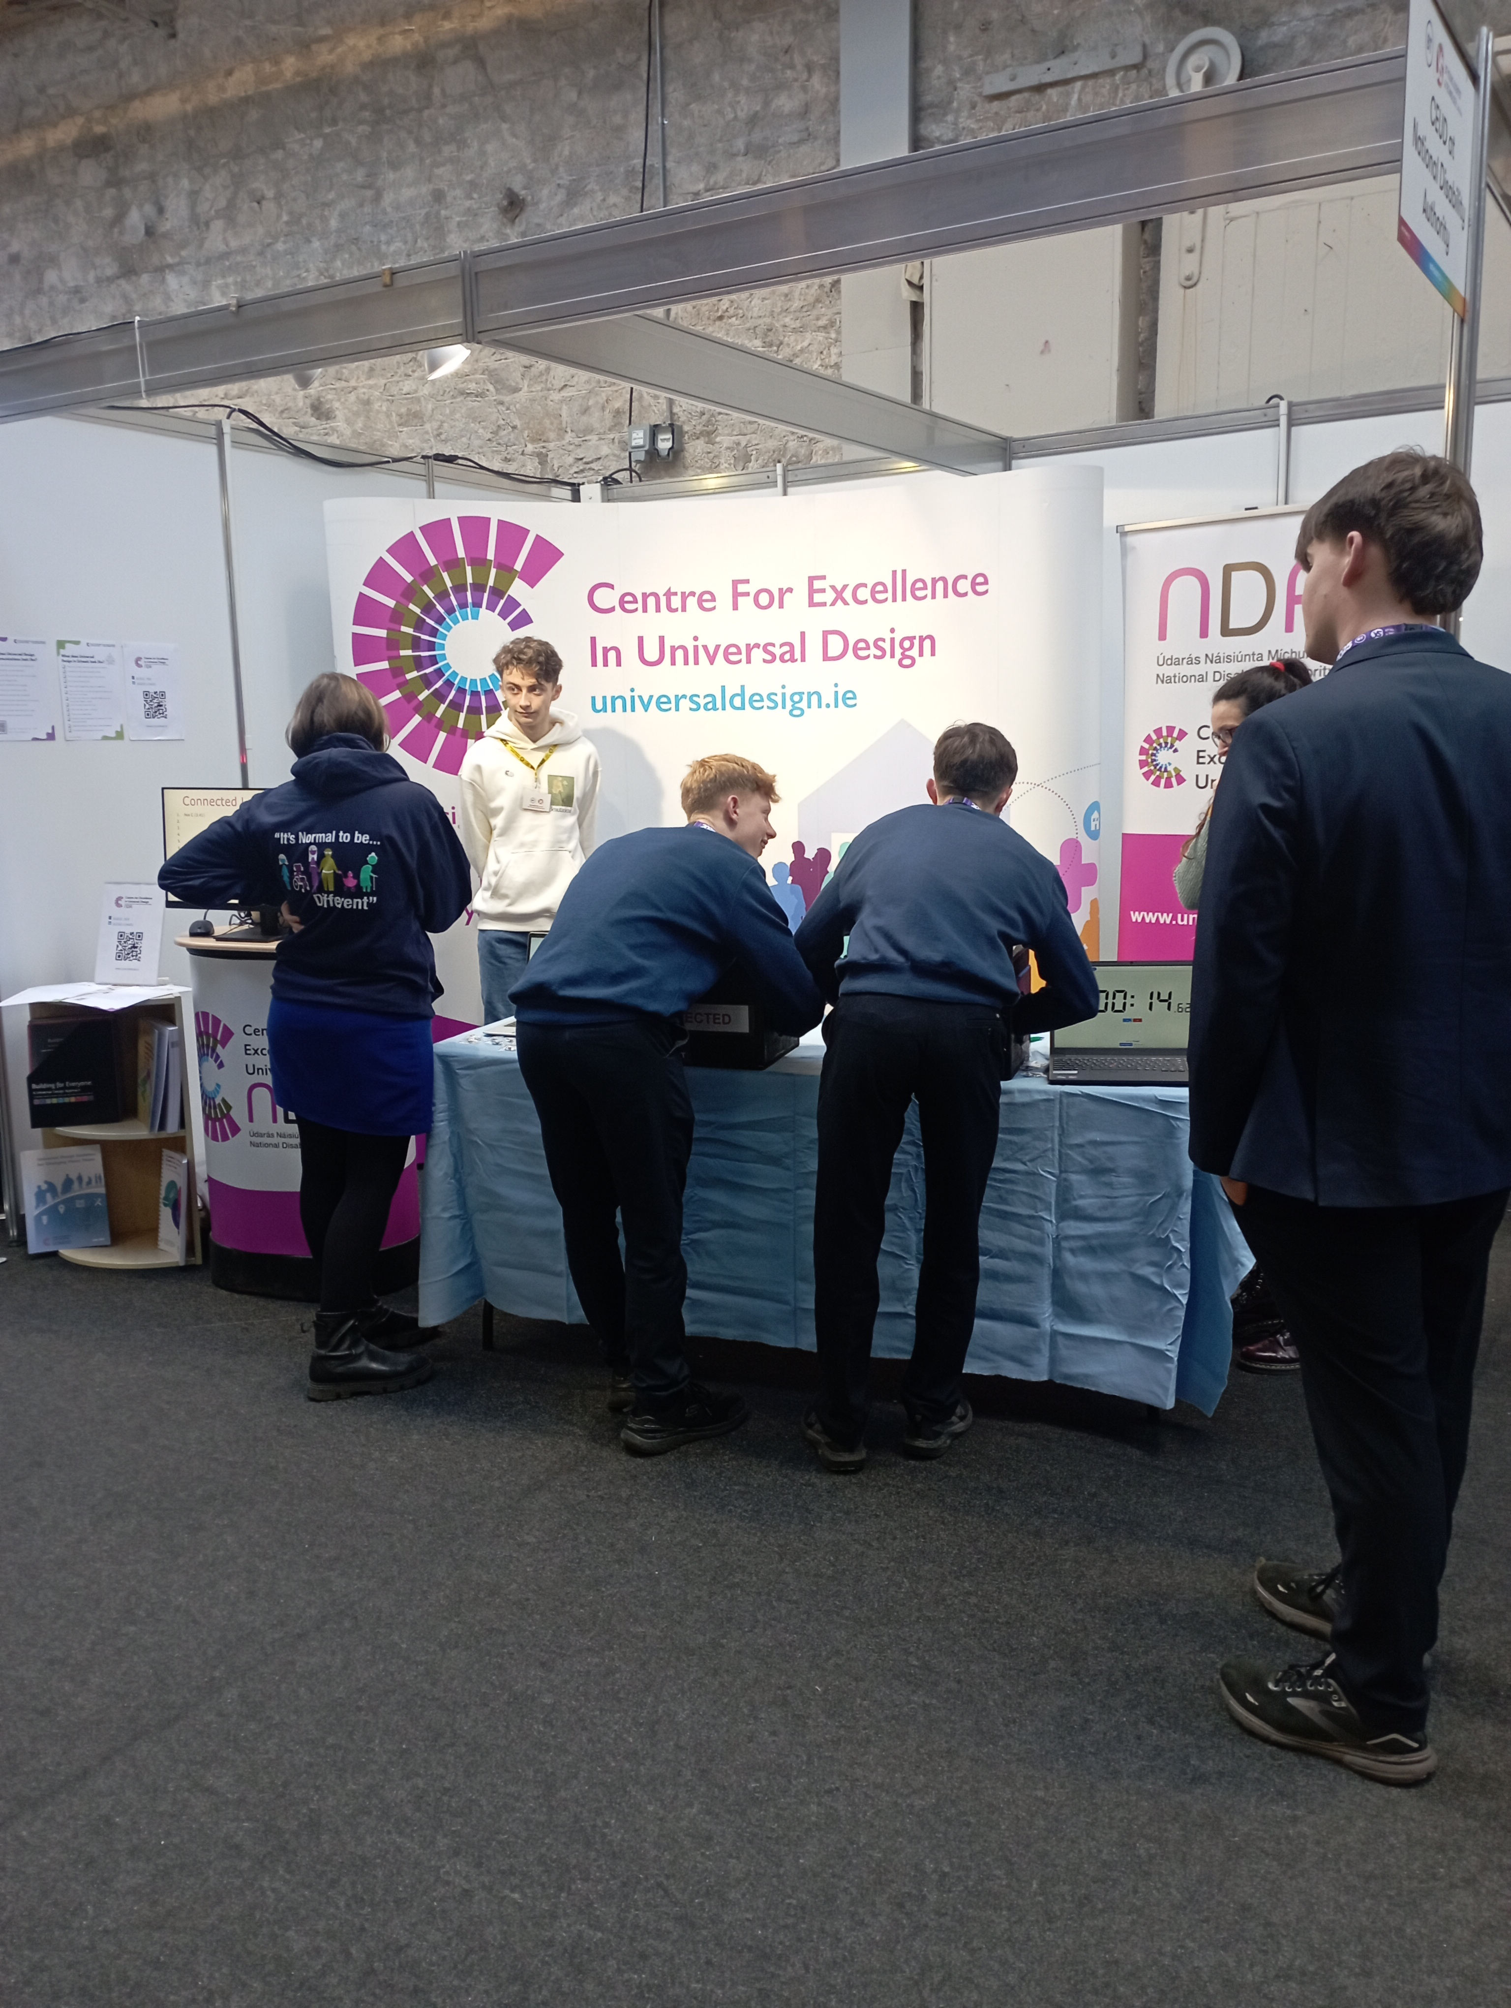
There was also positive engagement with other stands holders and teachers who wanted to know more about Universal Design. CEUD had a number of their Universal Design guidance documents on display, and this year had also designed two checklists that students could use. These checklists gave an overview of how students might identify Universal Design in their school building or in their written, spoken or signed communications.
The National Disability Authority also sponsors a Special Award at the exhibition. This award was won by Dana Carney from Mount St Michael Secondary School in Claremorris, Co. Mayo. She won the award for her project 'Secure Hands: Enhancing the efficiency in emergency communications through Irish Sign Language (ISL) in Ireland through the integration of Machine Learning in a mobile app'. Dana later in Q1 presented her project at a lunch and learn session to NDA staff. Dana plans to continue to develop the project and submit it for the Young Scientist 2026 competition.
Dana presents her award-winning project to NDA staff
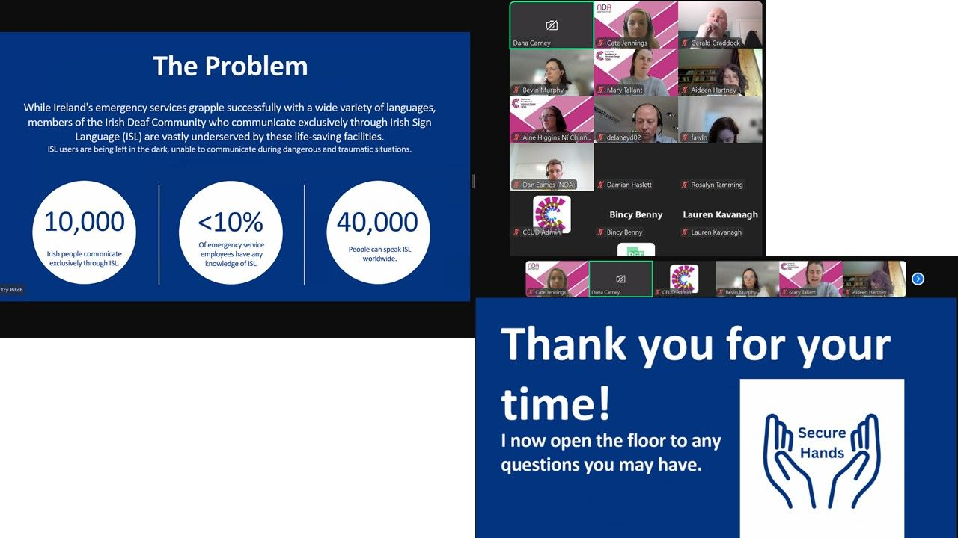

Universal Design Grand Challenge Student Awards 2025
On Thursday 25 September, students from Higher Education Institutions across Ireland presented their projects at the Universal Design Grand Challenge Student Awards which took place at the Aviva Stadium, Dublin.
Universal Design Grand Challenge finalists on stage
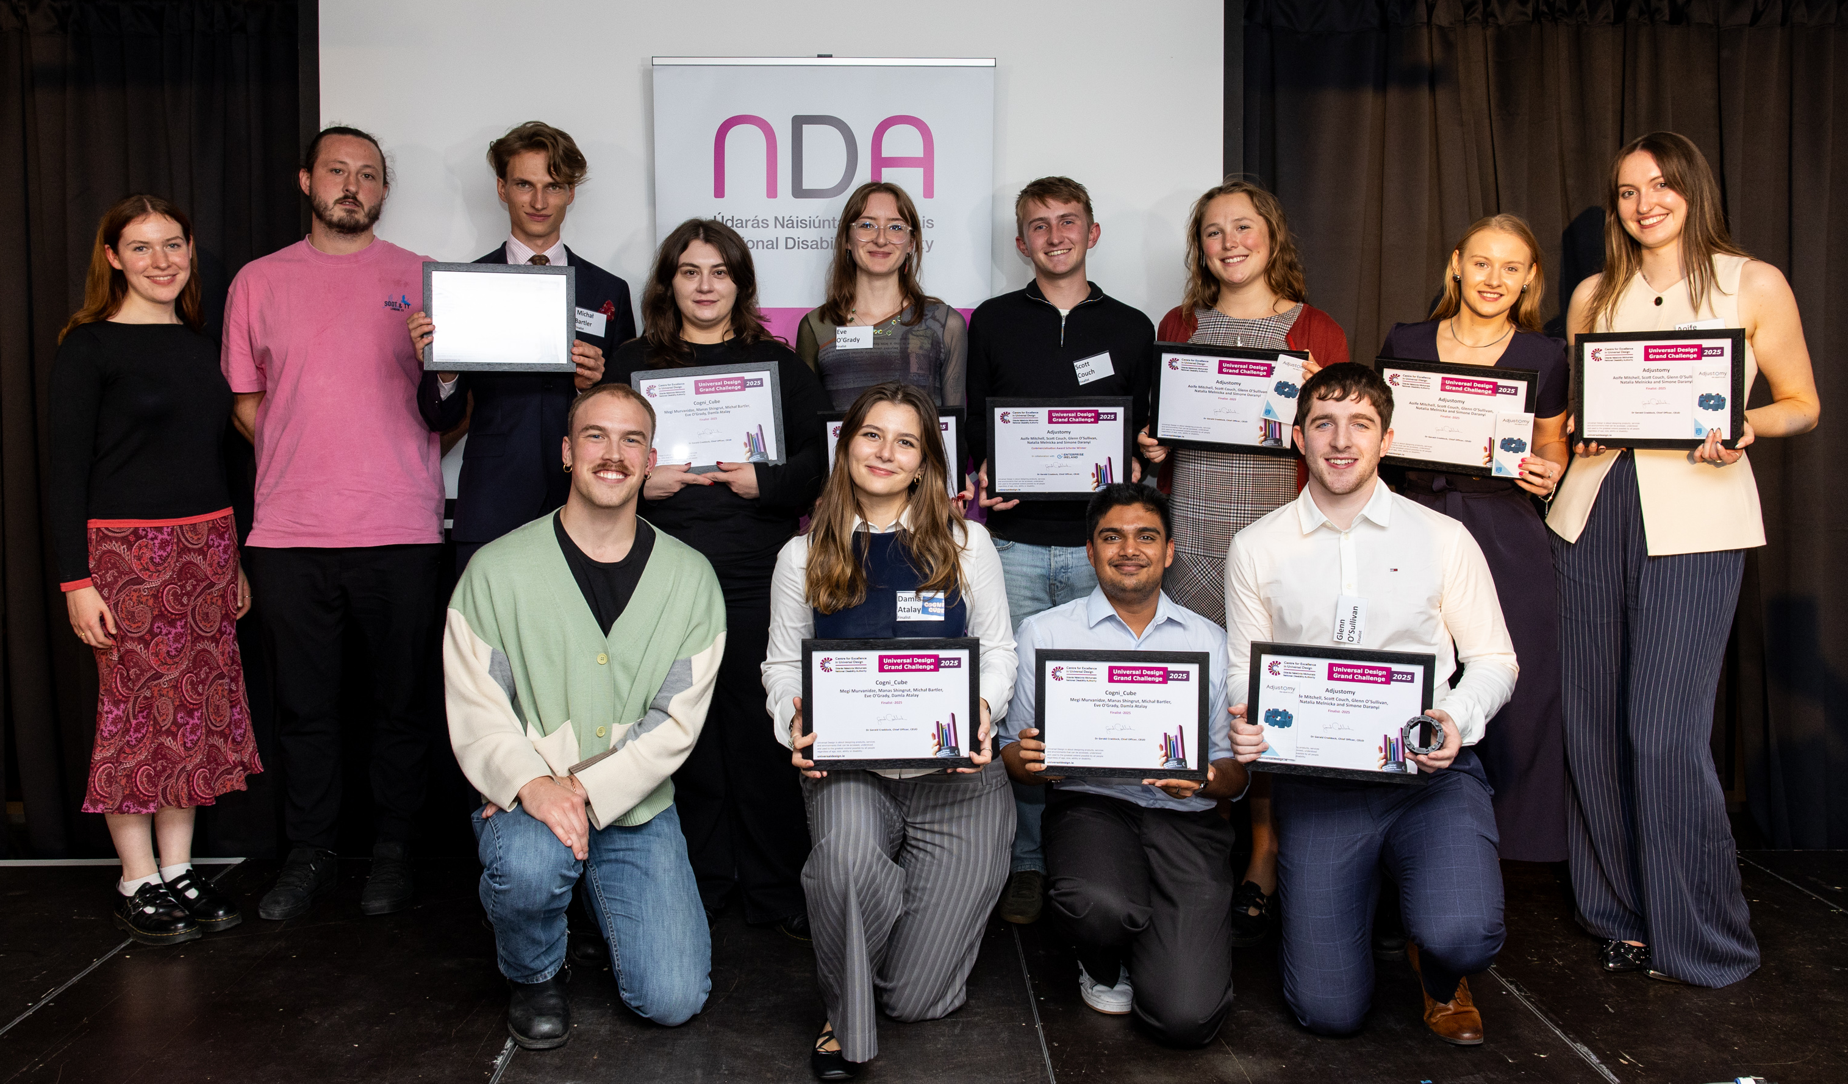
Finalists, judges and key stakeholders were invited to the annual networking portion of the event, ‘Meet the Finalists’, which allowed the students to present their projects in more details featuring prototypes, information booklets and presentations for attendees to interact with up-close and ask questions.
- Amy Byrne from Technological University Dublin received the Built Environment Award for her project Flúirse, a Mental Health and Wellness Centre in Bettystown, Co. Meath.
- The ICT Award went to Shannon Aisling Forde from Munster Technological University for Active Ease, a digital platform designed to help individuals with severe mental illness engage in physical activity independently.
- Leah Shanahan from the School of Design, University of Limerick, won the award in the Product & Services category for her project AMY, a pregnancy test designed to be accessible to all through a three-senses approach, touch, sight, and sound.
- The People’s Choice Award was also won be Leah Shanahan with her project AMY, making her a double winner on the night!
- The Commercialisation Award went to AdjustOmy, created by Aoife Mitchell, Scott Couch, Glenn O’Sullivan, Natalia Melnicka and Simone Daranyi from Biomedical Engineering, Trinity College Dublin. Their first-of-its-kind tool integrates both measuring and cutting of ostomy bags into one simple, accessible device.
Keynote speaker Kevin Horan, Head of Design at HSE Digital gave a presentation on the new HSE App and Universal Design in HSE Digital.
Kevin Horan (HSE Digital), Dan Eames (CEUD- NDA), Gerald Craddock (CEUD – NDA)
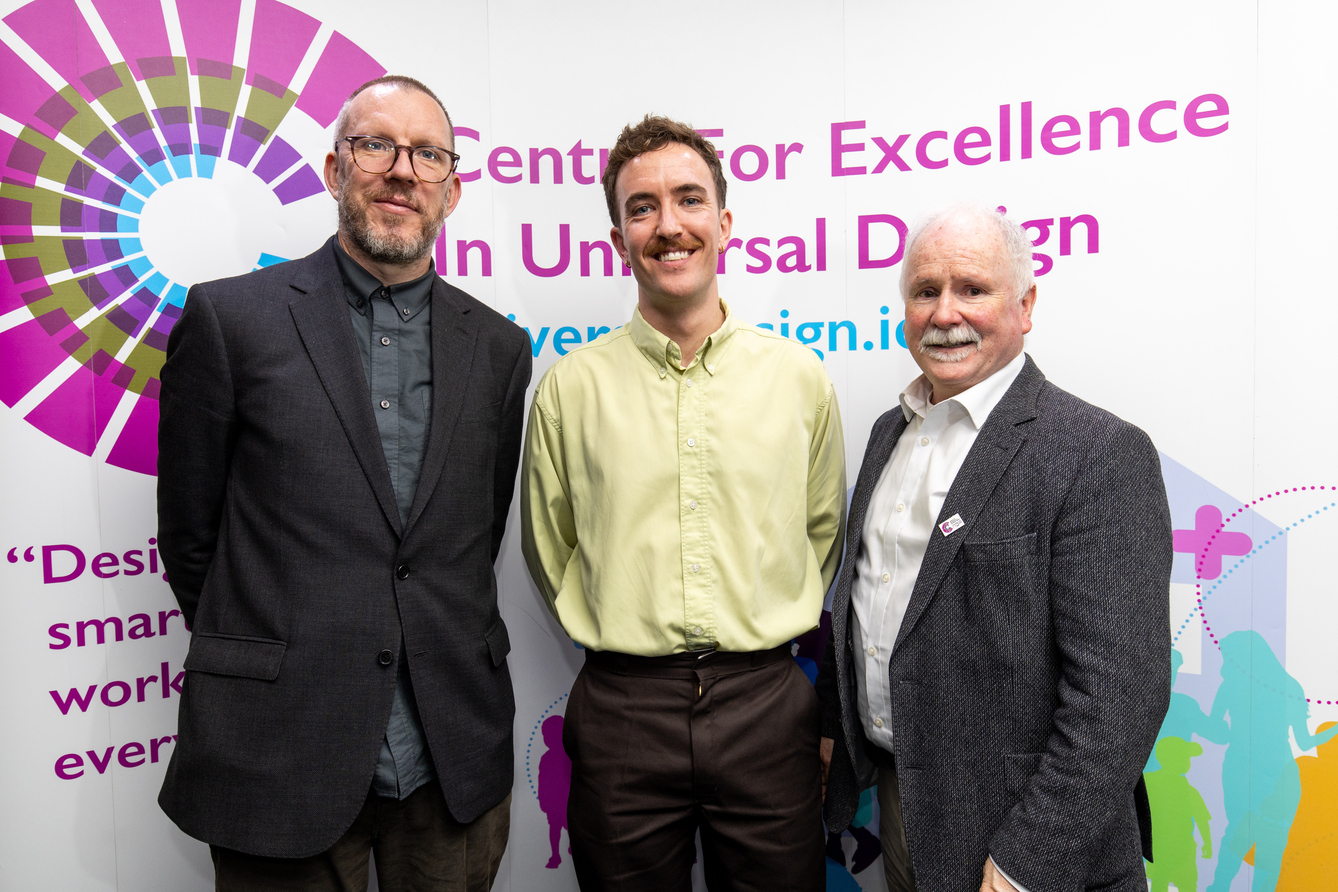

Institute of Designers Ireland (IDI) Graduate Awards
CEUD has a partnership with the Institute of Designers in Ireland (IDI) to promote Universal Design among the design community. CEUD awards a ‘Universal Design Award’ to a student designer in the IDI Graduate Design Awards each year. In 2025, the IDI Graduate Design Awards took place in October at The Architecture Factory at Munster Technological University, Cork.
CEUD judges reviewed over 170 design entries to the Universal Design category. These entries were divided between Built Environment, ICT and Product and Services.
This year the judges choose ‘Optimising Design Tokens for Accessibility in User Interface (UI) Design’ as the winner of the UD award. This project exemplified Universal Design by embedding accessibility into the foundation of a design system. Design tokens are optimised in such a way that makes accessible design choices intuitive and empowers designers to confidently create inclusive experiences. Naming conventions are clear, and visual documentation and various methods of onboarding resources all reduce barriers to understanding. Usability testing has confirmed ease of learning and measurable accessibility outcomes.

Create III
CEUD was represented on the assessing panel for HSE’s Cooperative Real Engagement for Assistive Technology Enhancement (CREATE) initiative. CEUD’s Senior Digital Design Advisor was part of the assessment team and attended a review session at HSE’s Dr Steevens Hospital to assess applications for grants of €75,000–€200,000. The criteria were for projects which design, demonstrate and implement good assistive technology service delivery, and/or create accessible digital education, training and resource hubs for all projects. The results were forwarded to the Minister for final sign off.

RIAI Universal Design Awards
CEUD has been supporting the RIAI to run the Universal Design category in its annual award scheme since 2013. The Universal Design task force committee nominated one member to sit on the main jury for the awards. This work included short-listing and visiting buildings, and inputting into the decisions on awards in all categories. CEUD’s Senior Built Environment Design Advisor was nominated to chair the UD sub-jury for 2025. This work included visiting short-listed buildings and inputting into the subgroup decision on the Universal Design category award. This year’s winner of the RIAI Universal Design Award was Hall Black Douglas architects for The Monaghan Peace Campus.
Monaghan Peace Campus, RIAI Universal Design Award winner for Hall Black Douglas architects


eGovernment & Spider Awards
CEUD were part of the judging and award ceremony of the Irish eGovernment Awards 2025 which was held in UCD in September. The winner of this year’s Universal Design & Inclusion Award was the Technological University of the Shannon (TUS) with their project ‘TUS – Universal Access – Unlocked Potential’ which embeds Universal Design for Learning (UDL) principles into the core of its Careers & Employability services.
L-R: Trish Bourke and Aoife Prendergast, Technological University of the Shannon (TUS), winner of the eGovernment Universal Design & Inclusion Award, and Dr. Gerald Craddock (CEUD).
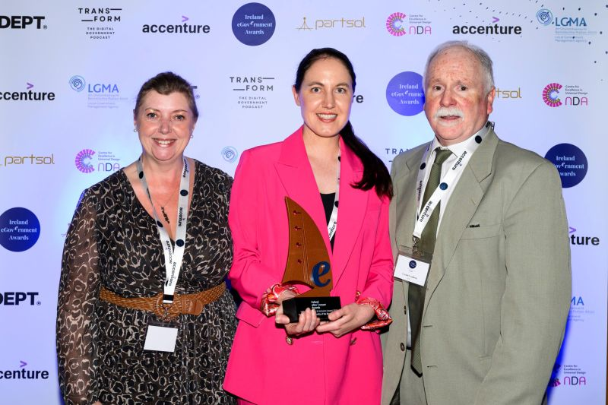
CEUD similarly collaborated with the Spider Awards for digital marketing where the ‘Best in Universal Design Award’ went to Kooba for the website they created for South East Technological University (SETU) in which accessibility and universal design were priorities from the outset.

Big Idea UD School of the Year Award
The B!g Idea is a creative education programme for students in Transition Year and Leaving Cert Applied. Students work in teams to respond to one of five socially conscious project briefs while also developing key skills in critical and creative thinking, collaboration, and communication. Since 2021, CEUD has collaborated with the B!g Idea to integrate the Principles of Universal Design (UD) into this programme.
This year CEUD collaborated with B!g Idea on the UD School of the Year award. This award recognised the school that promoted a UD Approach to their students and whose students have submitted projects that demonstrated good practice in UD.
B!g Idea showcase 2025
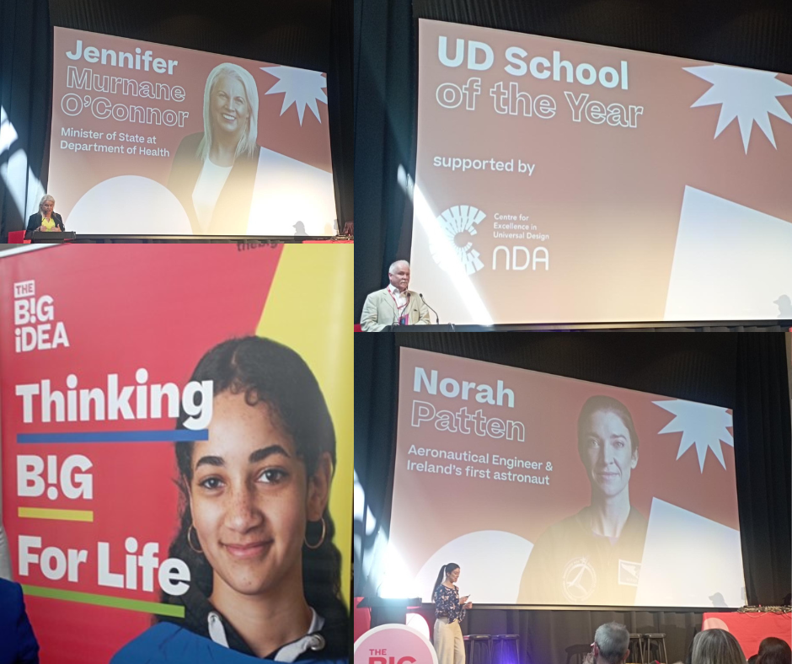
The winner of this award was Castletroy College from Limerick. They completed a number of projects through the B!g Idea programme where they applied a Universal Design Approach to their projects and they engaged with a number of diverse users’ groups both in and outside of their school community. Feedback from the school teachers and pupils was very positive on how they see Universal Design as part of their ongoing education.

JAI UD School of the Year award 2025
Since 2019, CEUD have collaborated with Junior Achievement Ireland (JAI) to integrate Universal Design (UD) into their Power of Design (POD) programme. The POD programme explores what design is and why it is important along with an exploration of careers in design. The UD part of POD is based on the CEUD video called Meet the Normals.
This year CEUD collaborated with JAI on the UD School of the Year award. This award recognised the school that promoted a UD Approach to their students and whose students have submitted a project that demonstrated good practice in UD and accessibility.
The winner of this award was St. Laurence O’ Toole’s National School, in Dublin 1. They submitted a project made up of both graphical representation along with quotes from the students about making the beach more accessible for diverse users. They considered how different design features could make the beach more accessible and usable by different users.
Winning entry from students in St. Laurence O’ Toole’s National School
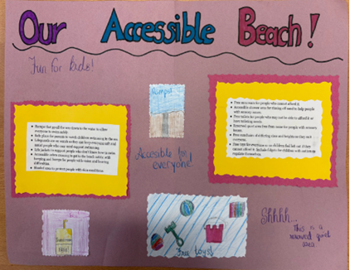

Internal Layout Checklist for Universal Design Homes
In partnership with Age Friendly Ireland, the NDA’s CEUD has published an Internal Layout Checklist for Universal Design Homes. The checklist is a summary of guidelines from the Universal Design Guidelines for Homes in Ireland that impact on the internal layout of dwellings. It is provided as a tool for designers to ensure that Universal Design is considered at the early stages of housing design. Five example floor plans are provided with the checklist, to demonstrate the checklist being applied in both UD Home and UD Home+ dwellings.

EASPD Webinar: Understanding universal design in digital education
In November, CEUD’s Education Design Advisor, delivered a webinar with the European Association of Service Providers for Persons with Disabilities. The Accessible Digital Education (ADEDU) project hosted the webinar on how Universal Design in Education (UDE) can be applied in digital education. The CEUD input highlighted our expertise on UDE and its importance on adapting to the increasingly digitalised way of learning and teaching.

Future of AI: Powering Progress and Protecting Rights at the IHREC Annual Conference
The NDA was pleased to present as part of this important panel discussion. The topics ranged from the benefits of AI for diverse populations, to the barriers created by bias in the training data used by these systems. Furthermore, conversations took place which highlighted the intersectionality of the issues relating to persons with disabilities, and other demographics. On foot of this engagement, the NDA was subsequently invited to join IHREC’s Disability Advisory Committee’s discussion on AI. This informative event again focussed on the pros and cons of AI in respect of persons with disabilities. There was specific emphasis on the possible impacts of the European AI Act. It was observed by participants of this forum that attention needs to be directed to the implementation of this legislation in order to ensure that the voice of persons with disabilities is included.

Irish Deaf Society (IDS) Event
The NDA attended IDS launch of their new research report “Barriers to studying and working as an ISL Interpreter: Developing an evidence base in order to launch a campaign to increase the number of ISL interpreters in Ireland”. This important research, funded by the Irish Human Rights and Equality Grant Scheme, explores the challenges facing Irish Sign Language interpreters and sets out an evidence base for a national campaign to increase the number of interpreters available in Ireland. This research informed the NDA’s ISL Act report.

Webinar Series on Universal Design in the Built Environment
CEUD provided a webinar series on Universal Design in the Built Environment in September and October 2025. In partnership with the RIAI, four lunchtime webinars were hosted with different speakers. The topics and speakers were as follows:
- Designing Homes for Life: The lasting value of Universal Design on the 16 September with Fíonnadh McGonigle, Centre for Excellence in Universal Design
- Monaghan Peace Campus: RIAI Universal Design Award case study, with Alistair Beckett and Jonathan Speirs, Hall Black Douglas architects
- Designing for Every Mind: Why addressing neurodiversity is fundamental to Universal Design in architecture. with Jean Hewitt, Buro Happold
- ISO 5727:2024 Accessibility of immovable cultural heritage - Principles and methodology for interventions, with Fionnuala Rogerson, Fionnuala Rogerson Architects
The webinars were very well attended with between 60 to 110 at each one. Recordings of the webinars are available to watch on the CEUD website.
L-R: Fíonnadh McGonigle, Jonathan Speirs, Alistair Beckett, Jean Hewitt, Fionnuala Rogerson
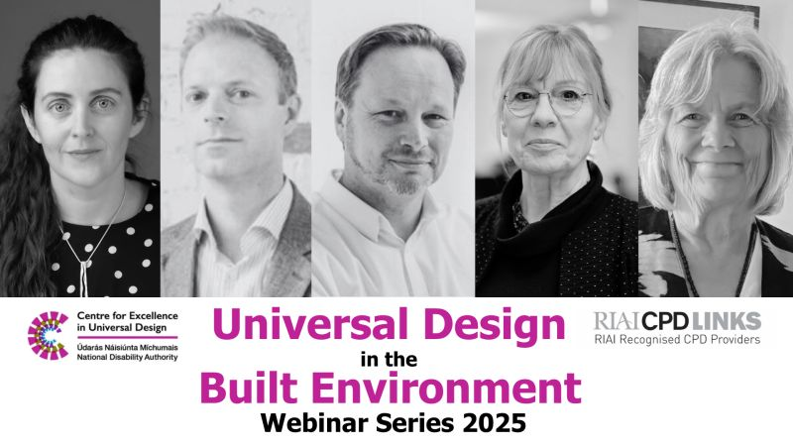

Guest lecture to Griffith College Interior Architecture Students
In October, the Senior Built Environment Design Advisor at CEUD provided a guest lecture to Interior Architecture students at Griffith College Dublin. The students were working on a project to refurbish and change the use of the building to a mixed residential and community space, with Universal Design incorporated into their project brief.

Design Sprint Workshop: AI as an Accessibility Partner
The Department of Public Expenditure, Infrastructure, Public Service Reform and Digitalisation ran Public Services Transformation Week (PSTW) in November. As part of PSTW, Senior Products & Services Design Advisor led an in-person design sprint at the NDA Office titled “AI as an Accessibility Partner” along with CEUD colleagues.
Public sector colleagues attend the ‘AI as an Accessibility Partner’ design sprint workshop as part of PSTW
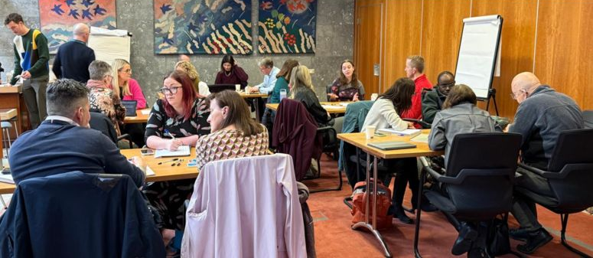
This exploratory design sprint workshop examined how AI might support in delivering accessible, equitable services – and where it may risk compromising them. Participants explored diverse user personas, real public service use cases and collaboratively shaped design principles and guardrails for AI within accessibility contexts across the public service in Ireland. Over 20 in-person participants attended this workshop. A summary report is being made available.

Places for People
The Higher Education Institutes (HEIs) as Places for People: Inclusive Infrastructures to Support Intersectionality in HEIs is a project that was established, with ‘EDI Enhancement’ funding from the Higher Education Authority, among four city-centre universities: Trinity College Dublin; University of Galway; Royal College of Surgeons Ireland; and Technological University Dublin (TU Dublin). The objective of this project is “to advance awareness and understanding of intersectionality and multi-dimensional approaches to equality, diversity and inclusion, by seeking to implement intersectionality in design and practice in planning for and shaping our built environment”. With their city-centre locations, the building stock of these universities includes heritage buildings, and this project seeks to create a network among and within the universities to share experience of addressing disability and inclusion in heritage buildings. During this project, each university is hosting a day of information-sharing and networking. The second of this series of events took place in November 2025, at which one of our Senior Standards and Monitoring Officer chaired one of the panel sessions. Presentations covered:
- the upgrading of existing library spaces
- the introduction of an audio application for use by students to hear directly from the lecturer through their personal phone and headphones
- the engagement of older people to promote their physical activity and use of the campus grounds
- the design of a new student building linking in with existing heritage buildings
- and a tour of one of the heritage buildings that was refurbished to house learning spaces for students
The project is due to run until mid-2026.

Strategic Priority 4:
“Engage strategically with our wide range of stakeholders, including disabled people through their representative organisations, to inform and enhance our advice and guidance”.

Sustain and enhance relationships with policy makers across government to guide on achieving mainstream recognition of the rights of disabled people

NDA’s introductory eLearning module on disability equality
In December 2025, the NDA completed its work to revise its eLearning module on disability equality. The objective of this module is to provide public bodies with models of good practice, developed in consultation with disabled people, to help them meet their statutory obligations to ensure that all public bodies achieve the minimum target of 5% employment of persons with disabilities by 2026; increase the recruitment and retention of disabled people and provide inclusive and accessible public services and products.
This eLearning module features the lived experience of disabled people and was developed in consultation with an advisory board, that consisted primarily of representatives from Disabled Person Organisations and disabled people. This module was also user tested by disabled people.
This module also aims to increase public bodies’ awareness about the importance of the NDA’s monitoring functions and how our advice helps public bodies to meet their statutory obligations as detailed above.
This eLearning module was launched in early 2026.

Submissions
In addition to submissions that were outlined under Strategic Priority 1 the NDA made a number of other submissions that highlighted the rights of disabled people.
Submissions were made to the consultation on the National Housing Plan emphasising the particular needs of disabled people and advising that universally designed housing is a core part of a housing plan. Two submissions to An Coimisiún Toghcháin on postering and on their new Education and Public Engagement Strategy focused on the strategies that need to be in place to consider the inclusion and safety of disabled people in the voting process. The NDA also made a submission to Ireland’s ongoing COVID-19 evaluation. This allowed us to share learnings from previous work about the impacts of COVID-19 on disabled people.

Continue to ensure NDA regularly engages with disabled people through Disabled Persons Organisations and other channels, and the wider disability community to inform our work

Someone Like Me
The ‘Someone Like Me’ art competition is an annual primary schools’ art competition organised and funded by the National Disability Authority. The competition allows Ireland’s young people to learn about inclusivity and diversity through classroom resources and express their understanding through the medium of art. The competition aims to promotes positive attitudes towards disabled people and encourages a focus on both visible and invisible disabilities.
The 2024/25 competition attracted 2,708 entries from 255 national schools across the country, and the 2024 county winners were announced at the end of 2024. The 2024/25 competition saw the introduction of a both a Junior and Senior Winner at national level, which were announced at the awards ceremony in Dublin City Hall on 22 January 2025. The event was livestreamed on the Someone Like Me website.
The overall Junior winning entry from Burgess National School, Co. Tipperary, was a large pair of glasses. Created by Junior Infants – second class pupils, the glasses aimed to highlight how we encounter both visible and invisible disabilities. Pupils also created a poster of their school to highlight its accessibility and the actions they take to be supportive to all.
The Senior winning entry was from Four Masters National School, in Co. Leitrim. Their entry, created by third class pupils, was a 3D model of Kinlough village, that celebrated the uniqueness and inclusivity of the local amenities and businesses.
Overall Junior and Senior winning entries from the 2024/25 Someone Like Me art competition
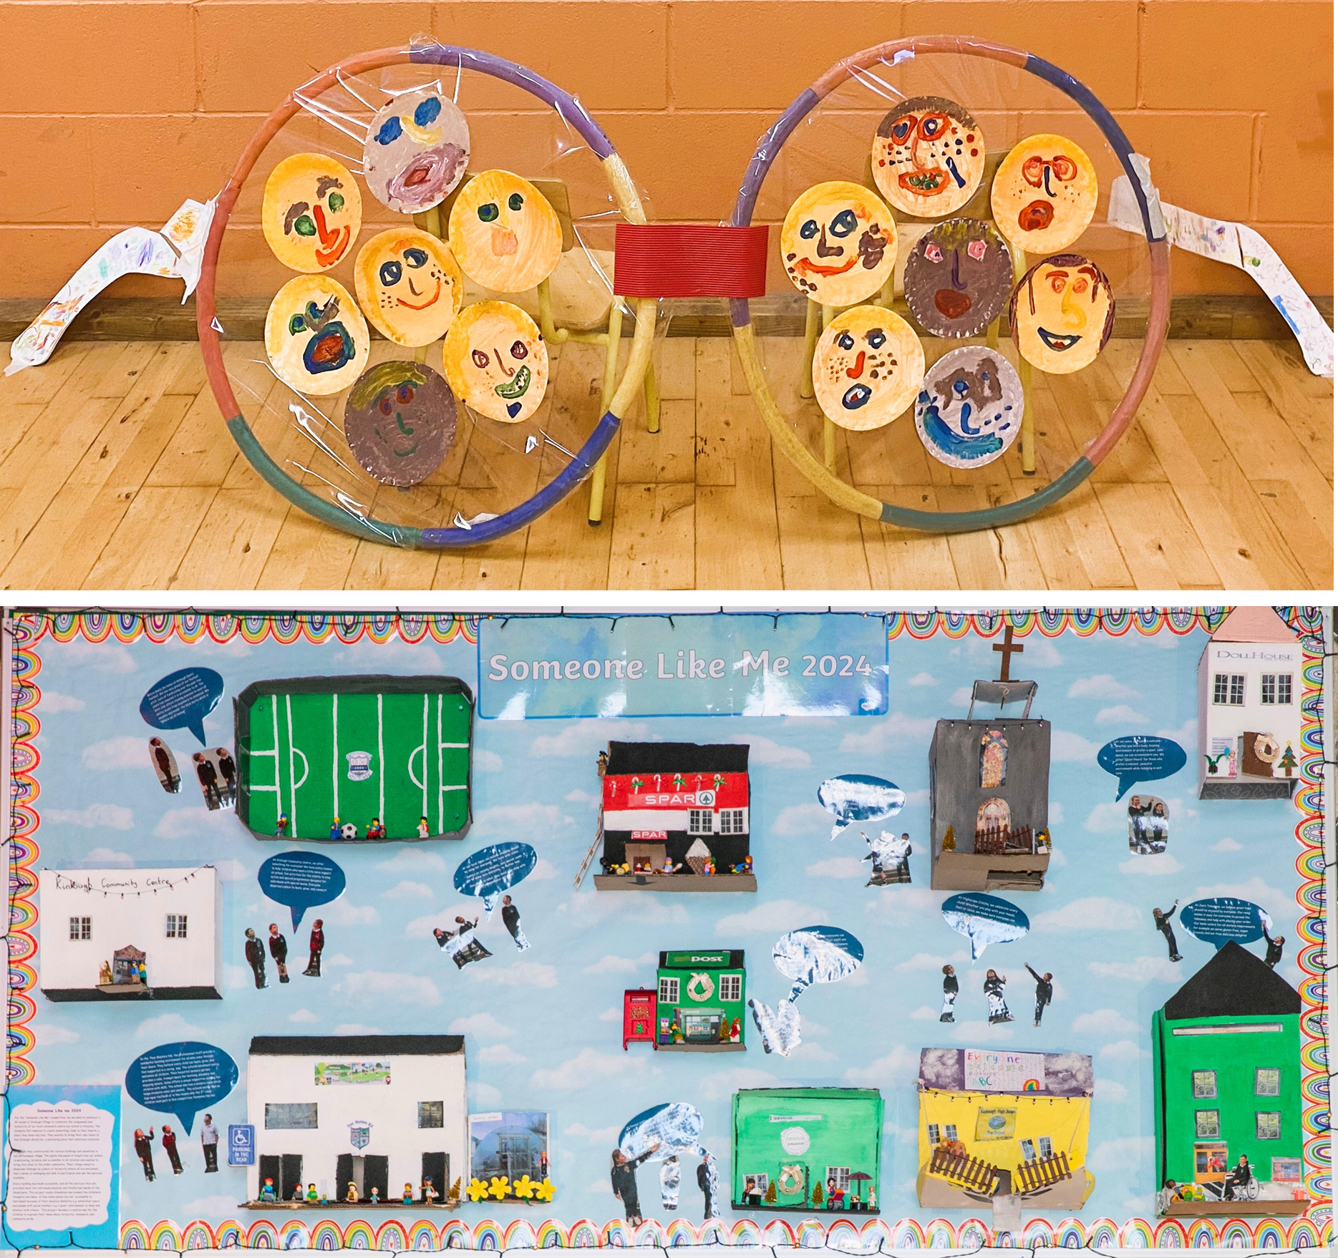
Minister Hildegarde Naughton formally launched the tenth year of the 2025/26 Someone Like Me art competition during a visit to Claddagh National School in Galway in September 2025.

Annual Conference
The NDA’s 2025 Annual Conference took place on Thursday, 16 October, in the AVIVA stadium, Dublin. The event focused on Parenting, Relationships, and Sexual & Reproductive Rights in the context of Article 23 UNCRPD. The event generated high interest, with 150 people attending the event in-person, and well over 100 participants joining online. Topics which were explored included parenting with a disability, relationships and sexuality, maternity care and sexual and reproductive health and rights.
The event featured over 20 speakers and the Minister of State with Responsibility for Disability, Hildegarde Naughton opened the conference. There were four panel discussions during the day, with a mix of national and international experts, including Jennie Williams, Founder and Chief Executive Officer of Enhance the UK, and Karen Henry, Midwife and Lecturer at the University of Suffolk. The event was very well received, with attendees highlighting the importance of building understanding and awareness of lesser-known provisions of the UNCRPD. Video recordings of the conference are available on the NDA website.
Minister Naughton addresses attendees at the annual conference
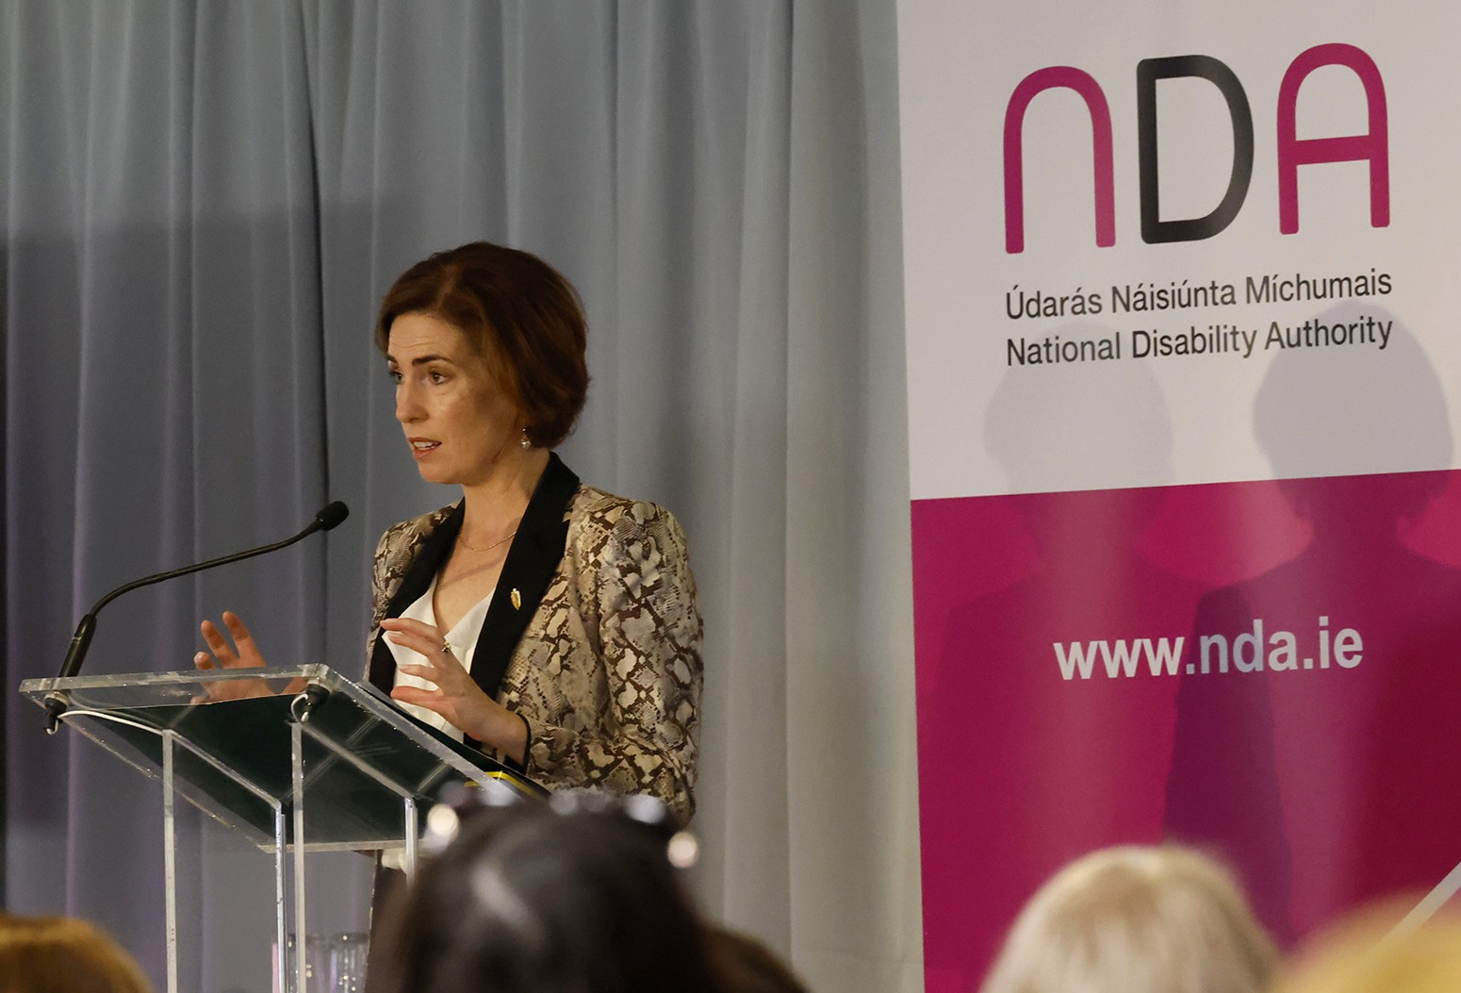

Universal Guidance on Sound Quality of Public-facing Services and Buildings
A Technical Advisory Group (TAG) was established to inform the development of a Universal Design Guidance on Sound Quality in Public Service and Buildings. Membership includes representation from As I Am, Chime, Age Friendly Ireland (AFI), Arts and Disability Ireland, Voice of Vision Impairment (VVI), National Transport Authority (NTA), HSE Estates, Local Government Management Agency (LGMA), Royal Institute of the Architects in Ireland (RIAI), Dept. of Housing and members with lived experience. We hosted the first TAG meeting in May 2025 where we presented a skeleton draft to the members and had a rich discussion about their perceptions of what would be important in the guidance, challenges faced regarding sound quality and possible solutions. The TAG will meet again in 2026 to inform progress on this guidance and a public consultation on a draft version is planned with the intention of finalising and publishing this guidance by the end of 2026.

Strategic priority 5:
“Clearly communicate the value of our work, while maintaining and enhancing organisational effectiveness”.

Staff Resources
In accordance with section 27 of the National Disability Authority Act 1999, the NDA is the employer of its staff. The Executive, led by the Director, implements the strategy, annual work plan and policies of the National Disability Authority on a day-to-day basis.
As of 31 December 2025, the National Disability Authority had 50 full-time equivalent staff. The NDA’s payroll, pension and travel and subsistence processing is provided by the Payroll Shared Service Centre of the Department of Public Expenditure and Reform. The NDA facilitates communication on key issues between management and a recognised trade union that represents NDA staff interests.
The Executive consists of three sections:
- Policy, Research and Public Affairs
- Centre for Excellence in Universal Design and Standards & Monitoring
- Corporate Services
The Heads of these three sections, reporting to the Director, comprise the Senior Leadership Team.

Senior Leadership at 31 December 2025
Director: Dr Aideen Hartney
Head of Policy, Research and Public Affairs: Dr Rosalyn Tamming
Chief Officer, Centre for Excellence in Universal Design and Standards & Monitoring: Dr Gerald Craddock
Head of Corporate Services: Ms Evelyn Moore

Training and Development
The NDA continued to roll out a training and development plan for staff informed by the Performance Development Management System (PMDS) and individual needs, which included attendance at seminars, conferences, webinars, training sessions and workshops. A number of training courses and workshops were scheduled internally for staff including:
- Moving into Management
- Interview training preparation
- Capability based interviewer training
- Leadership Development
The following is an example of some of the external training and development opportunities availed of in 2025:
- Improving Time Management and Prioritising your Workload
- CO, EO, HEO and AP Development
- Mastering Public Speaking and Presentation Skills Masterclass
- Practical Accessibility Course
- Level 1 MS Excel course
- Research with children and young people
- Project Management Masterclass
- Digital Learning Design
- Minute Taking
- Crisis Communication Masterclass
- Neurodiversity in the workplace
- Equality, Diversity and Inclusion (EDI) in Irish Workplaces Webinar
- Inclusive Approaches to Recruitment Webinar
- Tusla Children First
All new staff carried out the following training:
- NDA Disability Equality eLearning
- Protecting Data When Home Working eLearning
Health & Safety Training consisted of:
- Display Screen Equipment (DSE) Assessment
- Ergonomic Assessment
- First Aid Responder

Communications
The NDA published its Communications and Engagement Strategy 2025-2027 in May 2025. This document sets out the organisation’s overarching high-level external and internal communications objectives for the next three years and aligns communications objectives and principles with the NDA Strategic Plan 2025-2027.
Across the organisation, a total of 56 documents were published in 2025. This includes a combination of research papers, reviews, guidance documents, reports, Oireachtas statements, and public consultation submissions. These can be found on the NDA and CEUD websites and are listed in Appendix 3 and 4. In addition, a significant number of external stakeholders took the opportunity to attend one of the NDA’s ten online webinars and training sessions, one of the five in-person NDA events held, or one of the many external events the NDA partnered on.

NDA Website
The NDA website was one of the best performing websites among public body websites assessed as part of the Web Accessibility Monitoring in 2025, with an overall accessibility score of 92.13. Visitor numbers to the NDA English and Irish language websites increased by a significant 28% to 43,484 in 2025 and page views were also up.
The CEUD website received an overall accessibility score of 89.37 when assessed as part of the Web Accessibility Monitoring in 2025. Visitor numbers to the CEUD website also increased significantly in 2025, up 37% to 29,887.

Social Media
In 2025, LinkedIn was identified as the social media platform which best served the NDA’s target audience. Content was prioritised for this platform, and the result was an increase in followers and engagement across both NDA LinkedIn accounts. The NDA profile increased its followers from 4,636 in November 2024 to over 8,200 by mid-December 2025. The CEUD profile increased its followers from 671 in November 2024 to 1,325 by mid-December 2025.
The NDA has two free accounts on X. This platform was not prioritised during the second half of 2025 because engagement and views weakened across the platform. The @NDAIreland profile had 2,949 in November 2025. The @CEUD_NDA profile had 722 in November 2025.
The NDA activated a BlueSky profile on 10 July 2025 to explore this as an alternative platform to X. Engagement and interaction are low at this early stage and we will monitor whether engagement increases in the coming year.
NDA videos are hosted on YouTube and embedded on official NDA websites with both seeing an increase in the number of subscribers.

Newsletter
Four editions of the NDA Newsletter were published and circulated externally in 2025. Subscriber numbers continued to increase in 2025 from 1,250 subscribers in December 2024 to 1,632 in December 2025.

Media
There were six press releases issued externally by the NDA in 2025 covering topics including compliance with Part 5 of the Disability Act 2005, Universally Designed accessible accommodation, the NDA Annual Conference 2025, and the Universal Design Grand Challenge Awards 2025. NDA staff contributed articles to two Local Authority Times magazines in 2025 on Universal Design Homes and the European Accessibility Act. An NDA authored article on Artificial Intelligence and disability inclusion in Ireland was also published in the Business & Finance 2025 Annual.

Public Sector Duty
Implementation of the NDA’s Public Sector Equality and Human Rights Duty Action Plan 2024–2025 continued throughout the year. A list of the high-level actions contained in the Action Plan, together with an overview of the actions taken to implement these are detailed below. An updated Action Plan covering the period 2026–2027 will be published in early 2026. The intention is to realign our Public Sector Duty Action Plan and our next Strategic Plan, with preparatory work for the latter commencing in late 2026.

Action 1
Develop a consistent approach within the NDA to ensure that we apply a human rights and equality lens more explicitly to our work while maintaining a balanced approach and sound evidence informed advice. Key achievements during 2025 included:
- Ensuring intersectionality is considered in further depth in our policy advice and research work, for example through submissions on housing options for older people with disabilities, people with disabilities deprived of their liberty and disabled people experiencing social exclusion
- Publishing two new reports under our 2023-2024 Research Promotion Scheme under the theme of Disability in Marginalised Groups and Communities, including studies exploring the scale and impact of physical disability in people experiencing homelessness in Ireland and the experiences of disabled candidates who identified as holding intersecting identities and who stood in the Irish local and European elections in 2024
- Launching our 2025-2026 Research Promotion Scheme under the same theme of Disability in Marginalised Groups and Communities and awarding funding to three organisations to research the lived experiences of disabled Travellers accessing health services and housing, as well as older disabled adults experiencing homelessness

Action 2
Continue to implement the advice in the Participation Matters Guidelines in the NDA’s work and promote the use of the guidelines across the public sector. Key achievements during 2025 included:
- Inclusion of advice related to the engagement of disabled people through their representative organisations and a link to the Participation Matters report in the majority of NDA submission including to departments developing new Statements of Strategy

Action 3
Develop guidance for promoting good practice on accessibility and Universal Design for events for internal and external stakeholders. Key achievements during 2025 included:
- Commencing a scoping exercise on developing a new good practice guide on accessible and universally designed events
- Continuing to disseminate our Customer Communications Toolkit for Services to the Public to key stakeholders

Action 4
Ensure that the NDA provides a safe and accessible workspace. Key achievements during 2025 included:
- Completing building works at the NDA offices to make our working environment safer and more accessible, with accessibility upgrades including the provision of a Changing Places Toilet, improved entrance ramp and automatic front door

Action 5
Proof the existing strategic plan and our statutory duties against the Public Sector Duty and embed the Public Sector Duty in the current and subsequent strategic planning cycles. Key achievements during 2025 included:
- Incorporating human rights and equality considerations into the development of our Communications and Engagement Strategy 2025-2027, with accessible, inclusive communications identified as one of our primary communications objectives

Action 6
Review procurement guidelines specifically looking at them with a human rights and equality lens and examine the understanding of, and compliance with, universal design requirements in the procurement guidelines. Key achievements during 2025 included:
- Reviewing and amending our procurement guidelines to include accessibility as a marking criterion in all appropriate tenders

Action 7
Ensure the NDA is a welcoming safe and inclusive environment for all employees regardless of background or other characteristics. Key achievements during 2025 included:
- Organising three briefings for staff to enhance understanding of the intersectional barriers and challenges facing disabled people, with topics including intimate partner violence against disabled women, people with disabilities experiencing socio-economic disadvantage and mental health within the LGBTQI+ population with disabilities
- Reviewing and revising the NDA’s induction programme to ensure it meets the needs of all staff, including the rolling out of in-person induction sessions with new starters
- Starting the process of refreshing our staff wellness initiatives

Community Safety Duty
The Policing, Security and Community Safety Act 2024 – which was commenced in April 2025 – requires public bodies to assess community safety issues relevant to its functions and set out policies, plans and actions to address these in its strategic plan. It must then report on developments in relation to addressing the community safety issues identified in its annual report.
The NDA will set out an assessment of community safety issues relevant to its functions in its next strategic plan and develop an action plan for same.
During 2025, the NDA undertook several actions with a view to improving community safety for disabled people. These included:
- Writing to the Director of the newly established National Office for Community Safety highlighting the need to ensure the inclusion and participation of disabled people in new community safety mechanisms and initiatives
- Holding a meeting with the new Director of the National Office for Community Safety to discuss ways of improving community safety for people with disabilities
- Providing a submission in response to the consultation on the National Strategy for Improving Community Safety Issues Paper and
- Continuing to highlight community safety issues for disabled people through membership of An Garda Síochána’s Strategic Human Rights Advisory Committee.

Governance and Financial Reporting
The NDA is committed to attaining the highest standards of corporate governance within the organisation. The overall governance and control framework within the NDA is guided by compliance with the NDA Act 1999 and the provisions of the Code of Practice for the Governance of State Bodies (2016).
During 2025, given the ongoing implementation of the NDA’s Blended Working policy, particular emphasis continued on monitoring the control environment operating in the NDA, focussing on financial and data management.
An Oversight and Performance Framework Agreement was established between the NDA and the Department of Children, Disability & Equality. The 2025 Performance Delivery Agreement detailed the high-level goals and objectives, as well as the key programme of activity that the NDA committed to for 2025.
Internally produced financial reports showing details of expenditure against the agreed budget were reviewed by the Finance Committee and the Authority throughout the year on a bi-monthly basis (through management accounts and budget updates). The management accounts were also shared with the Audit & Risk Committee throughout the year. In accordance with the National Disability Authority Act 1999 and the Code of Governance for State Bodies 2016, the NDA prepared and submitted draft financial accounts for 2025 to our parent department and the Comptroller and Auditor General. The Financial Statements of the NDA for the year ended 31 December 2025 have been prepared under FRS102, the Financial Reporting Standard applicable to the UK and Ireland issued by the Financial Reporting Council (FRC). The NDA will submit the approved financial accounts for 2025 to the Minister.

Risk Management
The effective management of organisational risk requires robust control processes to support the Authority and the Executive in achieving the NDA’s objectives. Risk and control functions are established in the role of Audit & Risk Committee appointed by the Authority, who review performance, risk matters including policy and practice.
The risk environment for the NDA is monitored and considered by the Senior Management Group at regular intervals and is a standing item on the agenda for each Authority meeting. The NDA has an established Risk Register which is reviewed and approved at regular intervals by the Audit & Risk Committee and Authority, as appropriate. The Authority has a designated Chief Risk Officer and has developed and approved the organisation’s Risk Appetite Statement.
In line with the requirement under the Code of Practice for the Governance of State Bodies to publish top risks, and reflecting on key priorities of the organisation, the following were identified as the potential risks that could negatively impact the NDA during 2025:
- Risk of disruption and additional costs due to programme of building works.
- Risk of disruption due to Cyber-attack.
- Risk of insufficient resource capacity to respond to increased demands in the delivery of Statutory and operational functions of NDA especially in a challenging employment market.

Authority 2025
The Authority of the NDA consists of a Chairperson and 12 ordinary members. The Authority met 9 times during 2025. A schedule of 2025 attendance, fees and expenses is set out in the Governance Statement, which forms part of the Annual Financial Statements. The Authority underwent a self-evaluation of its performance in 2025 in line with the Code of Practice for the Governance of State Bodies (2016). Recommendations from the previous external evaluation process (2024) were also progressed throughout the year.

Oireachtas members’ enquiries
In accordance with DPER Circular 24/2016, the NDA provided a dedicated enquiries email address OireachtasReps@nda.ie for members of the Oireachtas seeking information on matters pertaining to the work of the NDA.

Health and Safety
The NDA is committed to ensuring the well-being of its employees by maintaining a safe place of work and ensuring compliance with the requirements pursuant to the Safety, Health and Welfare at Work Act 2005 (as amended). The NDA’s Health and Safety Committee continued to support monitoring and guidance on Health and Safety matters during 2025. A Health & Safety Advisory Audit was conducted by the NDA’s internal auditors in Q3 2023 with the final report received in early 2024. It observed that ‘Health and Safety is a clear priority for the NDA’. All recommendations have been enacted or are in the process of being enacted following the conclusion of the building improvement works.

Disability Act 2005
Under Part 5 of the Disability Act 2005, public sector bodies are required to report on their level of employment of persons with disabilities. As per the last staff census, the percentage of NDA employees with a disability, under the definition in the Disability Act 2005, was 30% for 2024.
The NDA has taken all reasonable measures to promote and support the employment by it of disabled people. For example, providing an accessible work environment, including Work Station Assessments, with further remote work station and ergonomic assessments conducted in 2025.

Accommodation and Facilities
The NDA’s Corporate Services Department is responsible for maintaining a safe and efficient premises. Over the course of the year a programme of preventative maintenance continued as well as commissioned works to ensure the effective maintenance and use of its accommodation.
Following a planning application submitted to Dublin City Council being granted in May 2023, a design team was appointed to progress building improvement works. The team’s consultative process, which included meeting with a working group comprised of staff from across the NDA, resulted in final designs being presented in early 2024. A Request for Tender for construction services issued shortly after, with Tolmac Construction the successful bidder. Construction work began in Q3 2024 and, with the exception of some minor snagging issues, finished in late 2025. This refurbishment project allowed us to achieve compliance with fire safety regulations and improved accessibility in reception, toilet facilities and the installation of a new Changing Places Toilet facility. The Changing Places Toilet will be made open for public use in 2026.

Energy
The NDA Corporate Services Department registers and maintains records for the NDA with the Sustainable Energy Authority of Ireland.
The NDA has a total floor area of 2,633 m2 which comprises a two-storey over garden level Victorian Building (×2), a link building completed in 2006 and an adjoining three-storey plus attic building completed in the early 1980s.
The main energy users are:
- Electrical Energy: Lighting, ICT & Offices
- Thermal Energy (Natural Gas): Space Heating (LTHW radiator circuits and under floor heating) and Hot Water (HWS).
For the purposes of making a statutory return for 2025, 100% of electrical energy use in the buildings was attributable to the NDA. In relation to thermal energy, 100% of the natural gas used was attributable to the NDA.
In 2025, the National Disability Authority consumed 265,300 kWh of energy, consisting of:
- 57,850 kWh of electricity;
- 207,450 kWh of fossil fuels;
- 0 kWh of renewable fuels.
The NDA can report a:
- 50% lower consumption since baseline.

SEAI requirements
The NDA’s Action Roadmap communicates how the organisation aims to meet the requirements of the Public Sector Climate Action Mandate. Senior Leadership review and update the document annually. We are committed to ensuring that the carbon emissions that arise as a result of our activities are kept to a minimum and, to this, to implementing energy-efficient and environmentally friendly practices. The NDA is satisfied with its progress to date in terms of the Mandate’s aims around reduction in CO2 emissions, energy efficiency improvements and increased renewable energy. The NDA is fully compliant with Circular 1/2020 (Procedures for offsetting the emissions associated with official air travel) for 2025 reporting.

Access Officer
The NDA’s Access Officer, appointed in line with the Disability Act 2005 continued to be available to guide on any assistance required for persons with disabilities who accessed the NDA’s facilities, events and website in 2025. The Officer’s contact details are on the NDA’s website.

Code of Conduct, Ethics in Public Office, Additional Disclosures by Authority Members and Protected Disclosures
For the year ended 31 December 2025, the NDA can confirm that a Code of Conduct for the Authority and staff members was in place and adhered to. Furthermore, all Authority members and relevant staff members complied with their statutory responsibilities under the Ethics in Public Office legislation.
As a public body, the NDA is required under section 22 of the Protected Disclosures Act 2014, to publish an annual report in relation to the number of protected disclosures made to it in the preceding year, and the action taken in response to any such protected disclosures.
No protected disclosures were made to the NDA in the period 1 January to 31 December 2025.

Data Protection/Freedom of Information
The NDA received three Freedom of Information (FOI) requests in 2024. One request was granted, and two requests were part-granted with some redactions. All were dealt with within the statutory timeframe.
During 2025, the NDA continued a programme of work to ensure its compliance with the General Data Protection Regulation (2018) and its related risks mitigated. This included updating and developing key policies and procedures as appropriate as well as having Data Protection refresher training for all staff.

Financial statements 2025

Financial Statements for Year ended 31 December 2025

General Information

Appendix 1: Authority and other committees in 2025

Authority members
Kathryn O’Donoghue, Chairperson, Appointed: August 2018*
Jack Kavanagh, Member, Appointed: August 2018*
Cathal Morgan, Member, Appointed: August 2018*
Rebecca Gageby, Member, Appointed: November 2022
Deirdre Sheehan, Member, Appointed: November 2022
Adrian Carroll, Member, Appointed: November 2022
Thomas Maguire, Member, Appointed: November 2022
Lorraine Lally, Member, Appointed: November 2022
Jane Ann Duffy, Member, Appointed: November 2022**
Vivian Rath, Member, Appointed: November 2022
Niamh Fawl, Member, Appointed: January 2021*
Roderick Bond, Member, Appointed: December 2023
Niall Brunell, Member, Appointed: July 2025***
Barbara O’Connell, Member, Appointed: September 2025
* Authority members currently serving a second term
** Jane Ann Duffy, appointed to the Authority in November 2022, was reassigned within the Department of Children, Disability and Equality in June 2025. Mr Niall Brunell (***) was appointed by the Minister to replace her on the Authority.

Audit and Risk Committee
John Fitzgerald , Chairperson, Appointed: March 2017**
Tony Fitzpatrick, Member, Appointed: June 2017**
Tim Maverley, Member, Appointed: August 2018*
John Maher, Member, Appointed: August 2018***
Rebecca Gageby, Member, Appointed: December 2022
Thomas Maguire, Member, Appointed: December 2022
Adrian Carroll, Member, Appointed: December 2022
Martin Higgins, Chairperson, Appointed: July 2025
Fergal O’Briain, Member, Appointed: July 2025
Helen Martin, Member, Appointed: July 2025
*Audit & Risk Committee members currently serving a second term.
**Audit & Risk Committee members whose term expired in 2025.
***Audit & Risk Committee member John Maher resigned his position in April 2025.

Finance Committee
Rebecca Gageby, Chairperson , Appointed: December 2022
Thomas Maguire, Member, Appointed: December 2022
Deirdre Sheehan, Member, Appointed: December 2022
Lorraine Lally, Member, Appointed: December 2022
Gary Watters, Member, Appointed: December 2022
Niall Scanlon, Member, Appointed: February 2023

Director Performance Committee
Kathryn O’Donoghue, Chairperson, Appointed: November 2022
Jack Kavanagh, Authority Member, Appointed: August 2018*
Cathal Morgan, Authority Member, Appointed: November 2022
Rodd Bond, Authority Member, Appointed: December 2023
*Director Performance Committee member currently serving a second term.

Appendix 2: Representation on external bodies in 2025
Department of Housing, Local Government, and Heritage and associated agencies
- National Housing Strategy for Disabled People 2022-27 National Implementation Steering Group
- Working Group on Accessible Voting

Department of Children, Equality, Disability, Integration and Youth and associated agencies
- DCDE Disability Services Stakeholder Advisory Group
- DCDE Autism Innovation Strategy Steering Group
- DCDE National Human Rights Strategy for Disabled People
- DCDE Personalised Budgets Implementation Oversight Group
- DCED/CSO National Disability Survey Steering Group and Sub-groups
- NHRSDP Monitoring and Delivery Group
- AIM Cross-Sectoral Implementation Group
- HSE Disability Services National Quality Improvement Governance Review Committee
- HSE Digital and Assistive Technology Committee
- Assessment panel of third iteration of the HSE Cooperative Real Engagement for Assistive Technology Enhancement (CREATE III) initiative
- HSE New Directions National Implementation Group
- HSE Human Rights and Ethics Oversight Group
- HSE Personal Assistance Review Group
- HSE U65 in nursing homes advisory group
- HSE National Consultative Committee
- HSE Research Consent Steering Group
- HSE Home Sharing Working Group
- Growing Up in Ireland advisory group
- Health Research Board (HRB) National Ability Supports System (NASS) Committee
- Employers for Change Strategy Group
- ISL Act Working Group
- Inter-Departmental Group on transposition/implementation of the EAA

Department of Justice and associated agencies
- Department of Justice – Youth Justice Advisory Group
- Irish Prison Service Autism Steering Group
- An Garda Síochána – Strategic Human Rights Advisory Committee

Department of Education and associated agencies
- National Council for Special Education (NCSE) Consultative Forum
- NCSE Research Sub-committee
- Special Needs Assistant Workforce Development Plan Stakeholders Group
- Stake Examinations Commission Steering Group for the Review of Reasonable Accommodations in Certification Examinations (RACE)

Department of Further and Higher Educational Research, Innovation and Science and associated agencies
- Dublin Regional Skills Forum

Department of Social Protection
- Disability Stakeholders Forum - Social Inclusion Division Technical Advisory Group on Data and Statistics

Department of Health and associated agencies
- HSE Disability Services National Quality Improvement Governance Review Committee on the Review of Part B Fire Safety
- Department of Health’s Protection of Liberty Expert Advisory Group
- Working group to update HIQA’s National guidance on good communication in health and social care: using plain language

Department of Taoiseach
- Senior Official’s Group on the National Disability Strategy
- Senior Official’s Group on Transport

Department of Public Expenditure, Infrastructure, Public Service Reform and Digitalisation
- Equality budgeting expert advisory group

Standards (NSAI and CEN)
- National Standards Authority of Ireland (NSAI) Universal Design Standards Consultative Committee (NSAI TC023) and its subcommittee and working groups
- The European Committee for Standardization (CEN) Technical Committees (TCs): CEN TC452 (and its workings groups (WGs)), CEN TC320, CEN TC228 WG14, CEN TC 293 WG12, CEN-CENELEC Standardisation Request Ad-hoc Group Accessibility (SRAHG-ACC) for M/587
- Non-Digital Information Standard Harmonized under the EAA working group
- Support Service Standard Harmonized under the EAA working group

Other
- IDS TILDA (Intellectual Disability Supplement of the Longitudinal Study on Ageing) Steering Committee Addressing Age-Related Complexity in Intellectual Disability – AARC-ID project
- Public Appointments Service’s Equality Diversity and Inclusion (EDI) network
- Public Service Recruitment Network
- ComReg consumer advisory panel
- Council of Institute of Designers in Ireland UCD AHEAD Steering Group on the development of a Digital Badge in Universal Design for Student/Learner Support & Engagement
- Universal Design: Dwellings, requirements and recommendations working group
- Accessibility of Deposit Return Scheme advisory group

Appendix 3: Publications in 2025
- NDA Gender Pay Gap Report 2025
- An Exploration of the Scale and Impact of Physical Disability in People Experiencing Homelessness in Ireland
- Disability, Diversity and Identity in Ireland’s Local and European Elections 2024
- Estimating Autism Prevalence in Ireland: Challenges and Opportunities
- A synthesis of existing data on current attitudes towards autistic people in Ireland
- Guidance for Justice Professionals on Effectively Communicating with Autistic people
- A Review of Available Resources to Support Employers to Create Autism-Friendly Workplaces
- National Human Rights Strategy for Disabled People 2025-2030 Consultation Report
- A literature review examining the evidence for task shifting to assistant therapists in healthcare services
- Literature review of non-clinical competencies and skill mix required by interdisciplinary teams who support children with disabilities
- Literature review on the evidence for family-centred practice within children's disability service
- Literature Review on determining appropriate caseloads and workloads for Children’s Disability Network Teams
- Literature Review on the prioritisation of referrals in interdisciplinary teams
- Literature review on the calculation of the optimal frequency and intensity of therapeutic intervention within children’s disability services
- Final Review of Progress under the Comprehensive Employment Strategy for People with Disabilities (2015-2024)
- Realising Article 12 of the UN Convention on the Rights of Persons with Disabilities: Ireland’s journey from wardship to supported decision-making
- Report on Compliance with Part 5 of the Disability Act (2005) for 2024
- Monitoring Report for the EU Web Accessibility Directive 2025
- Sound and safety in the age of electric vehicles: Pedestrian insights from the EVA project. International Journal on Advances in Intelligent Systems, December 2025, 18(3 & 4), 238–259. ISSN 1942-2679. Open Access.
- Making electric vehicles audible: Perception and inclusivity in acoustic vehicle alerting system design. In Technology for Inclusion and Participation for All: Recent Achievements and Future Directions (Proceedings of the 18th International Conference of the Association for the Advancement of Assistive Technology in Europe, AAATE 2025). Springer. Nicosia, Cyprus, 9–11 September 2025.
- Assessing the effectiveness of acoustic vehicle alerting systems (AVAS) for pedestrians with visual disabilities. In Proceedings of the Tenth International Conference on Universal Accessibility in the Internet of Things and Smart Environments (SMART ACCESSIBILITY 2025). Nice, France, 18–22 May 2025.

Appendix 4: Policy advice papers and submissions in 2025
Department of Housing, Local Government, and Heritage and associated agencies
- NDA submission to the Department of Housing, Local Government and Heritage to the Housing Policy for Older People Policy Group
- NDA submission to the Department of Housing, Local Government and Heritage on the new National Housing Plan 2025-2030
- NDA submission to the Department of Housing, Local Government and Heritage to inform the development of their new Statement of Strategy 2025–2027
- NDA submission to the Department of Housing, Local Government and Heritage on Digital Strategy: Sustainable Communities and Delivery of Homes
- NDA submission to the Department of Housing, Local Government and Heritage on the proposed changes to existing classes of exempted development or introduction of new classes
- NDA submission to An Coimisiún Toghcháin to inform its consultation on Electoral Postering
- NDA submission to An Coimisiún Toghcháin to inform the development of its new Education and Public Engagement Strategy

Department of Children, Equality, Disability, Integration and Youth and associated agencies
- NDA submission to the Department of Children, Disability and Equality to inform the development of their new Statement of Strategy 2025–2027
- NDA submission to the Department of Children, Disability and Equality on the National Policy Framework on Alternative Care

Department of Justice and associated agencies
- NDA submission to the Department of Justice to inform the development of their new Statement of Strategy 2025–2028
- NDA submission to An Garda Síochána concerning its Human Rights Strategy 2025–2027
- NDA submission to the Legal Services Regulatory Authority’s annual consultation on the admission policies of the legal professions
- NDA submission to the National Office for Community Safety to inform its consultation on the new National Strategy for Improving Community Safety
- NDA submission to the Policing and Community Safety Authority on their Draft Strategy 2026-2028

Department of Further and Higher Educational Research, Innovation and Science and associated agencies
- NDA submission to the Department of Further and Higher Education, Research, Innovation and Science to inform the development of their new Statement of Strategy 2025–2027
- NDA submission to the Department of Further and Higher Education, Research, Innovation and Science on the Tertiary Education Strategy
- NDA submission Solas to on their Strategy 2025-2029
- NDA submission to QQI on the Draft Statutory Quality Assurance Guidelines on Programmes Involving Work-integrated learning

Department of Social Protection
- NDA submission to the Department of Social Protection to inform the development of their new Statement of Strategy 2025–2027
- NDA submission to the Department of Social Protection on the successor to the ‘Pathways to Work 2021-2025'

Department of Health and associated agencies
- NDA submission to the Department of Health to inform its consultation on the development of Protection of Liberty Safeguards legislation
- NDA submission to the Department of Health on their consultation on the Suicide Reduction Policy
- NDA submission to the Mental Health Commission on the Development of National Standards for Child and Adolescent Mental Health Services
- NDA submission to Ireland’s Independent COVID-19 Evaluation on the impacts of the management of the pandemic in Ireland

Department of Culture, Communications and Sports and associated agencies
- NDA submission to Coimisiún na Meán Public Service Media in Ireland - A Call for Inputs
- NDA submission to the Department of Culture, Communications and Sport to inform the development of their new Statement of Strategy 2025–2028
- NDA submission to Coimisiún na Meán on the Digital Transformation Scheme

Other
- NDA submission to the Department of Finance to inform its consultation on the development of a new Action Plan for Insurance Reform (2025-2029)
- NDA submission to the Department of Agriculture, Food and the Marine to inform the development of their new Statement of Strategy 2025–2028
- NDA submission to the Department of Enterprise, Tourism and Employment to inform the development of their new Statement of Strategy 2025–2027
- NDA submission to the Office of the Revenue Commissioners to inform the development of their new Statement of Strategy 2025–2028
- NDA submission to the Department of Foreign Affairs and Trade to inform its consultation on the Development of the Priorities and Policy Programme for Ireland’s Presidency of the Council of the European Union 2026
- NDA submission to the Department of Rural and Community Development and the Gaeltacht’s Stakeholder Consultation on a new Strategy to support the Community and Voluntary Sector in Ireland
- NDA Submission to the Department of Transport to inform the development of their new Statement of Strategy 2025–2027

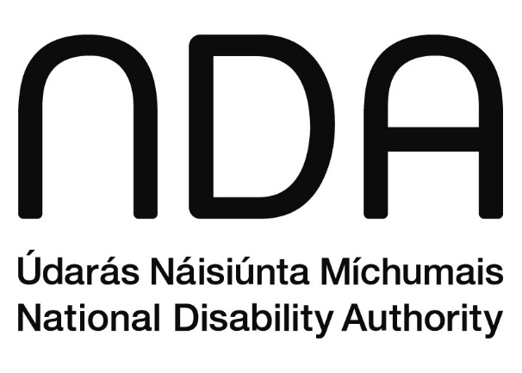
Údarás Náisiúnta Míchumais
25 Bóthar Chluaidh
Baile Átha Cliath 4
D04 E409
Teileafón: (01) 6080 400
Ríomhphost: info@nda.ie
Idirlíon: www.nda.ie/ga

National Disability Authority
25 Clyde Road
Dublin 4
D04 E409
Telephone: (01) 6080 400
Email: info@nda.ie
Web: www.nda.ie
The National Disability Authority (NDA) is the independent statutory body with a duty to provide evidence-informed advice and guidance to government on disability policy and practice and to promote Universal Design.

