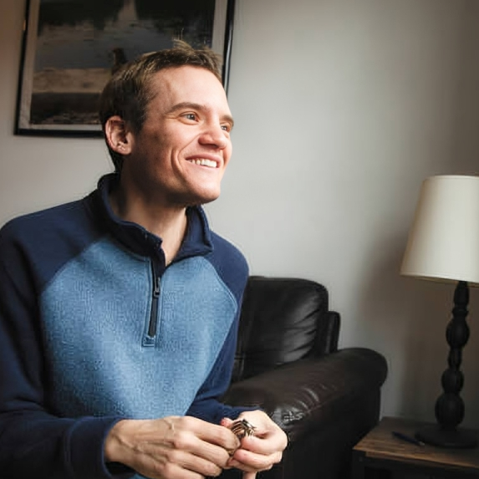


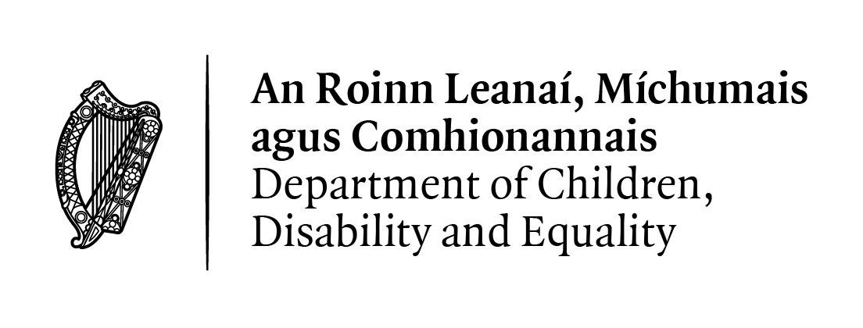
Plain English summary of the Literature Review on Autism, Ageing and Life Expectancy

​April 2026

In August 2024, the Government released the Autism Innovation Strategy. Part of this plan was for researchers to study topics that are important to autistic people. This report looks at what we currently know about:
- the difficulties autistic adults have when dealing with illness and death
- differences in how long autistic people live and the health conditions they have
- ways to improve the health of autistic adults and help them get better care

To do this, researchers at Trinity College Dublin checked many studies. They looked at 4,188 pieces of research and chose 115 studies that were the most useful and suitable. From these, they tried to answer six questions.

How common is autism?
A study from 2019 showed that the number people around the world who are diagnosed as autistic has increased. The number went from about 20 million people in 1990 to over 28 million in 2019. Between 1995 and 2010, the number of new people who were told they were autistic each year also increased a lot. Researchers found more autistic young adults and much fewer older autistic adults. This does not mean autism goes away with age. It is because older people were less likely to be diagnosed as autistic. This is because autism was not as likely to be recognised when they were children compared with children today.

How long do autistic people live?
Some studies looked at how long autistic people live. These studies collected information from big groups of autistic people over many years. They compared this with information from big groups of people who are not autistic. When researchers compared the information about the people who died during one study, they found the autistic people died at a younger age (average of 67 years) compared with the people who were not autistic (average of 82 years).
We must be very careful when reporting these numbers because:
- Lots of people in these studies did not die while the study was going on
- Many older autistic people were never diagnosed and were not included
- It can be hard to compare numbers from different countries
- Autistic people in these studies might have had more health problems than autistic people in general
For these reasons, the reported ages of death in these studies may be lower than they really are for autistic people. So, these numbers are not completely accurate. The real-life expectancy for all autistic adults is not known from these studies.
Another study used a better way to see if autistic people die younger. This study did show that some autistic people may have a higher risk of dying earlier than people in the general population. They found autistic people with no intellectual disability had a life expectancy that was 6 years less than non-autistic people. Life expectancy for autistic women with intellectual disability was 15 years less than non-autistic women. For men with intellectual disability, it was 7 years less than non-autistic men.
Even though it is hard to get accurate numbers about how long people with autism live, the research suggests that, on average, autistic people with an intellectual disability may not live as long as autistic people without an intellectual disability. This is especially true for women.

How is autistic adults’ physical health?
We looked at research about autistic people’s health. These studies were about which health conditions autistic people have. They also looked at how health conditions affect autistic people’s lives overall.
Different studies showed very different results for autistic people. This is probably because researchers used different ways of measuring autism and measuring health. These differences make it hard to get exact numbers about autism. Still, the research shows that autism has a big impact on people’s health around the world.
It is also important to know that autism is a lifelong condition, but many people are diagnosed later in life. Because of this, some measures do not always give a full or accurate picture. Having autism does not always mean someone has poor health.
Only three studies looked at the differences between autistic people who also have an intellectual disability and autistic people who do not. They found that autistic people with an intellectual disability are more likely to:
- Have mental health conditions
- Have physical disabilities
- Need more healthcare and support

How is autistic adults’ mental health?
Mental health problems, especially depression and anxiety, are more common in autistic adults than in non-autistic people. These can affect how happy and healthy someone feels.
Anxiety is very common in autistic people, affecting about 40% to 70% of them at some point in their lives, although it may decrease as people get older. Other mental health conditions, like bipolar disorder, are also more common in autistic people than in the general population.
Thoughts about suicide and suicide attempts are also more common, especially in autistic adults. Studies show they may be more than twice as likely to die by suicide. Past trauma where people had difficult experiences is linked to this. Some studies also found that:
- Older autistic adults may have more than one mental health condition
- People diagnosed with autism later in life may have more mental health problems compared to people diagnosed as children

How is quality of life for autistic adults?
Some studies show that autistic adults may have a lower quality of life, especially if they feel left out of social situations. This also affects their health and well-being. This can happen because of:
- Bullying
- Being excluded
- Difficulty socialising
- Feeling lonely
Not having enough support from others can also lead to lower self-esteem, which means that people do not feel good about themselves. Many autistic adults also have problems finding or keeping jobs, which can affect their quality of life. Research found that autistic women compared to other women may:
- Feel worse overall
- Be more likely to have memory or thinking difficulties as they age
- Have stronger menopause symptoms, including emotional and mental health problems

How do autistic adults experience healthcare?
Autistic adults often do not get all the healthcare they need. Studies show that when autistic people have more barriers to getting healthcare, their mental and physical health is often worse than people who do not have autism. Examples of issues include:
- Feeling misunderstood by doctors or nurses
- Difficulty getting services
- Being judged unfairly
- Sensory problems, like being overwhelmed by noise or bright lights
- Communication difficulties
- Not enough available services
All these difficulties can make the health problems of autistic people get worse over time.
Our results showed that good social support is very important. To improve care, healthcare workers need to better understand conditions that can be common for autistic people, such as anxiety and depression. Support systems should be set-up with autistic people’s needs in mind, for example:
- Better educate healthcare workers about autism
- Include autistic people in decisions about healthcare
- Communicate in ways that suit each person
- Show more understanding and sympathy
- Allow changes to minimise sensory stress, like providing a quiet place to wait
- Give support during big life changes, like moving from being a teenager to adulthood

