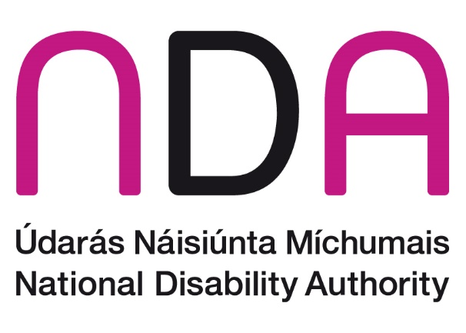

Climate Action Roadmap

Introduction

1.1 Organisation Overview
The National Disability Authority (NDA) is a statutory body that provides independent, evidence-informed advice to Ministers and officials on policy and practice relevant to the lives of persons with disabilities. Our work crosses all government departments and agencies. It also has statutory functions to promote the Universal Design of the built environment, products, services, and ICT so that they can be accessed, understood, and easily used by everyone regardless of their age, size, ability, or disability. We are a small Public Body with a staff complement of 44 and are based at 25 Clyde Road, Ballsbridge, a protected structure building.

1.2 Overview
The Climate Action Plan 2023 (CAP23) sets out a number of ambitious objectives, including reducing GHG emissions by 51% by 2030 and raising the targeted improvement in energy efficiency in the public sector from the previous aim of 33% by 2020 to 50% by 2030. This Climate Action Roadmap sets out the progress that has been made to date by the NDA as regards projects that have been commenced and efforts underway to meet the climate action plan targets. It will also focus on future projects that the NDA is planning in order to meet the targets outlined in CAP23. The themes laid out in the Climate Action Roadmap are guided by SEAI guidance documentation and CAP23. These are:
- Our People.
- Our Targets.
- Our Way of Working.
- Our Buildings (and Vehicles).

Our People
2.1 Energy Saving Champion & Green Team
Within the NDA, we have a ‘Green Team’ whose remit is to lead the organisation’s energy saving activities. The group is obliged to abide by the Energy & Green Code of Good Practice, which outlines the required standards of energy and environmentally friendly behaviour and practice by employees in undertaking their role with the National Disability Authority. The Green Team is made up of an Energy Performance Officer, Stephen Patten, an Energy Champion, Claire McGann, and a team of 4 other staff members.
In 2022 the NDA implemented an Energy Policy. This arose from a recommendation in an Energy Audit report, conducted by the NDA’s Internal Auditors. The policy outlines a list of energy-saving measures that are a commitment by the NDA to improve our overall energy usage. The policy was explained and disseminated to staff. The appointment of Claire McGann as Energy Champion is an important part of the policy. It is the role of the Energy Champion as well as the NDA Green Team to manage the various energy savings initiatives. Additionally, the energy-related matters are an agenda item for the NDA’s Senior Management Group (SMG) at least on a quarterly basis, and more frequently if required.
2.2 Training and workshops
The NDA will look to facilitate a range of climate action training through the SEAI (as normal practice,) and wider providers for specific roles and functions in the NDA.

Our targets
3.1 Energy-related usage
The National Disability Authority is committed to ensuring that the carbon emissions that arise as a result of its activities are kept to a minimum and, to this, to implementing energy-efficient and environmentally friendly practices. All of our measures are in line with the Government’s National Energy and Climate Plan 2021-2030, whose aims include a 30% reduction in CO2 emissions, a 32.5% improvement in energy efficiency, and up to 80% renewable electricity. In 2022 the NDA reported a 65.6% cost savings since baseline and 63.3% lower consumption since baseline. We are also dedicated to adhering to the energy cutting measures introduced by Government towards public sector bodies in September 2022.

2023 figures will be added as soon as they are available.

Our way of working
4.1 Annual Report
The NDA’s Annual Report includes the emissions outputs and sustainability activities carried out throughout the year.
The NDA Corporate Services Department registers and maintains records for the National Disability Authority with the Sustainable Energy Authority of Ireland.
The NDA has a total floor area of 2,633 m2 which comprises a two-storey over garden-level Victorian Building (×2), a link building completed in 2006, and an adjoining three-storey plus attic building completed in the early 1980s.

The main energy users are:
Electrical Energy: Lighting, ICT & Offices
Thermal Energy (Natural Gas): Space Heating (LTHW radiator circuits and under floor heating) and Hot Water (HWS).
In 2022, the National Disability Authority consumed 272,288 kWh of energy, consisting of:
- 139,062 kWh of electricity;
- 133,226 kWh of fossil fuels;
- 0 kWh of renewable fuels.
The NDA can report a:
- 65.6% cost savings since baseline;
- 63.3% lower consumption since baseline.
2023 figures will be added as soon as they are available.

4.2 IT Services
The IT Services of the NDA are provided via a shared services agreement with the Office of the Government Chief Information Officer (OGCIO) and we have adopted their digital initiatives in electronically storing documents. Since our migration to OGCIO in June 2023 we have significantly reduced our number of printers to discourage large unnecessary print jobs.
Internally in the NDA we are undergoing a large-scale document management project and the aim of this initiative is to create a more paperless environment within the organization. With this project, we finalised retention policies and guidelines and are continuously shredding large quantities of paper files based on these guidelines.
4.3 Adoption of Hybrid Working
The NDA is operating in a Blended working model with a requirement for staff to attend the office for a minimum of two days per week. We have designed and implemented an anchor day (Thursday) to allow staff to collaborate within their departments and units and meet external stakeholders and suppliers in person. The majority of staff members have therefore seen a significant reduction in their weekly commute and a decrease in emissions due to less travel over the 5-day working week. The corresponding reduction in electricity and heating usage within NDA offices is shown in the energy statistics referred to above.

Our Building and Vehicles
The National Disability Authority does not own any vehicles. However, there is a dedicated bicycle shed in place in the NDA’s building car park that provides areas for cyclists to securely store their bikes during work.

Our Wider Actions for 2024
We are committed to implementing wider actions on energy and resource efficiency. Our aims for 2024 include:
- Brown waste and green bins installed around the building
- Reduction in individual office bins
- Sensor taps installed in main bathroom areas subject to accessibility considerations
- Continually review of our waste management
- Review paper and printing use
- Green Procurement

