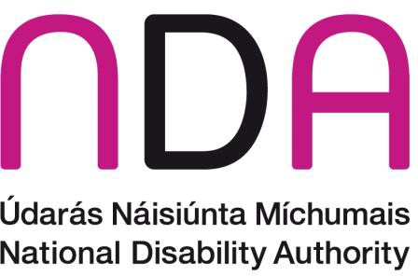

Information Leaflet on a Research Study
Going through a hard time – what can help

This is an Easy to Read leaflet

About the research

The National Disability Authority, or NDA, are running a research study. The NDA gives the Government advice.
We want to talk to children and young people who are autistic or disabled who have been through a hard time.
You can help us understand what that was like.
We want to know what helped you and what didn’t help you at that time.
We are trying to understand how to help other children and young people and their families who might be going through a hard time.

Who will take part in this research study?
We plan to talk to children and young people who have had something happen in their life that made them feel very upset, scared, or angry.
We will talk to families who have had a hard time too.
We will talk to people who work to help children, young people and families.
We will ask people to tell us what they think is the best way to help children and young people stop feeling upset, scared or angry and help them feel safe and calm.

How will the research study be carried out?
If you agree to take part in this research study, we will meet with you.
The meetings will be at times and dates that suit you.
The meetings will be in a place that suits you.
We would like to do face-to-face interviews but we can also do interviews by phone or on Zoom or we are open to your suggestions.

What happens during the interviews?
A trained researcher will carry out the interview.
If you would like, a family member or other trusted adult can be beside you during the interview or they can sit where you can see them, but they can’t hear your answers.
If you agree, we will record the interview using a digital audio recorder.
If you do not agree to an audio recording, the interviewer will take notes.
They may bring a second person with them to take notes.

How will the research study be carried out?
Some people might be upset talking about their lives. If you feel very angry, sad or upset before the interview, you can cancel.
You can ask for a break at any point in the interview.
Each interview will take about 45-60 minutes. Some interviews may take a little longer.
You can change your mind about taking part at any time during the interview.
Even if the research study has started and you have taken part in an interview, you can change your mind and drop out. You don't have to give us a reason.

The benefits and risks of taking part in this study
The benefits and risks are the good and bad things about taking part in a research study.
You might feel happy that you shared your experiences as part of this research study.
This study might bring good changes to how children, young people and families are supported through hard times.
Some people might be upset talking about their lives. If you get upset, you can stop or take a break at any time. We will give you a list of support services to contact if you need help.

Ethical approval
Ethics means making sure that a research project has the right values and ways of working.
The NDA makes sure that the highest standards are followed in all its research activities.
A HSE Research Ethics Committee has given their agreement for this research study.

Results
The results of the study will be published in reports. There will be no names or personal information in the reports.
The reports will be on the NDA website www.nda.ie. There will be an Easy to Read version of the report.
There will be a launch of the reports.
We hope people who take part in the research will come to the launch to see how their stories helped us.
The results may be presented at meetings, conferences, and in journals.

Where can I get more information?
If you have any questions you can get in touch with us by phone or email.
Dr Carly Cheevers is the researcher for this study.
You can email the research team at: research@nda.ie or 087 6712376.

This Easy to Read information is from
the National Disability Authority.

