**Effective Practice:**

Managing the transition of staff from congregated to community settings

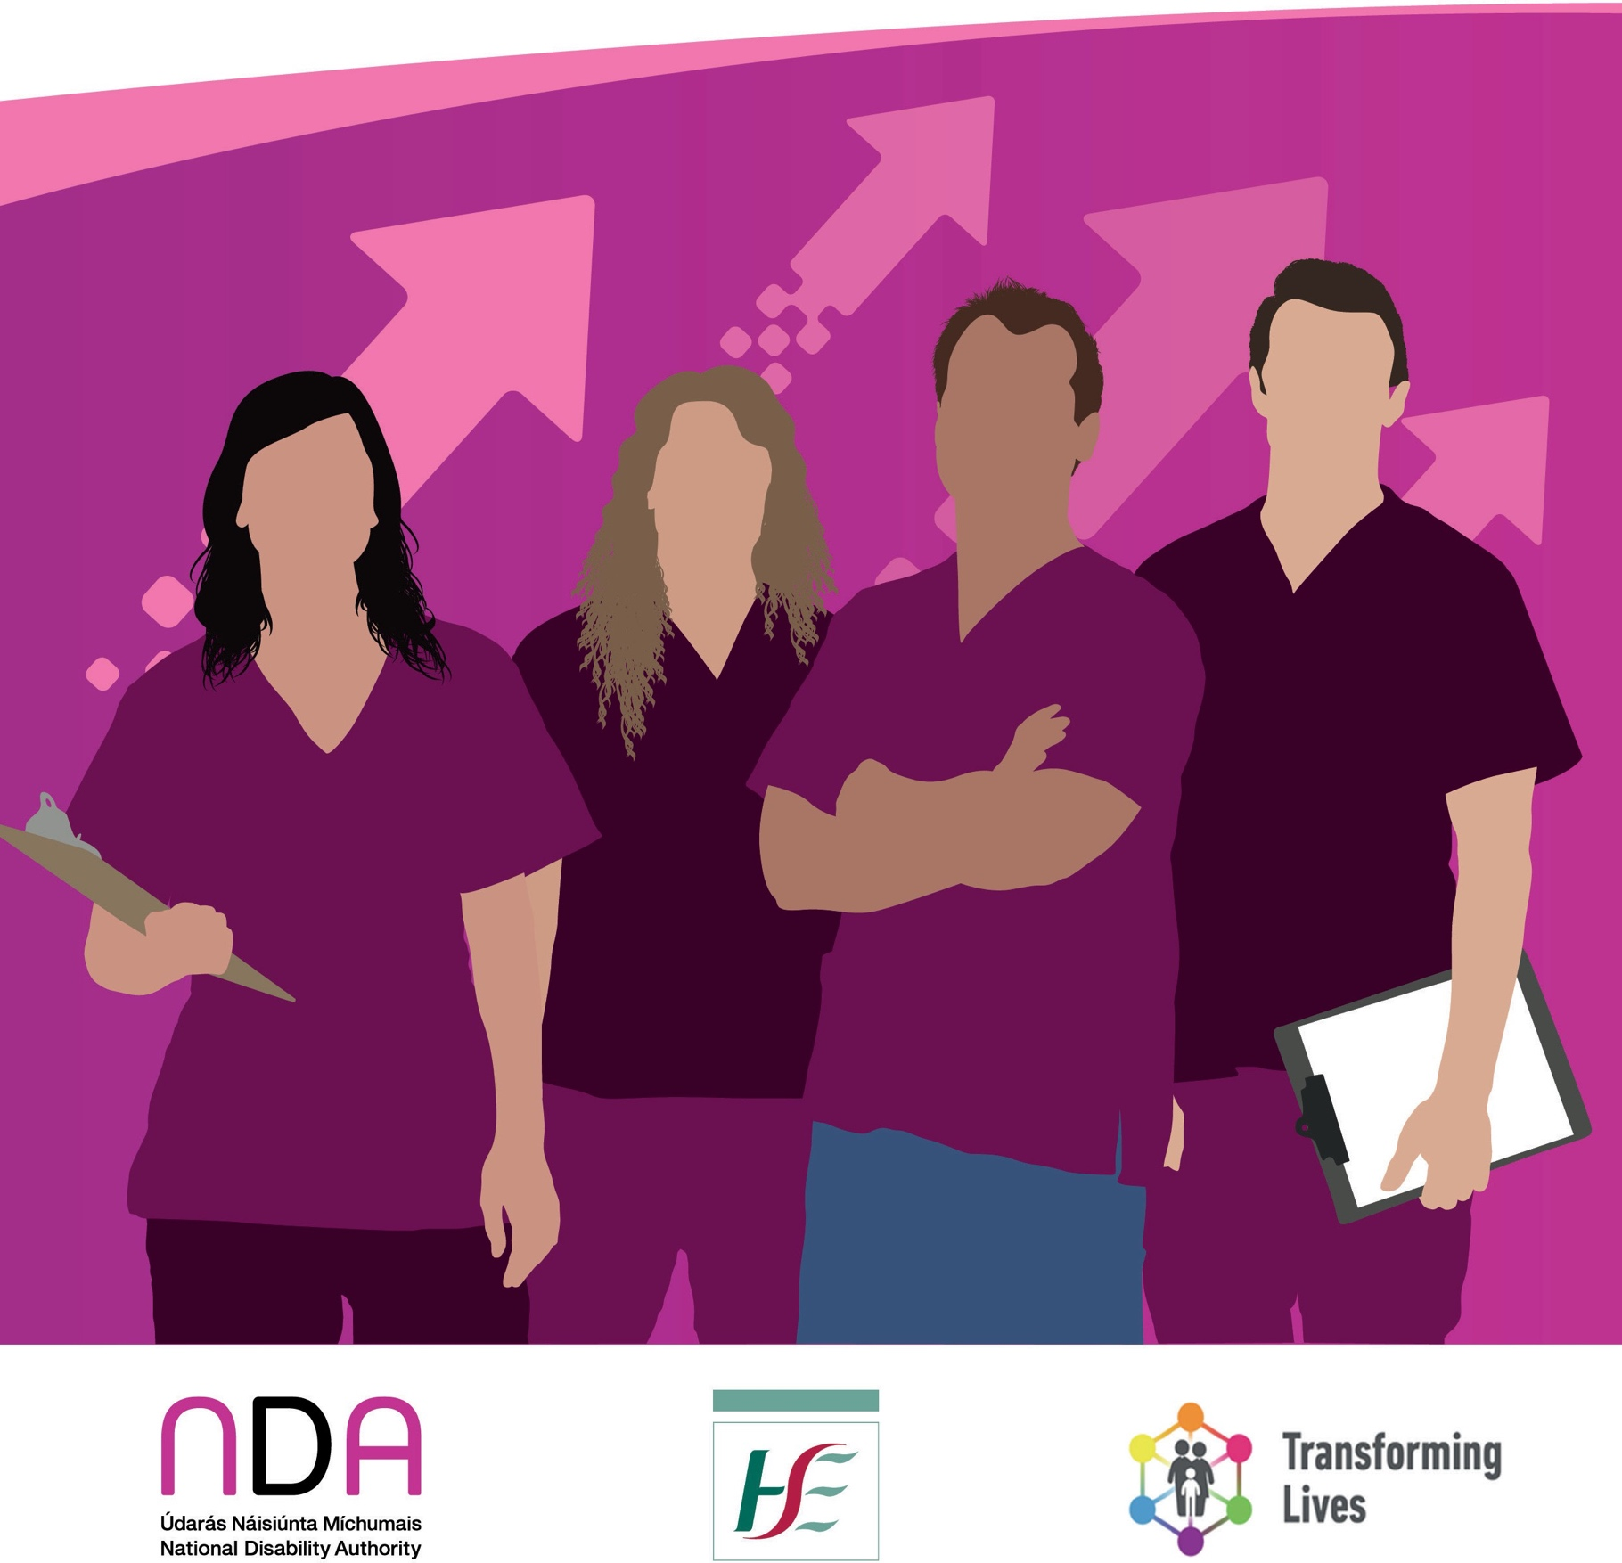



**Contents**

|  |  |
| --- | --- |
| **Introduction** | 3 |
| **Supporting staff to think positively of transition** | 5 |
| Lesson 1 – promote the positive aspects of community working | 5 |
| Lesson 2 – Engage with and reassure staff | 6 |
| Lesson 3 – Bringing staff on a journey | 7 |
| Lesson 4- Choosing which staff to transition | 9 |
| Lesson 5 – Involve staff in transition planning | 10 |
| Lesson 6 – Encourage experience sharing between staff | 11 |
| **Dealing with industrial relations issues** | 13 |
| Lesson 7 – Develop open and transparent lines of communication with staff | 13 |
| Lesson 8 – Maintain a good relationship with unions | 14 |
| **Supporting managers** | 16 |
| Lesson 9 – Request protected time and training | 16 |
| Lesson 10 – Build senior management buy in | 17 |
| Lesson 11 – Networking | 17 |
| Lesson 12 – Use existing tools and supports | 18 |
| Lesson 13 – Accept that you may not be able to achieve all you want to | 19 |
| **Conclusion** | 20 |
| **Additional Resources** | 21 |



The Health Service Executive’s (HSE’s) [Transforming Lives Programme](https://www.hse.ie/eng/services/publications/transforming-lives-progress-report-2016.pdf) is a national reform programme of disability services. Part of the Programme involves enabling persons with disabilities to transition from larger congregated settings1 to dispersed homes in the community where

they will have more choice and control over their lives. The [Time to Move on from Congregated](https://www.hse.ie/eng/services/list/4/disability/congregatedsettings/time-to-move-on-from-congregated-settings-%E2%80%93-a-strategy-for-community-inclusion.pdf) [Settings – A Strategy for Community Inclusion](https://www.hse.ie/eng/services/list/4/disability/congregatedsettings/time-to-move-on-from-congregated-settings-%E2%80%93-a-strategy-for-community-inclusion.pdf) is the strategy that underpins these transitions.

The National Disability Authority conducted a qualitative research study entitled [Staff and Change](https://nda.ie/uploads/publications/staff-and-change-management-report1.pdf) [Management, Good Practice in the Transition to Community Residential Disability Services](https://nda.ie/uploads/publications/staff-and-change-management-report1.pdf), published in 2021.This study examined how disability services have managed the transition process, particularly focusing on the management and experiences of staff. The experiences and learnings from this study have been condensed into two Effective Practices documents, published in 2024, as follows;

* Managing homes in the community following transition from congregated settings
* Managing the transition of staff from congregated to community settings

Drafts of the documents were shared with senior service managers with experience in transitioning services to the community and their insights have also been included to enhance the document.

The staff and managers in the study acknowledged that a lot of what they did in relation to transition to the community was through trial and error and that it was a huge learning curve from them.The key learning from the staff and managers in relation to **Managing the transition**

**of staff from congregated to community settings** is presented in this document using quotes where relevant to highlight particular points and linking to key HSE supporting documentation.

These drafts are primarily intended for residential services managers who are coordinating or overseeing the transition of residential services to the community. Frontline staff may also find

1. Larger congregated settings are defined as living arrangements where 10 or more people share a single living unit or where the living arrangements are campus-based.



them useful in reflecting on their own practices or in offering suggestions to their managers to improve the transition process. Similarly, the leadership of disability organisations may use

them to help support their managers and enhance the change management process within their organisations.

This document takes a practical approach to supporting managers with transition. However, it is also acknowledged that practice needs to be focused on the residents and their will and

preferences with the underlying assumption that they have capacity to make decisions about their own lives in line with the Assisted Decision Making (Capacity) Act 2015 (as amended).Therefore, the approach to transition should reflect the rights of the residents, with a primary focus on the rights included the United Nations Convention on the Rights of Persons with Disabilities and in particular Article 19, Living independently and being included in the community.2

Thirteen lessons across three themes (supporting staff to think positively of transition, dealing with industrial relations issues and supporting mangers) are outlined below.

1. [https://www.un.org/development/desa/disabilities/convention-on-the-rights-of-persons-with-disabilities/article-19-](https://www.un.org/development/desa/disabilities/convention-on-the-rights-of-persons-with-disabiliti) [living-independently-and-being-included-in-the-community.html](https://www.un.org/development/desa/disabilities/convention-on-the-rights-of-persons-with-disabiliti)

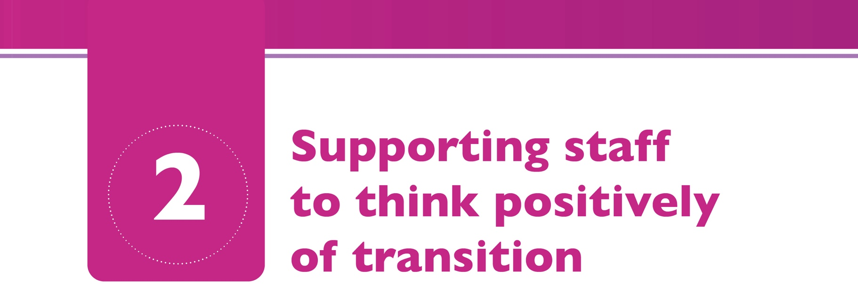

One of the most predictable challenges of the transition, which was overlooked by many managers, was the realisation that not all staff were as enthusiastic about the transition of residents to homes in the community as they were.The attitudes of staff to the news that residents were to transition to the community ran along a scale from staff who were delighted and embraced the change, to staff who were fearful and had concerns, to those who questioned the wisdom of the transition, and to those who didn’t buy into the concept at all. Staff concerns included concerns for the residents’ health and wellbeing, concerns for their own terms and conditions, concerns about a perceived lack of supports for staff working in the community, and concerns about the new roles and responsibilities they would have to take on.

Ah, no I was very open to it. I was delighted cos I knew it meant better quality of life for the residents. (Chloe, Frontline Staff)

… residential staff have being brought out kicking and screaming, they would avoid community like the, like the plague. (Conor, Frontline Staff)

Many managers acknowledged that this resistance likely comes from a place of fear and concern, and many have worked with staff to develop more positive attitudes to transition. Below are a list of some of the learning related to this.



**Lesson 1 – promote the positive aspects of community working**

Some managers and staff suggested that the positive aspects of community working are promoted to encourage staff to look at transition as an opportunity. Some staff reported enjoying taking on new roles, having the opportunity to use their initiative more, to make decisions, and to have more autonomy.



…say there could be five other nurses here [in the congregated setting], that I could have gone down and asked a question or whatever, but now you have to use your own initiative and look up things a bit more… Because I do find here you just become a bit reliant nearly on people. (Hannah, Frontline Staff)

However, managers emphasised that along with supporting the positives staff should be clear on what is required to work the community, a mindset to support community inclusion and supporting residents to manage their own homes.

# Resources

* + The [People’s Needs Defining Change – Health Services Change Guide](https://www.hse.ie/eng/staff/resources/changeguide/resources/change-guide.pdf) aims to enable managers to strengthen change capacity, support the ongoing implementation of the Health Services People Strategy and deliver on the challenging policy and reform agenda across the health and social care system. People are central to change at all levels – the key to successful change is creating commitment to a shared purpose through early and ongoing engagement. A focus on building change capacity will enable staff to work with and embrace change as an enabler of better outcomes for service users and local communities. Section 3 of the Guide has sections on Assessing readiness and capacity for change (3.2.4 page 58) and Co-designing the ‘vision’ for the future (3.3.1 page 62)



**Lesson 2 – Engage with and reassure staff**

Keeping staff informed of developments and allowing them the opportunity to ask questions and listening to their concerns will give them reassurance about the issues of concern to them. Often the answers are not known but it is important to continue to keep staff informed and work to find answers for them.

… we had issues you know, a lot of issues but [name of two managers] came up and all our questions was answered, and I think once we were told exactly, that reassured us. (Lily, Frontline Staff)

One senior manager explained how they introduced staff briefings before any transitions took place.These were done at different times to facilitate all roster patterns.

These sessions were well attended and kept the staff informed. (Senior Manger, reviewer)



# Resources

Effective communication and engagement is essential to support and drive the implementation of the Time to Move on policy.The following resources have been developed to support this.

* + [Communication Plan and Key Messages](https://www.hse.ie/eng/services/list/4/disability/congregatedsettings/commsplan.pdf)
    - This document supports the development of a communication and engagement strategy and relevant key messages.The key messages can be tailored for each specific group of stakeholders, to ensure that the focus of the message, language and medium used are appropriate and effective.
  + [Communication Plan Stakeholder Mapping Tool](https://www.hse.ie/eng/services/list/4/disability/congregatedsettings/commsplanmappingtool.pdf)
    - This mapping tool identifies many of the stakeholders that may need to be considered and included in the Communication and Engagement Strategy. The tool prompts the providers to consider Who,What,When and How in terms of **Who** is the stakeholder, **What** is the message relevant to them, **When** should engagement and communication happen, **How** should this be done in terms of the appropriate method of communication and by whom.
  + [time-to-move-on-briefing-note-for-employees.pdf (hse.ie)](https://www.hse.ie/eng/services/list/4/disability/congregatedsettings/time-to-move-on-briefing-note-for-employees.pdf)
    - This is a briefing note specifically for staff on the time to move on from congregated settings website.



**Lesson 3 – Bringing staff on a journey**

Managers reported bringing staff on a journey to help them understand the rights of all individuals, regardless of disability level, to live in ordinary homes in ordinary places.The theory of person- centredness needs to constantly be re-emphasised. Many managers found that this is done best through direct engagement with staff rather than through formal training. A focus on these key areas is essential for successful transitions for residents and staff. It is crucial to work with staff and involve them in every step of the process.

…as the process went on and as we got the communication better and we were better at making sure that people understood what it was we were trying to achieve, then yes, more and more staff, did fairly quickly I’d have to say started to see the possibilities for people… (Jack, Manager)

In staff briefings we were very clear of the need for change, explaining the rights-based approach and the new disability policy landscape of Ireland (Senior Manager, reviewer)



Some staff reported that residents said they don’t want to move to the community. However, the managers emphasised that this is not always an informed choice, and all individuals need to be supported to make informed choices and decisions impacting on their lives. One manager reported that they had a designated transition team who worked with the direct support team in preparation for transitions and were trained in Social Role Valorisation.This assisted sharing the vision of the future service model.This service also provided formal training for all levels of

management across all functions to ensure everyone had the same vision and was talking from the same perspective. As people moved into the community, the positive stories from the perspective of people supported and staff were shared at trainings and briefing which assisted the change mindset.They also reported that redesigning their person-centred planning framework assisted in the mindset shift.

# Resources

* + [A National Framework for Person-Centred Planning in Services for Persons with a Disability](https://www.hse.ie/eng/services/list/4/disability/newdirections/framework-person-centred-planning-services-for-persons-with-a-disability.pdf)
    - The process of supporting each person’s transition to their new home should follow the principles of person-centred planning and this work in most cases, will commence well in advance of the moving date.There are many documents, resources and websites that provide guidance on person-centred planning, based on different approaches and theories.The framework for person-centred planning sets out the key stages of the process and what is important at each stage for person-centred planning to be effective and states that the best measure of success is where “the person has experienced a real change for the better in his or her life, as a result of their person-centred plan being implemented.”
  + [A Guide to Understanding the Difference Between the Person-Centred Plan and Personalised](https://www.hse.ie/eng/services/list/4/disability/newdirections/report%20on%20the%20demonstration%20project%202019.pdf#%3A~%3Atext%3DPerson-centred%20planning%20is%20about%20what%20is%20important%20to%2Cthey%20need%20to%20stay%20healthy%2C%20safe%20and%20well) [Care and Support Plans has also been developed.](https://www.hse.ie/eng/services/list/4/disability/newdirections/report%20on%20the%20demonstration%20project%202019.pdf#%3A~%3Atext%3DPerson-centred%20planning%20is%20about%20what%20is%20important%20to%2Cthey%20need%20to%20stay%20healthy%2C%20safe%20and%20well)
  + A Quality Framework: Supporting Persons with disabilities to achieve personal outcomes
    - The focus on outcomes is an essential part of the service delivery framework being progressed in Ireland for people with disabilities. Following research and consultation by the National Disability Authority, the Department of Health and the HSE have approved nine outcome domains for Irish disability services for adults. A Quality Framework: Supporting Persons with disabilities to achieve personal outcomes (HSE, 2018,Working Group Four report unpublished) has been developed which captures these domains and identifies the outcome predictors that service providers can use to assess and measure how well they are supporting the achievement of these outcomes.The outcome predictors identified should inform and guide continuous quality improvement, aimed at providing outcomes-

focussed services and supports.While this report has not been published the NDA paper on [Outcomes for Disability Services](https://nda.ie/publications/nda-paper-on-outcomes-for-disability-services-2) is available for download.

* + - The HSE’s [People’s Needs Defining Change – Health Services Change Guide](https://www.hse.ie/eng/staff/resources/changeguide/resources/change-guide.pdf) has a section on modelling shared values that may be of use (Section 1.2.2 page 14).





**Lesson 4 – Choosing which staff to transition**

Some services, particularly in the early stages of the transition were able to choose what staff were transitioned to the community first. Some managers reported transitioning staff who were motivated to move and could see the positive benefits for residents and were keen to be part of making that happen. Many managers reported operating an expression of interest policy in determining which staff transitioned. Where it was not possible to choose particular staff, some managers reported mixing those staff who wanted to move with those who had concerns about moving with the intention that the staff with more buy-in would help convince those that were uncertain.

So, what we ended up doing that was to put, I think it was 40-60%, 40% of staff that didn’t want to go there and tried to mix them with the staff that were actually motivated and were willing to make change. And it actually required more governance then from ourselves to go down and do spot checks and kind of ask what they were doing. (Ava, Manager)

Staff who get on well together will ensure a more harmonious working environment and this will result in a better life for the residents. Therefore, some managers advised that consideration be given to inter-staff compatibility when transitioning staff. This is particularly important as there will be a smaller staff cohort in the community houses than in the congregated setting.

Participants also advised to facilitate staff to transition with residents they know where possible.

Many staff expressed a preference for this.They felt that this would make it easier to adjust to working in the community and was also of benefit to the residents. Working with the same manager as in the congregated setting was also preferred.

I particularly wanted this house because I’d worked with all the clients that moved in there, and the manager, the new PIC [Persons in Charge] over there, I’d worked with on the same unit here for three years here, so I really wanted into this house and its right on my doorstep. (Saoirse, Frontline Staff)

We developed a staff profile per house to clearly define the skill set, disciplines and experience required for each house.We then used an expression of interest process that was agreed with unions and took into account the staff members experiences/interests/ hobbies, local connectedness, familiarity and qualifications and length of service.The unions had originally wanted length of service to be the deciding factor which we opposed. Getting the right ‘fit’ for staff for each house is key as this often results in a ‘win win’ situation. (Senior manager, reviewer)



Staff may express an interest to work in a particular community home because it is nearer to their own home and therefore, reduces their commute.This should be facilitated where possible as it can support recruitment and retention of staff.

# Resources

* + Section 1.2.6 (page 25) of the [People’s Needs Defining Change – Health Services Change Guide](https://www.hse.ie/eng/staff/resources/changeguide/resources/change-guide.pdf) relates to investing in people and teams and give guidance on fostering a team culture of taking responsibility to address issues and problems.



**Lesson 5 – Involve staff in transition planning**

Involve staff in transition planning by using their knowledge during the discovery process and transition planning. Some staff reported feeling very disrespected and side-lined when not consulted about the transition of residents that they had worked with for a long time, for example, where a dedicated transition coordinator was brought in who did not consult with them. Involving staff in practical aspects of the transition and house preparation such as buying furniture and decorating the houses was reported to help build buy-in.This, however, should not be done at the expense of including residents in the process.

But you have to get people on board, and you will not get them on board by making formalised managerial announcements, you’ll get them on board by involving them in the process. (Jack, Manager)

Some team members were reported as being very keen to use their own networks to assist the person to connect in the local community. Senior managers emphasised that the changes that would be experienced in the community should be introduced long before transitions for example, cooking within a house on campus, supermarket shopping with individuals for campus- based houses, attending mass in the local community, and supporting individuals to hold a valued role within their home on campus.Teaching should also take place before transition such as

teaching residents how to load the dishwasher and washing machines so that this is not all a new experience for staff or individuals when moving to the community.

# Resources

* The [Project Action Plan Template 2018 version](https://www.hse.ie/eng/services/list/4/disability/congregatedsettings/project-action-plan-template.docx) is a template that guides services to set out their current configuration and their future proposed structure to enable them to plan how to transition and from an institutional model of care to a community based service. The Project Action Plan identifies the eight key work streams that need to be managed in order to drive



the change in services and includes a pre-populated work plan for each of these work streams that services can adapt for their specific project and use as a project management tool. The key work streams covered are: housing, person centred planning, transitioning, staffing, finance, governance, communications, and training. The template also includes a range of practical project management tools.

* + The [Community Living Transition Planning (CLPT) Toolkit](https://www.hse.ie/eng/services/list/4/disability/congregatedsettings/community-living-transition-planning-toolkit-nov-2018.pdf) aims to guide service providers through the process of supporting each person to develop their plan to move into the community. It will equip service providers with an understanding of what is required to support people to transition successfully to their new homes but will not be prescriptive.
  + [Supporting me to stay safe and well. Guidance document](https://www.hse.ie/eng/services/list/4/disability/disability-quality-improvement/risk-management/supporting-me-to-stay-safe-and-well-guidance.pdf) and the accompanying [Risk Assessment](https://www.hse.ie/eng/services/list/4/disability/disability-quality-improvement/risk-management/supporting-me-to-stay-safe-and-well-risk-assessment-tool.pdf) [Tool](https://www.hse.ie/eng/services/list/4/disability/disability-quality-improvement/risk-management/supporting-me-to-stay-safe-and-well-risk-assessment-tool.pdf) document were developed to adapt a person-centred approach in risk assessment. Current literature supports a Human Rights Based Approach (HRBA) which prioritises individual self- determination, autonomy and positive risk taking.The Assisted Decision Making (Capacity) Act 2015 (as amended) also underpins the legal rationale and support for the right to decide. This choice should be supported with person-centred and individualised approaches that best suit the individual. A HRBA also recognises the capacity building potential of individuals and that a change in this capacity can enable or prevent them in choosing to partake in an activity or event that is deemed “risky”. Assessment of risk should consider carefully the consequences of not taking the risk and how it interacts with the individual’s human rights.



**Lesson 6 – Encourage experience sharing between staff**

Get staff already working in the community to share their experiences. Peer staff from other services or the existing service who have already transitioned to the community can be very effective in changing staff attitudes around transition. If possible, arrange visits for staff to existing community houses. Participants in the study felt that these strategies were not used enough.

… the only thing I said to them [colleagues] was ‘You can’t say no for something that you haven’t tried’…I know change is scary but sometimes at the end of that change you will realise it’s better. (Amelia, Frontline Staff)

Some staff shared their very positive experiences and these experiences tended to travel back fast to the campus and the success stories were helpful in reducing fear for those residents and staff who were yet to move. Managers also said they can learn a lot from staff who have transitioned.



I have had the privilege of working with people of all ages with Intellectual Disability for the last 22 years, it has been amazing to see the development of most of them transitioning from residential care to community living in the last few years and how they have been accepted by the public. I have been involved in a transition recently and I have to say how positive

it has been, we have been using the amenities in the local village i.e., hairdressers, local shop and all our encounters have been very positive and in the next few weeks she will be

joining a cookery class which she is really looking forward to doing. (Catriona frontline staff member)

Sharing our learning and people’s journeys of growth and development is still the most motivating manner in which we bring people along with us. (Senior Manager, reviewer)

# Resources

There are also many events run by the HSE that staff can be encouraged to attend or to look at the webinars, for example

* + The HSE National Sharing Day can be found [here](https://www.hse.ie/eng/services/list/4/disability/disability-quality-improvement/).
  + A number of webinars relating to transforming lives developed by Genio and the HSE can be found on the [Genio website](https://www.genio.ie/videos?page=1).



While many services managed the transition of residents to the community with little or no union involvement a small number of services had adversarial union relations. Where issues became contentious, managers described being blocked from implementing changes, making the process of transitioning to the community in a person-centred way more difficult. Sometimes staffing could not be structured in such a way to best fit the needs of the residents. Negotiations with unions were required and solutions and compromises had to be found.

I suppose looking in you can see that if you changed hours and stuff like that how the service might work a little bit better, but sure your hands are tied with that. (Olivia, Manager)

**Lesson 7 – Develop open and transparent lines of communication with staff**

Where staff feel included and are kept fully informed with access to management to discuss any concern, issues are less likely to prove contentious.Where possible problems should be solved internally. Some managers realised that not doing this had caused problems further into the transition process.

No, the union, we never got that far. No, there were constantly negotiations with the staff. (Lucy, Manager)

The damage control should have been done before hand [before engagement with the union] you know and going out to meet the team and giving them that opportunity to be able to express their ideas or views. (Emily, Manager)



Some managers said that it was essential to move away from the concepts of caring and keeping safe and there was a need to support staff to support individuals to live, to make choices, to take all opportunities and to experience new things.

Providing clear expectations to staff about their role and how it will change in advance of transition was considered key to building buy in and preventing any discontent. For example, having to take on a community connector role or to do domestic duties needed to be explicitly stated up front.

Staff who are going to transition out into community need to be told … ‘This is what you are going to be expected to do’. Because you have staff coming out saying, ‘No I didn’t know I was going to have to wash somebody’s clothes like’. (Robyn, Frontline Staff)

**Lesson 8 - Maintain a good relationship with unions**

Managers advised avoiding an adversarial relationship with unions by maintaining good engagement with them and keeping them informed about changes. Some services had regular forum meetings with union officials and staff representatives. Carefully consider union advice when implementing changes to avoid issues becoming contentious.

We have a Forum that meets regularly with the Union and with staff representatives for the whole organisation and decongregation is part of some of those conversations...We have found that has worked really well. (Emma, Manager)

We reviewed all job descriptions with the unions and discussed this within the context of the public payment agreement for social reformation. Also, the context of HIQA has

necessitated and changed everyone’s role.The discipline who experienced the most change within our service was the Health Care Assistants - whose role changed considerably. (Senior manager, reviewer)

Some managers tried to bring unions on a journey to understand the human rights of residents, the underpinning of a person-centred approach and the theory behind community living.They tried to get them to understand that industrial relations issues do not have a higher weight than these fundamental values. However, many managers spoke of bringing staff, residents, and families on a journey, but this did not extend to unions and there sometimes seemed to be a gap in what services were trying to achieve for residents and what unions were trying to achieve for staff.

It was clear that work needs to be done so that management and unions are working together through continued consultation to support staff with national change and the move from an over medicalised models in some cases to a social and inclusive model of care, one of enabling and empowering individuals in their own lives.



These forums [with unions] were often contentious, but we worked our way through the issues.We co-produced a roster toolkit.We shared a values-based presentation with the unions showcasing the need for change and we rooted it in the National Service Reform Program citing the relevant Public Pay Agreement where required. (Senior Manager, reviewer)

Take a stand against issues that unions may be pushing for if you believe that they are not conducive to a good life for residents in the community. This is particularly important as the regulator does not accept union issues as a reason for lack of progress in transition to the community.

But I think when it comes to patient care and improving patient care, the unions should be told to back off… I fought them all the way. I just feel that you have to challenge them. (Aoife, Manager)

# Resources

* Unions are one of the key stakeholders listed on the HSE.Time to Move On from Congregated Settings [Communication Plan- Stakeholder Mapping Tool](https://www.hse.ie/eng/services/list/4/disability/congregatedsettings/commsplanmappingtool.pdf).

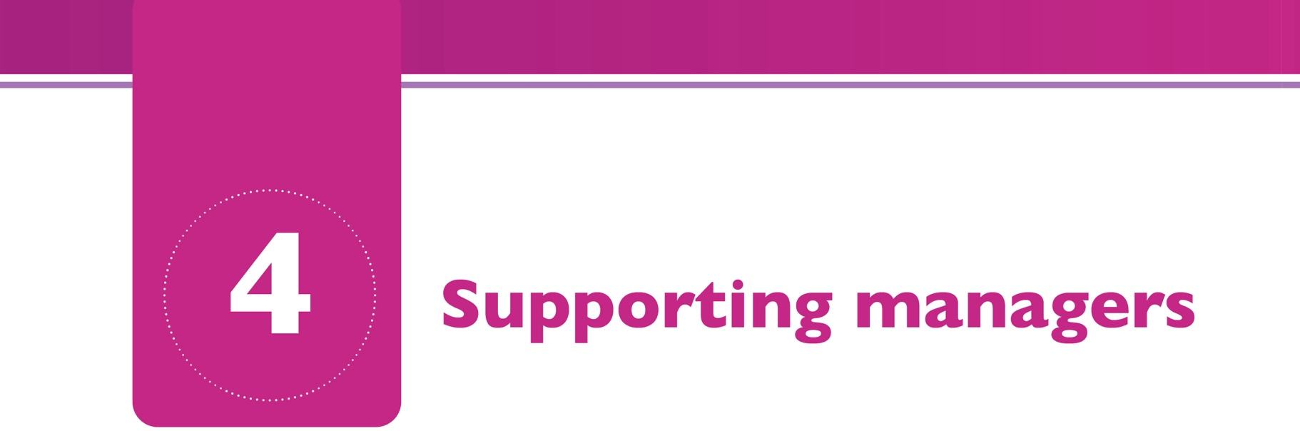

Some managers found they did not get adequate support from the leadership of their organisations in relation to the transition process.They had to constantly fight for more resources, were sometimes overwhelmed by the workload, felt out of their depth, and often felt isolated and stressed.

…for the last couple of months I’ve been doing both [community and congregated setting] and it’s impossible. It’ll be either one or the other.Yeah, it’s too much [laughs]…yeah, going grey…by the day. [laughs] (Olivia, Manager)

And we were thrown in at the deep end. Because we, there was no plan.You were literally, for the first couple of months running blind. You didn’t know what you were supposed to be doing, you were nearly winging it. You were buying beds, you were buying furniture, you were picking paint, you were ringing landscapers, I’d a septic tank that broke down and I’d to go out and look at it. Now I’m an RNID, I know nothing about septic tanks, I was looking into the hole going ‘What am I supposed to do with it?’. (Olivia, Manager)

Managers reported a number of things they did or should have done to address this outlined in the lessons below.



**Lesson 9 – Request protected time and training**

Some managers realised in hindsight that they should have requested protected time to manage the transition process. Most managers found it overwhelming to manage the transition in addition to the same responsibilities they had within the existing congregated setting.

[If I was doing it all again] I definitely would have gone to management to say that I probably needed protected time to do it. A lot of it ate into my own personal time, as in my time off. I never got time back for it or any payment for it. (Ava, Manager)

Training was not commonly mentioned but a few managers talked about the need to assess their skill set and request relevant training when necessary. For example, training in change management, conflict management, team building, or community access may have been of benefit.





**Lesson 10: Build senior management buy in**

In most services the organisational leadership were totally on board with transition to the community and some senior managers advised that decongegation be part of the organisation strategy with clear Key Performance Indicators. Other managers reported trainings on transitions and social role valorisation for the leadership team to gain traction and change mindsets, practices and to enhance accountability. However, in some organisations it was clear that the leadership was not supporting managers sufficiently in the transition process, despite these managers sometimes being on the leadership team. These organisations struggled the most in managing successful transitions. Some managers reported that they had to build buy-in among the organisational leadership and continually educate the organisation leadership about the principles of person- centredness.

# Resources

* Organisational leaders are one of the key stakeholders listed on the HSE.Time to Move On from [Congregated Settings Communication Plan- Stakeholder Mapping Tool](https://www.hse.ie/eng/services/list/4/disability/congregatedsettings/commsplanmappingtool.pdf).
* There is also a [Briefing Note for Board Directors and Senior Managers](https://www.hse.ie/eng/services/list/4/disability/congregatedsettings/time-to-move-on-briefing-note-for-board-directors-and-senior-managers.pdf) on the HSE’s time to move on from congregated settings website that may be of use.



**Lesson 11 - Networking**

Some managers found that networking with other services who have already transitioned to seek advice and support was helpful. Some visited other services who were further in the transition process to learn from them. Some benefited from attending HSE run information and networking events.

I did link up with somebody [at a networking event] and kind of was just general chit chat one day about the barriers and the challenges and she offered me to pop down. So, I did take her up on that and just took one or two others from the organisation down. (Ava, Manager)

We facilitated multiple visits to the service both during and post transition to share learning and resources. (Senior Manager, reviewer)



# Resources

There are also many events run by the HSE that staff can be encouraged to attend or to look at the webinars, for example

* The HSE National Sharing Day can be found [here](https://www.hse.ie/eng/services/list/4/disability/disability-quality-improvement/national-sharing-day/).
* A number of webinars relating to transforming lives developed by Genio and the HSE can be found on the [Genio website](https://www.genio.ie/videos?page=1).



**Lesson 12: Use existing tools and supports**

Some managers mentioned keeping abreast of the guidance and literature around transitions to the community. They said that this helped with motivation and could prevent reinventing the

wheel. Some managers reported that they spent a lot of time and energy developing materials for example, transition plans not realising that tools to support these activities already existed.

A colleague had forwarded on the newsletter from ‘A Time to Move On’ working group. First time I’ve ever seen a newsletter from that group. I knew the group existed, but it was different parts of that that I read that kind of lit a fire in me again (Grace, Manager)

…like we were doing a transition in our head, but like [laugh] it wasn’t until HIQA started doing visits and saying ‘Oh well where is your transition plan?’ And we were kinda going, ‘Transition plan?’ … then afterwards we’d discovered there were all of these things online… (Ava, Manager)

# Resources

* The [Time to Move on From Congregated Settings website](https://www.hse.ie/eng/services/list/4/disability/congregatedsettings/timetomoveon.html) contains a lot of resources relating to transition including newsletters.
* There is also a growing body of research being generated much of which is shared through webinars for example by [Genio](https://www.genio.ie/videos?page=1).





**Lesson 13 - Accept that you may not be able to achieve all you want to**

Many managers said that they grew in confidence as the transition process progressed and began to be more assertive and were more confident in advocating for the residents.

Probably that’s one of the biggest things I’ve learned, particularly when I was more junior, you know you’re less inclined to go against the tide. And now, I suppose it comes with age and it comes with confidence, I’ve no difficulty going against the tide if I feel the right thing to do for the lads, even if it gets me shot. (Amanda, Manager)

However, many managers said that they had to accept that there are lots of things that they had no control over and could not change. Many expressed self-doubts about whether they did things well enough, how they could have done things differently. However, most displayed resilience and reported overcoming their challenges. Many managers kept motivated by seeing small incremental changes as successes.

But at the same time we still kept going because our main focus was bringing it back to that person so at the end of every week you’d be able to say ‘OK, what small little thing’, you know. Because it was the small little things that will ultimately motivate you. (Emily, Manager)

# Resources

* In the HSE’s [People’s Needs Defining Change – Health Services Change Guide](https://www.hse.ie/eng/staff/resources/changeguide/) section 1.2.1 (page 11) is on practicing collective leadership and has a section on being self-aware that may be useful.



It is hoped that this document will be useful to managers in managing future transitions. As decongregation progresses more and more organisations are gaining experience and there are more tools, materials, and lessons available to share. Managers should make the most of these and continue to network to make the transition as easy as possible. There are other resources that may be of use in managing staff for transition and these are listed in the additional resources section below.

Thanks are due to the staff and managers who took part in the original research and to the senior managers who reviewed the Effective Practice Documents.



* [HSE Time To Move On from Congregated Settings website](https://www.hse.ie/eng/services/list/4/disability/congregatedsettings/timetomoveon.html)

This site contains newsletters, progress reports and several documents to support service providers to implement change including;

* + HSE (2019) [Making a home. A practical guide to creating a home and moving to the](https://www.hse.ie/eng/services/list/4/disability/congregatedsettings/making-a-home-a-practical-guide-to-creating-a-home-and-moving-to-the-community-july-2019.pdf) [community](https://www.hse.ie/eng/services/list/4/disability/congregatedsettings/making-a-home-a-practical-guide-to-creating-a-home-and-moving-to-the-community-july-2019.pdf). HSE.
  + HSE (2018) [Community Living Transition Planning Toolkit.](https://www.hse.ie/eng/services/list/4/disability/congregatedsettings/community-living-transition-planning-toolkit-nov-2018.pdf) HSE.
  + HSE.Time to Move On” from Congregated Settings [Communication Plan- Stakeholder](https://www.hse.ie/eng/services/list/4/disability/congregatedsettings/commsplanmappingtool.pdf) [Mapping Tool](https://www.hse.ie/eng/services/list/4/disability/congregatedsettings/commsplanmappingtool.pdf).

## HSE. SCD/QID Project [Tool box for Residential Services for Adults with](https://www.lenus.ie/bitstream/handle/10147/628036/Social%20Care%20QI%20Toolbox.pdf?sequence=1) [Intellectual Disabilities](https://www.lenus.ie/bitstream/handle/10147/628036/Social%20Care%20QI%20Toolbox.pdf?sequence=1)

The purpose of the Project Toolbox is to build a range of resources to support the efforts of residential services in implementing good practice and improving the delivery of quality safe services. It includes tools, guides, policies, templates, and signposts to online resources from HIQA, the HSE and other national bodies, where relevant, and is aligned to the 18 Outcomes upon which services are inspected by HIQA against regulations and standards.

