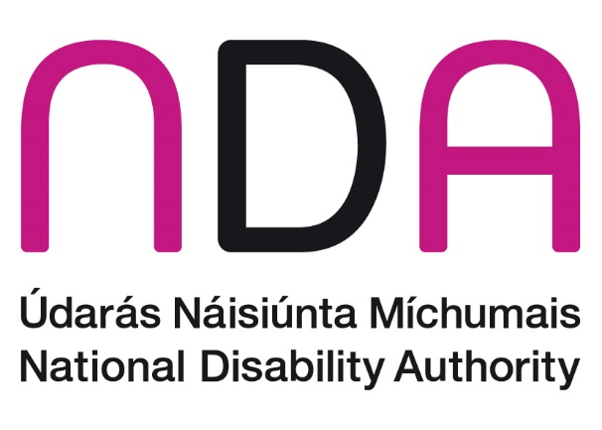
July 2024

Frequently Asked Questions: European Disability Card

What is the European Disability Card?
The European Disability Card will serve as proof of ‘disability status’ or of entitlement to specific services based on a disability across all EU countries.
The European Disability Card will complement national disability cards or certificates, which will continue to be awarded by national authorities, based on their own criteria, unless a Member State decides to merge their national card or certificate with the European Disability Card.
The European Disability Card does not attempt to harmonise disability assessments across the EU and does not affect a Member States' competence to determine the criteria for recognising ‘disability status’.
Rather, it seeks to ensure the mutual recognition of disability status to holders of a European Disability Card. This will allow residents in an EU Member State in possession of a European Disability Card to avail of the same preferential treatment or special conditions (in certain areas) offered to nationals in another EU Member State that hold a European Disability Card when they are visiting during a short-term stay.
The proposal for the European Disability Card delivers on a commitment made by the European Commission in the EU’s Strategy for the Rights of Persons with Disabilities 2021-2030.

What is its purpose?
It is widely acknowledged that people with disabilities face additional barriers when exercising their free movement rights across the EU, oftentimes due to the lack of recognition of a disability card, certificate or entitlement to services issued or recognised by their EU Member State of residence. As a result, when persons with disabilities visit another EU Member State, they might not have access to the same special conditions and preferential treatment that are available to those with recognised ‘disability status’ residing in that Member State.
The European Disability Card seeks to address this challenge by providing the same access to special conditions or preferential treatment in certain areas to persons with disabilities temporarily travelling to another EU Member State as are available to persons with disabilities residing in that country.

What will it cover?
The special conditions or preferential treatment will apply when using public transport, accessing certain services, attending cultural events and visiting museums, leisure and sports centres, amusement parks, as well as other areas. The European Disability Card does not apply to social security benefits or social assistance.
The special conditions or preferential treatment provided to persons with disabilities in the areas of culture, leisure, sport and transport vary across EU Member States, and can take a variety of forms, including:
- free entry
- reduced tariffs
- priority access
- personal assistance
- access to restricted traffic and pedestrian zones
- priority seating on public transport

How can persons with disabilities apply?
EU Member States are responsible for assessing the ‘disability status’ of their own residents for the purposes of the European Disability Card. Each Member State must designate a competent authority to oversee the issuance, renewal, and withdrawal of the European Disability Card according to the respective national rules and practices.
The European Disability Card will be provided for free (though reissuance in cases of loss or damage may be subject to a fee) and will be available in both physical and digital versions.

When will the cards be available?
European Disability Cards are not yet available, and will not be available for several years.
The EU Directive providing for the creation of the European Disability Card has yet to be adopted, though this is expected during 2024. Once the Directive is adopted and enters into force, EU Member States will have 42 months (3.5 years) to start issuing the Cards, including 30 months (2.5 years) to transpose the legislation (that is to create national laws to translate the requirements of the EU law). It is therefore possible that the first European Disability Cards may not be issued to people with disabilities legally resident in Ireland until the end of 2027.

What is the current situation in Ireland?
Unlike some European Union countries, Ireland does not currently issue disability cards or certificates that recognise the ‘disability status’ of residents for the purposes of ensuring access to special conditions or preferential treatment with respect to services, activities or facilities offered to or reserved for persons with disabilities under the scope of the proposed EU Directive.
There are various schemes and allowances that disabled people legally resident in Ireland may apply for currently and these have different sets of eligibility criteria. The proposed EU Directive does not require any changes to national schemes.
In addition, special conditions or preferential treatment for disabled people in Ireland in areas such as transport, leisure, culture and sport sectors are not common. For example, many ticketed events will have a child and older person discount but not a discount for a disabled person. Under the proposed Directive, this situation may not change as service providers and operators are not obliged to offer any special conditions or preferential treatment unless those are mandated by national law.

