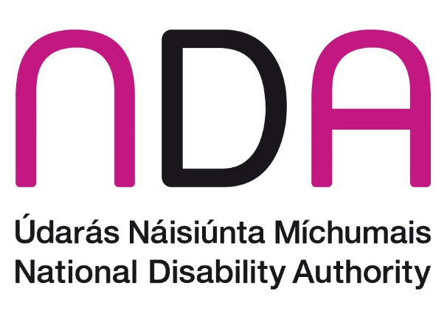

NDA Submission to An Coimisiún Toghcháin to inform its consultation on Electoral Postering
April 2025

Introduction
The National Disability Authority (NDA) is the independent statutory body with a duty to provide information and advice to the Government on policy and practice relevant to the lives of persons with disabilities, and to promote the adoption and application of a Universal Design approach across all sectors. We thank An Coimisiún Toghcháin (the Electoral Commission) for the opportunity to contribute to its consultation on electoral postering.

Do you see positive aspects/advantages to election posters? If yes, please explain.
The NDA advises that posters can serve as a prominent and straightforward visual reminder of the identity of candidates for certain disabled people, including those who may have an intellectual disability and those who require support to exercise decision-making. Posters can also assist some people with a vision impairment due to the large print.
In addition, the NDA recently funded a study under its Research Promotion Scheme, entitled Disability, Diversity and Identity in Ireland’s Local and European Elections 2024, which found that representation of particular communities in politics was of concern to those interviewed. The study underscored that it is particularly pressing for disabled candidates, including those with intersecting identities, to have a visible presence during election campaigns, and postering continues to play a vital role in this. This can be especially true for first-time candidates, with incumbents holding a significant advantage in terms of re-election.

Do you see negatives aspects/disadvantages to election posters? If yes, please explain.
The NDA notes that election posters should be erected at a minimum height of 2.3 metres above footpaths, cycle tracks or any area to which pedestrians have access. However, the NDA is aware that election posters are regularly hung below the regulation height, creating obstacles for some people with disabilities, including people with a vision impairment and wheelchair users.
The NDA notes that some Disabled Persons’ Organisations and disability stakeholder groups have voiced concerns about the hazards posed by low-hanging posters to people with a vision impairment, with the latter noting that the sharp corners and edges of posters can cause cuts or lacerations to the face. Vision Ireland have also reported that low hanging posters are difficult to detect by guide dogs or canes, increasing the likelihood of a person with a vision impairment suffering an injury.
Additionally, the NDA-funded study on disabled election candidates found that erecting election posters caused annoyance for some disabled candidates participating in the research, including those with mobility issues, with some raising questions about their necessity. For example, one disabled election candidate stated:
“I mean I physically can’t climb ladders. you’re utterly dependent on others to do it, or again you’re looking for funding for doing it, and it’s not something… I think people take for granted, you know if… you’re there kind of waiting and everybody else has posters up and you don’t, and you’re just reminded again about how your lack of visibility metaphorically and actually, you know?”
Another barrier spotlighted in the NDA-funded study was the financial barriers experienced by disabled candidates running for election. In addition to the costs borne by all election candidates, including the costs associated with producing and erecting posters, disabled candidates incur additional, disability-specific costs when running for election, which they must cover themselves. The NDA advises that the cost of erecting electoral posters for disabled candidates should be considered, including for independent candidates.
Furthermore, the NDA recognises the concerns related to the environmental impact stemming from the use of posters.

Do you think Ireland’s rules and approach to election posters should change? If yes, please explain the changes you’d like to see and the reasons for this.
The NDA recommends the importance of election candidates making greater efforts to adhere to the law and ensure that their posters are erected at regulation height or higher. Where election posters do not meet the minimum 2.3 metres (7.5 ft) height from the ground, the NDA would welcome more proactive enforcement of regulations by local authorities, particularly the removal of posters in breach of the regulation height which pose a safety concern for some disabled people. Local authorities are responsible for the removal of posters which constitute a hazard to either pedestrians or road users.
Relatedly, the NDA advises that there should be more information and greater awareness about avenues for complaint to local authorities by members of the public where a poster fails to meet regulation height or poses a hazard. Such complaints mechanisms must be accessible to all disabled people.
In addition, the NDA-funded study on disabled election candidates recommended that consideration be afforded to the introduction of communal postering, via billboards that show all election candidates, as observed in some European countries. The NDA understands that the Commission’s research will examine the rules and practices around postering in other countries and suggests that this practice merits consideration in this regard.

Is there anything else you would like to say about the use of election posters in Ireland?
Research consistently shows that disabled people have lower levels of political participation, with the Electoral Commission’s own Research Strategy 2024–2026 highlighting that people with disabilities are one of several under-reached and/or underrepresented groups with lower levels of political engagement, voting and also participation as candidates in elections. As the Electoral Commission outlines in its own consultation document, the presence of posters helps raise awareness among the whole population that a vote is about to take place. This includes disabled people.
The NDA advises that the Commission’s research examine whether any move away from posters in other jurisdictions entailed consideration of alternative means of communication for engaging disabled people or sought to mitigate any unintended consequences that might have served to disadvantage disabled people, reduce awareness of an election or create barriers to voting.
Furthermore, the NDA underscores the importance of engagement by the Electoral Commission with Disabled Persons’ Organisations (DPOs) during this consultation exercise. As the representatives and voices of disabled people, DPOs will have unique perspectives to share on the use of electoral posters during election campaigns.
The NDA also wishes to draw the Electoral Commission’s attention to Article 4(3) of the UN Convention on the Rights of Persons with Disabilities (UNCRPD), which requires all government departments and statutory agencies to ensure the effective participation of persons with disabilities in the creation and implementation of policies and legislation that impact their lives. The NDA’s Participation Matters guidelines may be a useful resource in this regard and we are happy to advise further.
Finally, the NDA advises that printed electoral posters should be as accessible as possible, for example they should contain good colour contrast, have legible font sizes and use simple, clear language. The NDA’s Centre for Excellence in Universal Design is happy to advise further on this point.

Conclusion
The NDA welcomes the focus afforded by An Coimisiún Toghcháin (the Electoral Commission) to the issue of election postering and is available to engage further on any of the issues raised in this submission.

Electoral Commission, Electoral Postering Consultation: https://www.electoralcommission.ie/consultation/
University of Galway and Trinity College Dublin (2025) Disability, Diversity and Identity in Ireland’s Local and European Elections 2024, available at: https://nda.ie/publications/disability-diversity-and-identity-in-irelands-local-and-european-elections-2024
See for instance Voice of Vision Impairment, Accessibility Report on Referendums of March 8th, 2024: https://vvi.ie/voice-of-vision-impairment-accessibility-report-on-referendums-of-march-8th-2024/
See for instance Vision Ireland: https://vi.ie/vision-ireland-urges-candidates-to-prevent-poster-hazards/
National Disability Authority (2022) Participation Matters guidelines, available at https://nda.ie/uploads/publications/NDA-Participation-Matters_Web-PDF_092022.pdf

