Briefing Report: NDA Factsheet 2: Employment

**November 2024**



NDA Factsheet 2: Employment and Disability

# Introduction

This factsheet is part of a series produced by the National Disability Authority (NDA) on different aspects of the lives of people with disabilities in Ireland. The goal of the series is to bring together up-to-date and accurate statistical information across different themes that may be useful to a range of stakeholders. Interested readers may include individuals with disabilities, Disabled Persons Organisations, service providers, policy makers, researchers, and the general public.

This factsheet presents information on the employment of people with disabilities in Ireland. First, key labour statistics terms are defined. Next, information is given on the employment and unemployment of people with disabilities in relation to that of the population without disabilities. Employment levels and pay of disabled people in Ireland are then compared with those in other countries.

This document draws much of its information from the Census of Population 2022 carried out by the Central Statistics Office (CSO). In Census 2022, people were asked to report whether they experienced each of a series of long-lasting conditions or difficulties. People who responded that they experienced a condition ‘to some extent’ or ‘to a great extent’ and people who reported that they experienced a difficulty ‘a little’ or ‘a lot’ were classified as having a disability. The Disability and Difficulties questions included in the census were changed substantially in 2022, meaning Census 2022 results cannot be compared directly with those from previous censuses (see Appendix A for more information).

Throughout this document, the terms ‘persons with disabilities’ and ‘disabled people’ are used interchangeably. The term ‘disabled people’ is recognised by many within the disability rights movement in Ireland to align with the social and model of disability, as it is considered to acknowledge the fact that people with an impairment are disabled by environmental and societal barriers. However, we recognise that other people prefer the term “persons with disabilities” because of the inherent understanding in the term that they are first and foremost human beings entitled to human rights. This reflects the language used in the UNCRPD. Finally, we recognise that some people do not identify as being disabled.

# Definitions

## Working Age

Different age brackets can be used when examining the employment levels of a population or group. In Ireland, the 20-64-years age group has sometimes been used to look at the employment of disabled people; other times, employment levels for the population with disabilities aged 15 years and over have been of focus.

International organisations like the International Labour Organization (ILO) and the Organisation for Economic Cooperation and Development (OECD) define the ‘working age population’ as 15-64 years of age. The Central Statistics Office (CSO) also uses the 15-64 years age bracket when reporting the official employment rate for Ireland.

Here, we use the age grouping of 15-64 years of age to look at the employment of disabled people, where possible. Where a set of figures relate to a different age group (mostly due to data availability issues), we state this in the text or in a footnote.

## Employment

The working age population in a country can be divided into three separate groups (Figure 1): 1) people employed, 2) people unemployed, and 3) people outside the labour force.

Figure 1: Labour force categories

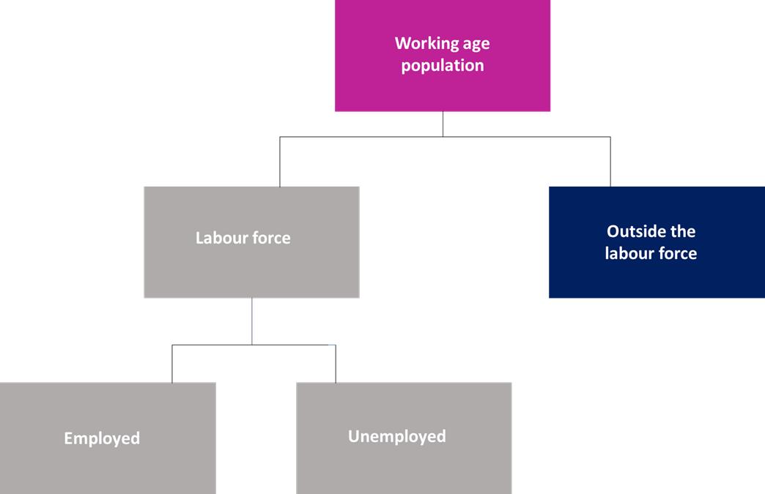

### Labour force participation rate

The labour force participation rate is a way to measure how many people in a country are actively involved in the workforce. It shows the percentage of the working age population that are either working or actively looking for a job. This rate helps us to understand how many people are available to work compared to the total working age population.

### Outside the labour force

People who are not considered part of the labour force are people of working age who are not working and are also not looking for work because they are, for example, retired, studying, looking after their home or family, or because they cannot work due to disability or illness.

### Unemployment rate

The unemployment rate is a measure that tells us the percentage of people in the labour force who are actively looking for a job but cannot find one.

### Employment rate

The employment rate is a measure that tells us the percentage of people of working age who have jobs and are currently working.

### Disability employment gap

The disability employment gap is the difference in employment rates between people with disabilities and those without disabilities.

# Measuring Unemployment

When the ‘unemployment rate’ is discussed in Ireland, it can be based on three different sources of data:

1. The Live Register
2. The Labour Force Survey
3. The Census

Each of these data sources captures unemployment in different ways. This can cause confusion, so it is important to understand the differences.

The ‘**Live Register**’ is a count of the number of people claiming unemployment benefits. It is often called the claimant count. The Live Register counts the number of people currently registered for Jobseekers Benefit (JB), Jobseekers Allowance (JA) or for various other statutory entitlements at local offices of the Department of Social Protection. The Department provides this information to the CSO.

The Live Register is updated monthly. Because not all unemployed people claim benefits, however, the Live Register may not reflect the true level of unemployment in Ireland. This is particularly true for people married to someone who is working; because they may have no entitlements to welfare, they may not register as unemployed. In addition, some people are put off registering, as they cannot prove they are looking for work. It is generally recognised that the Live Register underestimates actual unemployment levels.

The second source of unemployment data is the **Labour Force Survey (LFS)**[1]. The CSO surveys a sample of 25,000 households and measures the unemployment rate based on the International Labour Organisation (ILO) definitions (employed, unemployed, outside the labour force). The survey of households and individuals in those households is taken every three months (quarterly). All members of the EU must use the ILO standardised measure of unemployment.

For a person to count as unemployed in this survey, there are three conditions that must be met:

1. The person has been out of work for 4 weeks.
2. The person is able to start work in the next 2 weeks - they must be readily available for work.
3. The person is available and looking for work for one hour per week.

Unemployment numbers in the LFS tend to be much higher than the Live Register, as the Labour Force Survey is a direct assessment of unemployment, while the Live Register is just a count of those who claim benefits.

The final source of information we have on unemployment is the five-yearly **Census**. In the Census, people self-declare their status as employed or unemployed or other. This means that they do not have to be on the Live Register or meet the three ILO criteria to be considered unemployed. The Census records how people think about their own status.

All three sources of data are interesting, and each tells us something about the numbers of people unemployed. However, we would not expect the three sources of data to give exactly the same numbers. Text box 1 illustrates how the three different surveys might treat the same case differently.

Mark is a 40-year-old married man who works for 5 hours a week doing accounts for a semi-state firm. The rest of the time, he minds his two children and studies for accountancy exams. He would like to work full time but is waiting for the right job to come along. Mark’s wife is a high earner, so Mark is not entitled to any state benefits.

Live register: Mark is not registered for benefits so is not counted as unemployed.

LFS: as Mark works 5 hours a week and is not actively looking for more work, he is considered employed.

Census: when filling in the census Mark answered the question ‘How would you describe your present principal status?’ as ‘Looking after home/family’ so he is counted as being outside the labour force. However, he could have ticked the employed or student boxes instead.

Text box 1: the different ways employment is treated under the live register, LFS and Census

Another issue is that the Live Register data does not allow comparisons of people with and without a disability. Therefore, the only sources of data we have for the employment and unemployment of people with a disability are the Census and the LFS.

Because the Census gives us the fullest information, this paper draws mainly on census data on employment and unemployment. Where other data sources are used, this is highlighted in the text.

# Disability prevalence

The 2022 Census shows that 1,109,557 people in Ireland experiences a long-standing condition or difficulty. This means that 21.5% of the population, or more than one in every five people in Ireland, has a disability.

Looking just at people aged 15-64 (those approximately of working age), there are 661,083 persons with a disability, which represents 19.7% of that age group.

# Overall employment picture

## Employment

Almost half (49.3%) of people with disabilities of working age in Ireland are at work, compared to 70.8% of people without disabilities. This means that the difference in employment rates between people with and without disabilities, i.e., the disability employment gap, is 21.5 percentage points. Available cross-country data indicate that the gap in Ireland is considerably larger than the average gap across the European Union.[2] The link between employment and social inclusion is well established, and Ireland also ranks near the bottom of all 27 EU Member States on a number of social inclusion indicators for people with disabilities, including severe material deprivation and being at risk of poverty[3].

Employment levels also vary considerably depending on the extent of disability reported, with the employment rate of people with a disability to some extent (60.3%), more than double that of people with a disability to a great extent (27.3%).

## Labour force participation

Based on Census 2022, the labour force participation rate of people with disabilities is 68.3% in Ireland, compared to 76.5% of people without disabilities. However, the participation rate of people with disabilities to a great extent (35.2%) is less than half that of people without disabilities.

The labour force participation rate of people with disabilities to some extent (68.3%) is closer to the participation rate of people with no disabilities than to that of people with disabilities to a great extent (Table 1).

## Unemployment

Not only are people with a disability less likely to be in the labour force, but once in the labour force, they are also more likely to be unemployed than people who do not have a disability.

There were 52,509 unemployed people with a disability (including those looking for their first regular job) according to Census 2022. Therefore, the unemployment rate for people with a disability is 13.9% compared to 7.5% for people who do not have a disability. The unemployment rate of people with a disability to some extent is 11.7%, around half that of people with a disability to a great extent.

Table 1: Labour force participation and unemployment rates by disability status[4]

|  | All | People with a disability to any extent | People with a disability to some extent | People with a disability to a great extent | People without a disability |
| --- | --- | --- | --- | --- | --- |
| Total population aged 15-64 (number) | 3,360,537 | 661,083 | 440,794 | 220,289 | 2,699,454 |
| At work (number) | 2,236,811 | 325,981 | 265,894 | 60,087 | 1,910,830 |
| Employment rate (%) | 66.6 | 49.3 | 60.3 | 27.3 | 70.8 |
| Unemployed, including looking  for first regular job (number) | 207,512 | 52,509 | 35,070 | 17,439 | 155,003 |
| Total in the labour force (number) | 2,444,323 | 378,490 | 300,694 | 77,526 | 2,065,833 |
| Not in labour force  (Number) | 916,214 | 282,593 | 140,100 | 142,763 | 633,621 |
| Labour force participation rate (%) | 72.7 | 57.3 | 68.3 | 35.2 | 76.5 |
| Unemployment rate (%) | 8.5 | 13.9 | 22.5 | 11.7 | 7.5 |

Source: Census 2022

## Gender

Both males and females with a disability are less likely to be working than people without a disability of the same gender (Table 3). Just over half (52.8%) of males with a disability to any extent are at work, compared to just over three quarters (75.6%) of males without a disability. Similarly, 46.3% of females with a disability to any extent are employed, compared to 66% of females without a disability. The lowest employment rate is that of females with a disability to a great extent, at 26.4%.

Table 2: Employment rate by gender and disability status

|  | Male | Female |
| --- | --- | --- |
| Population with a disability to any extent | 52.8 | 46.3 |
| Population with a disability to some extent | 65.1 | 51.9 |
| Population a disability to a great extent | 28.3 | 26.4 |
| Population with no disability | 75.6 | 66.0 |

Source: Census 2022

However, in terms of unemployment, females with a disability are less likely to be unemployed (that is, not working but seeking employment) than their male counterparts (Table 3). The unemployment gap between males and females is larger among disabled people (ranging from 2-4% depending on the extent of disability report) than among people without disabilities (a 0.5% gender difference)

Table 3: Unemployment rate by gender and disability status

|  | Male | Female |
| --- | --- | --- |
| Population with a disability to any extent | 15.1 | 12.6 |
| Population with a disability to some extent | 12.6 | 10.7 |
| Population a disability to a great extent | 24.8 | 20.2 |
| Population with no disability | 7.7 | 7.2 |

Source: Census 2022

The lower employment rate but also the lower unemployment rate of females than males with a disability is explained by the fact that more females than males are outside the labour force (Table 4).

The gap between the labour force participation rate between males and females is 10.8 percentage points, which is identical to the gap between males and females without disabilities.

Table 4: Proportion of males and females outside the labour force, by disability status

|  | Male | Female |
| --- | --- | --- |
| Population with a disability to any extent | 62.1 | 52.9 |
| Population with a disability to some extent | 74.5 | 62.8 |
| Population a disability to a great extent | 37.6 | 33.0 |
| Population with no disability | 81.9 | 71.1 |

Source: Census 2022

# Labour force participation and disability type

Of people with different types of disability, people who report blindness or a vision impairment have the highest labour force participation rate, at 42.8%, and people who have a difficulty with basic physical activities have the lowest, at 16.6.% (Table 4).

The unemployment rate is highest for people with an intellectual disability (29.4%) and lowest for people who are deaf or have a hearing impairment (9.9%) and those who are blind or have a vision impairment (10.5%).

The Census records information on activity limitation (difficulties people might have doing certain things). The labour force participation rate is very low among people who have a difficulty in dressing, bathing or getting around inside the home (10.2%) and among people who have difficulty going outside the home (10.9%).

Table 5: Labour force participation and unemployment rates by disability type (population aged 15 and over)[5]

|  |  |  |
| --- | --- | --- |
|  | Labour force participation rate | Unemployment rate |
| Difficulty with pain, breathing or any other chronic illness/condition | 33.7 | 13.8 |
| A difficulty with basic physical activities | 16.6 | 22.4 |
| Blindness or vision impairment | 44.3 | 10.5 |
| A psychological or emotional condition or a mental health issue | 42.8 | 19.9 |
| A difficulty with learning, remembering, or concentrating | 26.2 | 23.0 |
| Deafness or hearing impairment | 27.8 | 9.9 |
| Intellectual disability | 22.5 | 29.4 |

Table 6: Labour force participation and unemployment rates by type of difficulty with activities of daily living (population aged 15 and over)[6]

|  |  |  |
| --- | --- | --- |
|  | Labour force participation rate | Unemployment rate |
| Difficulty dressing, bathing or getting around inside the home | 10.2 | 25.5 |
| Difficulty going outside the home | 10.9 | 32.9 |
| Difficulty working at a job or business or attending school or college | 20.9 | 30.8 |
| Difficulty participating in other activities | 19.1 | 22.8 |

Source: Census 2022

## Appendix A: Definition of disability in Census 2022

In Census 2022, data on disability were derived from answers to two questions on the census form. In the first question, census respondents were asked to indicate if they had any of a list of long-lasting conditions or difficulties, by choosing one of three response options: ‘yes, to some extent’, ‘yes, to a great extent’ or ‘no’ (see Q15 below). In previous censuses, only two response options were provided: ‘yes’ and ‘no’. The second question asked respondents to indicate whether they had difficulty doing any of a series of daily activities, by responding that they had ‘no difficulty’, ‘some difficulty’ or ‘a lot of difficulty’ (see Q16 below). In previous censuses, respondents were only asked to respond to this question on activity limitation if they had already indicated that they experienced one of the conditions or difficulties in the previous question; in 2022, everyone was asked to respond to both questions.

Individuals who selected a response of 'yes, to some extent' for at least one condition/difficulty or 'yes, a little' for difficulty with one activity, but did not select 'yes to a great extent' or 'yes, a lot' for either question were classified as having a 'disability to some extent'. Individuals who selected at least one of the 'yes, to a great extent' or 'yes, a lot' response options were classified as having a 'disability to a great extent'. Any individual who ticked any of the 'yes' boxes in either question was considered as part of the 'disability to any extent' group.

**Census Q15: Do you have any of the following long-lasting conditions or difficulties?**

|  |  |  |  |
| --- | --- | --- | --- |
|  | 1 Yes, to a great extent | 2 Yes, to some extent | 3 No |
| a) Blindness or a vision impairment |  |  |  |
| b) Deafness or a hearing impairment |  |  |  |
| c) A difficulty with basic physical activities such as walking, climbing stairs, reaching, lifting or carrying |  |  |  |
| d) An intellectual disability |  |  |  |
| e) A difficulty with learning, remembering or concentrating |  |  |  |
| f) A psychological or emotional condition or a mental health issue |  |  |  |
| g) A difficulty with pain, breathing, or any other chronic illness or condition |  |  |  |

**Census Q16: As a result of a long-lasting condition, do you have difficulty doing any of the following?** *Include issues due to old age.*

|  |  |  |  |
| --- | --- | --- | --- |
|  | 1 Yes, a lot | 2 Yes, a little | 1. No |
| a) Dressing, bathing, or getting around inside the home |  |  |  |
| b) Going outside the home to shop or visit a doctor’s surgery |  |  |  |
| c) Working at a job or business or attending school or college |  |  |  |
| d) Participating in other activities, such as leisure or using transport |  |  |  |

1. The LFS was called the Quarterly National Household Survey: also known as the QNHS until 2017.
2. Eurostat (2023). Disability employment gap by level of activity limitation and sex (source EU-SILC). https://ec.europa.eu/eurostat/web/products-datasets/-/tepsr_sp200
3. Sprong, S. & Maitre, B. (2023). Poverty and Social Inclusion Indicators in the

   Roadmap for Social Inclusion 2020–2025 in Comparative Perspective Covering

   2018–2021, Dublin: Department of Social Protection [BKMNEXT434_0.pdf (esri.ie)](https://www.esri.ie/system/files/publications/BKMNEXT434_0.pdf)
4. Given differences in how the employment rate and unemployment rate are defined and calculated (see Definitions section above), the unemployment and employment rates do not sum to the labour force participation rate.
5. It is not possible to calculate the unemployment and unemployment rates of people aged 15-64 with different disability types, as this information has not been published by the CSO.
6. It is not possible to calculate the unemployment and unemployment rates of people aged 15-64 with different types of activity limitation, as this information has not been published.