Briefing Report for NDA Factsheet: Disability Statistics

**November 2024**

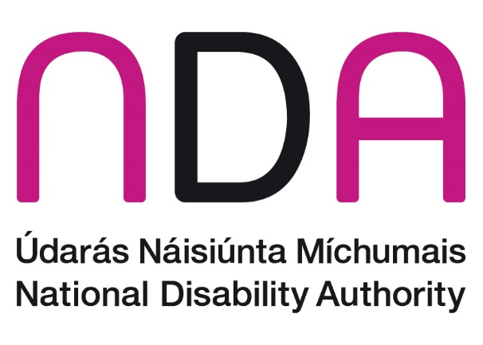

# Introduction

This factsheet is part of a series produced by the National Disability Authority (NDA) on different aspects of the lives of people with disabilities in Ireland. The goal of the series is to compile timely and accurate statistical information across different themes that may be useful to a range of stakeholders. Interested readers may include individuals with disabilities, Disabled Persons Organisations, other organisations, service providers, policy makers, researchers, and the general public.

This introductory factsheet provides information on the number of people with disabilities in Ireland and on the nature and extent of those disabilities. Information is also provided on selected characteristics of the population with a disability, such as age profile, education levels, labour market participation, and general health. While an overview of these characteristics is given here, more detailed information will be provided in separate factsheets dedicated to themes such as employment, education, housing, and children with disabilities.

This document draws much of its information from the Census of Population 2022 carried out by the Central Statistics Office (CSO). Respondents to Census 2022 were asked to indicate whether they experienced each of a series of long-lasting conditions or difficulties. Individuals indicating that they experienced a condition ‘to some extent’ or ‘to a great extent’ and individuals indicating that they experienced a difficulty ‘a little’ or ‘a lot’ were classified as having a disability. The Disability and Difficulties questions included in the census were changed substantially in 2022, meaning Census 2022 results are not directly comparable with those from previous censuses (see Appendix A for more information).

Throughout this document, the terms ‘persons with disabilities’ and ‘disabled people’ are used interchangeably. The term ‘disabled people’ is recognised by many within the disability rights movement in Ireland to align with the social and human rights model of disability, as it is considered to acknowledge the fact that people with an impairment are disabled by environmental and societal barriers. However, we recognise that other people prefer the term “persons with disabilities” because of the inherent understanding in the term that they are first and foremost human beings entitled to human rights. This reflects the language used in the UNCRPD. Finally, we recognise that some people do not identify as being disabled.

# Prevalence of disability

In Census 2022, 1,109,557 people reported experiencing a long-lasting condition or difficulty to any extent. This means that 21.5% of the population, or more than 1 in 5 people in Ireland, have a disability. Specifically, 13.6% of the population in 2022 reported having a long-lasting condition or difficulty ‘to some extent’, and a further 7.9% reported having at least one condition or difficulty ‘to a great extent’.

Disability is slightly more prevalent among females (22.2%) than males (20.9%) in Ireland. This is probably accounted for by the fact that females live longer, on average, than males, and disability rates increase with age. Women are slightly more likely to have both a long-lasting condition or difficulty to some extent (13.9% of females, 13.4% of males) and to a great extent (8.3% of females, 7.5% of males).

# Common types of disability

The most common type of long-lasting condition experienced by people in Ireland is ‘difficulty with pain, breathing, or any other chronic illness or condition’ (Figure 1), which is reported by 8.5% of the total population and 39.7% of all those reporting a disability. The next most common long-lasting condition is ‘a difficulty with basic physical activities such as walking, climbing stairs, reaching, lifting or carrying’, which is experienced by 6.8% of the population and 31.5% of the population with a disability. The third most common condition is ‘blindness or visual impairment’, which is experienced by 5.8% of the population and 26.7% of disabled people.

Overall, 5.2% of the total population and 24.3% of people with disabilities experience a psychological or emotional condition or mental health issue. Similarly, 5.0% of the population and 23.3% of those with a disability have a difficulty with learning remembering or concentrating, and 4.5% of the total population and 21.0% of disabled people experience deafness or a hearing impairment. Finally, 2.1% of the total population have an intellectual disability, which is 9.8% of those who have a disability to any extent.

Figure 1: Numbers of people experiencing long-term conditions or difficulties

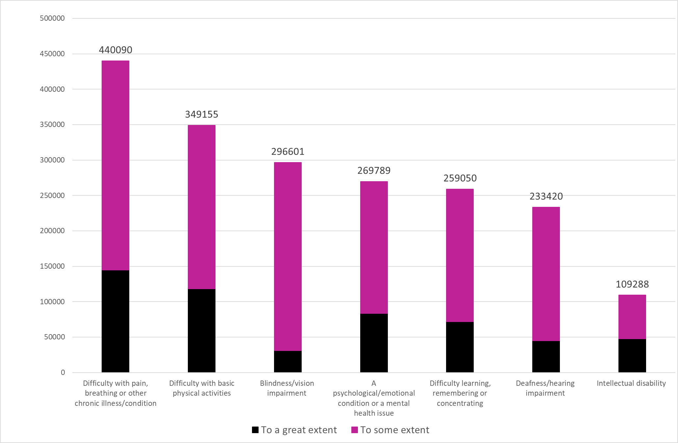

Source: Census 2022

# Difficulty with Everyday Activities

In Census 2022, respondents were asked whether they experienced difficulties with everyday activities as a result of a long-lasting condition.

The most commonly reported difficulty is with participating in ‘other activities, such as leisure or using transport’ (Figure 2), which is experienced by 6.8% of the total population and 31.5% of the population with a disability. The next most common difficulty is with working at a job or business or attending school or college, with 5.9% of the total population and 27.4% of disabled people experiencing difficulty with this.

Overall, one in 20 people in Ireland (5.0%) and 23.3% of people with a disability have difficulty with going outside the home alone to shop or visit a doctor’s surgery. Finally, 4.2% of the total population and 19.4% of people with a disability have difficulty dressing, bathing or getting around inside the home.

Figure 2: Numbers of people experiencing difficulty with everyday activities

This bar chart shows the number of people in Ireland experiencing difficulty with everyday activities as a result of a long-standing condition. 349,995 people had difficulty participating in 'other' activities, such as leisure or using transport (188,898
 to some extent, 161,097
 to a great extent). 303,859 people had difficulty working at a job or business or attending school or college (126,497
 to some extent, 177,362
 to a great extent). 258,243 people had difficulty going outside the home alone to shop or visit a doctor's surgery (139,182 to some extent, 119,061
 to a great extent). 215,609 people had difficulty dressing, bathing or getting around inside the home (126,349
 to some extent, 89,260 to a great extent).

# Age and disability

Most disability is acquired, meaning disability that develops during a person's lifetime as a result of an accident or illness, rather than a disability that a person is born with. The rate of disability therefore increases with age. Approximately 4% of children under the age of five, or one in 25, in Ireland have a disability (Table 1). In the 75-79 years age group, just under half (47%) of people have a disability. This rises to 60% of 80-84-year-olds and more than three in four of those aged over 84 (76%).

Table 1 Percentage of the population with a disability by extent and age group

|  |  |  |  |
| --- | --- | --- | --- |
| Age group | Disability to any extent (%) | Disability to a great extent (%) | Disability to some extent (%) |
| All ages | 21.5 | 7.9 | 13.6 |
| 0 - 4 years | 4.3 | 2.1 | 2.2 |
| 5 - 9 years | 10.2 | 3.8 | 6.4 |
| 10 - 14 years | 13.6 | 4.5 | 9.2 |
| 15 - 19 years | 17.1 | 5.5 | 11.6 |
| 20 - 24 years | 19.4 | 5.9 | 13.5 |
| 25 - 29 years | 18.2 | 5.2 | 13.0 |
| 30 - 34 years | 16.1 | 4.4 | 11.7 |
| 35 - 39 years | 15.6 | 4.6 | 11.0 |
| 40 - 44 years | 16.6 | 5.2 | 11.4 |
| 45 - 49 years | 19.1 | 6.3 | 12.8 |
| 50 - 54 years | 22.3 | 8.0 | 14.3 |
| 55 - 59 years | 25.8 | 10.1 | 15.7 |
| 60 - 64 years | 30.2 | 12.0 | 18.1 |
| 65 - 69 years | 33.2 | 11.8 | 21.4 |
| 70 - 74 years | 37.7 | 13.4 | 24.3 |
| 75 - 79 years | 47.0 | 18.4 | 28.6 |
| 80 - 84 years | 59.9 | 28.0 | 31.9 |
| 85 years and over | 75.7 | 48.2 | 27.6 |

Source: Census 2022

At the same time, because the number of people aged 80 and older is a very small part of the total population, the majority of people (60% or three-fifths) with a disability are of working age (defined here as 15 to 64 years of age).

These demographic effects can be seen in Figure 3, which has two lines. The black line shows the total number of people with a disability in each age group (labelled on the vertical axis on the left side of the figure) and the pink line represents the percentage of people with a disability in each age group (labelled on the righthand side of the figure).

Figure 3 Disability and age

Source: Census 2022

# Disability rates by area

There is some geographical variation in disability prevalence in Ireland. The overall proportion of people with disabilities ranged from 19% in Fingal to 24% in Wexford (Figure 4). As noted above, age is strongly associated with disability, and areas with an older age profile will tend to have higher rates of disability than areas whose population is younger.

Figure 4 Percentage of people with a disability in each administrative area

Source: Census 2022

# Disability and Employment

Persons with a disability are less likely to be employed than people without disabilities. In 2022, people with disabilities comprised 19.6% of the working age population and 14.6% of all those of working age in employment (Figure 5). This underrepresentation is more pronounced among those who report disabilities ‘to a great extent’, who represent 6.5% of the working age population but just 2.7% of those in employment. People with disabilities ‘to some extent’ represent 13% of the working age population and 12% of those of working age who are employed.

Figure 5 Percentages of the working age population and of the workforce with a disability

Overall, 71% of people with no disability were working as of April 2022, compared to 49% of people with disabilities. Of people who reported that they had a disability ‘to some extent’, 60% were employed; of those who reported a disability ‘to a great extent’, 27% were in employment.

# Disability and social class

In the census, every member of the population is assigned to a social class based on their occupation (in the case of those over 15 years of age in employment), their former occupation (for those unemployed or retired), or on the occupation of a reference person (e.g., parent, spouse) in their household (for those outside the labour market).

In Ireland, people with a disability are less likely to be in higher social classes than people with no disability.[1] Of people without disabilities, 42% are in the highest two social classes: professional and managerial or technical, compared to 32% of people with disabilities (37% of those with disabilities ‘to some extent’ and 24% of those with disabilities ‘to a great extent’; see Table 2).

Looked at another way, people with a disability make up 21.5% of the total population, but just 15% of the professional class and 18% of the managerial and technical class (Table 3). At the other end of the scale, people with disabilities are over-represented in the unskilled class (28%).

Table 2 Social class of the population with and without disabilities

|  | **Professional** | **Managerial and technical** | **Non-manual** | **Skilled manual** | **Semi-skilled** | **Unskilled** | **All other gainfully occupied and unknown** | **Total** |
| --- | --- | --- | --- | --- | --- | --- | --- | --- |
| **Without a disability** | 10.0 | 32.0 | 16.1 | 12.8 | 10.8 | 2.8 | 15.5 | 100 |
| **Disability to any extent** | 6.5 | 25.9 | 16.3 | 13.5 | 12.9 | 4.1 | 20.8 | 100 |
| **Disability to some extent** | 7.7 | 29.4 | 17.6 | 13.9 | 13.1 | 3.8 | 14.5 | 100 |
| **Disability to a great extent** | 4.2 | 20.1 | 14.1 | 12.9 | 12.5 | 4.5 | 31.7 | 100 |

Source: Census 2022

Table 3 Percentage of each social class with a disability, 2022

|  | **All** | **Professional** | **Managerial & technical** | **Non-manual** | **Skilled manual** | **Semi-skilled** | **Unskilled** | **All other gainfully occupied and unknown** |
| --- | --- | --- | --- | --- | --- | --- | --- | --- |
| **Disability to any extent** | 21.5 | 15.0 | 18.3 | 21.8 | 22.5 | 24.7 | 28.3 | 26.9 |

Source: Census 2022

# Education

People with disabilities have lower levels of educational attainment, on average, then people without disabilities (Table 4). In 2022, 6.5% of people without a disability[2] had no formal education or had primary education as their highest level of education. This rises to 14.3% of people with disabilities to some extent and to 27.8% of people with disabilities to a great extent (19.3% of people with disabilities to any extent).

Further, 28.5% of people without disabilities have an honours bachelor degree (or equivalent) or higher, compared to 22.3% of people with a disability to some extent, and just 10.3% of people with disabilities to a great extent (17.7% of people with disabilities to any extent).

Table 4 Population aged 15 years and over with and without a disability by highest level of education completed

|  |  |  |  |  |
| --- | --- | --- | --- | --- |
| **Highest level of education** | **People without disabilities** | **People with disabilities to any extent** | **People with disabilities to some extent** | **People with disabilities to a great extent** |
| No formal education | 1.5 | 4.9 | 2.9 | 8.4 |
| Primary | 5.0 | 14.4 | 11.4 | 19.4 |
| Lower secondary | 11.6 | 17.7 | 16.4 | 19.9 |
| Upper secondary | 18.3 | 17.5 | 17.9 | 16.7 |
| Technical/vocational | 7.3 | 8.2 | 8.5 | 7.7 |
| Advanced certificate/completed apprenticeship | 5.9 | 4.8 | 5.4 | 3.9 |
| Higher certificate | 5.7 | 5.0 | 5.6 | 4.0 |
| Ordinary bachelor degree/professional qualification or both | 8.4 | 6.9 | 8.1 | 5.1 |
| Honours bachelor degree/professional qualification or both | 14.7 | 9.4 | 11.6 | 5.7 |
| Postgraduate diploma or degree | 12.5 | 7.5 | 9.6 | 4.1 |
| Doctorate (Ph.D.) | 1.2 | 0.9 | 1.1 | 0.5 |
| Not stated | 7.8 | 2.6 | 1.4 | 4.6 |

Source: Census 2022

# General health

People with a disability are less likely to rate their health as good than people without a disability (Figure 6). In 2022, 88% of the population without a disability rated their general health as good or very good, compared to 63.1% of the population with a disability. This varies with the extent of the disability, with 75.8% of the population with a disability to some extent reporting their health as being good or very good, falling to 41.1% of the population with a disability to a great extent.

Just 0.1% of the population without a disability indicated that their general health was bad or very bad, rising to 1.5% of the population with a disability to some extent, and rising again to 18.1% of the population with a disability to a great extent (totalling 7.6% of the population with a disability to any extent).

Figure 6 Ratings of general health by disability status 2022

# What will happen in the future?

The Irish population was 5.15 million in 2022, but the CSO expects this to grow to 5.8 million by 2036. In addition, people are living longer in Ireland while fewer babies are being born. As a result of the combination of population growth and population ageing, the population with a disability in Ireland is expected to continue to increase.

In 2021, a disability capacity review published by the Department of Health projected that the number of people with disabilities would increase by 17% in the period from 2018 to 2032. These projections may need to be updated in light of Census 2022 results, which indicate that more than one in five people in Ireland now have a disability. In 2020, the budget for disability services was just over €2 billion, and it was estimated that this would need to be increased by somewhere between 25% and 50% to meet identified unmet and future social care capacity needs by 2032. In 2023, the HSE’s budget for disability services was 2.4 billion[3].

## Note on statistics used

All census data cited in this factsheet can be found in the tables associated with [the Health, Disability and Carers profile 2022 on the website of the Central Statistics Office](https://www.cso.ie/en/releasesandpublications/ep/p-cpp4/census2022profile4-disabilityhealthandcarers/)

Future population projections are available under the [population projections](https://www.cso.ie/en/releasesandpublications/ep/p-plfp/populationandlabourforceprojections2017-2051/populationprojectionsresults/) section at the CSO.

The future projection of the number of people with disabilities and the need for increased disability spending were taken from the [Disability Capacity Review to 2032 - A Review of Social Care Demand and Capacity Requirements to 2032](https://www.gov.ie/pdf/154163/?page=1).

# Appendix A: Definition of disability in Census 2022

In Census 2022, data on disability were derived from answers to two questions on the census form. In the first question, census respondents were asked to indicate if they had any of a list of long-lasting conditions or difficulties, by choosing one of three response options: ‘yes, to some extent’, ‘yes, to a great extent’ or ‘no’ (see Q15 below). In previous censuses, only two response options were provided: ‘yes’ and ‘no’. The second question asked respondents to indicate whether they had difficulty doing any of a series of daily activities, by responding that they had ‘no difficulty’, ‘some difficulty’ or ‘a lot of difficulty’ (see Q16 below). In previous censuses, respondents were only asked to respond to this question on activity limitation if they had already indicated that they experienced one of the conditions or difficulties in the previous question; in 2022, everyone was asked to respond to both questions.

Individuals who selected a response of 'yes, to some extent' for at least one condition/difficulty or 'yes, a little' for difficulty with one activity, but did not select 'yes to a great extent' or 'yes, a lot' for either question are classified by the Central Statistics Office as having a 'disability to some extent'. Individuals who selected at least one of the 'yes, to a great extent' or 'yes, a lot' response options were classified as having a 'disability to a great extent'. Any individual who ticked any of the 'yes' boxes in either question was considered as part of the 'disability to any extent' group.

**Census Q15: Do you have any of the following long-lasting conditions or difficulties?**

|  |  |  |  |
| --- | --- | --- | --- |
|  | 1 Yes, to a great extent | 2 Yes, to some extent | 3 No |
| a) Blindness or a vision impairment |  |  |  |
| b) Deafness or a hearing impairment |  |  |  |
| c) A difficulty with basic physical activities such as walking, climbing stairs, reaching, lifting or carrying |  |  |  |
| d) An intellectual disability |  |  |  |
| e) A difficulty with learning, remembering or concentrating |  |  |  |
| f) A psychological or emotional condition or a mental health issue |  |  |  |
| g) A difficulty with pain, breathing, or any other chronic illness or condition |  |  |  |

**Census Q16: As a result of a long-lasting condition, do you have difficulty doing any of the following?** *Include issues due to old age.*

|  |  |  |  |
| --- | --- | --- | --- |
|  | 1 Yes, a lot | 2 Yes, a little | 1. No |
| a) Dressing, bathing, or getting around inside the home |  |  |  |
| b) Going outside the home to shop or visit a doctor’s surgery |  |  |  |
| c) Working at a job or business or attending school or college |  |  |  |
| d) Participating in other activities, such as leisure or using transport |  |  |  |

1. It should be noted that there was an interruption in the time series for social class in Census 2022, meaning that the findings for this question are not comparable to those in previous censuses. For more information, see [Background Notes - CSO - Central Statistics Office](https://www.cso.ie/en/releasesandpublications/ep/p-cpsr/censusofpopulation2022-summaryresults/backgroundnotes/).
2. Over the age of 15 who have ceased education.
3. [gov.ie - Minister Anne Rabbitte announces disability services Budget for 2023 (www.gov.ie)](https://www.gov.ie/en/press-release/59a35-minister-anne-rabbitte-announces-disability-services-budget-for-2023/#:~:text=Last%20updated%20on%205%20October%202022%20Minister%20Anne,an%20unprecedented%20level%20of%20funding%20for%20Disability%20services.)