
Ireland’s Annual Monitoring Report 2025
EU Web Accessibility Directive

December 2025

Ireland’s Annual Monitoring Report 2025
EU Web Accessibility Directive
December 2025

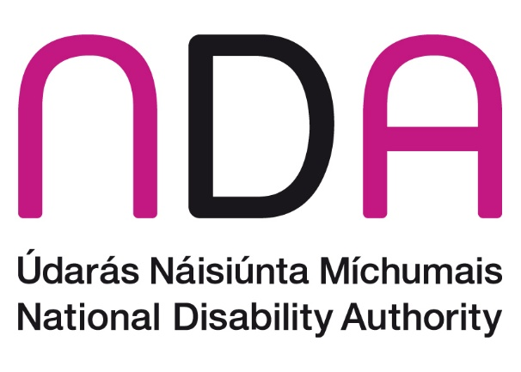

Contents
List of Acronyms 14
Executive Summary 15
Highlights from In-depth Website and Mobile App Reviews 16
Highlights from Simplified Reviews 17
Capacity building and training 19
AI and accessibility 20
Introduction 21
Legislative background 21
The impact of inaccessible websites and mobile apps on persons with disabilities 22
Stakeholder engagement 23
Continuous Improvement 23
Structure of this report 24
In-depth Reviews 24
Methods and Methodology 24
Register 24
Scope 25
Conduct of In-depth Reviews 25
Reporting In-depth Reviews 26
Results 28
Website results 31
1 An Post 31
2 Central Bank of Ireland 34
3 Cheshire Ireland 37
4 Coimisiún Na Meán 40
5 ComReg 43
6 Competition and Consumer Protection Commission 46
7 Gov.ie 49
8 HSeLanD eLearning Module: ‘Designated Person in Incident Management and Open Disclosure’ 52
9 HSE.ie 55
10 Irish Aviation Authority website 58
11 Irish Aviation Authority MySRS eComplaint Form 61
12 National Disability Authority website 64
13 National Shared Services Office Core Portal 67
14 National Transport Authority 70
15 Passport Online (passport renewal form) 73
16 RTB360 76
17 Residential Tenancies Board website 79
18 State Examinations Commission 82
19 UCC Canvas 85
20 UniversalDesign.ie 88
21 Workplace Relations Commission 91
22 Workplace Relations Commission eComplaint form 94
Mobile Application Results 97
1. HSE Health App Android 97
2. HSE Health App iOS 100
3. LEAP Top-Up App Android 103
4. LEAP Top-Up App iOS 106
5. Iarnród Éireann - Irish Rail App Android 109
6. Iarnród Éireann - Irish Rail App iOS 112
7. TFI Driver Check Android 115
8. TFI Driver Check iOS 118
9. TFI GO Android 121
10. TFI GO iOS 124
11. TFI Live Android 127
12. TFI Live iOS 130
Simplified Reviews 133
Methods and Methodology 133
Simplified Reviews Accessibility Score 134
Simplified Review Results 134
User impact 135
Number of errors per page per website 137
Accessibility scores 138
1. Local Authorities 140
2. Transport Service Providers 143
3. Higher Education Institutions 147
4. Education and Training Boards 150
5. European Accessibility Act (EAA) Market Surveillance and Compliance Authorities 153
Conclusion 157
Annex – Accessible Tables 158
In-depth Reviews - Websites 158
An Post 158
Central Bank of Ireland 158
Cheshire Ireland 159
Coimisiún Na Meán 159
ComReg 159
Competition and Consumer Protection Commission 160
Gov.ie 160
HSeLanD eLearning Module: ‘Designated Person in Incident Management and Open Disclosure’ 161
HSE.ie 161
Irish Aviation Authority 162
Irish Aviation Authority eComplaint form 162
National Disability Authority 162
National Shared Services Office Core Portal 163
National Transport Authority 163
Passport Online (passport renewal form) 164
Residential Tenancy Board (RTB) My Account/RTB360 164
Residential Tenancy Board (RTB) main site 165
State Examination Commission 165
UCC Canvas 165
UniversalDesign.ie 166
Workplace Relations Commission 166
Workplace Relations Commission eComplaint 167
In-depth Reviews Mobile Applications 167
HSE Health App Android 167
HSE Health App iOS 167
LEAP Top-Up App Android 168
LEAP Top-Up App iOS 168
Iarnród Éireann - Irish Rail App Android 169
Iarnród Éireann - Irish Rail App iOS 169
TFI Driver Check Android 169
TFI Driver Check iOS 170
TFI GO Android 170
TFI GO iOS 170
TFI Live Android 171
TFI Live iOS 171
Simplified Reviews 172
All Sites 172
Local Authorities 177
Transport Service Providers 179
Higher Education Institutions 180
Education and Training Boards (ETB) 181
EAA Market Surveillance and Compliance Authorities 182
Appendices 184
Appendix 1: WCAG 2.1 Success Criteria 184
Appendix 2: Survey to develop a register of public sector websites and mobile apps 2025 186
Appendix 3: Criteria used to assess Accessibility Statements as part of In-Depth Reviews in 2025 monitoring period 189
Applicable Implementing Decision 189
Provision of Statement 189
Content of Statement 189

Table of Tables
Table 1: Prevalence of disability types in Census 2022 22
Table 2: Total number of WCAG 2.1 A/AA, EN 301 549 and WAD issues identified in In-depth Website and App reviews 28
Table 3: Number and Types of Error per Site 135
Table 4: An Post Most Frequently Identified Issues 158
Table 5: Central Bank of Ireland Most Frequently Identified Issues 158
Table 6: Cheshire Ireland Most Frequently Identified Issues 159
Table 7: Coimisiún Na Meán Most Frequently Identified Issues 159
Table 8: ComReg Most Frequently Identified Issues 159
Table 9: Competition and Consumer Protection Commission Most Frequently Identified Issues 160
Table 10: Gov.ie Most Frequently Identified Issues 160
Table 11: HSeLanD eLearning Module Most Frequently Identified Issues 161
Table 12: HSE.ie Most Frequently Identified Issues 161
Table 13: Irish Aviation Authority Most Frequently Identified Issues 162
Table 14: Irish Aviation Authority eComplaint form Most Frequently Identified Issues 162
Table 15: National Disability Authority Most Frequently Identified Issues 162
Table 16: National Shared Services Office Core Portal Most Frequently Identified Issues 163
Table 17: National Transport Authority Most Frequently Identified Issues 163
Table 18: Passport Online (passport renewal form) Most Frequently Identified Issues 164
Table 19: RTB My Account/RTB360 Most Frequently Identified Issues 164
Table 20: Residential Tenancy Board (RTB) main site Most Frequently Identified Issues 165
Table 21: State Examination Commission Most Frequently Identified Issues 165
Table 22: UCC Canvas Most Frequently Identified Issues 165
Table 23: UniversalDesign.ie Most Frequently Identified Issues 166
Table 24: Workplace Relations Commission Most Frequently Identified Issues 166
Table 25: Workplace Relations Commission eComplaint Most Frequently Identified Issues 167
Table 26: HSE Health App Android Most Frequently Identified Issues 167
Table 27: HSE Health App iOS Most Frequently Identified Issues 167
Table 28: LEAP Top-Up App Android Most Frequently Identified Issues 168
Table 29: LEAP Top-Up App iOS Most Frequently Identified Issues 168
Table 30: Iarnród Éireann - Irish Rail App Android Most Frequently Identified Issues 169
Table 31: Iarnród Éireann - Irish Rail App iOS Most Frequently Identified Issues 169
Table 32: TFI Driver Check Android Most Frequently Identified Issues 169
Table 33: TFI Driver Check iOS Most Frequently Identified Issues 170
Table 34: TFI GO Android Most Frequently Identified Issues 170
Table 35: TFI GO iOS Most Frequently Identified Issues 170
Table 36: TFI Live Android Most Frequently Identified Issues 171
Table 37: TFI Live iOS Most Frequently Identified Issues 171
Table 38: Accessibility Scores - All Sites 172
Table 39: Accessibility Scores - Local Authorities 177
Table 40: Total Number of Errors per Site - Local Authorities 178
Table 41: Accessibility Scores – Transport Service Providers 179
Table 42: Total Number of Errors per Site – Transport Service Providers 179
Table 43: Accessibility Scores – Higher Education Institutions 180
Table 44: Total Number of Errors per Site – Higher Education Institutions 181
Table 45: Accessibility Scores - Education and Training Boards 181
Table 46: Total Number of Errors per Site – Education and Training Boards 182
Table 47: Accessibility Scores - EAA Market Surveillance and Compliance Authorities 182
Table 48: Average Number of Errors per Site - EAA Market Surveillance and Compliance Authorities 183
Table 49: Web Content Accessibility Guidelines (WCAG) 2.1 Success Criteria 184

Table Of Figures
Figure 1: An Post Accessibility Compliance 31
Figure 2: An Post Number of Issues 31
Figure 3: An Post Number of Issues by User Impact 32
Figure 4: An Post 10 Most Frequently Identified Issues 33
Figure 5: Central Bank of Ireland Accessibility Compliance 34
Figure 6: Central Bank of Ireland Number of Issues 34
Figure 7: Central Bank of Ireland Number of Issues by User Impact 35
Figure 8: Central Bank of Ireland 10 Most Frequently Identified Issues 36
Figure 9: Cheshire Ireland Accessibility Compliance 37
Figure 10: Cheshire Ireland Number of Issues 37
Figure 11: Cheshire Ireland Number of Issues by User Impact 38
Figure 12: Cheshire Ireland 10 Most Frequently Identified Issues 39
Figure 13: Coimisiún Na Meán Accessibility Compliance 40
Figure 14: Coimisiún Na Meán Number of Issues 40
Figure 15: Coimisiún Na Meán Number of Issues by User Impact 41
Figure 16: Coimisiún Na Meán 10 Most Frequently Identified Issues 42
Figure 17: ComReg Accessibility Compliance 43
Figure 18: ComReg Number of Issues 43
Figure 19: ComReg Number of Issues by User Impact 44
Figure 20: ComReg 10 Most Frequently Identified Issues 45
Figure 21: Competition and Consumer Protection Commission Accessibility Compliance 46
Figure 22: Competition and Consumer Protection Commission Number of Issues 46
Figure 23: Competition and Consumer Protection Commission Number of Issues by User Impact 47
Figure 24: Competition and Consumer Protection Commission 10 Most Frequently Identified Issues 48
Figure 25: Gov.ie Accessibility Compliance 49
Figure 26: Gov.ie Number of Issues 49
Figure 27: Gov.ie Number of Issues by User Impact 50
Figure 28: Gov.ie 10 Most Frequently Identified Issues 51
Figure 29: HSeLanD eLearning Module Accessibility Compliance 52
Figure 30: HSeLanD eLearning Module Number of Issues 52
Figure 31: HSeLanD eLearning Module Number of Issues by User Impact 53
Figure 32: HSeLanD eLearning Module 10 Most Frequently Identified Issues 54
Figure 33: HSE.ie Accessibility Compliance 55
Figure 34: HSE.ie Number of Issues 55
Figure 35: HSE.ie Number of Issues by User Impact 56
Figure 36: HSE.ie 10 Most Frequently Identified Issues 57
Figure 37: Irish Aviation Authority Accessibility Compliance 58
Figure 38: Irish Aviation Authority Number of Issues 58
Figure 39: Irish Aviation Authority Number of Issues by User Impact 59
Figure 40: Irish Aviation Authority 10 Most Frequently Identified Issues 60
Figure 41: Irish Aviation Authority MySRS eComplaint Form Accessibility Compliance 61
Figure 42: Irish Aviation Authority MySRS eComplaint Form Number of Issues 61
Figure 43: Irish Aviation Authority MySRS eComplaint Form Number of Issues by User Impact 62
Figure 44: Irish Aviation Authority MySRS eComplaint Form 10 Most Frequently Identified Issues 63
Figure 45: National Disability Authority Accessibility Compliance 64
Figure 46: National Disability Authority Number of Issues 64
Figure 47: National Disability Authority Number of Issues by User Impact 65
Figure 48: National Disability Authority 10 Most Frequently Identified Issues 66
Figure 49: National Shared Services Office Core Portal Accessibility Compliance 67
Figure 50: National Shared Services Office Core Portal Number of Issues 67
Figure 51: National Shared Services Office Core Portal Number of Issues by User Impact 68
Figure 52: National Shared Services Office Core Portal 10 Most Frequently Identified Issues 69
Figure 53: National Transport Authority Accessibility Compliance 70
Figure 54: National Transport Authority Number of Issues 70
Figure 55: National Transport Authority Number of Issues by User Impact 71
Figure 56: National Transport Authority 10 Most Frequently Identified Issues 72
Figure 57: Passport Online (passport renewal form) Accessibility Compliance 73
Figure 58: Passport Online (passport renewal form) Number of Issues 73
Figure 59: Passport Online (passport renewal form) Number of Issues by User Impact 74
Figure 60: Passport Online (passport renewal form) 10 Most Frequently Identified Issues 75
Figure 61: RTB360 Accessibility Compliance 76
Figure 62: RTB360 Number of Issues 76
Figure 63: RTB360 Number of Issues by User Impact 77
Figure 64: RTB360 10 Most Frequently Identified Issues 78
Figure 65: Residential Tenancies Board Accessibility Compliance 79
Figure 66: Residential Tenancies Board Number of Issues 79
Figure 67: Residential Tenancies Board Number of Issues by User Impact 80
Figure 68: Residential Tenancies Board Most Frequently Identified Issues 81
Figure 69: State Examinations Commission Accessibility Compliance 82
Figure 70: State Examinations Commission Number of Issues 82
Figure 71: State Examinations Commission Number of Issues by User Impact 83
Figure 72: State Examinations Commission 10 Most Frequently Identified Issues 84
Figure 73: UCC Canvas Accessibility Compliance 85
Figure 74: UCC Canvas Number of Issues 85
Figure 75: UCC Canvas Number of Issues by User Impact 86
Figure 76: UCC Canvas 10 Most Frequently Identified Issues 87
Figure 77: UniversalDesign.ie Accessibility Compliance 88
Figure 78: UniversalDesign.ie Number of Issues 88
Figure 79: UniversalDesign.ie Number of Issues by User Impact 89
Figure 80: UniversalDesign.ie Most Frequently Identified Issues 90
Figure 81: Workplace Relations Commission Accessibility Compliance 91
Figure 82: Workplace Relations Commission Number of Issues 91
Figure 83: Workplace Relations Commission Number of Issues by User Impact 92
Figure 84: Workplace Relations Commission 10 Most Frequently Identified Issues 93
Figure 85: Workplace Relations Commission eComplaint form Accessibility Compliance 94
Figure 86: Workplace Relations Commission eComplaint form Number of Issues 94
Figure 87: Workplace Relations Commission eComplaint form Number of Issues by User Impact 95
Figure 88: Workplace Relations Commission eComplaint form 10 Most Frequently Identified Issues 96
Figure 89: HSE Health App Android Accessibility Compliance 97
Figure 90: HSE Health App Android Number of Issues 97
Figure 91: HSE Health App Android Number of Issues by User Impact 98
Figure 92: HSE Health App Android Most Frequently Identified Issues 99
Figure 93: HSE Health App iOS Accessibility Compliance 100
Figure 94: HSE Health App iOS Number of Issues 100
Figure 95: HSE Health App iOS Number of Issues by User Impact 101
Figure 96: HSE Health App iOS 10 Most Frequently Identified Issues 102
Figure 97: LEAP Top-Up App Android Accessibility Compliance 103
Figure 98: LEAP Top-Up App Android Number of Issues 103
Figure 99: LEAP Top-Up App Android Number of Issues by User Impact 104
Figure 100: LEAP Top-Up App Android Most Frequently Identified Issues 105
Figure 101: LEAP Top-Up App iOS Accessibility Compliance 106
Figure 102: LEAP Top-Up App iOS Number of Issues 106
Figure 103: LEAP Top-Up App iOS Number of Issues by User Impact 107
Figure 104: LEAP Top-Up App iOS Most Frequently Identified Issues 108
Figure 105: Iarnród Éireann - Irish Rail App Android Accessibility Compliance 109
Figure 106: Iarnród Éireann - Irish Rail App Android Number of Issues 109
Figure 107: Iarnród Éireann - Irish Rail App Android Number of Issues by User Impact 110
Figure 108: Iarnród Éireann - Irish Rail App Android 10 Most Frequently Identified Issues 111
Figure 109: Iarnród Éireann - Irish Rail App iOS Accessibility Compliance 112
Figure 110: Iarnród Éireann - Irish Rail App iOS Number of Issues 112
Figure 111: Iarnród Éireann - Irish Rail App iOS Number of Issues by User Impact 113
Figure 112: Iarnród Éireann - Irish Rail App iOS 10 Most Frequently Identified Issues 114
Figure 113: TFI Driver Check Android Accessibility Compliance 115
Figure 114: TFI Driver Check Android Number of Issues 115
Figure 115: TFI Driver Check Android Number of Issues by User Impact 116
Figure 116: TFI Driver Check Android Four Identified Issues 117
Figure 117: TFI Driver Check iOS Accessibility Compliance 118
Figure 118: TFI Driver Check iOS Number of Issues 118
Figure 119: TFI Driver Check iOS Number of Issues by User Impact 119
Figure 120: TFI Driver Check iOS Five Identified Issues 120
Figure 121: TFI GO Android Accessibility Compliance 121
Figure 122: TFI GO Android Number of Issues 121
Figure 123: TFI GO Android Number of Issues by User Impact 122
Figure 124: TFI GO Android 10 Most Frequently Identified Issues 123
Figure 125: TFI GO iOS Accessibility Compliance 124
Figure 126: TFI GO iOS Number of Issues 124
Figure 127: TFI GO iOS Number of Issues by User Impact 125
Figure 128: TFI GO iOS 10 Most Frequently Identified Issues 126
Figure 129: TFI Live Android Accessibility Compliance 127
Figure 130: TFI Live Android Number of Issues 127
Figure 131: TFI Live Android Number of Issues by User Impact 128
Figure 132: TFI Live Android 10 Most Frequently Identified Issues 129
Figure 133: TFI Live iOS Accessibility Compliance 130
Figure 134: TFI Live iOS Number of Issues 130
Figure 135: TFI Live iOS Number of Issues by User Impact 131
Figure 136: TFI Live iOS 10 Most Frequently Identified Issues 132
Figure 137: Average Errors by Severity Level – All Websites 136
Figure 138: WCAG 2.1 Success Criteria with Most Issues Found – All Websites 137
Figure 139: Errors per Page – All Websites 137
Figure 140: Sites with Score of 90% or Higher – All Websites 138
Figure 141: Sites with Score of 10% or Less – All Websites 138
Figure 142: Average Number of Errors per Site – Local Authorities 140
Figure 143: Average Accessibility Scores – Local Authorities 140
Figure 144: Frequency of Main Errors – Local Authorities 141
Figure 145: Total Number of Errors per Site – Local Authorities 142
Figure 146: Accessibility Scores – Local Authorities 142
Figure 147: Average Number of Errors per Site – Transport Service Providers 143
Figure 148: Average Accessibility Score - Transport Service Providers 144
Figure 149: Frequency of Main Errors – Transport Service Providers 144
Figure 150: Total Number of Errors per Site – Transport Service Providers 145
Figure 151: Accessibility Scores – Transport Service Providers 146
Figure 152: Average Number of Errors per Site – Higher Education Institutions 147
Figure 153: Average Accessibility Score - Higher Education Institutions 148
Figure 154: Frequency of Main Errors – Higher Education Institutions 148
Figure 155: Total Number of Errors per Site – Higher Education Institutions 149
Figure 156: Accessibility Scores – Higher Education Institutions 149
Figure 157: Average Number of Errors per Site – Education and Training Boards 150
Figure 158: Average Accessibility Scores – Education and Training Boards 151
Figure 159: Frequency of Main Errors – Education and Training Boards 151
Figure 160: Total number of Errors per Site – Education and Training Boards 152
Figure 161: Accessibility Scores – Education and Training Boards 152
Figure 162: Average Number of Errors per Site - EAA Market Surveillance and Compliance Authorities 153
Figure 163: Average Accessibility Scores - EAA Market Surveillance and Compliance Authorities 153
Figure 164: Frequency of Main Errors – EAA Market Surveillance and Compliance Authorities 154
Figure 165: Total Number of Errors per Site – EAA Market Surveillance and Compliance Authorities 155
Figure 166: Accessibility Scores – EAA Market Surveillance and Compliance Authorities 156

List of Acronyms
ARIA – Accessible rich internet applications
CSS – Cascading style sheets
EAA - European Accessibility Act
EN – European norm
ETB – Education and training board
EU – European Union
HTML – Hypertext markup language
ICS – Irish Computer Society
IDR - In-depth review
NDA – National Disability Authority
NVDA – Non-visual Desktop Access
OGCIO - Office of the Government Chief Information Office
SC – success criteria
SI – statutory instrument
SR – simplified review
URL – uniform resource locator
WAD – Web Accessibility Directive
WCAG – Web Content Accessibility Guidelines

Executive Summary
Directive (EU) 2016/2102 of the European Parliament and of the Council of 26 October 2016 on the accessibility of the websites and mobile applications of public sector bodies” (the Directive) requires Member States to ensure that websites and mobile applications (apps) of public sector bodies are fully accessible to persons with disabilities. The National Disability Authority (NDA) is named as the National Monitoring Body in the European Union (Accessibility of Websites and Mobile Applications of Public Sector Bodies) Regulations 2020.
This report covers the 2025 monitoring period. NDA is required under the Directive’s Implementing Decision 2018/1524 to provide monitoring data in a national report to the European Commission every three years. The current report is the first of three annual reports for the monitoring period 2025-2027. Collectively, these reports fulfil NDA’s reporting obligations under the Directive’s Implementing Decision and will be available on the NDA website.
The NDA conducted 233 Simplified Reviews, 22 In-depth Reviews on websites and 12 In-depth Reviews on mobile apps for the 2025 monitoring period. NDA continued to monitor the websites and mobile apps of priority digital services for persons with disabilities in the areas of transport, health, education and training and employment. Comparative data for specific groupings of public bodies monitored, including the higher education, Local Authority and transport sectors, is presented in the section on Simplified Reviews. In this monitoring year on 28 June 2025, the European Accessibility Act came into effect. This is a European Directive that contains accessibility requirements for a range of products and services. The NDA is responsible for advising the relevant market surveillance authority and compliance authorities in Ireland on matters related to the accessibility requirements. These six public sector bodies underwent simplified review and formed a new comparative grouping, and each also underwent in-depth review in this year’s report.
The NDA continued to work closely with the Office of the Government Chief Information Office (OGCIO) and conducted an in-depth review on gov.ie the central website for government services and information where the websites of Irish government departments can be accessed. For the first time, the NDA reviewed a registered charitable organisation called Cheshire Ireland, which was chosen because its largest funder is a public sector body, the Health Service Executive. NDA reviewed an eLearning course, namely the Health Service Executive’s “Role of the designated person in Incident Management and Open Disclosure”. The NDA expects that the learning from this review will be applied to further eLearning courses provided to staff by the HSE.

Highlights from In-depth Website and Mobile App Reviews
The WCAG 2.1 AA Success Criteria with the largest number of issues detected by In-depth Reviews for the 2025 monitoring period are “Contrast (Minimum)” (19.5% of issues), “Name, Role, Value” (17.4%) and “Information and relationships” (15.2%). These 3 criteria were also the top sources of issues in 2024. There is a remarkable decrease in “Name, Role, Value” issues, from 1,151 in 2024 to 454 in 2025. However, the number of issues under “Contrast (Minimum)” has more than doubled, from 225 in 2024 to 507 in 2025. “Info and Relationships” has also modestly but noticeably increased, from 321 in 2024 to 397 in 2025. Of the 2,604 issues identified in 2025, 2,530 related to WCAG 2.1 Level A or AA criteria. In 2024, 2,585 issues relating to WCAG 2.1 Level A or AA were identified. This indicates that the decrease in “Name, Role, Value” issues is being largely offset by increased issues counted elsewhere.
A key difference between Simplified and In-depth Reviews is in the number of tests conducted manually and using assistive technology by expert reviewers. The decrease in “Name, Role, Value” errors detected is positive as these errors typically are found on interactive elements of a website. This indicates that operable elements of the websites and apps reviewed in 2025 are distinctly more accessible than in 2024. These elements include buttons, form fields, search fields, cookie modals, and more.
The “Contrast (Minimum)” and “Info and Relationships” criteria are related to how perceivable the information on a webpage or app screen is. There was also an increase in “Non-Text Contrast” issues in this monitoring period, from 126 in 2024 to 192 in 2025. At the same time, there was a decrease in “Non-Text Content” issues, from 184 in 2024 to 120 in 2025. While text alternatives for non-text content are being provided, text and other content being displayed may not meet colour contrast thresholds, and there may still be information that is presented visually without text alternative.
NDA continued to observe new digital development and redesign projects considering accessibility from the start. The Residential Tenancies Board deployed a new website in 2025. This redesign significantly reduced the number of “Name, Role, Value”, “Contrast (Minimum)”, and “Headings” issues identified on the site. The NDA reviewed the new Health App from the HSE for Android and iOS, which had been developed with continuous internal accessibility testing. This app met 88% and 85% of applicable criteria on Android and iOS respectively, showing the immediate impact of developing with accessibility in mind.

Public sector websites and mobile apps are required under the Directive to provide an Accessibility Statement. An Accessibility Statement must include information such as a declaration of compliance and information on how a person may provide feedback or make a complaint regarding the accessibility of the website or mobile app. For websites (n=22), 27% had no Accessibility Statement, 18% had Accessibility Statements meeting some requirements and 50% met most requirements of the Directive. Only one website (4.5%) met all requirements. For mobile applications (n=12), 17% had no Accessibility Statement and 83% met most of the requirements of the Directive. No mobile app met all the requirements of the Directive.
The NDA recommends that all public bodies publish and maintain an accurate and up to date Accessibility Statement on each of their websites and mobile apps.

Highlights from Simplified Reviews
Several improvements have been demonstrated by the analysis of simplified data for the 2025 monitoring period:
- The average number of errors per site reduced from 4,200 in 2024 to 3,570 in 2025. No errors were found on 47.9% of pages reviewed.
- In 2024 the number of serious errors was 3,026 and critical errors was 1,174. These figures reduced to 2,600 and 969 respectively in the 2025 monitoring period. This may be due to the NDA’s advice to prioritise the remediation of critical errors.
The NDA encourages public bodies that have achieved high Simplified Review scores to conduct user testing and in-depth manual accessibility testing to progressively improve accessibility and compliance with the Directive.
The most common error identified on most sites related to PDFs. PDF errors were the most common kind of error on 158 of 233 sites, or 68% of sites subject to Simplified Review in 2025. This is similar to the findings of the 2024 report, when PDF errors accounted for the highest total number of errors on 139 of the 232 sites. Next, Colour Contrast accounted for the highest number of errors for thirty-six, or 15.4% of websites. The third most frequent error “Name, Role, Value” was found on seventeen, or 7.3% of websites. It is frequently associated with how interactive elements are coded on pages such as search forms, application forms, cookie banners and other interactive components.
The NDA provided training on PDF accessibility in 2024 and presented to content providers from government departments on accessible document and content creation. The OGCIO has developed guidance to support content creators in this regard. Further training on PDF accessibility was provided in 2025.
The NDA recommends that accessibility is considered at the earliest stage of content creation. The accessibility features and checkers in office application software such as MS Word and Adobe Acrobat Pro should be used. Additional manual checks should also be performed. Where PDFs are created by a design agency, a clear set of accessibility requirements should be provided to the agency.
Application forms in inaccessible PDFs have a critical impact on some users’ ability to use a service online and should be prioritised for remediation. The NDA welcomes initiatives by the OGCIO such as FormsIE, “a digital solution for online forms that is user-friendly, efficient and accessible”, as this will provide an accessible alternative to inaccessible PDF forms.
The practice of publishing inaccessible PDFs will continue to be a barrier to public sector bodies in reaching full compliance with the Directive.

For the fifth monitoring period in succession, a large majority of websites reviewed (n=123) contained seven or more errors per page, many of which were the same error repeated either multiple times on the same page, or the same error occurring across multiple pages. For some categories of errors, one repair could resolve numerous errors.
The following priority sectors were comparatively grouped in the analysis:
- Local Authorities
- Transport Service Providers
- Higher Education Institutions
- Education and Training Boards
- European Accessibility Act (EAA) Market Surveillance and Compliance Authorities. As the EAA came into force on 28 June 2025 this was added as a new comparative group this year.
Similar to the previous monitoring period, there was an increase in the number of Local Authority websites scoring greater than 90% in their Simplified Review results (n= 11). Accessibility scores significantly increased in several local authorities including:
- Donegal County Council (from 37.8% in 2024 to 94.4% in 2025)
- Laois County Council (from 21% in 2024 to 84.0% in 2025)
- Galway City Council (from 36.2% in 2024 to 79.1% in 2025)
- Monaghan County Council (from 39.4% in 2024 to 73.1% in 2025).
However, a significant minority of Local Authority Simplified Review results remain static.
Other websites that made notable improvements in their Simplified Review results between 2024 and 2025 monitoring periods include:
- Bord Bia (38.6% to 94.7%)
- the Courts Service of Ireland (40.7% to 100%)
- Donegal County Council (37.8% to 94.4%)
- Dundalk Institute of Technology (28.3% to 81.7%)
- ESB International (0% to 92%)
- Go Ahead Ireland (0% to 58.5%)
- Health Products Regulatory Authority (1.6% to 83.8%)
- Tourism Ireland (0.5% to 64.4%)
- IHREC (23.5% to 76.4%)
- Mary Immaculate College (36.3% to 92%)
- ETB Tipperary (1.7% to 52.8%)
- ETB Kerry (48.1% to 90.3%)
- Luas (1.7% to 69.5%).
In the transport sector, the average number of errors for all transport providers increased from 1,543 in 2024 to 2,315 in the 2025 monitoring period. Luas, Go Ahead Ireland and TFI Leap reduced their total number of website errors. Bus Éireann, Dublin Bus and Iarnród Éireann - Irish Rail increased the total number of errors on their websites. Accessibility Scores for Luas and Go Ahead Ireland increased. Scores for other providers decreased.

Capacity building and training
The NDA in partnership with the Irish Computer Society (ICS) hosted an online training webinar delivered by AbilityNet titled ‘PDF Accessibility’ on 17 April 2025. The NDA recommends that PDF forms should be avoided for all online services and accessible HTML used instead. However, there has been feedback from some public sector bodies that certain documents cannot be made available in a form other than PDF. The NDA advises that specialised supports from accessibility experts may be required to ensure forms and online services are accessible from start to finish.
The webinar was attended by more than 300 online participants and covered topics such as checking PDFs for accessibility, working with tags in PDFs and accessibility of scanned documents and PDF forms. Slides from the event are available on the CEUD website and a recording was shared with public sector body staff who are registered on the Monitoring and Reporting Platform.

AI and accessibility
In last year’s report, the NDA recommended that all interactive elements, including forms and widgets such as Cookie Banners, are designed and implemented to be accessible. During this year the NDA noticed a sharp decrease in the accessibility score for some websites it was monitoring. After a thorough investigation, the reason for the reduced scores was a critical issue being caused by a third-party cookie consent manager. The NDA reached out to all affected public sector bodies to inform them of the situation and urged them to contact the company that provides the cookie consent manager. The NDA also reached out to the company to inform them of the impact this issue was having on our requirements as the National Monitoring Body for the EU WAD. The issue was eventually resolved by the company after an investigation.
Article 1 of the Web Accessibility Directive states that third-party content can only be exempt if it is 'neither funded nor developed by, nor under the control of, the public sector body concerned'. Therefore, third-party content on a website must be accessible if it is funded by, developed by or is under a control of public sector body. The NDA reached out to all public sector bodies registered on our monitoring and reporting platform to inform them of the increased risk and to advise caution when procuring AI or AI-powered tools and having processes in place for testing and addressing issues that arise.
In November 2025 as part of Public Service Transformation Week, the Centre for Excellence in Universal Design (CEUD) at the NDA ran an in-person event entitled “AI as an Accessibility Partner” to raise awareness and promote discussion on the challenges and potential benefits of AI use in the public sector. The workshop explored how AI could support the public sector in delivering accessible services, and where it risks compromising accessibility.

Introduction
This report contains monitoring data on the 233 Simplified, 22 In-depth website reviews and 12 in-depth mobile app reviews conducted by NDA for the 2025 monitoring period under the EU Web Accessibility Directive. Ireland’s monitoring reports for the years 2018-2024 are available on the NDA’s website. The NDA conducts two types of monitoring reviews reported in this document:
- In-depth reviews on websites and mobile apps
- Simplified reviews on websites.
The completed report will be submitted to the Minister and published on the NDA website.

Legislative background
The EU Web Accessibility Directive is also known as Directive (EU) 2016/2102 of the European Parliament and of the Council of 26 October 2016 on the accessibility of the websites and mobile applications of public sector bodies. Under this directive public bodies in Ireland must ensure their websites and mobile apps are accessible to all people, including persons with disabilities.
In summary public sector bodies must:
- Ensure their website and mobile apps are procured, developed and maintained to comply with all relevant parts of the harmonised standard EN 301 549 v 3.2.1 “Accessibility requirements for ICT products and services”. This is broadly equivalent to reaching conformance-rating AA with the Web Content Accessibility Guidelines 2.1.
- Maintain an up-to-date Accessibility Statement on a prominent area of the website or link from the mobile app. The Accessibility Statement must contain accurate information on the website’s compliance. It must include contact details for people to request assistance or make a formal complaint in relation to the website’s accessibility as required under Irish Regulations. (S7.4.c)). See more on the requirement for an Accessibility Statement and NDA guidance.
- Ensure relevant staff are aware of and receive adequate training on web accessibility.
Commission Implementing Decision (EU) 2018/1523 of 11 October 2018 establishing a model accessibility statement in accordance with Directive (EU) 2016/2102 of the European Parliament and of the Council on the accessibility of the websites and mobile applications of public sector bodies. This provides the model accessibility statement to be used by public sector bodies in the Member States on the compliance of their websites and mobile applications with the requirements of Directive (EU) 2016/2102.
Commission Implementing Decision 2018/1524 of 11 October 2018 establishing a monitoring methodology and the arrangements for reporting by Member States in accordance with Directive (EU) 2016/2102 of the European Parliament and of the Council on the accessibility of the websites and mobile applications of public sector bodies. This requires National Monitoring Bodies to maintain a register of websites and mobile apps for review in the current monitoring period. The selection of the sample for review should include websites representing as much as possible the variety of services provided by the public sector bodies. This includes “social protection, health, transport, education, employment and taxes, environmental protection, recreation and culture, housing and community amenities and public order and safety.”
S.I. No. 358/2020 - European Union (Accessibility of Websites and Mobile Applications of Public Sector Bodies) Regulations 2020 which came into force on 23 September 2020. These Regulations transpose the European Union Web Accessibility Directive and oblige public bodies to take necessary measures to make their websites and mobile applications more accessible by making them perceivable, operable, understandable and robust.

The impact of inaccessible websites and mobile apps on persons with disabilities
In Ireland, the most common source of data on disability comes from the Central Statistics Office (CSO). The CSO carries out many surveys and is an authoritative source for lots of information. The 2022 Census tells us that 1,109,557 people in Ireland have a disability, that is 21.5% of the population, or 1 in 5. The most common type of disability is ‘Pain, breathing or any other chronic illness or condition’. The next most common is ‘A condition that causes difficulty participating in other physical activities’. Table 1 is adapted from the CSO dataset presented in their table “F4066 Population with a Disability” and numbers shown do not add up to the 1,109,557 reported above because people can have more than one disability. The next national census is scheduled for 2027.
Table 1: Prevalence of disability types in Census 2022
Type of difficulty or condition | Population
People with a disability | 1,109,557
Pain, breathing or any other chronic illness or condition | 440,090
Difficulty participating in other activities | 349,995
Basic physical activities | 349,155
Difficulty working at a job or business or attending school or college | 303,859
Blindness or vision impairment | 296,601
Psychological or emotional condition or a mental health issue | 269,789
Learning, remembering or concentrating | 259,050
Difficulty going outside the home | 258,243
Deafness or hearing impairment | 233,420
Difficulty dressing, bathing or getting around inside the home | 215,609
An intellectual disability | 109,288

Stakeholder engagement
Consultation with persons with disabilities and disabled persons organisations is a key part of the development of this report. In previous years the NDA developed a register of websites and mobile apps to review based on a survey circulated in August 2021 and ongoing consultation with stakeholders and disabled persons organisations. In January 2025 a new survey was circulated to NDA stakeholders and disabled persons organisations (DPOs) which informed the development of the register in combination with ongoing consultation. This survey included one additional question (question 2): “Do you think that public sector websites and apps are more accessible than they were three years ago?” The full survey can be viewed in Appendix 1.

Continuous Improvement
The NDA is committed to continuous improvement in our monitoring and reporting activities.
Actions to improve accessibility implemented in this reporting period:
- committing to undertaking an annual survey to consult with the public on websites and mobile apps
- the consultation survey was run on the Microsoft Forms platform which was designed with accessibility in mind and pre-tested
- our reporting outputs are being published as accessible Microsoft Word documents instead of PDF
- ensuring charts have sufficient colour contrast where applicable
- ensuring that data contained in charts is also provided in the main text of the document
- publishing a screen reader friendly version of the report
- publishing a plain language executive summary of the report.
For the 2026 monitoring period, the NDA are planning to trial the six-month snapshot that was a feature of their Summary Report of Ireland’s Monitoring 2022-2024 three-year report. This will mean that public sector bodies subject to simplified review for that year will have a snapshot taken most likely in April and another snapshot likely in September. This will offer public bodies the opportunity to view their website accessibility and take steps to improve before the next snapshot.
If you have suggestions on how to make our reporting documentation more accessible, please email webaccessmonitor@nda.ie.

Structure of this report
The main body of the report presents the methods and methodology, results from the 34 In-depth Reviews and 233 Simplified Reviews conducted, as well as the conclusion. The Annex contains accessible data tables, and the appendices present the selection criteria used in testing, the survey questions used to inform the development of the 2025 register and criteria used to assess Accessibility Statements as part of In-Depth Reviews in 2025 monitoring period.

In-depth Reviews

Methods and Methodology
The methods developed by the NDA for In-depth Reviews is optimised to provide accurate and actionable feedback to public sector bodies based on the review.

Register
A register of websites and mobile applications for review was developed based on:
- a consultative survey with members of the public including persons with disabilities, and disabled persons organisations (DPOs)
- a small number of reviews scheduled annually
- agreed areas of focus for the year 2025.
A Notice of Monitoring email was sent to all public bodies with websites and mobile applications subject to review. This email notified the public bodies of the specific websites/apps being reviewed and requested dedicated liaisons to be nominated for follow-up contact. Information on public bodies’ obligations under the EU WAD and links to relevant legislation, guidance and webinars were included in this email.
For each website and mobile application, a brief qualitative summary description of the accessibility of the site is provided based on the review results and information provided by that public body.

Scope
Based on the sampling criteria in Implementing Decision 2018/1524, a scope of 8-12 pages was chosen for each website/app.
The following pages were added to the testing scope:
- the Home, Sitemap, Contact, Help and Legal Information pages, where each of these pages were present
- pages containing the Accessibility Statement or policy and the pages containing the feedback mechanism, if separate
- search function/results page
- one relevant page for each type of service provided by the website or mobile application and any other primary intended uses of it
- examples of pages having a substantially distinct appearance or presenting different elements
- examples of pages with interactive elements
- at least one relevant downloadable document, where applicable, for each type of service provided by the website or mobile application and any other primary intended uses of it
- any other page deemed relevant to persons with disabilities by the monitoring body.
Components repeated across the website or mobile application, such as headers, footers, and navigation menus, were added to the testing scope as Components. This allowed for any issues therein to be identified without having to note the same issue across multiple pages.

Conduct of In-depth Reviews
From June to August 2022, the NDA conducted a public procurement exercise to provide a robust and transparent Review and Reporting Process for conducting in-depth, manual reviews of mobile apps and websites, as specified in Commission Implementing Decision (EU) 2018/1524. This contract was awarded to Deque Systems.
In-depth Reviews were conducted by the NDA and Deque Systems. The Axe Accessibility browser extension tool, developed by Deque, was used to execute some of the automated testing. These tests were identical in scope to the automated tests covered by Simplified Reviews.
Tests were then manually conducted for each WAD success criterion. This included WCAG 2.1 A criteria, WCAG 2.1 AA criteria, criteria specific to EN 301 549, and criteria specific to the WAD. Each Success Criterion was marked Pass, Fail or Not Applicable (N/A).
Where a Fail was recorded, a description of the element that failed to meet the standard and of how it failed to meet the standard was provided. Screenshots were sometimes included to help illustrate the location of the element or the issue being described.
The severity of the errors was also recorded (Blocker, Critical, Serious, Moderate or Minor) based on the potential impact of that error to users of the website.

Tools
The following tools sets were used for testing.
Browser/OS and screen readers:
- Google Chrome browser and NVDA screen reader
- Android mobile OS and TalkBack screen reader
- iOS mobile OS and VoiceOver screen reader.
Accessibility testing tools:
- Chrome Developer Toolbar
- WAVE Evaluation Tool browser extension
- Axe Accessibility browser extension
- Colour Contrast Analyser desktop application
Reporting and collaboration tools:
- axe Auditor browser extension
- Microsoft Planner software application.

Reporting In-depth Reviews

User impact
In-depth Reviews use WCAG 2.1 AA Success Criteria to check user impact based on four basic principles for ensuring accessibility for persons with disabilities:
- Can all users, with the abilities and senses that they possess, perceive the information the application presents to them?
- Can users, with their specific input device or assistive technology, operate all the controls within the application’s user interface?
- Can the users understand the information and the user interface controls?
- Is the content robust enough that it can be interpreted reliably by a wide variety of user agents, including assistive technologies?
Five types of user impacts provided for In-depth Reviews:
- Blocker: prevents some users with disabilities from using core content
- Critical: prevents some users with disabilities from accessing certain parts of the content, potentially rendering it unusable
- Serious: presents serious barriers for some users with disabilities and will partially prevent them from using portions of the content
- Moderate: presents some barriers for users with disabilities that will reduce their overall experience with the content
- Minor: causes some nuisance or can be annoying, but do not present barriers for users with disabilities.
Key findings and issues identified across all WCAG 2.1 AA success criteria are also presented for each website and mobile application.

Results
Table 2 identifies the total number of issues identified for all Success Criteria (SC) across websites and apps reviewed in 2025. These SC comprise criteria from WCAG 2.1 Level A and AA, criteria specific to EU standard EN 301 549, and criteria specific to the Web Accessibility Directive. As this expands on the list of criteria included in Table 2 in previous years, comparisons across years will be made using total number of issues under a given criterion, rather than percentages. The coloured rows below highlight the three most frequently identified issues.
Table 2: Total number of WCAG 2.1 A/AA, EN 301 549 and WAD issues identified in In-depth Website and App reviews
SC  Description | SC Source | Issues | #errors as a % of total
1.1.1 Non-Text Content | WCAG 2.1 A | 120 | 4.6%
1.2.1 Audio-only and Video-only (Pre-recorded) | WCAG 2.1 A | 1 | 0.0%
1.2.2 Captions (Pre-recorded) | WCAG 2.1 A | 2 | 0.1%
1.2.3 Audio Description or Media Alternative (Pre-recorded) | WCAG 2.1 A | 3 | 0.1%
1.2.4 Captions (Live) | WCAG 2.1 AA | 0 | 0.0%
1.2.5 Audio Description (Pre-recorded) | WCAG 2.1 AA | 4 | 0.2%
1.3.1 Info & Relationships | WCAG 2.1 A | 397 | 15.2%
1.3.2 Meaningful Sequence | WCAG 2.1 A | 68 | 2.6%
1.3.3 Sensory Characteristics | WCAG 2.1 A | 1 | 0.0%
1.3.4 Orientation | WCAG 2.1 AA | 8 | 0.3%
1.3.5 Identify Input Purpose | WCAG 2.1 AA | 33 | 1.3%
1.4.1 Use of Colour | WCAG 2.1 A | 50 | 1.9%
1.4.10 Reflow | WCAG 2.1 AA | 64 | 2.5%
1.4.11 Non-Text Contrast | WCAG 2.1 AA | 192 | 7.4%
1.4.12 Text Spacing | WCAG 2.1 AA | 13 | 0.5%
1.4.13 Content on Hover or Focus | WCAG 2.1 AA | 23 | 0.9%
1.4.2 Audio Control | WCAG 2.1 A | 0 | 0.0%
1.4.3 Contrast (Minimum) | WCAG 2.1 AA | 507 | 19.5%
1.4.4 Resize Text | WCAG 2.1 AA | 22 | 0.8%
1.4.5 Images of Text | WCAG 2.1 AA | 15 | 0.6%
2.1.1 Keyboard | WCAG 2.1 A | 76 | 2.9%
2.1.2 No Keyboard Trap | WCAG 2.1 A | 8 | 0.3%
2.1.4 Character Key Shortcuts | WCAG 2.1 A | 0 | 0.0%
2.2.1 Timing Adjustable | WCAG 2.1 A | 7 | 0.3%
2.2.2 Pause, Stop, Hide | WCAG 2.1 A | 4 | 0.2%
2.3.1 Three Flashes or Below Threshold | WCAG 2.1 A | 0 | 0.0%
2.4.1 Bypass Blocks | WCAG 2.1 A | 1 | 0.0%
2.4.2 Page Titled | WCAG 2.1 A | 27 | 1.0%
2.4.3 Focus Order | WCAG 2.1 A | 57 | 2.2%
2.4.4 Link Purpose (In Context) | WCAG 2.1 A | 40 | 1.5%
2.4.5 Multiple Ways | WCAG 2.1 AA | 0 | 0.0%
2.4.6 Headings and Labels | WCAG 2.1 AA | 65 | 2.5%
2.4.7 Focus Visible | WCAG 2.1 AA | 71 | 2.7%
2.5.1 Pointer Gestures | WCAG 2.1 A | 5 | 0.2%
2.5.2 Pointer Cancellation | WCAG 2.1 A | 0 | 0.0%
2.5.3 Label in Name | WCAG 2.1 A | 60 | 2.3%
2.5.4 Motion Actuation | WCAG 2.1 A | 0 | 0.0%
3.1.1 Language of Page | WCAG 2.1 A | 6 | 0.2%
3.1.2 Language of Parts | WCAG 2.1 AA | 39 | 1.5%
3.2.1 On Focus | WCAG 2.1 A | 1 | 0.0%
3.2.2 On Input | WCAG 2.1 A | 0 | 0.0%
3.2.3 Consistent Navigation | WCAG 2.1 AA | 0 | 0.0%
3.2.4 Consistent Identification | WCAG 2.1 AA | 0 | 0.0%
3.3.1 Error Identification | WCAG 2.1 A | 9 | 0.3%
3.3.2 Labels or Instructions | WCAG 2.1 A | 28 | 1.1%
3.3.3 Error Suggestion | WCAG 2.1 AA | 5 | 0.2%
3.3.4 Error Prevention (Legal, Financial, Data) | WCAG 2.1 AA | 0 | 0.0%
4.1.1 Parsing | WCAG 2.1 A | 0 | 0.0%
4.1.2 Name, Role, Value | WCAG 2.1 A | 454 | 17.4%
4.1.3 Status Messages | WCAG 2.1 AA | 44 | 1.7%
5.2 Activation of accessibility features | EN 301 549 | 0 | 0.0%
5.3 Biometrics | EN 301 549 | 0 | 0.0%
5.4 Preservation of accessibility information during conversion | EN 301 549 | 0 | 0.0%
7.1.1 Captioning playback | EN 301 549 | 0 | 0.0%
7.1.2 Captioning synchronization | EN 301 549 | 0 | 0.0%
7.1.3 Preservation of captioning | EN 301 549 | 0 | 0.0%
7.1.4 Captions characteristics | EN 301 549 | 0 | 0.0%
7.1.5 Spoken subtitles | EN 301 549 | 0 | 0.0%
7.2.1 Audio description playback | EN 301 549 | 22 | 0.8%
7.2.2 Audio description synchronization | EN 301 549 | 0 | 0.0%
7.2.3 Preservation of audio description | EN 301 549 | 0 | 0.0%
7.3 User controls for captions and audio description | EN 301 549 | 11 | 0.4%
9 Web | EN 301 549 | 0 | 0.0%
10 Non-web Documents | EN 301 549 | 0 | 0.0%
11 Software | EN 301 549 | 0 | 0.0%
11.7 User Preferences | EN 301 549 | 2 | 0.1%
11.8.2 Accessible Content Creation | EN 301 549 | 0 | 0.0%
11.8.3 Preservation of accessibility information in transformations | EN 301 549 | 0 | 0.0%
11.8.4 Repair Assistance | EN 301 549 | 0 | 0.0%
11.8.5 Templates | EN 301 549 | 4 | 0.2%
12.1.1 Accessibility and compatibility features | EN 301 549 | 6 | 0.2%
12.1.2 Accessible documentation | EN 301 549 | 0 | 0.0%
12.2.2 Information on accessibility and compatibility features | EN 301 549 | 0 | 0.0%
12.2.3 Effective communication | EN 301 549 | 1 | 0.0%
12.2.4 Accessible documentation | EN 301 549 | 0 | 0.0%
Accessibility Statement | Web Accessibility Directive | 26 | 1.0%
Feedback Mechanism | Web Accessibility Directive | 2 | 0.1%
Total |  | 2604 | 100%

Website results

1 An Post

Key findings
This website met 69% of applicable success criteria while 31% were not satisfied (Figure 1)
Figure 1: An Post Accessibility Compliance
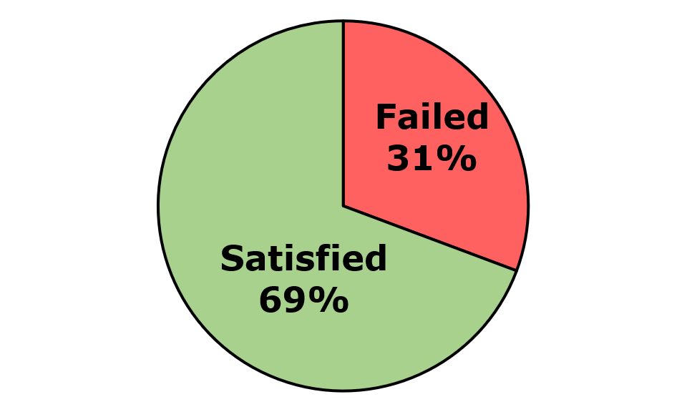
Across the five components and 12 pages that were assessed, 120 issues were identified. These comprised 118 WCAG issues, two EN 301 549-specific issues, and zero WAD-specific issues. Of the WCAG issues, there were 61 WCAG Level A and 57 WCAG Level AA issues (Figure 2).
Figure 2: An Post Number of Issues
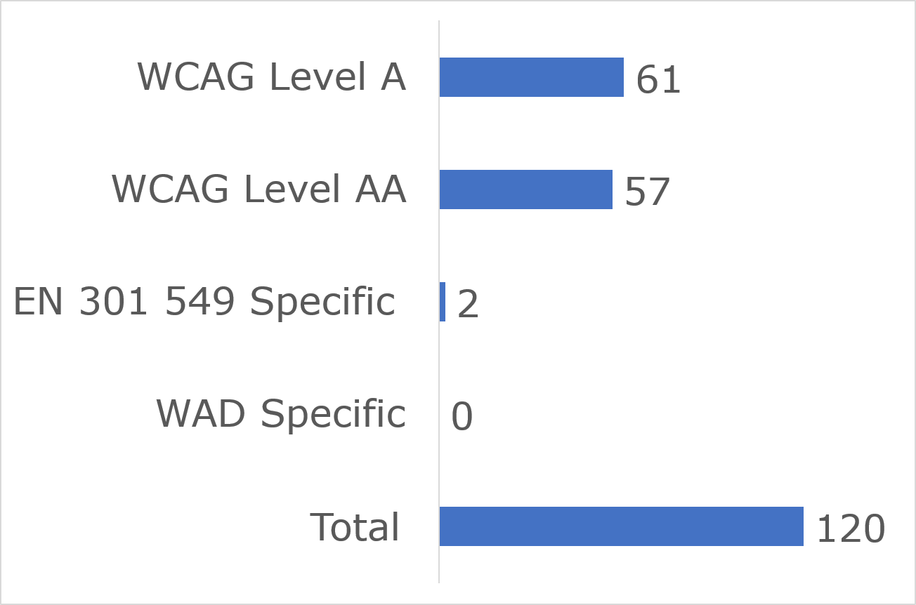

User impact
Most errors were classified as having “Serious” user impact (n=92), with the second highest number classified as “Critical” (n=22) and then “Moderate” (n=6). No “Blocker” or “Minor” issues were identified (Figure 3).
Figure 3: An Post Number of Issues by User Impact
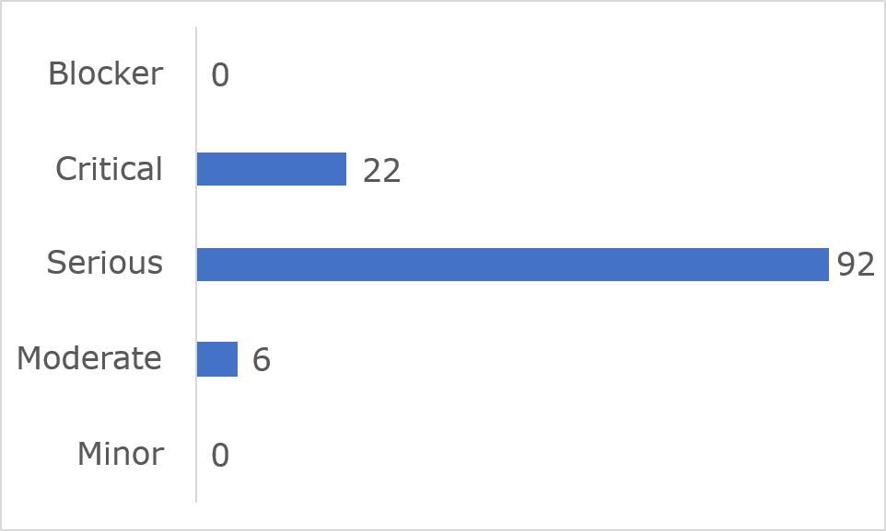

Frequently Identified Issues
Five success criteria were related to 55.1% of all issues:
- 1.4.11 Non-text Contrast: 25.0%
- 4.1.2 Name, Role, Value: 9.2%
- 1.4.3 Contrast (Minimum): 7.5%
- 2.4.4 Link Purpose (In Context): 6.7%
- 2.5.3 Label in Name: 6.7%
Figure 4: An Post 10 Most Frequently Identified Issues
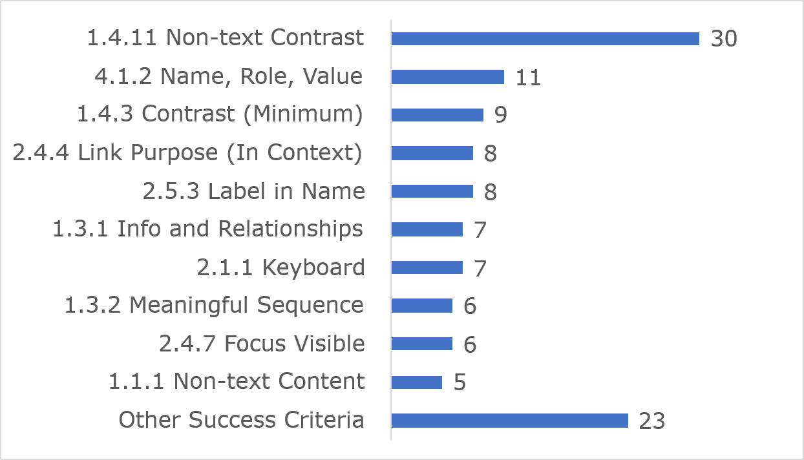
Among the 10 most frequently identified issues, (1.4.11) Non-text Contrast accounted for 30 instances, 11 were related to (4.1.2) Name, Role, Value and nine issues were linked to (1.4.3) Contrast (Minimum).
Link to accessible table

Accessibility Statement
An Post’s website Accessibility Statement contains most of the content required under the Directive.

2 Central Bank of Ireland

Key Findings
This website met 75% of applicable success criteria while 25% were not satisfied (Figure 5).
Figure 5: Central Bank of Ireland Accessibility Compliance
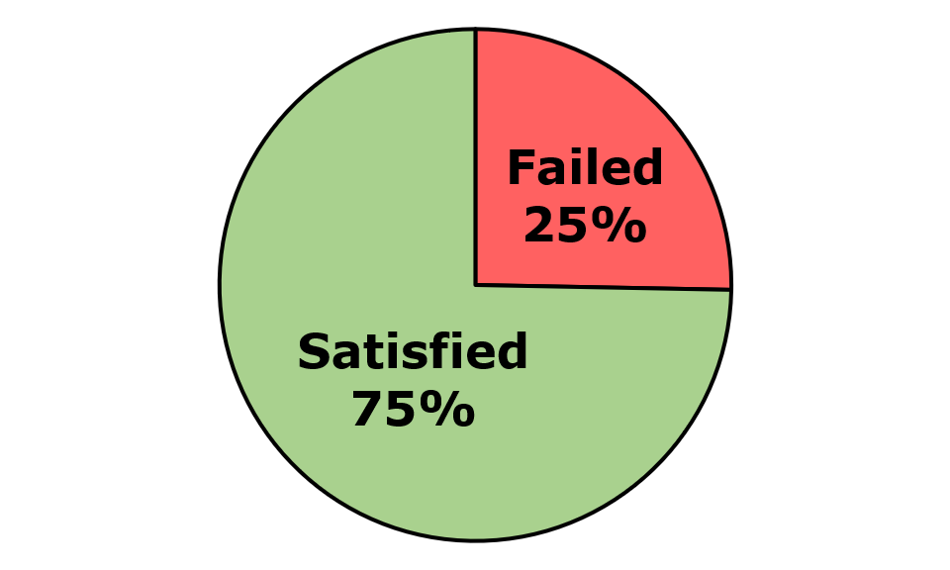
Across the three components and nine pages that were assessed, 57 issues were identified. These comprised 57 WCAG issues, zero EN 301 549-specific issues, and zero WAD-specific issues. Of the WCAG issues, there were 31 WCAG Level A and 26 WCAG Level AA issues (Figure 6).
Figure 6: Central Bank of Ireland Number of Issues
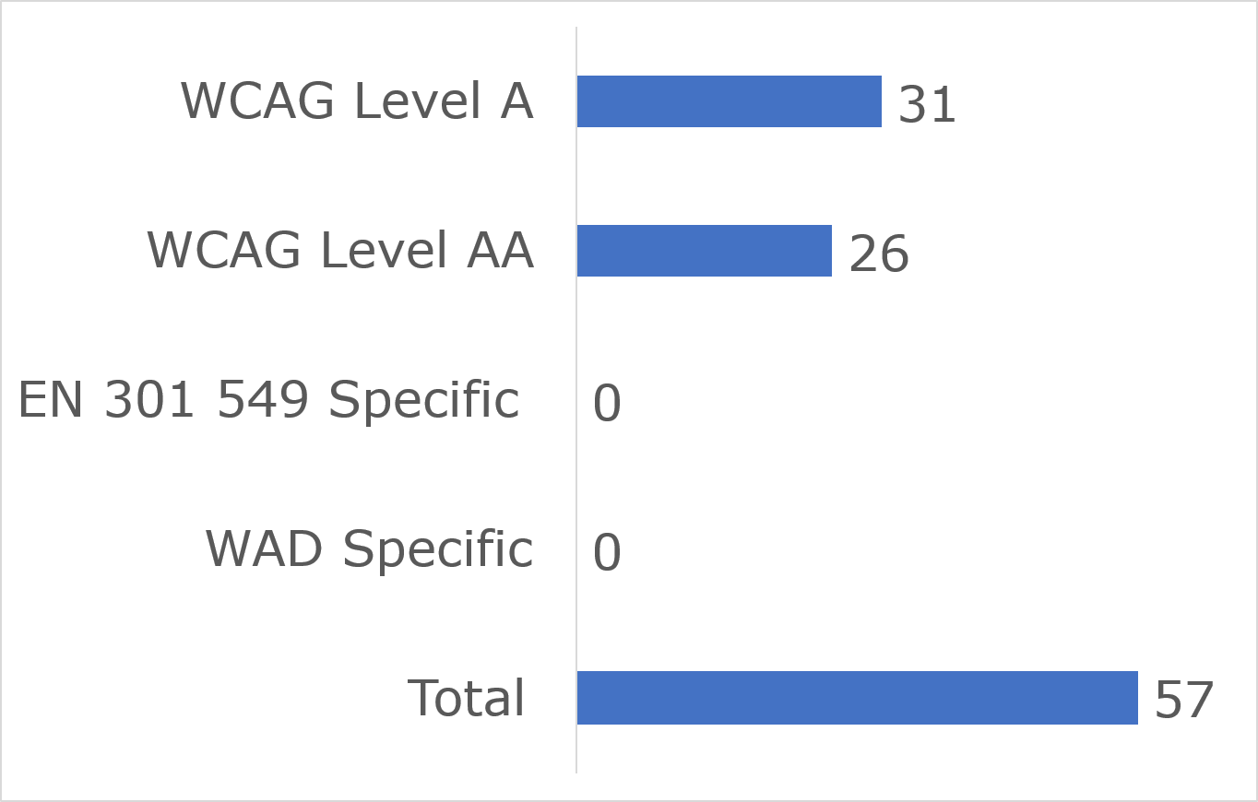

User impact
Most errors were classified as having “Serious” user impact (n=47), with the second highest number classified as “Critical” (n=6) and next “Moderate” (n=4). No “Blocker” or “Minor” issues were identified (Figure 7).
Figure 7: Central Bank of Ireland Number of Issues by User Impact
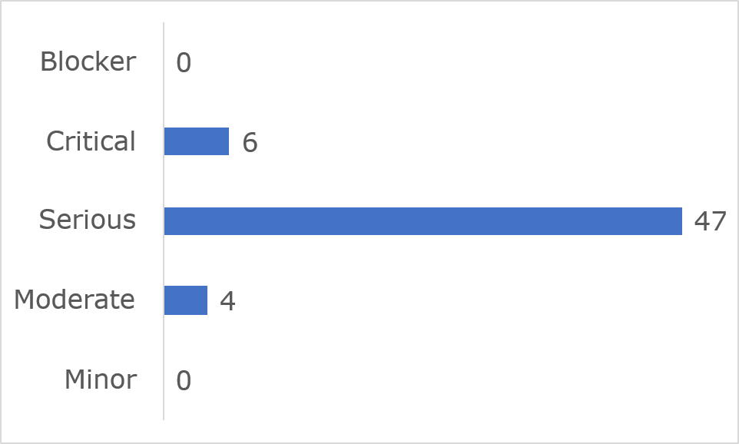

Frequently Identified Issues
Five success criteria were related to 56.1% of all issues:
- 1.4.3 Contrast (Minimum): 14.0%
- 1.3.1 Info and Relationships: 14.0%
- 1.4.11 Non-text Contrast: 10.5%
- Non-Text Content: 8.8%
- 4.1.2 Name, Role, Value: 8.8%
Figure 8: Central Bank of Ireland 10 Most Frequently Identified Issues
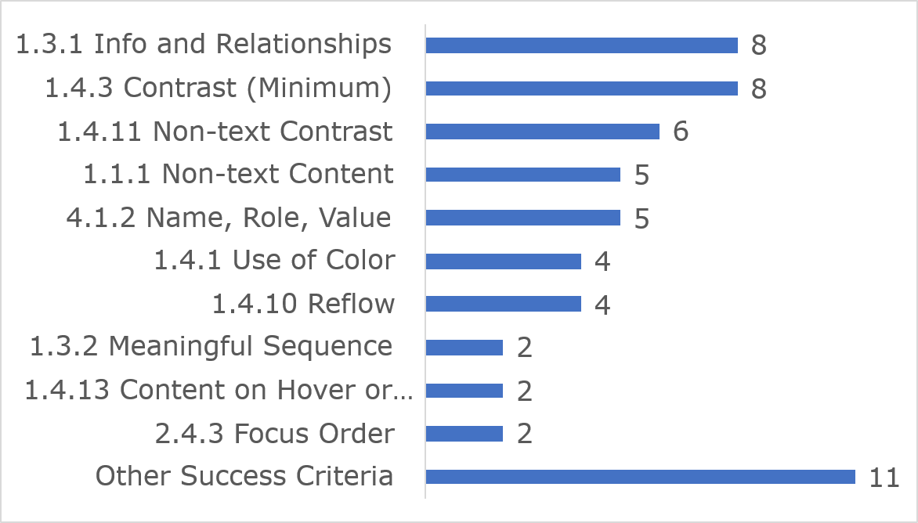
Among the 10 most frequently identified issues, (1.3.1) Info and relationships accounted for eight instances, eight were related to (1.4.3) Contrast (Minimum) and six were linked to (1.4.11) Non-text Contrast.
Link to accessible table

Accessibility Statement
The Central Bank of Ireland’s website Accessibility Statement contains most of the content required under the Directive.

Cheshire Ireland

Key Findings
This website met 69% of applicable success criteria while 31% were not satisfied (Figure 9).
Figure 9: Cheshire Ireland Accessibility Compliance
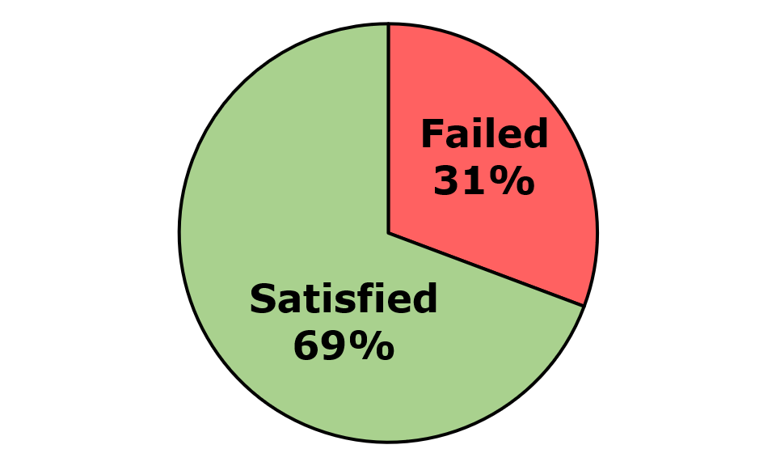
Across the three components and 12 pages that were assessed, 234 issues were identified. These comprised 228 WCAG issues, three EN 301 549-specific issues, and three WAD-specific issues. Of the WCAG issues, there were 101 WCAG Level A and 127 WCAG Level AA issues (Figure 10).
Figure 10: Cheshire Ireland Number of Issues
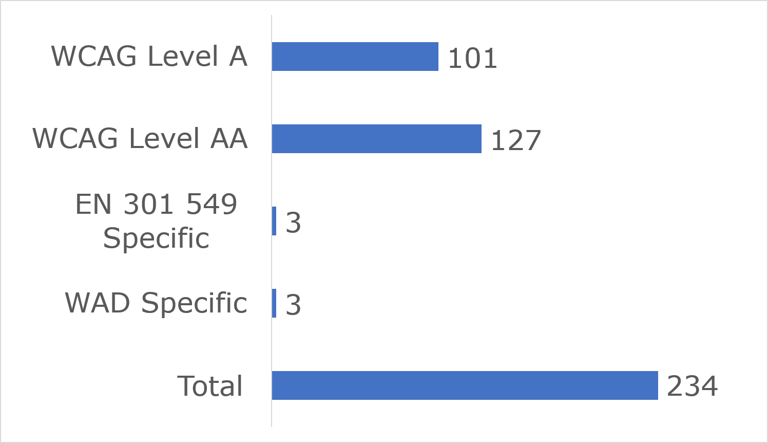

User impact
Most errors were classified as having “Serious” user impact (n=188), with the second highest number classified as “Critical” (n=39) and then “Moderate” (n=7). No “Blocker” or “Minor” issues were identified (Figure 10).
Figure 11: Cheshire Ireland Number of Issues by User Impact
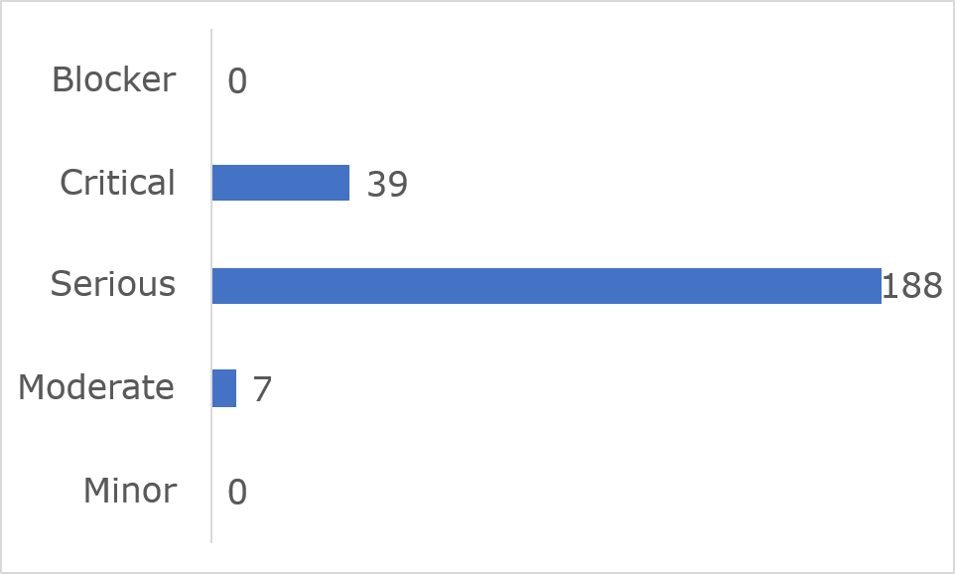

Frequently Identified Issues
Five Success Criteria were related to 82.8% of all issues:
- 1.4.3 Contrast (Minimum): 39.7%
- 4.1.2 Name, Role, Value: 15%
- 1.3.1 Info and Relationships: 11.1%
- 1.1.1 Non-text Content: 8.5%
- 1.4.11 Non-text Contrast: 8.5%
Figure 12: Cheshire Ireland 10 Most Frequently Identified Issues
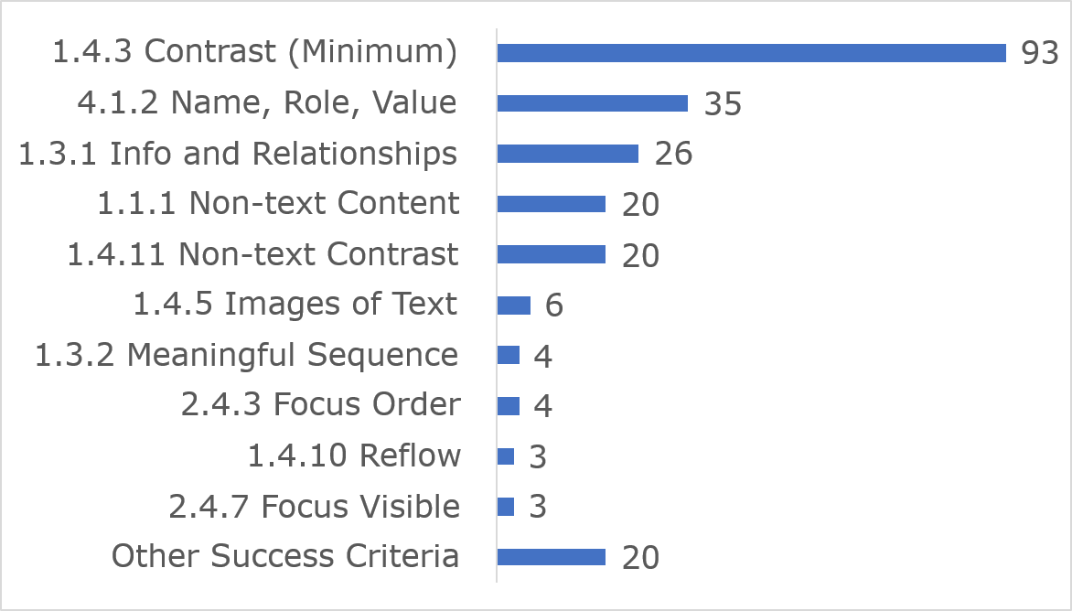

Among the 10 most frequently identified issues, (1.4.3) Contrast (Minimum) accounted for 93 instances, 35 were related to (4.1.2) Name, Role, Value and 26 were linked to (1.3.1) Info and Relationships.
Link to accessible table

Accessibility Statement
The Cheshire Ireland’s website Accessibility Statement contains most of the content required under the Directive. The NDA advises that the Accessibility Statement is presented in accessible HTML rather than PDF format.

Coimisiún Na Meán

Key findings
This website met 79% of applicable success criteria while 21% were not satisfied (Figure 13).
Figure 13: Coimisiún Na Meán Accessibility Compliance
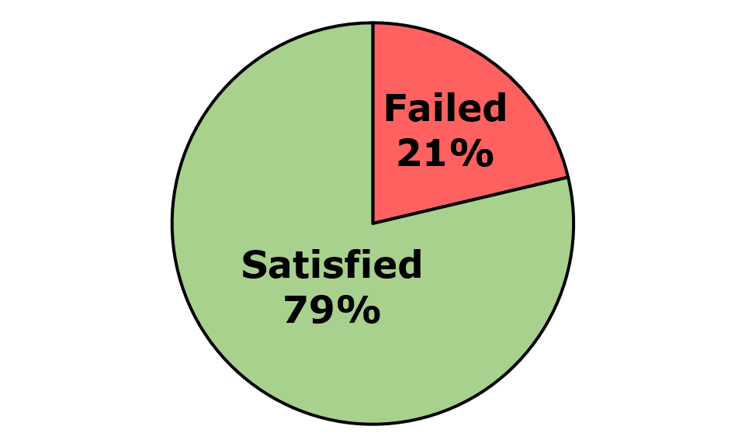
Across the three components and nine pages that were assessed, 30 issues were identified. These comprised 27 WCAG issues, two EN 301 549-specific issues, and one WAD-specific issue. Of the WCAG issues, there were 16 WCAG Level A and 11 WCAG Level AA issues (Figure 14).
Figure 14: Coimisiún Na Meán Number of Issues
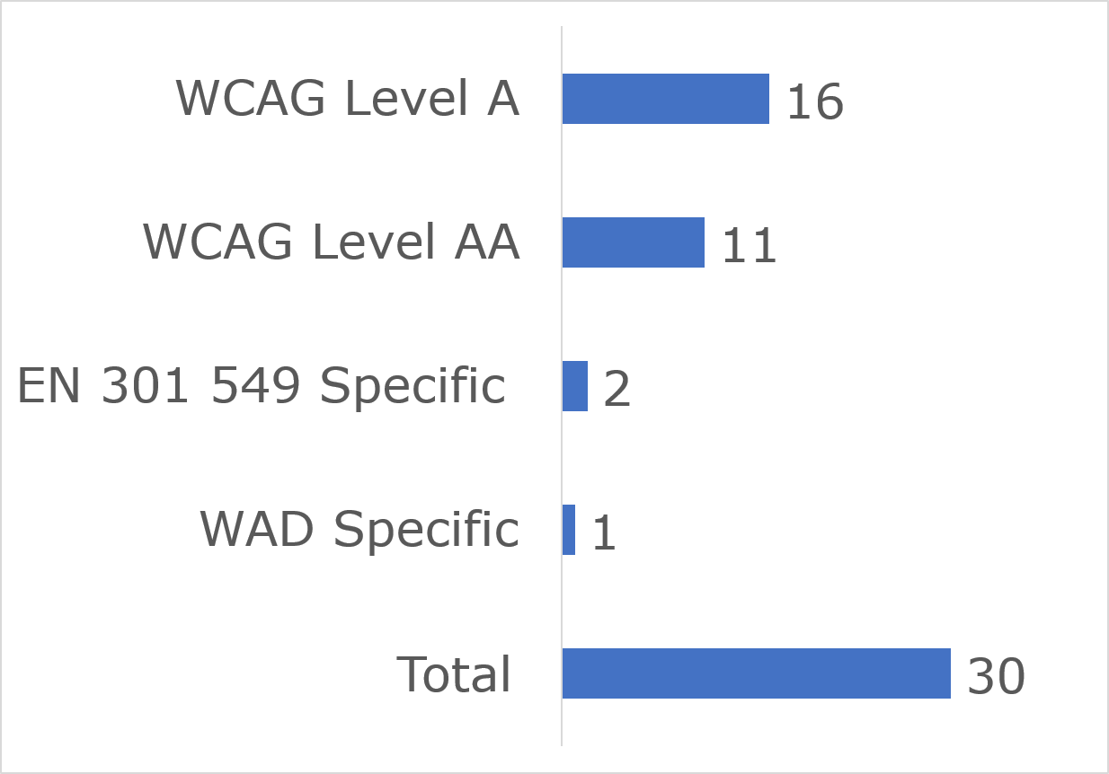

User impact
Most errors were classified as having “Serious” user impact (n=23), with the second highest number classified as “Critical” (n=5) and then “Moderate” (n=2). No “Blocker” or “Minor” issues were identified (Figure 15).
Figure 15: Coimisiún Na Meán Number of Issues by User Impact
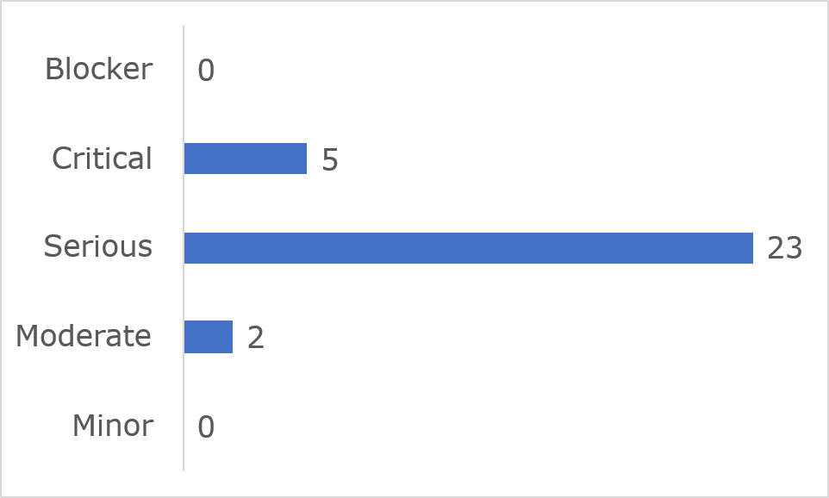

Frequently Identified Issues
Five Success Criteria were related to 63.3% of all issues:
- 1.3.1 Info and Relationships: 23.3%
- 1.4.11 Non-text Contrast: 16.7%
- 4.1.2 Name, Role, Value: 13.3%
- 1.4.3 Contrast (Minimum): 6.7%
- 1.1.1 Non-text Content: 3.3%
Figure 16: Coimisiún Na Meán 10 Most Frequently Identified Issues
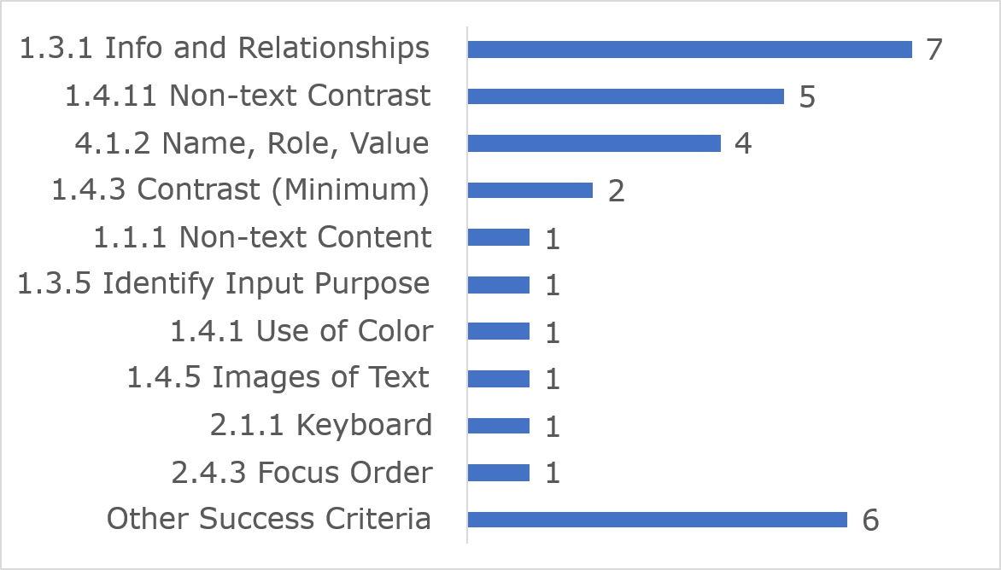
Among the 10 most frequently identified issues, (1.3.1) Info and relationships accounted for seven instances, five were related to (1.4.11) Non-text Contrast, and four were linked to (4.1.2) Name, Role, Value.
Link to accessible table

Accessibility Statement
Coimisiún Na Meán’s website Accessibility Statement contains some of the content required under the Directive.

ComReg

Key findings
This website met 84% of applicable success criteria while 16% were not satisfied (Figure 17)
Figure 17: ComReg Accessibility Compliance
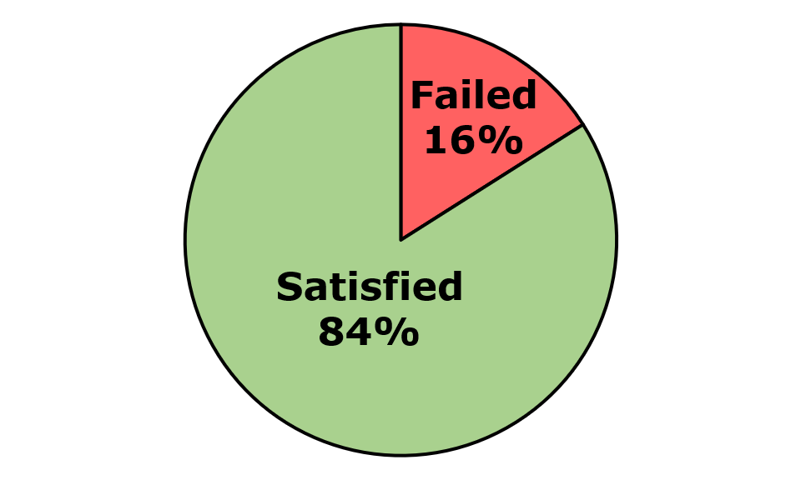
Across the three components and nine pages that were assessed 31 issues were identified. These comprised 28 WCAG issues, two EN 301 549-specific issues, and one WAD-specific issue. Of the WCAG issues, there were 16 WCAG Level A and 12 WCAG Level AA issues. (Figure 18).
Figure 18: ComReg Number of Issues
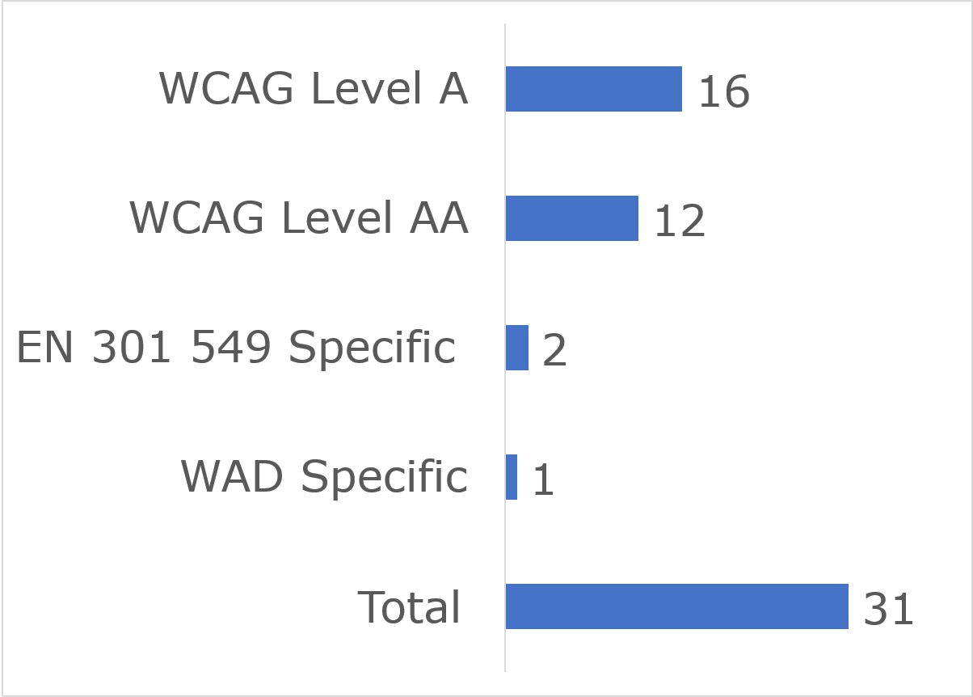

User impact
Most errors were classified as having “Serious” user impact (n=26), with the second highest number classified as “Critical” (n=5). No “Blocker”, “Moderate” or “Minor” issues were identified (Figure 19).
Figure 19: ComReg Number of Issues by User Impact
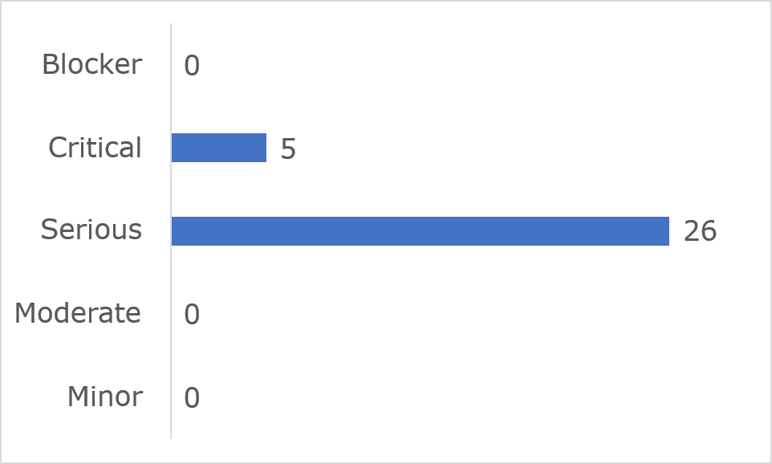

Frequently Identified Issues
Five Success Criteria were related to 77.5% of all issues:
- 1.3.1 Info and Relationships: 35.5%
- 1.4.3 Contrast (Minimum): 16.1%
- 2.4.7 Focus Visible: 9.7%
- 3.3.2 Labels or Instructions: 9.7%
- 4.1.3 Status Messages: 6.5%
Figure 20: ComReg 10 Most Frequently Identified Issues
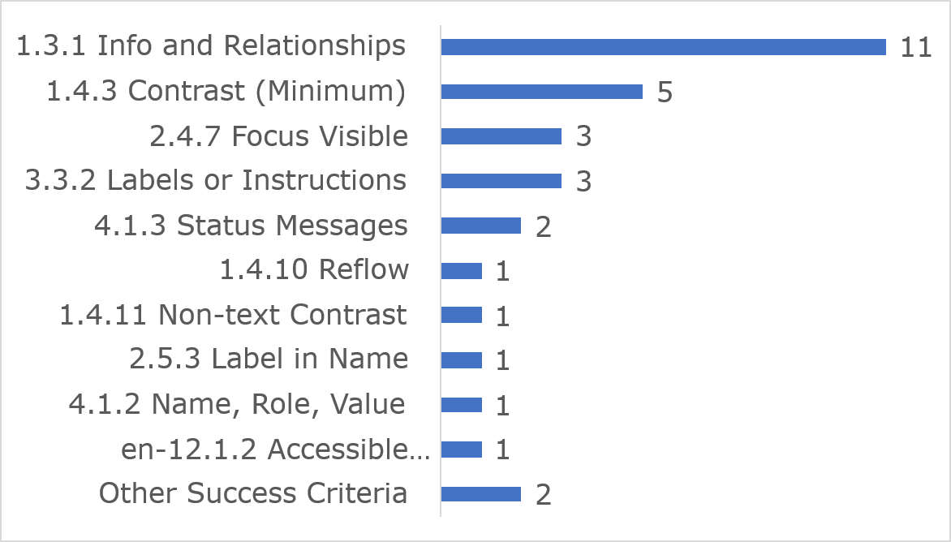
Among the 10 most frequently identified issues, (1.3.1) Info and relationships accounted for 11 instances, five were related to (1.4.3) Contrast (Minimum) and three were linked to (2.4.7) Focus Visible.
The NDA is aware that ComReg is undertaking ongoing work to address some of the issues reported in our findings.
Link to accessible table

Accessibility Statement
The ComReg website Accessibility Statement contains some of the content required under the Directive.

Competition and Consumer Protection Commission

Key findings
This website met 67% of applicable success criteria while 33% were not satisfied (Figure 21).
Figure 21: Competition and Consumer Protection Commission Accessibility Compliance
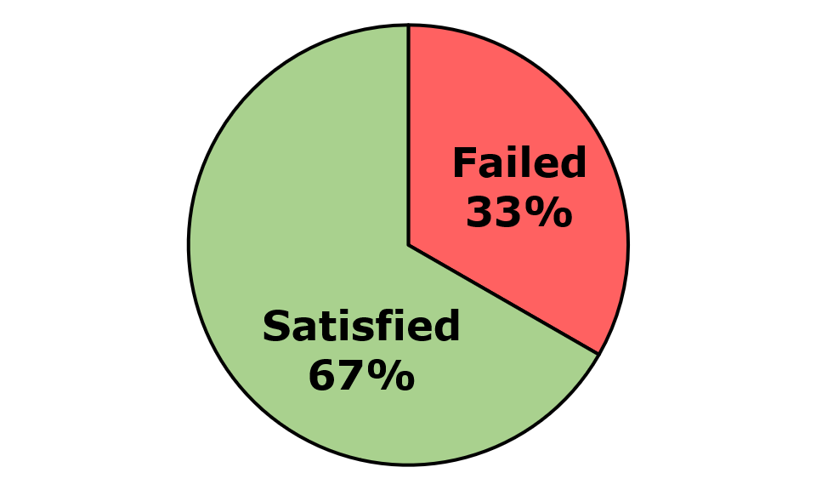
Across the three components and 11 pages that were assessed, 107 issues were identified. These comprised 104 WCAG issues, two EN 301 549-specific issues, and one WAD-specific issue. Of the WCAG issues, there were 74 WCAG Level A and 30 WCAG Level AA issues (Figure 22).
Figure 22: Competition and Consumer Protection Commission Number of Issues
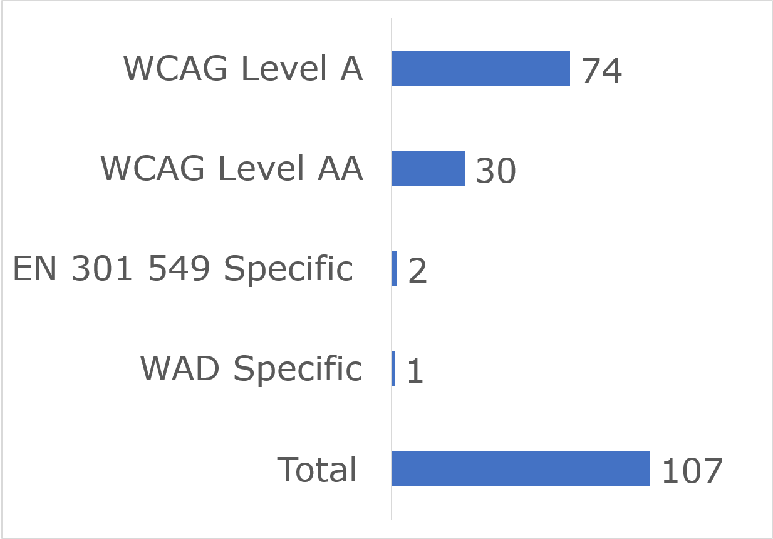

User impact
Most errors were classified as having “Serious” user impact (n=61), with the second highest number classified as “Critical” (n=40) and then “Moderate” (n=4). No “Blocker” issues were identified and there were two minor issues (Figure 23).
Figure 23: Competition and Consumer Protection Commission Number of Issues by User Impact
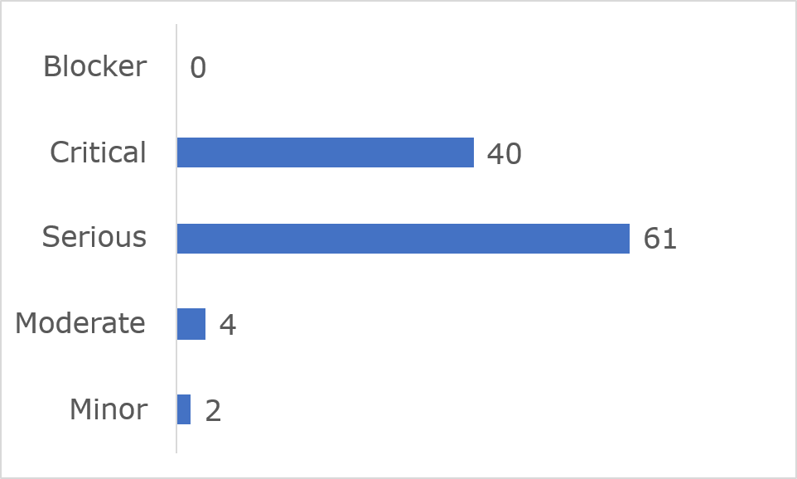
Frequently Identified Issues
Five Success Criteria were related to 65.4% of all issues:
- 4.1.2 Name, Role, Value: 27.1%
- 1.3.1 Info and Relationships: 21.5%
- 1.4.3 Contrast (Minimum): 6.5%
- 1.4.11 Non-text Contrast: 5.6%
- 1.1.1 Non-text Content: 4.7%
Figure 24: Competition and Consumer Protection Commission 10 Most Frequently Identified Issues
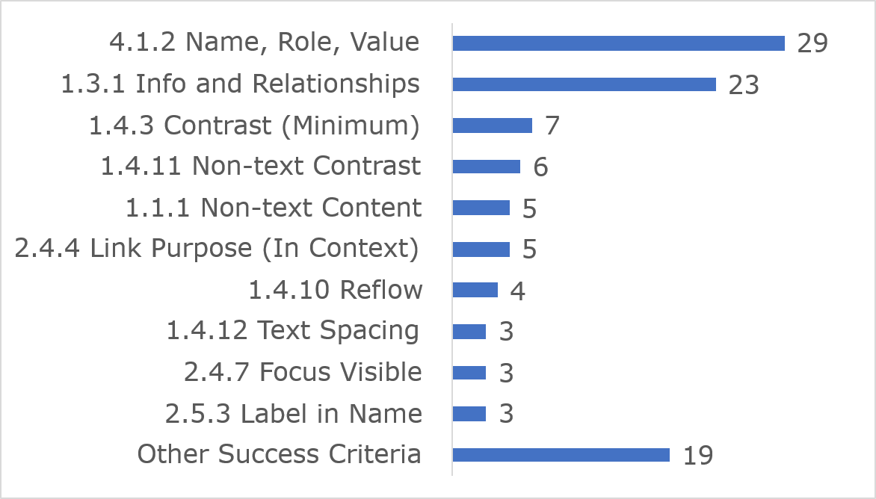
Among the 10 most frequently identified issues, (4.1.2) Name, Role, Value accounted for 29 instances, 23 were related to (1.3.1) Info and relationships and seven were linked to 1.4.3 Contrast (Minimum).
Link to accessible table

Accessibility Statement
The Competition and Consumer Protection Commission’s website Accessibility Statement contains most of the content required under the Directive.

Gov.ie

Key findings
This website met 87% of applicable success criteria while 13% were not satisfied (Figure 25).
Figure 25: Gov.ie Accessibility Compliance
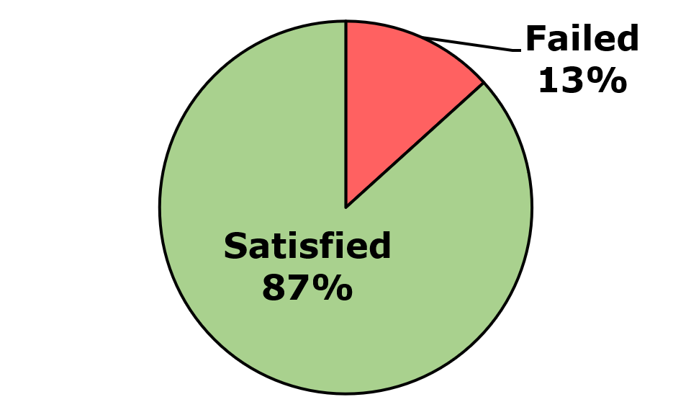
Across the three components and 12 pages that were assessed, 16 issues were identified. These comprised 13 WCAG issues, 3 EN 301 549-specific issues, and zero WAD-specific issues. Of the WCAG issues, there were 11 WCAG Level A and WCAG Level AA issues (Figure 26).
Figure 26: Gov.ie Number of Issues
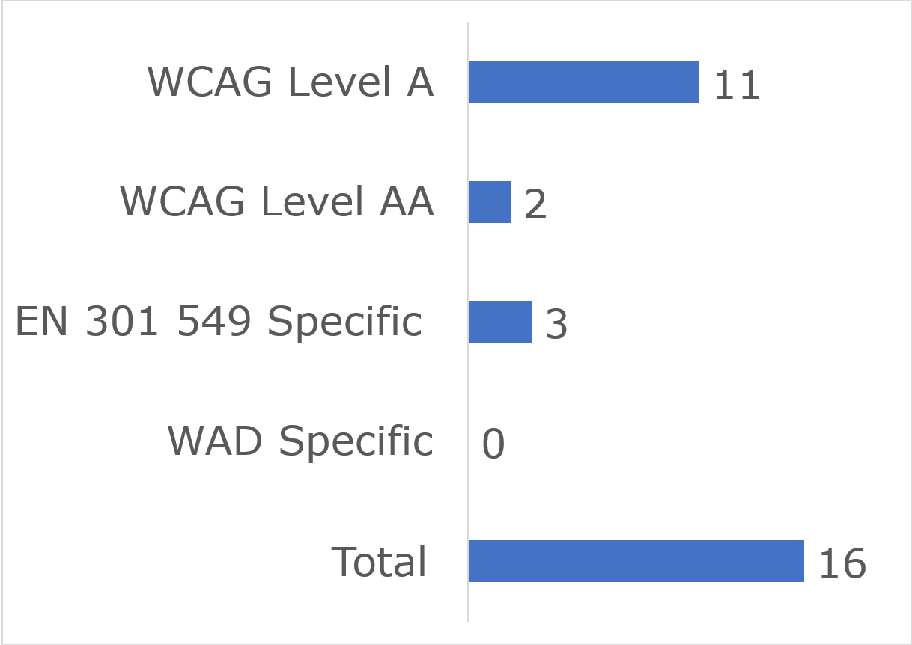

User impact
Most errors were classified as having “Serious” user impact (n=7), with the second highest number classified as “Critical” (n=5) and then “Moderate” (n=4). No “Blocker” or “Minor” issues were identified (Figure 27).
Figure 27: Gov.ie Number of Issues by User Impact
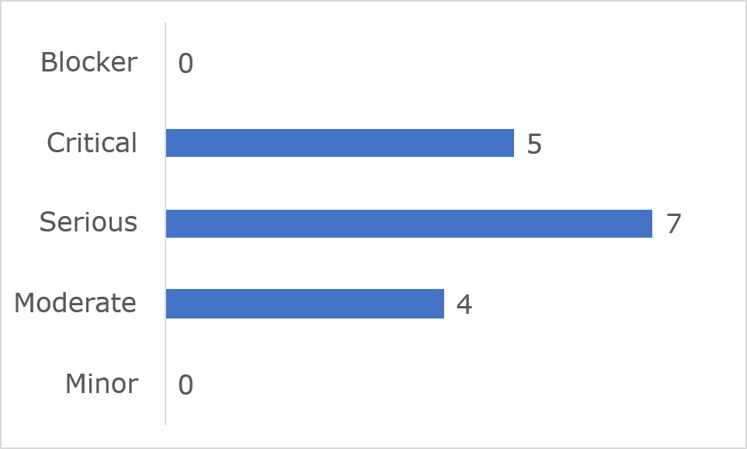
Frequently Identified Issues
Five Success Criteria were related to 70.2% of all issues:
- 1.3.1 Info and Relationships: 24.3%
- 1.1.1 Non-text Content: 21.6%
- 4.1.2 Name, Role, Value: 10.8%
- 2.4.3 Focus Order: 8.1%
- 1.2.3 Audio Description or Media Alternative (Prerecorded): 5.4%
Figure 28: Gov.ie 10 Most Frequently Identified Issues
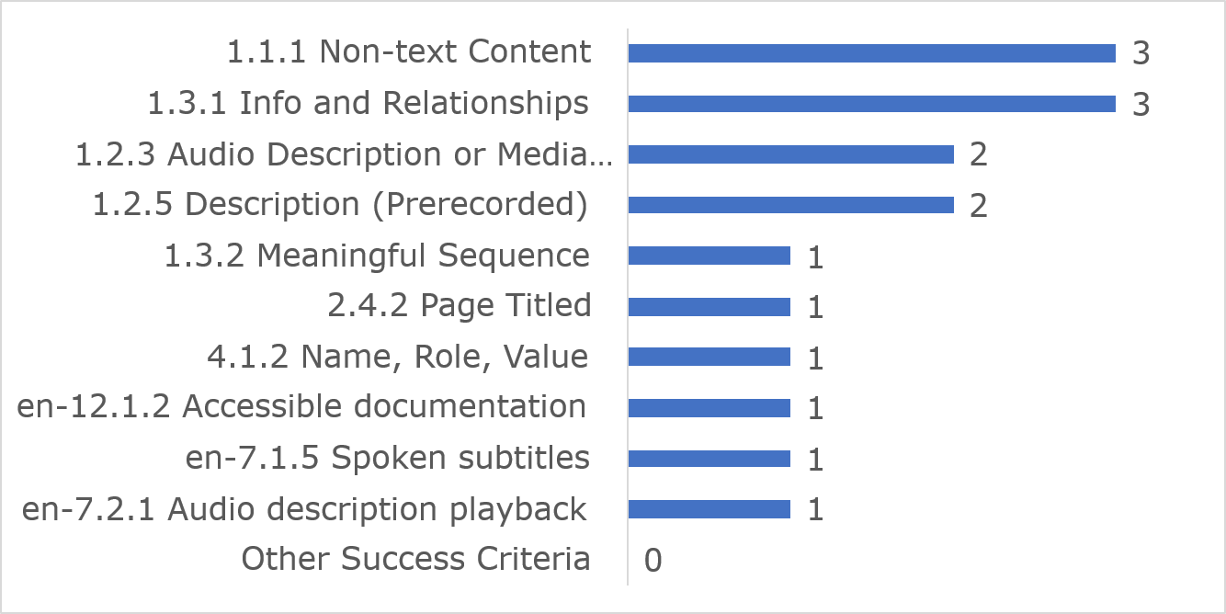
Among the 10 most frequently identified issues, (1.1.1) Non-text Content and (1.3.1) Info and relationships accounted for three instances each and two issues each were linked to (1.2.3) Audio Description or Media Alternative and 1.2.5 Description (Prerecorded).
Link to accessible table

Accessibility Statement
The gov.ie website Accessibility Statement contains most of the content required under the Directive.

HSeLanD eLearning Module: ‘Designated Person in Incident Management and Open Disclosure’

Key findings
This website met 75% of applicable success criteria while 25% were not satisfied (Figure 29).
Figure 29: HSeLanD eLearning Module Accessibility Compliance
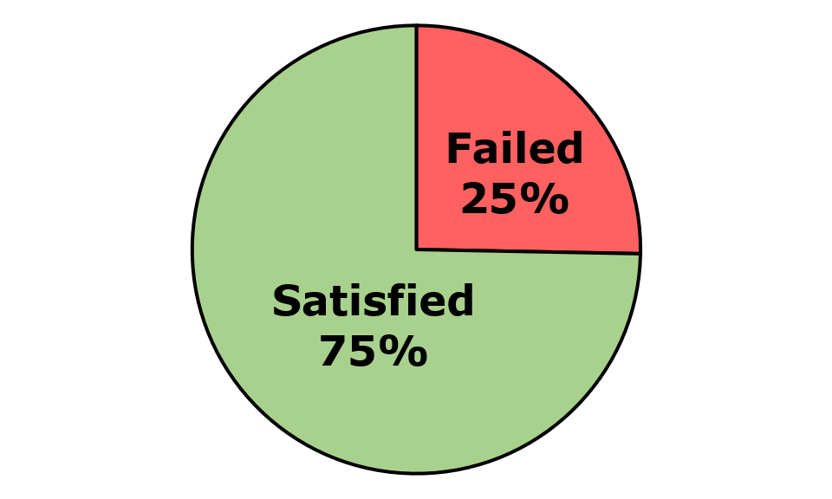
Across the eight components and 14 pages that were assessed, 286 issues were identified. These comprised 284 WCAG issues, zero EN 301 549-specific issues, and two WAD-specific issues. Of the WCAG issues, there were 72 WCAG Level A and 212 WCAG Level AA issues (Figure 30).
Figure 30: HSeLanD eLearning Module Number of Issues
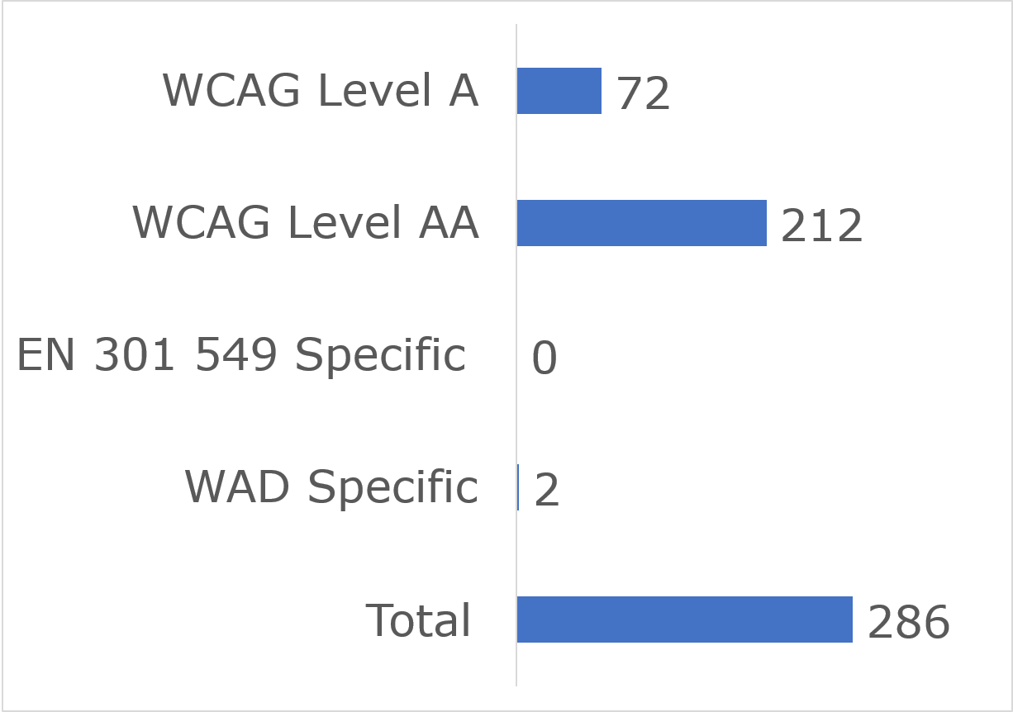

User impact
Most errors were classified as having “Serious” user impact (n=254), with the second highest number classified as “Critical” (n=25) and then “Moderate” (n=4). Three “Minor” and zero “Blocker” issues were identified (Figure 31).
Figure 31: HSeLanD eLearning Module Number of Issues by User Impact
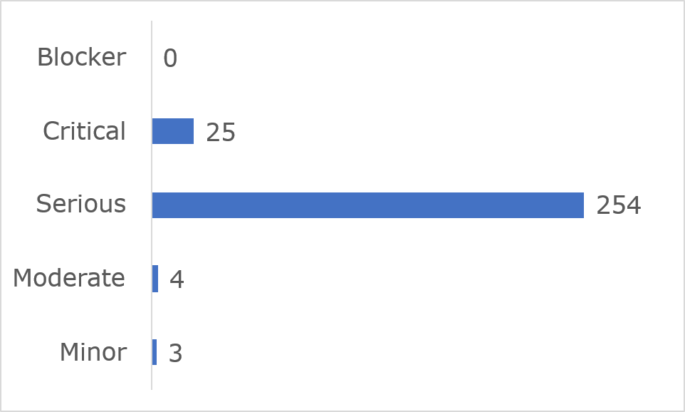
Frequently Identified Issues
Five Success Criteria were related to 89.1% of all issues:
- 1.4.3 Contrast (Minimum): 64%
- 1.3.1 Info and Relationships: 14.3%
- 1.4.11 Non-text Contrast: 4.2%
- 4.1.2 Name, Role, Value: 3.8%
- 2.4.6 Headings and Labels: 2.8%
Figure 32: HSeLanD eLearning Module 10 Most Frequently Identified Issues
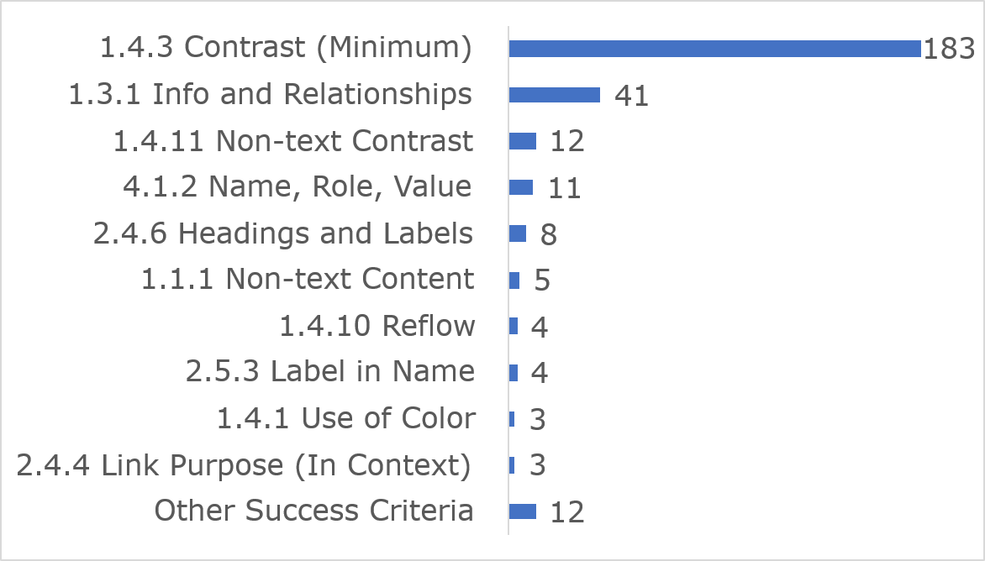
Among the 10 most frequently identified issues, (1.4.3) Contrast (Minimum)and (1.3.1) Info and relationships accounted for 41 instances, 12 were related to (1.4.11) Non-text Content and 11 issues were linked to (4.1.2) Name, Role, Value.
Link to accessible table

Accessibility Statement
The HSeLanD eLearning Module website Accessibility Statement contains most of the content required under the Directive. The NDA advises that the Accessibility Statement is presented in accessible HTML rather than PDF format.

HSE.ie

Key findings
This website met 71% of applicable success criteria while 29% were not satisfied (Figure 33).
Figure 33: HSE.ie Accessibility Compliance
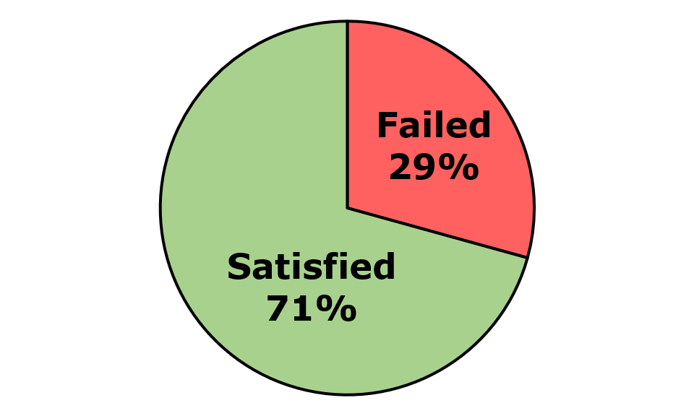
Across the 12 components and three pages that were assessed, 42 issues were identified. These comprised 39 WCAG issues, two EN 301 549-specific issues, and one WAD-specific issue. Of the WCAG issues, there were 24 WCAG Level A and 15 WCAG Level AA issues (Figure 34).
Figure 34: HSE.ie Number of Issues
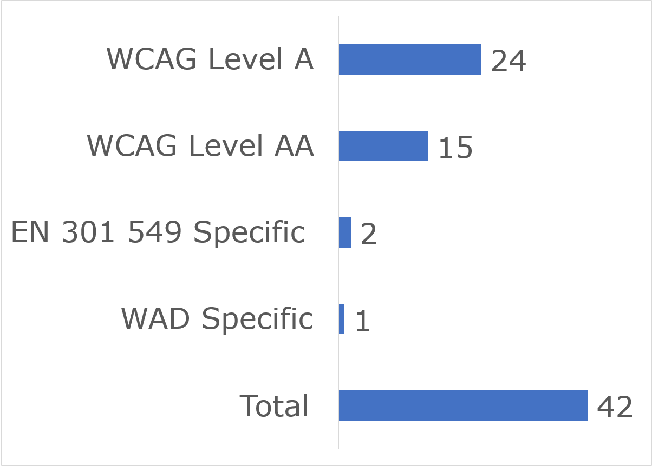

User impact
Most errors were classified as having “Serious” user impact (n=27), with the second highest number classified as “Critical” (n=13) and then “Moderate” (n=2). No “Blocker” or “Minor” issues were identified (Figure 35).
Figure 35: HSE.ie Number of Issues by User Impact
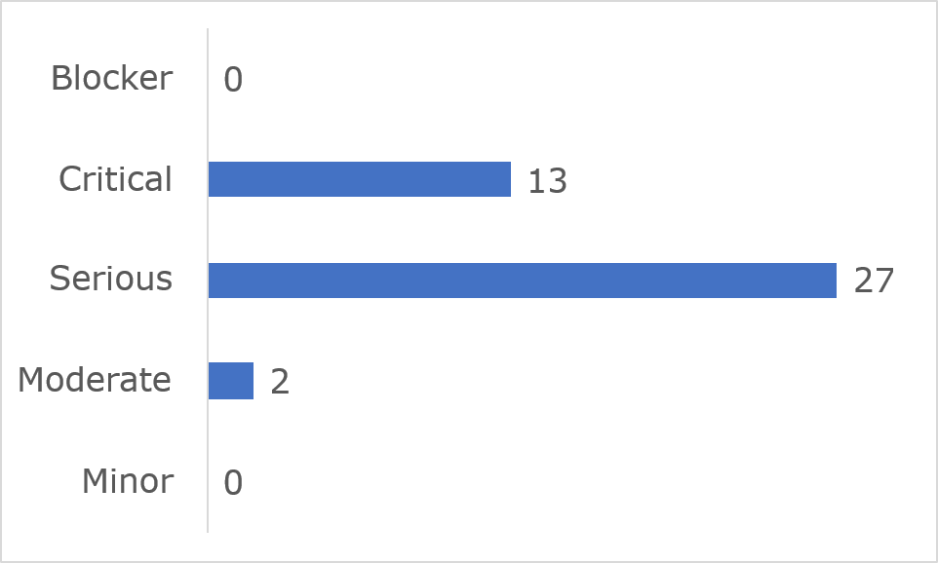

Frequently Identified Issues
Five Success Criteria were related to 52.3% of all issues:
- 4.1.2 Name, Role, Value: 16.7%
- 1.3.1 Info and Relationships: 14.3%
- 1.1.1 Non-text Content: 7.1%
- 1.4.11 Non-text Contrast: 7.1%
- 1.4.3 Contrast (Minimum): 7.1%
Figure 36: HSE.ie 10 Most Frequently Identified Issues
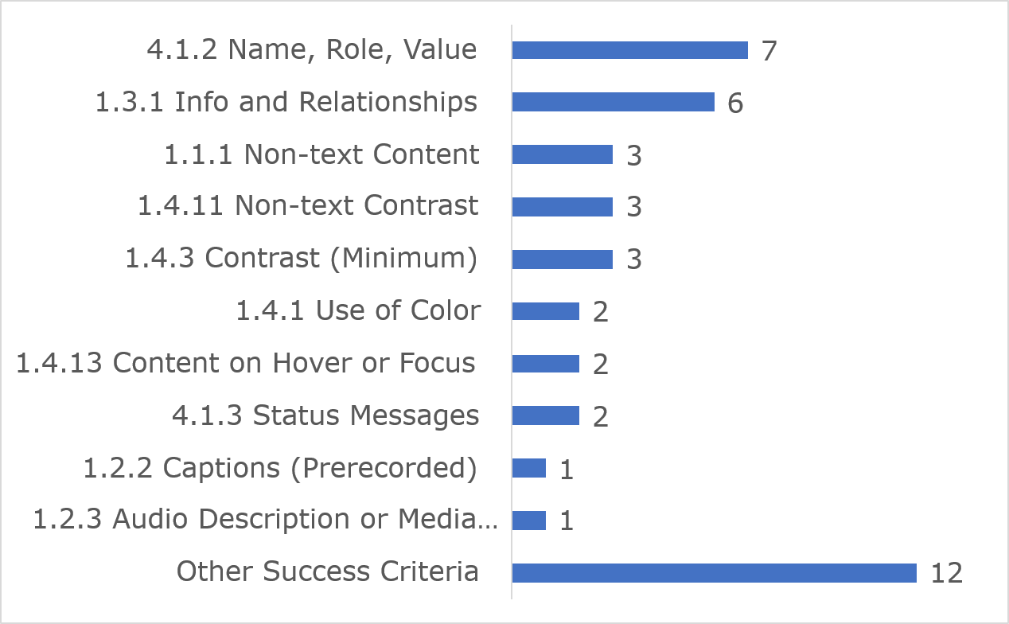
Among the 10 most frequently identified issues, (4.1.2) Name, Role, Value accounted for seven instances, six were related to (1.3.1) Info and Relationships and three issues were linked to (1.1.1) Non-text Contrast.
Link to accessible table

Accessibility Statement
The HSE.ie website Accessibility Statement contains most of the content required under the Directive.

Irish Aviation Authority website

Key findings
This website met 72% of applicable success criteria while 28% were not satisfied (Figure 37).
Figure 37: Irish Aviation Authority Accessibility Compliance
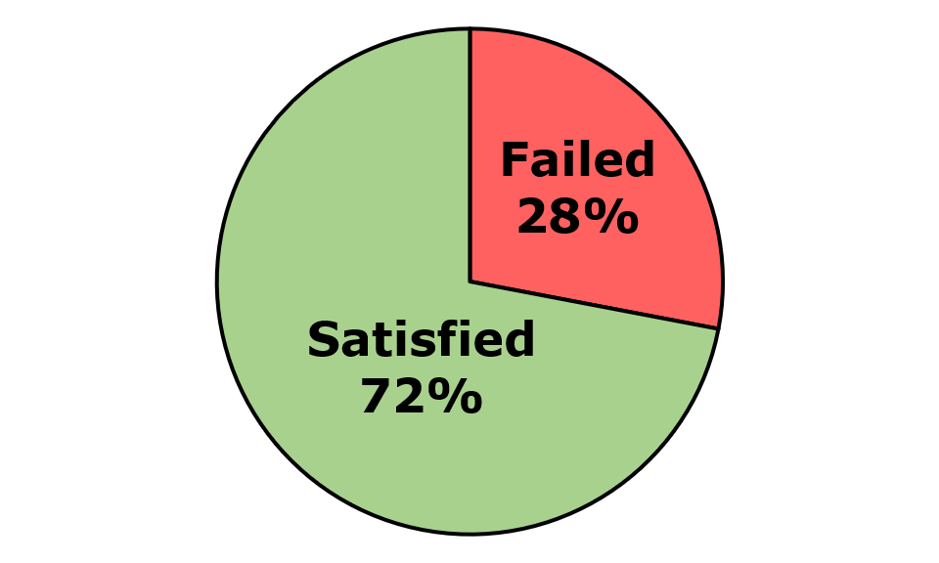
Across the three components and eight pages that were assessed, 117 issues were identified. These comprised 115 WCAG issues, two EN 301 549-specific issues, and zero WAD-specific issues. Of the WCAG issues, there were 42 WCAG Level A and 73 WCAG Level AA issues (Figure 38).
Figure 38: Irish Aviation Authority Number of Issues
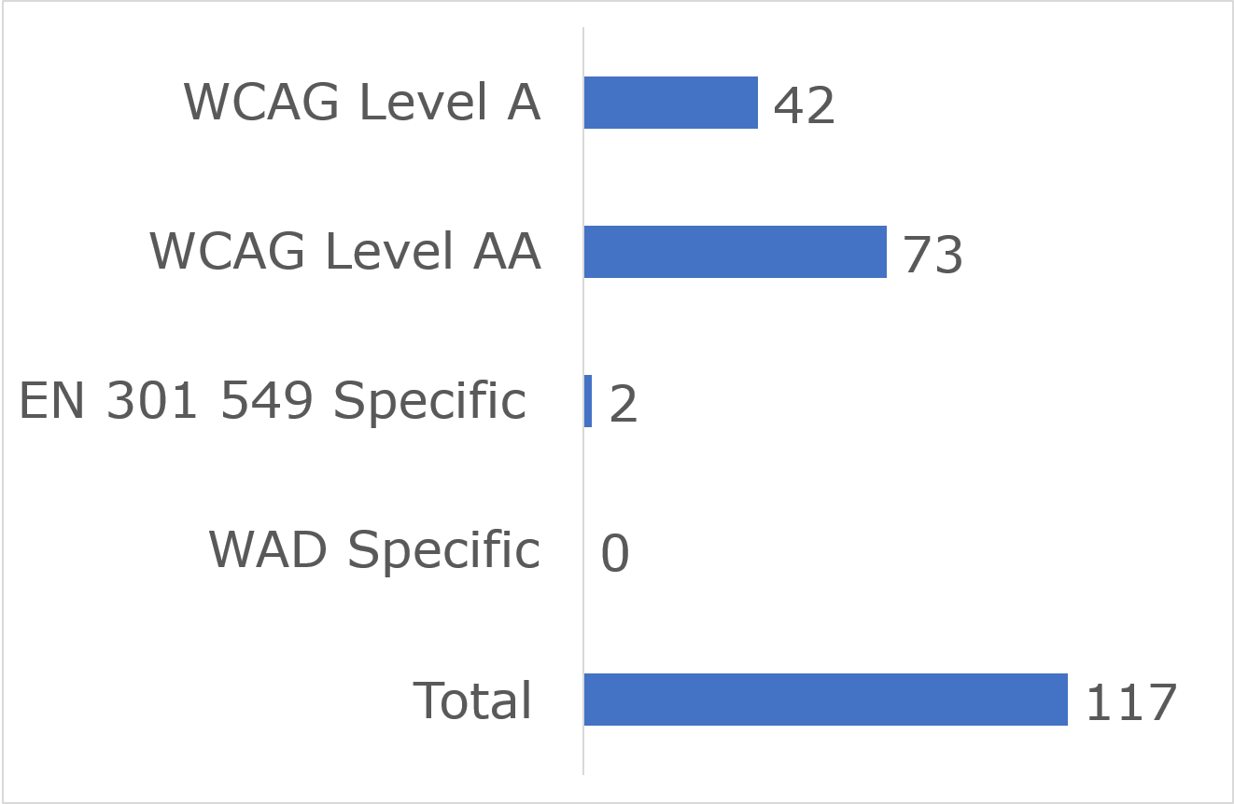

User impact
Most errors were classified as having “Serious” user impact (n=107), with the second highest number classified as “Critical” (n=5) and “Moderate” (n=5). No “Blocker” and “Minor” issues were identified (Figure 39).
Figure 39: Irish Aviation Authority Number of Issues by User Impact
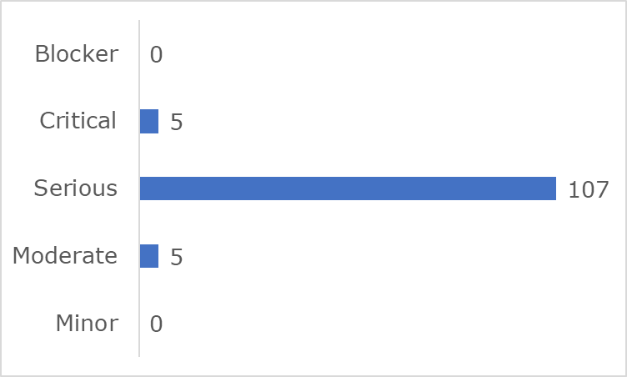

Frequently Identified Issues
Five Success Criteria were related to 74.4% of all issues:
- 1.4.3 Contrast (Minimum): 43.6%
- 4.1.2 Name, Role, Value: 12.0%
- 1.3.1 Info and Relationships: 8.5%
- 1.4.13 Content on Hover or Focus: 6.0%
- 1.4.10 Reflow: 4.3%
Figure 40: Irish Aviation Authority 10 Most Frequently Identified Issues
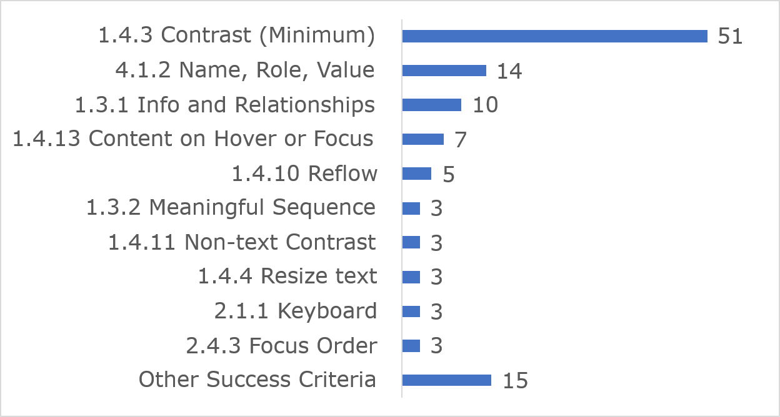
Among the 10 most frequently identified issues, (1.4.3) Contrast (Minimum) accounted for 51 instances, 14 were related to (4.1.2) Name, Role, Value and 10 issues were linked to (1.3.1) Info and Relationships.
Link to accessible table

Accessibility Statement
The Irish Aviation Authority website Accessibility Statement contains some of the content required under the Directive.

Irish Aviation Authority MySRS eComplaint Form

Key findings
This website met 68% of applicable success criteria while 32% were not satisfied. (Figure 41)
Figure 41: Irish Aviation Authority MySRS eComplaint Form Accessibility Compliance
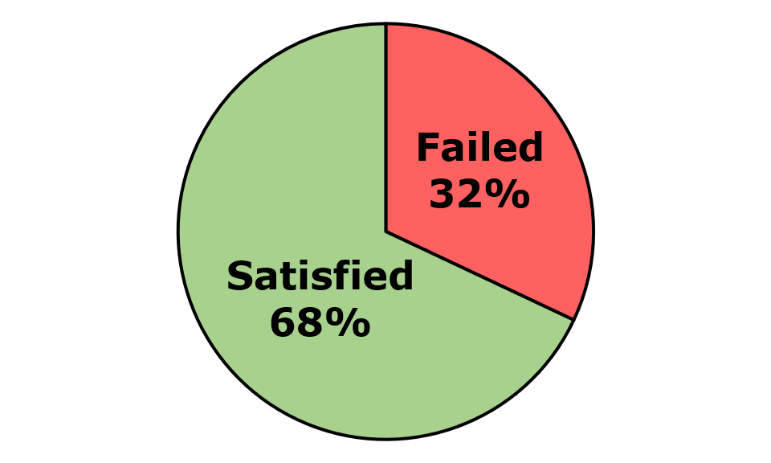
Across the four components and nine pages that were assessed, 111 issues were identified. These comprised 108 WCAG issues, three EN 301 549-specific issues, and zero WAD-specific issues. Of the WCAG issues, there were 70 WCAG Level A and 38 WCAG Level AA issues (Figure 42).
Figure 42: Irish Aviation Authority MySRS eComplaint Form Number of Issues
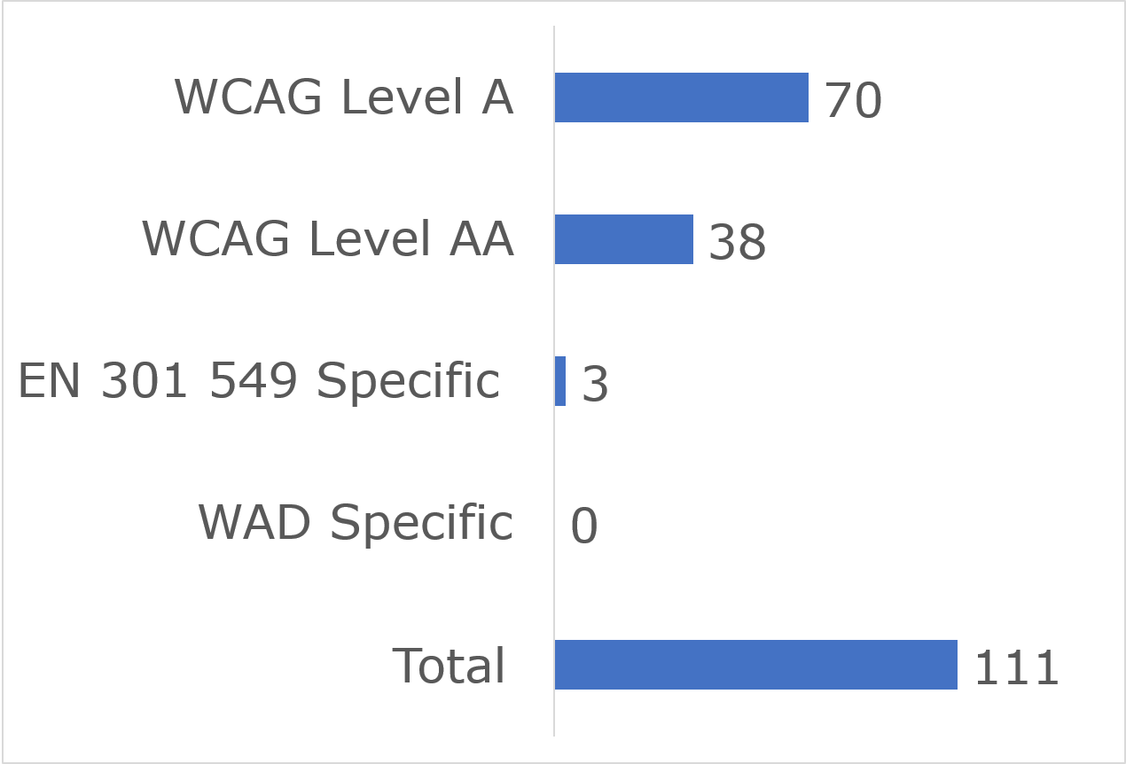

User impact
Most errors were classified as having “Serious” user impact (n=95), with the second highest number classified as “Critical” (n=13) and then “Moderate” (n=3). No “Blocker” or “Minor” issues were identified (Figure 43).
Figure 43: Irish Aviation Authority MySRS eComplaint Form Number of Issues by User Impact
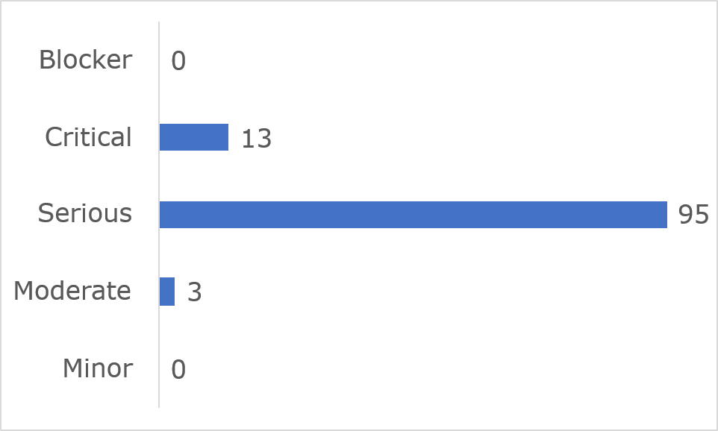

Frequently Identified Issues
Five Success Criteria were related to 58.5% of all issues:
- 1.1.1 Non-text Content: 20.7%
- 1.3.1 Info and Relationships: 10.8%
- 1.4.1 Use of Colour: 9.9%
- 1.4.11 Non-text Contrast: 9.9%
- 4.1.2 Name, Role, Value: 7.2%
Figure 44: Irish Aviation Authority MySRS eComplaint Form 10 Most Frequently Identified Issues
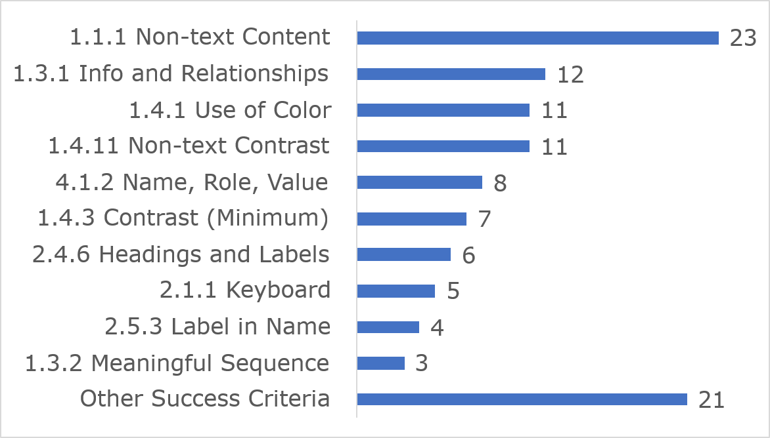
Among the 10 most frequently identified issues, (1.1.1) Non-text Content accounted for 23 instances, twelve were related to (1.3.1) Info and Relationships and 11 issues were linked to (1.4.1) Use of colour.
Link to accessible table

Accessibility Statement
No Accessibility Statement could be found during the In-depth Review.

National Disability Authority website

Key findings
This website met 87% of applicable success criteria while 13% were not satisfied (Figure 45).
Figure 45: National Disability Authority Accessibility Compliance
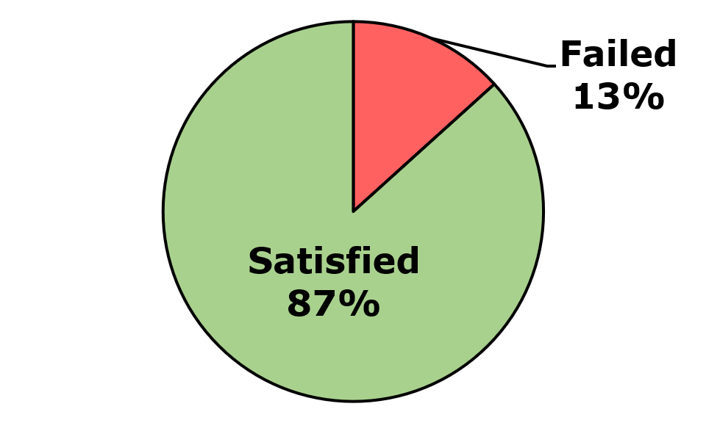
Across the four components and nine pages that were assessed, 16 issues were identified. These comprised 13 WCAG issues, three EN 301 549-specific issues, and zero WAD-specific issues. Of the WCAG issues, there were 11 WCAG Level A and two WCAG Level AA issues (Figure 46).
Figure 46: National Disability Authority Number of Issues
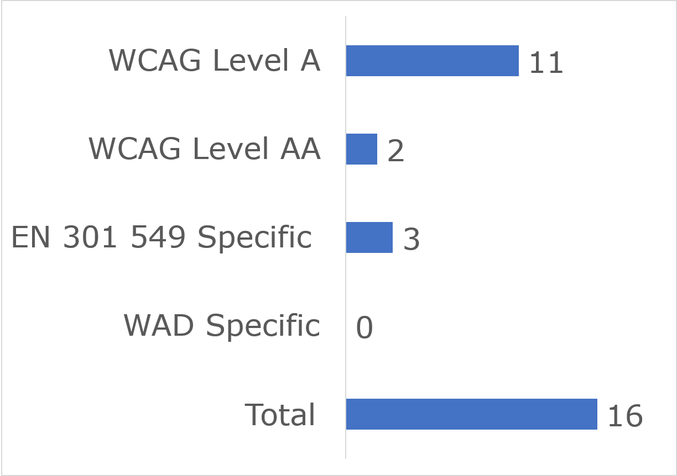

User impact
Most errors were classified as having “Serious” user impact (n=11), with the second highest number classified as “Minor” (n=2) or “Moderate” (n=2). One “Critical” issue (n=1) and no “Blocker” issues were identified (Figure 47).
Figure 47: National Disability Authority Number of Issues by User Impact
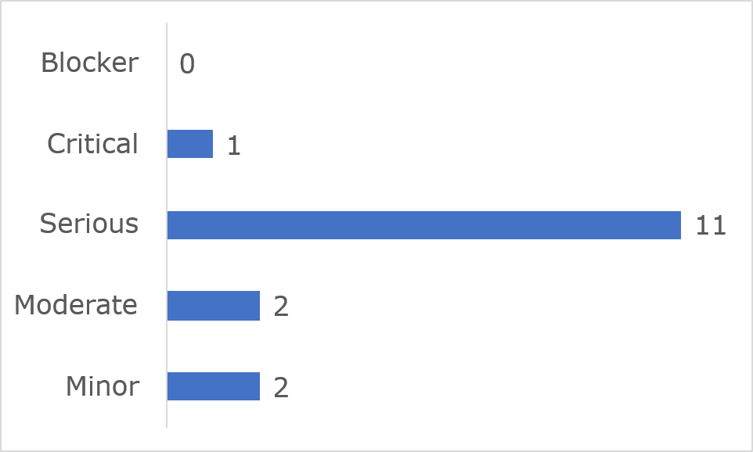
Frequently Identified Issues
Five Success Criteria were related to 62.6% of all issues:
- 1.3.1 Info and Relationships: 25%
- 1.1.1 Non-text Content: 12.5%
- 2.4.4 Link Purpose (In Context): 12.5%
- 1.4.11 Non-text Contrast: 6.3%
- 2.1.1 Keyboard: 6.3%
Figure 48: National Disability Authority 10 Most Frequently Identified Issues
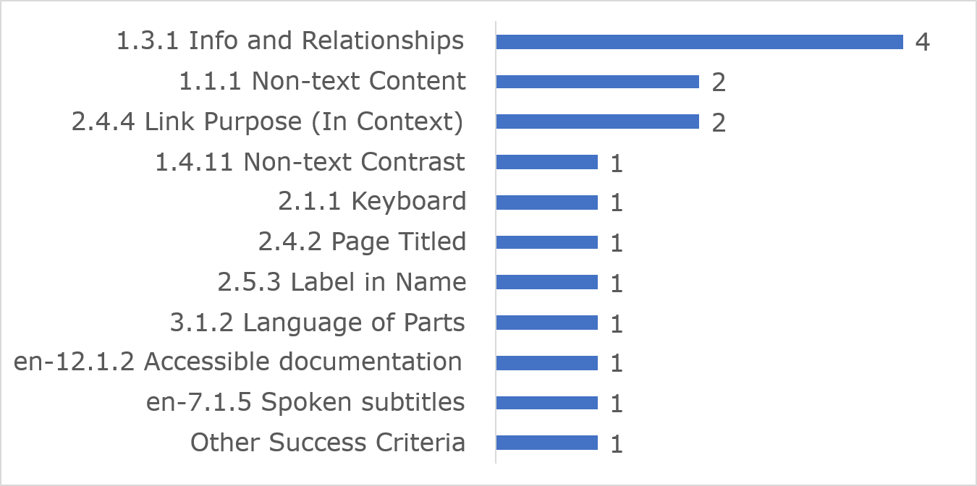
Among the 10 most frequently identified issues, (1.3.1) Info and Relationships accounted for four instances, two were related to (1.1.1) Non-text Content and two issues were linked to (2.4.4) Link Purpose (In Context).
Link to accessible table

Accessibility Statement
The National Disability Authority’s website Accessibility Statement contains all of the content required under the Directive.

National Shared Services Office Core Portal

Key findings
This website met 68% of applicable success criteria while 32% were not satisfied (Figure 49).
Figure 49: National Shared Services Office Core Portal Accessibility Compliance
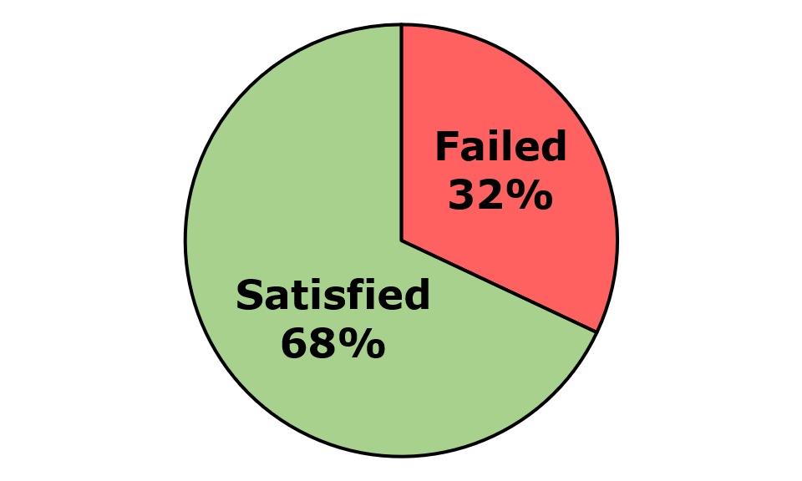
Across the two components and thirteen pages that were assessed, 356 issues were identified. These comprised 353 WCAG issues, one EN 301 549-specific issue, and two WAD-specific issues. Of the WCAG issues, there were 286 WCAG Level A and 67 WCAG Level AA issues (Figure 50).
Figure 50: National Shared Services Office Core Portal Number of Issues
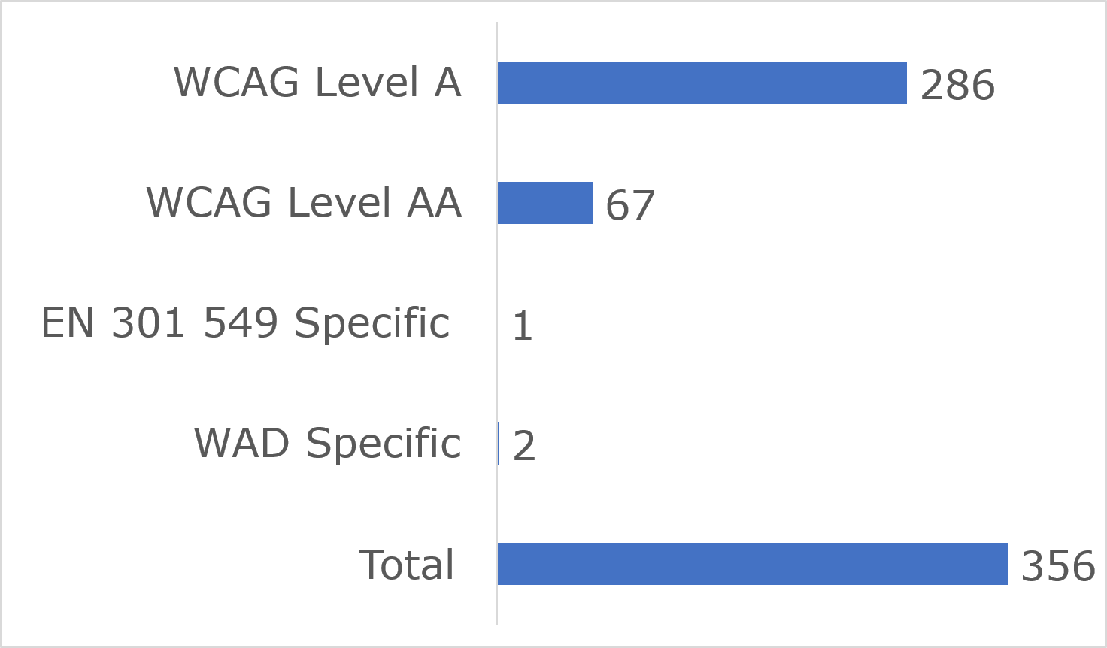

User impact
Most errors were classified as having “Serious” user impact (n=106), with the second highest number classified as “Critical” (n=249) and then “Moderate” (n=1). No “Blocker” and “Minor” issues were identified (Figure 51).
Figure 51: National Shared Services Office Core Portal Number of Issues by User Impact
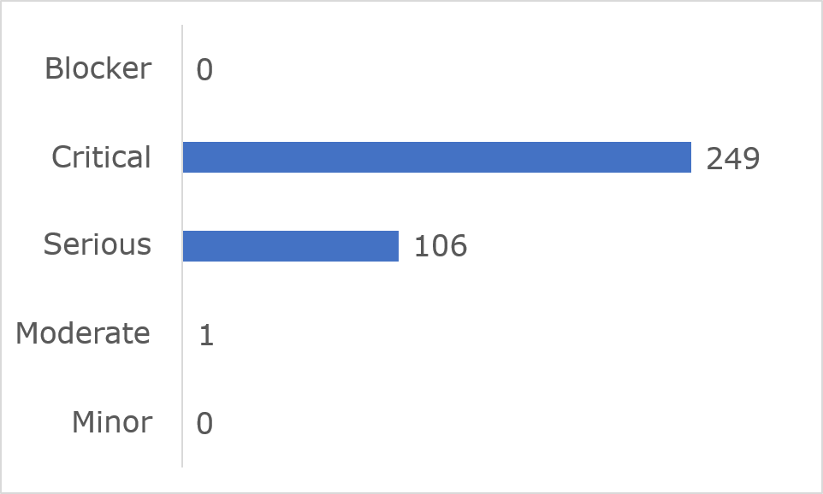

Frequently Identified Issues
Five Success Criteria were related to 82.7% of all issues:
- 4.1.2 Name, Role, Value: 47.8%
- 1.3.1 Info and Relationships: 17.7%
- 2.4.7 Focus Visible: 10.7%
- 1.4.3 Contrast (Minimum): 3.7%
- 2.4.2 Page Titled: 2.8%
Figure 52: National Shared Services Office Core Portal 10 Most Frequently Identified Issues
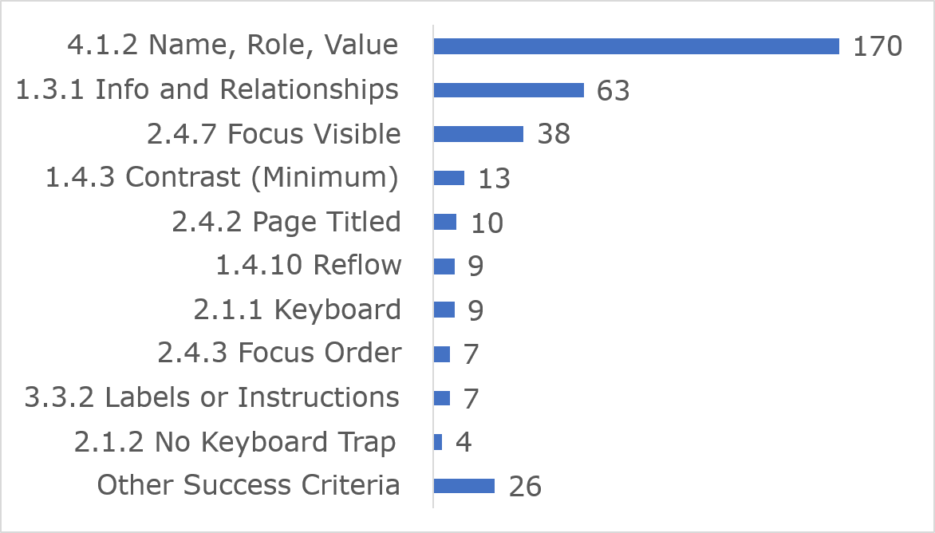
Among the 10 most frequently identified issues, (4.1.2) Name, Role, Value accounted for 170 instances, 63 were related to (1.3.1) Info and Relationships and 38 issues were linked to (2.4.7) Focus Visible.
Link to accessible table

Accessibility Statement
No Accessibility Statement could be found during the In-depth Review.

National Transport Authority

Key findings
This website met 79% of applicable success criteria while 21% were not satisfied (Figure 53).
Figure 53: National Transport Authority Accessibility Compliance
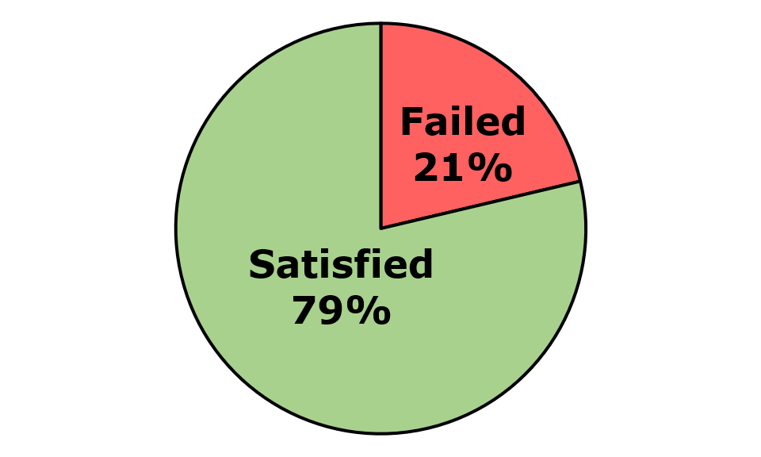
Across the two components and nine pages that were assessed, 43 issues were identified. These comprised 41 WCAG issues, two EN 301 549-specific issues, and zero WAD-specific issues. Of the WCAG issues, there were 21 WCAG Level A and 20 WCAG Level AA issues (Figure 54).
Figure 54: National Transport Authority Number of Issues
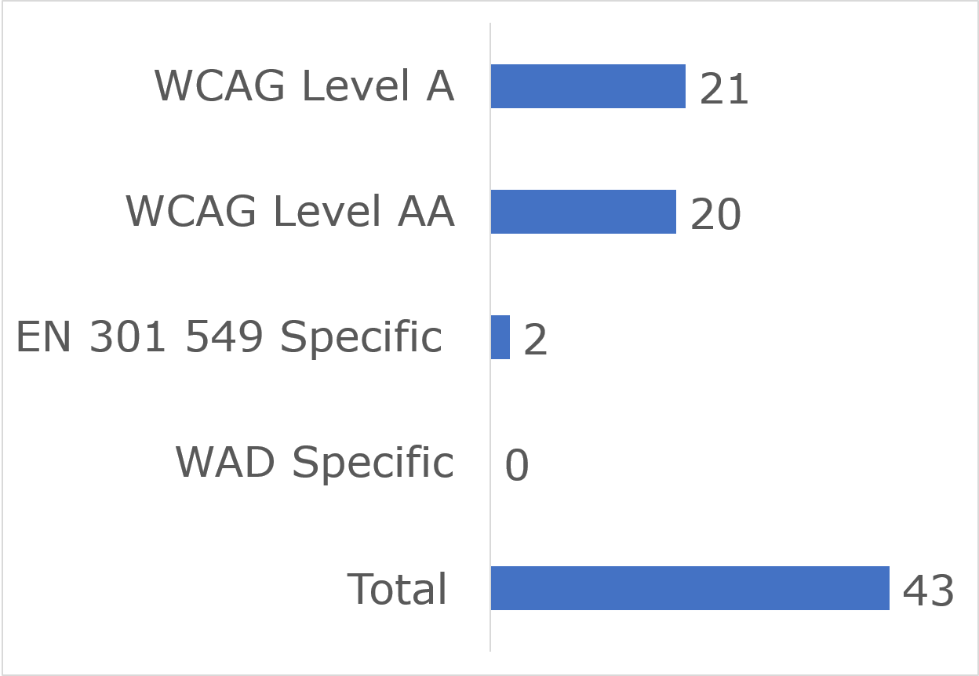

User impact
Most errors were classified as having “Serious” user impact (n=33), with the second highest number classified as “Critical” (n=7) and “Moderate” (n=2). No “Blocker” and one “Minor” issue was identified (Figure 55).
Figure 55: National Transport Authority Number of Issues by User Impact
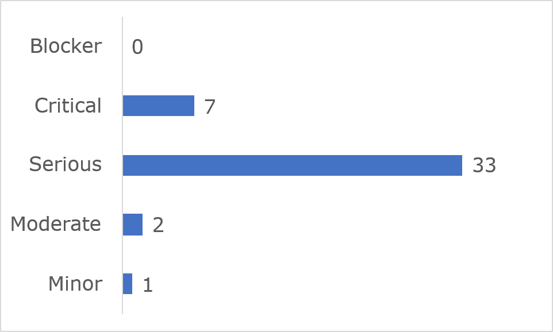
Frequently Identified Issues
Five Success Criteria were related to 67.4% of all issues:
- 1.3.1 Info and Relationships: 20.9%
- 1.4.4 Resize text: 16.3%
- 1.4.11 Non-text Contrast: 11.6%
- 1.4.3 Contrast (Minimum): 9.3%
- 4.1.2 Name, Role, Value: 9.3%
Figure 56: National Transport Authority 10 Most Frequently Identified Issues
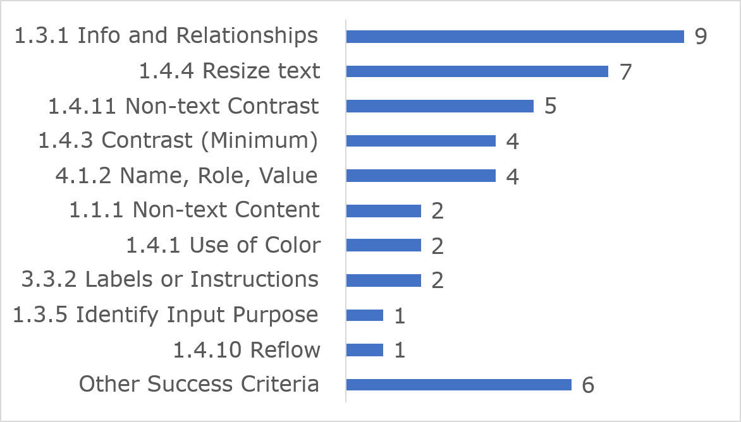
Among the 10 most frequently identified issues, (1.3.1) Info and Relationships accounted for nine instances, seven were related to (1.4.4) Resize text and five issues were linked to (1.4.11) Non-text Contrast.
Link to accessible table

Accessibility Statement
The National Transport Authority website Accessibility Statement contains most of the content required under the Directive.

Passport Online (passport renewal form)

Key findings
This website met 67% of applicable success criteria while 33% were not satisfied (Figure 57).
Figure 57: Passport Online (passport renewal form) Accessibility Compliance
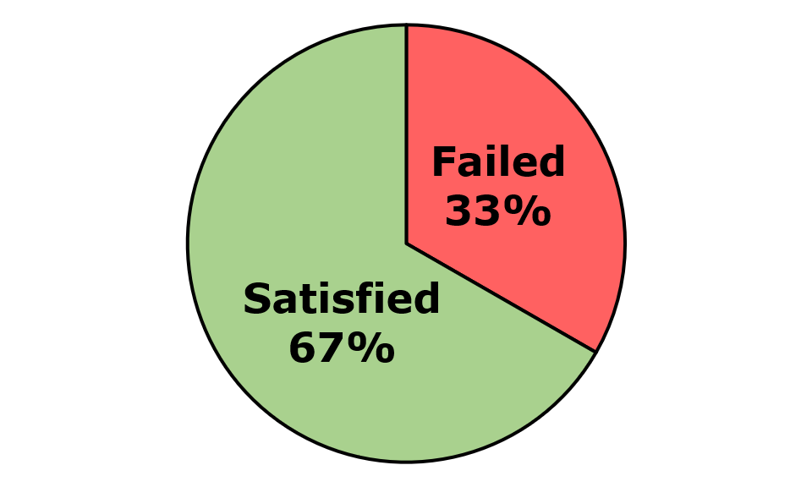
Across the eight components and twenty-five pages that were assessed, 153 issues were identified. These comprised 152 WCAG issues, zero EN 301 549-specific issues, and one WAD-specific issue. Of the WCAG issues, there were 97 WCAG Level A and 55 WCAG Level AA issues (Figure 58).
Figure 58: Passport Online (passport renewal form) Number of Issues
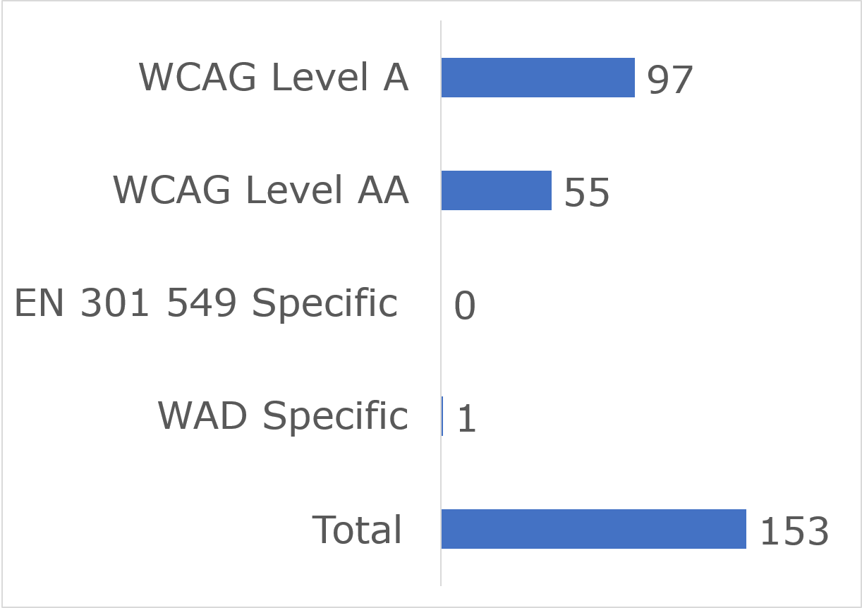

User impact
Most errors were classified as having “Serious” user impact (n=109), with the second highest number classified as “Critical” (n=40) and then “Moderate” (n=4). No “Blocker” or no “Minor” issues were identified (Figure 59).
Figure 59: Passport Online (passport renewal form) Number of Issues by User Impact
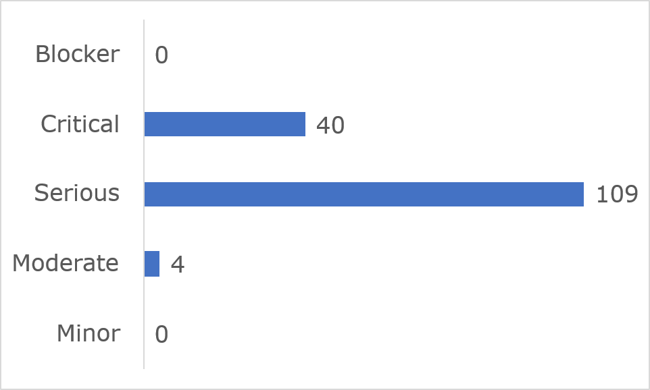
Frequently Identified Issues
Five Success Criteria were related to 61.4% of all issues:
- 1.3.1 Info and Relationships: 17%
- 4.1.2 Name, Role, Value: 15.7%
- 1.3.5 Identify Input Purpose: 11.1%
- 2.5.3 Label in Name: 11.1%
- 2.4.6 Headings and Labels: 6.5%
Figure 60: Passport Online (passport renewal form) 10 Most Frequently Identified Issues
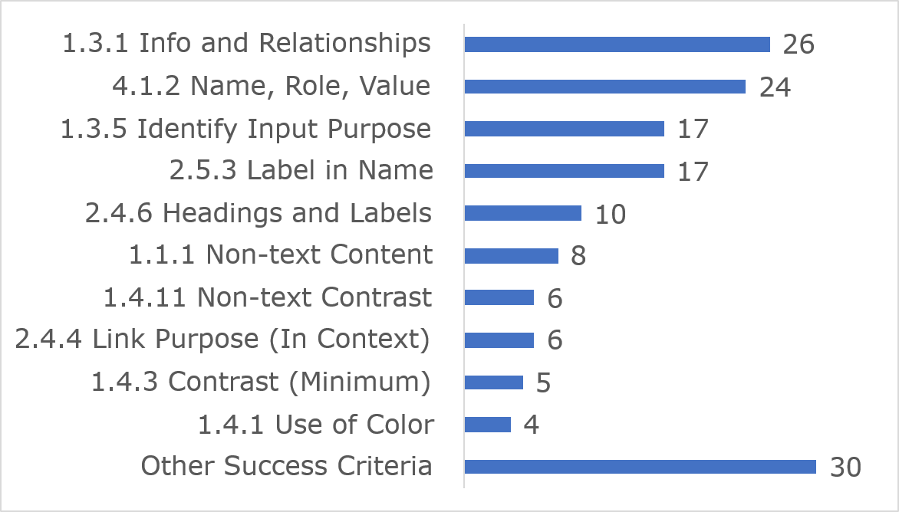
Among the 10 most frequently identified issues, (1.3.1) Info and Relationships accounted for 26 instances, 24 were related to (4.1.2) Name, Role, Value and 17 issues were linked to (1.3.5) Identify Input Purpose.
Link to accessible table

Accessibility Statement
No Accessibility Statement could be found during the In-depth Review.

RTB360

Key findings
This website met 73% of applicable success criteria while 27% were not satisfied (Figure 61).
Figure 61: RTB360 Accessibility Compliance
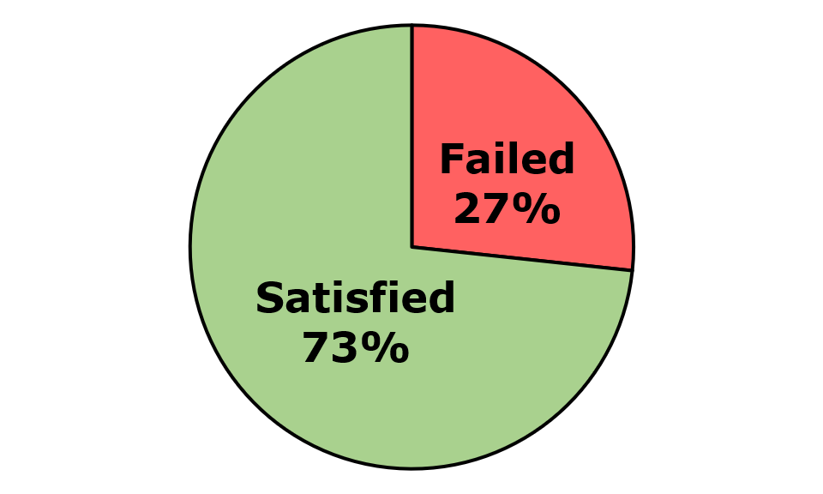
Across the two components and twelve pages that were assessed, 220 issues were identified. These comprised 220 WCAG issues, zero EN 301 549-specific issues, and zero WAD-specific issues. Of the WCAG issues, there were 96 WCAG Level A and 124 WCAG Level AA issues. (Figure 62)
Figure 62: RTB360 Number of Issues
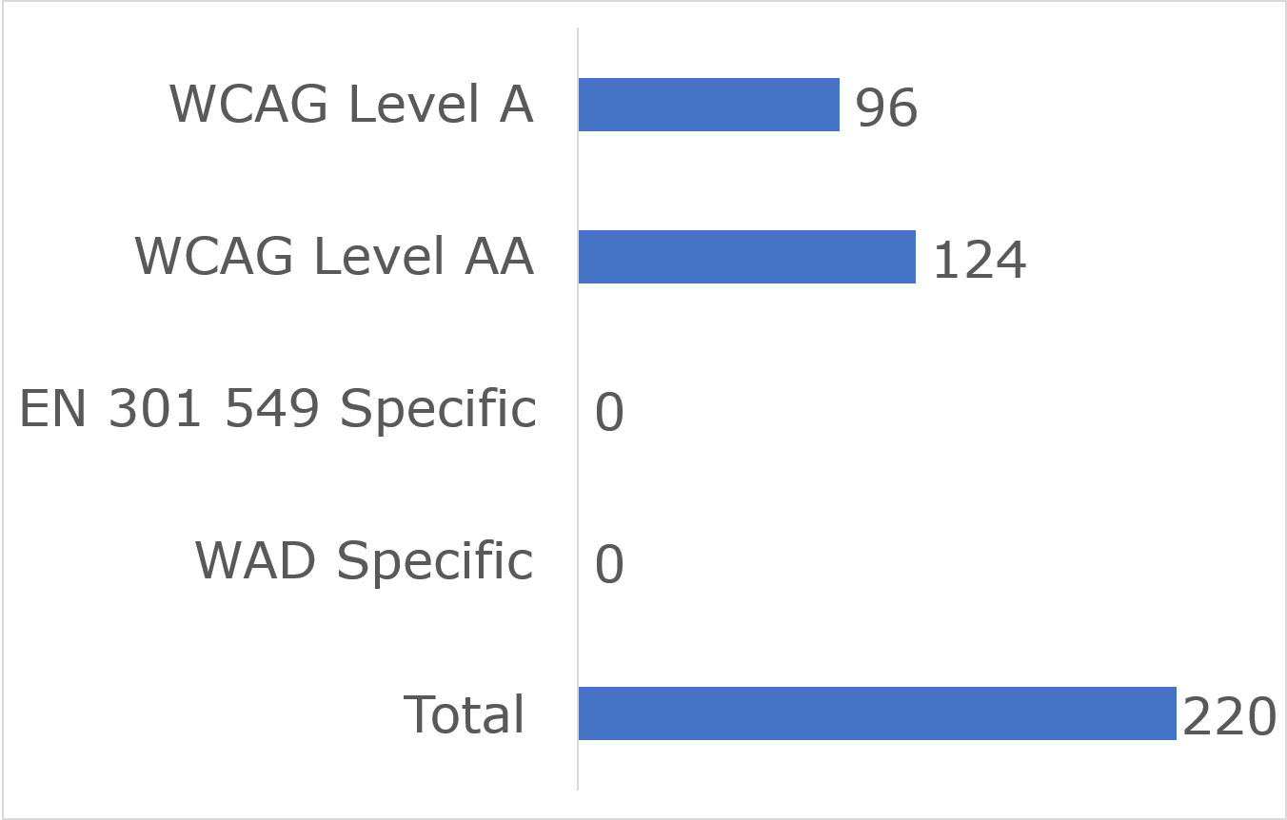

User impact
Most errors were classified as having “Serious” user impact (n=173), with the second highest number classified as “Critical” (n=47) and then “Moderate” (n=0). No “Blocker” or “Minor” issues were identified (Figure 63).
Figure 63: RTB360 Number of Issues by User Impact
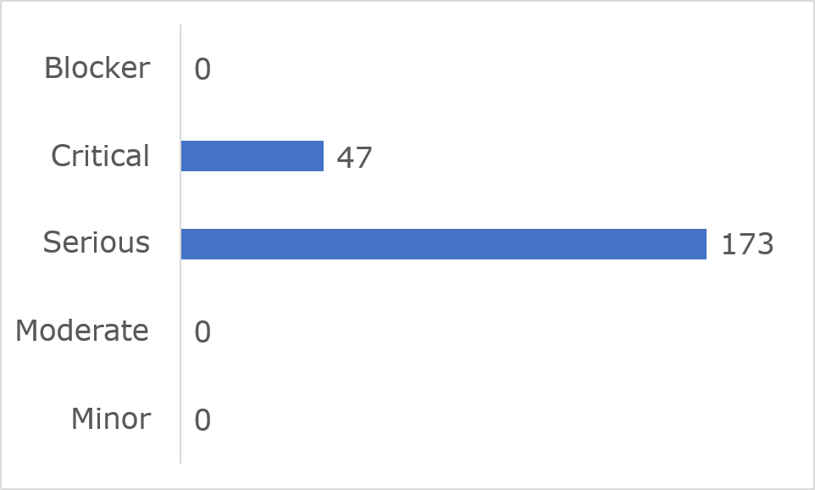
Frequently Identified Issues
Five Success Criteria were related to 76.8% of all issues:
- 1.4.3 Contrast (Minimum): 25.9%
- 4.1.2 Name, Role, Value: 18.2%
- 1.4.11 Non-text Contrast: 16.8%
- 1.3.1 Info and Relationships: 11.8%
- 2.4.3 Focus Order: 4.1%
Figure 64: RTB360 10 Most Frequently Identified Issues
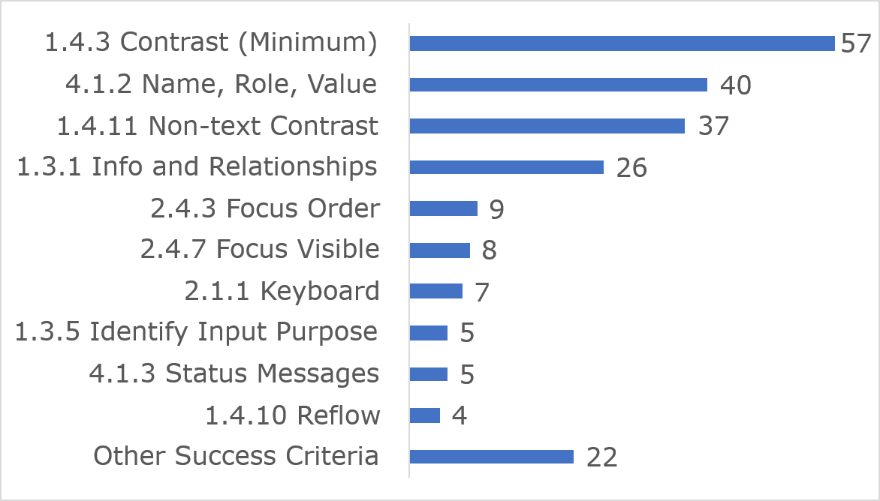
Among the 10 most frequently identified issues, (1.4.3) Contrast (Minimum) accounted for 57 instances, 40 were related to (4.1.2) Name, Role, Value and 37 issues were linked to (1.4.11) Non-text Contrast.
The RTB360 portal is scheduled for replacement or upgrading in 2026. The RTB made the decision that investment to improve accessibility in the existing system would be short-lived, duplicative and a poor use of public funds. They have committed to incorporating accessibility standards and compliance requirements into the new or upgraded platform.
Link to accessible table

Accessibility Statement
No Accessibility Statement could be found during the In-depth Review.

Residential Tenancies Board website

Key findings
This website met 89% of applicable success criteria while 11% were not satisfied (Figure 65).
Figure 65: Residential Tenancies Board Accessibility Compliance
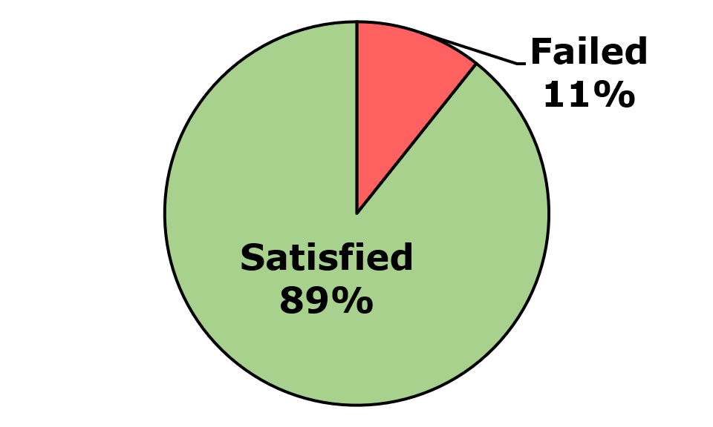
Across the eight pages and four components that were assessed, 34 issues were identified. These comprised 31 WCAG issues, zero EN 301 549-specific issues, and zero WAD-specific issues. Of the WCAG issues, there were 16 WCAG Level A and 15 WCAG Level AA issues (Figure 66).
Figure 66: Residential Tenancies Board Number of Issues
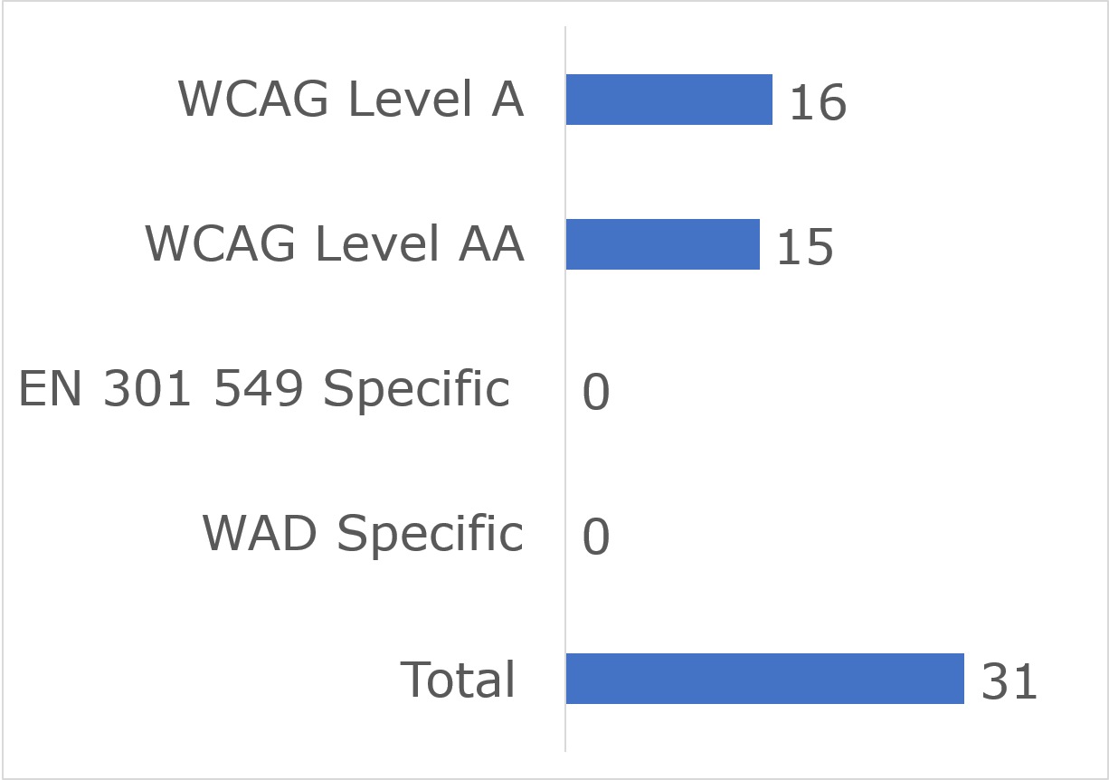

User impact
Most errors were classified as having “Serious” user impact (n=21), with the second highest number classified as “Critical” (n=9) and then “Moderate” (n=1). No “Blocker” or “Minor” issues were identified (Figure 67).
Figure 67: Residential Tenancies Board Number of Issues by User Impact
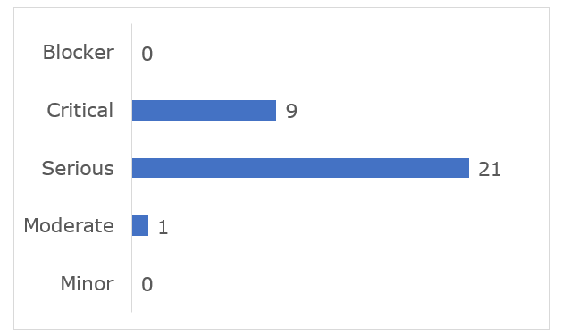
Frequently Identified Issues
Five Success Criteria were related to 90.4% of all issues:
- 1.4.3 Contrast (Minimum): 41.9%
- 1.3.1 Info and Relationships: 29.0%
- 1.1.1 Non-text Content: 6.5%
- 1.4.11 Non-text Contrast: 6.5%
- 2.1.1 Keyboard: 6.5%
Figure 68: Residential Tenancies Board Most Frequently Identified Issues
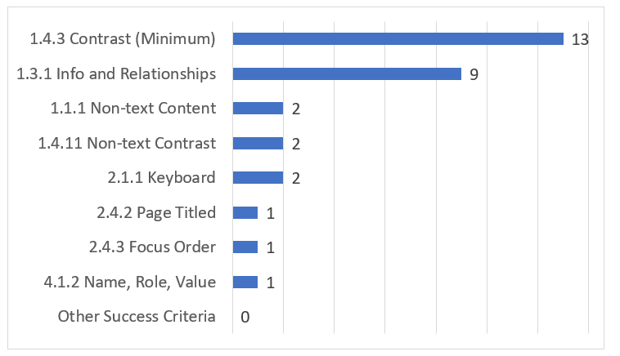
Among the 10 most frequently identified issues, (1.4.3) Contrast (Minimum) accounted for 13 instances, nine were related to (1.3.1) Info and Relationships and four issues were linked to (1.1.1) Non-text Content.
Link to accessible table

Accessibility Statement
The Residential Tenancies Board website Accessibility Statement contains most of the content required under the Directive.

State Examinations Commission

Key findings
This website met 75% of applicable success criteria while 25% were not satisfied. (Figure 69)
Figure 69: State Examinations Commission Accessibility Compliance
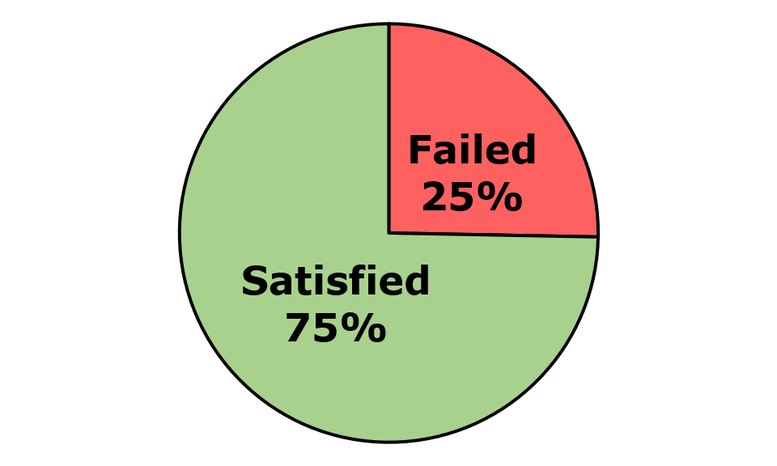
Across the five components and seventeen pages that were assessed, 167 issues were identified. These comprised 165 WCAG issues, one EN 301 549-specific issue, and one WAD-specific issue. Of the WCAG issues, there were 108 WCAG Level A and 57 WCAG Level AA issues. (Figure 70)
Figure 70: State Examinations Commission Number of Issues
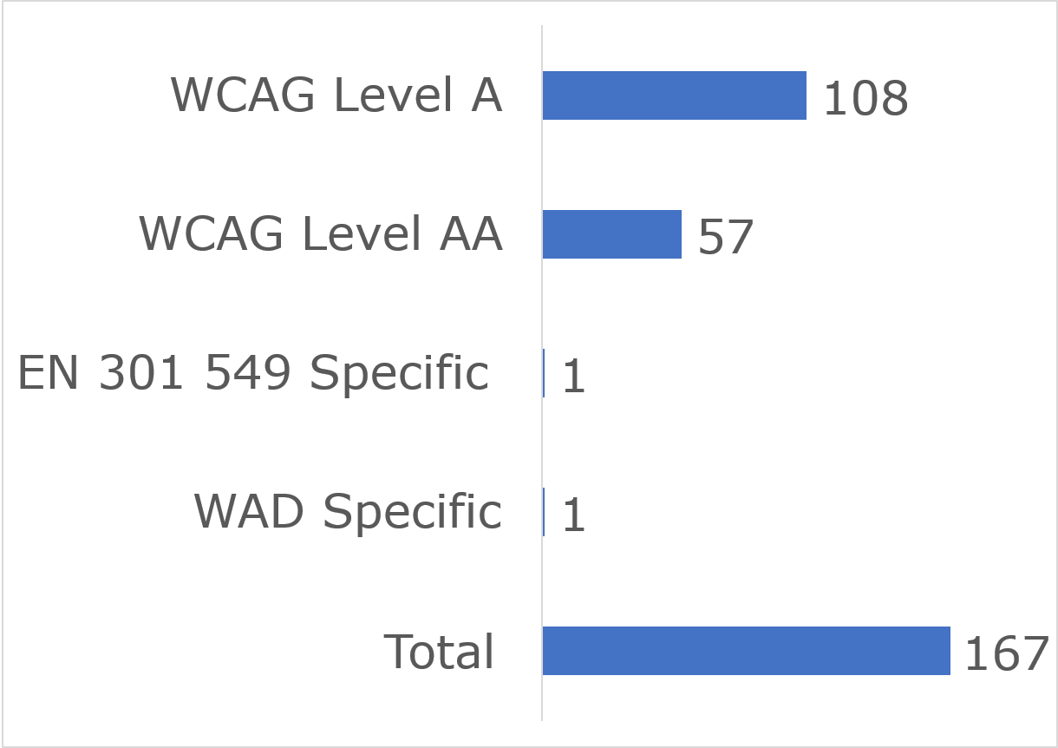

User impact
Most errors were classified as having “Serious” user impact (n=102), with the second highest number classified as “Critical” (n=46) and “Moderate” (n=15). Three “Blocker” and one “Minor” issue was identified (Figure 71).
Figure 71: State Examinations Commission Number of Issues by User Impact
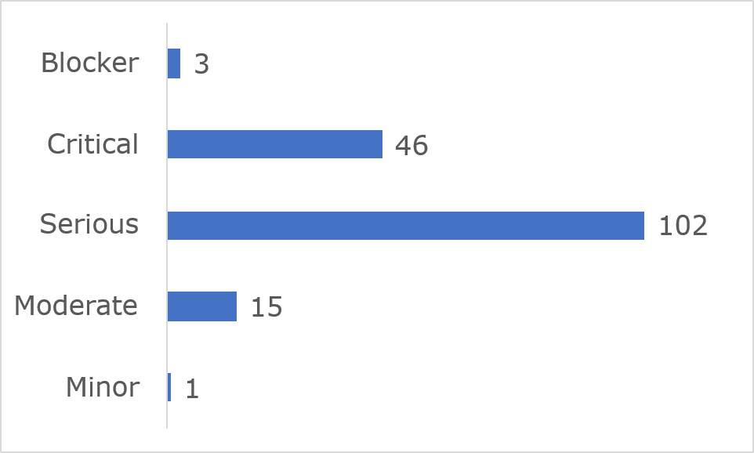

Frequently Identified Issues
Five Success Criteria were related to 76.7% of all issues:
- 1.3.1 Info and Relationships: 27.5%
- 4.1.2 Name, Role, Value: 18%
- 3.1.2 Language of Parts: 17.4%
- 1.1.1 Non-text Content: 8.4%
- 1.4.10 Reflow: 5.4%
Figure 72: State Examinations Commission 10 Most Frequently Identified Issues
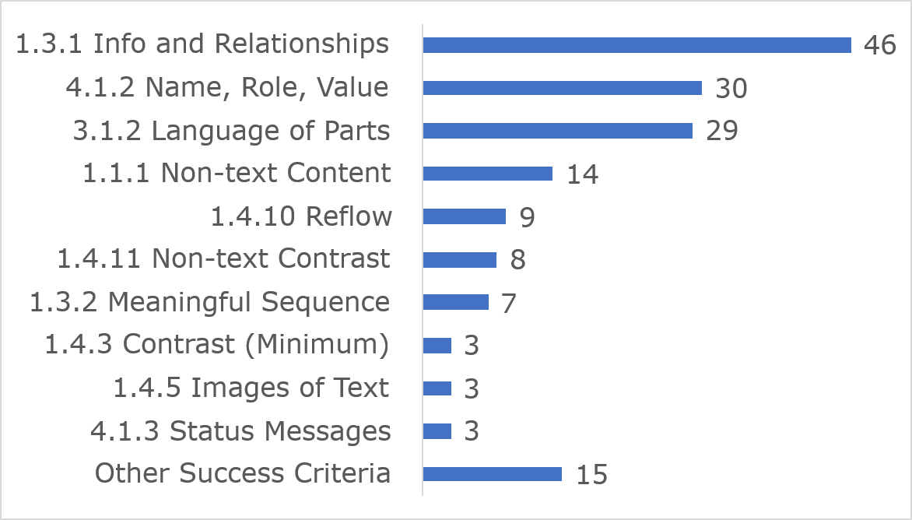
Among the 10 most frequently identified issues, (1.3.1) Info and Relationships accounted for 46 instances, 30 were related to (4.1.2) Name, Role, Value and 29 issues were linked to (3.1.2) Language of Parts.
Link to accessible table

Accessibility Statement
The State Examinations Commission website Accessibility Statement contains most of the content required under the Directive.

UCC Canvas

Key findings
This website met 75% of applicable success criteria while 25% were not satisfied (Figure 73).
Figure 73: UCC Canvas Accessibility Compliance
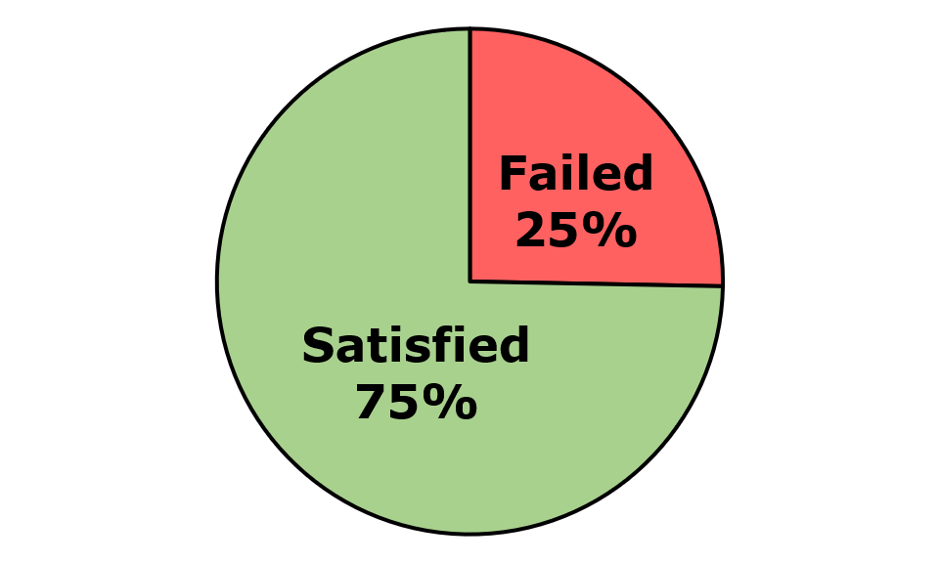
Across the three components and nine pages that were assessed, 60 issues were identified. These comprised 57 WCAG issues, two EN 301 549-specific issues, and one WAD-specific issues. Of the WCAG issues, there were 34 WCAG Level A and 23 WCAG Level AA issues (Figure 74).
Figure 74: UCC Canvas Number of Issues
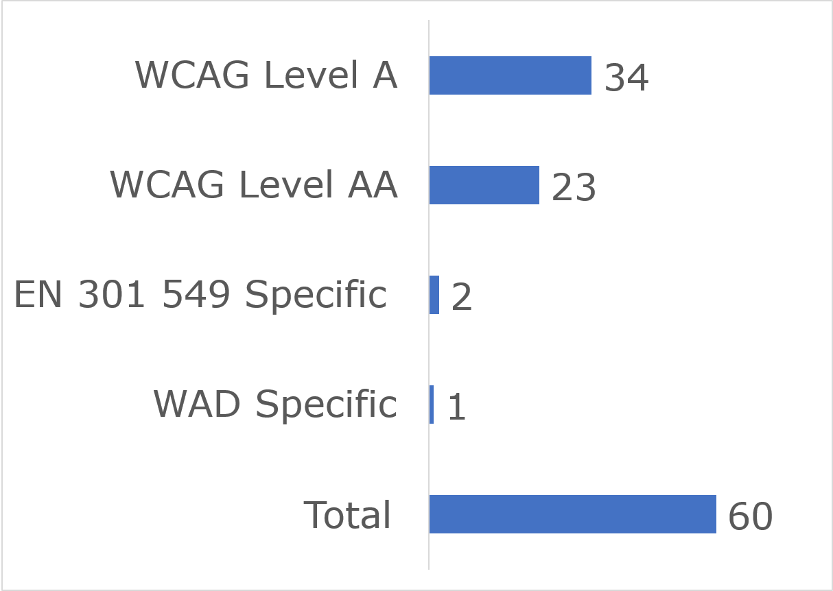

User impact
Most errors were classified as having “Serious” user impact (n=45), with the second highest number classified as “Critical” (n=13) and then “Moderate” (n=2). No “Blocker” or “Minor” issues were identified (Figure 75).
Figure 75: UCC Canvas Number of Issues by User Impact
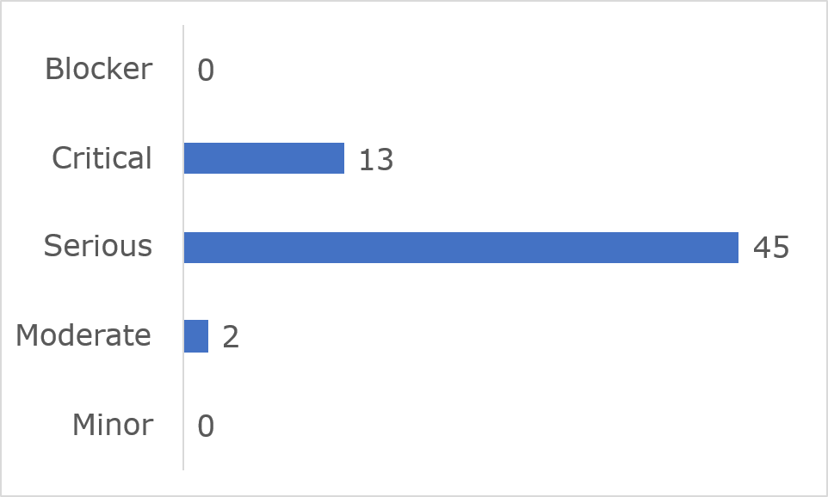
Frequently Identified Issues
Five Success Criteria were related to 54.9 % of all issues:
- 1.3.1 Info and Relationships: 13.3%
- 4.1.2 Name, Role, Value: 13.3%
- 1.4.11 Non-text Contrast: 10%
- 2.1.1 Keyboard: 10%
- 1.4.1 Use of Colour: 8.3%
Figure 76: UCC Canvas 10 Most Frequently Identified Issues
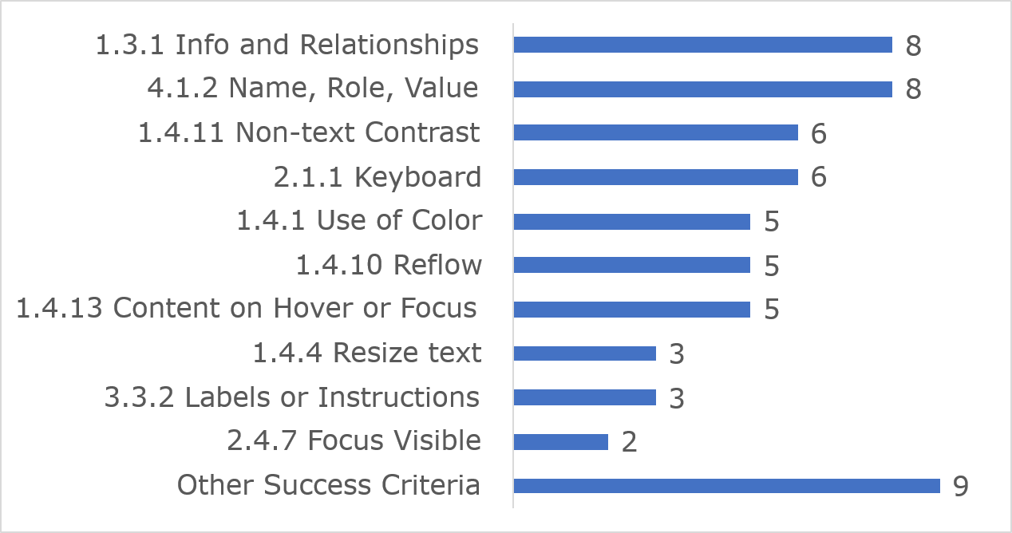

Among the 10 most frequently identified issues, (1.3.1) Info and relationships accounted for eight instances, eight were related to (4.1.2) Name, Role, Value and six were linked to (1.4.11) Non-text Contrast.
Link to accessible table

Accessibility Statement
No Accessibility Statement could be found during the In-depth Review.

UniversalDesign.ie

Key findings
This website met 91% of applicable success criteria while 9% were not satisfied (Figure 77).
Figure 77: UniversalDesign.ie Accessibility Compliance
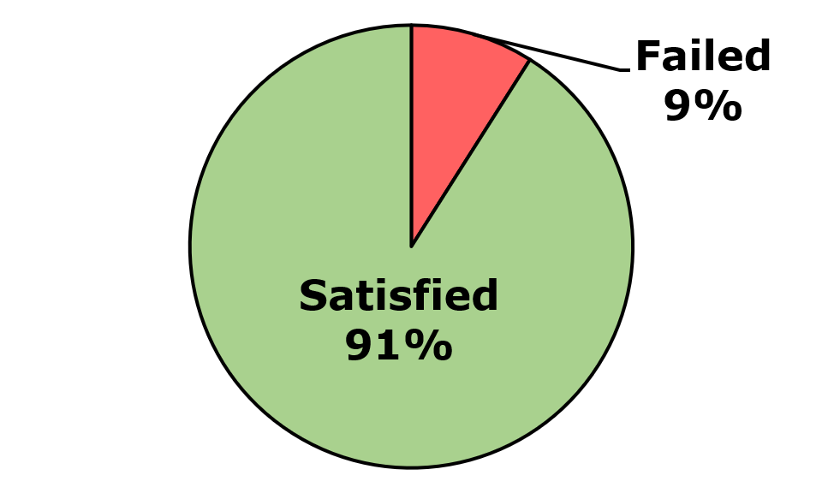
Across the three components and nine pages that were assessed, 15 issues were identified. These comprised 11 WCAG issues, four EN 301 549-specific issues, and zero WAD-specific issues. Of the WCAG issues, there were nine WCAG Level A and two WCAG Level AA issues (Figure 78).
Figure 78: UniversalDesign.ie Number of Issues
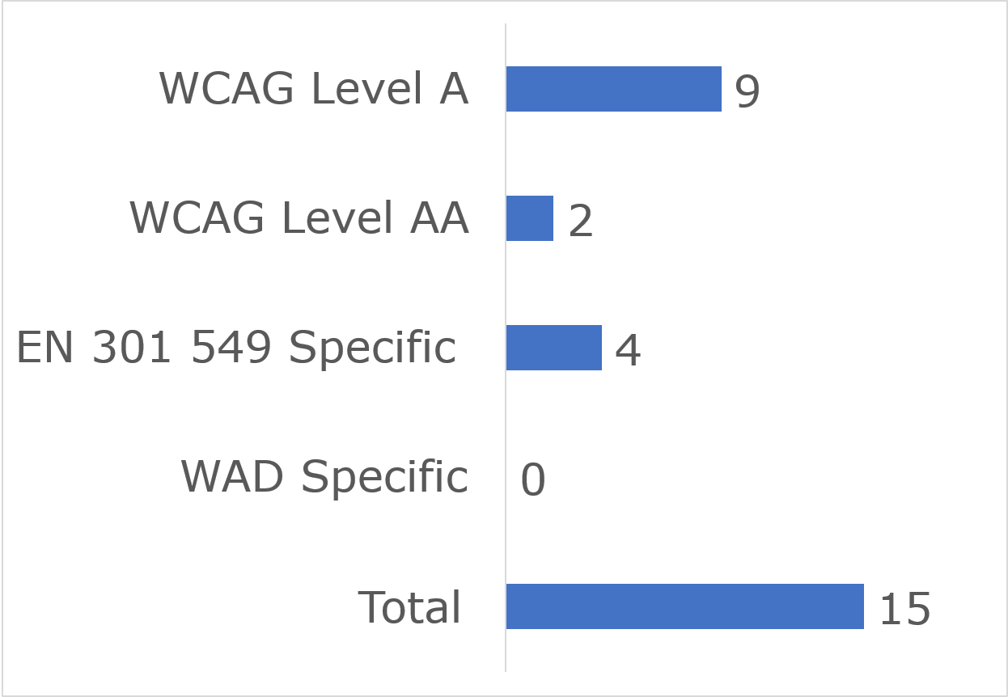

User impact
Most errors were classified as having “Serious” user impact (n=10), with the second highest number classified as “Critical” (n=1) and then “Moderate” (n=4). No “Blocker” or “Minor” issues were identified (Figure 79).
Figure 79: UniversalDesign.ie Number of Issues by User Impact
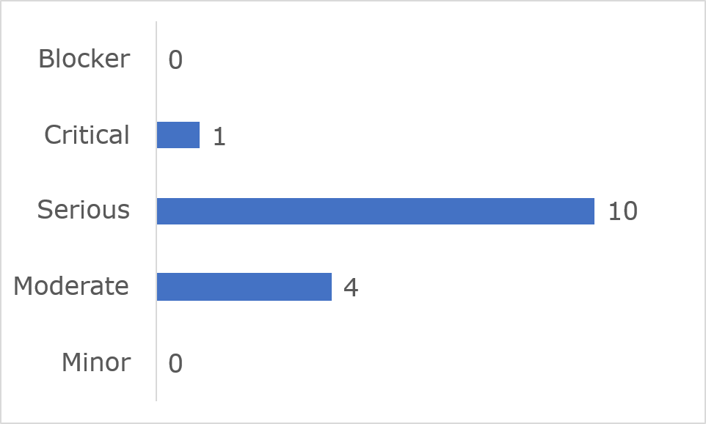
Frequently Identified Issues
Five Success Criteria were related to 86.7% of all issues:
- 1.3.1 Info and Relationships: 40%
- 1.4.3 Contrast (Minimum): 13.3%
- 2.4.2 Page Titled: 13.3%
- EN-7.1.5 Spoken subtitles: 13.3%
- 1.1.1 Non-text Content: 6.7%
Figure 80: UniversalDesign.ie Most Frequently Identified Issues
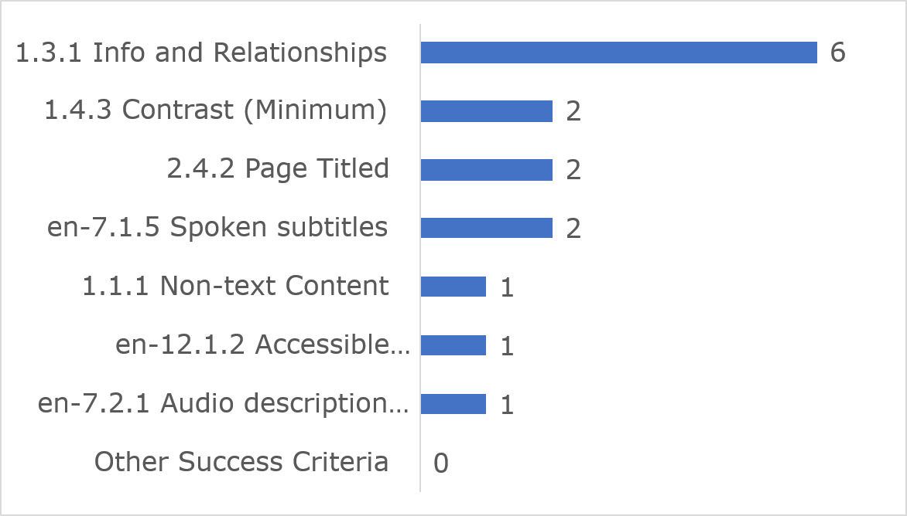
Among the 10 most frequently identified issues, (1.3.1) Info and relationships accounted for six instances, two were related to (1.4.3) Contrast (Minimum) and two were linked to (2.4.2) Page Titled.
Link to accessible table

Accessibility Statement
The Centre for Excellence in Universal Design’s website Accessibility Statement contains most of the content required under the Directive.

Workplace Relations Commission

Key findings
This website met 72% of applicable success criteria while 28% were not satisfied (Figure 81).
Figure 81: Workplace Relations Commission Accessibility Compliance
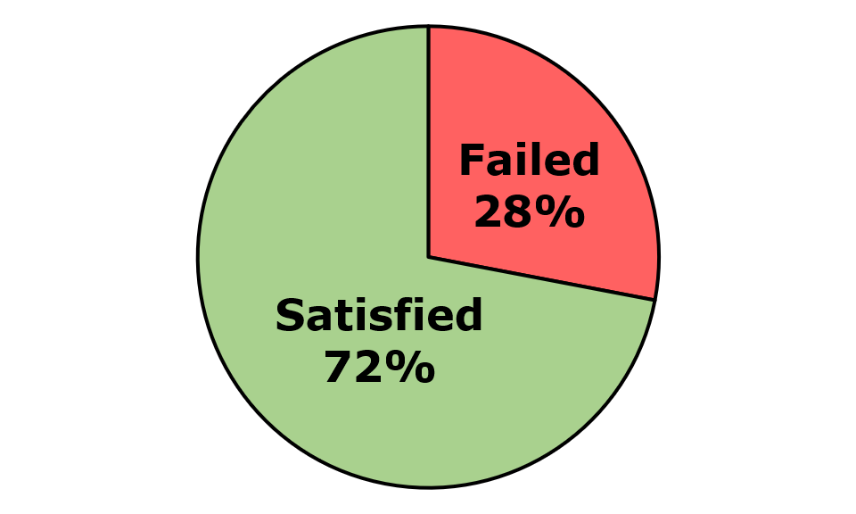
Across the six components and 11 pages that were assessed, 43 issues were identified. These comprised 40 WCAG issues, two EN 301 549-specific issues, and one WAD-specific issue. Of the WCAG issues, there were 24 WCAG Level A and 16 WCAG Level AA issues (Figure 82).
Figure 82: Workplace Relations Commission Number of Issues
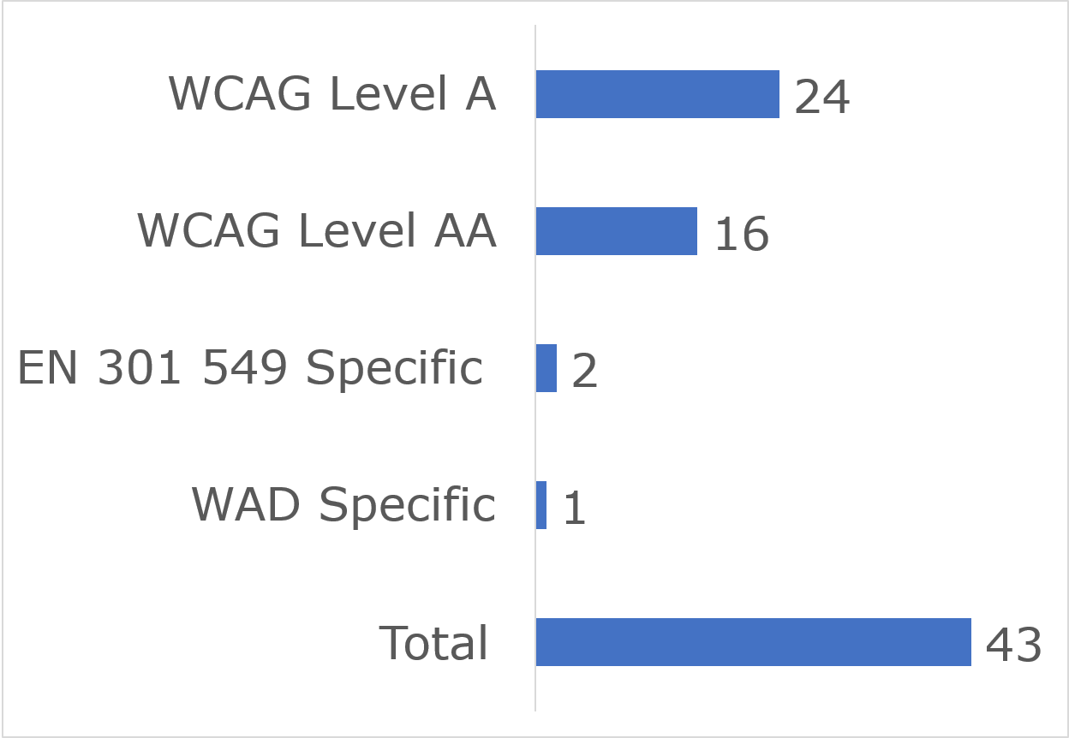

User impact
Most errors were classified as having “Serious” user impact (n=35), with the second highest number classified as “Critical” (n=2) and then “Moderate” (n=6). No “Blocker” or “Minor” issues were identified (Figure 83).
Figure 83: Workplace Relations Commission Number of Issues by User Impact
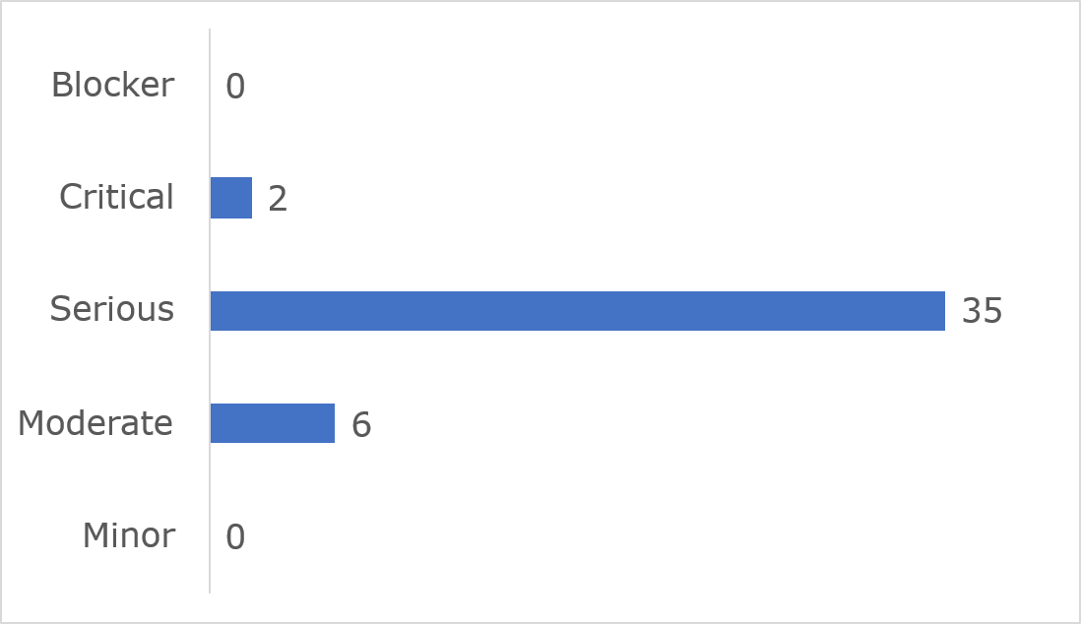
Frequently Identified Issues
Five Success Criteria were related to 51.2% of all issues:
- 4.1.2 Name, Role, Value: 14.0%
- 1.3.1 Info and Relationships: 11.6%
- 1.4.10 Reflow: 11.6%
- 1.1.1 Non-text Content: 7.0%
- 1.4.11 Non-text Contrast: 7.0%
Figure 84: Workplace Relations Commission 10 Most Frequently Identified Issues
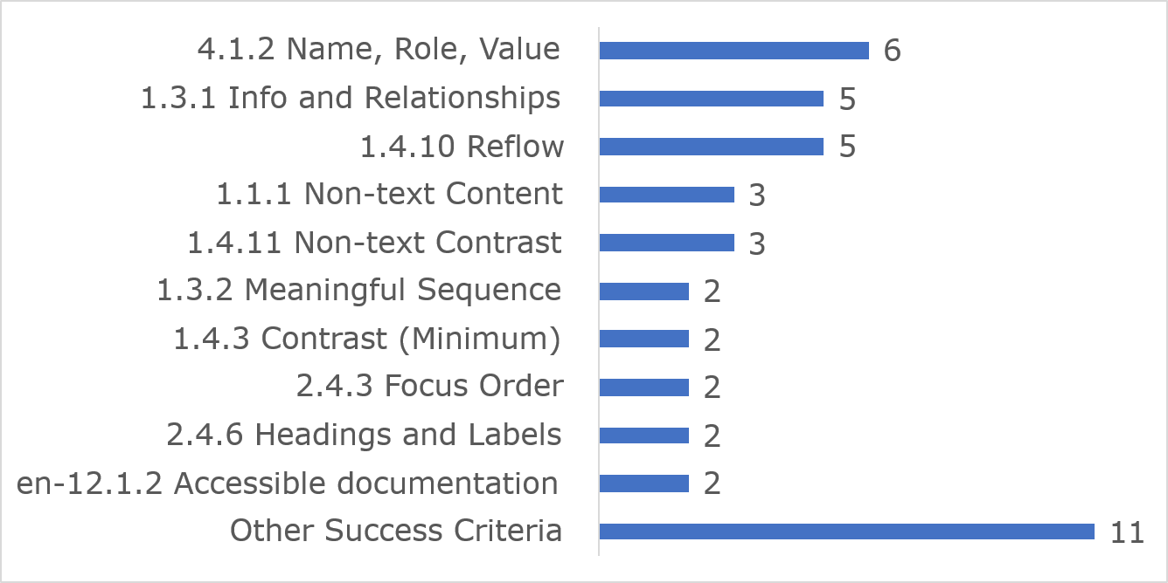
Among the 10 most frequently identified issues, (4.1.2) Name, Role, Value accounted for six instances, five were related to (1.3.1) Info and Relationships and five issues were linked to (1.4.10) Reflow.
Link to accessible table

Accessibility Statement
The Workplace Relations Commission website Accessibility Statement contains some of the content required under the Directive.

Workplace Relations Commission eComplaint form

Key findings
This website met 84% of applicable success criteria while 16 % were not satisfied. (Figure 85)
Figure 85: Workplace Relations Commission eComplaint form Accessibility Compliance
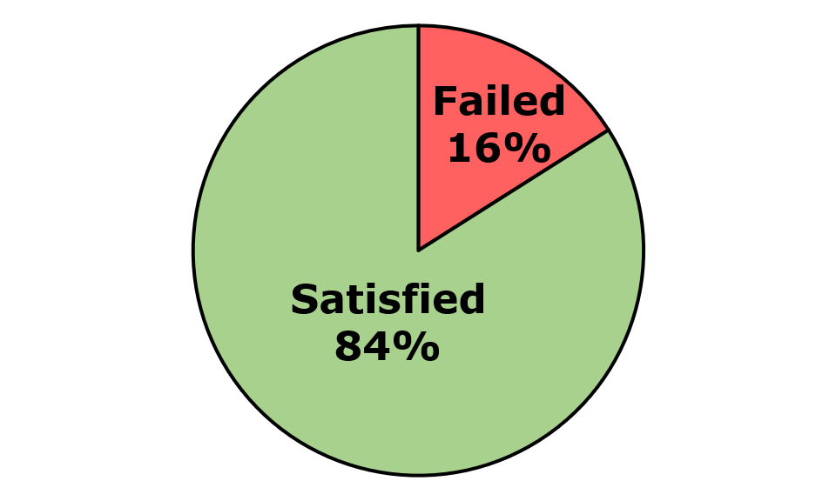
Across the three components and eight pages that were assessed, 48 issues were identified. These comprised 48 WCAG issues, zero EN 301 549-specific issues, and zero WAD-specific issues. Of the WCAG issues, there were 18 WCAG Level A and 30 WCAG Level AA issues. (Figure 86).
Figure 86: Workplace Relations Commission eComplaint form Number of Issues
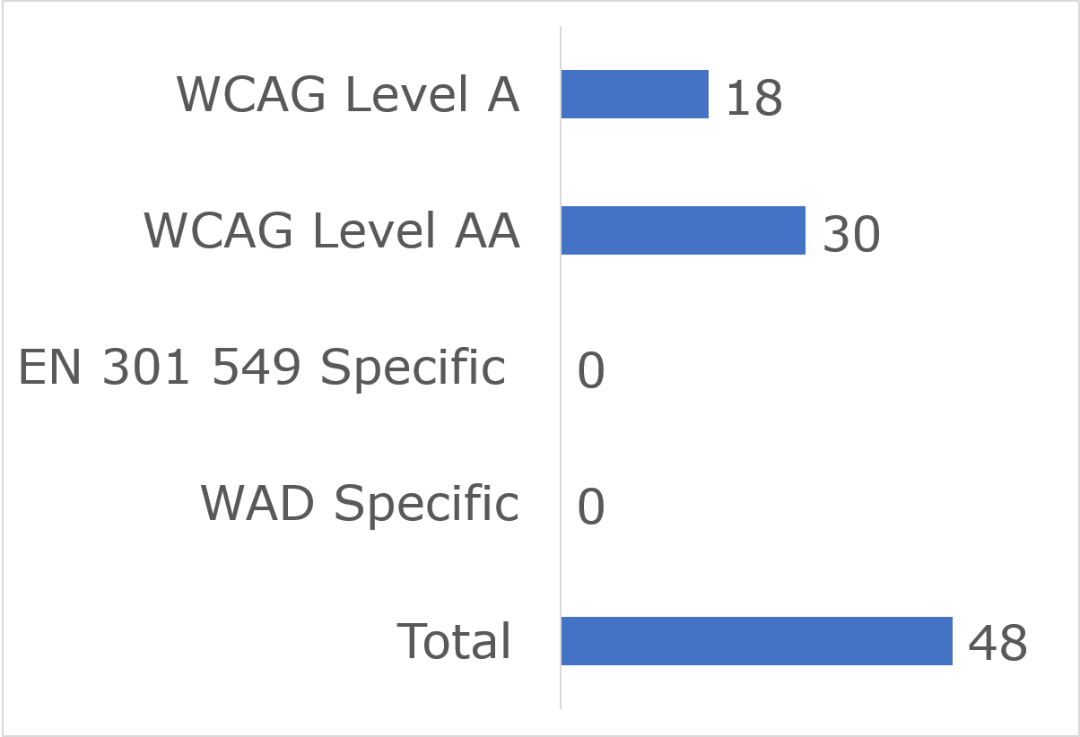

User impact
Most errors were classified as having “Serious” user impact (n=41), with the second highest number classified as “Critical” (n=6) and then “Moderate” (n=1). No “Blocker” or “Minor” issues were identified (Figure 87).
Figure 87: Workplace Relations Commission eComplaint form Number of Issues by User Impact
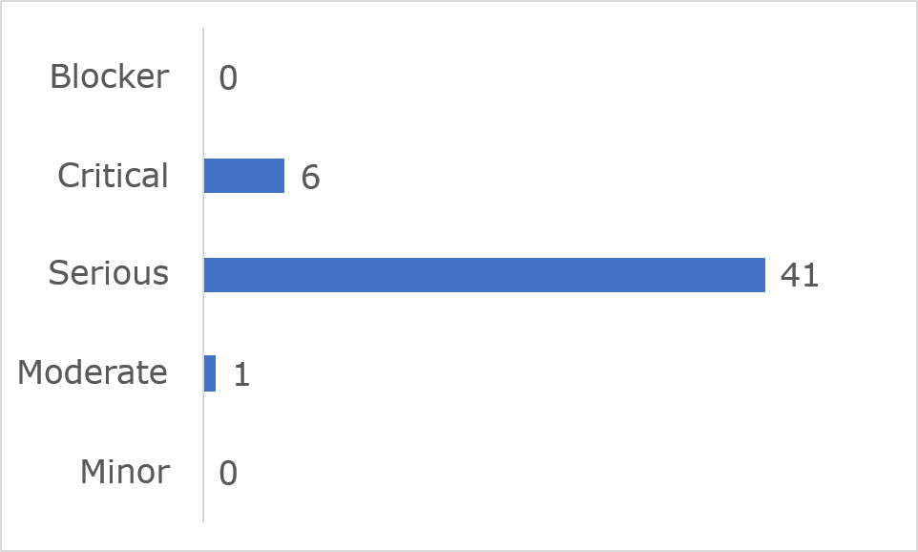
Frequently Identified Issues
Five Success Criteria were related to 81.2% of all issues:
- 1.4.3 Contrast (Minimum): 33.3%
- 1.3.1 Info and Relationships: 16.7%
- 1.4.11 Non-text Contrast: 12.5%
- 4.1.2 Name, Role, Value: 10.4%
- 1.4.10 Reflow: 8.3%
Figure 88: Workplace Relations Commission eComplaint form 10 Most Frequently Identified Issues
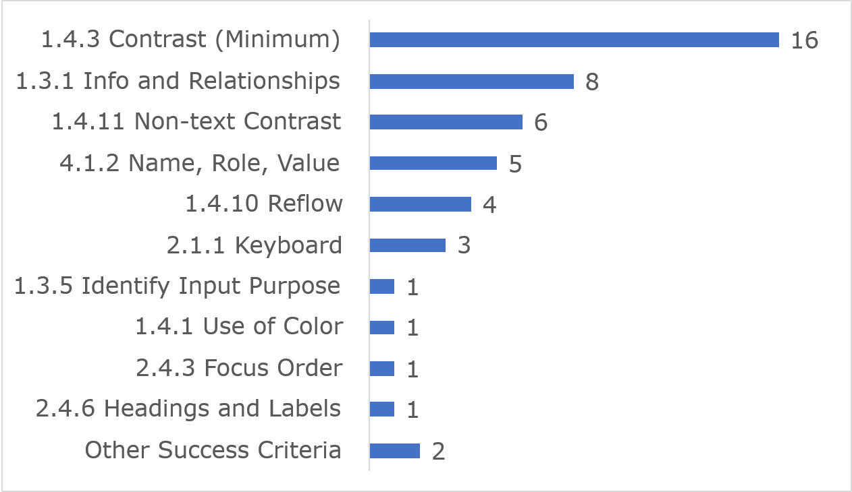
Among the 10 most frequently identified issues, (1.4.3) Contrast (Minimum) accounted for 16 instances, eight were related to (1.3.1) Info and Relationships and six issues were linked to (1.4.1) Non-text Contrast.
Link to accessible table

Accessibility Statement
No Accessibility Statement could be found during the In-depth Review.

Mobile Application Results

HSE Health App Android

Key findings
This app met 88% of applicable success criteria while 12% were not satisfied (Figure 89).
Figure 89: HSE Health App Android Accessibility Compliance
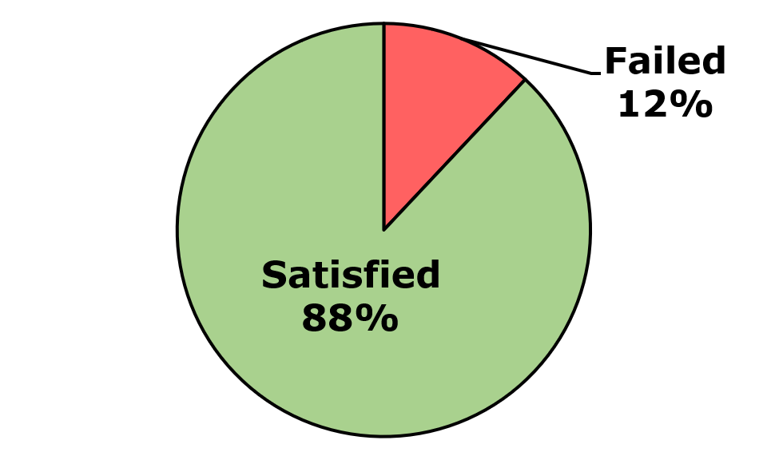
Across the twelve pages and three components that were assessed, 19 issues were identified. These comprised 17 WCAG issues, zero EN 301 549-specific issue, and two WAD-specific issues. Of the WCAG issues, there were 14 WCAG Level A and three WCAG Level AA issues (Figure 90).
Figure 90: HSE Health App Android Number of Issues
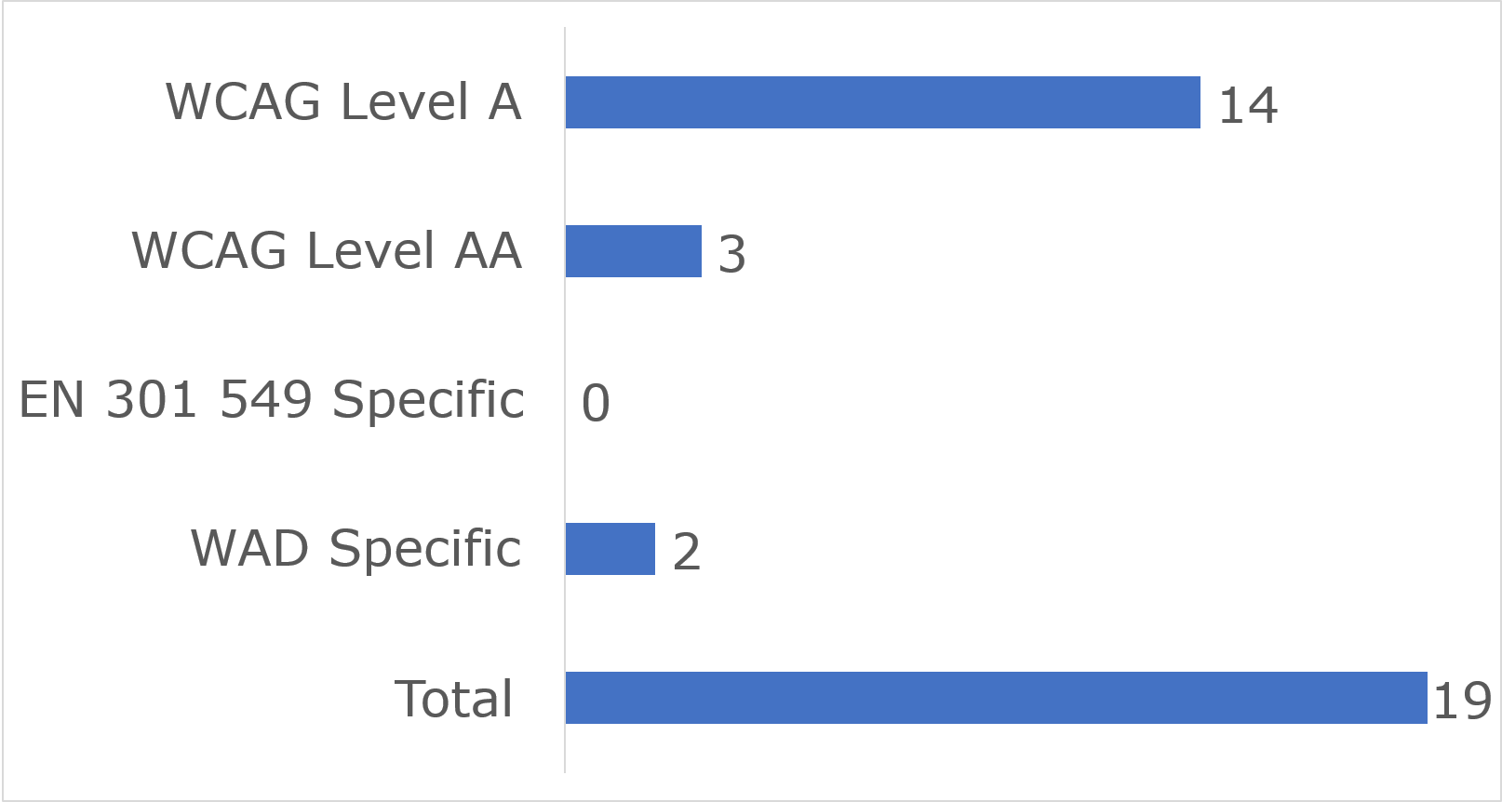

User impact
Most errors were classified as having “Serious” user impact (n=11), with the second highest number classified as “Critical” (n=4) and then “Moderate” (n=4). No “Blocker” and no “Minor” issue was identified (Figure 91).
Figure 91: HSE Health App Android Number of Issues by User Impact
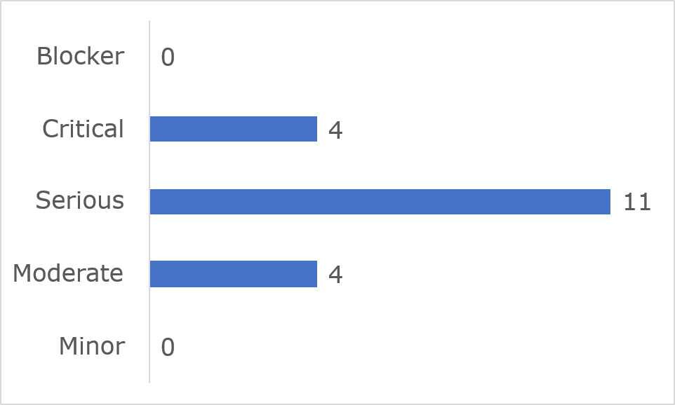
Frequently Identified Issues
Five Success Criteria were related to 93.3% of all issues:
- 1.3.1 Info and Relationships: 40.0%
- 2.4.3 Focus Order: 20.0%
- 1.3.2 Meaningful Sequence: 13.3%
- WAD Accessibility Statement: 13.3%
- 2.5.3 Label in Name: 6.7%
Figure 92: HSE Health App Android Most Frequently Identified Issues
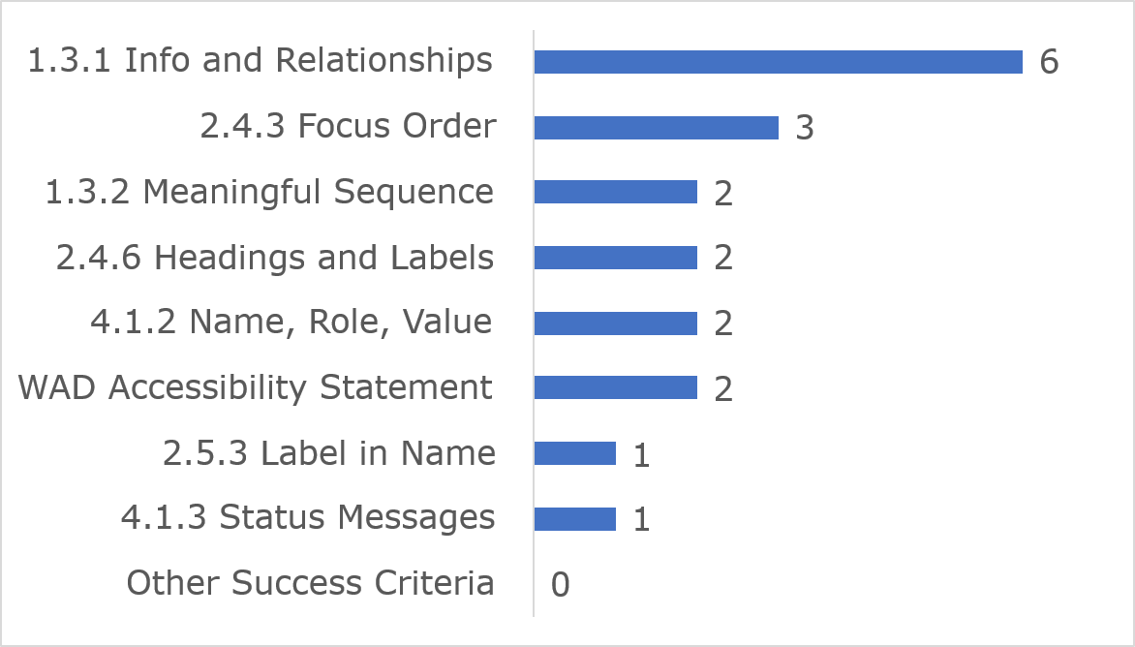
Among the 10 most frequently identified issues, (1.3.1) Info and Relationships accounted for six instances, three were related to (2.4.3) Focus Order and two were linked to (1.3.2) Meaningful Sequence.
Link to accessible table

Accessibility Statement
The HSE Health App (Android) Accessibility Statement contains most of the content required under the Directive.

HSE Health App iOS

Key findings
This app met 85% of applicable success criteria while 15% were not satisfied (Figure 93).
Figure 93: HSE Health App iOS Accessibility Compliance
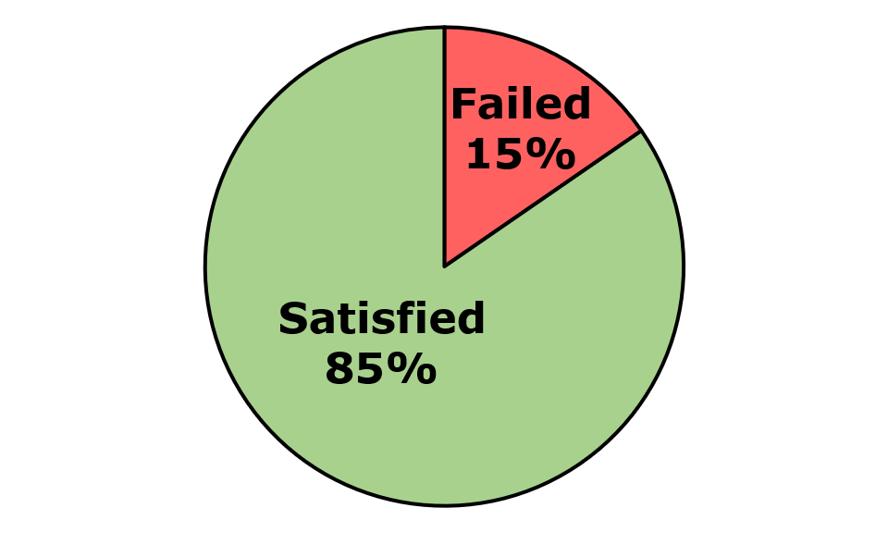
Across the eleven pages and three components that were assessed, 18 issues were identified. These comprised 16 WCAG issues, zero EN 301 549-specific issue, and two WAD-specific issues. Of the WCAG issues, there were 13 WCAG Level A and three WCAG Level AA issues (Figure 94).
Figure 94: HSE Health App iOS Number of Issues
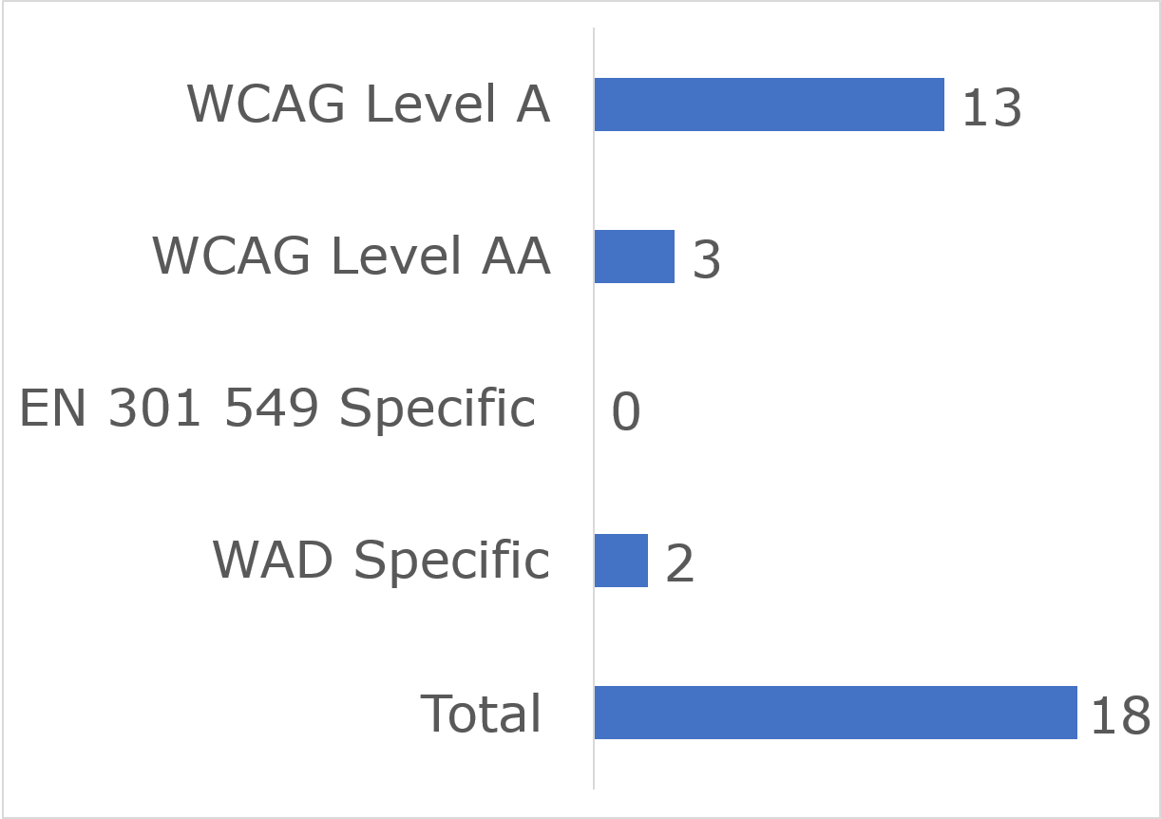

User impact
Most errors were classified as having “Serious” user impact (n=10), with the second highest number classified as “Critical” (n=5) and then “Moderate” (n=2). One “Blocker” and no “Minor” issue was identified (Figure 95).
Figure 95: HSE Health App iOS Number of Issues by User Impact
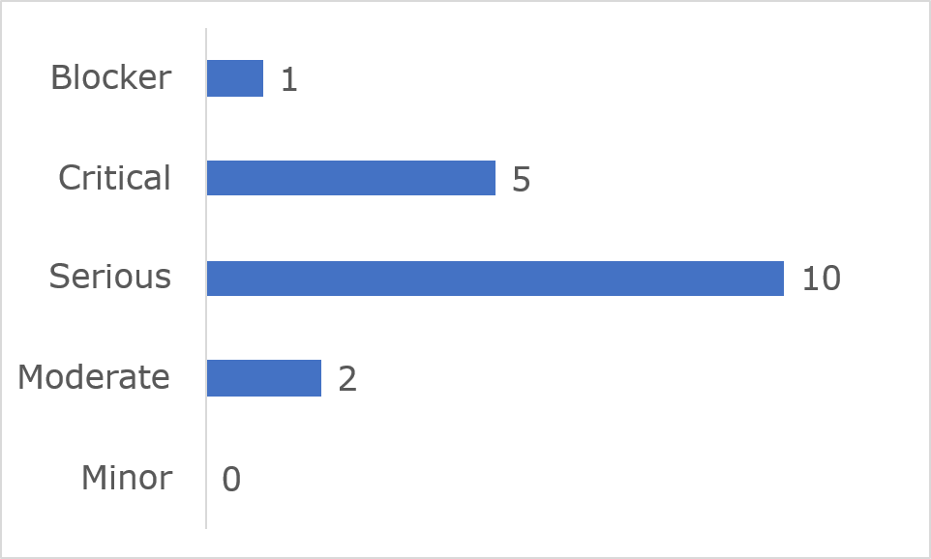

Frequently Identified Issues
Five Success Criteria were related to 72.3% of all issues:
- 1.3.1 Info and Relationships: 16.7%
- 1.3.2 Meaningful Sequence: 16.7%
- 4.1.2 Name, Role, Value: 16.7%
- 2.4.6 Headings and Labels: 11.1%
- WAD Accessibility Statement: 11.1%
Figure 96: HSE Health App iOS 10 Most Frequently Identified Issues
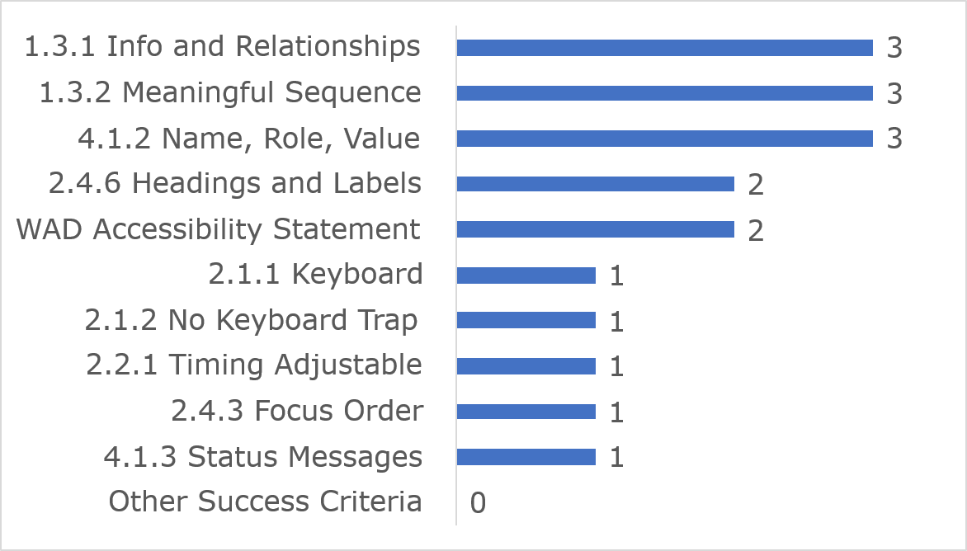
Among the 10 most frequently identified issues, (1.3.1) Info and Relationships accounted for three instances, three were related to (1.3.2) Meaningful Sequence and three were linked to (4.1.2) Meaningful Sequence.
Link to accessible table

Accessibility Statement
The HSE Health App (Android) Accessibility Statement contains most of the content required under the Directive

LEAP Top-Up App Android

Key findings
This app met 88% of applicable success criteria while 12% were not satisfied (Figure 97).
Figure 97: LEAP Top-Up App Android Accessibility Compliance
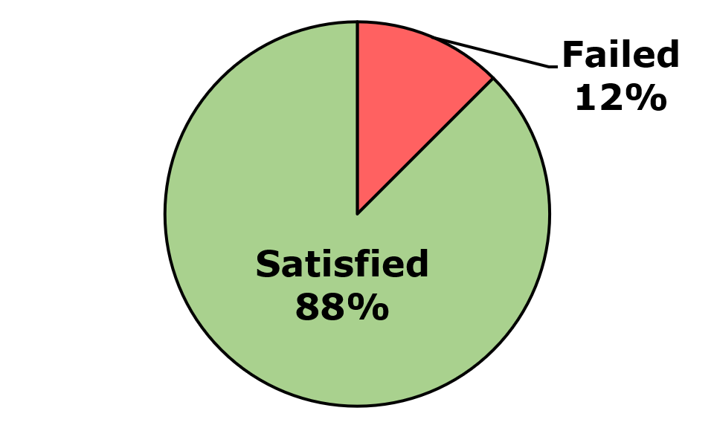
Across the nine pages and two components that were assessed, nine issues were identified. These comprised six WCAG issues, one EN 301 549-specific issue, and two WAD-specific issues. Of the WCAG issues, there were five WCAG Level A and one WCAG Level AA issues (Figure 98).
Figure 98: LEAP Top-Up App Android Number of Issues
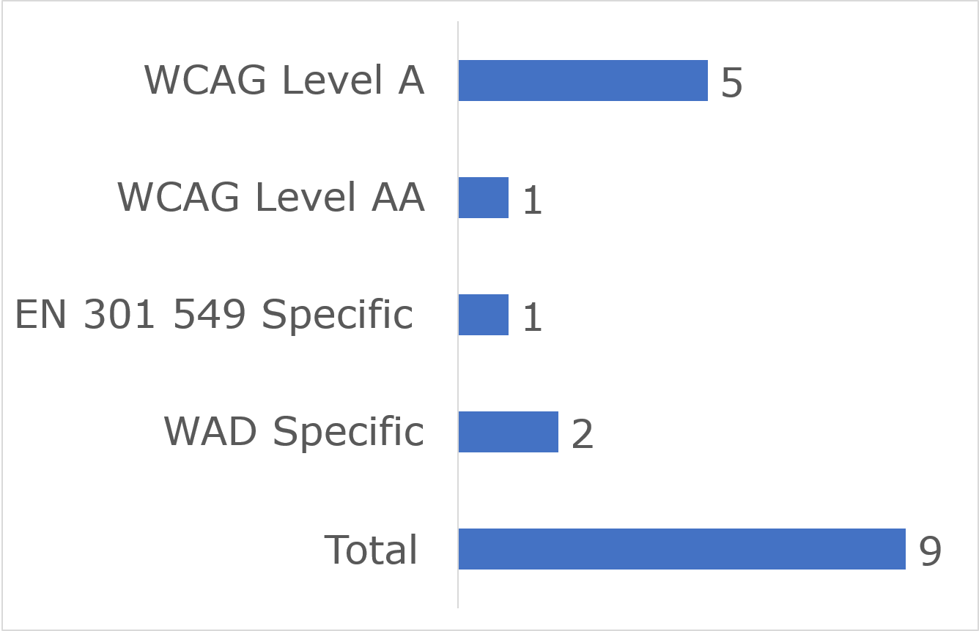

User impact
Most errors were classified as having “Serious” user impact (n=6), with the second highest number classified as “Critical” (n=1) and then “Moderate” (n=1). No “Blocker” and one “Minor” issue was identified (Figure 99).
Figure 99: LEAP Top-Up App Android Number of Issues by User Impact
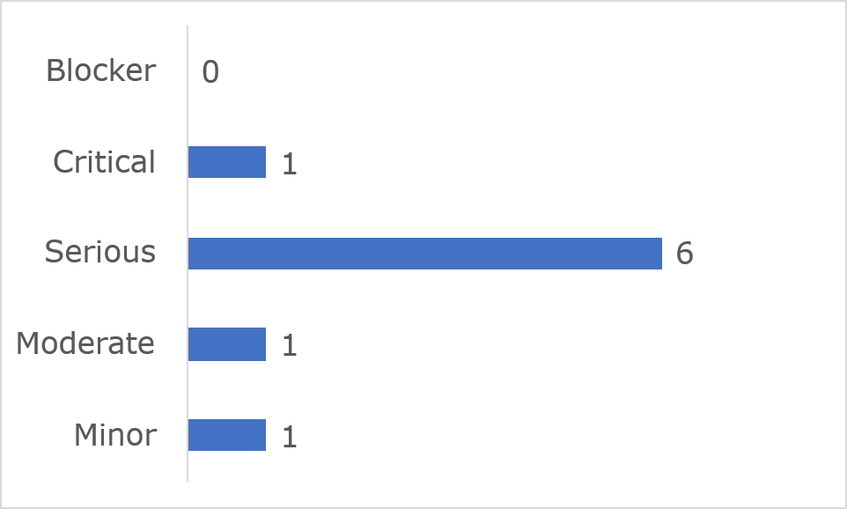

Frequently Identified Issues
Five Success Criteria were related to 66.6% of all issues:
- WAD Accessibility Statement: 22.2%
- 1.3.1 Info and Relationships: 11.1%
- 1.3.2 Meaningful Sequence: 11.1%
- 1.3.4 Orientation: 11.1%
- 2.2.2 Pause, Stop, Hide: 11.1%
Figure 100: LEAP Top-Up App Android Most Frequently Identified Issues
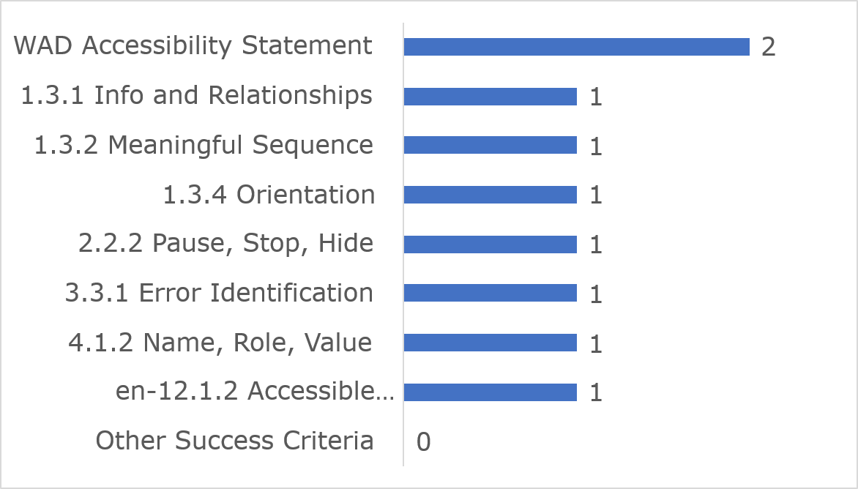
Among the 10 most frequently identified issues, (1.3.1) Info and Relationships accounted for two instances, one was related to (1.3.1) Info and Relationships and one was linked to (1.3.2) Meaningful Sequence.
Link to accessible table

Accessibility Statement
The Leap Top-Up App (Android) Accessibility Statement contains most of the content required under the Directive.

LEAP Top-Up App iOS

Key findings
This app met 88% of applicable success criteria while 12% were not satisfied (Figure 101)
Figure 101: LEAP Top-Up App iOS Accessibility Compliance
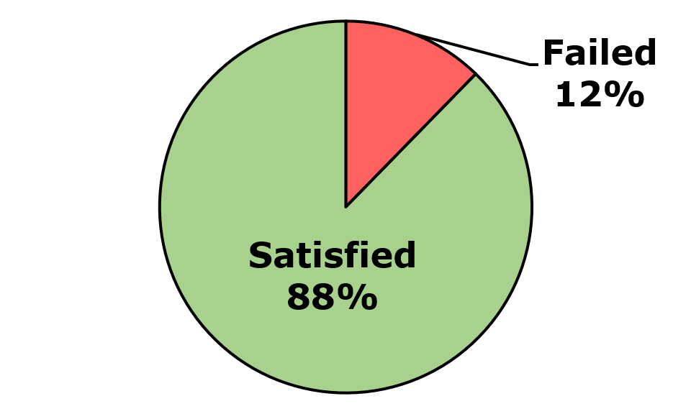
Across the nine pages and two components that were assessed, 11 issues were identified. These comprised eight WCAG issues, one EN 301 549-specific issues, and two WAD-specific issues. Of the WCAG issues, there were five WCAG Level A and three WCAG Level AA issues (Figure 102)
Figure 102: LEAP Top-Up App iOS Number of Issues
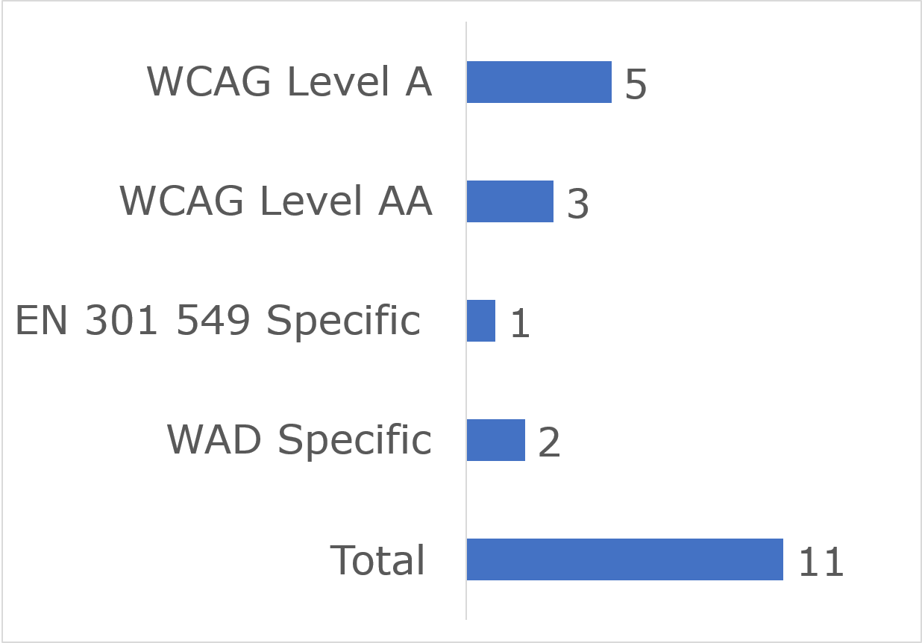

User impact
Most errors were classified as having “Serious” user impact (n=9), and the second highest number were classified as “Critical” (n=2). No “Blocker” “Moderate” or “Minor” issues were identified (Figure 103).
Figure 103: LEAP Top-Up App iOS Number of Issues by User Impact
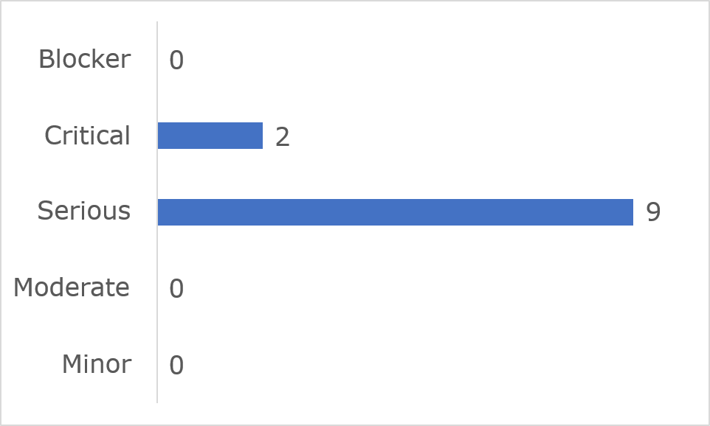
Frequently Identified Issues
Five Success Criteria were related to 72.8% of all issues:
- 2.4.3 Focus Order: 27.3%
- WAD Accessibility Statement: 18.2%
- 1.3.2 Meaningful Sequence: 9.1%
- 1.3.4 Orientation: 9.1%
- 2.2.1 Timing Adjustable: 9.1%
Figure 104: LEAP Top-Up App iOS Most Frequently Identified Issues
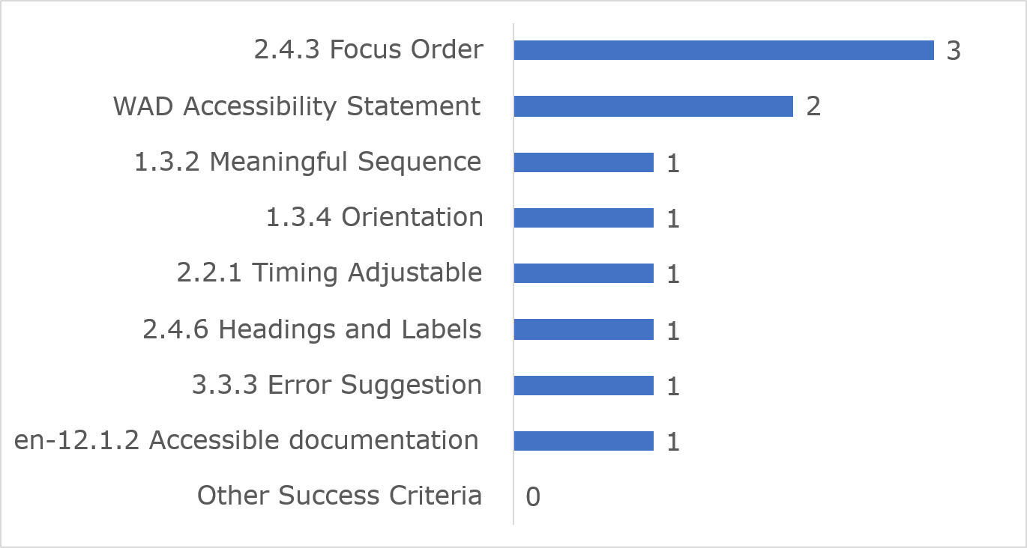
Among the 10 most frequently identified issues, (2.4.3) Focus Order accounted for three instances and two were related to the Accessibility Statement.
Link to accessible table

Accessibility Statement
The Leap Top-Up App (iOS) Accessibility Statement contains most of the content required under the Directive.

Iarnród Éireann - Irish Rail App Android

Key findings
This app met 80% of applicable success criteria while 20% were not satisfied (Figure 105)
Figure 105: Iarnród Éireann - Irish Rail App Android Accessibility Compliance
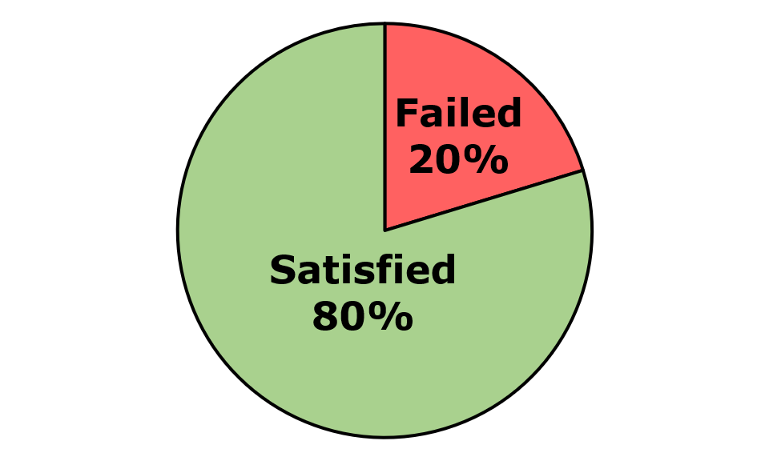
Across the nine pages and two components that were assessed, 43 issues were identified. These comprised 43 WCAG issues, no EN 301 549-specific issues, and no WAD-specific issues. Of the WCAG issues, there were 26 WCAG Level A and 17 WCAG Level AA issues (Figure 106).
Figure 106: Iarnród Éireann - Irish Rail App Android Number of Issues
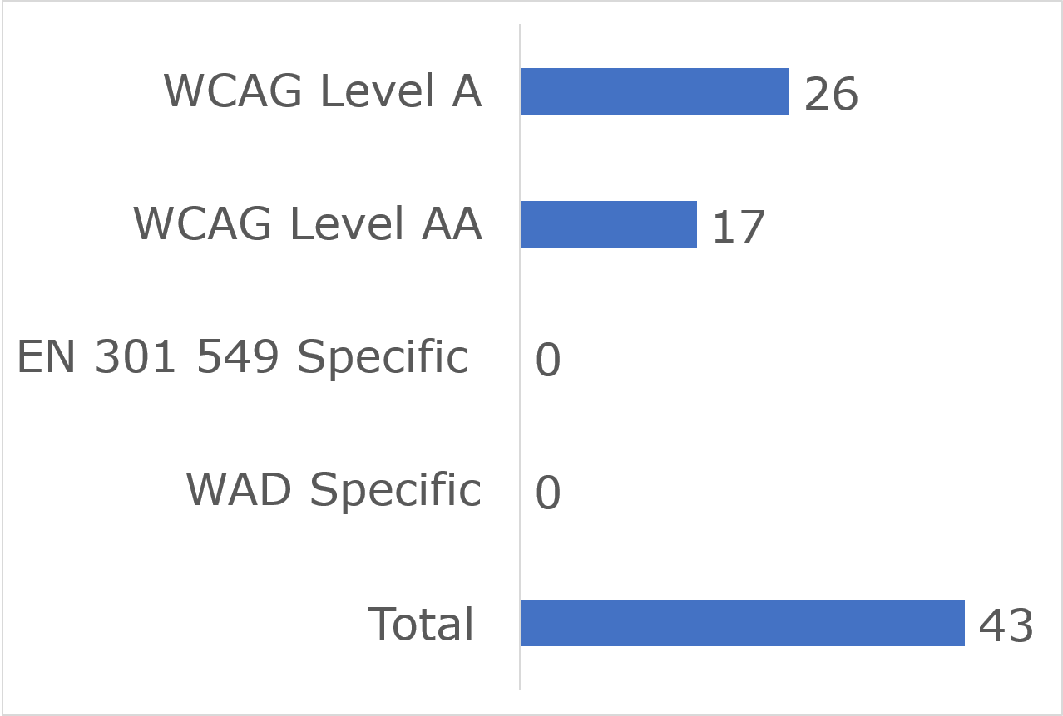

User impact
Most errors were classified as having “Serious” user impact (n=25), with the second highest number classified as “Critical” (n=4) and then “Moderate” (n=13). No “Blocker” and one “Minor” issue was identified (Figure 107).
Figure 107: Iarnród Éireann - Irish Rail App Android Number of Issues by User Impact
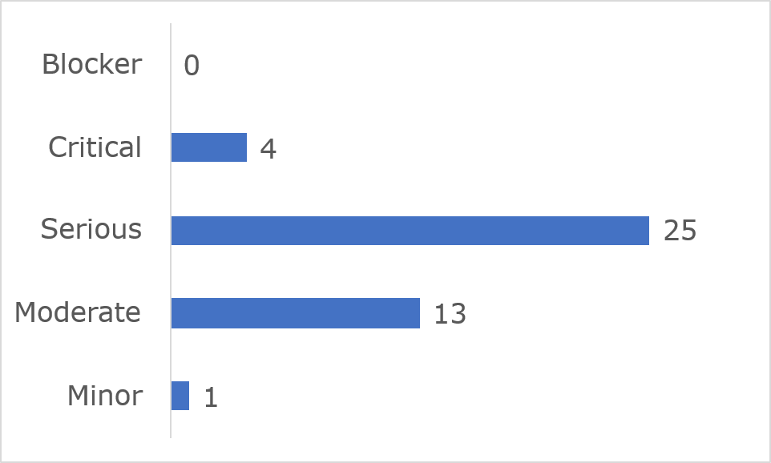
Frequently Identified Issues
Five Success Criteria were related to 74.5% of all issues:
- 1.3.1 Info and Relationships: 27.9%
- 1.4.3 Contrast (Minimum): 16.3%
- 2.4.6 Headings and Labels: 14%
- 1.3.2 Meaningful Sequence: 9.3%
- 4.1.2 Name, Role, Value: 7%
Figure 108: Iarnród Éireann - Irish Rail App Android 10 Most Frequently Identified Issues
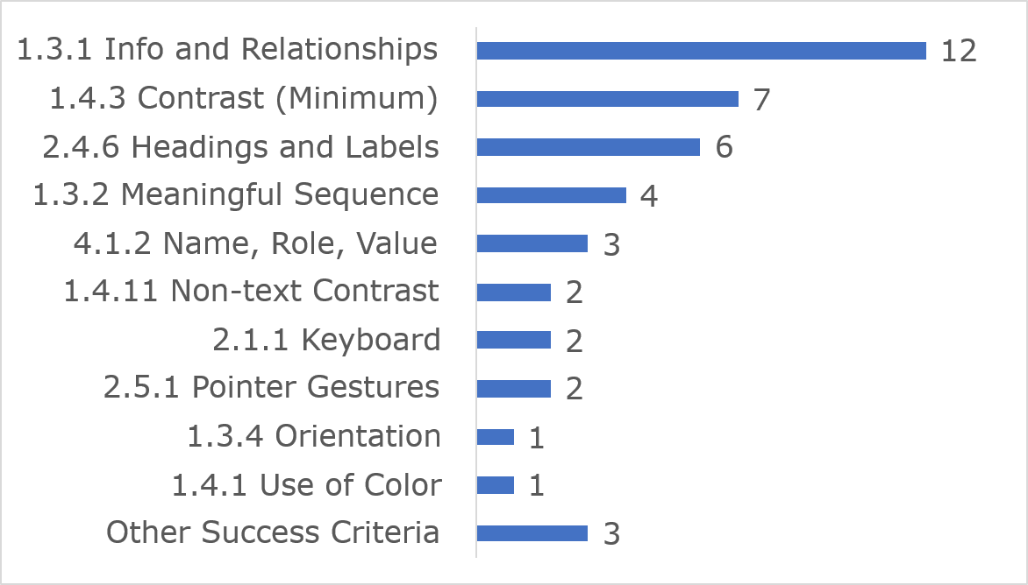
Among the 10 most frequently identified issues, (1.3.1) Info and Relationships accounted for 12 instances, seven were related to (1.4.3) Contrast (Minimum) and six were linked to (2.4.6) Headings and Labels.
Link to accessible table

Accessibility Statement
The Iarnród Éireann – Irish Rail app Android Accessibility Statement contains most of the content required under the Directive.

Iarnród Éireann - Irish Rail App iOS

Key findings
This app met 83% of applicable success criteria while 17% were not satisfied (Figure 109)
Figure 109: Iarnród Éireann - Irish Rail App iOS Accessibility Compliance
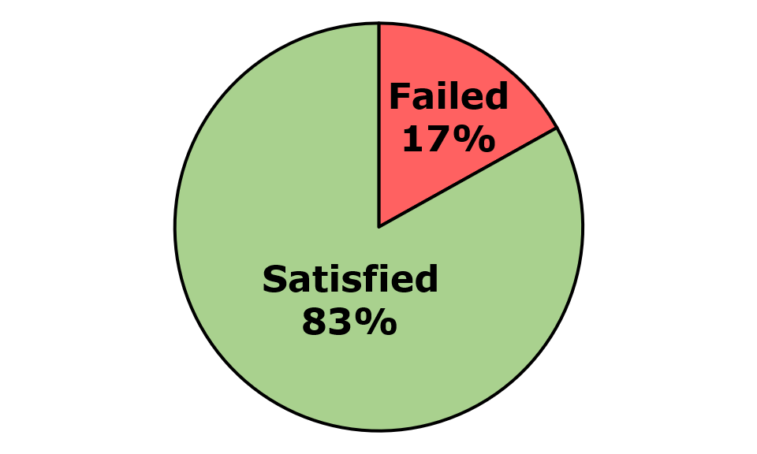
Across the nine pages and two components that were assessed, 38 issues were identified. These comprised 38 WCAG issues, no EN 301 549-specific issues, and no WAD-specific issues. Of the WCAG issues, there were 16 WCAG Level A and 22 WCAG Level AA issues (Figure 110).
Figure 110: Iarnród Éireann - Irish Rail App iOS Number of Issues
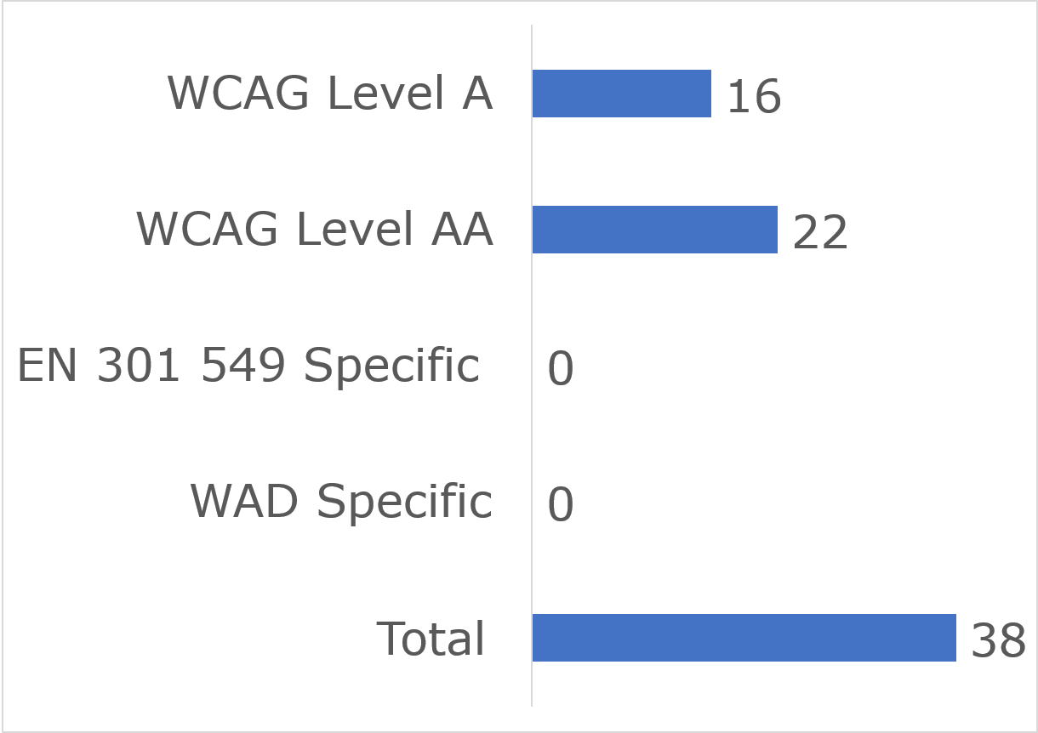

User impact
Most errors were classified as having “Serious” user impact (n=31), with the second highest number classified as “Critical” (n=3) and then “Moderate” (n=3). No “Blocker” and one “Minor” issue was identified (Figure 111).
Figure 111: Iarnród Éireann - Irish Rail App iOS Number of Issues by User Impact
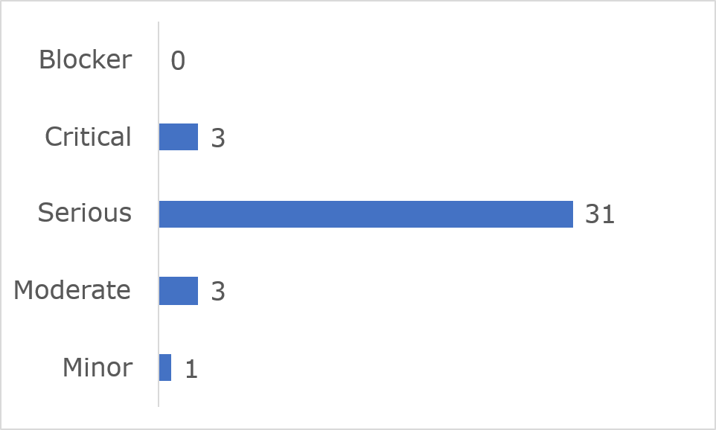
Frequently Identified Issues
Five Success Criteria were related to 71.1% of all issues:
- 1.4.3 Contrast (Minimum): 21.1%
- 1.4.11 Non-text Contrast: 18.4%
- 2.4.6 Headings and Labels: 13.2%
- 1.4.1 Use of Colour: 10.5%
- 1.3.1 Info and Relationships: 7.9%
Figure 112: Iarnród Éireann - Irish Rail App iOS 10 Most Frequently Identified Issues
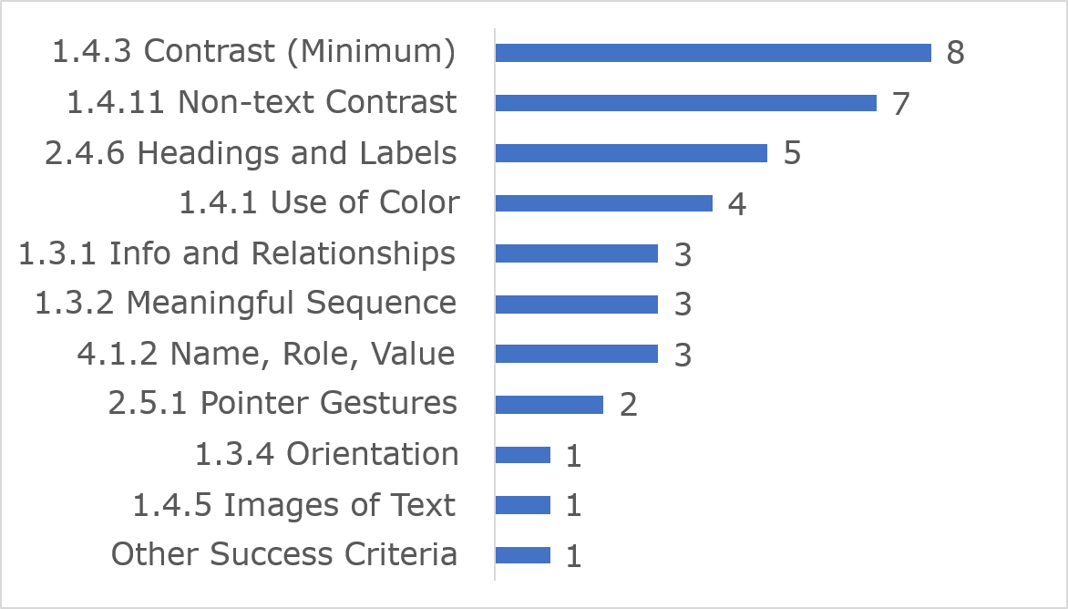
Among the 10 most frequently identified issues, (1.4.3) Contrast (Minimum) accounted for eight instances, seven were related to (1.4.11) Non-text Contrast (Minimum) and five were linked to (2.4.6) Headings and Labels.
Link to accessible table

Accessibility Statement
The Iarnród Éireann – Irish Rail app iOS Accessibility Statement contains most of the content required under the Directive.

TFI Driver Check Android

Key findings
This app met 95% of applicable success criteria while 5% were not satisfied (Figure 113)
Figure 113: TFI Driver Check Android Accessibility Compliance
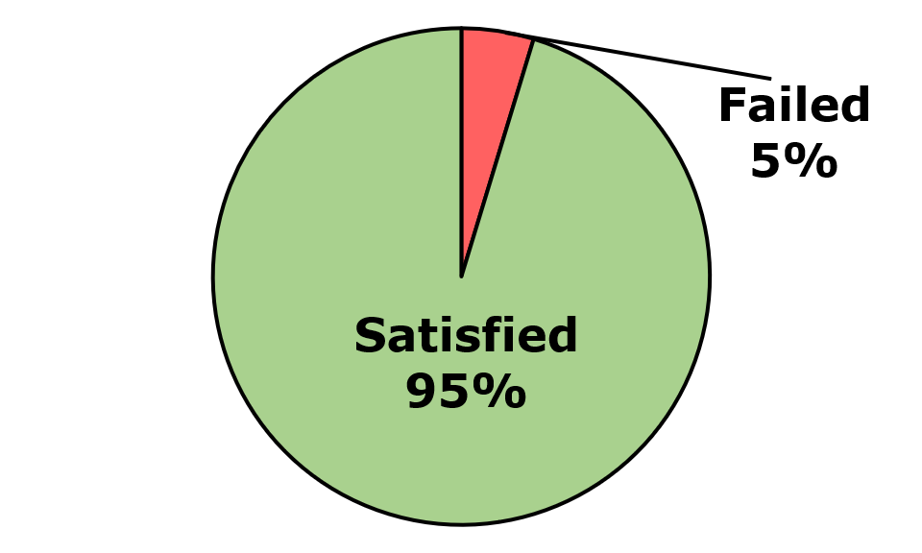
Across the two pages and no components that were assessed, four issues were identified. These comprised four WCAG issues, no EN 301 549-specific issues, and no WAD-specific issues. Of the WCAG issues, there were 3 WCAG Level A and 1 WCAG Level AA issues (Figure 114).
Figure 114: TFI Driver Check Android Number of Issues
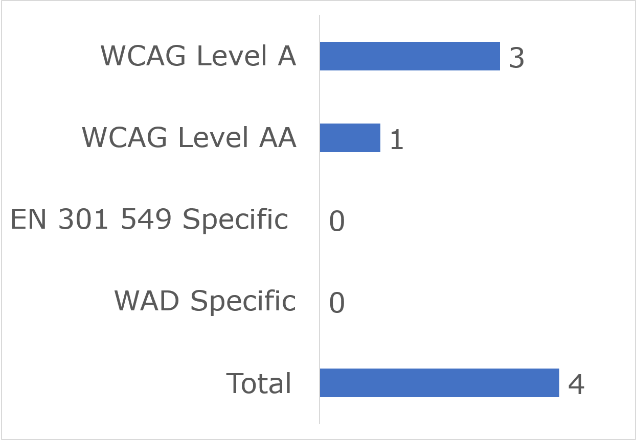

User impact
Most errors were classified as having “Serious” user impact (n=2), with the second highest number classified as “Critical” (n=1) and then “Moderate” (n=1). No “Blocker” or “Minor” issues were identified (Figure 115).
Figure 115: TFI Driver Check Android Number of Issues by User Impact
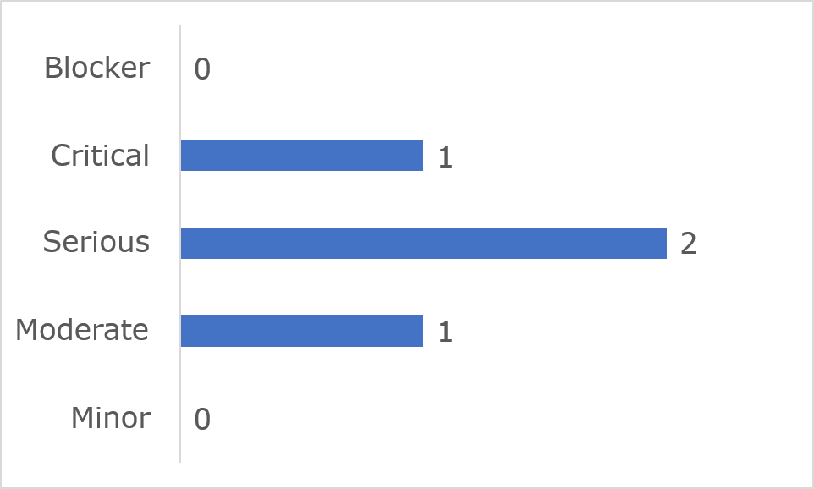
Frequently Identified Issues
Three Success Criteria were related to 100% of all issues:
- 4.1.2 Name, Role, Value: 50%
- 1.4.1 Use of Colour: 25%
- 1.4.3 Contrast (Minimum): 25%
Figure 116: TFI Driver Check Android Four Identified Issues
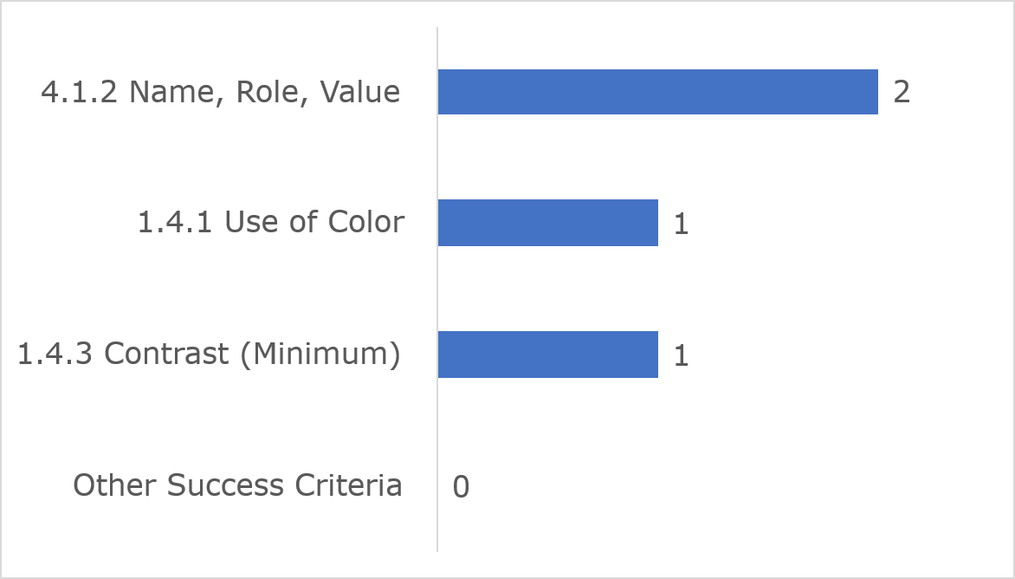
The four identified issues were (4.1.2) Name, Role, value which accounted for two instances, one was related to (1.4.1) Use of colour and one was linked to (1.4.3) Contrast (Minimum).
Link to accessible table

Accessibility Statement
The TFI Driver Check Android app Accessibility Statement contains most of the content required under the Directive.

TFI Driver Check iOS

Key findings
This app met 92% of applicable success criteria while 8% were not satisfied (Figure 117)
Figure 117: TFI Driver Check iOS Accessibility Compliance
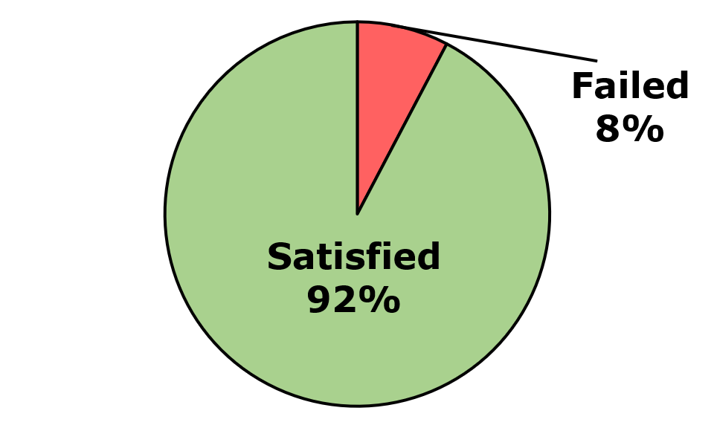
Across the two pages and no components that were assessed, six issues were identified. These comprised four WCAG issues, no EN 301 549-specific issues, and no WAD-specific issues. Of the WCAG issues, there were 4 WCAG Level A and 2 WCAG Level AA issues (Figure 118).
Figure 118: TFI Driver Check iOS Number of Issues
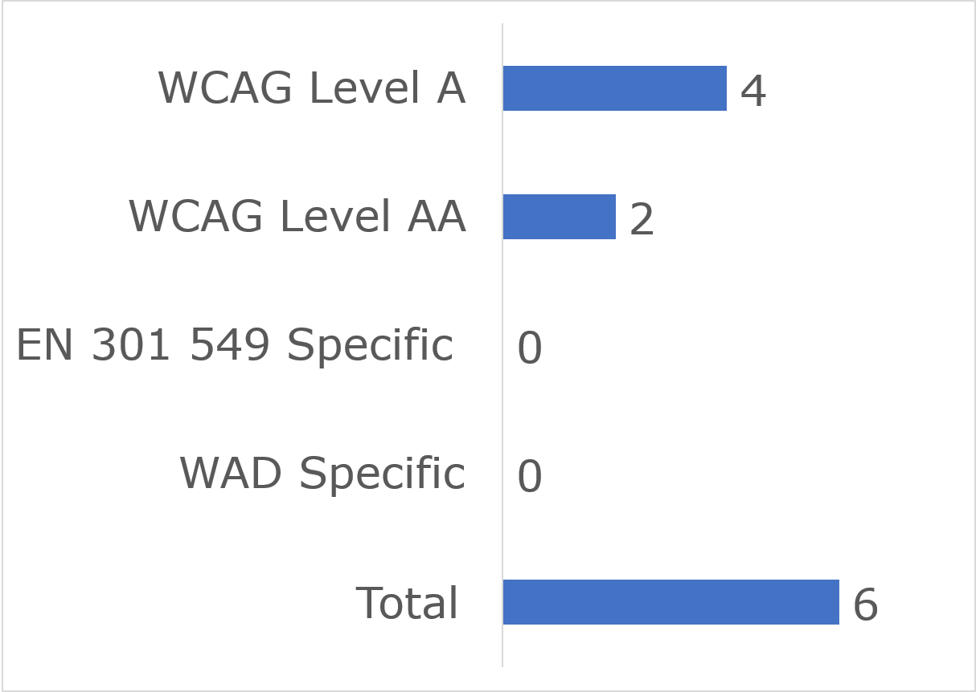

User impact
Most errors were classified as having “Serious” user impact (n=4) and the second highest number were classified as “Critical” (n=2). No “Blocker” “Moderate” or “Minor” issues were identified (Figure 119).
Figure 119: TFI Driver Check iOS Number of Issues by User Impact
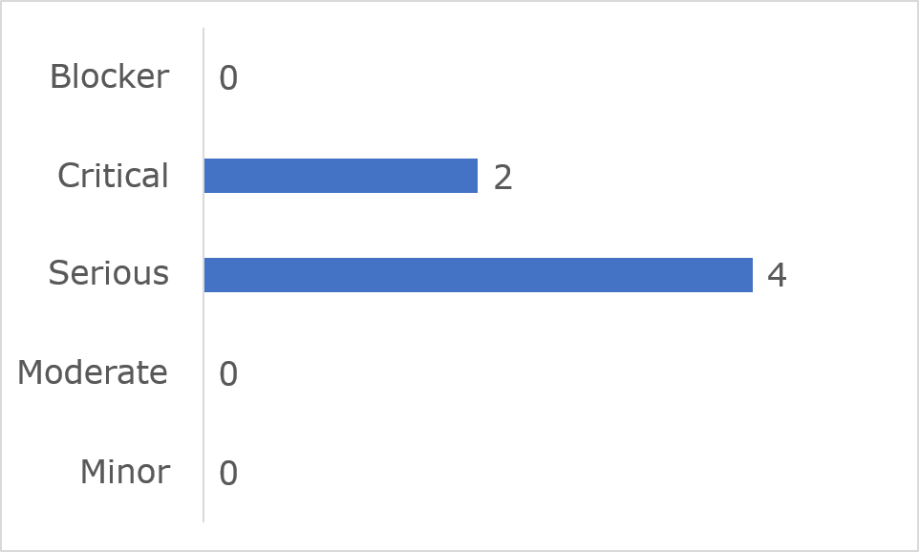
Frequently Identified Issues
Five Success Criteria were related to 100% of all issues:
- 4.1.2 Name, Role, Value: 33.3%
- 1.4.1 Use of Colour: 16.7%
- 1.4.3 Contrast (Minimum): 16.7%
- 2.1.1 Keyboard: 16.7%
- 4.1.3 Status Messages: 16.7%
Figure 120: TFI Driver Check iOS Five Identified Issues
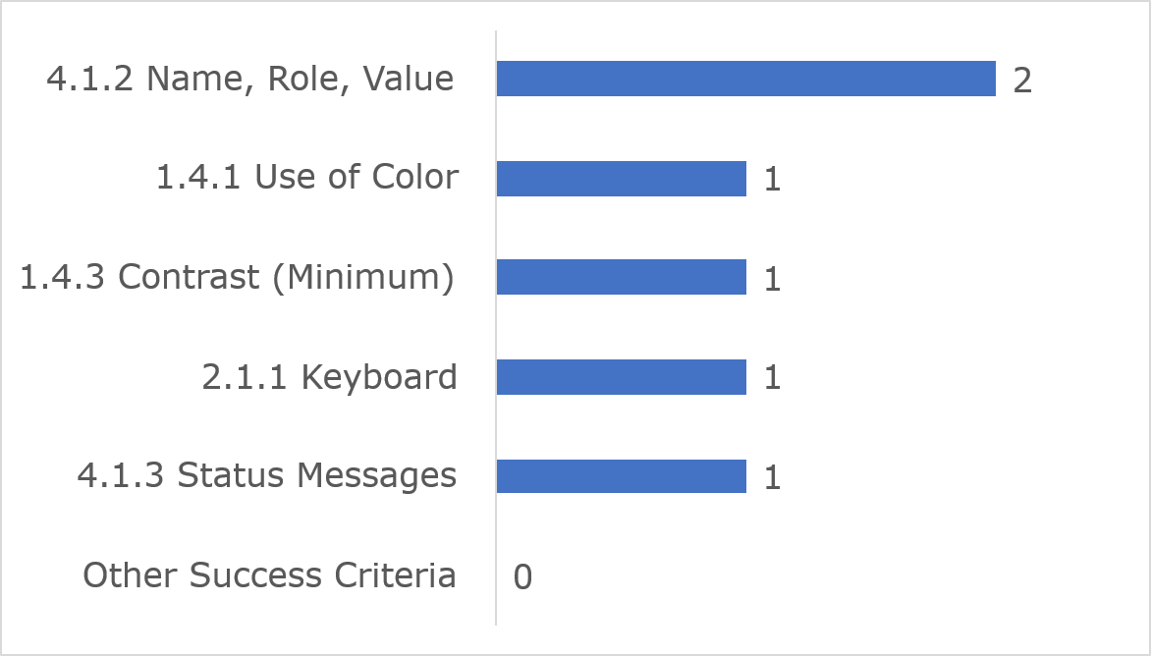
Of the five issues that were identified, (4.1.2) Name, Role, value accounted for two instances, one was related to (1.4.1) Use of colour and one was linked to (1.4.3) Contrast (Minimum).
Link to accessible table

Accessibility Statement
The TFI Driver Check iOS app Accessibility Statement contains most of the content required under the Directive.

TFI GO Android

Key findings
This app met 78% of applicable success criteria while 22% were not satisfied (Figure 121)
Figure 121: TFI GO Android Accessibility Compliance
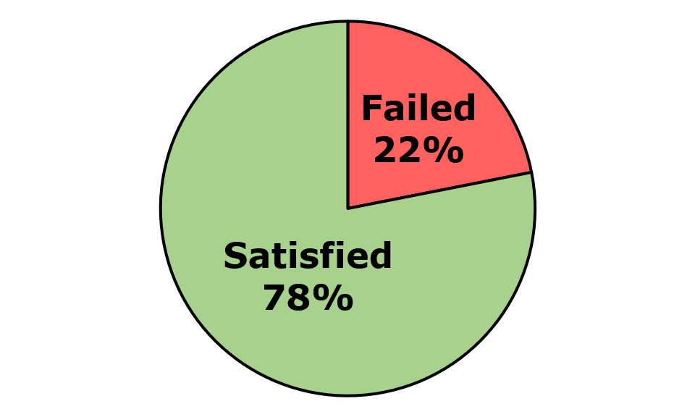
Across the twelve screens and one component that were assessed, 29 issues were identified. These comprised 25 WCAG issues, two EN 301 549-specific issues, and two WAD-specific issues. Of the WCAG issues, there were 16 WCAG Level A and 9 WCAG Level AA issues (Figure 122).
Figure 122: TFI GO Android Number of Issues
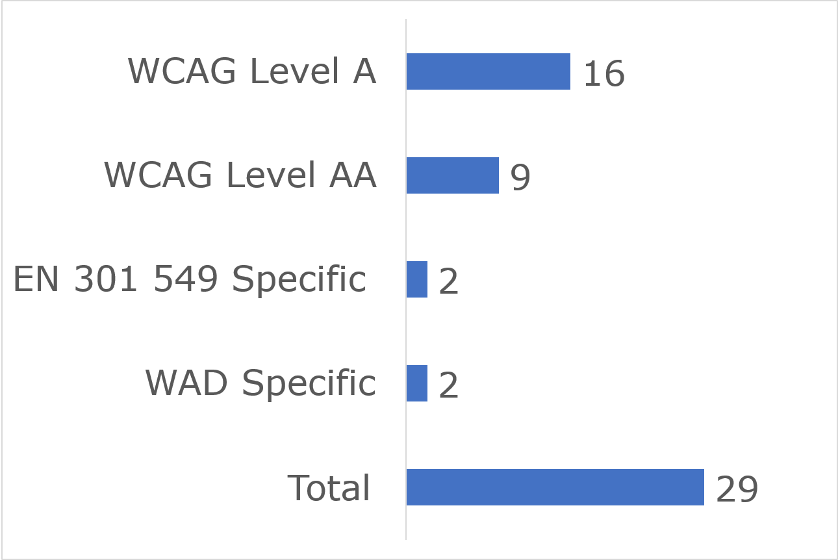

User impact
Most errors were classified as having “Serious” user impact (n=18), with the second highest number classified as “Critical” (n=7) and then “Moderate” (n=3). No “Blocker” and one “Minor” issue was identified (Figure 123).
Figure 123: TFI GO Android Number of Issues by User Impact
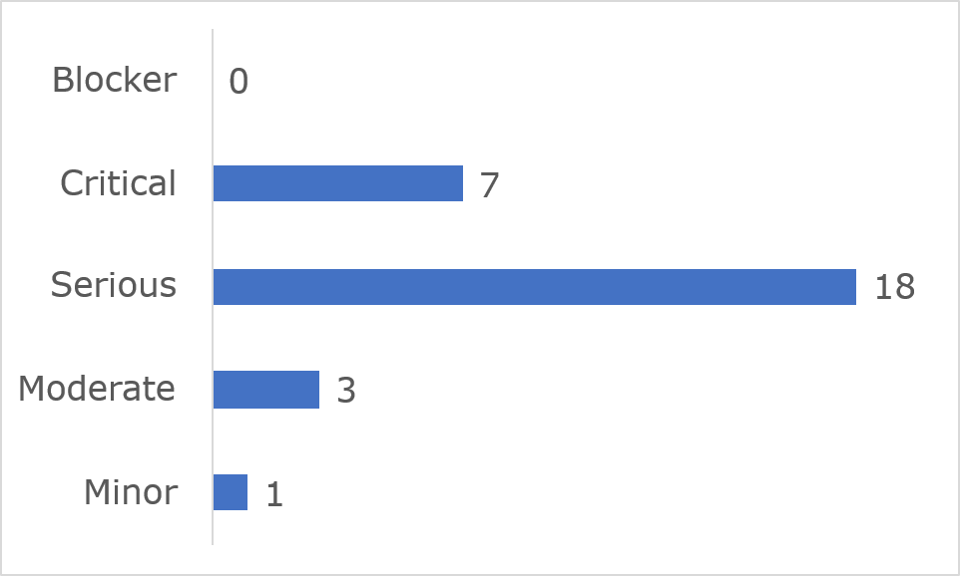
Frequently Identified Issues
Five Success Criteria were related to 55% of all issues:
- 4.1.3 Status Messages: 17.2%
- 1.3.1 Info and Relationships: 10.3%
- 1.4.11 Non-text Contrast: 10.3%
- 4.1.2 Name, Role, Value: 10.3%
- 1.1.1 Non-text Content: 6.9%
Figure 124: TFI GO Android 10 Most Frequently Identified Issues
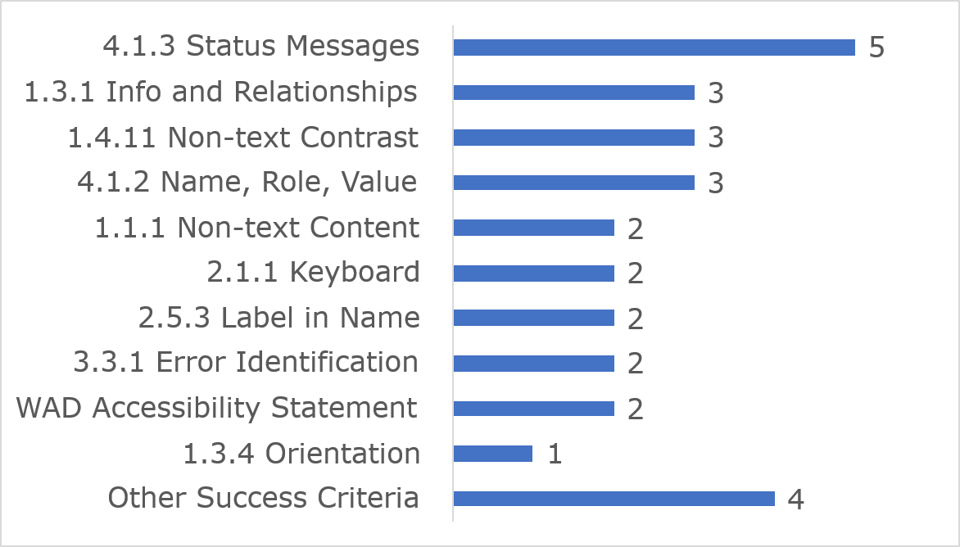
Among the 10 most frequently identified issues, (4.1.3) Status Messages accounted for five instances, three were related to (1.3.1) Info and Relationships and three were linked to (1.4.11) Non-text Contrast.
Link to accessible table

Accessibility Statement
The TFI Go Android App’s Accessibility Statement contains most of the content required under the Directive. The NDA advises that the Accessibility Statement be relocated to a more prominent location on the website, or in the app.

TFI GO iOS

Key findings
This app met 77% of applicable success criteria while 23% were not satisfied (Figure 125)
Figure 125: TFI GO iOS Accessibility Compliance
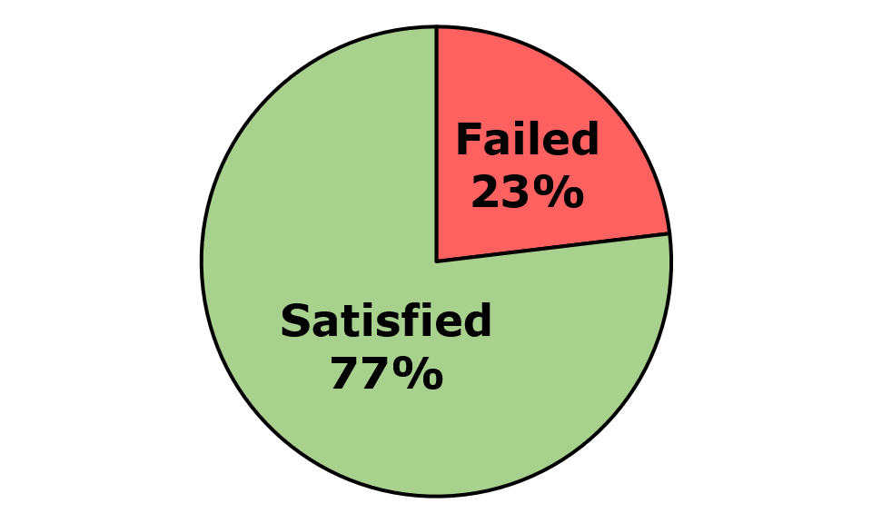
Across the twelve screens and one component that were assessed, 37 issues were identified. These comprised 33 WCAG issues, two EN 301 549-specific issues, and two WAD-specific issues. Of the WCAG issues, there were 21 WCAG Level A and 12 WCAG Level AA issues (Figure 126).
Figure 126: TFI GO iOS Number of Issues
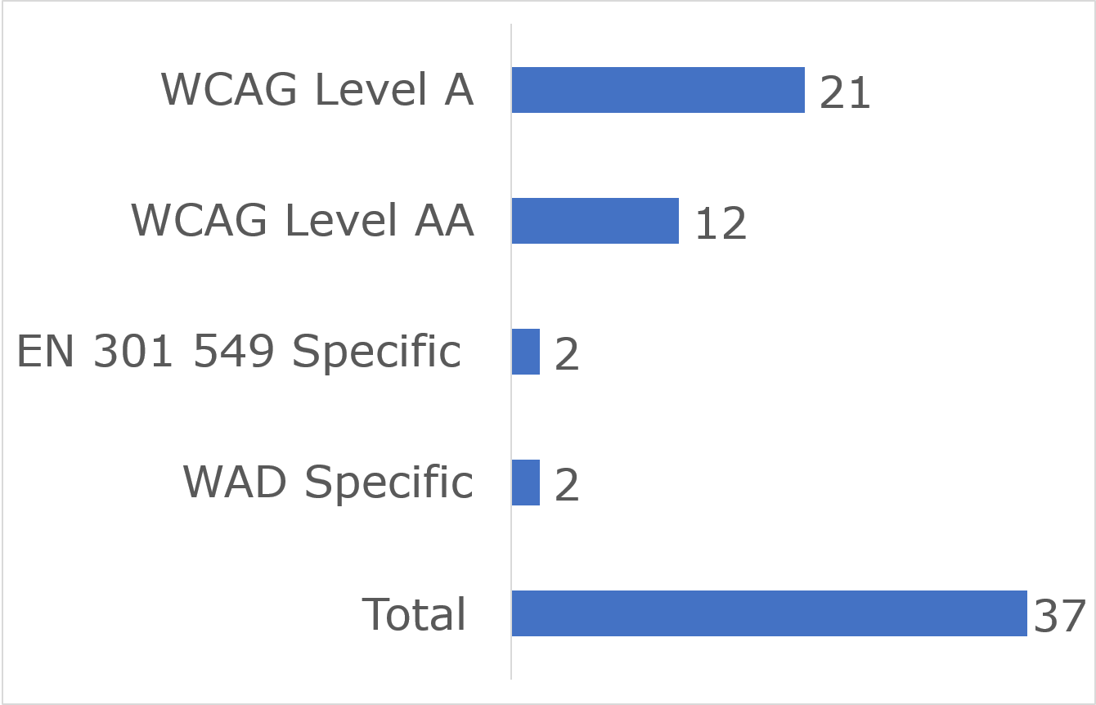

User impact
Most errors were classified as having “Serious” user impact (n=26), with the second highest number classified as “Critical” (n=8) and then “Moderate” (n=1). No “Blocker” and two “Minor” issues were identified (Figure 127).
Figure 127: TFI GO iOS Number of Issues by User Impact
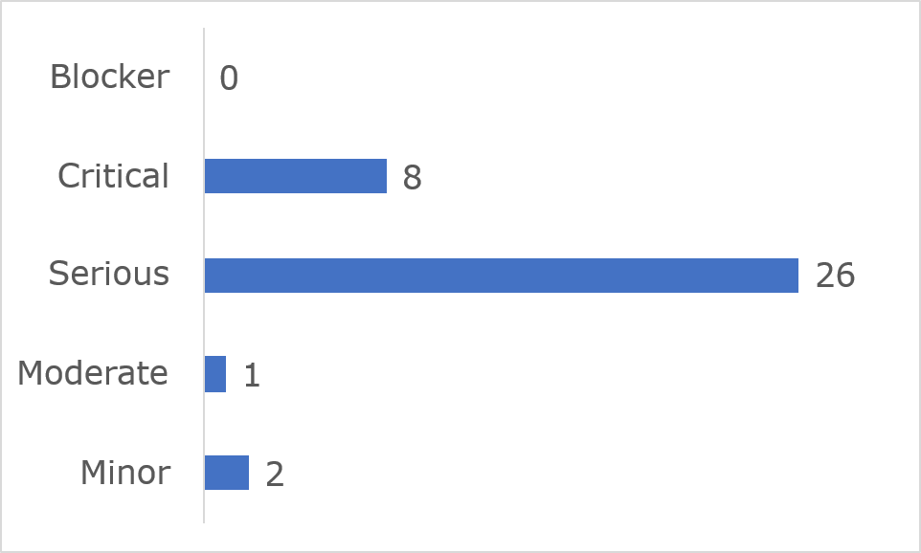
Frequently Identified Issues
Five Success Criteria were related to 62.2% of all issues:
- 4.1.2 Name, Role, Value: 21.6%
- 4.1.3 Status Messages: 13.5%
- 1.4.11 Non-text Contrast: 10.8%
- 2.1.1 Keyboard: 8.1%
- 2.5.3 Label in Name: 8.1%
Figure 128: TFI GO iOS 10 Most Frequently Identified Issues
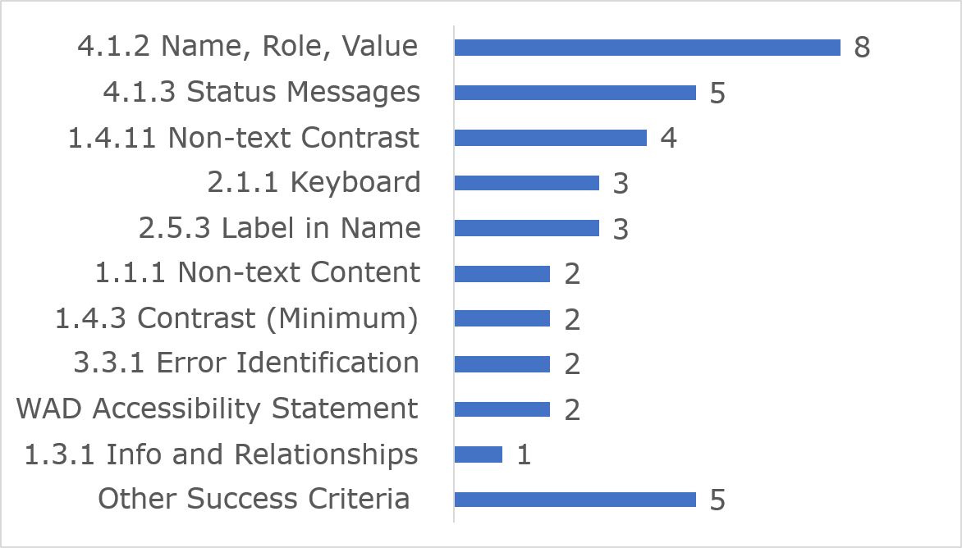
Among the 10 most frequently identified issues, (4.1.2) Name, Role, Value accounted for eight instances, five were related to (4.1.3) Status Messages and four were linked to (1.4.11) Non-text Contrast.
Link to accessible table

Accessibility Statement
The TFI Go iOS app’s Accessibility Statement contains most of the content required under the Directive. The NDA advises that the Accessibility Statement be relocated to a more prominent location on the website or in the app.

TFI Live Android

Key findings
This app met 75% of applicable success criteria while 25% were not satisfied (Figure 129).
Figure 129: TFI Live Android Accessibility Compliance
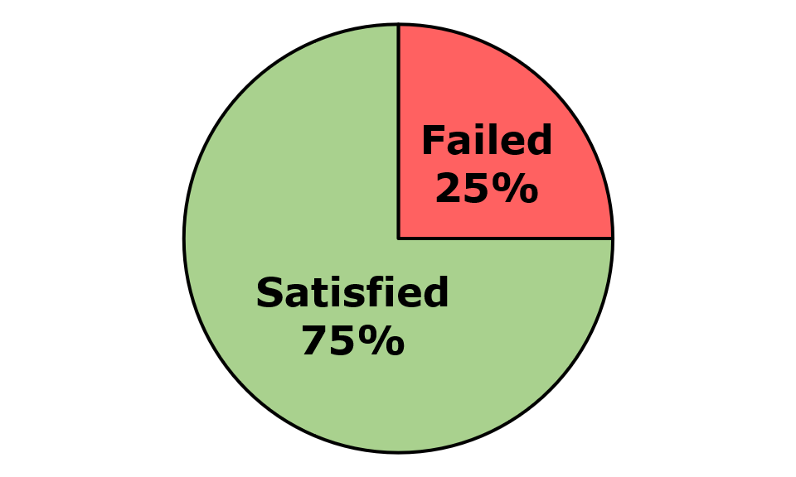
Across the nine screens and one component that were assessed, 54 issues were identified. These comprised 51 WCAG issues, two EN 301 549-specific issues, and one WAD-specific issues. Of the WCAG issues, there were 42 WCAG Level A and 9 WCAG Level AA issues (Figure 130).
Figure 130: TFI Live Android Number of Issues
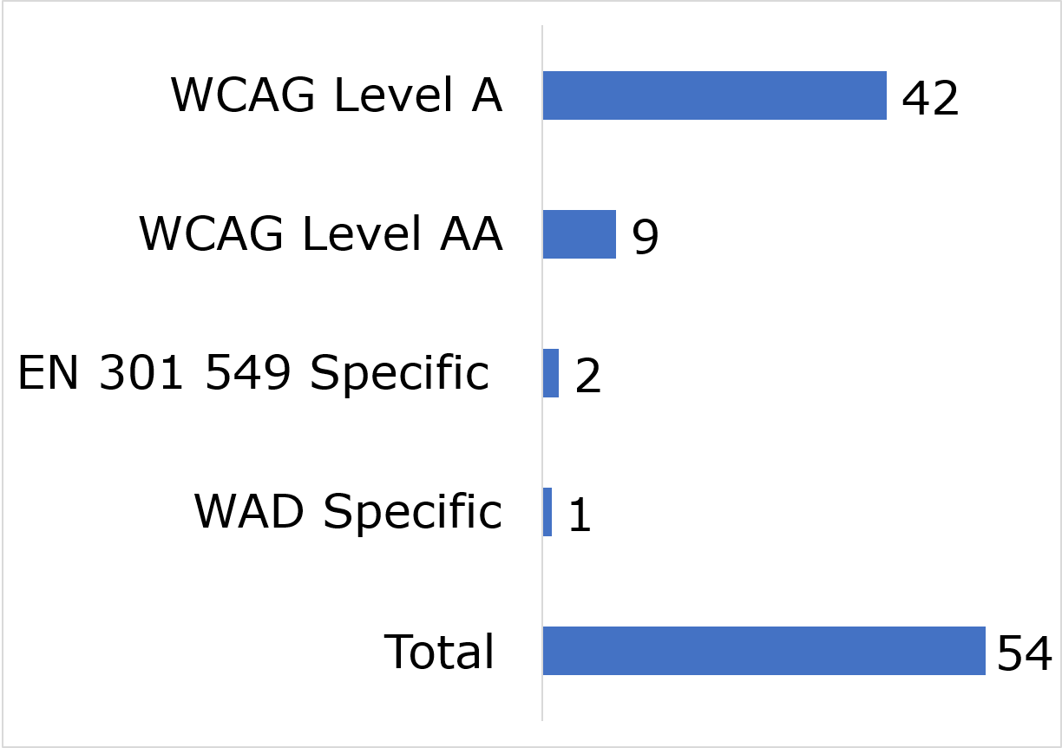

User impact
Most errors were classified as having “Serious” user impact (n=34), with the second highest number classified as “Critical” (n=16) and then “Moderate” (n=3). No “Blocker” and one “Minor” issue was identified (Figure 131).
Figure 131: TFI Live Android Number of Issues by User Impact
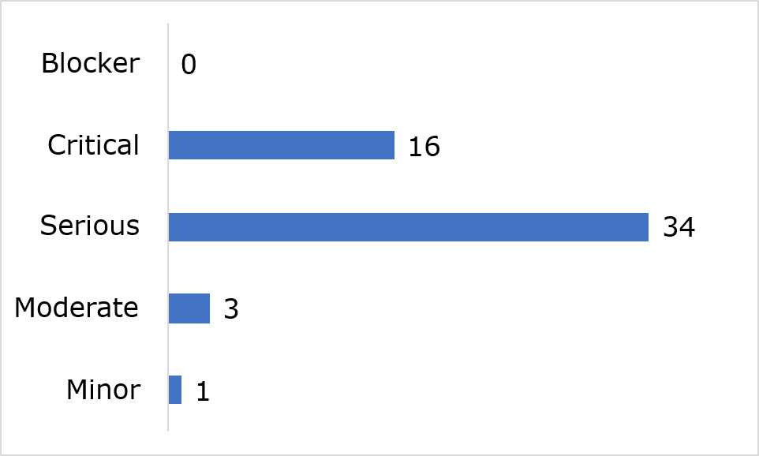
Frequently Identified Issues
Five Success Criteria were related to 70.4% of all issues:
- 1.3.2 Meaningful Sequence: 22.2%
- 4.1.2 Name, Role, Value: 16.7%
- 2.1.1 Keyboard: 14.8%
- 2.4.3 Focus Order: 11.1%
- 1.1.1 Non-text Content: 5.6%
Figure 132: TFI Live Android 10 Most Frequently Identified Issues
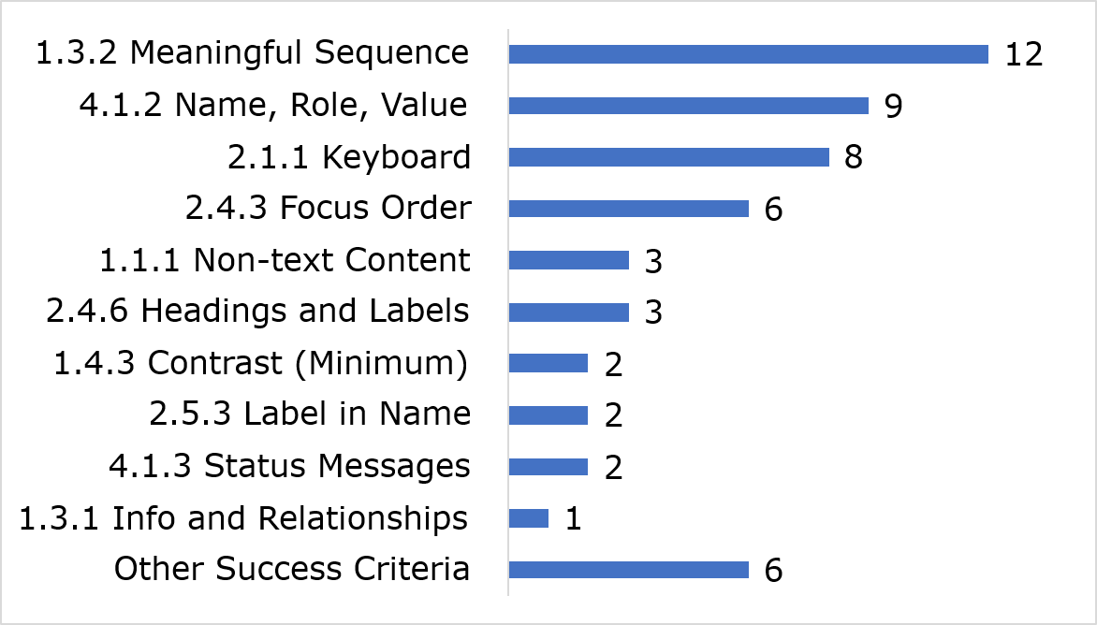
Among the 10 most frequently identified issues, (1.3.2) Meaningful Sequence accounted for twelve instances, nine were related to (4.1.2) Name, Role, Value and eight were linked to (2.1.1) Keyboard.
Link to accessible table

Accessibility Statement
No Accessibility Statement could be found during the In-depth Review.

TFI Live iOS

Key findings
This app met 74% of applicable success criteria while 26% were not satisfied (Figure 133)
Figure 133: TFI Live iOS Accessibility Compliance
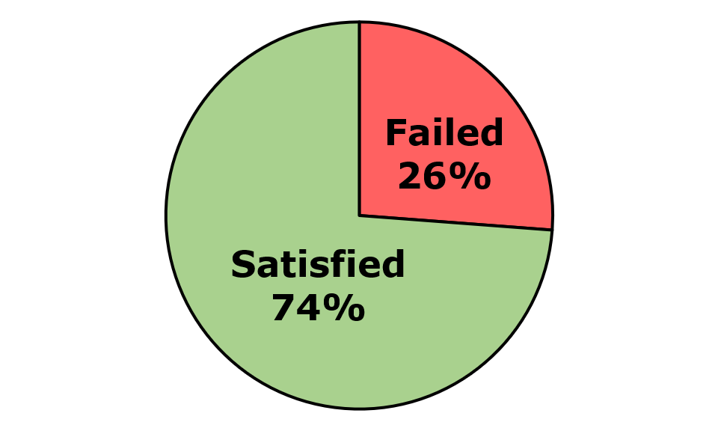
Across the eight pages and one component that were assessed, 35 issues were identified. These comprised 31 WCAG issues, two EN 301 549-specific issues, and two WAD-specific issues. Of the WCAG issues, there were 22 WCAG Level A and 9 WCAG Level AA issues (Figure 134).
Figure 134: TFI Live iOS Number of Issues
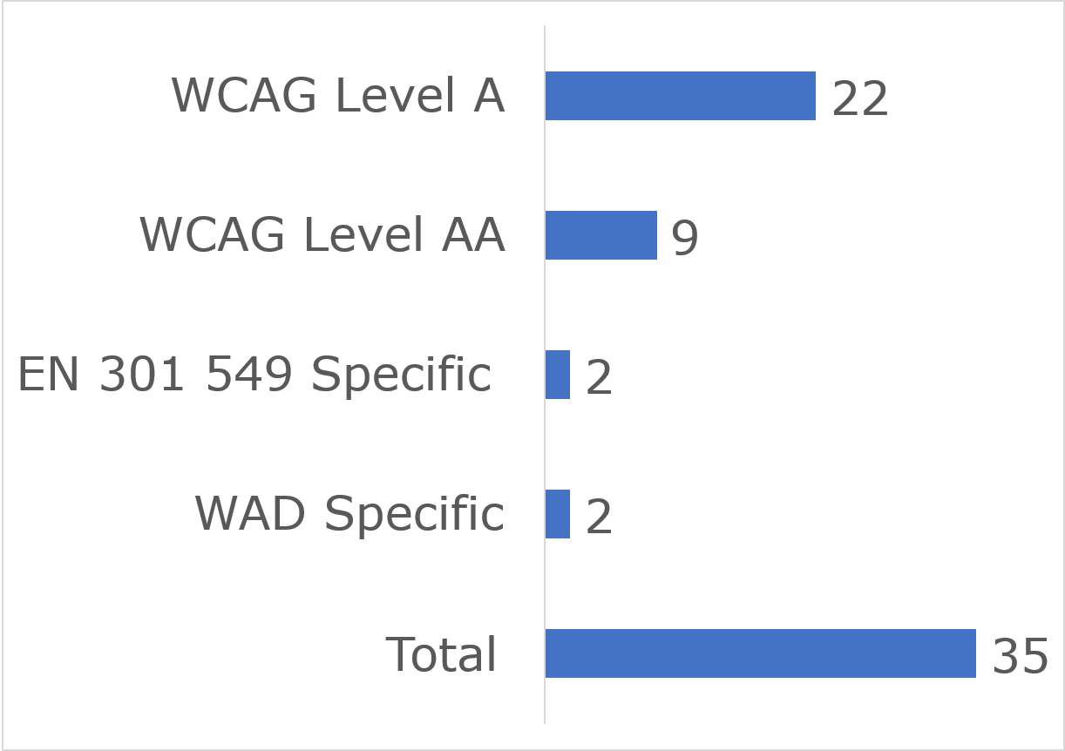

User impact
Most errors were classified as having “Serious” user impact (n=23), with the second highest number classified as “Critical” (n=11). No “Blocker” and one “Minor” issue was identified (Figure 135).
Figure 135: TFI Live iOS Number of Issues by User Impact
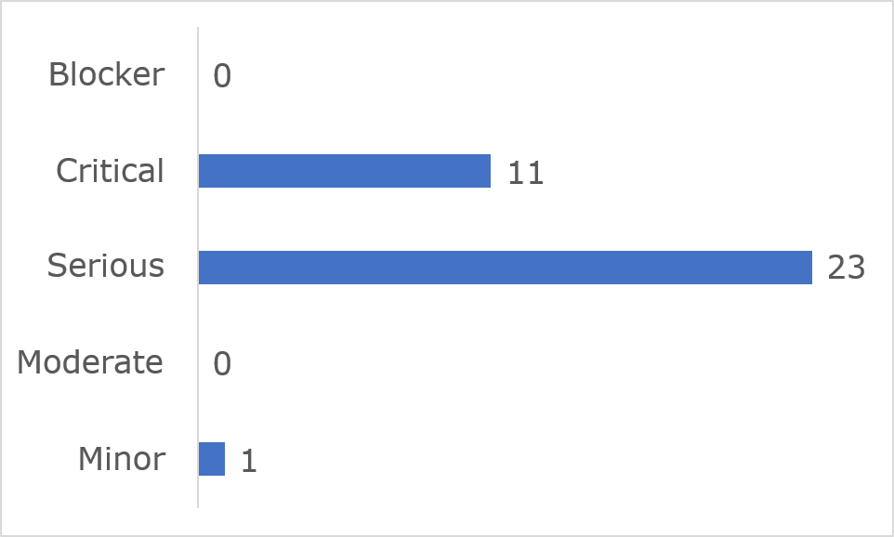
Frequently Identified Issues
Five Success Criteria were related to 57.1% of all issues:
- 2.1.1 Keyboard: 14.3%
- 1.3.2 Meaningful Sequence: 11.4%
- 2.4.6 Headings and Labels: 11.4%
- 4.1.2 Name, Role, Value: 11.4%
- 1.3.1 Info and Relationships: 8.6%
Figure 136: TFI Live iOS 10 Most Frequently Identified Issues
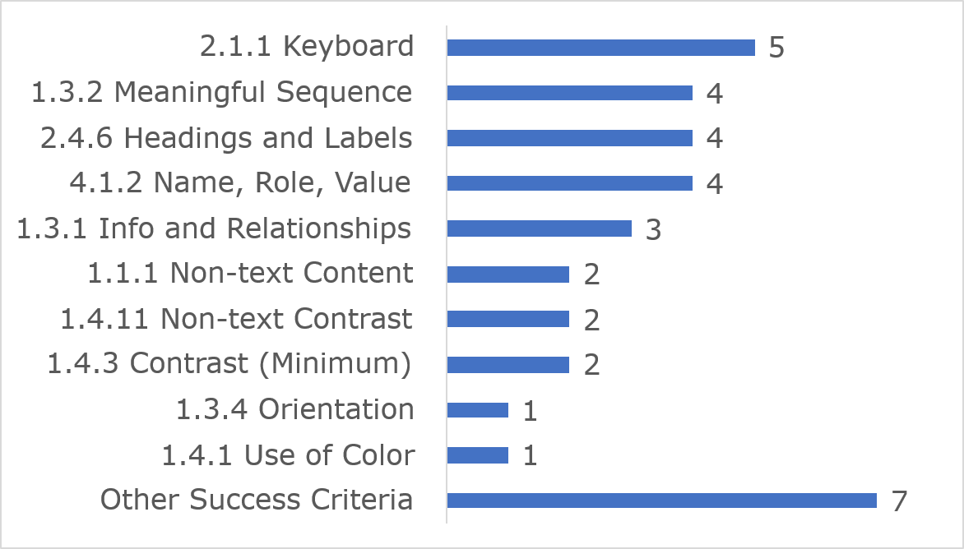
Among the 10 most frequently identified issues, (2.1.1) Keyboard accounted for five instances, four were related to (1.3.2) Meaningful sequence and four were linked to (2.4.6) Headings and Labels.
Link to accessible table

Accessibility Statement
No Accessibility Statement could be found during the In-depth Review.

Simplified Reviews

Methods and Methodology
A Simplified Review as defined under Commission Implementing Decision (EU) 2018/1524, includes tests related to each of the requirements of perceivability, operability, understandability and robustness referred to in Article 4 of Directive (EU) 2016/2102, detects instances of non-compliance with a subset of requirements of Article 6 of Directive (EU) 2016/2102. They cannot confirm compliance with the Directive.
A Simplified Review is conducted on a subset of Success Criteria, under the Web Content Accessibility Guidelines WCAG 2.1, on many website pages. The NDA conducts these reviews across a sample of up to 400 pages per site with automated software called axe Monitor which uses the axe-core accessibility testing engine. The axe-core testing engine claims to detect up to 57% of errors with WCAG 2.1 AA Success Criteria.
After a prioritisation process to identify public sector bodies to include in simplified monitoring for the year in question, the NDA issues a Notice of Monitoring to each included public sector body advising them of their obligations under the Directive, the name of the website/mobile app to be reviewed and the type of review to be conducted. The public sector body is asked to register relevant staff on the NDA’s secure Monitoring and Reporting Platform (MRP) https://euwad.nda.ie/through which they can access the review results. The MRP also provides access to guidance on understanding and addressing the accessibility issues identified and allows the public body send queries to NDA.
The Simplified Review data gives public sector bodies a baseline understanding of their website’s accessibility health and enables them to understand key trends through larger data samples. This in turn enables the public body to direct resources to address priority issues and to continuously measure issues and the accessibility of improvements. Simplified Review scans are updated weekly.
The following data is presented in this report for each website:
- Accessibility Score, all sites (Annex)
- Total number of errors by category (total of average errors per site) (Annex)
- Average accessibility scores by category (Annex)
- Number and type of errors (Annex)

Simplified Reviews Accessibility Score
The Simplified Reviews provide an Accessibility Score based on the number of pages containing issues that are classified as having a critical, serious or moderate impact on users. A website’s Accessibility Score increases with fewer errors. A site with no errors detected will achieve a score of 100% and sites with at least one critical error on each page will achieve a score of zero.
An Accessibility Score of 100% does not equate to full compliance with either EN 301 549 or WCAG 2.1 AA. Full compliance with EN 301 549 is achieved when ALL clauses are met, including all relevant WCAG 2.1 AA Success Criteria.
NDA recommends public bodies use the Simplified Review’s Accessibility Score as a high-level indicator of the accessibility ‘health’ of a website. It should never be viewed as a measure of a site’s compliance with EN 301549.
A website’s Accessibility Score may fluctuate over time for a number of reasons including:
- scans picking up new pages
- changes made to the site by the public body
- updated content published to the site
- improvements to the axe-core testing engine rules resulting in the detection and recording of more issues.
While the Directive and its Implementing Decisions do not require such a scoring, it is used in this report as a high-level indicator of the accessibility ‘health’ of the website, and this information is provided to public bodies subject to monitoring. It also motivates public bodies to improve their Accessibility Score over time by addressing the most critical and serious issues first and seeing tangible improvements in the Accessibility Score.
NDA recommends public bodies confirm their compliance through conducting or commissioning a full accessibility review of their site, to include manual and automated testing.
The monitoring results presented below are based on a snapshot of data taken from each site on 1 October 2025.

Simplified Review Results
NDA conducted Simplified Reviews on 233 websites during the 2025 monitoring period. The monitoring results presented here are based on a snapshot of data taken from the last scan of each site by 30 September 2025.
An average of 330 pages were tested per site. The average number of errors identified per site was 3,570. In 2024 the average number of errors identified per site was 4,200. Overall, no errors were found on 47.87% of pages reviewed. It is important to consider the impact of these errors on the end-users. The “Accessibility Score” assigns a weighting to the seriousness of the impact on users for each error. Table 3 provides further details on the number and potential user impact of the errors detected.
Table 3: Number and Types of Error per Site
Pages and types of error | Errors
Average pages tested | 330
% of pages with no errors | 47.87%
Average errors per site | 3,570
Average critical errors per site | 969
Average serious errors per site | 2,600
Average errors per page | 11
Average Accessibility Score | 55.25%

User impact
The errors reported on are classified as “Serious” or “Critical”.
A serious issue results in some barriers for individuals with disabilities but would not prevent them from accessing fundamental elements or content.
A critical issue results in severe barriers for individuals with disabilities. Users relying on Assistive Technology will experience frustration when attempting to access the content and some content will be inaccessible.
Most errors identified (2,600) were classified as Serious and 969 Critical errors were identified.
This shows an improvement in accessibility since the 2024 monitoring period, where the number of serious errors was 3,026 and the number of critical errors was 1,174. This may be the result of public bodies subject to monitoring across both periods following the NDA’s advice to prioritise the remediation of critical errors.
Figure 137: Average Errors by Severity Level – All Websites
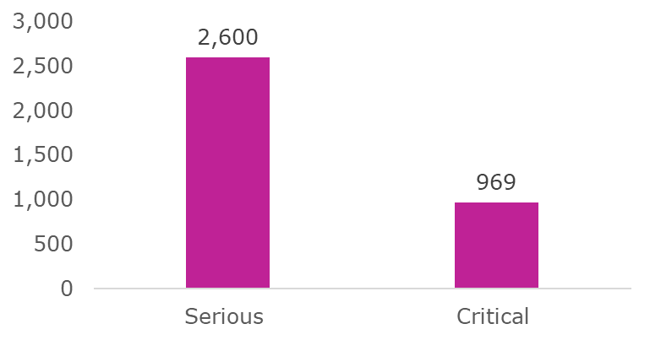
Types of errors
The most common error identified on most sites (158, 68%) related to PDFs (Figure 138). Colour Contrast accounted for the highest number of errors for thirty-six, or 15.4% of websites. The error “Name, Role, Value” is frequently associated with how interactive elements are coded on pages such as search forms, application forms, cookie banners and other interactive components. This category of error accounted for the most frequent errors found on seventeen, or 7.3% of websites.
There were five websites which had no errors identified in the scan which achieved the highest possible accessibility scores of 100%:
- Cavan County Council
- Housing Assistance Payment (DHLGH)
- Covid19Evaluation
- Passport Online
- Courts Service of Ireland
Figure 138: WCAG 2.1 Success Criteria with Most Issues Found – All Websites
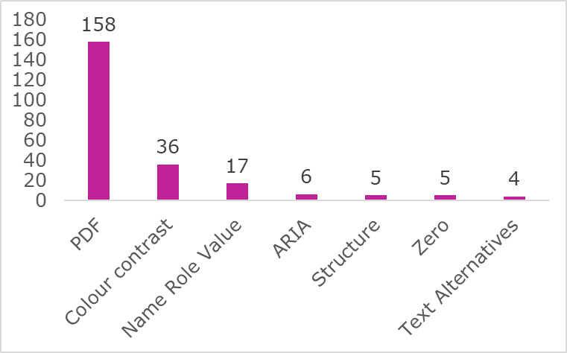

Number of errors per page per website
For the fifth monitoring period in succession, a large majority of websites reviewed (123) contained either seven or more errors per page (Figure 139).
Secondary analysis by NDA reviewers confirmed that many of the errors identified were the same error repeated either multiple times on the same page or the same errors occurring across multiple pages. For some categories of errors, repairing an error in the CSS file or in the HTML of the website’s template can result in numerous errors being addressed.
Figure 139: Errors per Page – All Websites
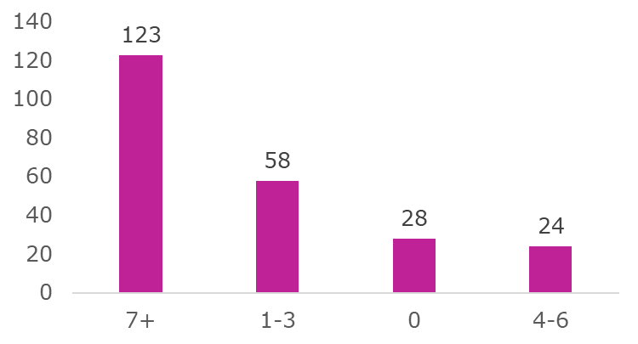

Accessibility scores
In 2025, 20.6% of websites attained an Accessibility Score of 90% or higher, an increase in the number from the 2024 monitoring period (16%). In 2025, 15.5% of websites had an Accessibility Score of 10% or less, which represents a decrease from the 2024 monitoring period (23.7%). It is possible for a website to get an accessibility score of zero if many errors occur on the pages tested.
Figure 140: Sites with Score of 90% or Higher – All Websites
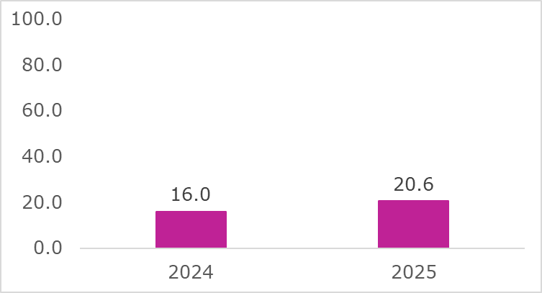
Figure 141: Sites with Score of 10% or Less – All Websites
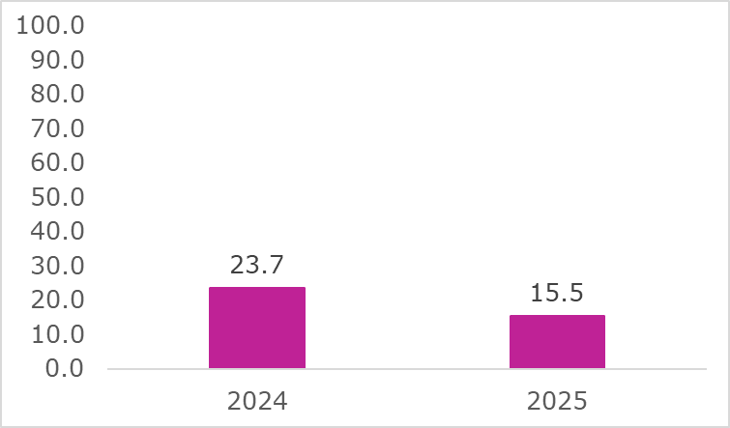
See the Annex for the Accessibility Score of all sites subject to monitoring (Simplified Review) in 2025.
The following section shows monitoring data specific to the following priority sectors:
- Local Authorities
- Transport Service Providers
- Higher Education Institutions
- Education and Training Boards
- European Accessibility Act (EAA) Compliance Authorities
The European Accessibility Act (EAA) is a European Directive that contains accessibility requirements for a range of products and services. The EAA commenced on 28 June 2025. The EAA will prevent product and services that do not meet its accessibility requirements from being made available on the EU market. This will ensure a minimum level of accessibility for key products and services throughout the EU. The NDA is responsible for advising the relevant market surveillance authority and compliance authorities on matters related to the accessibility requirements. The market surveillance authority is responsible for regulating the relevant products and services covered under the EAA. In Ireland the market surveillance authority is the Competition and Consumer Protection Commission (CCPC) (This website was also subject to in-depth review monitoring for 2025) and the compliance authorities are:
- Commission for Communications Regulation (ComReg). This website was also subject to in-depth review monitoring for 2025.
- Coimisiún na Meán. This website was also subject to in-depth review monitoring for 2025.
- Irish Aviation Authority. This website was also subject to in-depth review monitoring for 2025.
- National Transport Authority. This website was also subject to in-depth review monitoring for 2025.
- Central Bank of Ireland. This website was also subject to in-depth review monitoring for 2025.

1. Local Authorities
NDA conducted Simplified Reviews on the main websites of 31 Local Authorities.

Errors and user impact
The average number of errors on the 31 Local Authority websites was lower than that of all other websites reviewed (2,463 versus 3,570) Figure 142. The average Accessibility Score for Local Authorities (70.21%) is higher than for all sites (55.25%) Figure 143.
Figure 142: Average Number of Errors per Site – Local Authorities
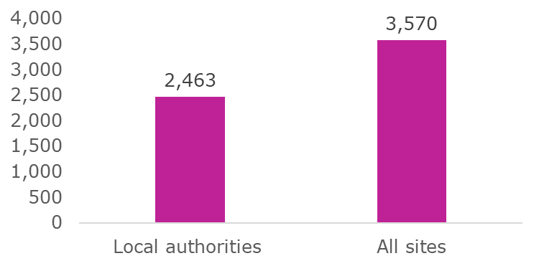
Figure 143: Average Accessibility Scores – Local Authorities
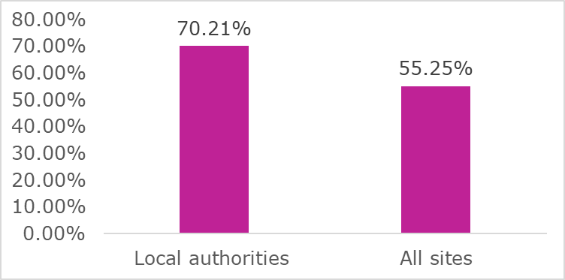

Types of errors – Local Authorities
The most common errors identified on Local Authority websites are similar to those found on all sites, with errors related to PDF, Colour Contrast and Name, Role, Value accounting for the three most frequent errors, as outlined in Figure 144.
Figure 144: Frequency of Main Errors – Local Authorities
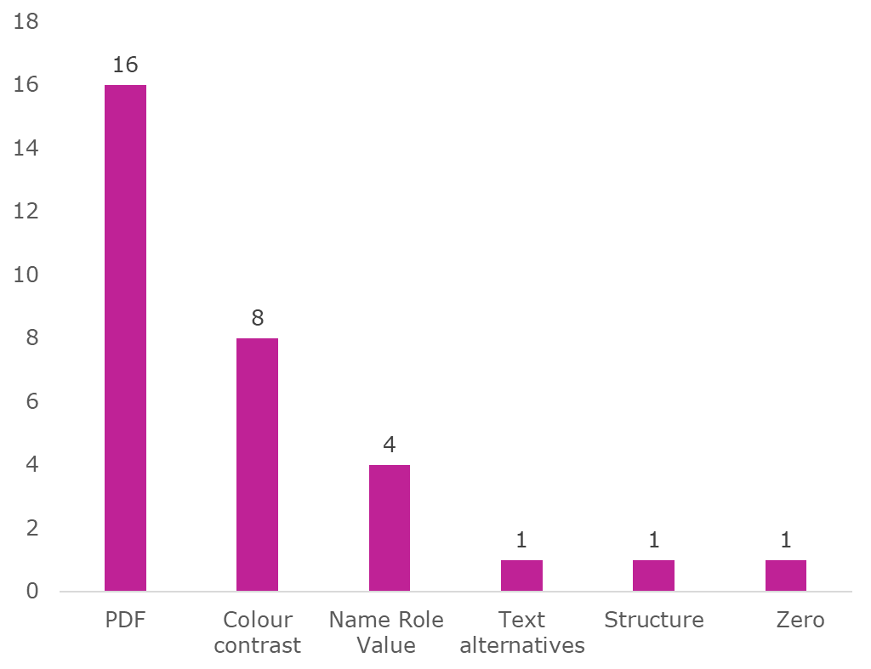
While some Local Authorities have addressed many of the accessibility errors identified in their Simplified Review for HTML pages on their websites, the practice of publishing inaccessible PDFs will continue to be a challenge to reaching full compliance with the Directive.
Errors and Accessibility Scores per site – Local Authorities
There was a large variance in the number of errors across all Local Authority websites reviewed. Figure 145 shows wide variance in the number of errors. Due to space limitations and the need for a clear uncluttered layout, the values (which varied widely from no errors on the Cavan County Council website to 10,998 errors on the Monaghan County Council website) are presented in the accessible table linked below the figure.
Figure 145: Total Number of Errors per Site – Local Authorities
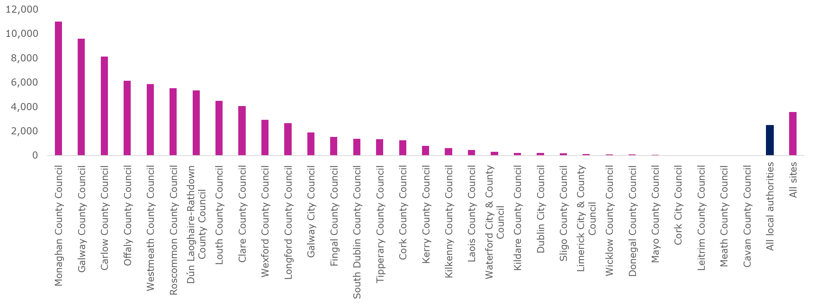
See accessible table in Annex
Eleven Local Authorities have achieved an Accessibility Score of 90% or more, in comparison to nine in 2024. Figure 146 presents the Accessibility Score for each Local Authority. Due to space limitations and the need for a clear uncluttered layout, the values (which varied widely from 100% on the Cavan County Council website to 0.00% on the Louth County Council website) are presented in the accessible table linked below the figure.
Figure 146: Accessibility Scores – Local Authorities
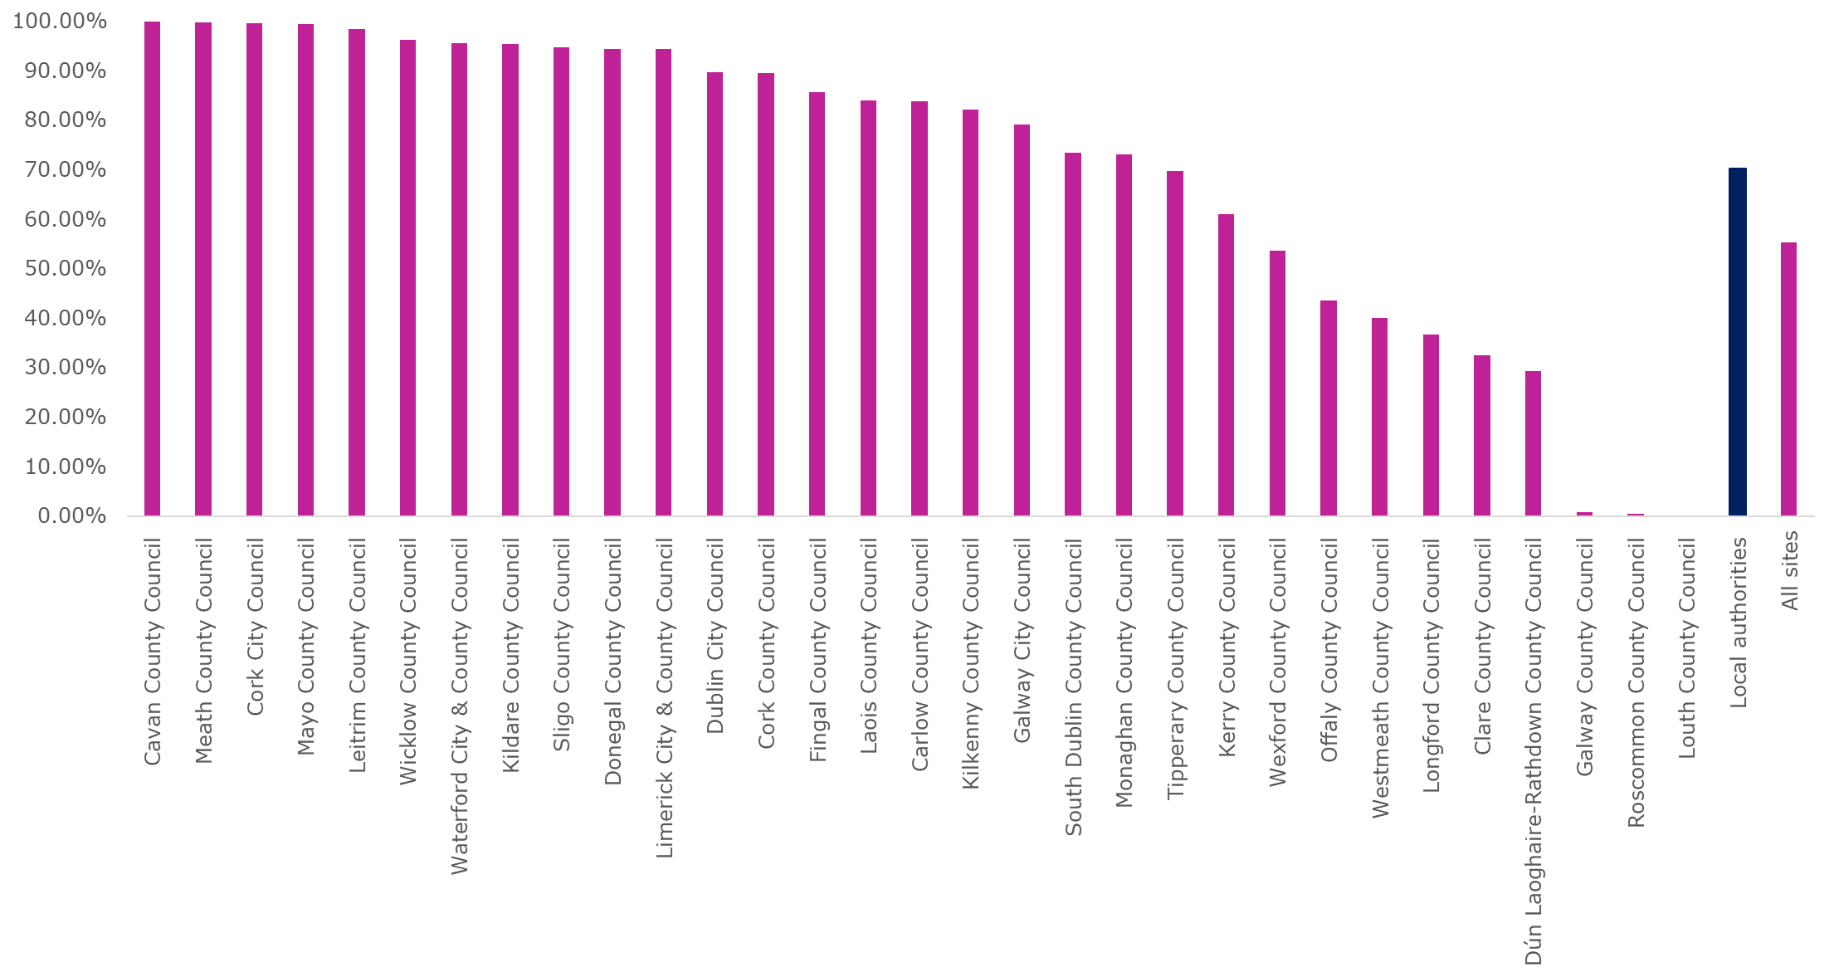
See accessible table in Annex

2. Transport Service Providers
Transport providers tend to have websites that typically contain a lot of functionality and complex interactions. In 2025 the NDA monitored the websites of six transport service providers:
- Bus Éireann
- Iarnród Éireann - Irish Rail
- TFI Leap
- Luas
- Go Ahead Ireland
- Dublin Bus

Errors and user impact
The average number of errors on the six transport service providers websites (2,315) was lower than that of All Sites (3,570) for this monitoring period (Figure 147). The average Accessibility Score for transport service providers (51.53%) was slightly lower than the average accessibility score for All Sites (55.25%) (Figure 148).
Figure 147: Average Number of Errors per Site – Transport Service Providers
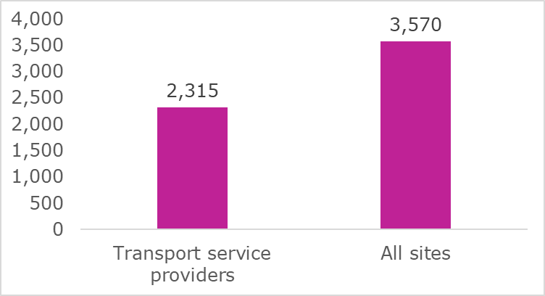
Figure 148: Average Accessibility Score - Transport Service Providers
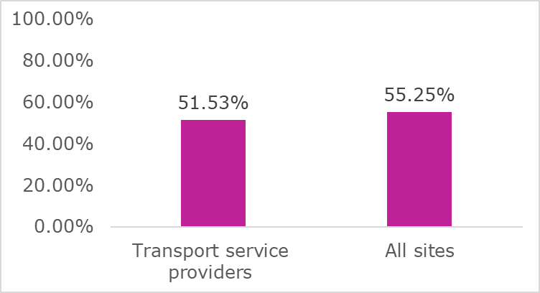

Types of errors - Transport Service Providers
The most common errors identified on transport providers websites are Colour Contrast, ARIA, PDF, Text Alternatives, Name Role Value and Structure (Figure 149).
Figure 149: Frequency of Main Errors – Transport Service Providers
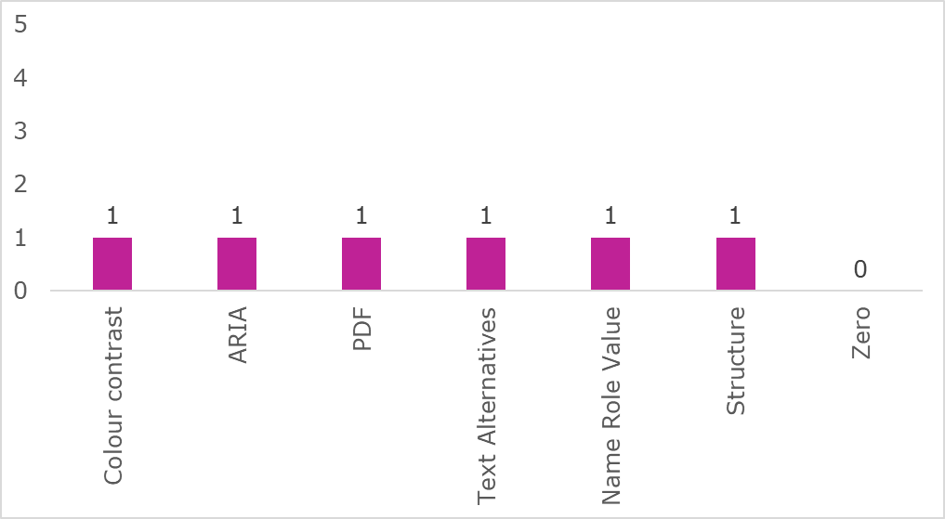

Errors and Accessibility Scores per site – Transport Service Providers
Figure 150 presents the number of errors per site of transport service providers. Bus Éireann’s 2025 review results had the highest number of errors of all sites in this category (5,790).
Figure 150: Total Number of Errors per Site – Transport Service Providers
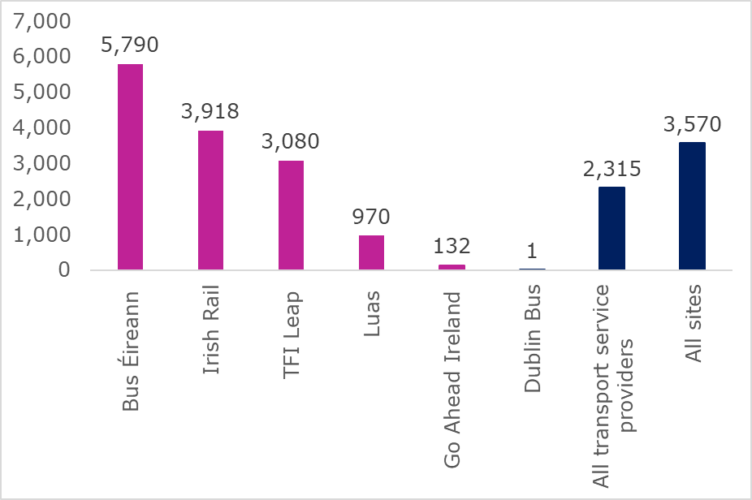
See accessible table in Annex
Two of the six Transport Service Providers websites reviewed have low Accessibility Scores. These websites have a large number of errors related to interactive elements on the websites (Figure 151). Many of these are categorised as “Critical errors” as they can block a user of Assistive Technology or a keyboard-only user completing a task.
Dublin Bus and Iarnród Éireann - Irish Rail maintained a high Accessibility Score from 2024 into 2025.
Figure 151: Accessibility Scores – Transport Service Providers
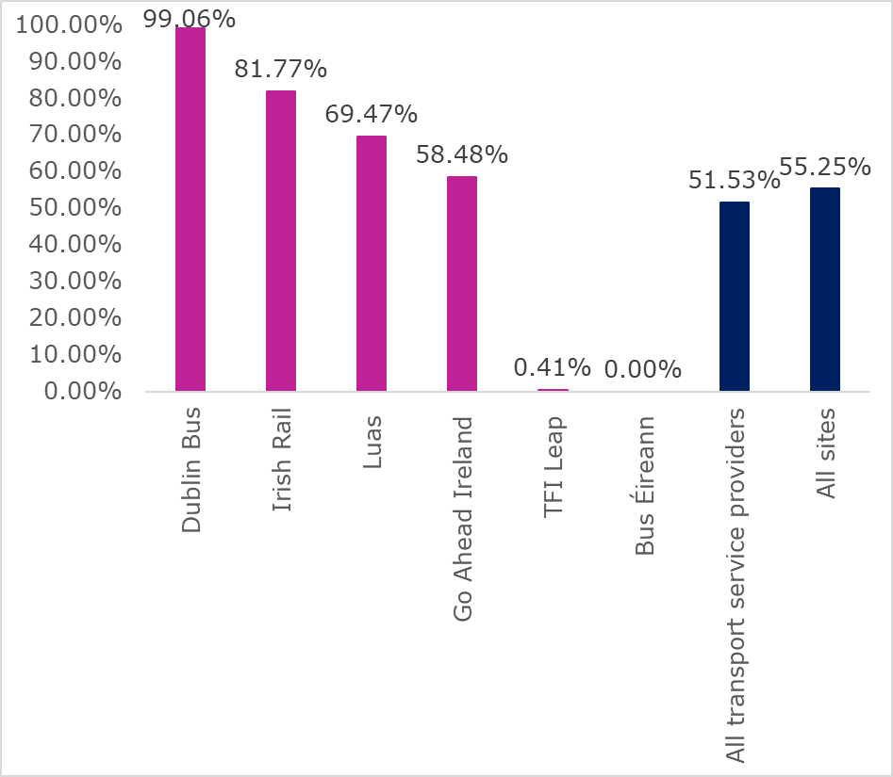
See accessible table in Annex

3. Higher Education Institutions
The NDA conducted Simplified Reviews on the main websites of 17 Higher Education Institutions (HEIs). The Simplified Reviews did not include student or staff extranets such as Learning Management Systems or other online services provided by HEIs that are accessed using a username and password.

Errors and user impact
The average number of errors on HEI websites (1,380) was significantly lower than that of All Sites (3,570) reviewed (Figure 152). The average Accessibility Score for HEIs (69.12%) was higher than that for All Sites (55.25%) (Figure 153).
Figure 152: Average Number of Errors per Site – Higher Education Institutions
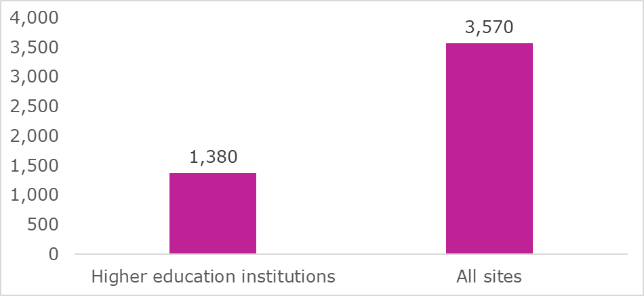
Figure 153: Average Accessibility Score - Higher Education Institutions
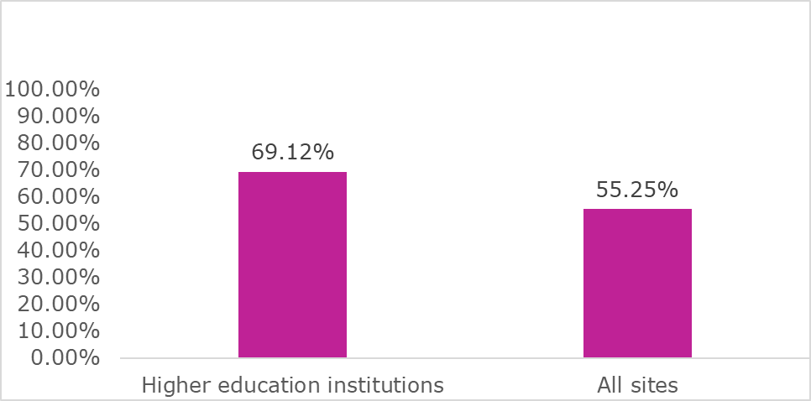

Types of errors - Higher Education Institutions
PDFs accounted for the highest number of errors on a majority of the HEI websites (Figure 154).
Figure 154: Frequency of Main Errors – Higher Education Institutions
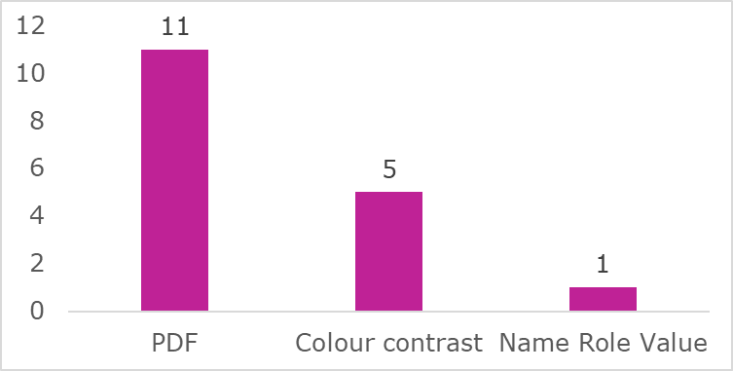

Errors and Accessibility Score per site – Higher Education Institutions
There was a large variance in the number of errors across all HEI websites from 3,144 to 147.
Figure 155: Total Number of Errors per Site – Higher Education Institutions
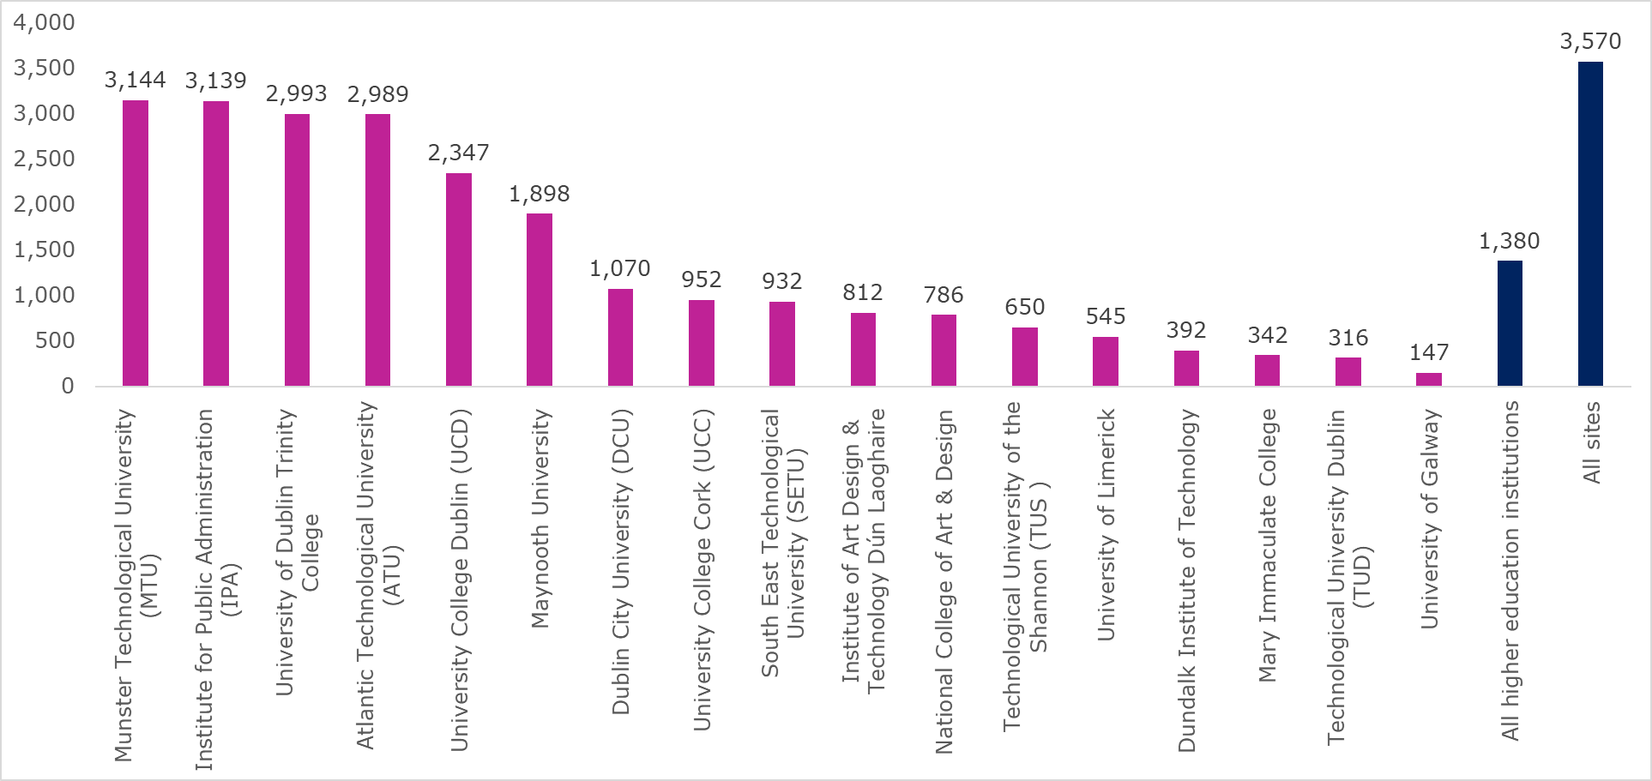
See accessible table in Annex
All the HEI websites reviewed provided key documents in inaccessible PDF. This presents significant barriers for example, students with disabilities being able to find information on HEI courses in these institutions.
Figure 156 presents the Accessibility Scores by HEI. These range from 96.96% to 28.18%. The average Accessibility Score for the HEI’s (69.12%) is slightly higher than the Accessibility Score for All sites (55.25%).
Figure 156: Accessibility Scores – Higher Education Institutions
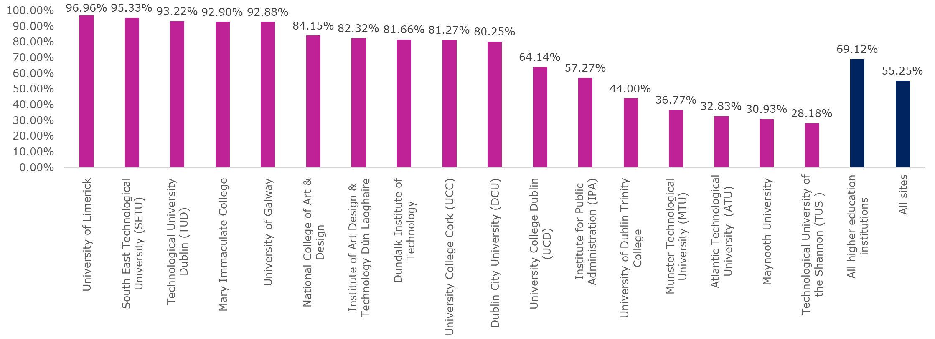
See accessible table in Annex

4. Education and Training Boards
NDA conducted Simplified Reviews on the main websites of 16 Education and Training Boards (ETBs).

Errors and user impact
The average number of errors on the 16 ETBs websites (6,526) was higher than that of all other websites reviewed (3,570) (Figure 157).
Figure 157: Average Number of Errors per Site – Education and Training Boards
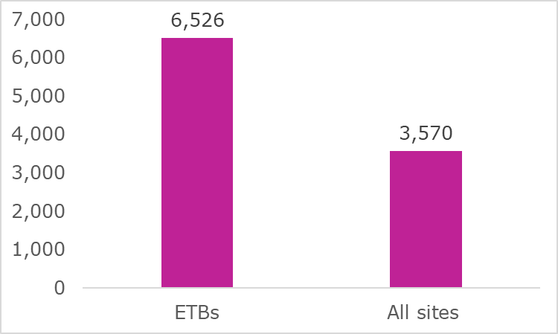
Figure 158 presents the Accessibility Scores by ETB. These range from 90.27% to 0.39%. The average accessibility score for ETBs (45.56%) is lower than for all sites (55.25%) Figure 158.
Figure 158: Average Accessibility Scores – Education and Training Boards
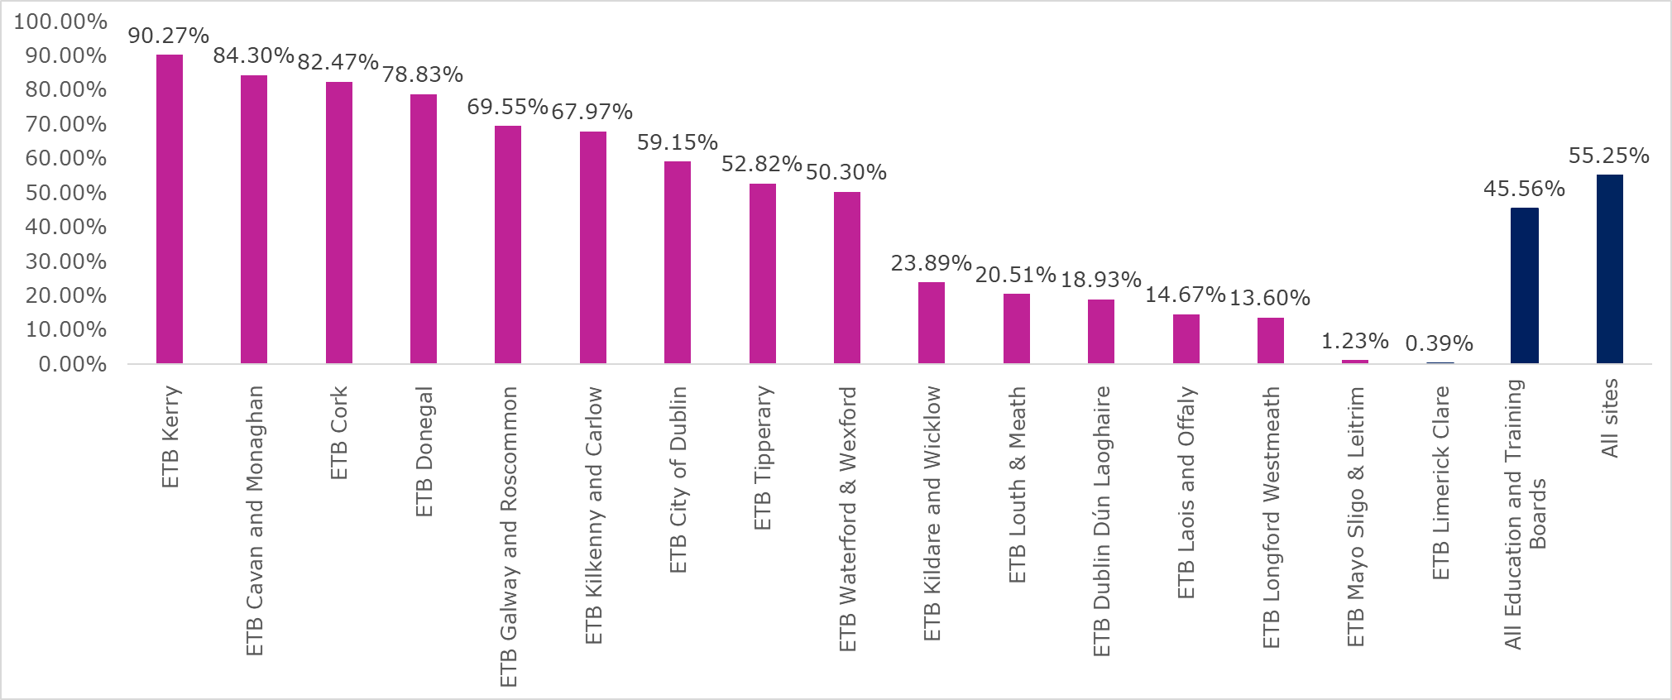
See accessible table in Annex.

Types of errors – Education and Training Boards
Inaccessible PDFs accounted for the highest number of errors on fifteen ETB websites (Figure 159).
Figure 159: Frequency of Main Errors – Education and Training Boards
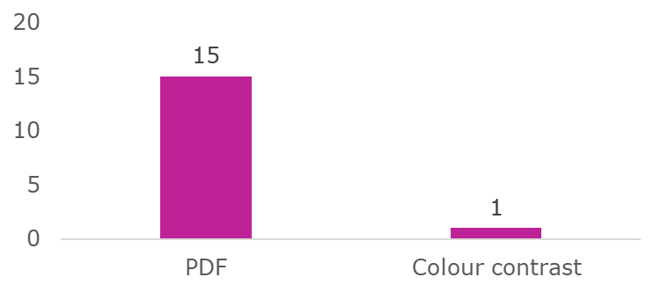

Errors and Accessibility Score per site – Education and Training Boards
There was a large variance in the number of errors across all ETB websites (Figure 160). These range from 21,136 to 396 errors per site.
Figure 160: Total number of Errors per Site – Education and Training Boards
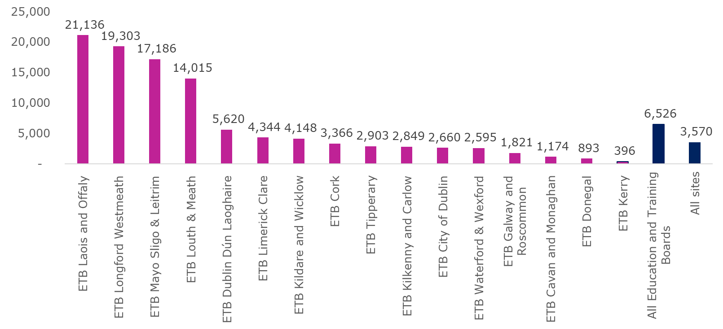
See accessible table in Annex
Overall, ETBs websites contain errors that could be remediated as part of routine website development and maintenance.
Key documents on all ETB websites reviewed are provided in inaccessible PDF. This presents a significant barrier to students with disabilities being able to find information on courses in these institutions.
Figure 161 presents the Accessibility Scores by ETB. These range from 90.27% to 0.39%.
Figure 161: Accessibility Scores – Education and Training Boards
See accessible table in Annex

5. European Accessibility Act (EAA) Market Surveillance and Compliance Authorities
NDA conducted Simplified Reviews on the websites of six EAA Compliance Authorities.

Errors and user impact
The average number of errors on the 6 EAA Compliance Authority websites (2,054) was higher than that of all other websites reviewed (3,570) (Figure 162).
Figure 162: Average Number of Errors per Site - EAA Market Surveillance and Compliance Authorities
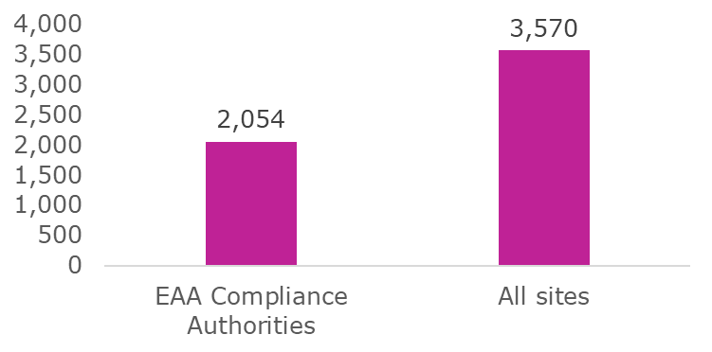
The average accessibility score for the EAA Compliance Authorities (66.54%) is higher than for all sites (55.25%) Figure 163.
Figure 163: Average Accessibility Scores - EAA Market Surveillance and Compliance Authorities
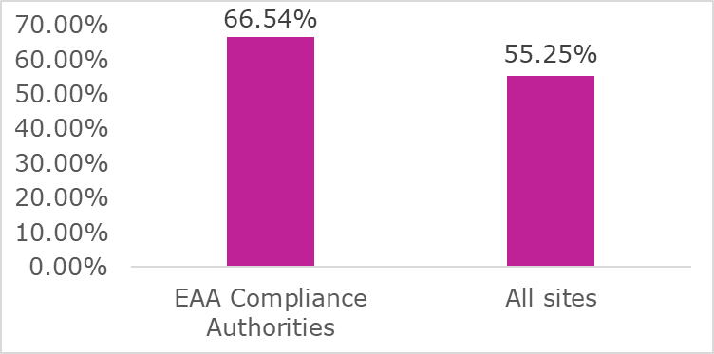

Types of errors – EAA Compliance Authorities
Inaccessible PDFs accounted for the highest number of errors on the EAA Compliance Authority websites (Figure 164).
Figure 164: Frequency of Main Errors – EAA Market Surveillance and Compliance Authorities
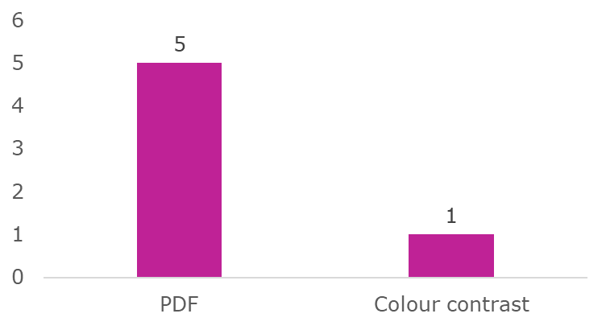

Errors and Accessibility Score per site – EAA
There was a large variance in the number of errors across all the EAA Market Surveillance and Compliance Authorities websites (Figure 165). These range from 4,702 to 124 errors per site.
Figure 165: Total Number of Errors per Site – EAA Market Surveillance and Compliance Authorities
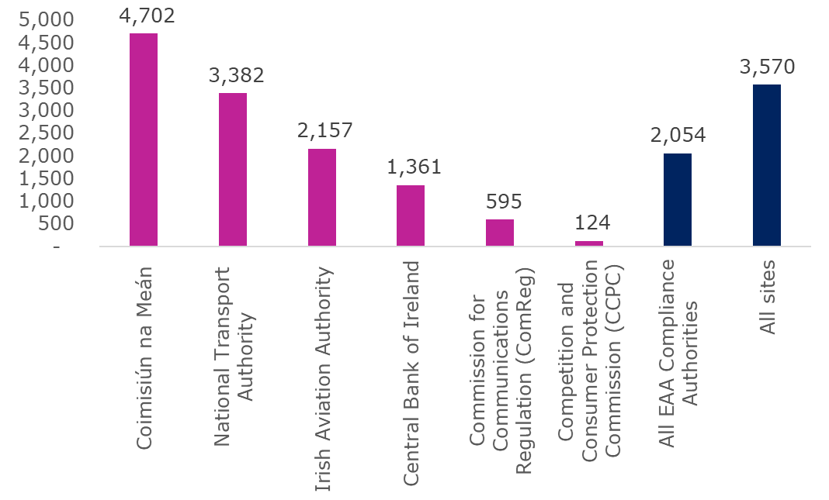
See accessible table in Annex
Figure 166 presents the Accessibility Scores by EAA Market Surveillance and Compliance Authorities. These range from 97.16% to 2.49%.
Figure 166: Accessibility Scores – EAA Market Surveillance and Compliance Authorities
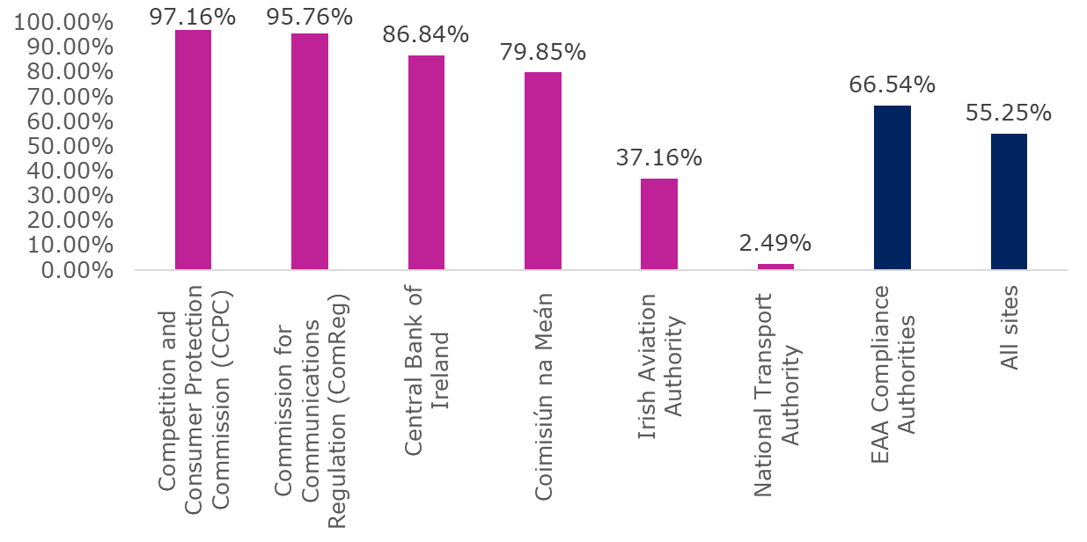
See accessible table in Annex

Conclusion
This report presents monitoring data for Ireland for the 2025 monitoring year. This is the first of three annual reports that fulfils the NDA’s monitoring and reporting obligations for 2025-2027 under the Directive as per Implementing Decision 2018/1524.
This report has shown significant improvement in levels of compliance across certain cohorts of public bodies. Many public sector bodies have addressed accessibility issues identified by the automated and manual tests. Public bodies subject to In-depth Review, Simplified Review, or both, for the 2025 monitoring period should consider these results as the beginning of their accessibility journey. The NDA advises that engagement with real users including persons with disabilities, and addressing issues identified in automated and manual testing are key to ensuring meaningful accessibility and achieving compliance with the Web Accessibility Directive.
The NDA has observed that in general, public sector bodies who engage with their monitoring results and reach out to the NDA and other sources of authoritative information to receive and share guidance, demonstrate ongoing improvements in their compliance. The NDA observes a consistent and welcome trend by public bodies in addressing accessibility in the development of new or existing websites and mobile apps. It is also critical that public bodies continue to consider accessibility in the publishing of content to their website and avoid the routine publishing of inaccessible PDFs.
Monitoring compliance with minimum standards alone cannot achieve Universal Design. The NDA encourages all public bodies to take a Universal Design approach in the design and provision of their websites, apps, and customer services. Public sector bodies can learn more about the Universal Design Approach from recordings or training and information events provided by the NDA and The NDA’s Centre for Excellence in Universal Design’s “Customer Communications Toolkit for Services to the Public – A Universal Design Approach”. This approach aims to create an environment that can be accessed, understood and used to the greatest extent possible by all people, regardless of their age, size, ability or disability.

Annex – Accessible Tables
This annex presents accessible tables with the most frequently identified issues for the 22 websites and 12 mobile apps that were subject to an in-depth review and accessible tables with data from 233 simplified reviews.

In-depth Reviews - Websites

An Post
Table 4: An Post Most Frequently Identified Issues
Success Criteria | Description | Occurrences
1.4.11 | Non-text Contrast | 30
4.1.2 | Name, Role, Value | 11
1.4.3 | Contrast (Minimum) | 9
2.4.4 | Link Purpose (In Context) | 8
2.5.3 | Label in Name | 8
1.3.1 | Info and Relationships | 7
2.1.1 | Keyboard | 7
1.3.2 | Meaningful Sequence | 6
2.4.7 | Focus Visible | 6
1.1.1 | Non-text Content | 5
 | Other Success Criteria | 23

Central Bank of Ireland
Table 5: Central Bank of Ireland Most Frequently Identified Issues
Success Criteria | Description | Occurrences
1.3.1 | Info and Relationships | 8
1.4.3 | Contrast (Minimum) | 8
1.4.11 | Non-text Contrast | 6
1.1.1 | Non-text Content | 5
4.1.2 | Name, Role, Value | 5
1.4.1 | Use of Colour | 4
1.4.10 | Reflow | 4
1.3.2 | Meaningful Sequence | 2
1.4.13 | Content on Hover or Focus | 2
2.4.3 | Focus Order | 2
 | Other Success Criteria | 11

Cheshire Ireland
Table 6: Cheshire Ireland Most Frequently Identified Issues
Success Criteria | Description | Occurrences
1.4.3 | Contrast (Minimum) | 93
4.1.2 | Name, Role, Value | 35
1.3.1 | Info and Relationships | 26
1.1.1 | Non-text Content | 20
1.4.11 | Non-text Contrast | 20
1.4.5 | Images of Text | 6
1.3.2 | Meaningful Sequence | 4
2.4.3 | Focus Order | 4
1.4.10 | Reflow | 3
2.4.7 | Focus Visible | 3
 | Other Success Criteria | 20

Coimisiún Na Meán
Table 7: Coimisiún Na Meán Most Frequently Identified Issues
Success Criteria | Description | Occurrences
1.3.1 | Info and Relationships | 7
1.4.11 | Non-text Contrast | 5
4.1.2 | Name, Role, Value | 4
1.4.3 | Contrast (Minimum) | 2
1.1.1 | Non-text Content | 1
1.3.5 | Identify Input Purpose | 1
1.4.1 | Use of Colour | 1
1.4.5 | Images of Text | 1
2.1.1 | Keyboard | 1
2.4.3 | Focus Order | 1
 | Other Success Criteria | 6

ComReg
Table 8: ComReg Most Frequently Identified Issues
Success Criteria | Description | Occurrences
1.3.1 | Info and Relationships | 11
1.4.3 | Contrast (Minimum) | 5
2.4.7 | Focus Visible | 3
3.3.2 | Labels or Instructions | 3
4.1.3 | Status Messages | 2
1.4.10 | Reflow | 1
1.4.11 | Non-text Contrast | 1
2.5.3 | Label in Name | 1
4.1.2 | Name, Role, Value | 1
en-12.1.2 | Accessible documentation | 1
 | Other Success Criteria | 2

Competition and Consumer Protection Commission
Table 9: Competition and Consumer Protection Commission Most Frequently Identified Issues
Success Criteria | Description | Occurrences
4.1.2 | Name, Role, Value | 29
1.3.1 | Info and Relationships | 23
1.4.3 | Contrast (Minimum) | 7
1.4.11 | Non-text Contrast | 6
1.1.1 | Non-text Content | 5
2.4.4 | Link Purpose (In Context) | 5
1.4.10 | Reflow | 4
1.4.12 | Text Spacing | 3
2.4.7 | Focus Visible | 3
2.5.3 | Label in Name | 3
 | Other Success Criteria | 19

Gov.ie
Table 10: Gov.ie Most Frequently Identified Issues
Success Criteria | Description | Occurrences
1.3.1 | Info and Relationships | 9
1.1.1 | Non-text Content | 8
4.1.2 | Name, Role, Value | 4
2.4.3 | Focus Order | 3
1.2.3 | Audio Description or Media Alternative (Prerecorded) | 2
1.2.5 | Description (Prerecorded) | 2
1.3.2 | Meaningful Sequence | 2
en-12.1.2 | Accessible documentation | 2
1.4.5 | Images of Text | 1
2.4.2 | Page Titled | 1
 | Other Success Criteria | 3

HSeLanD eLearning Module: ‘Designated Person in Incident Management and Open Disclosure’
Table 11: HSeLanD eLearning Module Most Frequently Identified Issues
Success Criteria | Description | Occurrences
1.4.3 | Contrast (Minimum) | 183
1.3.1 | Info and Relationships | 41
1.4.11 | Non-text Contrast | 12
4.1.2 | Name, Role, Value | 11
2.4.6 | Headings and Labels | 8
1.1.1 | Non-text Content | 5
1.4.10 | Reflow | 4
2.5.3 | Label in Name | 4
1.4.1 | Use of Colour | 3
2.4.4 | Link Purpose (In Context) | 3
 | Other Success Criteria | 12

HSE.ie
Table 12: HSE.ie Most Frequently Identified Issues
Success Criteria | Description | Occurrences
4.1.2 | Name, Role, Value | 7
1.3.1 | Info and Relationships | 6
1.1.1 | Non-text Content | 3
1.4.11 | Non-text Contrast | 3
1.4.3 | Contrast (Minimum) | 3
1.4.1 | Use of Colour | 2
1.4.13 | Content on Hover or Focus | 2
4.1.3 | Status Messages | 2
1.2.2 | Captions (Prerecorded) | 1
1.2.3 | Audio Description or Media Alternative (Prerecorded) | 1
 | Other Success Criteria | 12

Irish Aviation Authority
Table 13: Irish Aviation Authority Most Frequently Identified Issues
Success Criteria | Description | Occurrences
1.4.3 | Contrast (Minimum) | 51
4.1.2 | Name, Role, Value | 14
1.3.1 | Info and Relationships | 10
1.4.13 | Content on Hover or Focus | 7
1.4.10 | Reflow | 5
1.3.2 | Meaningful Sequence | 3
1.4.11 | Non-text Contrast | 3
1.4.4 | Resize text | 3
2.1.1 | Keyboard | 3
2.4.3 | Focus Order | 3
 | Other Success Criteria | 15

Irish Aviation Authority eComplaint form
Table 14: Irish Aviation Authority eComplaint form Most Frequently Identified Issues
Success Criteria | Description | Occurrences
1.1.1 | Non-text Content | 23
1.3.1 | Info and Relationships | 12
1.4.1 | Use of Colour | 11
1.4.11 | Non-text Contrast | 11
4.1.2 | Name, Role, Value | 8
1.4.3 | Contrast (Minimum) | 7
2.4.6 | Headings and Labels | 6
2.1.1 | Keyboard | 5
2.5.3 | Label in Name | 4
1.3.2 | Meaningful Sequence | 3
 | Other Success Criteria | 21

National Disability Authority
Table 15: National Disability Authority Most Frequently Identified Issues
Success Criteria | Description | Occurrences
1.3.1 | Info and Relationships | 4
1.1.1 | Non-text Content | 2
2.4.4 | Link Purpose (In Context) | 2
1.4.11 | Non-text Contrast | 1
2.1.1 | Keyboard | 1
2.4.2 | Page Titled | 1
2.5.3 | Label in Name | 1
3.1.2 | Language of Parts | 1
en-12.1.2 | Accessible documentation | 1
en-7.1.5 | Spoken subtitles | 1
 | Other Success Criteria | 1

National Shared Services Office Core Portal
Table 16: National Shared Services Office Core Portal Most Frequently Identified Issues
Success Criteria | Description | Occurrences
4.1.2 | Name, Role, Value | 170
1.3.1 | Info and Relationships | 63
2.4.7 | Focus Visible | 38
1.4.3 | Contrast (Minimum) | 13
2.4.2 | Page Titled | 10
1.4.10 | Reflow | 9
2.1.1 | Keyboard | 9
2.4.3 | Focus Order | 7
3.3.2 | Labels or Instructions | 7
2.1.2 | No Keyboard Trap | 4
 | Other Success Criteria | 26

National Transport Authority
Table 17: National Transport Authority Most Frequently Identified Issues
Success Criteria | Description | Occurrences
1.3.1 | Info and Relationships | 9
1.4.4 | Resize text | 7
1.4.11 | Non-text Contrast | 5
1.4.3 | Contrast (Minimum) | 4
4.1.2 | Name, Role, Value | 4
1.1.1 | Non-text Content | 2
1.4.1 | Use of Colour | 2
3.3.2 | Labels or Instructions | 2
1.3.5 | Identify Input Purpose | 1
1.14.10 | Reflow | 1
 | Other Success Criteria | 6

Passport Online (passport renewal form)
Table 18: Passport Online (passport renewal form) Most Frequently Identified Issues
Success Criteria | Description | Occurrences
1.3.1 | Info and Relationships | 26
4.1.2 | Name, Role, Value | 24
1.3.5 | Identify Input Purpose | 17
2.5.3 | Label in Name | 17
2.4.6 | Headings and Labels | 10
1.1.1 | Non-text Content | 8
1.4.11 | Non-text Contrast | 6
2.4.4 | Link Purpose (In Context) | 6
1.4.3 | Contrast (Minimum) | 5
1.4.1 | Use of Colour | 4
 | Other Success Criteria | 30

Residential Tenancy Board (RTB) My Account/RTB360
Table 19: RTB My Account/RTB360 Most Frequently Identified Issues
Success Criteria | Description | Occurrences
1.4.3 | Contrast (Minimum) | 57
4.1.2 | Name, Role, Value | 40
1.4.11 | Non-text Contrast | 37
1.3.1 | Info and Relationships | 26
2.4.3 | Focus Order | 9
2.4.7 | Focus Visible | 8
2.1.1 | Keyboard | 7
1.3.5 | Identify Input Purpose | 5
4.1.3 | Status Messages | 5
1.4.10 | Reflow | 4
 | Other Success Criteria | 22

Residential Tenancy Board (RTB) main site
Table 20: Residential Tenancy Board (RTB) main site Most Frequently Identified Issues
Success Criteria | Description | Occurrences
1.4.3 | Contrast (Minimum) | 13
1.3.1 | Info and Relationships | 9
1.1.1 | Non-text Content | 4
1.4.11 | Non-text Contrast | 2
2.1.1 | Keyboard | 2
4.1.2 | Name, Role, Value | 2
2.4.2 | Page Titled | 1
2.4.3 | Focus Order | 1
 | Other Success Criteria | 0

State Examination Commission
Table 21: State Examination Commission Most Frequently Identified Issues
Success Criteria | Description | Occurrences
1.3.1 | Info and Relationships | 46
4.1.2 | Name, Role, Value | 30
3.1.2 | Language of Parts | 29
1.1.1 | Non-text Content | 14
1.4.10 | Reflow | 9
1.4.11 | Non-text Contrast | 8
1.3.2 | Meaningful Sequence | 7
1.4.3 | Contrast (Minimum) | 3
1.4.5 | Images of Text | 3
4.1.3 | Status Messages | 3
 | Other Success Criteria | 15

UCC Canvas
Table 22: UCC Canvas Most Frequently Identified Issues
Success Criteria | Description | Occurrences
1.3.1 | Info and Relationships | 8
4.1.2 | Name, Role, Value | 8
1.4.11 | Non-text Contrast | 6
2.1.1 | Keyboard | 6
1.4.1 | Use of Colour | 5
1.4.10 | Reflow | 5
1.4.13 | Content on Hover or Focus | 5
1.4.4 | Resize text | 3
3.3.2 | Labels or Instructions | 3
2.4.7 | Focus Visible | 2
 | Other Success Criteria | 9

UniversalDesign.ie
Table 23: UniversalDesign.ie Most Frequently Identified Issues
Success Criteria | Description | Occurrences
1.3.1 | Info and Relationships | 6
1.4.3 | Contrast (Minimum) | 2
2.4.2 | Page Titled | 2
en-7.1.5 | Spoken subtitles | 2
1.1.1 | Non-text Content | 1
en-12.1.2 | Accessible documentation | 1
en-7.2.1 | Audio description playback | 1

Workplace Relations Commission
Table 24: Workplace Relations Commission Most Frequently Identified Issues
Success Criteria | Description | Occurrences
4.1.2 | Name, Role, Value | 6
1.3.1 | Info and Relationships | 5
1.4.10 | Reflow | 5
1.1.1 | Non-text Content | 3
1.4.11 | Non-text Contrast | 3
1.3.2 | Meaningful Sequence | 2
1.4.3 | Contrast (Minimum) | 2
2.4.3 | Focus Order | 2
2.4.6 | Headings and Labels | 2
en-12.1.2 | Accessible documentation | 2
 | Other Success Criteria | 11

Workplace Relations Commission eComplaint
Table 25: Workplace Relations Commission eComplaint Most Frequently Identified Issues
Success Criteria | Description | Occurrences
1.4.3 | Contrast (Minimum) | 16
1.3.1 | Info and Relationships | 8
1.4.11 | Non-text Contrast | 6
4.1.2 | Name, Role, Value | 5
1.4.10 | Reflow | 4
2.1.1 | Keyboard | 3
1.3.5 | Identify Input Purpose | 1
1.4.1 | Use of Colour | 1
2.4.3 | Focus Order | 1
2.4.6 | Headings and Labels | 1
 | Other Success Criteria | 2

In-depth Reviews Mobile Applications

HSE Health App Android
Table 26: HSE Health App Android Most Frequently Identified Issues
Success Criteria | Description | Occurrences
1.3.1 | Info and Relationships | 6
2.4.3 | Focus Order | 3
1.3.2 | Meaningful Sequence | 2
2.4.6 | Headings and Labels | 2
4.1.2 | Name, Role, Value | 2
WAD-1 | Accessibility Statement | 2
2.5.3 | Label in Name | 1
4.1.3 | Status Messages | 1
 | Other Success Criteria | 0

HSE Health App iOS
Table 27: HSE Health App iOS Most Frequently Identified Issues
Success Criteria | Description | Occurrences
1.3.1 | Info and Relationships | 3
1.3.2 | Meaningful Sequence | 3
4.1.2 | Name, Role, Value | 3
2.4.6 | Headings and Labels | 2
WAD-1 | Accessibility Statement | 2
2.1.1 | Keyboard | 1
2.1.2 | No Keyboard Trap | 1
2.2.1 | Timing Adjustable | 1
2.4.3 | Focus Order | 1
4.1.3 | Status Messages | 1
 | Other Success Criteria | 0

LEAP Top-Up App Android
Table 28: LEAP Top-Up App Android Most Frequently Identified Issues
Success Criteria | Description | Occurrences
WAD-1 | Accessibility Statement | 2
1.3.1 | Info and Relationships | 1
1.3.2 | Meaningful Sequence | 1
1.3.4 | Orientation | 1
2.2.2 | Pause, Stop, Hide | 1
3.3.1 | Error Identification | 1
4.1.2 | Name, Role, Value | 1
en-12.1.2 | Accessible documentation | 1
 | Other Success Criteria | 0

LEAP Top-Up App iOS
Table 29: LEAP Top-Up App iOS Most Frequently Identified Issues
Success Criteria | Description | Occurrences
2.4.3 | Focus Order | 3
WAD-1 | Accessibility Statement | 2
1.3.2 | Meaningful Sequence | 1
1.3.4 | Orientation | 1
2.2.1 | Timing Adjustable | 1
2.4.6 | Headings and Labels | 1
3.3.3 | Error Suggestion | 1
en-12.1.2 | Accessible documentation | 1
 | Other Success Criteria | 0

Iarnród Éireann - Irish Rail App Android
Table 30: Iarnród Éireann - Irish Rail App Android Most Frequently Identified Issues
Success Criteria | Description | Occurrences
1.3.1 | Info and Relationships | 12
1.4.3 | Contrast (Minimum) | 7
2.4.6 | Headings and Labels | 6
1.3.2 | Meaningful Sequence | 4
4.1.2 | Name, Role, Value | 3
1.4.11 | Non-text Contrast | 2
2.1.1 | Keyboard | 2
2.5.1 | Pointer Gestures | 2
1.3.4 | Orientation | 1
1.4.1 | Use of Colour | 1
 | Other Success Criteria | 3

Iarnród Éireann - Irish Rail App iOS
Table 31: Iarnród Éireann - Irish Rail App iOS Most Frequently Identified Issues
Success Criteria | Description | Occurrences
1.4.3 | Contrast (Minimum) | 8
1.4.11 | Non-text Contrast | 7
2.4.6 | Headings and Labels | 5
1.4.1 | Use of Colour | 4
1.3.1 | Info and Relationships | 3
1.3.2 | Meaningful Sequence | 3
4.1.2 | Name, Role, Value | 3
2.5.1 | Pointer Gestures | 2
1.3.4 | Orientation | 1
1.4.5 | Images of Text | 1
 | Other Success Criteria | 1

TFI Driver Check Android
Table 32: TFI Driver Check Android Most Frequently Identified Issues
Success Criteria | Description | Occurrences
4.1.2 | Name, Role, Value | 2
1.4.1 | Use of Colour | 1
1.4.3 | Contrast (Minimum) | 1
 | Other Success Criteria | 0

TFI Driver Check iOS
Table 33: TFI Driver Check iOS Most Frequently Identified Issues
Success Criteria | Description | Occurrences
4.1.2 | Name, Role, Value | 2
1.4.1 | Use of Colour | 1
1.4.3 | Contrast (Minimum) | 1
2.1.1 | Keyboard | 1
4.1.3 | Status Messages | 1

TFI GO Android
Table 34: TFI GO Android Most Frequently Identified Issues
Success Criteria | Description | Occurrences
4.1.3 | Status Messages | 5
1.3.1 | Info and Relationships | 3
1.4.11 | Non-text Contrast | 3
4.1.2 | Name, Role, Value | 3
1.1.1 | Non-text Content | 2
2.1.1 | Keyboard | 2
2.5.3 | Label in Name | 2
3.3.1 | Error Identification | 2
WAD-1 | Accessibility Statement | 2
1.3.4 | Orientation | 1
 | Other Success Criteria | 4

TFI GO iOS
Table 35: TFI GO iOS Most Frequently Identified Issues
Success Criteria | Description | Occurrences
4.1.2 | Name, Role, Value | 8
4.1.3 | Status Messages | 5
1.4.11 | Non-text Contrast | 4
2.1.1 | Keyboard | 3
2.5.3 | Label in Name | 3
1.1.1 | Non-text Content | 2
1.4.3 | Contrast (Minimum) | 2
3.3.1 | Error Identification | 2
WAD-1 | Accessibility Statement | 2
1.3.1 | Info and Relationships | 1
 | Other Success Criteria | 5

TFI Live Android
Table 36: TFI Live Android Most Frequently Identified Issues
Success Criteria | Description | Occurrences
1.3.2 | Meaningful Sequence | 12
4.1.2 | Name, Role, Value | 9
2.1.1 | Keyboard | 8
2.4.3 | Focus Order | 6
1.1.1 | Non-text Content | 3
2.4.6 | Headings and Labels | 3
1.4.3 | Contrast (Minimum) | 2
2.5.3 | Label in Name | 2
4.1.3 | Status Messages | 2
1.3.1 | Info and Relationships | 1
 | Other Success Criteria | 6

TFI Live iOS
Table 37: TFI Live iOS Most Frequently Identified Issues
Success Criteria | Description | Occurrences
2.1.1 | Keyboard | 5
1.3.2 | Meaningful Sequence | 4
2.4.6 | Headings and Labels | 4
4.1.2 | Name, Role, Value | 4
1.3.1 | Info and Relationships | 3
1.1.1 | Non-text Content | 2
1.4.11 | Non-text Contrast | 2
1.4.3 | Contrast (Minimum) | 2
1.3.4 | Orientation | 1
1.4.1 | Use of Colour | 1
 | Other Success Criteria | 7

Simplified Reviews

All Sites
Table 38: Accessibility Scores - All Sites
Name of Public Body | Accessibility Score %
Adoption Authority of Ireland (AAI) | 29.34
AHEAD | 89.67
An Coimisinéir Teanga | 46.31
An Coimisiún Pleanála | 32.66
An Garda Síochana | 29.92
An Post | 94.95
Atlantic Technological University (ATU) | 32.83
Backontrack.ie | 67.32
Birth Information & Tracing | 87.65
BordBia.ie | 94.72
Bus Connects | 2.01
Bus Éireann | 0
Carlow County Council | 83.84
Cavan County Council | 100
Central Bank of Ireland | 86.84
Central Statistics Office (CSO) | 41.85
Charities Regulator | 36.79
Cheshire Ireland | 33.29
Chester Beatty Library | 62.87
Citizens Information | 94.02
City Edge Project | 65.56
Clare County Council | 32.58
Climate Toolkit 4 Business | 0
Clonburris | 0
Coillte | 28.53
Coimisiún na Meán | 79.85
Commission for Communications Regulation (ComReg) | 95.76
Commission for Public Service Appointments (CPSA) | 77.58
Commission for Railway Regulation (CRR) | 31.73
Commission for Regulation of Utilities (CRU) | 87.01
Commission to Inquire into Child Abuse (CICA) | 34.13
Community National Schools | 3.75
Competition and Consumer Protection Commission (CCPC) | 97.16
Cork City Council | 99.6
Cork County Council | 89.6
Cork University Hospital | 88.74
Courts Service of Ireland | 100
Covid19Evaluation | 100
daa PLC | 1.88
Data Protection Commission | 91.15
Decision Support Service | 79.28
Defence Forces of Ireland | 31.12
Dept Enterprise, Tourism & Employment | 40.35
Discover Ireland (Fáilte Ireland) | 92.44
Donegal County Council | 94.46
Dublin Airport | 20.38
Dublin Bus | 99.06
Dublin Castle (OPW) | 0.9
Dublin City Council | 89.77
Dublin City Council Library | 33.82
Dublin City University (DCU) | 80.25
Dún Laoghaire-Rathdown County Council | 29.26
Dundalk Institute of Technology | 81.66
Eastern and Midland Regional Assembly | 19.02
eCollege | 97.25
Economic and Social Research Institute (ESRI) | 0.55
Educational & Training Boards Ireland | 31.7
Electoral Commission | 59.95
Electric Ireland | 47.12
Electricity Supply Board (ESB) | 62.73
Enterprise Ireland | 37.82
Environmental Protection Agency | 96.94
ESB International | 91.98
ESB Networks | 99.14
ETB Cavan and Monaghan | 84.3
ETB City of Dublin | 59.15
ETB Cork | 82.47
ETB Donegal | 78.83
ETB Dublin Dún Laoghaire | 18.93
ETB Galway and Roscommon | 69.55
ETB Kerry | 90.27
ETB Kildare and Wicklow | 23.89
ETB Kilkenny and Carlow | 67.97
ETB Laois and Offaly | 14.67
ETB Limerick Clare | 0.39
ETB Longford Westmeath | 13.6
ETB Louth & Meath | 20.51
ETB Mayo Sligo & Leitrim | 1.23
ETB Tipperary | 52.82
ETB Waterford & Wexford | 50.3
eTenders Office of Government Procurement | 37.9
Fáilte Ireland | 68.29
Farmleigh House and Estate (OPW) | 0
Financial Services & Pensions Ombudsman | 46.21
Fingal County Council | 85.69
Fís Éireann (Screen Ireland) | 90.1
Food Safety Authority of Ireland (FSAI) | 96.4
Further Education & Training Course Hub | 76
Galway City Council | 79.12
Galway County Council | 0.77
Garda Síochána Inspectorate | 48.21
Gas Networks Ireland | 68.81
Generation Apprenticeship | 0
Go Ahead Ireland | 58.48
Gov.ie | 88.89
Health & Safety Authority | 91.84
Health Information & Quality Authority (HIQA) | 12.88
Health Products Regulatory Authority | 83.77
Health Research Board | 65.13
Health Research Consent Declaration Committee | 55.19
Heritage Ireland (OPW) | 95.85
Higher Education Authority | 52.73
Home and Supports Hub | 84.86
Houses of the Oireachtas html | 96.91
Housing Agency | 21.87
Housing Assistance Payment (DHLGH) | 100
HSE | 83.44
HSE Health and Wellbeing | 0
Informing Families | 0.1
Injuries Resolution Board | 2.28
Institute for Public Administration (IPA) | 57.27
Institute of Art Design & Technology Dún Laoghaire | 82.32
International Protection Appeals Tribunal | 93.5
International Protection Office | 7.37
Ireland.ie | 43.25
Irish Aviation Authority | 37.16
Irish Human Rights & Equality Commission | 76.35
Iarnród Éireann - Irish Rail | 81.77
Irish Research Council | 64.37
Irish Statute Book (Attorney General) | 26.15
Irish Universities Association | 35.08
Jobs Ireland | 45.73
Kerry County Council | 61.09
Kildare County Council | 95.39
Kilkenny Castle (OPW) | 0.47
Kilkenny County Council | 82.19
Kilmainham Gaol Museum (OPW) | 0
Labour Court | 43.61
Laois County Council | 83.96
Léargas | 33.61
Leitrim County Council | 98.35
Libraries Ireland | 4.79
licences.ie | 28.33
Limerick City & County Council | 94.4
Lobbying.ie | 0.31
Local Government Management Agency (LGMA) | 64.72
Longford County Council | 36.74
Louth County Council | 0
Luas | 69.47
MABS | 80.6
Mary Immaculate College | 92.9
Maynooth University | 30.93
Mayo County Council | 99.49
Meath County Council | 99.74
Medical Council | 6.72
Meet in Ireland | 70.66
Mental Health Commission | 64.11
Met Éireann | 52.39
MetroLink | 39.55
Military.ie | 31.12
Monaghan County Council | 73.05
Motor Tax | 28.24
Munster Technological University (MTU) | 36.77
My Waste | 0.2
National Advocacy Service | 65.12
National College of Art & Design | 84.15
National Council for Curriculum & Assessment | 65.69
National Council for Special Education | 17.72
National Disability Authority | 92.13
National Gallery of Ireland | 73.96
National Library of Ireland | 24.99
National Museum of Ireland | 65.92
National Parks (DHLGH) | 43.62
National Screening Service | 20
National Shared Services Office | 92.51
National Standards Authority of Ireland | 63.27
National Transport Authority | 2.49
Northern & Western Regional Assembly | 13.68
Offaly County Council | 43.58
Office of the Commissioner for Environmental Information | 84.18
Office of the Comptroller & Auditor General | 52.63
Office of the Director of Public Prosecutions | 70.66
Office of the Information Commissioner | 64.02
Office of the Ombudsman Ireland | 85.88
Office of the Protected Disclosures Commissioner | 90.57
Office of the Revenue Commissioners | 90.95
Ombudsman for Children's Office | 33.16
Passport Online | 100
Patient Advocacy Service | 76.97
Phoenix Park (OPW) | 2.42
Pobal | 27.93
Policing Authority | 14.42
Probation Service | 1.06
Public Jobs (Public Appointments Service) | 49.72
Register of Irish Sign Language Interpreters | 98.06
Research Ireland | 69.25
Residential Tenancies Board | 3.36
Road Safety Authority (RSA) | 72.87
Roscommon County Council | 0.46
Royal Irish Academy | 67.34
Royal Victoria Eye & Ear Hospital | 60
Safefood | 86.98
Science Foundation Ireland | 2.73
SexualWellbeing.ie | 0
Skillnet Ireland | 86.13
Skills for Better Business | 30
Sligo County Council | 94.72
Solas | 0.47
Someone Like Me Art Competition | 32.59
South Dublin County Council | 73.5
South East Technological University (SETU) | 95.33
Southern Regional Assembly | 90.05
Sport Ireland | 29.24
State Examinations Commission | 10.33
Stem Craft | 83.54
Student Universal Support Ireland (SUSI) | 97.27
Sustainable Energy Authority of Ireland | 73.03
Tailte Éireann | 96.54
Tax Appeals Commission | 0.36
Teagasc | 81.21
Technological University Dublin (TUD) | 93.22
Technological University of the Shannon (TUS) | 28.18
TFI Leap | 0.41
Tipperary County Council | 69.72
Tourism Ireland | 64.43
Transport for Ireland | 18.86
TUSLA | 31.69
Uisce Éireann | 75.82
UniversalDesign.ie | 89.37
University College Cork (UCC) | 81.27
University College Dublin (UCD) | 64.14
University of Dublin Trinity College | 44
University of Galway | 92.88
University of Limerick | 96.96
VHI | 0
Visit Dublin | 99.7
Voter.ie | 0
Waterford City & County Council | 95.49
Waterways Ireland | 72.78
Westmeath County Council | 40
Wexford County Council | 53.6
Wicklow County Council | 96.25
Workplace Relations Commission (WRC) | 73.32

Local Authorities
Table 39: Accessibility Scores - Local Authorities
Local Authority | Accessibility Score%
Cavan County Council | 100.00
Meath County Council | 99.74
Cork City Council | 99.60
Mayo County Council | 99.49
Leitrim County Council | 98.35
Wicklow County Council | 96.25
Waterford City & County Council | 95.49
Kildare County Council | 95.39
Sligo County Council | 94.72
Donegal County Council | 94.46
Limerick City & County Council | 94.40
Dublin City Council | 89.77
Cork County Council | 89.60
Fingal County Council | 85.69
Laois County Council | 83.96
Carlow County Council | 83.84
Kilkenny County Council | 82.19
Galway City Council | 79.12
South Dublin County Council | 73.50
Monaghan County Council | 73.05
Tipperary County Council | 69.72
Kerry County Council | 61.09
Wexford County Council | 53.60
Offaly County Council | 43.58
Westmeath County Council | 40.00
Longford County Council | 36.74
Clare County Council | 32.58
Dún Laoghaire-Rathdown County Council | 29.26
Galway County Council | 0.77
Roscommon County Council | 0.46
Louth County Council | 0.00
Average local authorities | 70.21
Average all sites | 55.25

Table 40: Total Number of Errors per Site - Local Authorities
Local Authority | Number of errors per site
Monaghan County Council | 10,988
Galway County Council | 9,582
Carlow County Council | 8,118
Offaly County Council | 6,140
Westmeath County Council | 5,880
Roscommon County Council | 5,538
Dún Laoghaire-Rathdown County Council | 5,360
Louth County Council | 4,485
Clare County Council | 4,063
Wexford County Council | 2,937
Longford County Council | 2,668
Galway City Council | 1,886
Fingal County Council | 1,542
South Dublin County Council | 1,381
Tipperary County Council | 1,351
Cork County Council | 1,268
Kerry County Council | 803
Kilkenny County Council | 599
Laois County Council | 456
Waterford City & County Council | 293
Kildare County Council | 211
Dublin City Council | 199
Sligo County Council | 182
Limerick City & County Council | 114
Wicklow County Council | 102
Donegal County Council | 88
Mayo County Council | 71
Cork City Council | 19
Leitrim County Council | 17
Meath County Council | 1
Cavan County Council | 0
Average all local authorities | 2,463
Average all sites | 3,570

Transport Service Providers
Table 41: Accessibility Scores – Transport Service Providers
Transport Service Providers | Accessibility Score %
Dublin Bus | 99.06
Iarnród Éireann - Irish Rail | 81.77
Luas | 69.47
GO Ahead Ireland | 58.48
TFI Leap | 0.41
Bus Éireann | 0.00
Average all Transport Service Providers | 51.53
Average all sites | 55.25

Table 42: Total Number of Errors per Site – Transport Service Providers
Transport Service Providers | No of errors per site
Bus Éireann | 5790
Iarnród Éireann | 3918
TFI Leap | 3080
Luas | 970
Go Ahead Ireland | 132
Dublin Bus | 1
Average all Transport Service Providers | 2,315
Average all sites | 3,570

Higher Education Institutions
Table 43: Accessibility Scores – Higher Education Institutions
Higher Education Institution | Accessibility Score %
University of Limerick | 96.96
South East Technological University (SETU) | 95.33
Technological University Dublin (TUD) | 93.22
Mary Immaculate College | 92.90
University of Galway | 92.88
National College of Art & Design | 84.15
Institute of Art Design & Technology Dún Laoghaire | 82.32
Dundalk Institute of Technology | 81.66
University College Cork (UCC) | 81.27
Dublin City University (DCU) | 80.25
University College Dublin (UCD) | 64.14
Institute for Public Administration (IPA) | 57.27
University of Dublin Trinity College | 44.00
Munster Technological University (MTU) | 36.77
Atlantic Technological University (ATU) | 32.83
Maynooth University | 30.93
Technological University of the Shannon (TUS) | 28.18
Average all higher education institutions | 69.12
Average all sites | 55.25

Table 44: Total Number of Errors per Site – Higher Education Institutions
Higher Education Institution | Number of Errors per site
Munster Technological University (MTU) | 3,144
Institute for Public Administration (IPA) | 3,139
University of Dublin Trinity College | 2,993
Atlantic Technological University (ATU) | 2,989
University College Dublin (UCD) | 2,347
Maynooth University | 1,898
Dublin City University (DCU) | 1,070
University College Cork (UCC) | 952
South East Technological University (SETU) | 932
Institute of Art Design & Technology Dún Laoghaire | 812
National College of Art & Design | 786
Technological University of the Shannon (TUS) | 650
University of Limerick | 545
Dundalk Institute of Technology | 392
Mary Immaculate College | 342
Technological University Dublin (TUD) | 316
University of Galway | 147
Average all higher education institutions | 1,380
Average all sites | 3,570

Education and Training Boards (ETB)
Table 45: Accessibility Scores - Education and Training Boards
Education and Training Board | Accessibility Score %
ETB Kerry | 90.27
ETB Cavan and Monaghan | 84.30
ETB Cork | 82.47
ETB Donegal | 78.83
ETB Galway and Roscommon | 69.5
ETB Kilkenny and Carlow | 67.97
ETB City of Dublin | 59.15
ETB Tipperary | 52.82
ETB Waterford & Wexford | 50.30
ETB Kildare and Wicklow | 23.89
ETB Louth & Meath | 20.51
ETB Dublin Dún Laoghaire | 18.93
ETB Laois and Offaly | 14.67
ETB Longford Westmeath | 13.60
ETB Mayo Sligo & Leitrim | 1.23
ETB Limerick Clare | 0.3
Average all Education and Training Boards | 45.56
Average all sites | 55.25

Table 46: Total Number of Errors per Site – Education and Training Boards
Education and Training Board | Number of errors per site
ETB Laois and Offaly | 21,136
ETB Longford Westmeath | 19,303
ETB Mayo Sligo & Leitrim | 17,186
ETB Louth & Meath | 14,015
ETB Dublin Dún Laoghaire | 5,620
ETB Limerick Clare | 4,344
ETB Kildare and Wicklow | 4,148
ETB Cork | 3,366
ETB Tipperary | 2,903
ETB Kilkenny and Carlow | 2,849
ETB City of Dublin | 2,660
ETB Waterford & Wexford | 2,595
ETB Galway and Roscommon | 1,821
ETB Cavan and Monaghan | 1,174
ETB Donegal | 893
ETB Kerry | 396
Average all Education and Training Boards | 6,526
Average all sites | 3,570

EAA Market Surveillance and Compliance Authorities
Table 47: Accessibility Scores - EAA Market Surveillance and Compliance Authorities
EAA Market Surveillance and Compliance Authority | Accessibility Score %
Competition and Consumer Protection Commission (CCPC) | 97.16
Commission for Communications Regulation (ComReg) | 95.76
Central Bank of Ireland | 86.84
Coimisiún na Meán | 79.85
Irish Aviation Authority | 37.16
National Transport Authority | 2.49
Average EAA Market Surveillance or Compliance Authorities | 66.54
Average all sites | 55.25

Table 48: Average Number of Errors per Site - EAA Market Surveillance and Compliance Authorities
EAA Market Surveillance and Compliance Authority | Number of errors per site
Coimisiún na Meán | 4,702
National Transport Authority | 3,382
Irish Aviation Authority | 2,157
Central Bank of Ireland | 1,361
Commission for Communications Regulation (ComReg) | 595
Competition and Consumer Protection Commission (CCPC) | 124
Average all EAA Market Surveillance and Compliance Authorities | 2,054
Average all sites | 3,570

Appendices

Appendix 1: WCAG 2.1 Success Criteria
Table 49: Web Content Accessibility Guidelines (WCAG) 2.1 Success Criteria
Success Criteria Description | Success Criteria Level
1.1.1 Non-Text Content | A
1.2.1 Audio-only and Video-only (Pre-recorded) | A
1.2.2 Captions (Pre-recorded) | A
1.2.3 Audio Description or Media Alternative (Pre-recorded) | A
1.2.4 Captions (Live) | AA
1.2.5 Audio Description (Pre-recorded) | AA
1.3.1 Info & Relationships | A
1.3.2 Meaningful Sequence | A
1.3.3 Sensory Characteristics | A
1.3.4 Orientation | AA
1.3.5 Identify Input Purpose | AA
1.4.1 Use of Colour | A
1.4.10 Reflow | AA
1.4.11 Non-Text Contrast | AA
1.4.12 Text Spacing | AA
1.4.13 Content on Hover or Focus | AA
1.4.2 Audio Control | A
1.4.3 Contrast (Minimum) | AA
1.4.4 Resize Text | AA
1.4.5 Images of Text | AA
2.1.1 Keyboard | A
2.1.2 No Keyboard Trap | A
2.1.4 Character Key Shortcuts | A
2.2.1 Timing Adjustable | A
2.2.2 Pause, Stop, Hide | A
2.3.1 Three Flashes or Below Threshold | A
2.4.1 Bypass Blocks | A
2.4.2 Page Titled | A
2.4.3 Focus Order | A
2.4.4 Link Purpose (In Context) | A
2.4.5 Multiple Ways | AA
2.4.6 Headings and Labels | AA
2.4.7 Focus Visible | AA
2.5.1 Pointer Gestures | A
2.5.2 Pointer Cancellation | A
2.5.3 Label in Name | A
2.5.4 Motion Actuation | A
3.1.1 Language of Page | A
3.1.2 Language of Parts | AA
3.2.1 On Focus | A
3.2.2 On Input | A
3.2.3 Consistent Navigation | AA
3.2.4 Consistent Identification | AA
3.3.1 Error Identification | A
3.3.2 Labels or Instructions | A
3.3.3 Error Suggestion | AA
3.3.4 Error Prevention (Legal, Financial, Data) | AA
4.1.1 Parsing | A
4.1.2 Name, Role, Value | A
4.1.3 Status Messages | AA

Appendix 2: Survey to develop a register of public sector websites and mobile apps 2025
- Are you:
- A person with a disability
- A family member or carer for a person with a disability
- From an organisation that represents persons with disabilities (a Disabled Persons Organisation)
- From an organisation that provides services to persons with disabilities 10
- Other (please explain in textbox below)
- If you answered Other in Q1 please explain here:
- Do you use assistive technology to use public sector websites or mobile apps?
  - Yes
  - No
- If you do use assistive technology, please tell us what you use:
- Screen reader (for example NVDA, JAWS, VoiceOver
- Screen magnifier
- Speech recognition such as Dragon Naturally Speaking
- An adaptive keyboard or mouse
- An input device such as a mouth stick or head wand
- Other, please let us know in the textbox below
- Other assistive technology that you use:
- Which are the most important online public services?
- Social Protection
- Health
- Transport
- Education
- Employment
- Taxes
- Environment Protection
- Recreation and Culture
- Housing and community amenities
- Public order and safety
- Other - please explain in textbox below
- Other important online public services:
- Please tell us the names of the public sector websites or mobile apps you use regularly.
- How often would you say that you come across accessibility issues on public sector websites or mobile apps?
- Very frequently
- Frequently
- Occasionally
- Very rarely
- Never
- What is the biggest obstacle you encountered with the public sector websites or mobile apps? Please choose one:
- Difficult to use
- Difficult to find the information you need
- Information that is difficult to read
- Language or instructions too complex or difficult to understand
- Forms are difficult to fill out
- Difficulty with office file formats such as PDF, Word or PowerPoint
- Difficulty with accessing content in videos
- Other please specify in textbox below
- Other obstacles
- Have you personally or on behalf of another person ever made a complaint to a public body about the accessibility of their website or mobile app?
- Yes
- No
- Have you ever made a complaint to either of these two organisations about the accessibility of a public sector website?
- Office of the Ombudsman
- Workplace Relations Commission
- Is there anything else you wish to tell us about the accessibility of public sector websites and mobile apps?
- Do you think that public sector websites and mobile apps are now more accessible than they were three years ago?

Appendix 3: Criteria used to assess Accessibility Statements as part of In-Depth Reviews in 2025 monitoring period

Applicable Implementing Decision
The below criteria were sourced from Commission Implementing Decision (EU) 2018/1523 of the European Commission, with reference to Article 7 of Directive (EU) 2016/2102 of the European Parliament and of the Council. Quotations are directly cited from Implementing Decision (EU) 2018/1523, Annex, Section 1.

Provision of Statement
- Accessibility Statement is provided
- Accessibility Statement is published on website being assessed, or on website of public body who developed the mobile application being assessed
- Accessibility Statement is “provided in an accessible format in accordance with Article 4 of Directive (EU) 2016/2102”

Content of Statement
- A statement of commitment to making website(s)/mobile application(s) accessible in accordance with applicable legislation
- The scope of the Accessibility Statement
- Compliance status, e.g. fully compliant, partially compliant, not compliant
- A list of content which is non-accessible
- The reason why the content is non-accessible
- Where appropriate, the accessible alternatives
- Date the Statement was prepared
- The method used to prepare the Statement
- Date the Statement was last reviewed
- A description of, and a link to, a feedback mechanism to report compliance failures
- Contact information of relevant entities/units/persons responsible for processing the feedback
- “A description of, and a link to, the enforcement procedure to be used in the case of unsatisfactory responses to any notification or request sent through the feedback mechanism”
- “Contact information of the relevant enforcement body”.

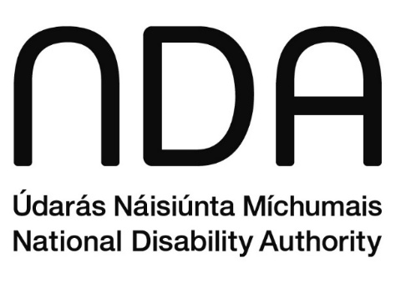
Údarás Náisiúnta Míchumais
25 Bóthar Chluaidh
Baile Átha Cliath 4
D04 E409
Teileafón: (01) 6080 400
Ríomhphost: info@nda.ie; info@ceud.ie
www.nda.ie/ga
www.universaldesign.ie/

National Disability Authority
25 Clyde Road
Dublin 4
D04 E409
Telephone: (01) 6080 400
Email: info@nda.ie;
info@ceud.ie
www.nda.ie/
www.universaldesign.ie/

https://eur-lex.europa.eu/legal-content/EN/TXT/HTML/?uri=CELEX:32016L2102
https://www.irishstatutebook.ie/eli/2020/si/358/made/en/print
https://eur-lex.europa.eu/eli/dec_impl/2018/1524/oj/eng
https://www.gov.ie/en/govie-team/publications/formsie/
https://nda.ie/publications/monitoring-report-eu-wad-ireland-2021-nda-report
https://www.anpost.com/- An Post is the state-owned provider of postal services in Ireland.
https://www.centralbank.ie/ - The Central Bank of Ireland serves the public interest by maintaining monetary and financial stability while ensuring that the financial system operates in the best interests of consumers and the wider economy.
https://www.cheshire.ie/- Cheshire Ireland is a registered charity whose largest funder is the Health Service Executive. It provides a range of services to people with both physical, sensory and neurological conditions.
https://www.cnam.ie/ - Coimisiún Na Meán is the media regulator in Ireland.
https://www.comreg.ie/ ComReg is a statutory body in Ireland responsible for regulating the electronic communications and postal sectors.
https://www.ccpc.ie/consumers/ The Competition and Consumer Protection Commission is a statutory body responsible for promoting compliance with, and enforcing, competition and consumer protection law in Ireland.
https://www.gov.ie/en/ - gov.ie is a central website for government services and information where the websites of Irish government departments can be accessed.
https://www.hseland.ie/dash/Account/Login - HSeLanD is the Irish Health Service Executive’s national online learning and development portal.
https://www.hse.ie/- The Health Service Executive is the public health and social care service for Ireland.
https://www.iaa.ie/ - The Irish Aviation Authority is the single civil aviation regulator for Ireland responsible for the regulation of safety, security and consumer interests.
https://www.iaa.ie/contactus/submit-a-complaint-against-the-iaa- Online form to submit a complaint to the Irish Aviation Authority (IAA) and provide support for those who need assistance, according to the IAA Complaints Policy.
https://nda.ie/ - The National Disability Authority is an independent statutory body providing evidence-based advice and research to the government on disability policy.
https://www.nsso.gov.ie/en/services/access-the-payroll-portal/ - The National Shared Services Office (NSSO) is an Irish shared services provider for human resources, payroll administration and finance services for Government Departments and Public Service Bodies. The Core Portal is a web-based platform accessible for employees of public service bodies in Ireland. It serves as a central hub for self-service HR and payroll functions.
https://www.nationaltransport.ie/ - The National Transport Authority is a statutory, non-commercial body responsible for developing and implementing strategies to provide high-quality, accessible, and sustainable transport across Ireland.
https://www.ireland.ie/en/dfa/passports/passport-online/ Passport Online is the secure online Passport Application Service provided by the Irish government and this online form allows citizens to renew their passports.
portal-uat.portal.rtb.ie/ The Residential Tenancies Board (RTB) is an independent public body that regulates Ireland’s rental sector. RTB RTB360 is a portal for landlords to register their tenancies.
https://rtb.ie/ - The Residential Tenancies Board (RTB) is an independent public body that regulates Ireland’s rental sector.
https://www.examinations.ie/ The State Examinations Commission is a statutory body responsible for the operation of the State Certificate Examinations from the Department of Education.
https://ucc.instructure.com/ - University College Cork is a research-based university located in Cork, Ireland and Canvas is their learning management system used for online teaching and learning.
https://universaldesign.ie/ - The Centre for Excellence in Universal Design (CEUD) is dedicated to enabling the design of environments that can be accessed, understood and used regardless of a person's age, size, ability or disability. It is part of the National Disability Authority.
https://www.workplacerelation\s.ie/en/ - The Workplace Relations Commission is a workplace relations service and employment rights framework for employers and employees.
https://www.workplacerelations.ie/en/e-complaint_form/ - The eComplaint portal enables people to make complaints to the Workplace Relations Commission in relation to alleged contraventions of employment, equality, equal status and certain industrial relations legislation.
https://play.google.com/store/apps/details?id=com.hse.hsehealth - HSE Health App is a secure way to access HSE information, find health services, and keep and find your personal health information
https://apps.apple.com/ie/app/hse-health-app/id6448852768 - HSE Health App is a secure way to access HSE information, find health services, and keep and find your personal health information
https://play.google.com/store/apps/details?id=ie.leapcard.tnfc Allows you to instantly top-up your TFI Leap Card, check your balance and buy tickets.
https://apps.apple.com/ie/app/leap-top-up/id1535791064 Allows users to instantly top-up their TFI Leap Card, check their balance and buy tickets.
https://play.google.com/store/apps/details?id=de.hafas.android.irishrail&hl=en Provides real-time train information, journey planning, and the ability to purchase tickets.
https://apps.apple.com/ie/app/iarnr%C3%B3d-%C3%A9ireann-irish-rail/id588339413 Provides real-time train information, journey planning, and the ability to purchase tickets.
https://play.google.com/store/apps/details?id=com.trapezegroup.TFILive.nta&hl=en&gl=US Allows users to check the vehicle is registered correctly and that the driver has the appropriate license to operate the vehicle.
https://www.transportforireland.ie/getting-around/by-taxi/driver-check-app/ - Allows users to check the vehicle is registered correctly and that the driver has the appropriate license to operate the vehicle.
https://play.google.com/store/apps/details?id=tfigo.app&hl=en_IE Allows you to buy tickets for various bus services around Ireland directly from your phone.
https://play.google.com/store/apps/details?id=tfigo.app&hl=en_IE - Allows you to buy tickets for various bus services around Ireland directly from your phone.
https://play.google.com/store/apps/details?id=com.trapezegroup.TFILive.nta&hl=en&gl=US - Android App that allows access to Live real time information regarding departure and journey planning information across the Transport for Ireland (TFI) network.
TFI Live on the App Store - An iOS App that allows access to Live real time information regarding departure and journey planning information across the Transport for Ireland (TFI) network.
ARIA, or Accessible Rich Internet Applications is a technical specification published by the World Wide Web Consortium that specifies how to increase the accessibility of web content.
https://eur-lex.europa.eu/eli/dec_impl/2018/1524/oj/eng
As part of an upgrade of the ESB Networks website, office file formats were temporarily migrated to a new storage URL. Consequently, these files were not captured in our monitoring snapshot and as a result, their accessibility score may not be accurate.

