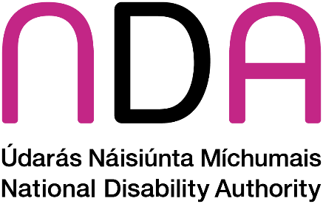
Guidance to Support Non-Speaking and Minimally Speaking People to Access
Public Services
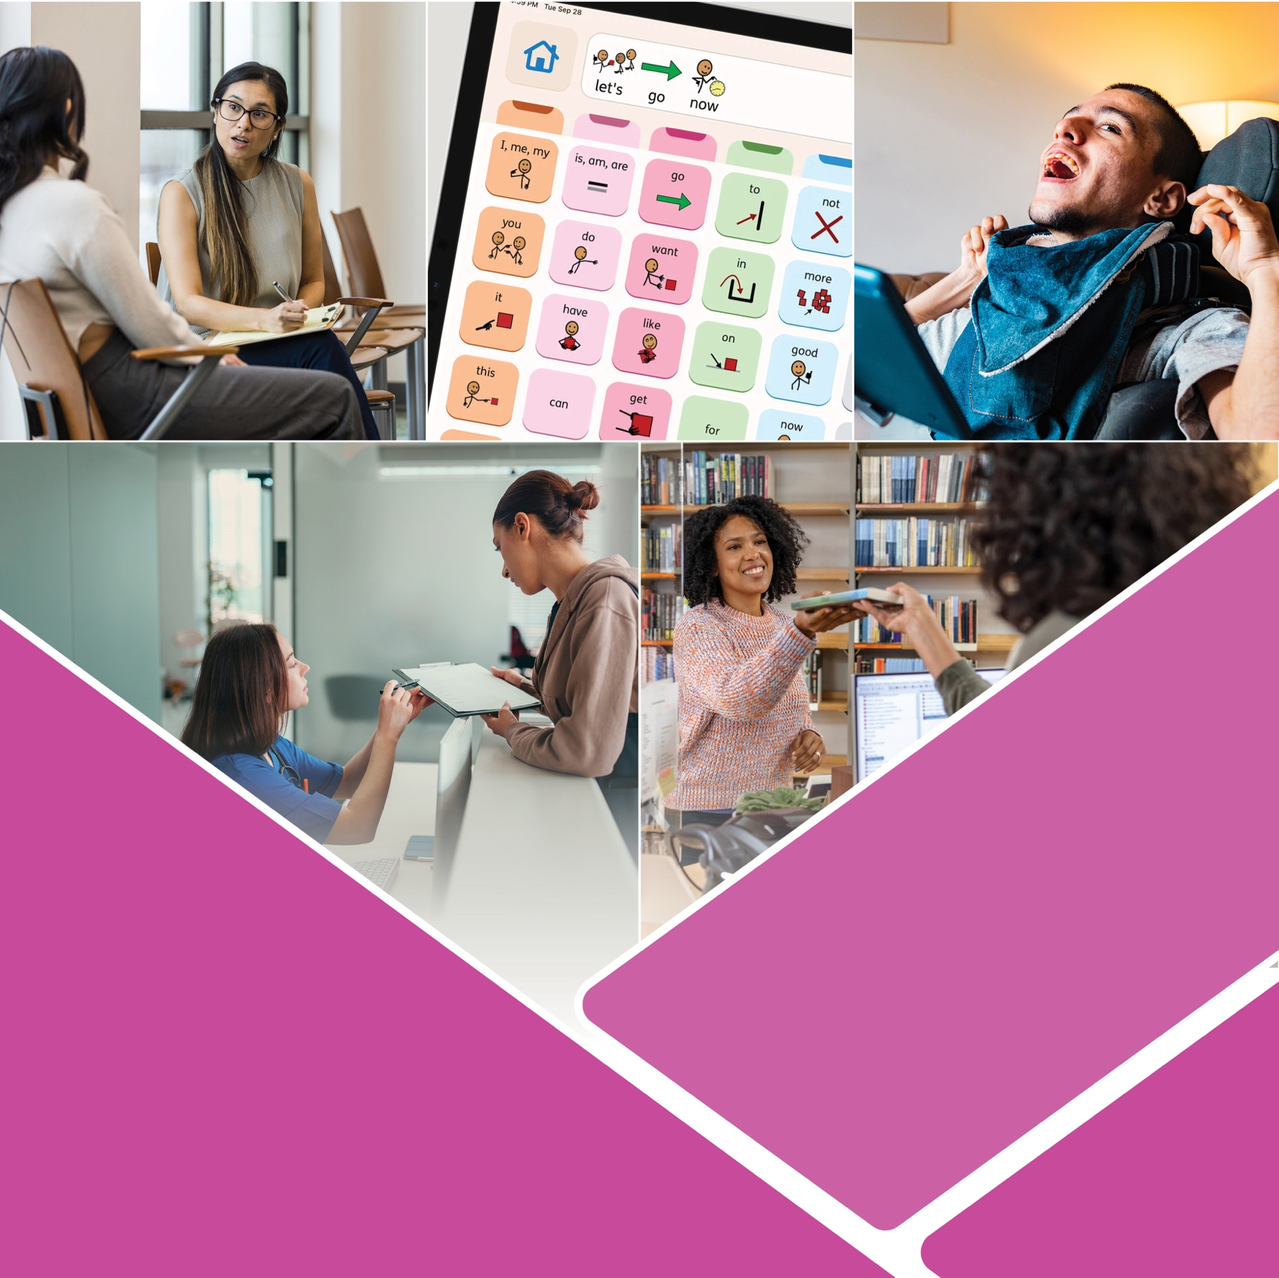
February 2026

Contents
Acknowledgements 3
What is the purpose of this guide? 4
How was this guide produced? 4
What is AAC? 4
What do we mean by ‘non-speaking’? 5
Who is this guide for? 5
What do we mean by public services? 6
What are the different types of Alternative and Augmentative Communication? 7
Unaided AAC 7
Aided AAC 8
Why support people who are non-speaking or minimally speaking? 10
Increasing awareness 10
Laws, policies, and human rights standards 11
Inclusive communication 11
Practical ways to support AAC users who access your services 12
Before an appointment 12
At the start of a conversation 13
Conversations when a support person is present 14
Conversations with AAC user 14
At the end of a conversation 15
Key points to remember 15
More information 17
Useful organisations 17
Further resources 17

Acknowledgements
The National Disability wishes to acknowledge the valuable contribution and input of our advisory group members in the development of this guidance. Special thanks to Teresa Gadd and the team at ACE Communication for their support in facilitating the input of individuals with lived experience on this project.
Throughout this document, you will see quotes from people with lived experience of alternative and augmentative communication so, in particular, the NDA wishes to thank all who provided their personal experiences and agreed to have them inform this guidance and be included in the guide.

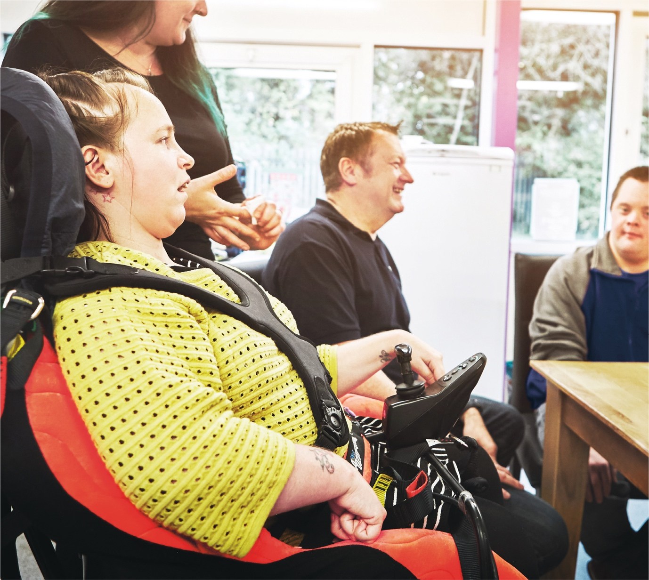

What is the purpose of this guide?
This document provides guidance for public services staff on how to support autistic people and other users of alternative and augmentative communication (AAC) who are non-speaking or minimally speaking to access public services. This work is in fulfilment of Action 82 of the Autism Innovation Strategy.

How was this guide produced?
The guidance was developed in consultation with members of the autistic community and other persons with disabilities. Two advisory groups were formed to inform this guidance.
1. The first group consisted of five individuals who had lived experience of using AAC and one person with a disability who taught Lámh. Due to the nature of their communication needs, these participants opted to contribute to the project via individual interviews. The NDA contracted ACE Communication; an organisation who provides specialist communication supports to assist with this process. One participant contributed using a written format, while the others attended in-person meetings, with multiple sessions offered as needed.
2. The second group was a supporters group consisting of six individuals with personal or professional perspectives on autism, AAC and communication to share their views at different stages of the drafting process. This group met twice.
To complement this guidance, the NDA also completed a literature review around supporting non-speaking and minimally-speaking autistic and disabled people to access public services. The findings will be available to download from our website.
Quotes from AAC users are included throughout this report.

What is AAC?
Alternative and augmentative communication (AAC) is a term which describes the strategies and tools which some people use to communicate effectively and to be heard. It helps people who may have difficulties in speaking to express their thoughts and needs.
Augmentative means to support or enhance speech. An example might be when a person uses images or signs to support what they’re trying to communicate.
Alternative means using a method or device instead of speech. An example might be a person using a digital device that generates speech for them.

What do we mean by ‘non-speaking’?
This guide makes conscious use of the term “non-speaking” as opposed to “non-verbal”. This is because to say that someone is non-verbal is to say that they are without words or language generally. This may not be the case because someone who is non-speaking may have words and language but is not able to communicate using spoken language. Minimally speaking is another term used; it means that people may use some spoken words or may not use spoken words all of the time.
Some non-speaking or minimally speaking people can be autistic or they may have other disabilities which affect their communication.1
It is important to note that people who use AAC do not necessarily have an intellectual disability. Many non-speaking autistic and disabled people will be able to fully understand what you are saying and will communicate using different modes. Some will require on-going support to communicate using powered devices or other materials.

Who is this guide for?
It is the intention for this guide to be used by public service staff across a range of different public services. It may be particularly useful for front-line staff, who interact with members of the public on a daily basis but may lack the specialist knowledge of autism and other communication support needs that health or education professionals working with non-speaking or minimally speaking children or adults may have.
The principles of this document can be applied to non-speaking and minimally-speaking people of all ages across all public services, and the information contained here may also be relevant for others, including members of the public, or staff in the private sector who provide services to the public.

1. Examples include Down Syndrome, Cerebral Palsy, stroke, acquired brain injury, dementia, Parkinson’s disease, Multiple Sclerosis, Motor Neurone Disease, Tourette’s Syndrome, apraxia of speech.

What do we mean by public services?
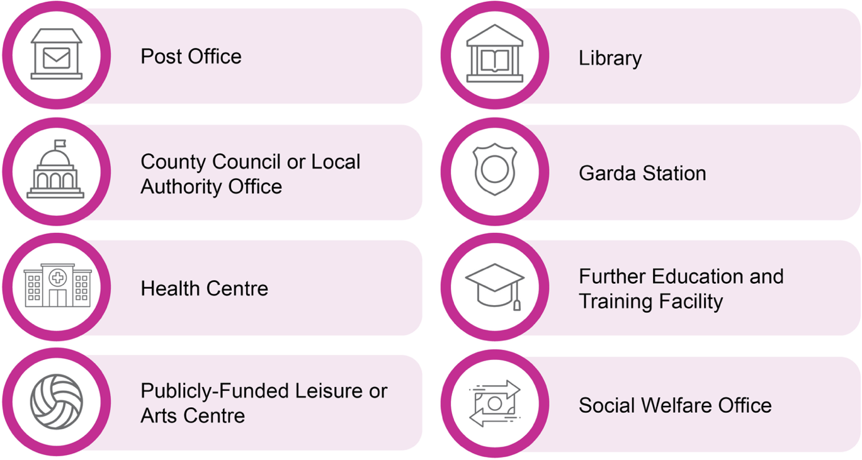
The term “public services” refers to everyday services funded by the government and provided in ordinary places within the local community. This includes but is not exhaustive of services such as a:


What are the different types of Alternative and Augmentative Communication?
AAC can be described as a set of tools used by an individual to solve everyday communication challenges.
These tools can replace or support spoken language, thus supporting a person who has difficulties communicating with speech.
Some types of unspoken communication are used by everyone, but AAC users may rely on them more heavily.
It is likely that AAC users will use a combination of aided and unaided AAC.

Unaided AAC
This form of communication requires no tools or materials. Examples of unaided AAC are body language, vocalisations, gestures, facial expressions, and Lámh.2

2. Lámh is a system of key-word signing or Sign-supported English used by people with an intellectual disability or other communication needs. It is distinct from Irish Sign Language (ISL) which is the official language of Ireland’s Deaf community.

Aided AAC
This can be high tech or low tech, with some people using physical paper options, and others using electronic options. These can be symbol or text-based.
It is important to note that some AAC users will require support to use their aided AAC devices. Some aided AAC examples that are commonly used in Ireland are described below:

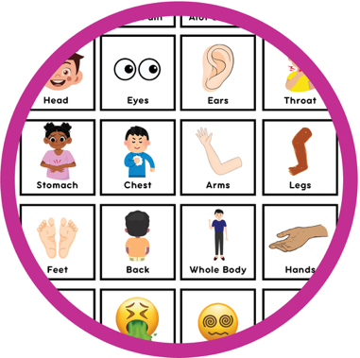
Choice cards
These are a number of interchangeable illustrations of objects or activities which can be paired together for the user to choose from by pointing. For example, saying yes/no, visiting the library or the park. Some supporters will also use objects of reference which are objects that can be used to represent an activity person or place to engage with non-speaking individuals.

Letterboard
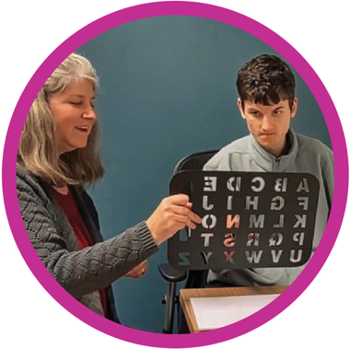
A letterboard is a tool that displays the alphabet and, in some cases, numbers. It allows a person to communicate by pointing to letters to spell out words, which a supporter can then write down or read aloud.
Some people with motor and/or sensory impairments work with a supporter to assist their movements while pointing or typing, as they struggle to do so independently.3
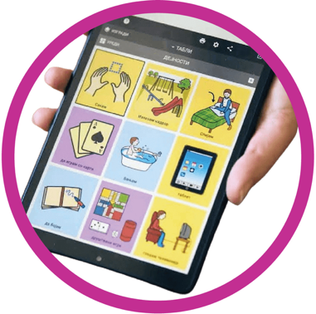
Communication boards
This is a board with labelled illustrations, photos or symbols which the user can gesture to. Some persons with disabilities who have physical impairments may use eye-tracking technology to do this.

3. Some forms of spelling have come under scrutiny due to concerns about whether the person’s voice is being represented. However, it is a form of communication used by many in Ireland.

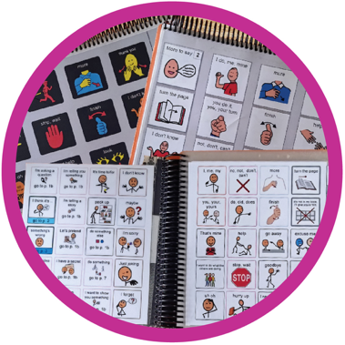
Communication books
This is a book with labelled illustrations, photos, or symbols which the user can flip through and point to. It includes a system called Pragmatic Organisation Dynamic Display (PODD).

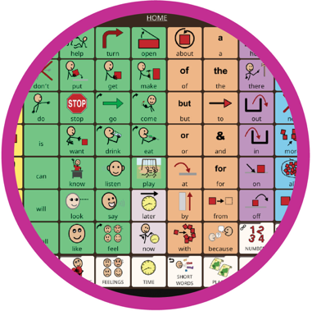
AAC apps
These are applications which can be downloaded directly to an individual’s smart phone or tablet. Some apps are free to use, while others must be purchased. They can facilitate different communication systems including text-to-speech, text based, symbol based, or picture based communications with new systems being continually developed. All of the modes of the systems described above have a similar electronic version available.
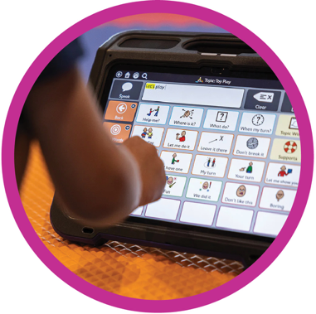

Speech generating devices
Otherwise known as Voice Output Communication Aids (VOCAs). These are devices which come with built-in AAC programmes. They can be hand-held, or attached to mobility equipment, such as a wheelchair. The AAC user will select or spell the word they want to use, having chosen their preferred voice in advance. This allows the words to be spoken aloud as they are inputted.

Why support people who are non-speaking or minimally speaking?

Increasing awareness
AAC users who advised on this project were very strong in their message that awareness about AAC and how to communicate with people using AAC needed to be increased. This was also emphasised by the supporters advisory group. Within the literature there was limited acknowledgement of the specific needs of non-speaking or minimally speaking people in the context of public services.
They need to be educated. Everyone of all ages so that they understand
- Participant #4
Help people to be aware. Awareness raising is very important
- Participant #1


Laws, policies, and human rights standards
Ireland has obligations towards persons with disabilities (including autistic people) to uphold their rights on an equal basis with others.
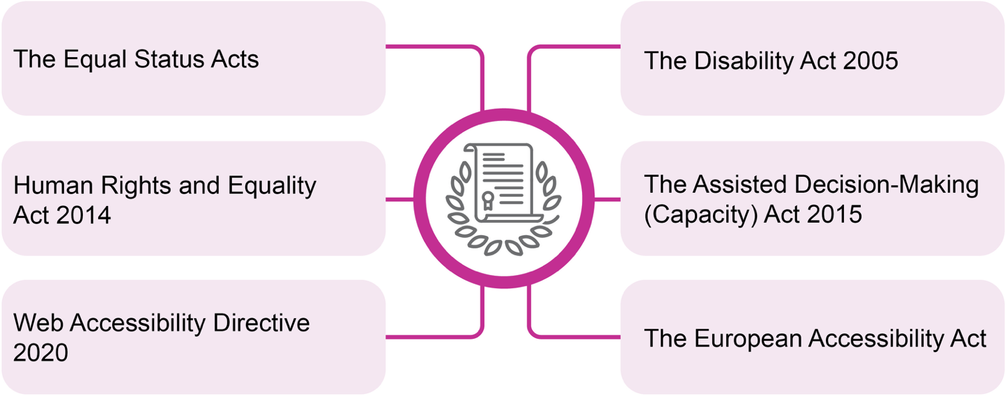
The rights of persons with disabilities are recognised and protected within several pieces of legislation:

Additionally, as part of Public Sector Duty implementation public sector employees must promote equality, prevent discrimination and protect the human rights of their employees, customers, service users and others impacted by their work.
In 2018, Ireland ratified the UN Convention on the Rights of Persons with Disabilities (UNCRPD). Article 21 on Access to Information requires States to accept and facilitate different forms of communication, including Augmentative and Alternative Communication.
Under the Convention, Ireland also has an obligation to undertake and promote Universal Design. This is the design of an environment or service so that it can be accessed, understood and used to the greatest extent possible by all people regardless of their age, size, ability or disability.

Inclusive communication
People who use AAC say that how they choose to communicate is very personal. Autistic people and other persons with disabilities described their attachment to their particular device or setting, emphasising that it served as their unique voice. For example, many people use speech-generating apps that have an Irish accent.
It is also important to note that behaviour is another form of communication which can be used to demonstrate a person’s needs, wants or feelings. Being unable to communicate in other ways can cause a person to experience anger or frustration, which may lead to distressed behaviour.
Therefore, it is important that an inclusive approach to communication is used. Inclusive communication means creating a supportive environment, using every mode of communication available to enable a person to understand and to be understood.
It is no more, no less than any other communication style
- Participant #2
I was reluctant to use it at first but now it is part of my life
- Participant #1

Practical ways to support AAC users who access your services

Before an appointment
• Check records to see if an existing service user has any notes on file about their communication needs or other access needs.
• Offer flexible options for appointment scheduling or location. Consider the nature of the appointment and any privacy concerns, as well as the potential for background noise. For example, an extended appointment at the start/end of day in a quiet space.
• Give priority where possible, to minimise the stress of long waiting times in loud or busy areas.
• Provide any materials in advance, allowing an AAC user to prepare their responses to relevant questions. Offer materials in different formats as needed. For example, Easy Read documents or audio/visual information.
• Provide information on the organisation’s website about what to expect during a visit. This can help someone with a disability to be prepared. For example, photos of staff they might meet, different areas of the building. Clear signage and information on the check-in process will also be useful.

At the start of a conversation
• Remember that not everyone who is an AAC user will have a visible disability or have a supporter with them.
I like to be independent…If no-one knows the signs I use, then I need more support from staff to communicate and cannot be as independent as I want
- Participant #5
• Recognise that a person should not have to tell you about their particular disability or diagnosis to access communication support. Some people needing extra help may identify themselves in a different way. For example, by presenting a Just A Minute (JAM) card, by wearing a sunflower lanyard or a Neurodiversity Ireland lanyard.
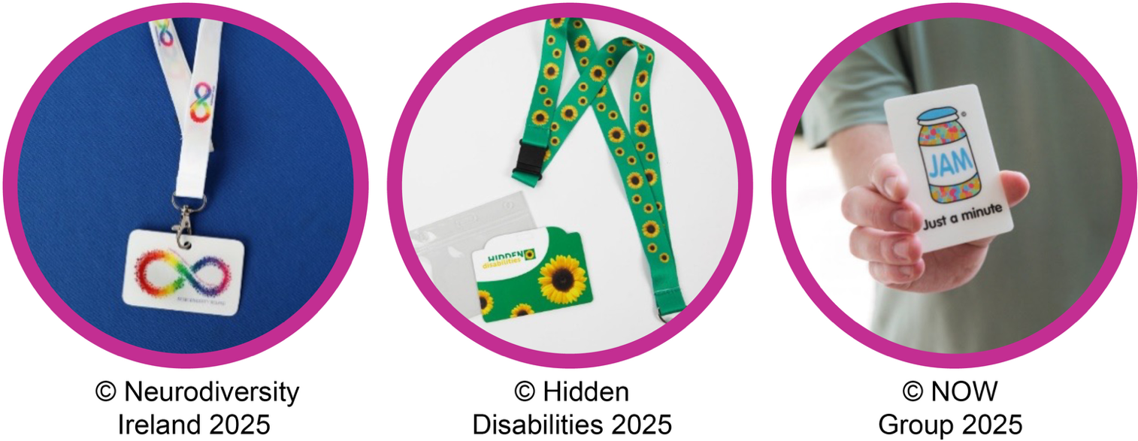
• Value all forms of communication equally and encourage the use of AAC. Welcome persons with disabilities and acknowledge that you are there to help everyone, whether they can use speech or not.

Conversations when a support person is present
• Communicate with the AAC user first, rather than speaking to their supporter by default.
• Ask permission from the AAC user if you need to communicate directly with their support person, for example to confirm personal details.

Conversations with AAC user
• Speak to them in a friendly, age-appropriate manner. Speak clearly and use plain English.
• Ask one question at a time and give extra time for AAC users to process the information and respond, before moving to the next topic. Remember that communication will take longer, especially if using a device for typing.
• Wait until the AAC user has finished their sentence before speaking, to get a full picture of what they want to say. Do not take away their voice by speaking for them.
• Avoid relying on yes/no answers only. Engage in a meaningful conversation by using questions such as ‘who’ ‘what’ ‘when’ ‘where’ and ‘how.’ Actively listen and give time for the person to ask questions, rather than just answer them.
• Remember that like any conversation, pauses, delays, and errors are to be expected. If miscommunication occurs, it is important to keep trying. If problems persist, it might be useful to offer a short break or seek advice from someone that knows the person well about how to move forward.
They need to understand that my communication is seriously slower than other ways but is no less important
- Participant #6
Sometimes, the hard thing for me is that the conversation moves on while I am still trying to type an answer. Then when I speak, people wonder what I am talking about.
- Participant #1

At the end of a conversation
• Check in with the person (and their supporter) after each exchange to ensure communication was successful. Ask if they have any follow-up questions or additional information for you.
• Recognise that face-to-face conversation may not be the preferred communication method for non-speaking people. Offer additional options for on-going engagement where possible. For example, email, text messaging or live chat service.
• Think carefully about the ways in which your communication can be improved. For example, reinforcing your spoken words with a written or visual record of what was discussed and any follow-up actions.

Key points to remember
• Recognise and respect a person’s right to communicate in their own way. Provide support, give a person time, assume competence, and avoid assumptions about their ability to use speech.
I need them to presume that speech is not necessarily the only way to show your thoughts or opinions
- Participant #6
There are soo many [assumptions]. But the most isolating one is that we don’t have any intelligence or understanding. It doesn’t really create much respect for us either
- Participant #4
• Be mindful that autistic people and other AAC users with disabilities can have other physical and sensory needs which must be met to allow for meaningful communication. Universal Design is key to ensuring that persons with disabilities can access public services on equal basis with others. For example, providing alternatives to interactive voice communication systems, such as intercoms.
• Remember that a person’s communication needs and preferences can change based on how they are feeling and how they experience their environment on a given day. For example, if they are anxious, overwhelmed or tired.
• Understand that some individuals may use AAC from the start or a conversation, switch to AAC during the conversation, or use a combination of different modes if they feel likely to be misunderstood. For example, using a speech-generating app if their speech is unclear, or adding Lámh signs to get their meaning across.
If you’re trying to understand them, Lámh can really help
- Participant #3
• Honour requests for support and keep an open mind. Autistic people and persons with disabilities of all ages use AAC and may benefit from your patience and understanding with regard to their communication needs.
• When supporting non-speaking or minimally-speaking people to access public services, staff should not pass judgement on the type of AAC used, or what that looks like.
• What is most important is that family members and other supporters act as communication partners, rather than speaking for them.
• If a person’s needs are being met and they can hold a meaningful conversation as a result, it should be clear that they are sharing their own perspective on any questions asked or issues discussed. If this is not the case, then this may be cause for concern. Otherwise, an exchange should continue as normal.

More information
For more information a number of organisations and links to further resources are listed below. The most relevant have been selected based on the literature review and recommendations from the advisory groups but their inclusion does not mean endorsement by the NDA.

Useful organisations
AsIAm: Ireland’s National Autism Charity
Neurodiversity Ireland
Enable Ireland
Inclusion Ireland
Lámh
Middletown Centre for Autism
Communication Matters
Communication First

Further resources
Autism Innovation Strategy
AsIAm: Language Guide
Neurodiversity Ireland: Guide to Inclusive Language and Values
Inclusion Ireland: Report on Communication as a Human Right
Communication Matters UK: Focus on What is AAC?
Communication Matters UK: Focus on Speaking with Someone who Uses AAC
Enable Ireland: SLT Top Tips for supporting AAC and Multimodal Communication
Royal College of Speech and Language Therapists: Inclusive Communication and the Role of Speech and Language Therapy
National Disability Authority: Customer Communications Toolkit for Services to the Public-A Universal Design Approach
CEN- CENELEC: Guide for Addressing Accessibility in Standards (Voice and Speech)

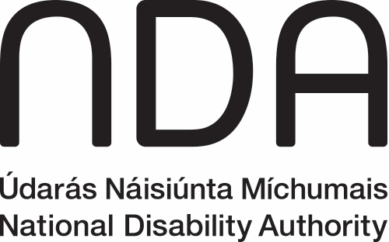

Údarás Náisiúnta Míchumais
25 Bóthar Chluaidh
Baile Átha Cliath 4
D04 E409
Teileafón: (01) 6080 400
Ríomhphost: info@nda.ie
Idirlíon: www.nda.ie/ga

National Disability Authority
25 Clyde Road
Dublin 4
D04 E409
Telephone: (01) 6080 400
Email: info@nda.ie
Web: www.nda.ie

