Briefing report for NDA Factsheet 5: Housing and accommodation circumstances of disabled people
January 2024

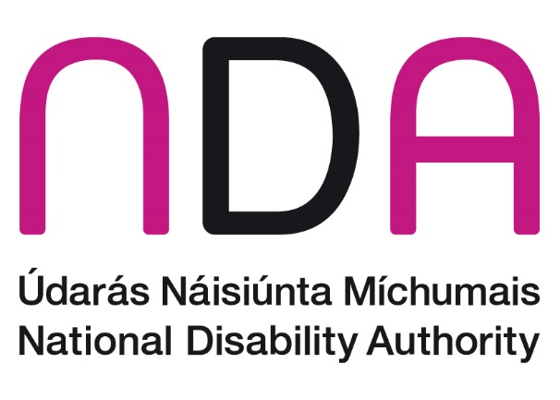

Introduction
This factsheet is part of a series produced by the National Disability Authority (NDA) on different aspects of the lives of persons with disabilities in Ireland. The goal of the series is to bring together up-to-date and accurate statistical information, across different themes, that may be useful to a range of stakeholders. Interested readers may include individuals with disabilities, Disabled Persons Organisations, other organisations, service providers, policy makers, researchers, and the general public.
This paper includes information on the living arrangements of disabled people in Ireland. Article 19 of the United Nations Convention on the Rights of Persons with Disabilities (UNCRPD) recognises the right of persons with disabilities to live independently and to be included in their communities, with choices equal to others. Access to appropriate and secure housing is recognised as a key factor in assisting disabled people to lead independent and fulfilling lives in the community. Ireland is one of the few countries worldwide to have a dedicated national strategy for housing for disabled people. The vision of The National Housing Strategy for Disabled People 2022-2027 is:
To facilitate disabled people to live independently with the appropriate choices and control over where, how, and with whom they live, promoting their inclusion in the community.
To further enable equal access for disabled people to housing with integrated support services.
This paper also includes information on persons with disabilities staying in communal establishments on Census Night 2022, even if this is not their usual place of residence. This allows consideration of the numbers of disabled people in hospitals, nursing homes, prisons, etc. at the time of the Census.
The paper opens by defining key terms as they are used here, followed by a short account of disability prevalence in Ireland in 2022. Next, the population of disabled people living in private households is described. Finally, the population of persons with disabilities enumerated in communal establishments at the time of Census 2022 is considered.
Throughout this document, the terms ‘persons/people with disabilities’ and ‘disabled people’ are used interchangeably. The term ‘disabled people’ is recognised by many within the disability rights movement in Ireland to align with the social model of disability, as it is considered to acknowledge the fact that people with an impairment are disabled by environmental and societal barriers. However, we recognise that other people prefer the term “persons/people with disabilities” because of the inherent understanding in the term that they are first and foremost human beings entitled to human rights. This reflects the language used in the UNCRPD. Finally, we recognise that some people do not identify as being disabled.

Defining key terms

Disability
This document draws its information from the Census of Population 2022 carried out by the Central Statistics Office (CSO). In Census 2022, people were asked to report whether they experienced each of a series of long-lasting conditions or difficulties. They could choose one of three response options: ‘no’, ‘to some extent’, or ‘to a great extent’. In a second question, people were asked to indicate if they experienced difficulties completing various activities. Again, people could choose one of three response options: ‘no’, ‘yes, a little’ or ‘yes, a lot’. Any individual who responded that they experienced at least one condition or difficulty ‘to some extent’ or ‘to a great extent’ or reported that they experienced at least one difficulty with activities ‘a little’ or ‘a lot’ are classified as having a disability. The Disability and Difficulties questions included in the Census were changed substantially in 2022, meaning Census 2022 results are not directly comparable with those from previous censuses (see Appendix A for more information).

Housing
There are three overarching categories of housing circumstances enumerated in the Census: (1) Private Households; (2) Non-Private Households (Communal Establishments) and (3) Homelessness. At the time of publishing this background report, data on homelessness had not been released by the CSO, and so the first two categories are of focus in this paper.

Private Households
A private household comprises one person living alone or a group of people living at the same address with common housekeeping arrangements (that is, sharing at least one meal a day or sharing a living room or sitting room). Private Households are broken down into two distinct categories: permanent and temporary private households.

Permanent private households
A permanent private household is a private household occupying a permanent dwelling such as a house, flat, or bed-sit.

Temporary private households
A temporary private household is a private household occupying a caravan, mobile home, or other temporary dwelling.

Non-Private Households (Communal Establishments)
Communal Establishments are broken down into fourteen distinct categories: a) Hotel, (b) Guest house, boarding house or B&B, (c) Tourist hostel, youth hostel or campsite, (d) Student specific accommodation, (e) Religious community, (f) Residential facility for people with an intellectual and/or physical disability (g) Children’s home, (h) Nursing home (i) Hospital, (j) Defence establishment, (k) Prison, (l) Shelter or refuge (including accommodation for homeless persons), (m) Civilian ships, boats and barges, and (n) Other types of establishments.
A non-private household is a group of persons enumerated in one of these communal establishments and may include usual residents and/or visitors. However, proprietors and managers of hotels, principals of boarding schools, persons in charge of various other types of institutions and members of staff who, with or without their families, occupy separate living accommodation on the premises are classified as private households.

Homelessness
The term homelessness refers to rough sleeping or staying in temporary accommodation as a result of having nowhere else to go and being generally unable to provide accommodation from one’s own resources. This paper will be updated with homelessness data from Census 2022 following its release.

Prevalence of disability
In Census 2022, 1,109,557 people, or 21.5% of the population, are classified as having a disability. Specifically, 13.6% of the population in 2022 reported having a long-lasting condition or difficulty ‘to some extent’, and a further 7.9% reported having at least one condition or difficulty ‘to a great extent’.
The most commonly reported difficulty was with pain, breathing or another chronic illness or condition, experienced by 8.5% of the total population and 39.7% of all people with a disability. This was followed by difficulty with ‘other’ activities, including leisure or using transport, and by difficulty with basic physical activities; each of these difficulty types was experienced by 6.8% of the total population and 31.5% of the population with disabilities (Table 1).
Table 1: Prevalence of disability types and difficulties in the total population
 | Number | % of population with disabilities | % of total population
Difficulty with pain, breathing or any other chronic illness/condition | 440,090 | 39.7 | 8.5
Difficulty with other activities, such as leisure or using transport | 349,995 | 31.5 | 6.8
Difficulty with basic physical activities | 349,155 | 31.5 | 6.8
Difficulty working at a job or business or attending school or college | 303,859 | 27.4 | 5.9
Blindness or vision impairment | 296,601 | 26.7 | 5.8
Psychological or emotional condition or a mental health issue | 269,789 | 24.3 | 5.2
Difficulty with learning, remembering or concentrating | 259,050 | 23.3 | 5.0
Difficulty with going outside the home to shop or visit a doctor’s surgery | 258,243 | 23.3 | 5.0
Deafness or hearing impairment | 233,420 | 21.0 | 4.5
Difficulty dressing, bathing, or getting around inside the home | 215,609 | 19.4 | 4.2
Intellectual disability | 109,288 | 9.8 | 2.1
Source: Census 2022

Private Households

Type of Housing Units
As is the case for the general population, the vast majority of persons with disabilities live in private households. A total of 1,035,415 persons with disabilities lived in private households in permanent housing units in Ireland in 2022. Of these, the largest proportion lived in detached houses (41.4%), while less than 0.1% lived in bed-sits (Figure 1).
Disabled people were less likely to live in flats or apartments than the general population (9.2% of the total number of disabled people living in permanent housing units, compared to 14.1% for the general population), regardless of whether these flats or apartments were in purpose-built blocks or in converted houses or commercial buildings (Figure 1).
Figure 1: Private households in permanent housing units, by type of housing unit and disability status
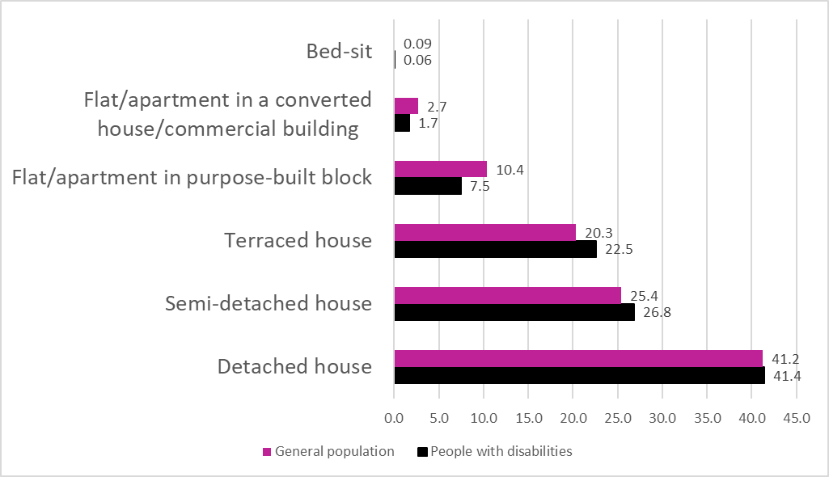
Source: Census 2022

Private households with at least one disabled person
Overall, there were 1,841,152 private households in Ireland in 2022. Of these, 747,163 (40.6%) included at least one household member with a disability (to any extent). Further, 16.8% of private households had at least one household member with a disability to a great extent, and 36.7% had at least one household member with a disability to some extent (Figure 2).
Figure 2: Proportion of private households with at least one disabled household member, by extent of disability
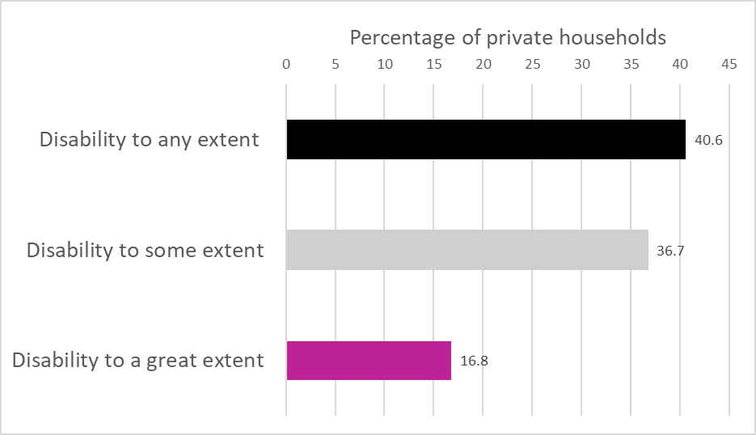
Source: Census 2022

Adults with disabilities living with their parents
According to Census 2022, there were 228,594 people over the age of 25 in Ireland cohabiting with their parents; of these, 51,942 or 22.7% had a disability. Since 20.0% of the 25-64-year-old cohort have a disability, this means that disabled people are somewhat overrepresented in the population of adults aged 25 and older living with their parents, although not by a very large degree. Approximately 1 in 8 people (12.9%) over the age of 25 co-habiting with parents have a disability to some extent and 1 in 10 (9.9%) have a disability to a great extent.
The most prevalent disability types or difficulties among the cohort of people over 25 living with their parents are a psychological or emotional condition or mental health issue (experienced by 39.3% of disabled people and 8.9% of all people over 25 cohabiting with parents) and a difficulty working at a job or business or attending school or college (experienced by 38.5% of disabled people and 8.7% of all people over 25 cohabiting with parents; Table 2).

Table 2: Prevalence of disability types and difficulties among people over 25 cohabiting with parents
 | Number | % of disabled people over 25 living with parents | % of all people over 25 living with parents
Psychological or emotional condition or a mental health issue | 20,405 | 39.3 | 8.9
Difficulty working at a job or business or attending school or college | 19,986 | 38.5 | 8.7
Difficulty in participating in other activities, such as leisure or using transport | 17,009 | 32.7 | 7.4
Difficulty with pain, breathing or any other chronic illness or condition | 16,207 | 31.2 | 7.1
Difficulty with learning, remembering, or concentrating | 14,664 | 28.2 | 6.4
An intellectual disability | 11,964 | 23.0 | 5.2
Difficulty with going outside the home to shop or visit a doctor’s surgery | 11,555 | 22.2 | 5.1
Blindness or a vision impairment | 11,286 | 21.7 | 4.9
Difficulty with basic physical activities | 10,457 | 20.1 | 4.6
Difficulty dressing, bathing, or getting around inside the home | 7,121 | 13.7 | 3.1
Deafness or a hearing impairment | 4,549 | 8.8 | 2.0
All persons with a disability | 5,1942 | 100 | 22.7
Source: Census 2022

Non-Private Households (Communal Establishments)
At the time of Census 2022, 130,009 people were enumerated in communal establishments, of which 46,552 were disabled people (Table 3). Overall, then, 35.8% of people in communal establishments were people with disabilities in 2022.
For the general population, the most common communal establishment type in which people were enumerated on Census Night was a hotel (46,222 people). The most common type of communal establishment in which persons with disabilities were enumerated was nursing homes (20,062), followed by hospitals (6,461).
The share of disabled people was highest in residential facilities for people with an intellectual and/or physical disability (88.0%), nursing homes (81.8%), and religious communities (60.7%). There was also overrepresentation of people with disabilities in hospitals (42.3%), children’s homes (35.1%), shelters and refuges (28.6%), and prisons (23.3%), given national disability prevalence (21.5% of the population having a disability according to Census 2022). In the case of some categories of establishment in which the proportion of people with disabilities might be expected to be higher than reported here (for example, in residential facilities for people with an intellectual and/or physical disability), it should be remembered that the numbers and percentages presented also include staff and visitors (who may or may not have a disability).
Persons with disabilities were underrepresented among those enumerated in hotels, guest houses, hostels, etc. on Census Night, as well as in defence establishments and on civilian boats and barges (Table 3).
Table 3: Total population and population with disabilities in communal establishments
 | Total population | Population with disabilities | % people with disabilities
Residential facility for people with an intellectual and/or physical disability | 4,718 | 4,153 | 88.0
Nursing home | 24,527 | 20,062 | 81.8
Religious community | 3,178 | 1,930 | 60.7
Hospital | 15,273 | 6,461 | 42.3
Children's home | 319 | 112 | 35.1
Shelter or refuge (including accommodation for homeless persons) | 8,900 | 2,543 | 28.6
Other, including not stated | 4,136 | 1,061 | 25.7
Prison | 3,958 | 922 | 23.3
Student specific accommodation | 11,403 | 2,417 | 21.2
Guest house, boarding house or B&B | 3,386 | 614 | 18.1
Tourist/youth hostel or campsite | 2,625 | 379 | 14.4
Defence establishment | 416 | 57 | 13.7
Hotels | 46,222 | 5,837 | 12.6
Civilian ships, boats and barges | 448 | 4 | 0.9
Total | 130,009 | 46,552 | 35.8
Source: Census 2022

Of the total population enumerated in communal establishments, 8.8% had a disability to some extent, and 24.7% had a disability to a great extent. Of all those with a disability in communal establishments, 69.0% had a disability to a great extent (Table 4).
Of the population with disabilities in communal establishments, the share of people with a disability to a great extent is highest in nursing homes (90.9%) and residential facilities for people with an intellectual and/or physical disability (90.5%), and lowest in student-specific accommodation (20.9%) and defence establishments (17.5%).

Table 4: Population with disabilities in communal establishments, by extent of disability
 | To some extent (Number) | To some extent (Percent) | To a great extent (Number) | To a great extent (Percent)
Nursing home | 1,822 | 9.1 | 18,240 | 90.9
Residential facility for people with an intellectual and/or physical disability | 393 | 8.5 | 3,760 | 90.5
Hospital | 1,824 | 28.2 | 4,637 | 71.8
Other, including not stated | 385 | 32.3 | 676 | 63.7
Shelter or refuge (including accommodation for homeless persons) | 1,259 | 49.5 | 1,284 | 50.5
Religious community | 1,115 | 57.8 | 815 | 42.2
Children's home | 65 | 58.0 | 47 | 42.0
Prison | 550 | 59.7 | 372 | 40.3
Guest house, boarding house or B&B | 419 | 68.2 | 195 | 31.8
Tourist/youth hostel or campsite | 271 | 72.5 | 108 | 28.5
Hotel | 4,365 | 74.8 | 1,472 | 25.2
Civilian ships, boats and barges | <5 | n/a | <5 | n/a
Student specific accommodation | 1912 | 79.1 | 505 | 20.9
Defence establishment | 47 | 82.5 | 10 | 17.5
Total* | 14,427 | 31.0 | 32,121 | 69.0
Source: Census 2022
*Please note that the totals are exclusive of the cells indicating fewer than five people

Residential facilities for people with an intellectual and/or physical disability
The most commonly reported disability type or difficulty among people in residential facilities for people with an intellectual and/or physical disability was difficulty working at a job or business or attending school or college, which was experienced by 84.1% of disabled people enumerated in these settings (Table 5). More than three quarters (78.4%) of people with disabilities had an intellectual disability, and 63.1% had difficulty with basic physical activities.

Table 5: Prevalence of disability types and difficulties experienced in residential facilities for people with an intellectual and/or physical disability
 | Number | % of disabled people in residential facilities  N=4,135 | % of all people in residential facilities N=4,718
Difficulty working at a job or business or attending school or college | 3493 | 84.1 | 74.0
Difficulty in participating in other activities, such as leisure or using transport | 3374 | 81.2 | 71.5
An intellectual disability | 3257 | 78.4 | 69.0
Difficulty in going outside the home to shop or visit a doctor’s surgery | 3242 | 78.1 | 68.7
Difficulty with learning, remembering, or concentrating | 3192 | 76.9 | 67.7
Difficulty dressing, bathing, or getting around inside the home | 2975 | 71.6 | 63.1
Psychological or emotional condition or a mental health issue | 2672 | 64.3 | 56.6
Difficulty with basic physical activities | 2622 | 63.1 | 55.6
Difficulty with pain, breathing or any other chronic illness or condition | 1843 | 44.4 | 39.1
Blindness or a vision impairment | 1051 | 25.3 | 22.3
Deafness or a hearing impairment | 590 | 14.2 | 12.5

Nursing homes
The most commonly reported disability type or difficulty among people in nursing homes in 2022 was difficulty dressing, bathing, or getting around inside the home, reported by 75.0% of all people in nursing homes and 91.7% of all persons with a disability in nursing homes (Table 6). This was followed closely by difficulty in going outside the home to shop or visit a doctor’s surgery (73.9% of all people in nursing homes and 90.4% of all persons with a disability in nursing homes) and difficulty with basic physical activities (72.9% of all people in nursing homes and 89.2% of all persons with a disability in nursing homes).
While the least common disability type among persons in nursing homes was an intellectual disability, at 16.8% of people in nursing homes in Census 2022, this is approximately eight times the rate of intellectual disability in the general population (2.1%, Table 1).
Table 6: Prevalence of disability types and difficulties in nursing homes
 | Number | % of disabled people in nursing homes  N= 20,062 | % of all people in nursing homes  N = 24,527
Difficulty dressing, bathing, or getting around inside the home | 18,389 | 91.7 | 75.0
Difficulty in going outside the home to shop or visit a doctor’s surgery | 18,136 | 90.4 | 73.9
Difficulty with basic physical activities | 17,886 | 89.2 | 72.9
Difficulty in participating in other activities, such as leisure or using transport | 17,584 | 87.6 | 71.7
Difficulty working at a job or business or attending school or college | 15,539 | 77.5 | 63.4
Difficulty with learning, remembering, or concentrating | 14,627 | 72.9 | 59.6
Difficulty with pain, breathing or any other chronic illness or condition | 12,489 | 62.3 | 50.9
Psychological or emotional condition or a mental health issue | 9,640 | 48.1 | 39.3
Blindness or a vision impairment | 8,297 | 41.4 | 33.8
Deafness or a hearing impairment | 7,604 | 37.9 | 31.0
An intellectual disability | 4,124 | 20.6 | 16.8
Source: Census 2022

In Census 2016, the categories of nursing and children’s homes were combined, and 25,356 disabled people were in a children’s home or nursing home on Census Night. This represented an increase from the 2011 figure of 24,743. In 2022, nursing homes and children’s homes were included as separate categories on the census form. When the numbers of people in each category are summed to facilitate comparison with earlier censuses, 20,174 persons with disabilities were in a nursing home or children’s home in 2022. This represents a 20% decrease from 2016, even in the context of the large increase in the number of the population classified as having a disability in Census 2022.
Overall, there was a net decrease of 4,178 people in nursing homes and children’s homes from 2016 to 2022: 5,182 fewer disabled people and 1,116 more people without disabilities living in nursing and children’s homes in 2022 than in 2016. This finding is in line with the overall trend of the gradual transition of persons with disabilities away from communal establishments and into private accommodation in recent years. It may also reflect increasing numbers of older people with disabilities living at home with supports rather than in long-term care settings for older persons.

Religious communities
In religious communities, the most common disability type or difficulty in 2022 was difficulty with basic physical activities, experienced by one third (33.6%) of all people and 55.3% of all people with disabilities (Table 7). The next most common disability type or difficulty in religious communities was deafness or a hearing impairment, experienced by 30.3% of all people and half (49.8%) of all people with disabilities. Least common were psychological or emotional conditions and mental health issues (5.1% of all people) and intellectual disabilities (2.7%), which were experienced by similar proportions of people in these communities as in the general population (see Table 1 for population figures).

Table 7: Prevalence of disability types and difficulties in religious communities
 | Number | % of disabled people in religious communities  N=1,930 | % of all people in religious communities  N=3,178
Difficulty with basic physical activities | 1067 | 55.3 | 33.6
Deafness or a hearing impairment | 962 | 49.8 | 30.3
Difficulty in participating in other activities, such as leisure or using transport | 886 | 45.9 | 27.9
Difficulty in going outside the home to shop or visit a doctor’s surgery | 823 | 42.6 | 25.9
Difficulty with pain, breathing or any other chronic illness or condition | 790 | 40.9 | 24.9
Difficulty with learning, remembering, or concentrating | 665 | 34.5 | 20.9
Blindness or a vision impairment | 660 | 34.2 | 20.8
Difficulty dressing, bathing, or getting around inside the home | 591 | 30.6 | 18.6
Difficulty working at a job or business or attending school or college | 566 | 29.3 | 17.8
Psychological or emotional condition or a mental health issue | 163 | 8.4 | 5.1
An intellectual disability | 85 | 4.4 | 2.7
Source: Census 2022

Hospitals
The most common disability type or difficulty among individuals in hospital on Census Night was a difficulty with basic physical activities (28.3% of all people in hospitals and 66.8% of people with a disability in hospital). This was followed by difficulty participating in other activities, such as leisure or using transport (26.0% of all people in hospital and 61.5% of persons with a disability in hospital), and difficulty with going outside the home alone (25.8% of all people in hospital and 61.1% of all persons with disabilities in hospital) (Table 8).
Table 8: Prevalence of disability types and difficulties in hospitals
 | Number | % of disabled people in hospitals  N=6,461 | % of all people in hospitals  N=15,273
Difficulty with basic physical activities | 4,317 | 66.8 | 28.3
Difficulty in participating in other activities, such as leisure or using transport | 3,973 | 61.5 | 26.0
Difficulty in going outside the home to shop or visit a doctor’s surgery | 3,946 | 61.1 | 25.8
Difficulty dressing, bathing, or getting around inside the home | 3,716 | 57.5 | 24.3
Difficulty working at a job or business or attending school or college | 3,495 | 54.1 | 22.9
Difficulty with pain, breathing or any other chronic illness or condition | 3,439 | 53.2 | 22.5
Difficulty with learning, remembering, or concentrating | 2,565 | 39.7 | 16.8
Psychological or emotional condition or a mental health issue | 2,212 | 34.2 | 14.5
Blindness or a vision impairment | 1,779 | 27.5 | 11.6
Deafness or a hearing impairment | 1,681 | 26.0 | 11.0
An intellectual disability | 653 | 10.1 | 4.3
Source: Census 2022

Children’s homes
In children’s homes, the most common disability type or difficulty was a difficulty with learning, remembering, or concentrating, which was experienced by 20.7% of all people in children’s homes and 58.9% of disabled people in children’s homes (Table 9). This was followed closely by a psychological or emotional condition or a mental issue, experienced by one in five (19.7%) people in children’s homes and 56.3% of disabled people in children’s homes.

Table 9: Prevalence of disability types and difficulties in children’s homes
 | Number | % of disabled people in children’s homes  N=112 | % of all people in children’s homes  N=319
Difficulty with learning, remembering, or concentrating | 66 | 58.9 | 20.7
Psychological or emotional condition or a mental health issue | 63 | 56.3 | 19.7
An intellectual disability | 35 | 31.3 | 11.0
Difficulty working at a job or business or attending school or college | 22 | 19.6 | 6.9
Blindness or a vision impairment | 18 | 16.1 | 5.6
Difficulty in participating in other activities, such as leisure or using transport | 16 | 14.3 | 5.0
Difficulty in going outside the home to shop or visit a doctor’s surgery | 13 | 11.6 | 4.1
Deafness or hearing impairment | 11 | 9.8 | 3.4
Difficulty dressing, bathing, or getting around inside the home | 9 | 8.0 | 2.8
Difficulty with basic physical activities | 8 | 7.1 | 2.5
Difficulty with pain, breathing or any other chronic illness or condition | 8 | 7.1 | 2.5
Source: Census 2022

Shelters and refuges
The most common disability type or difficulty among persons enumerated in shelters and refuges in Census 2022 was a psychological or emotional condition or a mental health issue, experienced by 28.6% of all people, almost six times the rate in the general population (5.2%, Table 1). Just over half (50.8%) of all people with a disability in shelters and refuges experienced a psychological or emotional condition or a mental health issue (Table 10).
The next most common disability type or difficulty experienced by those in shelters and refuges is difficulty with pain, breathing or another chronic condition or illness, experienced by 14.5% of all people and 42.4% of people with a disability.

Table 10: Prevalence of disability types and difficulties in shelters and refuges (including accommodation for homeless persons)
 | Number | % of disabled people in shelters and refuges  N=2,543 | % of all people in shelters and refuges  N=8,900
Psychological or emotional condition or a mental health issue | 1,291 | 50.8 | 28.6
Difficulty with pain, breathing or any other chronic illness or condition | 1,077 | 42.4 | 14.5
Difficulty working at a job or business or attending school or college | 898 | 35.3 | 12.1
Difficulty with learning, remembering, or concentrating | 886 | 34.8 | 10.1
Difficulty with basic physical activities | 845 | 33.2 | 10.0
Difficulty in participating in other activities, such as leisure or using transport | 716 | 28.2 | 9.5
Blindness or a vision impairment | 686 | 27.0 | 8.0
Difficulty in going outside the home to shop or visit a doctor’s surgery | 560 | 22.0 | 7.7
Difficulty dressing, bathing, or getting around inside the home | 373 | 14.7 | 6.3
Deafness or a hearing impairment | 329 | 12.9 | 3.7
An intellectual disability | 325 | 12.8 | 3.7
Source: Census 2022

Prisons
The most common disability type or difficulty among prisoners was a psychological or emotional condition or a mental health issue, experienced by 11.3% of all people in prisons and close to half (48.6%) of those with a disability in prison (Table 11). This compares to 5.2% in the general population (see Table 1).
The next most common disability or difficulty was a difficulty with learning, remembering, or concentrating (8.6% of all people in prison and 36.8% of all disabled people in prison), followed by difficulty with pain, breathing or another chronic illness or condition (8.5% of all people in prison and 36.4% of all disabled people in prison).
While intellectual disability is the least prevalent disability type in the general population at 2.1%, it is the eighth most common (out of 11 enumerated in the Census) among prisoners at 3.9%.

Table 11: Prevalence of disability types and difficulties in prisons
 | Number | % of disabled people in prisons  N=922 | % of all people in prisons  N=3,958
Psychological or emotional condition or a mental health issue | 448 | 48.6 | 11.3
Difficulty with learning, remembering, or concentrating | 339 | 36.8 | 8.6
Difficulty with pain, breathing or any other chronic illness or condition | 336 | 36.4 | 8.5
Blindness or a vision impairment | 224 | 24.3 | 5.7
Difficulty working at a job or business or attending school or college | 211 | 22.9 | 5.3
Difficulty in participating in other activities, such as leisure or using transport | 208 | 22.6 | 5.3
Difficulty with basic physical activities | 178 | 19.3 | 4.5
An intellectual disability | 154 | 16.7 | 3.9
Deafness or a hearing impairment | 126 | 13.7 | 3.2
Difficulty in going outside the home to shop or visit a doctor’s surgery | 120 | 13.0 | 3.0
Difficulty dressing, bathing, or getting around inside the home | 84 | 9.1 | 2.1
Source: Census 2022

Appendix A: Definition of disability in Census 2022
In Census 2022, data on disability were derived from answers to two questions on the census form. In the first question, census respondents were asked to indicate if they had any of a list of long-lasting conditions or difficulties, by choosing one of three response options: ‘yes, to some extent’, ‘yes, to a great extent’ or ‘no’ (see Q15 below). In previous censuses, only two response options were provided: ‘yes’ and ‘no’. The second question asked respondents to indicate whether they had difficulty doing any of a series of daily activities, by responding that they had ‘no difficulty’, ‘some difficulty’ or ‘a lot of difficulty’ (see Q16 below). In previous censuses, respondents were only asked to respond to this question on activity limitation if they had already indicated that they experienced one of the conditions or difficulties in the previous question; in 2022, everyone was asked to respond to both questions.
Individuals who selected a response of 'yes, to some extent' for at least one condition/difficulty or 'yes, a little' for difficulty with one activity, but did not select 'yes to a great extent' or 'yes, a lot' for either question are classified by the Central Statistics Office as having a 'disability to some extent'. Individuals who selected at least one of the 'yes, to a great extent' or 'yes, a lot' response options were classified as having a 'disability to a great extent'. Any individual who ticked any of the 'yes' boxes in either question was considered as part of the 'disability to any extent' group.
Census Q15: Do you have any of the following long-lasting conditions or difficulties?
 | 1 Yes, to a great extent | 2 Yes, to some extent | 3 No
a) Blindness or a vision impairment
b) Deafness or a hearing impairment
c) A difficulty with basic physical activities such as walking, climbing stairs, reaching, lifting or carrying
d) An intellectual disability
e) A difficulty with learning, remembering or concentrating
f) A psychological or emotional condition or a mental health issue
g) A difficulty with pain, breathing, or any other chronic illness or condition

Census Q16: As a result of a long-lasting condition, do you have difficulty doing any of the following? Include issues due to old age.
 | 1 Yes, a lot | 2 Yes, a little | - No
a) Dressing, bathing, or getting around inside the home
b) Going outside the home to shop or visit a doctor’s surgery
c) Working at a job or business or attending school or college
d) Participating in other activities, such as leisure or using transport

The release of the Census 2022 homelessness profile was originally slated for Q4 2023, but it has been postponed by the CSO to allow more time for analysis. At the time of publication of this paper, no new date for its release had been announced.
Data on the numbers living in temporary housing units had not been released by the CSO at the time of publication of this report.
While there are some people aged 65 or older living with their parents, these comprise less than 0.5% of the population over 25 cohabiting with their parents.
As some individuals experience more than one long-standing condition or difficulty, percentages do not sum to 100%.
It is important to note that these figures include people who are not ordinarily resident in Ireland, such as tourists in hotels. Data on disabled people in communal establishments with a breakdown by usual residence status was not available at the time of publication.
The high proportion of disabled people in religious communities is likely to be at least partially explained by the older average age profile of these communities and the increasing incidence of disability with age.
As some individuals experience more than one long-standing condition or difficulty, percentages do not sum to 100%.
As some individuals experience more than one long-standing condition or difficulty, percentages do not sum to 100%.
Please note that direct comparisons between censuses are not possible due to the change in definition of disability, but the decrease is included here as an interesting finding.
As some individuals experience more than one long-standing condition or difficulty, percentages do not sum to 100%.
As some individuals experience more than one long-standing condition or difficulty, percentages do not sum to 100%.
As some individuals experience more than one long-standing condition or difficulty, percentages do not sum to 100%.
As some individuals experience more than one long-standing condition or difficulty, percentages do not sum to 100%.

