Improving the Accessibility of School Buildings

May 2012

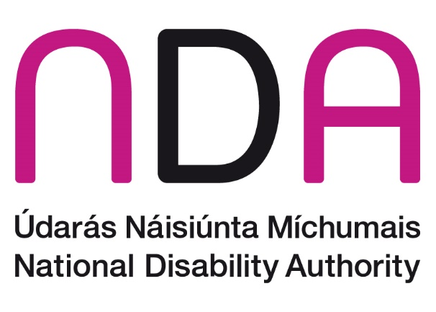
Table of Contents
Improving the Accessibility of School Buildings 1
Foreword 4
Introduction 5
Terminology 6
Barriers 6
Useful Resources 7
How many school children with disabilities? 7
Legislation 8
Building Regulations 8
Equal Status Legislation 8
Education for Persons with Special Educational Needs Act 2004 9
The Disability Act 2005 10
Management Responsibilities 11
Leadership and Planning 12
Raising Awareness 12
Maintenance Routines 13
Monitoring and Auditing 13
New Build Projects 14
Health and Safety 15
External School Environment 16
Transport Links 16
Arrival and Departure 16
External Circulation Routes 17
Space Allocation 18
Outdoor Spaces 18
Managing the External Environment 19
School Entrance 19
School Entrance – Good practice examples 20
Managing the School Entrance 22
Internal Circulation 23
Wayfinding 23
Using Colour in School Buildings 26
Horizontal Circulation 27
Vertical Circulation 30
Managing Internal Circulation 32
Evacuation 32
Managing Evacuation Procedures 35
Facilities 36
Reception 36
Toilets 37
Lockers and Cloakrooms 40
Managing Toilet Facilities 41
The Classroom 41
Classroom Acoustics 42
Space and Layout 45
Lighting 46
Environmental Controls 47
Assistive Technology 48
Specialist Rooms 48
Support Teaching Rooms 49
General Purpose Rooms/Assembly Rooms 49
Sports Halls and Fitness Suites 49
Cafeterias 50
Science Laboratories 50
Computer Rooms 51
Art Rooms 51
Home Economics Rooms 51
Workshops 52
Libraries 53
Managing Specialist Rooms 53
References and Further Reading 54
Glossary 55

Foreword
The aim of this document is to give guidance on the design of the physical environment in primary and post-primary school buildings and grounds, so that they are easy for everyone to use, including students with disabilities.
This guidance will help boards of management, school principals, teaching staff, parents and built environment design professionals to understand the barriers that the built environment often presents to students with disabilities, and to overcome these barriers.
The provision of education for all regardless of their age, size, ability or disabilities depends on a wide range of factors, including school policies, curriculum planning, teaching strategies, and the school environment. Well-designed schools allow all students to participate fully and independently. This frees their teachers to focus on educational goals. Students with disabilities should be able to get around the school along with their peers. They need to be able to navigate through the school building, use standard classroom equipment, and use their own assistive technologies with ease.
Principals and boards of management should plan to improve the accessibility of school buildings over time. Improving the accessibility of Ireland’s primary and post primary schools will be key in maximising the social inclusion of all young people in our society.
_________________________
Peter McKevitt
Chairperson
National Disability Authority

Introduction
This document suggests ways of designing and managing school buildings to improve accessibility for students with disabilities.
It begins by defining some terminology and exploring the background to this document. It then moves on to look at the legislation about accessibility in schools, and how school management can take practical steps to proceed.
This guidance is intended as a ‘good practice’ guide for the design of new schools and improvements to existing schools. It features sections on the external environment, school entrances, internal circulation, evacuation, other facilities, and classrooms. Additional good practices for managing the accessibility of the school are detailed at the end of each section.
The guidance will help schools to manage the limitations of existing buildings and facilities. It will also be particularly useful for schools engaged in refurbishment and new-build projects. While this document has been compiled with mainstream primary and post-primary schools in mind, much of the content is also relevant for special schools.
This document does not provide detailed technical specifications on accessibility features. Throughout the document and in the Further Reading section, there are signposts to where that level of detail is available. Building for Everyone (2012) is the National Disability Authority’s comprehensive guide to the detail design of buildings. It is available for free download from http://www.universaldesign.ie/buildingforeveryone.
The guidance in this document focuses on the needs of students with disabilities. However, students are not the only people to use the school building. Teachers and administration staff, parents, visiting students, and those who use the school outside of core hours all have particular requirements. A ‘universal design’ approach allows all users to make use of the services available in the school building.
A ‘universal design’ approach to school design will ensure that the school can be accessed, understood and used
- to the greatest possible extent
- in the most independent and natural manner possible
- in the widest range of situations, and
- without the need for adaptation, modification, assistive devices or specialised solutions
This document is not designed to address all possible barriers for students with disabilities taking part in school life. There may well be issues around curriculum design, staff training, access to personal care, interpretation services, and access to information that go beyond the scope of this publication.

Terminology
This document uses the term ‘students with disabilities’ to include students with special educational needs and those students with particular needs around accessing the built environment.

Barriers
Participation in quality education is important for all young people as it provides a cornerstone for social inclusion over their lifetime. Education is a key influence on life factors such as job prospects, earnings, and poverty risk.
A wide body of research has demonstrated that people with disabilities have fewer educational qualifications than non-disabled people in their age group. This leads to a double disadvantage, where economic prospects are reduced both by disability status and by lower levels of education. As educational underachievement is more prevalent for people with disabilities from childhood rather than for those whose disability arose later in life, having a disability during school or college years is clearly a factor in this underachievement.
Barriers to education identified by students with disabilities in ‘Hidden Voices’ (Kenny et. al., 2000), included inaccessible transport, buildings and facilities within the school. For example, inappropriate bench height and inaccessible laboratory equipment meant that students with disabilities were unable to participate fully in science or other practical classes. Some students with vision loss reported difficulties in finding their way round the school because of a lack of handrails on stairs and corridors. Therefore the problem of inaccessible school buildings is a real concern for many students with disabilities.
Students with disabilities will have certain unique requirements that impact how they use school facilities.
For example
- Students with mobility disabilities may have particular difficulties with steps, or heavy doors. They may need additional desk space if they use a wheelchair, or additional storage space for a walking frame or crutches
- Students with visual difficulties will benefit from improved lighting and clear visual contrasts on doorframes and support columns
- Some students with emotional, psychological or mental health difficulties will benefit from a calming environment created by appropriate use of light and colour schemes
- Many students have particular requirements for access to laptop computers or other assistive technology. Availability of power points for recharging will greatly benefit these students

Useful Resources
This publication draws on relevant guidance from other Irish and international publications.
The Planning and Building Unit of the Department of Education and Skills has published useful Technical Guidance Documents on school design.
The following publications are particularly relevant in relation to accessibility:
- TGD-020 - General Design Guidelines for Schools (Primary & Post-primary) – Revision 1 October 2011
- TGD-022 - Primary School Design Guidelines revision 2 August 2010
- TGD-023 - Post-primary School Design Guidelines
The National Disability Authority revised series 'Building for Everyone – a Universal Design approach' gives detailed technical guidance in relation to good practice in making all types of buildings easy to use for all. This publication is available free of charge at http://www.universaldesign.ie/buildingforeveryone.

How many school children with disabilities?
Data from Census 2006 suggests that about 5% of children of school age (age 4 -18) have a disability. While it is common that a child has more than one form of disability, the children with intellectual or learning disabilities form the largest single group.
As a follow-up to the Census, the National Disability Survey 2006 explored in more depth what kind of functional difficulty young people may have. Here the figures refer to the population under 18, rather than to those aged 4 to 18. Again, it must be recognised that some children have more than one disability, so the numbers are not necessarily exclusive. Here are the estimates of the number of children with some of the principal forms of disability that impact on design and management of school buildings
Principal Disability | No’s of Children
Moderate to profound sight difficulty (while wearing glasses) | 2,700
Moderate to profound hearing difficulty | 3,300
Mobility or dexterity difficulty | 8,100
Diagnosed intellectual disability | 21,400
Mental health disability | 9,900
Table 1 Source: National Disability Survey 2006 vol 1

Legislation
A broad legislative framework now supports the goal of promoting the full inclusion of people with disabilities in Irish society. The most relevant legislation in relation to the accessibility of school facilities is outlined below. The following is an introduction to the legal framework in this area, not a legal reference. It should not be interpreted as guidance or direction on legal matters.

Building Regulations
Part M of the Building Regulations, published by the Department of Environment, Heritage & Local Government, applies to new buildings and to material alterations or extensions of existing buildings. Those who own, design, and construct buildings are primarily responsible for observing the requirements of the Building Regulations.
The revised 2010 Part M regulations require that: “Adequate provision shall be made for people to access and use a building, its facilities and its environs”.
The revised version of the Part M regulations and associated Technical Guidance Document place significant additional obligations over and above earlier versions, including, for example, obligations regarding bathroom size, signage, car parking, and communication aids.
The Part M regulations set out the legal minimum facilities required. However, complying with these minimum requirements is not a guarantee that a building will meet all requirements for all students.

Equal Status Legislation
The Equal Status Acts 2000–2011 and the Employment Equality Acts 1998–2011 apply to all educational establishments, including primary and post-primary schools. The Acts prohibit discrimination across nine grounds, one of which is disability.
The Acts apply to people who attend or are in charge of educational establishments. They prohibit discrimination in relation to
- the admission, or the terms or conditions of admission
- the access of any student to any course, facility or benefit
- any other term or condition of participation in the school
- the expulsion of a student or other sanctions
The Acts require reasonable accommodation of people with disabilities. This means that a school must provide reasonable accommodation to meet the needs of a person with a disability if it would otherwise be impossible or unduly difficult for that person to participate in school without the special treatment, facilities or adjustments.
However, there is no obligation to provide special treatment, facilities or adjustments if they give rise to anything more than a 'nominal cost'. Reasonable accommodation could, for example, include improvements to a school premises to make it more accessible.
This is what the Equality Authority’s publication ‘Schools and the Equal Status Acts’ has to say about nominal cost:
The meaning of ‘nominal cost’ will depend on the circumstances such as the size of and resources available to the organisation. A large and well-resourced organisation is more likely to be able to afford a higher level of cost in making reasonable accommodation than a small one is. As most schools are funded by the State, this would suggest the ‘nominal cost’ exemption may not be very significant in practice. If the State provides grants or other resources for assisting in providing special treatment or facilities, there may be an onus on the school to avail of these.
The Employment Equality Acts prohibit discrimination in employment and self-employment. This protection extends to teachers and other staff employed by the school, as well as to independent contractors. The Acts require the reasonable accommodation of employees – both teachers and other staff – with disabilities.

Education for Persons with Special Educational Needs Act 2004
The Education for Persons with Special Educational Needs Act (EPSEN) Act states that a child with special educational needs shall be educated in an inclusive environment along with children who do not have special educational needs – unless it is not in the best interests of the child with special educational needs, or if it is inconsistent with the effective provision of education for the children with whom the child is to be educated.
The EPSEN Act defines the term ‘special educational needs’ as: “A restriction in the capacity of the person to participate in and benefit from education on account of an enduring physical, sensory, mental health or learning disability, or any other condition which results in a person learning differently from a person without that condition”.
The EPSEN Act promotes, and is informed by, the principle of inclusion. School design may potentially contribute to promoting inclusion through optimising all students’ access to the school environment and removing unnecessary barriers to participation.
The requirements of the EPSEN Act cover a range of issues, including: the preparation of education plans by schools; assessment of children with special educational needs; the duties of schools; and the work of the National Council for Special Education.
Some of the provisions of the act have not commenced at the date of publication of this guide (2012).

The Disability Act 2005
The Disability Act 2005 obliges public bodies to ensure that their buildings and services are accessible to people with disabilities.
Some community schools and colleges are operated by Vocational Educational Committees which are public bodies. Some newer schools, particularly Gaelscoileanna and multi-denominational schools are owned by the Department of Education and leased to operating bodies.
Many other schools, such as parish schools, are not technically operated by public bodies, and the Disability Act 2005 does not apply to such schools.
The main provisions of the Disability Act for schools operated by public bodies for accessibility of the built environment are as follows:
- All public buildings owned or managed by public bodies are required to comply with 2000 Part M building regulations by 2015 and with subsequent amendments to Part M not later than 10 years after the commencement of the amendment (Section 25)
- There is a statutory requirement on public bodies to integrate their services for people with disabilities with those for other citizens, where practical and appropriate (Section 26)
- Public bodies are required to ensure that goods or services purchased are accessible, unless it would not be practicable or justifiable on cost grounds, or unless it would result in an unreasonable delay (Section 27)
- Communications by a public body to a person with hearing or vision loss must be provided in an accessible format as far as is practicable, following a request. Information provided electronically must, as far as is practicable, be compatible with adaptive technology. Published information that is relevant to persons with intellectual disabilities must, as far as is practicable, be made available in clear language that is easily understood (Section 28)
The National Disability Authority's statutory 'Code of Practice on Accessibility of Public Services and Information provided by Public Bodies' gives guidance to public bodies on meeting their obligations in relation to these requirements. Compliance with the Code of Practice is deemed to be compliance with the Disability Act.
Universal design is defined in the Disability Act 2005 as:
"The design and composition of an environment so that it may be accessed, understood and used:
(i) to the greatest practicable extent;
(ii) in the most independent and natural manner possible;
(iii) in the widest possible range of situations and;
(iv) without the need for adaptation, modification, assistive devices or specialised solutions, by persons of any age or size or having any particular physical, sensory, mental health or intellectual ability or disability, and means, in relation to electronic systems, any electronics-based process of creating products, services or systems so that they may be used by any person.”

Management Responsibilities
Management policies and procedures are very important in ensuring a universally accessible built environment.
Even the most accessible premises can quickly become inaccessible if, for example, boxes are left in circulation routes, or fittings and fixtures are not maintained.
Good management can also produce a marked improvement in the accessibility of a poorly designed building. Consulting with students with disabilities and their parents will provide an appreciation of the students' practical day-to-day needs. Amending the management and maintenance regimes will support and reflect those needs.
The main issues to be addressed are detailed in the following sections below:
- Leadership and planning
- Raising awareness
- Maintenance routines
- Monitoring and auditing
- Initiating new build projects
- Health and safety

Leadership and Planning
The Board of Management needs to clearly define and communicate the responsibility for managing the accessibility of the school environment. While accessibility should be part of everyone’s job, it will benefit greatly from leadership by a key member of the management team.
By conducting periodic reviews of the accessibility of the building, and completing the required corrective actions, management can ensure that everyone can use the facilities.
Many of these actions will not be costly to fix. It may simply be a matter of moving obstructions, or finding appropriate storage, or disposing of obsolete furniture or equipment.

Raising Awareness
By using a universal design approach, accessibility features become an integral part of the building design: even people who use the building every day may not be aware of the importance of certain features in the environment to people with disabilities.

Provide information on accessibility
Providing information on accessibility will help raise awareness among staff, students, and their parents. It should also encourage all of the school's users to contribute to accessibility on an ongoing basis; for example, by ensuring that designated accessible parking is only used by those that need it, or by keeping access routes free of clutter that could cause obstruction.

Give accessibility details on school website
Providing information on the accessible features of a building and its grounds on the school website is useful for potential new students and first-time visitors to the school.

Ensure school trips are accessible
Ensuring accessibility of any activities or events that involve travelling outside school grounds will help all students to participate fully in school life. This would include educational trips, such as, visits to museums or theatres, visits to other schools, sports events, or work experience. It is also important to review the accessibility of the destination, and the transport to and from the destination, as part of the planning of any such activities.

Maintenance Routines
Accessibility should be a key consideration when routine maintenance is being carried out, as it often presents an opportunity to improve the accessibility of a building. For example, when handrails are being painted, the colour selected should ensure good visual contrast between the handrail and the wall.
Good practice in maintenance routines include
- regularly cleaning paths to remove debris, such as leaves, ice and snow, and ensuring that they are clear of obstructions such as bicycles and motor cycles
- ensuring circulation routes are kept clear of obstructions
- maintaining door closers to keep opening forces to a minimum
- ensuring accessible toilets are not used for storing cleaning equipment or other materials
- using clear and legible signage
- updating signage when the way the building is used changes
Additional good practices for managing the accessibility of the school are detailed at the end of each section in this document.
For further guidance on managing accessibility in buildings, refer to the National Disability Authority publication ‘Access Handbook Template, A Tool to Help Manage the Accessibility of the Built Environment’.

Monitoring and Auditing
An access audit is one of the first steps to be taken when making improvements for access to the built environment. It involves an inspection and assessment of a building and its external environment by an access expert in relation to its ease of use by everybody, particularly people with disabilities. A quality access audit requires a skilled and experienced access auditor.
Access audits identify elements of a school environment that may cause barriers to its use and suggest how these could be improved.
Some of these items may be fixed by changing how the building is managed or maintained. For example, if the transfer space in an accessible bathroom is blocked by cleaning equipment, there will need to be a new arrangement made with the cleaners to make sure this space is kept clear. Other elements may require building work, which can involve obtaining planning permission for larger works.
Consider carrying out an access audit, and developing an action plan to implement its recommendations. The action plan could then be added to the school plan.
An access audit may need to be reviewed over time, particularly if the building has been changed or extended, or if its use has changed. The action plan should prioritise the areas that need improvement, and set out a time-scale for making the required improvements.
For further guidance on access auditing, refer to the National Disability Authority publication ‘Guidelines on Access Auditing of the Built Environment’.
If it is not possible to engage an experienced access auditor, consider taking a ‘self-assessment’ approach to reviewing the accessibility of the school facilities. A self-assessment approach can be useful as a first step to identifying the scale and scope of accessibility issues to be addressed within the school.
As with any audit, using an external person to carry out a self-assessment audit can be helpful. It can be difficult to audit your own facility with the same rigor as would someone seeing it for the first time with a fresh pair of eyes.
There are a number of self-assessment checklists available on the Internet. Some of the checklists from UK local authorities, such as the Essex Schools Interlink network, may be helpful to Irish schools although legislation and building regulations may differ. See http://www.essex.gov.uk for more information.

New Build Projects
New buildings and extensions provide a great opportunity to go beyond the legal minimum and really accommodate the needs of many students – without incurring significant additional costs over and above an alternative building project. The school can provide access for everybody who will use the school facilities by using universal design principles and best practices.
In the case of a ‘new build’ project, it is important that accessibility is highlighted at the earliest possible stage. It should form a key part of the initial design brief, and it should be part of the criteria used to select the design team and the developer.
The Board of Management should designate a person with direct responsibility for the accessibility of the project. This person may need to get expert professional advice from an expert in accessibility or universal design. School staff, students and parents will be a valuable source of information to guide the design of a new facility.
Accessibility should be monitored and reviewed throughout the lifetime of the project. Formal access audits may be required at key stages to check that accessibility has been achieved.

Health and Safety
The guidance in this document reflects the large overlap between designing for accessibility and for health and safety. Improving the accessibility of an environment often results in improved health and safety for all users. This is one of the benefits of a universally-accessible approach.
Examples of this overlap include:
- designing traffic management and pedestrian routes at the approaches to schools to meet the needs of students with disabilities and improve safety for all users
- providing markings on glazed doors and screens to assist people with vision loss to identify the glazing, and reduce the chances of accidents for all building users
- ensuring that emergency communication systems, such as inter-class telephones, public address systems or personal emergency alarms, can be used and understood by all
- incorporating handrails, larger steps, and highlighted nosings on stairs to meet the needs of people with mobility disabilities or vision loss makes the stairs safer for all users

External School Environment
This section looks at different elements of the external built environment in schools, and highlights key areas for consideration in relation to accessibility.

Transport Links
Students using public transport, or those who walk or cycle to school should be able to independently use a safe, accessible route. These routes may often be outside the schools grounds. Working with the local authority can help achieve necessary improvements, such as installing appropriate signage, or upgrading pedestrian crossings to include dropped kerbs, audible warnings, and tactile paving.

Arrival and Departure
Circulation areas become very busy at the start and the end of the school day, when students are being dropped off and collected. The design of pedestrian routes and vehicular circulation in set-down and pick-up areas requires careful planning to ensure the health and safety of all users.
Traffic can be a particular hazard for some people, including people with mobility difficulties, those who have difficulty remembering and concentrating, and for those with sensory disabilities who cannot hear or see the vehicles. Guidelines for arrival and departure areas include the following:
- Designated pedestrian routes should be clearly separated from vehicular circulation
- Where parents’ cars enter the school grounds, vehicular circulation routes should provide for appropriate speed limits and set-down areas designed to avoid congestion, for instance by using a one-way system
- Appropriate signage to clearly designate entrances, drop off areas, and traffic flow
- Designated accessible parking bays and drop-off areas should be provided close to the school entrance for students and staff
- The provision of a dedicated shelter at the accessible parking spaces or designated set-down points to provide shelter from the weather is a desirable feature
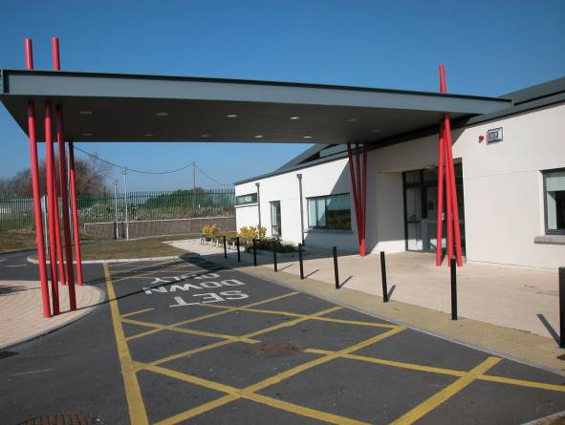Figure 1 School Approach
(photo by Michael Mohan Architects)
Accessible features:
The approach to this school has clearly marked set-down areas for cars.
The location of the entrance is easy to identify on approach, because of the recessed entrance lobby, the change in colour, and the canopy.
What could be improved?
Accessible parking spaces should be available beside the school entrance.

External Circulation Routes
Accessible circulation routes should allow for safe, independent use by all users. Providing a choice of steps or ramp at changes in level will ensure that everyone can use the same route. A wheelchair user is not be able to use steps, but some people with mobility difficulties find it easier to use steps than a ramp, so it is important to provide choice.
Routes should be sufficiently wide to allow each student to travel comfortably alongside their friends, be they a wheelchair user, someone using crutches, or someone with an assistance dog.

Space Allocation
When designing for accessibility in schools, a wide range of other people with spatial requirements will benefit from additional space, including:
- wheelchair users, who require extra space when passing others or turning
- people who use mobility aids such as walking frames or crutches
- people with vision loss using a white cane or assistance dog
- students with autistic spectrum disorders who may also have sensory difficulties and who may benefit from a spacious and predictably structured school environment
- students with emotional, behavioural or social difficulties that need extra space around them to feel comfortable
- parents with buggies and teachers carrying or wheeling bulky equipment

Outdoor Spaces
It is important that all students can access and use the external spaces in a school, so that they can participate in social and recreational activities.
Outdoor space in schools normally comprises a mix of hard surfaced and grassed areas. While grass may be a difficult surface for wheelchair users, access to grassed pitches can be provided using pathways or matting products.
As well as areas for activities such as games and sports, quieter social spaces with seating should also be provided for students to use.
Where playgrounds are provided, equipment should be carefully selected to ensure accessibility for all students, including wheelchair users, students who use crutches and walking frames, and those with hearing loss or vision loss.
Further information on the design of accessible designated parking and circulation routes is available from these publications:
Building for Everyone – A universal design approach (National Disability Authority), http://www.universaldesign.ie/buildingforeveryone
BS8300:2009 + A1:2010, Design of Buildings and their approaches to meet the needs of disabled people - Code of practice (British Standards Institution) – clause 6

Managing the External Environment
Allocate responsibility for managing external accessibility issues to appropriate staff.
Responsibilities in the external environment include:
- ensuring that designated accessible parking bays are only used by drivers with a ‘blue badge’ disabled parking permit
- ensuring that cars do not obstruct pathways or access routes when dropping off students
- making sure that locked bicycles do not obstruct pathways or access routes
- removing fallen leaves, moss, mud, ice and snow to avoid risk of slips and falls
- maintaining external lighting so that there is adequate light for those entering and leaving the school
- removing any obstructions to external paths or routes, such as temporary signs, advertising displays, and sports equipment
- making sure that turning areas at the top of ramps are kept clear for use by wheelchair users

School Entrance
The main school entrance should be easily identifiable from a distance by its design, location, signage and lighting. It should be easy for all students, staff and parents to use. This should be readily achievable in new buildings.
In existing buildings, it is important to ensure that students with disabilities can use the same entrance as other students.
Some key considerations in relation to entrances include:
- A level threshold, without steps. A ramp can be used to address small changes in level, up to 300mm. Where there is a change in level of 300mm or more at the approach to the entrance, both a ramp and steps should be provided
- Doors that are wide enough and easily operated. Automatically operated sliding doors provide a high level of accessibility for all users. The accessibility requirements need to be balanced with cost, maintenance issues, and security issues
- Manual door closers should be avoided where possible. These can cause difficulties for people with mobility disabilities because of the force needed to open the door,
- Revolving doors should also be avoided. These can be very difficult for wheelchair users and people with mobility difficulties to use
- Sufficient circulation space around the entrance can minimise congestion at the start and end of the day
- A good visual link between the internal office, reception and main entrance area, to the main external approach will help staff to identify any students or visitors in need of assistance
- A level covered area to provide shelter to students being dropped off or collected is also desirable
- Any access control system that stops unexpected visitors from getting into the building should be clearly visible. It should be reachable by a wheelchair user or a person of smaller stature and usable by people with hearing, speech or vision loss
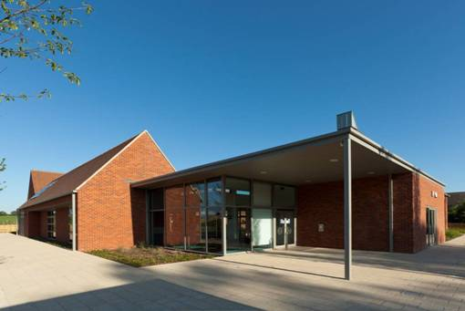
- Appropriate signage directs visitors to the entrance or reception area

School Entrance – Good practice examples
Figure 1 School Entrance
Accessible features:
The approach to this school has level pedestrian routes with generous widths which are kept clear of clutter.
The entrance has a large canopy which clearly identifies the position of the entrance on the approach, and provides shelter.
There is level access at the double glazed doors.
What could be improved?
The grey column at the corner of the canopy could be a hazard to someone with vision loss. Changing the colour of the column to provide a visual contrast with the background would improve the accessibility of the entrance, as would providing markings on the glazed screens.
Automatic opening doors would also make the entrance easier to use.
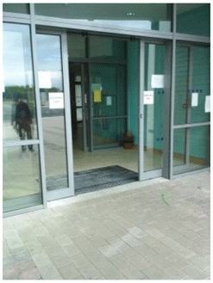
Figure 3 School Entrance
Accessible features:
The entrance to this school is level with automatic opening glazed doors.
The recessed matwell provides additional safety in wet conditions while avoiding the risk of tripping over a floor mat.
What could be improved?
Changing the colour or tone of the door-frame to create a visual contrast with the rest of the glazed screen would make it easier for people with vision loss to identify the position of the door.
Manifestations or markings on the glass to make sure that it stands out for people with vision loss would help reduce the risk of someone walking into the glass.

The following documents give further advice on the design of accessible entrances:
Building for Everyone – A universal design approach (National Disability Authority), http://www.universaldesign.ie/buildingforeveryone
BS8300:2009 + A1:2010, Design of Buildings and their approaches to meet the needs of disabled people - Code of practice (British Standards Institution) – clause 6
Building Bulletin 102, Designing for disabled children and children with special educational needs, guidance for mainstream and special schools (Department for Children, Schools and Families, UK)

Managing the School Entrance
Ensure that the following accessibility issues are regularly reviewed to maintain the accessibility of the entrance area:
Where automatic or power-assisted doors are in place, make sure these are regularly serviced in line with manufacturers’ recommendations. Where these doors are not working properly, ensure that they are fixed as soon as possible
Where manual door closers are fitted, make sure these are adjusted to provide the minimum force necessary to open or close the door
Make sure staff and students are aware of the need to offer assistance by holding open doors or carrying materials for people with disabilities who have difficulties at the entrance
Avoid clutter from cleaning equipment, gardening tools, stationery, sports equipment. Make sure that equipment is removed and stored at a safe location

Internal Circulation
Circulation refers to the ability to move around a building safely and independently.
Schools typically consist of a large number of similar classrooms with a small number of larger communal facilities, all linked by circulation routes.
Long corridors without distinguishing features should be avoided; instead the school layout and design should assist easy orientation, wayfinding, and movement around the building. Building layouts should be easy to understand for students with intellectual and learning disabilities and for first-time visitors. A building’s layout and subsequent travel distances should also meet the needs of users with varying levels of energy or stamina.
Ideally, all horizontal circulation within a school should be level, without steps or ramps.
Where this cannot be achieved in an existing building, schools will need to provide an adequate combination of steps, ramps, platform lifts, and passenger lifts to ensure that everybody can get around the school with ease, and without disrupting the timetable.
The section on classrooms below includes guidance in relation to acoustic design. Important social interaction also takes place in communal places outside the classroom, and these areas also need to be designed with the needs of students affected by acoustics in mind.

Wayfinding
As well as having an entrance that is easy to identify, circulation layouts should be clear and easy to understand. Signage and other means of orientation are invaluable for visitors and new students, particularly people with sensory disabilities, autistic spectrum disorders, speech communication and language needs, or learning disabilities.
Changes in colour, texture or proportion on circulation routes, as well as landmark features, such as seating or planting, can help people to find their way around a building. Different textures of floor coverings or particular shapes or symbols built into the flooring can be used to signal different types of rooms or other wayfinding information, particularly for people with vision loss. It is important to test proposed designs with building users to avoid any confusing patterns.
Handrails with a strong colour contrast against the background wall can provide wayfinding information and provide extra physical support to those who need it. This can be particularly useful during emergency evacuations, where vision may be reduced by smoke.
Clear and simple signage using raised letters, visual contrast, sans serif fonts, symbols, and Braille is also important to assist wayfinding. A combination of text, colour and symbols to indicate common facilities such as reception, principal’s office, toilets, and stairs help all students and visitors to find their way around the school.
Tactile maps can help people with vision loss to orient themselves within a building.
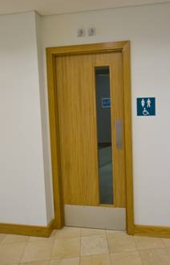
Raised letters, Braille, and visual contrast on signs assist people who are blind or partially sighted. There are some emerging technologies that use GPS and other facilities within smartphones to provide wayfinding information to users in both visual and audible formats for large campuses.
Figure 4 Internal Door and Sign
Accessible features:
The sign is within the recommend height range of 1400 – 1700mm for reading at close range. The lower part of this range may be more appropriate in primary schools.
Positioning the sign adjacent to the door rather than fixing it directly to it means that the sign will be visible, even if the door is left open. The sign incorporates features, such as visual contrast, and the use of recognisable symbols.
There is a visual contrast between the timber finish of the door and the surrounding wall.
The height of the glazed vision panel has been designed to suit both seated and standing users.
What could be improved?
The sign indicates that the male, female and accessible toilets are all accessed through a single door leading to a toilet lobby. It is generally preferable for accessible toilets to be accessed directly (without a lobby), as lobby doors can be difficult for wheelchair users to move through.
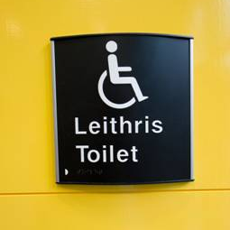
Figure 5 Internal Sign
Accessible features:
This sign incorporates features such as visual contrast, embossed letters, easy-to-read text, Braille, and use of a recognisable symbol.

Using Colour in School Buildings
For people with good vision, differences in colour and colour intensity provide adequate visual contrast. However, this is not the case for everybody with vision loss. The light reflectance value (LRV) of a colour is used by professional designers to identify those colours which adequately contrast against other colours.
Tonal contrast between different features is important for people with vision loss in a number of ways: floors that contrast with walls will indicate the size of a room; handrails that contrast with the wall indicate their location; and doors that contrast with their surrounding indicate their position and help wayfinding.
Improving the visual contrast in a school should be considered when carrying out maintenance or refurbishment work – for instance when painting walls and doors, or renewing floor finishes.
Careful consideration should be given to the use of colour in school environments. Colour can be used to support wayfinding and to help students orientate themselves. For example, appropriate use of colour can help highlight architectural features, or indicate a change in use. It can also be used to create visual contrast to assist people with vision loss – for example, by contrasting between floor and walls and between handrails and their background.
The Department of Education and Skills Technical Guidance Document 020 notes: “Spaces should be planned as appropriate to their use and should be bright and stimulating or calm and relaxing as appropriate. Special care should be taken while selecting the colour scheme. Complex colour schemes and the use of contrasting colours (e.g. red/green) that could create a difficulty to the visually impaired should be avoided”.
UK guidance advises that bright colours in large areas or busy patterns can confuse or over-stimulate (Department for Children, Schools and Families (UK), 2008). Researchers have found that many children with autistic spectrum disorders see colours with greater intensity than others; it is therefore advised to avoid using bright primary colours in favour of softer tones (Ahrentzen & Steele, 2009).
For further information on visual contrast and light reflectance values, refer to Annex B of BS8300:2009 + A1:2010, Design of Buildings and their approaches to meet the needs of disabled people - Code of practice.

Horizontal Circulation
In primary schools, students spend most of their time during the day in one classroom. However, in secondary schools, students tend to move between different general and specialist classrooms, so ease of movement and minimising travel distances needs to be carefully considered.

Corridors
Where possible, schools should be planned to minimise long travel distances, which can be a barrier for some students with mobility disabilities.
All circulation routes should be wide enough for two wheelchairs to pass one another. A minimum clear width of 2400 mm is preferable, with a recess of 900 mm for lockers or coat stands.
Consideration should be given to providing handrails along long corridors, provided they do not block access to lockers, with handrail heights to suit both students and adults.
Strong natural light and ventilation will help to create a comfortable environment in circulation areas.
The Department of Education and Skills Technical Guidance Document TGD-023 Post-primary School Design Guidelines provides detailed advice on circulation routes and other features of school design.

Doors
Door design should be given careful consideration in relation to door widths, vision panels, ease of operation, and the provision of visual contrast - for example between walls, door frames and door leafs - for people with visual impairments.
The Department of the Environment Part M Technical Guidance Document notes the importance of a ‘leading edge’ at every door. This is “an unobstructed space of at least 300mm between the leading edge of a single leaf door (when it opens towards you) and a return wall, unless the door is opened by remote automatic control. This enables a person in a wheelchair to reach and grip the door handle, then open the door without releasing hold on the handle and without the footrest colliding with the return wall”.
Some manual doors closers can require significant force to open the door, making it difficult for some people with disabilities (including those using mobility aids, those who are small in stature, or those with limited stamina) to move through doorways.
Using magnetic hold-open devices on doors on circulation routes should be considered, taking fire regulations into account.

Internal Circulation – good practice examples

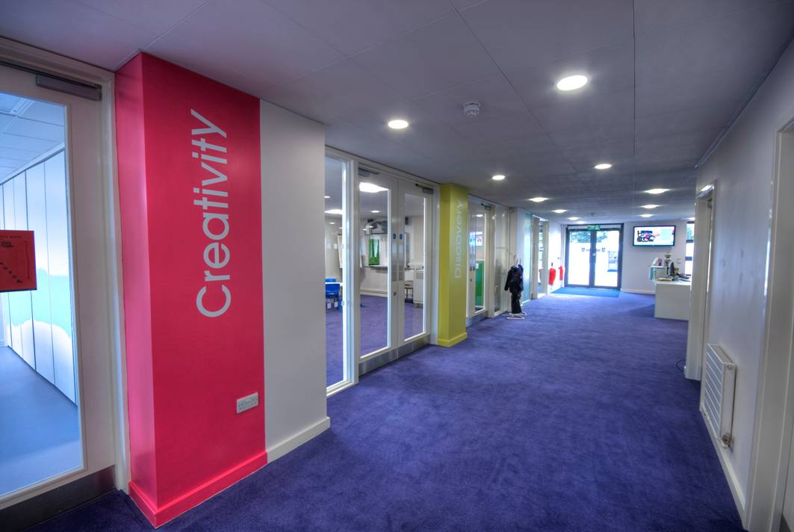
Figure 6 Internal Corridor
Accessible features:
The internal circulation space in this school has generous width, and there is good visual contrast between the floor and the walls.
Coloured wall panels incorporating signage and glazed screens give views to adjoining spaces to help wayfinding and orientation.
What could be improved?
The strong colours in this environment could over-stimulate some students, particularly those with autistic spectrum disorder.
Changing the colour of the doors (or their frames and architraves) to provide a visual contrast with the surrounding wall or screen would make it easier for people with vision loss to locate their position.
The glazed doors and screens should have markings on the glass.
Any objects that protrude out into a corridor may benefit from a guardrail or other protection to avoid any risk of injury.
When carpet is used as a floor finish, a short-pile carpet suitable for wheelchair users should be selected. This will also benefit people who use mobility devices and people who have difficulty in lifting their feet.
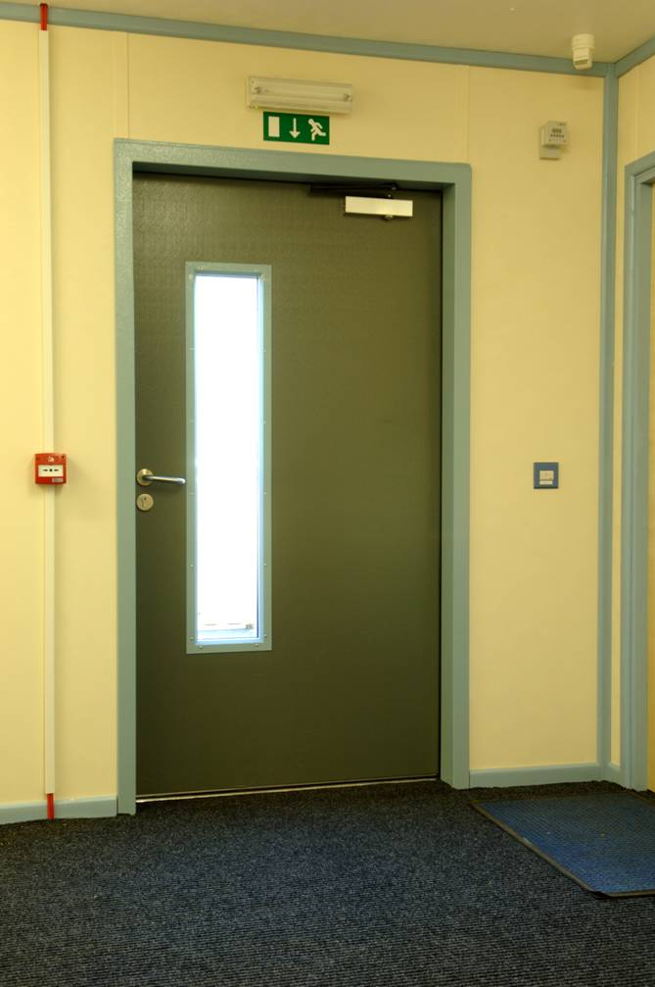
Figure 7 Internal Door
Accessible features:
The colour of this door provides visual contrast with the surrounding wall finish.
The height of the glazed vision panel has been designed to suit both seated and standing users and people of smaller stature.
What could be improved?
A colour contrasting panel at the door handle could be used to highlight the location of the door handle.
The door has a manual door closer, which can be difficult for people with mobility disabilities to use especially if the force required to open the door is significant. Where their use cannot be avoided (for instance for fire safety reasons), door closers should be adjusted to reduce the force required to open the door. BS8300:2009 + A1:2010, Design of Buildings and their approaches to meet the needs of disabled people - Code of practice, provides advice on acceptable door opening forces in clauses 6.3 and 6.5.

Vertical Circulation
Vertical circulation refers to moving up or down between different levels of the building using stairs or lifts.

Lifts
The provision of lifts as well as stairs between floors in multi-storey schools is of particular importance for wheelchair users and people with reduced mobility.
In existing primary schools, for example, where there is no lift installed, it may be possible to ensure that all facilities are available at ground level. This would ensure that students who cannot use a stairs are not disadvantaged.
In post-primary schools there may be greater challenges to overcome, particularly where specialist rooms are at first floor level or above.
In all cases an effective management plan must be drawn up by the school authority to address the matter.
Where students need to use lifts, it is important that they can do so independently, for example, without needing to ask a teacher or to get a key. There are various access control systems available than can restrict access to a lift, such as contactless smart cards. Make sure that any access control system can be used by everybody.

Stairs
On sloping sites, the provision of well-designed ramps between relatively small changes in levels will ensure that they are accessible to wheelchair users. However, many ambulant people with disabilities find it easier to use steps than a ramp.
A choice between steps and a ramp should be provided at changes in level greater than 300mm.
Stair design is important from both accessibility and health and safety points of view. Handrails are used for support by all users, but they are essential for people with vision loss or mobility disabilities.
Handrails should contrast visually with the wall. Schools should consider installing a second handrail on stairs at a lower height than the standard to suit younger students and smaller people.
Visual contrast on the nosing of steps is important to help people to identify the edge of the step.
Research has shown that using a larger flat section or ‘going’ (the distance between nosings) on a stairs helps to avoid accidents. It allows a person to place more of their foot on the step. Larger goings can also benefit people who wish to pause to rest in the middle of a flight of stairs. The minimum recommended going on stairs is 300mm. The step riser (the vertical part of the step) should generally be between 150mm and 180mm.
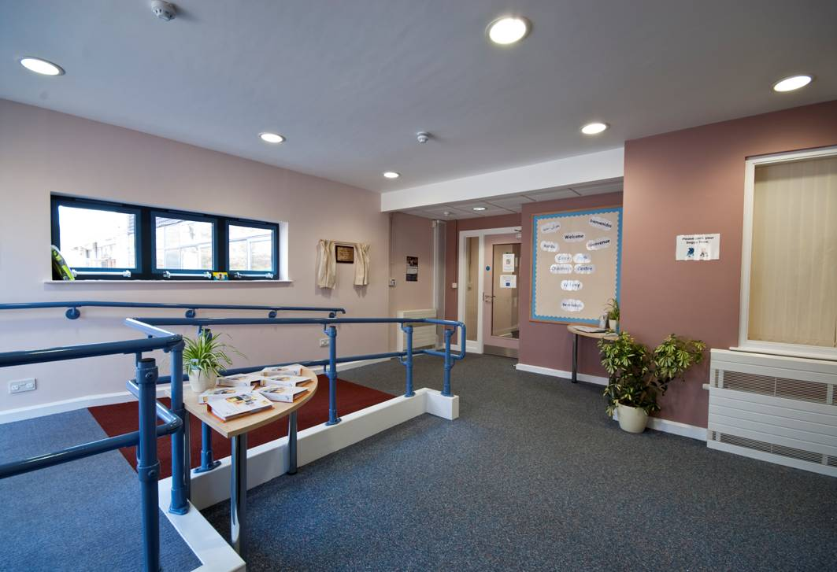Open risers, where there is no vertical part leaving a see-through effect, should be avoided, due to the risk of tripping.
Figure 8 Internal Ramp
Accessible features:
This short ramp in a school has handrails on both sides that contrast visually with their background.
There is also a visual contrast between the sloping surface of the ramp and the rest of the floor finish, which highlights the change in level. This helps all users to avoid what could be a tripping hazard but is especially useful to people with vision loss.
The radiator is fitted with a cover to make sure no-one comes into contact with a very hot surface.

The following documents give further advice on the detail design of internal circulation routes, doors, lifts, stairs and ramps.
Building for Everyone – A Universal Design Approach (National Disability Authority), http://www.universaldesign.ie/buildingforeveryone
BS8300:2009 + A1:2010, Design of Buildings and their approaches to meet the needs of disabled people - Code of practice (British Standards Institution) – clauses 6, 7 and 8
Building Bulletin 102, Designing for disabled children and children with special educational needs, guidance for mainstream and special schools (Department for Children, Schools and Families, UK)

Managing Internal Circulation
Ensure that responsibility for periodic audits of internal circulation is assigned to an appropriate staff member. Staff and students can be consulted to get their feedback about what works well and what are the problem areas. The following aspects of building accessibility should be included in the audit:
- Failed light fittings should be replaced promptly
- Circulation routes should be kept clear of obstructions, such as sports equipment, deliveries, and stationery
- Signs should be managed to avoid an overload of warning signs or outdated notices, as these will not get appropriate attention from visitors

Evacuation
It is vital to consider emergency evacuation when designing for accessibility or when making access improvements to existing buildings.
Staff and students with disabilities should be able to evacuate a building promptly in the case of an emergency. Ensuring safe evacuation in an emergency is a complex issue, requiring consideration of a broad range of factors that it is not possible to cover in detail in this document.
Some areas for consideration include:
- the use of both visual and audible alarm systems
- escape doors with opening devices and opening forces designed to meet the needs of both students and staff
- balancing personal dignity and independence with safety and speed of evacuation
- the risk of using lifts or evacuation chairs to evacuate people with mobility difficulties down or up to ground level
- ensuring that evacuation chairs are suitable for the intended users
- ensuring that emergency contact facilities inside lifts (phones or intercom systems) are monitored at all times that the school may be used
- the needs of students who require personal care – for example, someone could be toileting with a carer when the alarm is raised
- the possible impact of smoke on everybody, particularly students with asthma or other respiratory conditions in particular
- the use of zones and compartmentation to support phased evacuation of the building
- the use of vibrating alarms or other assistive technologies to raise the alarm for staff or students who are deaf or hard of hearing
- the location of assembly points to be reachable by all students
- Personal Emergency Evacuation Plans (PEEPs) for staff and students who may need assistance during evacuation
- training for staff and students in the use of emergency equipment, assistance techniques, and escape procedures
- making students aware of evacuation procedures, which should be practiced regularly throughout the school year.
The National Disability Authority publication ‘Safe Evacuation for All’ gives guidance on providing safe evacuation for people with disabilities.
Figure 9 Dual Visual and Auditory Alarm System
Accessible features:
This is an example of a dual visual and auditory alarm system. When the fire alarm is activated, an alarm bell sounds and the high intensity beacon (red light) flashes.
What could be improved?
Audible and visual alarms should not necessarily be placed side by side. Sound can generally travel through walls, but light cannot night. For example, you might need extra visual alarms in bathrooms and other rooms where audible alarms are not required.

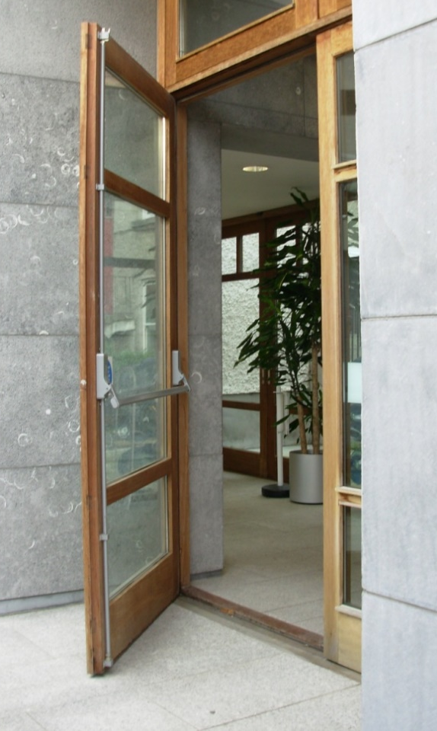
Figure 10 Emergency Escape Door
Accessible features:
This emergency exit door has a near-level threshold and an easy-to-use opening device.
What could be improved?
A fully level threshold will ensure that wheelchair users can exit the building with ease in an emergency.

Managing Evacuation Procedures
Ensure that appropriate evacuation plans are in place to meet the needs of all building users.
This will require the following actions:
- Review the evacuation plan and safety statement to ensure that the needs of people with disabilities have been met
- Make sure that all evacuation routes are kept clear of obstructions
- In multi-storey buildings, get expert advice on options for using a lift to evacuate wheelchair users and people with mobility impairments
- Make sure that safe evacuation arrangements including people with disabilities are in place when school facilities are rented out for classes or events
- Prepare a Personal Emergency Evacuation Plan (PEEP) for any students or staff members who need extra help to evacuate safely
- Make sure that a PEEP is prepared for any new students or new staff members who need extra help to evacuate safely, before they arrive at the school

Facilities

Reception
The reception facility in a school is often the first point of contact for parents and other visitors.
As with all other facilities, it should be designed to meet the needs of all people.
The height of the reception desk should be designed to accommodate students, wheelchair users, and people of tall and small stature. If a desk is to be used for form-filling, it should have a knee space so that a wheelchair user can pull into the desk.
An induction loop with appropriate signage should be provided to assist hearing-aid users to communicate with the receptionist.
It is important to avoid light sources such as windows behind the desk that could cause glare. Also, patterned backgrounds should be avoided, as these can make it difficult for people with hearing loss to lip-read.
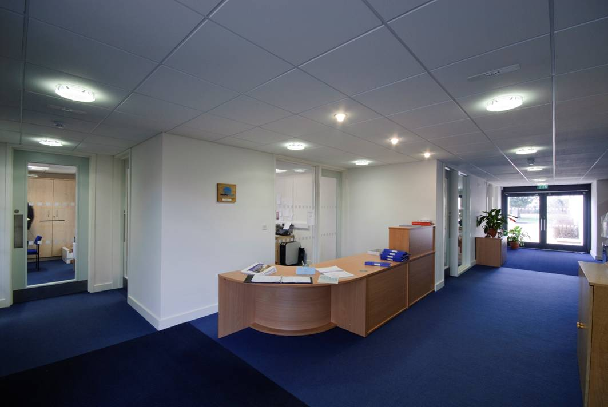
Figure 11 Reception Area
Accessible features:
This reception desk has surfaces to suit both standing and seated users, and there is a recessed section to provide knee-space on the corner.
There is good visual contrast between the floor and the walls.
What could be improved?
The glazed screen behind the reception desk could make it difficult for someone to lip-read.
There is no signage to indicate that an induction loop has been installed.
Providing visual contrast between the doors and the surrounding wall would make it easier for people with vision loss to locate their position.

Toilets
Accessible toilets are a fundamental requirement for many people with disabilities.

Provision of toilet facilities
The minimum accessible toilet provision usually includes providing larger-than-standard-sized cubicles with grabrails in separate sex washrooms for ambulant people with disabilities. It also includes providing separate unisex wheelchair-accessible toilets.
Unisex accessible toilets are designed with extra space and fittings to allow for independent use by wheelchair users. These are also commonly used by people with other mobility disabilities and vision loss. Providing a unisex cubicle with separate access allows for assistance to be provided by an assistant of either gender.
In general, accessible toilets in schools should be provided in the same location as other toilet facilities. In primary schools in Ireland, toilets are usually provided within the classroom. Consideration should be given to providing adjacent accessible toilets in some classrooms, so that students with disabilities do not have to travel further than other students. Principals can then consider students’ toileting needs when allocating classes to classrooms.
Some students may prefer to use accessible toilets away from the classroom, for reasons of privacy and dignity. They may want to avoid drawing attention to the time required for toileting or the need for assistance. It is therefore important that at least one accessible toilet is available outside the classroom, within a reasonable travel distance.
Some students with disabilities may require additional assistance with toileting. A separate facility with a toilet designed for assisted use, a shower, a hoist, and a changing bench should also be provided. These are sometimes known as hygiene rooms or ‘Changing Places’ facilities.
Some students with disabilities may need the toilet immediately on arrival at school, so the travel distance from the entrance to the nearest accessible toilet should be minimised.
Toilet facilities for staff should also include accessible toilets.

Design of toilet facilities
Controls in toilet facilities should be easy to understand and use. Door handles, cubicle latches, taps, and flushing mechanisms should be operable with a closed fist. The operation of these items should be uncomplicated.
For younger primary students, WCs should generally be of a lower height, and grabrails at a reduced width. The seat of an accessible WC should be at a similar height to the seat of the user’s wheelchair. The US Access Board produced the following advisory guidance on dimensions (in inches) for children’s toilets in healthcare settings:
Ages | 3-4 years | 5-8 years | 9-12 years
WC Centreline | 12 in | 12 – 15 in | 15 – 18 in
Toilet Seat Height | 11 – 12 in | 12 – 15 in | 15 – 17 in
Grab Bar Height | 18 – 20 in | 20 – 25 in | 25 – 27 in
Dispenser Height | 14 in | 14 – 17 in | 17 – 19 in

The following documents give further advice on the detail design of accessible toilet facilities:
Building for Everyone – A Universal Design approach (National Disability Authority), http://www.universaldesign.ie/buildingforeveryone
BS8300:2009 + A1:2010, Design of Buildings and their approaches to meet the needs of disabled people - Code of practice (British Standards Institution) – clause 12.6
Building Bulletin 102, Designing for disabled children and children with special educational needs, guidance for mainstream and special schools (Department for Children, Schools and Families, UK)

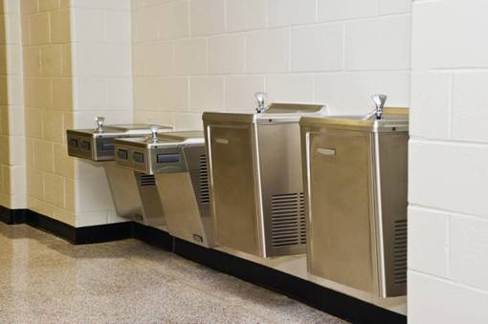
Figure 12 Drinking Fountains
Accessible features:
Hydration is important for all students: it impacts concentration and alertness. These drinking fountains have been designed with a range of users in mind.
The different heights suit students of different ages and heights.
Knee space is provided under the lower level fountains to allow wheelchair users to use them.
The fountains are recessed in the circulation space to avoid creating an obstruction on the route.

Lockers and Cloakrooms
Students with mobility difficulties can sometimes have difficulties using lockers or cloakrooms. Problems can arise with:
- the height of coat hooks
- the type of lock used on the locker
- the capacity of the locker to store mobility aids or assistive technology
- the space available around the locker
Schools should ensure that lockers are of adequate size and are usable by all students.

Managing Toilet Facilities
Ensure that the accessibility of all school facilities are regularly monitored and maintained.
Some of the issues to address include:
- keeping transfer areas in accessible toilets free of obstruction
- ensuring any alarm pull cords are located within 100mm of the floor
- ensuring that somebody will respond to alarms from an accessible toilet
- ensuring toilets used by people with disabilities are kept particularly clean, as some people depend on the WC surfaces for support
- providing sanitary disposal bins that are emptied regularly and positioned within reach of the toilet, but that do not block transfer areas

The Classroom
The classroom is the most common type of room in a school building. An appropriate classroom environment is important for successful teaching and learning and for ensuring that all students can participate equally in classroom activities.
The following guidance applies to both general and specialist classrooms. Additional guidance that is specific to different specialist classrooms is provided in the following sections.
It is important that all students can circulate freely around the classroom, and can access storage areas, equipment, sinks, sockets, and so on. The provision of ample space and level access is important for those using assistive devices, such as wheelchairs, crutches or canes. Worktops and sinks should have knee space underneath to allow a wheelchair user to use them comfortably.
Students with emotional, psychological or mental health issues may need more space around them, or they may need access to quiet rooms to allow them to refocus. In some cases, they may need spaces that allow for engagement with a number of adults at one time. Appropriate use of lighting and colour can help to create a calming environment.
Students who have intellectual or learning disabilities will benefit from a design approach that reduces visual and auditory distractions. Distractions can arise from other students passing through nearby corridors, or from noisy sports or music activities, or from external distractions, such as buses or grass cutting.
The Summary Guidelines for School Design to Include Children with Disabilities, from the Center for Architecture and Building Science Research at New Jersey Institute of Technology, notes that distractions in the classroom can result from “the close presence of other children: sharing a table that is too small, other kids’ materials (books, papers, devices, etc.) extending into their space, etc,.” and “excessive visual stimulation from glare, clutter, displays, equipment, and supplies that fill the classroom”.
Students who have difficulties with remembering and concentrating will also benefit from reduced distractions. They may need access to assistive technology (such as a laptop computer with specialist software) to help them to manage their learning processes.
Students who have speech disabilities may need alternative ways to communicate with their teachers and their peers. Classrooms designed to facilitate the use of computers with assistive technology can be very helpful in meeting and supporting these needs. Requirements include appropriate desk space, power points, and network connectivity (fixed or wireless). A suitable acoustic environment that avoids or reduces noise distractions will also be helpful.

Classroom Acoustics
Speech is a key element of teaching and learning in most classrooms: it is the main method of communication between teachers and students. Up to 80% of all classroom activities require listening and speaking.
The quality of a classroom's acoustics can influence speech intelligibility and is therefore an important consideration in classroom design.
All students need good acoustic conditions to help them concentrate and learn. The Department of Education and Skills publication, ‘Technical Guidance Document TGD-023 Post-primary School Design Guidelines’, notes that: “Good acoustic separation (min 45dB) is required for all teaching spaces and noise-sensitive rooms”.
Good acoustic conditions are especially important for students who are deaf or hard of hearing.
A poor acoustical environment is an architectural barrier to students with hearing loss as much as a set of stairs might be a barrier for a child in a wheelchair. (Roy, 2006)
Good acoustic conditions are also important for students:
- with speech and language difficulties
- whose first language is not English
- with vision loss
- with attention deficit hyperactivity disorders
- with central auditory processing difficulties (British Standards Institution, 2009)
- with autistic spectrum disorders (Mostafa, 2008)
Acoustics is a complex area and may require expert advice. Two of the main areas for consideration are background noise and reverberation time, both of which are affected by the construction materials and finishes in a room.

Background Noise
Background noise can mask speech and decrease intelligibility. It can also cause teachers to speak louder, which can lead to voice strain (UK Department of Education and Skills, 2003, Building Bulletin 93, Acoustic Design of Schools, A Design Guide p.54).
People with hearing loss are affected more by background noise than those with normal hearing (Ecophon, 2002, p.94).
Background noise can come from outside the building, for example, from traffic noise; and from inside the building, for example, from adjacent circulation spaces.
Background noise can be minimised at design stage by locating noisy activities away from rooms that require a quieter environment, and by ensuring that the school layout responds to external noise conditions.
Construction materials should be selected to provide sound insulation that will minimise background noise in classrooms.
In existing schools, management solutions can help to reduce problematic background noise and improve acoustics. Solutions include keeping windows closed; using window blinds; putting rubber caps on chair legs; and using soft materials on walls, ceilings and other hard surfaces to reduce echo. Tablecloths, mobiles hanging from the ceiling, and wall displays using soft materials can all help to reduce echo. If these management solutions are not sufficient, expert advice should be sought in relation to the installation of suitable sound insulation.

Reverberation Time
The term 'reverberation time' relates to the time that a sound is heard after it has been spoken. Long reverberation times mean that a word does not have time to finish before the next word reaches the listener – this can cause poor speech intelligibility. In classrooms with long reverberation times, teachers are competing with their own echo for attention from students.
Classroom reverberation times can be calculated based on the sound absorption qualities and areas of wall, floor and ceiling finishes. The American National Standards Institute (ANSI) standard for the acoustical design of schools S12.60-2002, "Acoustical Performance Criteria, Design Requirements and Guidelines for Schools" specifies maximum reverberation times of between 0.6 and 0.7 seconds for classrooms.
The finishes used in a classroom can affect the reverberation time in the room. In general, hard reflective surfaces will increase the reverberation time in a classroom, whereas softer surfaces tend to absorb sound and help reduce reverberation times.
In practical terms, using soft furnishings, carpets, or sound-absorbing noticeboards may help to reduce the reverberation time in a classroom. Where sound-absorbing floor and wall finishes and fittings may not be appropriate for maintenance and durability reasons, providing a sound-absorbing ceiling may be more appropriate.
Further detailed guidance on acoustics is available at:
- Here to Learn – a DVD resource for schools, (National Deaf Children’s Society UK)
- Building Bulletin 93, Acoustic Design of Schools, A Design Guide, (Department for Education and Skills UK)
- Quiet Classrooms - alliance of non-profit organizations working to create better learning environments in schools by reducing noise. http://www.quietclassrooms.org

Equipment for Students with Special Hearing Requirements
Students who use hearing aids may benefit from a range of technological solutions in the classroom, including radio aids (sometimes called personal FM systems), induction loop systems, infra-red transmitters, and classroom soundfield systems. Care should be taken when purchasing these systems to ensure that they are suitable for the school’s particular needs.
All these systems require the teacher to wear a microphone; usually a wireless mic worn around the neck or clipped to a lapel. These systems will not work successfully unless teachers wear the mic for every class. This can be problematic, particularly in secondary schools, where the teacher will change for each class period. Staff may also need to be trained in basic troubleshooting techniques, such as replacing batteries and ensuring that microphones and receivers are using the same frequency.
Radio aids, induction loops, and infra-red transmitters provide more direct sound input, while reducing or eliminating reverberation: they can provide optimal sound clarity.
Induction loop systems can overspill into neighbouring areas. This makes it difficult to fit loop systems to adjacent classrooms. Where loops are required, it may be more effective to fit loops to selected classrooms, and allocated students and subjects accordingly.
Soundfield systems may offer some benefit to students with mild hearing loss who don’t use hearing aids. The classroom will be fitted with speakers in the ceiling or walls to ensure that the teacher’s voice is heard clearly throughout the classroom. Soundfield systems differ from traditional public address systems by making the sound clearer, not louder. Portable soundfield systems are available that can be moved between classrooms as required.
Some of the technology may improve the student’s ability to hear the teacher, but may not help the student to hear their classmates in group-work scenarios. In situations where a student with hearing loss is part of a mainstream class, advice should be sought from a specialist as to the most appropriate technology to suit the student's needs.

Space and Layout
A key element of an accessible environment is the provision of sufficient space.
UK guidance points out that a student with learning aids and a special needs assistant may need the same space as two non-disabled students. A student using a wheelchair and/or mobility aids may need the space used by three non-disabled students. Additional storage space may be required for large objects such as crutches, walking frames, and standing frames, which may be required at certain times of the day. It is important that space is managed to keep adequate circulation space available over time.
Furniture layouts in classrooms need to be carefully planned to ensure space at the entrance and access to key facilities such as the whiteboard, storage areas, and practical zones.
An 1800mm turning space at these areas should be maintained as should a preferred circulation width of 1200mm for movement between them. A minimum of 900mm circulation width should be available on all routes. This space is based on the requirements of wheelchair users, but will also benefit a range of 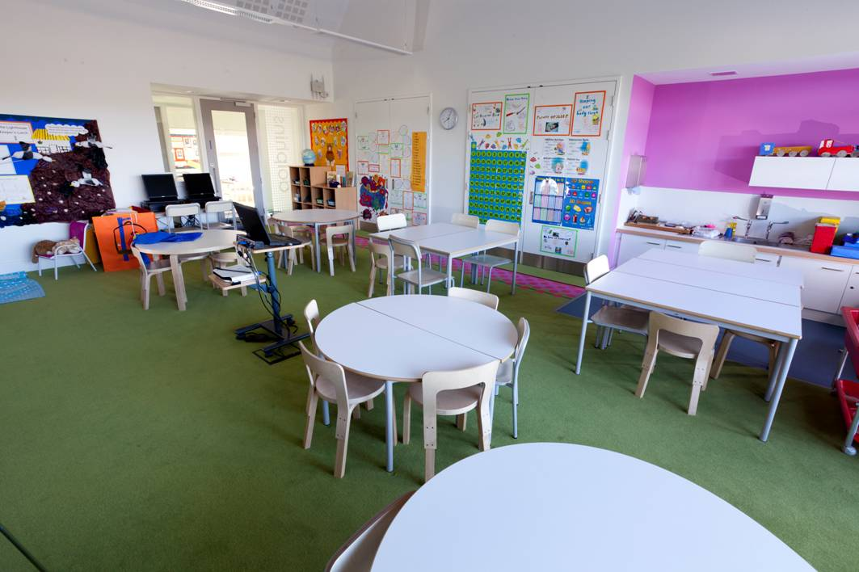other users.

Figure 13 Classroom
Accessible features:
This primary school classroom has good visual contrast between the floor and walls and between the floor and furniture.
A section of acoustic panelling is visible in the ceiling.
What could be improved?
In general, the furniture layout has good circulation space between the tables, although the area in front of the door is cluttered.

Lighting
Lighting has a significant impact on the ability of students to concentrate and learn in comfort. Controllable lighting systems, which can increase or decrease light levels in particular parts of the classroom, are very helpful for students with disabilities.
It is important that lighting levels are reasonably consistent, so students do not experience wide variations in light levels when moving their vision from their own desk to the teacher.
Day-lighting is an important factor in all schools. The Department of Education and Skills Technical Guidance Document 020 states that: “The geometry and distribution of glazed areas shall be carefully designed to provide a high level of natural light while avoiding glare and ensuring a good quality day-lighting distribution in the room with average day-lighting factor in the range of 4.5 to 5.5%”.
Lighting systems should accommodate the inherent variability of daylight by allowing the levels of light provided to be controlled or automatically adjusted. Automatic controls can help save energy costs by maximising use of daylight.
Lighting should take into account the different needs of all students. Students with vision loss need good lighting levels to enhance their sight, and may require additional lighting for certain tasks.
International standards for classroom lighting range from 300 Lux to 500 Lux. German standards require 1500 Lux for high-precision tasks. Emerging research shows significant improvements in classroom performance arising from improved lighting.
Deaf and hard-of-hearing students need clear visibility for lip-reading. Some students may be particularly sensitive to glare. Therefore, it is important to be able to control the sunlight entering a space by installing suitable blinds, for example, as detailed in the Department of Education and Skills Technical Guidance Documents.
Venetian blinds can create lined patterns of light that may be distracting or confusing for some students.

Environmental Controls
Effective ventilation is important for all students. A lack of fresh air can cause concentration and drowsiness issues.
Where mechanical ventilation systems are used, it is important that their operation is virtually silent: background noise can seriously affect the acoustic performance of a classroom.
Excessive heat or cold can be a distraction from learning. The UK publication ‘Building Bulletin 102 Designing for disabled children and children with special educational needs’ recommends temperatures of 18 – 21 degrees Centigrade for normal conditions.
Where radiators are used, care should be taken to eliminate any risk of burn injuries though contact with radiator surfaces, particularly for younger students, students with intellectual disabilities or people with reduced sensation.

Assistive Technology
Students with disabilities may use a wide range of assistive technology, including magnifiers, screen reading technology, and portable writing and communication devices.
There should be a sufficient supply of electrical outlets around a classroom to facilitate those who need access to electrical power. Using floor-mounted sockets can avoid the hazard of cables trailing across the floor.
Managing the Classroom Environment
Schedule periodic reviews to ensure that classroom accessibility is maintained.
Some items for consideration include:
- periodically testing equipment such as induction loops and audio systems to ensure they continue to function
- ensuring an adequate supply of fresh or freshly charged batteries to power any portable accessibility devices or microphones
- maintaining audio visual equipment, such as projectors, to ensure they do not cause difficulties such as background noise or excessive heat
- removing clutter from equipment or class projects and so on to keep access routes clear throughout the room
- ensuring that lighting is kept in good working order by replacing any used bulbs or fittings
- inviting students and teachers to point out any problems that they notice with lighting or acoustics, so that these can then be addressed within a reasonable time

Specialist Rooms
The important features of classroom design outlined above also apply to other teaching rooms. However, specialist rooms require additional consideration. Some of this information is more relevant to post-primary than primary schools.

Support Teaching Rooms
Small group rooms that allow for flexible use are an invaluable resource for most schools. They can be used for small group learning or one-to-one work by learning support, resource and language teachers. They are also suitable for therapists providing some types of services.
Support teaching rooms should be located close to mainstream classrooms to allow for ease of movement between spaces (Department for Children, Schools and Families (UK), 2008).

General Purpose Rooms/Assembly Rooms
General purpose rooms and spaces are used for a range of functions including assembly, presentations and performances.
A number of features should be included in general purpose rooms, including:
- good acoustic design and the provision of a hearing enhancement system, such as an induction loop
- glare-free lighting
Where a permanent or temporary stage is being used, access to the stage for all students is important. This may involve a ramp or a platform lift and stepped access.

Sports Halls and Fitness Suites
Sports and physical activity are a fundamental element in a student’s education. Schools should ensure that students with disabilities should have access to appropriate physical activities. Disability organisations and local authority Disability Sports Officers can be a valuable source of information on opportunities and good practices.
Sports halls should incorporate all of the access requirements that apply to general building design.
Other considerations include accessible facilities for both spectators and participants, such as accessible viewing areas, and changing, showering and toilet facilities. Sports wheelchairs may be longer than traditional wheelchairs, and may require extra turning and circulation space.
If a fitness suite is provided at an upper level, it is important that all students have access to this level of the building.
Accessible Sports Facilities from Sport England gives further advice on the design of accessible sports facilities – see http://www.sportengland.org.

Cafeterias
Where dining, eating or food preparation facilities are provided; care should be taken to ensure that all students and staff members can safely and independently use the facility.
Cafeteria environments should not be viewed as purely functional but should be structured to facilitate social interaction and inclusion with peers.
Other considerations in cafeteria environments:
- Tables should be accessible to wheelchair users
- Aisles should be wide enough to allow students carrying trays to safely pass
- Self-service shelves and dispensers for cutlery and condiments should be within reach of wheelchair users and people of small stature.
- Tray slides allow trays to be rested while moving along a counter. These should be continuous to reduce the chances of dropping trays, and have knee space underneath to accommodate wheelchair users
- Some students may need privacy during meals, so it would be helpful to have screens available as required

Science Laboratories
Physical access, the use of equipment, high workbenches, and safety are some of the barriers that students with disabilities face when using a science laboratory.
Addressing these issues will allow all students to participate in practical experiments and demonstrations which form a vital element of teaching and learning.
Some items for consideration include:
- accessible workbenches and laboratory stations – featuring height-adjustable benches, appropriate chair design, space around the work station, and appropriate reach ranges to equipment and storage
- accessible equipment – for example, controls such as gas-on and -off switches should have lever handles suitable for people with limited dexterity, and clear visual indicators
- health and safety requirements– particularly important in laboratories. For example, evacuation routes and safety equipment should be accessible to all
The UK publication ‘Building Bulletin 102 Designing for disabled children and children with special educational needs’ includes a template design for a science laboratory which includes a wheelchair-accessible workbench and a height-adjustable sink.

Computer Rooms
Computer facilities are of particular importance to students with disabilities – they can use IT facilities to access services and information that would otherwise be unavailable to them.
Computer room furniture should be laid out to ensure easy movement around the room.
Circulation routes should be kept clear of cables and other equipment which could cause obstruction.
Items for consideration in computer rooms:
- Some students may require height-adjustable tables
- Lighting should be glare-free to ensure that computer screens can be clearly seen
- Adequate space should be made available for specialist assistive technologies, such as joysticks and screen magnification software, which may be required by certain students
- Individual study areas may be useful to reduce distraction, for instance if speech recognition software is being used

Art Rooms
Important considerations in the design of art rooms are lighting, ventilation, displays, washing facilities, and safety equipment.
There are a number of ways to improve the accessibility of these rooms including:
- providing height-adjustable easels and workstations
- storing equipment at accessible locations and heights
- providing a height-adjustable sink

Home Economics Rooms
Important elements in the design of home economics rooms are the design and layout of practical areas; the layout, location and ease of use of equipment and appliances; and lighting, noise levels and storage.
Wall-mounted ovens with side hinges are often easier to operate because they do not require students to bend their back or knees (Bar and Galluzzo, 1999). They also allow wheelchair users to position themselves closely to the oven. A pull-out board beneath the oven provides a safe and convenient resting place for hot dishes.
A hob should be flush with the adjoining counter so that students can safely slide pots on and off the surface. For safety reasons, there should not be knee clearance under a hob.

Workshops
In 2003, the Department of Education and Science carried out research on the design of practical workshops for subjects such as Engineering, Technology, Technical Graphics, and Construction.
The research identified five key areas relating to educational and operational inclusion of students with disabilities:
- Safety
- Access
- Workbench design
- Tool design
- Machine design
Research suggests that addressing these elements allows students with disabilities to use these facilities in a safe and productive environment.
The workbench is the main work area for students or employees, and traditional designs present major obstacles. Height-adjustable workbenches are required for some students with disabilities.
In summary, to allow all users safely use the workshops, the following elements need to be introduced or redesigned:
- Height-adjustable workbenches
- Accessible circulation routes
- Access to portable storage
- Wide doors
- Accessible computer workstations
- Accessible drawing desks in design rooms
- Accessible emergency exits
- Accessible machines
- Accessible work counters
Schools may need to engage with manufacturers and suppliers when purchasing workshop equipment to ensure that it is accessible for all students.
Many workshop activities involve a certain degree of risk for all students. Schools should avoid any kind of ‘blanket ban’ on participation in these activities for students with disabilities. Decisions about including students should be taken as a result of a risk assessment based on the students own particular abilities and disabilities. The Safety Statement may need to be updated to reflect agreed approaches for workshops.
Care should be taken in workshops to ensure that dust or other airborne pollutants do not cause difficulties for students with asthma or other respiratory conditions.

Libraries
The important elements that need to be considered in the library include:
- circulation – all students should be able to get around the library independently
- check-out counters, which should feature an induction loop, high- and low-level counters, space to access the counter, and good lighting
- storage – books should be located so that they are accessible to all students, including wheelchair users. If this is not practicable, alternative ways of making books on high shelves available to everybody should be considered
- assistive technology – facilities for technology such as magnifiers, screen reading technology, alternate keyboards, and joysticks should be available
- window blinds may be needed to ensure computer screens can be clearly seen during daylight hours

Managing Specialist Rooms
Consider the following accessibility issues as part of the ongoing management processes for specialist rooms:
- Ensure the annual timetabling process that allocates students and classes to rooms takes account of the needs of students and teachers with disabilities
- Ensure that the requirements of students with disabilities are considered when buying new equipment for any specialist rooms, including lab equipment, computer equipment, audio visual equipment, cooking facilities, workshop tools, and so on. When buying equipment with a long life span, the needs of all potential students should be taken into account

References and Further Reading
Ahrentzen, S. & Steele, K., 2009, Advancing Full Spectrum Housing: Design for Adults with Autism Spectrum Disorders, ASU Stardust Center for Affordable Homes and the Family and ASU Herberger Institute School of Architecture and Landscape Architecture, [pdf download] http://stardust.asu.edu/research_resources/detail.php?id=60, cited 31st August 2010
Bar L., & Galluzzo, J., 1999. The accessible school: Universal design for educational settings, Berkeley, CA: MIG Communications.
British Standards Institution, 2009, BS8300:2009 + A1:2010, Design of Buildings and their approaches to meet the needs of disabled people - Code of practice, BSI
Department for Children, Schools and Families (UK), 2008, Building Bulletin 102 Designing for disabled children and children with special educational needs - Guidance for mainstream and special schools, London, the Stationery Office.
Department of Education and Skills (UK), 2003, Building Bulletin 93, Acoustic Design of Schools, A Design Guide, London, the Stationery Office.
Department of Education and Skills, 2008, Technical Guidance Document TGD-020 - General Design Guidelines for Schools (Primary & Post-primary) – Revision 1 October 2011
Department of Education and Skills, 2008, Technical Guidance Document TGD-022 - Primary School Design Guidelines revision 2 August 2010
Department of Education and Skills, 2008, Technical Guidance Document TGD-023 Post-primary School Design Guidelines
Department of the Environment, Community and Local Government, 2010, Building Regulations 2010, Technical Guidance Document M - Access and Use, Department of the Environment, Community and Local Government,
Ecophon, 2002, Don't Limit Your Senses, Sound and the Learning Environment, Sweden, Saint Gobain Ecophon
Equality Authority, 2005, Schools and the Equal Status Acts, Equality Authority.
Irish Wheelchair Association, 2010, Best Practice Access Guidelines, Irish Wheelchair Association
Kenny, M., McNeela, E., Shevlin, M., & Daly, T., 2000, Hidden Voices: Young People with Disabilities Speak about their Second Level Schooling. Baillincollig County Cork, The South West Regional Authority.
Mostafa, M., 2008, An Architecture for Autism: Concepts of Design Intervention for the Autistic User, International Journal of Architectural Research 2(1):189-211
National Deaf Children’s Society (UK), 2008, Here to Learn (DVD)
National Disability Authority, 2012, Building for Everyone- a universal design approach, National Disability Authority http://www.universaldesign.ie/buildingforeveryone
OPTIC - OPTimising the Inclusive Classroom, http://optic-comenius.eu/en.html, cited 11th May 2011
Richard V. Olsen, Ph.D , 20xx, Summary Guidelines for School Design to Include Children with Disabilities, Center for Architecture and Building Science Research. New Jersey Institute of Technology
Roy, K. P., 2006, Acoustic Classroom Designs Break Learning Barrier, Commercial Building Products, [webpage], http://www.cbpmagazine.com/article.php?articleid=103, cited 12th August 2010

Glossary
Access Control System: Any technique used to control passage into or out of any area (Source:SilvaConsultants.com)
Ambulant People: People who can move or walk about. (Source: TheFreeDictionary.com)
Assistive Technology: Any product or service designed to enable independence for people with disabilities and older people. .
Communication Aid: Anything that helps an individual communicate more effectively with those around them (Source: AssistIreland.ie)
Compartmentation: Restricting the spread of fire within a building by sub-dividing it into compartments separated from one another by walls and/or floors of fire-resisting construction. (Source: Part B Technical Guidance Document, Department of the Environment, Community and Local Government).
Door Closer: Device that makes use of a spring for closing, and a compression chamber from which liquid or air escapes slowly, to close a door at a controlled speed. (Source: TheFreeDictionary.com)
Evacuation Chair: Devices to allow people with disabilities, particularly those with mobility difficulties, to be helped to move down and, in some case, up stairs during an evacuation.
Induction Loop: A system enabling partially deaf people to hear dialogue and sound in theatres, cinemas, counters etc., consisting of a loop of wire placed round the perimeter of a designated area. (Source: TheFreeDictionary.com)
Magnetic hold-open devices: Devices that enable doors to be held open in a fixed position, allowing unobstructed or at least much easier and useable access for all building users, especially older people and those with limited strength, reach or dexterity. When the power supply to these devices is interrupted by a smoke detection signal, operated by a manual release mechanism or power failure, the doors close under the power of the closing device.
Nosing: An edge part of the step tread that protrudes over the riser beneath in a flight of stairs.
Passenger Lift: A conventional motorised lift enclosed within a structural shaft and rising one or more storeys within a building. Lift and door movement is automatic.
Platform Lift: Sometimes Vertical platform lift – A guarded platform that travels vertically and is designed to accommodate one wheelchair user and one companion. Vertical platform lifts do not require a structural shaft, but are required to be enclosed if they rise more than 2000mm. Also termed vertical lifting platform; vertical-rise platform lift; short-rise platform lift (up to 2000mm rise); enclosed platform lift; hydraulic platform lift; and scissor lift.
Reverberation Time: Reverberation is the persistence of sound in a particular space after the original sound is removed. (Source: Wikipedia)
Riser: The vertical portion between each tread on the stair.
Soundfield System: Soundfield is a speech intelligibility audio system that provides clarity of voice and distributes sound evenly in a classroom or learning environment. (Source: lightspeedtek.co.uk)
Speech Intelligibility: a measure of the degree to which a person can be understood by a listener. (Source: Bernd J. Kröger, University Hospital, Technical University Aachen)
Tactile Paving Or Tactile paving surface: A profiled paving or textured surface that provides guidance or warning to pedestrians with visual difficulties.
Transfer Space: The space beside the toilet in an accessible bathroom where a wheelchair user will normally position themselves before transferring onto the toilet seat
Turning Area: An area where a wheelchair user can change direction, ideally a circle of 1800 diameter
Universal Design: Universal Design refers to the design and composition of an environment so that it can be accessed, understood and used to the greatest extent possible by all people, regardless of their age, size, ability or disability.
Vibrating Alarm: Portable devices that are normally linked to the fire alarm system that can provide a vibrating signal to warn the person to evacuate the building.

