Indicators for Monitoring Progress under the Comprehensive Employment Strategy for Persons with Disabilities 2015-2024
October 2020
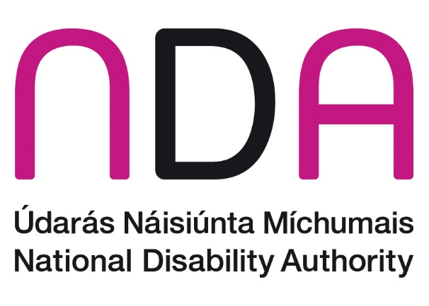

Contents
List of Acronyms 3
Executive Summary 5
Introduction 12
Methods 15
Strategic Priority 1: Building skills, capacity and independence 16
Strategic Priority 2: Provide bridges and supports into work 30
Strategic Priority 3: Make Work Pay 42
Strategic Priority 4: Promote job retention and re-entry to work 45
Strategic Priority 5: Provide coordinated and seamless support 51
Strategic Priority 6: Engage employers 54
Conclusion 64
Appendix I. Amendments to original indicator set 73
Appendix II. New indicators added to set 80

List of Acronyms
ADD Attention Deficit Disorder
ADHD Attention Deficit Hyperactivity Disorder (ADHD)
AIM Access and Inclusion Model
BTEA Back to Education Allowance
CES Comprehensive Employment Strategy
CHO Community Healthcare Organisation
CSO Central Statistics Office
DA Disability Allowance
DARE Disability Access Route to Education
DBEI Department of Business, Enterprise and Innovation
DCA Domiciliary Care Allowance
DCYA Department of Children and Youth Affairs
DEASP Department of Employment Affairs and Social Protection
DEIS Delivering Equality of Opportunity in Schools
DES Department of Education and Skills
DOH Department of Health
ECCE Early Childhood Care and Education
EDI Employer Disability Information Service
ETBI Education and Training Boards Ireland
FET Further Education and Training
HEA Higher Education Authority
HRB Health Research Board
HSE Health Service Executive
IB Illness Benefit
IPS Individual Placement and Support
NASS National Ability Support System
NCCA National Council for Curriculum and Assessment
NCSE National Council for Special Education
NDA National Disability Authority
NDIS National Disability Inclusion Strategy
NEET Not in Education, Employment or Training
NEPS National Educational Psychological Services
NTA National Transport Authority
OWL Oireachtas Work Learning Programme
RAF Reasonable Accommodation Fund
RT Rehabilitative Training
UNCRPD United Nations Convention on the Rights of Persons with Disabilities
WAM Willing and Able Mentoring Programme
WSS Wage Subsidy Scheme
YESS Youth Employment Support Scheme

Executive Summary
This document provides a mid-term analysis of the suite of indicators for monitoring progress under the Comprehensive Employment Strategy for Persons with Disabilities 2015-2024. It has been prepared by the National Disability Authority (NDA). This report presents information on 31 indicators across six strategic priorities. The indicators are categorised as being process (73%) or outcome (27%) indicators. There are no structural indicators. While publically available data was used where possible, for example from the Central Statistics Office or in the annual reports of various bodies, other data was accessed upon request from the HSE and the DEASP. At this time, a number of requests for data are outstanding. This has been indicated in the main body of the report where applicable. A number of indicators were modified from the original set due to the absence of recorded data. Appended to the report is a table outlining the indicators that have been modified. Below is a summary of the main findings under the six strategic priorities.

SP1: Building skills, capacity and independence
The intention of this priority area is that “Each person with a disability will have the education, skills, competence and independence to obtain employment.” The main findings within this strategic priority area are set out below.
The Access and Inclusion Model (AIM) - a model of supports designed to ensure that children with disabilities can access the Early Childhood Care and Education (ECCE) Programme has experienced a 67% increase in numbers of children accessing targeted pre-school support between the years 2016 and 2018. There have been positive changes in the educational profile and participation of persons with disabilities over time. Between 2011 and 2016, the proportion of persons with disabilities whose highest level of education was primary school decreased by 6.3%, the proportion with further education and training (FET) and tertiary level education increased by 1.6% and 2.3% respectively, and the proportion of early school leavers had decreased from 22.9% in 2011 to 18.1% in 2016.
In 2015, the National Educational Psychological Services (NEPS) revised their existing materials on transitions from primary to post-primary and in 2016 the National Council for Special Education (NCSE) published a number of resources to support planning for effective transitions for those with special educational needs. A taskforce is being convened by the Department of Education and Skills (DES) in 2020 to focus specifically on the issue of career guidance for those with special educational needs as children and young people in special schools are still unable to avail of this guidance. Work was commenced by NCSE and the HSE in 2019 to consider transition arrangements between HSE-funded services and education, and vice versa. And in 2018, a pilot process was set up to enable school leavers with disabilities to defer their place in an adult day service or in rehabilitative training (RT) in order to experience further education, training or employment first. All of these initiatives suggest progress is being made on transition planning, however there is no data available on the impact of these activities on the lives of children and young people with disabilities.
For those with disabilities who have undertaken RT, the figures show a notable increase in the proportion of exits into HSE-funded day services. While this increase is partly due to a concerning decrease exiting into employment, training and education, it is also due to a decrease in for example, exits due to illness or to no occupation.
The participation by persons with disabilities in higher education has increased yearly since 2015. Of note, is that the gap between persons with and without disabilities lessened in relation to completing FET and early school leaving between 2011 and 2016. On the other hand, the gap between persons with and without disabilities who had completed higher education widened over the same period. By 2016, persons with disabilities were still more likely to have left school early, to have no formal education or have only completed primary school, and were less likely to have completed FET or tertiary level education than their non-disabled counterparts. By 2018, persons with disabilities were better represented in higher education than in FET and in FET than the apprenticeship population. However, persons with disabilities were still underrepresented in higher education, FET and most markedly so, the apprenticeship populations.
The number of young people aged 16 to 19 in receipt of Disability Allowance (DA) increased between 2015 and 2018, and over this time they also made up an increasing percentage of the total DA recipients.
The Back to Education Allowance (BTEA) scheme provides income support to persons in receipt of certain social welfare payments, including disability payments, to undertake education or training. The numbers of BTEA recipients who had moved from disability payments reduced each year from 318 in 2015 to 199 in 2018, as did the overall number of BTEA recipients. Persons with disabilities made up very small proportions of BTEA recipients between 2015 and 2018, although these proportions did improve between from 1.8% in 2015 to 2.3% in 2018.

SP2: Provide bridges and supports into work
The intention of this priority area is that “People with disabilities will be provided with individualised bridges and supports to secure jobs in the open labour market.”
Under the HSE’s New Directions policy for adult day services there is a commitment to ensuring persons with disabilities can transition out of sheltered employment, while recognising the need for coordinated and tailored supports to facilitate this process. The NDA advises the importance of continued focus on the work being progressed by the HSE to address sheltered work, as well as the necessity for collaborative approaches from other departments and agencies in this regard.
The need for bridges and supports into education, training and employment is emphasised by the proportion of young persons with disabilities not in education, employment or training (NEET). Although the proportion of young people with disabilities who are NEET improved between 2011 and 2016, the same gap remained between those with and without disabilities. In 2016, almost one quarter of 15 to 24 year olds with disabilities were NEET. Positive impacts on persons with disabilities in this regard can be seen in the increases in the number of graduates on placements through the Willing Able and Mentoring programme each year since 2015 and on the introduction of the Oireachtas Work Learning (OWL) programme. After the first year of this programme, 7 out of the 10 OWL graduates had gained employment. The Youth Employment Support Scheme (YESS) which offers a way for young persons with disabilities aged 18-24 to gain work experience has had less of an impact given the uptake for those with disabilities has been extremely low. While the EmployAbility programme has consistently had approximately 30% of participants with disabilities exit into employment each year since 2014, as acknowledged previously, there is room for this figure to improve.
There have been a number of improvements in public transport accessibility in recent years, including the introduction of apps to make journeys for those with disabilities easier, improvements to the accessibility of transport stops, and an increase in the number of wheelchair accessible taxis. It is challenging to estimate the impact of such changes on the lives of those with disabilities using available data. Census data does indicate that in 2016, persons with disabilities were more likely to take a bus, minibus or coach to work than persons without disabilities and just as likely to take a train, DART or Luas. However, without geographical data it is not possible to establish the extent to which inequities in urban/rural provision of accessible transport remain, although NDA notes that it is an issue regularly raised by stakeholders. The census data also relates to the cohort of people already in work, and of particular interest is whether recent initiatives have improved the situation of those for whom a lack of accessible transport has previously been a barrier to employment. NDA advises this would require further exploration.
EI and Local Enterprise Offices provide a range of enterprise supports to individuals. Their impact on those with disabilities are unknown, as there are no supports aimed specifically at persons with a disability and information on disability is not sought or recorded for those using supports. NDA has indicated herein that it would welcome the collection of such data by EI/DBEI.

SP3: Make work pay
The intention of this priority area is that “Work will pay, and will be seen to pay. People who get a job and have to leave it will have a streamlined return to disability payments.”
One of the outputs of the Make Work Pay report was the development of on online Ready Reckoner to enable people to estimate the net benefits and financial implications of working. This tool is available to those with and without disabilities and data on use of the Ready Reckoner by only those with a disability is not available. Use of this service increased from 2018 to 2019, and during the second half of 2019 10,777 people accessed the Ready Reckoner.
The overall number of recipients of Disability Allowance, Partial Capacity Benefit, Illness Benefit and Invalidity Pension increased between 2015 and 2018. While the number of people receiving allowances/benefits is important information, it would be more useful to have data on changes in allowances and the movement of people to and from allowances and employment to examine the impact of the CES. In particular, more detailed data would allow us to see if the earnings disregard, introduced as part of the Make Work Pay report has had an impact on the numbers of people in receipt of DA who are working.

SP4: Promote job retention and re-entry to work
The intention of this priority area is that “Individuals who acquire a disability during their working years will be supported to obtain, retain or regain employment, as appropriate.”
In general, increasing numbers of persons with disabilities have been supported through the Wage Subsidy Scheme (WSS) since 2015, while the numbers of applications to the Reasonable Accommodation Fund (RAF) have mostly decreased between 2015 and 2019, peaking in 2015. It is unclear whether persons with disabilities who are supported by these schemes are being supported to enter, re-enter or retain employment. However, these supports are perhaps less likely about employee retention given that persons employed in the organisation over one year are not eligible for the WSS and that there has only been one application to the Employee Retention Grant of the RAF since 2015.
The original indicator set included an indicator on the employment situation of those with acquired disabilities. However, this is not possible to examine with available data. Instead, the percentage of persons with and without disabilities who were unemployed after having lost or given up their previous job was considered. There are of course many caveats with this analysis as it includes all persons with disabilities and does not take into account the contexts in which this unemployment has occurred. However, census data indicated that across all age groups between 20 and 54 years, there was a consistent gap between the proportion of persons with and without disabilities unemployed due to having giving up or lost their job. Figures were higher for those with disabilities, and although these figures did decrease for those aged 20-64 between 2011 and 2016, the gap between persons with and without disabilities widened. If there was no issue with the retention of persons with disabilities in employment, it is unlikely there would be such an obvious, consistent gap across age groups and across time between persons with and without disabilities in this type of unemployment.
The EDI service was piloted under the CES in 2016 as a way of supporting employers to employ and retain staff with disabilities. Despite the fact that the number and type of calls to EDI were not recorded, an audit of the EDI website conducted in 2018 indicated an increase in the number of employers seeking access to information and advice in relation to acquired disabilities, hidden disabilities and examples of reasonable accommodations.

SP5: Provide coordinated and seamless support
The intention of this priority area is that “The services provided by public bodies to support people with disabilities in their pathway to work and to sustain them in employment, will be both seamless and co-ordinated.”
The development of protocols and memorandum of understandings as outlined in Pathways to Work 2016-2020 will serve to improve and enhance joint governance structures for provision of pathways into employment. Protocols between the DEASP and DJEI agencies for example, and inter-agency protocols between Intreo offices and DEASP promise to provide a more coherent and collaborative approach on matters such as incentivising employers to offer jobs and opportunities to those unemployed.
In addition, two promising approaches to the coordination of public services in helping persons with disabilities on the path to employment can be seen in the previously mentioned IPS model and the Ability Programme of projects for young people with disabilities. Learning from these programmes will be critical in helping to further understand how best to coordinate services for persons with disabilities. Although data is not yet available on the impact of the Ability Programmes, after one year in operation, 886 young people with disabilities were being supported across Ireland and the programme had worked with 754 employers and 278 service providers across multiple sectors and industries. Although this falls short of the targeted number of persons with disabilities to be supported (2,600), it is a promising position at this half way juncture. The limited data collection on the Individual Placement and Support (IPS) model for those with mental health issues means it is difficult to accurately consider its impact but we do know that in March 2020, 86 programme participants were in employment – and that this figure had fallen due to Covid-19. NDA welcomes the fact that the IPS service has moved to a more robust data collection process, meaning data will be available in future on the impact of this work on the lives of person with disabilities.

SP6: Engage employers
The intention of this priority area is that “Employers will be supported and encouraged to employ people with disabilities, to support job retention and to facilitate return to work after the onset of a disability.”
As previously noted, the number of persons in employment supported through the WSS increased in the period from 2,144 in 2015 to 2,703 in 2019. However, issues have been identified with certain conditions pertaining to the WSS, which may dis-incentivise employers from providing certain forms of reasonable accommodations, such as part-time or reduced working hours. Numbers supported by the RAF have decreased between 2015 and 2019 and a 2019 NDA review of Reasonable Accommodations identified areas where the scheme could be examined with a view to widening its benefits. These include low levels of awareness of the RAF amongst some employers, low levels of uptake and inconsistencies in processing times across areas.
The EDI service pilot project which began in 2016 and ceased in January 2020 came about as a response to this strategic priority. The number of calls to the helpline and the reasons for those calls were not collected or recorded. Use of the EDI website was however monitored and it found that users increased by 42% between 2017 and 2018. By 2018, there had been 9,763 total users of the site. The 2018 EDI survey on employers’ attitudes to employing people with disabilities highlighted an increased awareness of the EDI service among employers since the previous 2016 survey. Further positive change was reflected in the increase in numbers of employers employing a person with a disability in the period 2016-2018. The Employer Peer Network launched by EDI in 2018 serves to support employers by creating a forum in which knowledge, experience and concerns can be shared. Growth of the forum is anticipated as is continued positive results in terms of employer attitude to and employment of persons with disabilities.
The ultimate goal of the CES is to improve the employment situation of persons with disabilities. Employment levels of persons with disabilities did improve from 2011 to 2016, when 36.5% of persons with disabilities of working age (20-64) were in employment. This is close to the 38% target which the CES aims to achieve by 2024. While this is positive news, the improvement in employment for those with disabilities was to a lesser extent than those without disabilities, meaning the gap between levels of employment and unemployment for those with and without disabilities had widened by 2016. In both 2011 and 2016, the proportions of persons without disabilities in employment were twice the proportions of those without disabilities in employment. Another area of concern is that the percentage of employees in relevant public sector bodies reporting a disability has decreased over time from 2015 to 2018, from 3.6% to 3.3%. Although the numbers of persons with disabilities employed in this sector have increased over this time, it has been to a much lesser extent than the increase in the number of those without disabilities. However, on a positive note, the proportion of public bodies achieving the 3% target as set out in Part 5 of the Disability Act 2005 has increased over time, from 73.6% in 2015 to 84.3% in 2018. The levels of self-employment of both persons with and without disabilities remained steady between 2011 and 2016. In both years, over twice the proportion of persons without a disability were self-employed compared to persons with a disability, and the proportion of males with disabilities who were self-employed was around four times higher than the proportion of self-employed females with disabilities.

Conclusion
This report has shown progress in many areas regarding the education, skills, and employment of persons with disabilities, the supports provided to facilitate them in transitioning to employment and supports provided to employers to enable them to recruit and retain employees with disabilities. The data presented has also shown areas where the gaps in employment outcomes between persons with and without disabilities have widened, where progress has perhaps stalled, and where there is room for improvement in the uptake of supports by employers. More data will be needed in order to fully consider the impact of the CES on the lives of those with disabilities, and this is addressed in the recommendations section of the report.

Introduction
The Comprehensive Employment Strategy for Persons with Disabilities 2015-2024 (CES) was developed as a whole-of-government response to challenges experienced by persons with disabilities in finding and retaining employment. The first three years of the implementation of the strategy was intended as a foundation phase, to allow structures and processes be put in place to facilitate achievement of the strategy’s goals. The second three-year action plan (2019-2021) aims to build on these foundations and includes modified and new actions to ensure the overarching goal of the strategy is realised in its lifetime.
At this halfway juncture, it is timely to measure progress against the objectives of the strategy. To date, departments and public bodies with responsibilities under the CES report on their activities bi-annually and the NDA produces an annual independent assessment on progress against the CES’s strategic objectives. However, the purpose of this report is to consider, where possible, the impact of the activities under the CES on the lives of persons with disabilities. This will be examined using a suite of indicators developed by the NDA and stakeholders in 2019 and which was approved by the CES Implementation Group.
At the time the original indicator set was developed, it was acknowledged that it could be subject to change over time and there have been a number of amendments made to the indicators in this report. Appendix 1 outlines any amendments made to the original set of indicators and the rationale for changes. These changes are largely about reducing duplication, better alignment with specific strategic priorities, due to a lack of available data and renaming indicators to match available data. Please note that the amendments have led to some changes in the order in which indicators appear in this report. Appendix II describes any new indicators included and the rationale for their inclusion. In the main document, any indicator which has been revised is noted with the letter R (R) and any new indicators are noted by the letter (N). The NDA will examine the need for further indicators in line with any new strategy action plans in future. The NDA also wishes to acknowledge the cooperation and support of departments, agencies and other stakeholders in providing information and data relevant to the indicators, and in their commitment to ongoing data collection and review.
While there is broad alignment between the indicators and the actions in the strategy, there was a deliberate decision not to align every action to an indicator. Indicators are intended to be higher level and fewer in number than actions. In this report, the structure, process and outcome indicators framework is used based on the human rights indicators framework. Structural indicators reflect the ratification and adoption of legal instruments and the existence as well as the creation of basic institutional mechanisms deemed necessary for the promotion and protection of human rights. These help in capturing the acceptance, intent and commitment of the State to undertake measures in keeping with its human rights obligations. Process indicators help in assessing a State’s efforts, through its implementation of policy measures and programmes of action, to transform its human rights commitments into the desired results. Outcome indicators capture individual and collective attainments that reflect the state of enjoyment of human rights in a given context. These indicators help in assessing the results of State efforts in furthering the enjoyment of human rights.
This report presents information on 31 indicators across the six strategic priorities of the CES (Table 1.0). Overall 74% indicators are process indicators (n=23), 26% are outcome indicators (n=8) and 0% are structural indicators (n=0). Ideally, we would have more outcome indicators but limitations in the data available means that this is not possible. However, we will examine opportunities to increase the number of outcome indicators for an expanded analysis in the future, through influencing data collection and research processes.
Table 1.0: Type of indicator by strategic priority of the CES
 | Structural | Process | Outcome | Total
SP1: Building skills, capacity and independence | 0 | 7 | 1 | 8
SP2: Provide bridges and supports into work | 0 | 5 | 3 | 8
SP3: Make work pay | 0 | 2 | 0 | 2
SP4: Promote job retention and re-entry to work | 0 | 2 | 0 | 2
SP5: Provide coordinated and seamless support | 0 | 3 | 1 | 4
SP6: Engage employers | 0 | 4 | 3 | 7
Total | 0 | 23 | 8 | 31

We have used the indicators to help paint an overall picture of the position in Ireland in relation to the employment of persons with disabilities, with a view to giving a sense where possible of the degree of progress, or lack thereof, under the priority headings of the strategy. A fuller picture would benefit from more extensive available quantitative data and also establishing a means of gathering information directly from persons with disabilities on their lived experience. This would require a largescale survey or series of surveys with persons with disabilities encompassing a robust sample size and framework to support the development of baseline data against which progress could be measured over time. It was not possible to deliver this within the timeframe for this report, but the NDA is exploring how this can be achieved in terms of methods and sources for the future.
It should be noted that it will always be challenging to align a specific improvement or outcome with a specific action within the strategy, or even to wholly credit the strategy itself with such an improvement. There are a range of inter-locking factors that can lead to improvements or dis-improvements in a person’s employment journey, and this particular strategy would only be one such factor. There are other national policies, programmes and strategies which will also have a bearing on education and employment outcomes for people with disabilities, including the National Access Plan (2015), Transforming Lives programme, the recommendations of the Task Force on Personalised Budgets, and the National Disability Inclusion Strategy (NDIS). The NDA therefore considers this indicators report as one of a number of approaches to reviewing progress achieved.

Methods
Details on the development of the initial indicator set for the CES are available elsewhere. For this review, where possible, any available baseline data on these indicators was compared to more recent data. While the year 2015 is considered as the baseline for this strategy, data from 2015 is not always available and so the ‘baseline’ varies. Where possible, data for multiple years are included to indicate a trend. The vast majority of indicators relate to time periods before 2020 and as such, before any impact of Covid-19. Government departments and agencies were contacted where necessary to provide information from their administration datasets when it was not readily available through existing datasets or set out in their annual reports.

Strategic Priority 1: Building skills, capacity and independence
The intention of this priority area is that “Each person with a disability will have the education, skills, competence and independence to obtain employment.” It consists of seven indicators.

1.1 Number of children receiving targeted pre-school support (levels 4-7 of the AIM model) (Process)
The Access and Inclusion Model (AIM) is a model of supports designed to ensure that children with disabilities can access the Early Childhood Care and Education (ECCE) Programme. The number of children receiving targeted pre-school support at levels 4, 5, 6 and 7 of AIM increased from 4,760 in 2016 to 7,969 in 2018 (a 67% increase). There has been a considerable year-on-year increase in the number of AIM Level 7 supports provided to children with disabilities. Level 7 supports involves additional assistance in the pre-school room. Possible reasons for this may include an increased awareness of AIM or parents increasingly choosing mainstream preschool over specialist provision. The Department of Children and Youth Affairs (DCYA) has established a working group to examine possible reasons for this increase. The NDA participates in this working group.
An end of year 1 review commissioned by DCYA, published in 2019, found that the AIM programme has been ‘broadly welcomed and well received’ and has had positive impacts for children. The review found the model was accessible and equitable. A further evaluation will be carried out which will shed more light on the success of the model as it becomes more embedded into services. Recommendations for improvements in areas such as communication, coverage and scope were included in the review. The NDA advises that it would be useful to be able to monitor unmet need, waiting lists, any impact of overage exemptions and general satisfaction with the programme by parents and carers of children with a disability and that data should be collected on these where possible.

1.2 Proportion of people with and without disabilities achieving each educational attainment level (primary, secondary, tertiary, FET) and educational level by disability type (Process)
Figure 1.0 shows that in the 2016 census, 20.8% of persons aged fifteen and older with a disability had primary education as their highest level of education compared to 6.7% of those without a disability. The corresponding figures were 29.9% vs 26.8% for secondary level, 13.6% vs 16.7% for FET, 13.1% vs 25.4% for tertiary education, and 5.0% vs 0.7% for no formal education. These figures show that persons with a disability are more likely to have no formal education or a primary level education and are less likely to go to FET or third level. However, it should be noted that some of this difference may be accounted for by the older age profile of those with disabilities, as older persons with disabilities are more likely to have lower levels of education than younger age groups.
Between the 2011 and 2016 censuses, the proportion of persons with a disability, whose highest level of education was primary education, decreased by 6.3% (see Figure 1.0). There was a slight decrease of 0.5% in the proportion of those with secondary level as their highest completed education. The proportion of persons with disabilities with further education and training (FET) and tertiary education as their highest education level increased by 1.6% and 2.3%, respectively. The proportion of persons with disabilities with no formal education increased by 1.2% between 2011 and 2016. There was a similar pattern between 2011 and 2016 for persons without disabilities, albeit with a less marked decrease in those with primary education as their highest education level, a slightly larger decrease in secondary level, a slightly smaller increase in those with FET as their highest level of education and a slightly larger increase in those whose highest education level was tertiary education. There was no difference in the proportion of persons without disabilities whose highest level of educational attainment was ‘no formal education’ between 2011 and 2016.
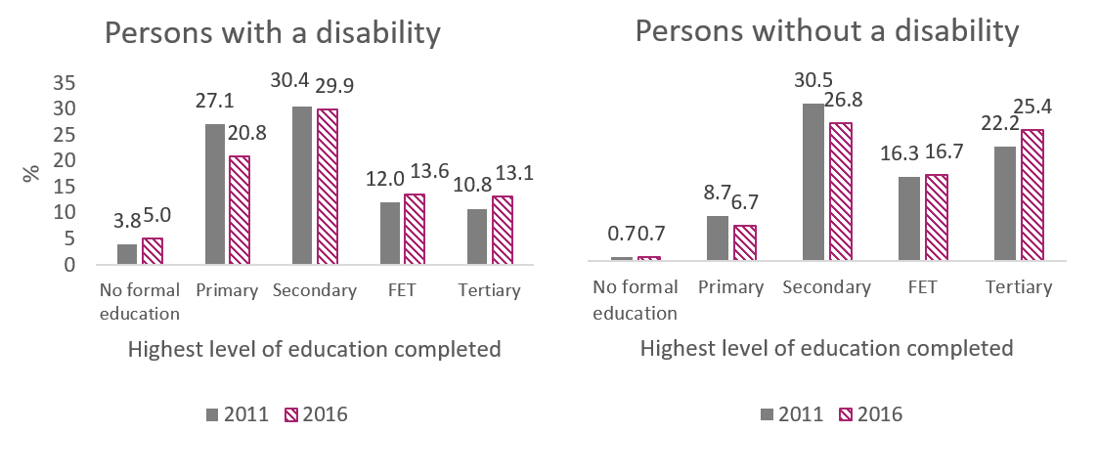
Figure 1.0 Highest level of education completed by persons with and without a disability aged fifteen and over 2011 and 2016
Table 1.1 below illustrates the highest level of education completed by persons with different types of disabilities in 2011 and 2016. Largely the pattern for each disability type mirrors that of persons with disabilities overall between 2011 and 2016. This pattern shows an increase in the proportion of those with no formal education, a decrease in those with primary education as their highest level of education, and an increase in those completing FET and tertiary education. The exception was in relation to secondary education, where there was an increase in the proportion of people in 2016 for whom this was their highest level of educational attainment (aside from those with psychological and emotional conditions).
Table 1.1 also shows that in 2016, persons with an intellectual disability had the highest proportion of persons with no formal education (29.2%), and the lowest proportion of those with secondary (24.2%), FET (6.5%) and tertiary level education (3.5%). Those with deafness or a serious hearing impairment had the highest proportion of people with primary level education (30.7%). Those with psychological or emotional conditions had the lowest proportion of people whose highest level of education was primary education (15.6%), and the highest proportion of people with secondary (35.5%) and FET level education (16.7%). Persons with another disability including chronic illness had the lowest levels of no formal education (4.9%), and the highest level of tertiary education (15.8%).
All of these figures will be updated after the 2021 Census where it would be hoped that the gaps between educational attainment of those with and without a disability and between those with different types of disabilities will have narrowed.

Table 1.1 Highest level of education completed by persons with different disabilities aged fifteen and over 2011 and 2016
Type of Disability | Highest level of education (%)
 | No formal education |  | Primary |  | Secondary |  | FET |  | Tertiary
 | 2011 | 2016 | 2011 | 2016 | 2011 | 2016 | 2011 | 2016 | 2011 | 2016
Blindness or serious vision impairment | 5.4 | 7.3 | 35.7 | 29.1 | 30.4 | 31.4 | 11.5 | 13.1 | 9.9 | 11.6
Deafness or serious hearing impairment | 3.9 | 5.4 | 37.1 | 30.7 | 30.3 | 31.3 | 11.9 | 13.5 | 10.1 | 12.1
Condition substantially limiting 1+ basic physical activities | 5.3 | 6.8 | 37.5 | 30.5 | 31.7 | 33.3 | 10.6 | 12.6 | 7.3 | 8.9
Intellectual disability | 25.2 | 29.2 | 35.1 | 26.1 | 22.1 | 24.2 | 5.0 | 6.5 | 2.6 | 3.5
Difficulty learning, remembering or concentrating | 10.7 | 14.6 | 34.6 | 25.9 | 29.7 | 30.9 | 9.7 | 11.7 | 6.4 | 8.4
Psychological or emotional condition | 7.8 | 8.8 | 22.6 | 15.6 | 36.2 | 35.5 | 13.9 | 16.7 | 13.0 | 17.5
Other disability, including chronic illness | 3.7 | 4.9 | 30.7 | 23.8 | 33.1 | 33.4 | 13.8 | 16.1 | 13.0 | 15.8

1.3 Proportion of all people accessing higher education, further education and training who have a disability (Process)
Data from the Higher Education Authority (HEA) and SOLAS has shown that the majority of the higher education and FET populations are aged between 18 and 24. As a reference for this indicator, census 2016 indicates that 9.3% of this age group reported having a disability.

1.3.1 Higher education
The proportion of students with disabilities in higher education institutions increased from 5.2% in the 2015/16 academic year, to 5.7% in 2016/17, to 6.2% in the 2017/2018 academic year.,, It is important to note that these figures may be an underestimation as persons with a disability may choose not to disclose their disability and there is no obligation for them to do so. The number of eligible applications to the Disability Access Route to Education (DARE) scheme have also increased each year since 2010, from 948 in 2010 to 3,542 in 2017. These are welcome developments and it is anticipated that these numbers will continue to rise. As noted, full representation of persons with disabilities would see them make up more than 9% of the student population.
Table 1.2 below shows that in each academic year since 2015/16 the largest proportion of those with disabilities had a specific learning disability, a mental health condition or a significant ongoing illness. The smallest proportions of the population of students with disabilities were those who were blind/visually impaired, deaf/hard of hearing and other illness. The proportion who were blind/visually impaired has not changed since 2015/2016. A HEA progress review of the National Action Plan (2015) found that the slowest rate of increase in participation at third level for underrepresented disability groups was for those who were blind/visually impaired.
Table 1.2 Primary disability of students with disabilities in higher education institutions by Academic Year 2015-2018
Primary Disability | 2015/16 | 2016/17 | 2017/18
Specific learning disability | 45.5 | 41.4 | 38.9
Mental health condition | 12.6 | 13.9 | 15.1
Significant ongoing illness | 10.6 | 11.2 | 11.6
Physical disability | 6.5 | 6.3 | 6.3
Dyspraxia/dysgraphia | 6 | 6.1 | 6.2
Aspergers/autism | 4.8 | 5.4 | 5.9
Attention deficit disorder (ADD)/Attention deficit Hyperactivity disorder (ADHD) | 4.1 | 5.2 | 4.9
Neurological/speech and language | 4.2 | 4.3 | 4.2
Other disability | 1.1 | 1.8 | 2.6
Deaf/hard of hearing | 2.8 | 2.6 | 2.5
Blind/visually Impaired | 1.8 | 1.8 | 1.8
As the HEA is a target driven organisation and the work of the access unit is driven by clear targets for other cohorts of students. The NDA have advised the HEA that the inclusion of people with intellectual disabilities is also set as a target in higher education. The NDA welcome the HEA move towards the Universal Design approach to learning, which will increase access to higher education for all. In the meantime the NDA advise the HEA collect data from the colleges involved in the Inclusive National Higher Education Forum (INHEF) on the access and participation of those with an intellectual disability in higher education courses.

1.3.2 Further education and training
In 2018, 8,644 persons reporting at least one type of disability were enrolled in FET in Ireland, representing 5% of the FET population. It is important to note that this figure may be an underestimation as persons with a disability may choose not to disclose their disability and there is no obligation for them to do so. Of those reporting a disability, 53.5% were women and 46.5% were men, while 69% were older than 25 years. Figure 1.2 below indicates that the most common types of disabilities among those enrolled in FET were difficulties in learning, remembering or concentrating (32.4% of persons with disabilities enrolled), another disability including chronic illness (29.3%) and intellectual disability (24.7%). The least common disability types were blindness/serious vision impairment or deafness/serious hearing impairment (4.7% and 6.3%, respectively).
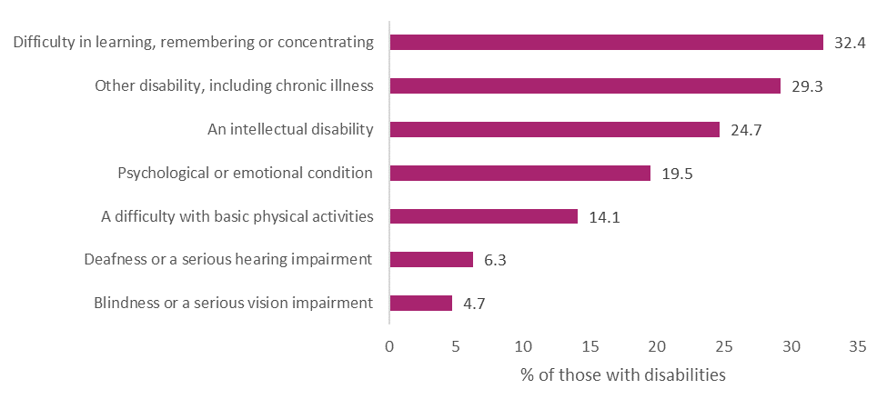
Figure 1.1. Types of disabilities of those enrolled in FET 2018
The NDA greatly welcomes SOLAS publishing such detailed data on FET learners with disabilities and appreciates that this kind of data will be available into the future to help consider changes over time. With this awareness in SOLAS about the importance of collecting data on students with disabilities and addressing barriers to disclosure, it is hoped that these numbers will rise. In order to channel this awareness into constructive change within individual institutions, SOLAS guidance to institutions as to how to address/overcome this issue would be welcomed.
Data collected by SOLAS does not include information on apprenticeships. A review of pathways into apprenticeships in Ireland found that in October 2018, 423 persons with disabilities completed apprenticeship training, representing 2.8% of the Irish apprentice population. The review acknowledged that persons with disabilities were significantly underrepresented in the 2018 apprenticeship population and set out baselines and targets to improve their inclusion, which the NDA welcomes. Apprenticeships will be covered in more detail in Indicator 2.2.4.

1.4 Improved transition planning for children and young people with disabilities (Process) (R)

1.4.1 Transition supports for young children
A number of initiatives and processes have been developed and implemented to support smooth transitions of children and young people between settings. These mostly focused on transition from pre-school to primary school. For example, in 2018 the National Council for Curriculum Assessment (NCCA) developed a suite of supports for transition to primary school. In 2019 a working group was established in the DCYA to address the issue of overage exemptions and transitions for children with disability in ECCE settings. The NDA welcomes this work and recommends that this working group reconvene and finalise the report on their work/recommendations.

1.4.2 Transition from primary to secondary school
A publication from the Growing Up in Ireland study, entitled “Off to a Good Start? Primary School Experiences and the Transition to Second-Level Education”, noted that significant differences exist between young people with special educational needs and their peers in terms of the transition to second-level education. A number of resources have been developed or revised over the lifetime of the CES to improve the transition from primary to post-primary schools for children with special educational needs. In 2015, the National Educational Psychological Services (NEPS) revised a number of their existing materials on this topic, including a good practice guide to support students with autistic spectrum disorders who are transitioning from primary to post-primary school. In 2016, the National Council for Special Education (NCSE) also published a number of resources to support planning for effective transitions. These include guidelines for parents and guardians of students with special educational needs and guidelines for schools on supporting students with special educational needs to make successful transitions. The NCSE also produced the booklet Transition from Primary to Post-Primary for Pupils with Special Educational Needs: Challenges for the Pupil and Strategies for the Teacher.

1.4.3 Expansion of guidance counselling to special schools and special classes within mainstream schools
Career guidance can facilitate students to make successful transitions from school to their chosen post-school option. Guidance counselling services are only available in post-primary schools. However, as all special schools in Ireland are designated as primary schools, children attending a special school do not have access to career guidance counsellors during their education. The NDA has underlined that career guidance should be for all students, including those in special education provision, and has called for the introduction of an effective model of career guidance for special education schools. More generally, the NDA has stated that career guidance for learners with disabilities should be delivered in an individually focused, person-centred way across the learner pathway.
In 2018, the Department of Education and Skills (DES) commissioned Indecon International Consultants to carry out a review of career guidance tools and information provision at post-primary level up to further and higher education. The Indecon review was published in 2019 and it noted that guidance counsellors are not allocated to special schools. Indecon outlined that there is merit in a policy providing enhanced provision for career guidance training for teachers in special needs schools, and also in enhancing the access of such schools to wider career guidance supports. Following publication of this report, DES established an internal taskforce, chaired initially by the Secretary General, to examine each of the recommendations and develop a prioritised implementation plan. It is the NDA’s understanding that a subgroup of the taskforce will be established in 2020 and will be tasked with advising on the issue of career guidance in special education.

The NDA has advised that Indecon’s review offers limited new evidence regarding the provision of guidance counsellors allocated to special schools or mainstream school, and contained little with regard to the provision of guidance for people with disabilities returning to education. The NDA further noted that the independent review did not address previous commitments to deliver career guidance training and provision outlined in the CES 2015-2018 action plan.

The Mid-Term Review of the National Disability Inclusion Strategy (NDIS) commits the DES to implementing relevant recommendations arising out of the Review of Career Guidance provision as they relate to learners with special educational needs, progression and participation in further education and training and higher education. The Mid-Term Review also commits the NDA to exploring learning from other jurisdictions on effective career guidance models for students with disabilities to further inform same.

1.4.4 School leavers transitioning to work/further education/third level
Over the past number of years a more systematic and streamlined system has been introduced by the Health Service Executive (HSE) with the independent guidance of the NDA to assess the needs of school leavers and to allocate them funding for an adult day service placement. This has helped to make the approach more person-centred and more transparent.
The NDA also welcomes the work being commenced by NCSE and HSE in 2019 to consider transition arrangements between HSE-funded services and education, and vice versa. We particularly note the importance of the planned expansion of this work to incorporate wider transition arrangements, e.g., between secondary school and higher/further education and/or employment. NDA notes the plans for SOLAS, Education and Training Boards Ireland (ETBI) and others to join the steering group and recognises the potential of this action to provide more effective post-school options for young people with high support needs to access training and support rather than a direct route to adult day services. The agreed aim from this collaborative action is to pilot a transition programme in 2020 and to monitor over a two year period.

1.4.5 No. of deferrals of adult day services to take up further education and training
Until 2018 school leavers with disabilities were assessed and offered a place in an adult day service or in rehabilitative training (RT). However, if the person did not accept this offer at the time, their place would be lost and it was not possible to re-enter the system. The deferral process was piloted in 2018 in acknowledgement of the fact that some school leavers would like to try further education, training or employment first, but may want to take a place in a day service or rehabilitative training at a later date. HSE records show that 71 people availed of the pilot deferral process in 2019. This represents 4.1% of the total number of school leavers profiled by the HSE. In future it would be beneficial to know the destinations of those who have deferred. NDA advise that the HSE gather this data going forward.

1.5 Destination of persons exiting Rehabilitative Training – i.e. to work, further education and training, or other (Outcome)
Rehabilitative training is a training programme of up to 4 years duration which focuses on the development of participants’ life skills, social skills and basic work skills that will enable them to progress to greater levels of independence and integration in their own community. RT is funded by the HSE but delivery is primarily via voluntary agencies throughout the country. RT is available to people with varying profiles and support needs between the ages of 18-65 that are willing to engage and would benefit from the opportunities afforded through participation. Table 1.3 below shows the RT outcomes from 2015 to 2019. The figures show an annual increase in the proportion of exits into HSE-funded day services from 27% in 2015 to 48% in 2019. The proportion of those in RT exiting into employment has decreased from 9% in 2015 to 7% in 2019 and those exiting into training and education has also decreased from 23% in 2015 to 19% in 2019. While fewer exits into employment and education and training accounts for some of the notable growth in exits to HSE-funded day services, this growth is also accounted for in a reduction of ‘other’ exits – including ceasing to attend, due to illness or into no occupation. It is hoped that the proportion of those exiting into employment and further education or training relative to day services will increase over time.
Table 1.3: Rehabilitative Training Outcomes 2015-2019
 | 2015  %  (n) | 2016  %  (n) | 2017  %  (n) | 2018  %  (n) | 2019  %  (n)
Employment* | 9%  (112) | 5%  (74) | 6%  (73) | 6%  (64) | 7%  (80)
Training and Education** | 23%  (282) | 18%  (288) | 22%  (257) | 22%  (243) | 19%  (204)
HSE-funded Day Service | 27%  (341) | 30%  (472) | 34%  (405) | 41%  (452) | 48%  (528)
Other*** | 41%  (508 | 46%  (723) | 38%  (458) | 30%  (333) | 26%  (289)
Total | 1,243 | 1,557 | 1,193 | 1,092 | 1,101
* Employment figures combines numbers engaged in DEASP employment programmes; supported employment, sheltered employment (included up until 2017 – then abolished), open and self-employment
** Combines numbers engaged in ETB mainstream, ETB specialist training, Fáilte Ireland training; Teagasc training; PLC education, private education, ETB education; 3rd level education
*** Combines numbers that have ceased to attend; illness; mental health services; voluntary/community work; unoccupied

1.6 Proportion of Disability Allowance recipients aged 16-19 (Process) (R)
The number and proportion of all Disability Allowance (DA) recipients aged 16-19 has increased each year between 2015 and 2018. In 2015, 4.9% of DA recipients were aged 16 to 19 (n=5,879), this increased to 5.2% in 2016 (n=6,573), 5.4% in 2017 (n=7,221) and to 5.5% in 2018 (n=7,700). The overall number of recipients of DA has also increased each year between 2015 and 2018 (see indicator 3.2). In an analysis of DA inflows and outflows between 2012 and 2017, the Department of Employment Affairs and Social Protection (DEASP) found that the population within most age groups receiving any illness and disability payment is relatively stable over time and that increases in payments have been driven by demographics and by an increased share of the working age population in the older age groups. However, using the numbers of those receiving Domiciliary Care Allowance (DCA), they estimate “if the share of those moving to Disability Allowance aged 16 remains constant and the number of beneficiaries increases, the inflow to Disability Allowance from DCA can be expected to increase.” It is hoped that this expected increase will be mitigated by the work of the CES as expectations are raised for young persons with disabilities and supports are provided for other activities.

1.7 Numbers of Back to Education Allowance recipients with disabilities (Process) (R)
The Back to Education Allowance (BTEA) provides income support to certain social welfare recipients in order to undertake a range of education and training options. Table 1.4 below shows that the numbers of BTEA recipients who had moved from disability supports decreased each year between 2015 and 2018. The total number of BTEA recipients had also decreased each year over this period. The percentage of all BTEA recipients who had moved from disability supports increased from 1.8% to 2.3% between 2015 and 2018, although this had fluctuated each year. , While the uptake in BTEA shows a downward trend, it is not affecting the numbers engaging in education and training as these are continually rising. The NDA suggests it would be beneficial to consider why the uptake for the BTEA for persons with disabilities is so low and if targeted awareness raising may be needed.
Table 1.4. Back to Education Allowance recipients moving from disability supports 2015-2018
Year | Number moved to BTEA from disability supports | Total number of BTEA recipients | Percentage of overall BTEA recipients who had moved from disability supports
2015 | 318 | 17,879 | 1.8%
2016 | 276 | 13,895 | 2.0%
2017 | 201 | 10,916 | 1.8%
2018 | 199 | 8,816 | 2.3%

1.8 The proportion of persons with disabilities who are early school leavers compared to persons without disabilities (Process) (N)
Persons with disabilities traditionally have higher than average early school leaving rates. Accordingly, early school leaving has been added as a new indicator under this strategic priority as it offers another way to consider the inclusion of persons with disabilities in education. Early school leaving is defined here as having left full time education before the age of 16.
In census 2011, 22.9% of those with disabilities aged 15 and over were early school leavers compared to 8.7% of those without disabilities. By 2016, this gap had narrowed and the proportion of early school leavers had dropped in persons with disabilities (18.1%) and without disabilities (6.4%).
Figure 1.2 illustrates the proportion of early school leavers by disability type in 2011 and 2016. For all disability types, the proportion of early school leavers dropped between 2011 and 2016, with the largest drop for those with a condition substantially limiting one or more basic physical activities (-5.3%) and the smallest drop for those who have difficulty learning, remembering or concentrating (-3.8%). In 2016, those with a condition substantially limiting one or more basic physical activities still had the highest proportion of early school leavers (24.2%), while those with an intellectual disability had the lowest proportion of early school leavers (12.9%). However, of note is that as per indicator 1.1, in 2016 almost 3 in 10 persons aged over 15 with intellectual disabilities had received no formal education.
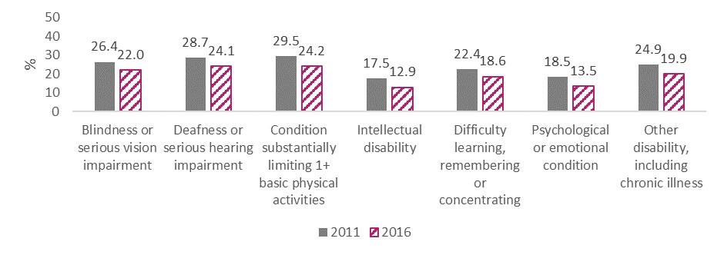
Figure 1.2. Proportion of early school leavers by disability type 2011 and 2016
One of the strategic goals of the DES’s Statement of Strategy 2019-2021 is to “advance the progress of learners at risk of educational disadvantage and learners with special educational needs in order to support them to reach their potential.” As part of this, the development of an evaluation framework to measure the outcomes of students with special education needs was initiated in 2019. As retention/early school leaving data from DES is typically disaggregated according to attendance at Delivering Equality of Opportunity in Schools (DEIS)/non-DEIS schools, the NDA looks forward to seeing data on the retention of those with special education needs into the future.

Strategic Priority 2: Provide bridges and supports into work
The intention of this priority area is that “People with disabilities will be provided with individualised bridges and supports to secure jobs in the open labour market.” It consists of eight indicators.

2.1 Nos. of persons with disabilities in sheltered work (Outcome) (R)
Sheltered work has been defined as ‘work undertaken by people with disabilities in workshops specifically established for that purpose. People working in sheltered workshops retain their social welfare benefits, typically DA, and usually receive a small discretionary additional weekly payment from the work provider’. Sheltered work traditionally has been prevalent in Ireland and other countries, although over time was called into question by self-advocates and other stakeholders regarding discrimination, lack of legal protections, and effectiveness and quality of sheltered work programmes. , Under the 2012 New Directions policy, the system in Ireland is currently undergoing reform, with a move away from sheltered workshops. An analysis of the National Intellectual Disability Database found that between 2009 and 2014 the number of adults with intellectual disability in sheltered workshops dropped by 27% from 3,933 to 2,879. Current data on this indicator is not available at present but in future will be available from the Health Research Board’s (HRB’s) National Ability Support System (NASS). During the foundational phase of the CES activities, the HSE did review data on those with disabilities in sheltered workshops in order to effectively plan for future transition to alternative supports in services or into work.

2.2 Nos. of persons with disabilities in work placements, internships and apprenticeships (Process)

2.2.1 Work-placements

Youth Employment Support Scheme
The Youth Employment Support Scheme (YESS) is a work experience placement programme targeted at young jobseekers aged 18-24 who are long-term unemployed or face barriers to employment. The scheme provides a three month work experience programme for young people that is extendable to six months. There is no cost to employers as the participants are paid by Intreo.
From October 2018 to approximately January 2020, 3% of the young people availing of the YESS scheme were in receipt of a disability-related payment (n=19). To date, 13 of these young people had completed the programme, and 5 of these were then employed by the host employer. This low uptake may be linked to potential barriers to uptake for persons with disabilities as previously advised by the NDA, such as the suitability of a 24 hour week and the time it may take for young people to settle into the scheme. At this point, the NDA would advise that young people with disabilities are actively targeted with information about this scheme in order to improve uptake.

Willing Able Mentoring programme
Willing Able Mentoring (WAM) is a work placement programme which aims to promote access to the labour market for graduates with disabilities and build the capacity of employers to integrate disability into the mainstream workplace. The WAM programme is run by AHEAD, the Association for Higher Education Access and Disability. Participating employers, including civil and public service employers, collaborate with WAM to offer graduates with disabilities a paid and mentored graduate internship for a minimum of 6 months. The number of graduates on placements through WAM have increased each year since 2015. In 2015, 31 graduates were in paid placements, this increased to 46 in 2016, 49 in 2017 and in 2018, there were 73 active placements throughout the year. AHEAD evaluated the impact of the WAM Programme between 2012 and 2016 and found that 77% of graduates who had completed a placement had secured employment, 10% went back to study and 11% were still looking for work. The NDA welcomes these increases and the efforts to track graduate outcomes.
The YESS and WAM programmes relate to persons aged 18 and over. The NDA has noted previously that exposure to work experience can lead to paid employment and if paid employment is achieved during school years, the chances of future employment also increase. For many students, work experience or placements achieved during Transition Year in school are a valuable step in this process. However, many students with disabilities either cannot access Transition Year, particularly those in special schools where such programmes are not available, or cannot access the work-placement modules of same. The NDA has recommended that information on the numbers of students with disabilities accessing Transition Year and any associated work-experience be collated, and that this data be utilised to highlight any gaps, and provide a baseline for further actions to be developed.

2.2.2 Internships
The use of internships and new recruitment avenues are to be examined by the Department of Public Expenditure and Reform (DPER), as alternative recruitment methods for qualified applicants with disabilities.

2.2.3 Work Learning Programmes

OWL programme
The Oireachtas Work Learning (OWL) programme is an applied learning, development and socialisation programme for young adults with an intellectual disability. The programme is a four way partnership between the Houses of the Oireachtas, WALK, KARE and the Adult Education Service of City of Dublin Education and Training Board. The HSE provided funding for two full time on site co-ordinators to support the interns in their roles and work towards QQI qualifications. Ten young people with intellectual disabilities completed the OWL programme during its pilot phase between September 2018 and July 2019. Of these, 7 participants then gained part-time employment, 6 of them in the public sector and 1 in the private sector.
The OWL programme is now in its second year, and it has expanded to the Department of Agriculture, Food and Marine and the Department of Culture Heritage & Gaeltacht. DPER has committed to developing a pilot Civil Service internship for people with disabilities that could lead to permanent positions. The NDA has advised that the OWL model could be applied across the wider civil and public service.

2.2.4 Apprenticeships
A review of pathways into apprenticeships in Ireland found that in October 2018, 423 persons with disabilities completed apprenticeship training, representing 2.8% of the Irish apprentice population. A majority of these, 64.5%, identified themselves as having dyslexia and a further 10% identified other disabilities related to learning (dyscalculia, dyspraxia, ADD, ADHD). Almost 13% had physical, hearing or visual disabilities (12.8%), while 28% did not specify what disability they had. The review acknowledged that persons with disabilities were significantly underrepresented in the 2018 apprenticeship population. Actions identified in this review included gathering more detailed data on those with disabilities and setting baselines and targets for inclusion of persons with disabilities in apprenticeships. The NDA appreciates these actions and looks forward to seeing targets being reached to improve the representation of persons with disabilities in apprenticeships in Ireland.

2.3 No. of persons with disabilities in receipt of case management services through Intreo and broader public employment service (Process)
This data had not been received by the time of report publication. However, as this is a critical indicator, it will be retained as a placeholder.

2.4 Proportion of EmployAbility participants exiting into employment (Outcome) (R)
The EmployAbility programme is a national employment service dedicated to improving employment outcomes for job seekers with a disability. EmployAbility participants are people with a disability, who are “job ready”, who are able to work a minimum of 8 hours per week and who need the support of a job coach to obtain employment in the open labour market. The service is not suitable for those that have limited ability or skills. The duration of the service is 18 months.
Table 2.0 shows the number of participants on the EmployAbility programme since 2014, the numbers exiting into employment (where available) and the proportion of participants who have exited into employment. It is important to note that exit figures are underestimates as calculations do not include those who dropped out or did not otherwise complete the programme (due to factors including ill health). The number of participants on the scheme increased each year between 2014 and 2018, with the exception of 2017 where it dropped slightly. In 2014, 30.3% of participants exited into employment, this dropped slightly in 2016 to 29.7%, and then increased to 34.3% in 2017. Full data was not available for 2018, however by the end of October, the exit rate to employment was approximately 28.4%.
Table 2.0. Details on EmployAbility participants 2014-2018
Year | Number of participants | Number of people exiting into employment | % of participants exiting into employment
2014 | 2,936 | 891 | 30.3
2015 | 3,000 | N/A | unable to calculate
2016 | 3,095 | 920 | 29.7
2017 | 2,994 | 1,027 | 34.3
2018 | 3,128* | 888** | 28.4 approx.
* To end of Oct 2018 ** To end of Sep 2018
An independent review of the EmployAbility service by Indecon consultants found that the service was well received by both clients and employer organisations but that the service supports only a small cohort of clients relative to the potential demand for supported employment services. The review made a number of recommendations with regard to improving the rate of persons placed in employment including ensuring appropriate referrals in the first instance and linking funding with programme performance.

2.5 Nos. of persons with mental health difficulties benefiting from IPS model of supported employment (Process) (R)
Individual Placement and Support (IPS), is a peer reviewed ‘evidence-based model of supported employment’ that facilitates people with mental health difficulties to move into mainstream competitive employment. It works by integrating an Employment Specialist into Community Health Organisation (CHO) level HSE Multidisciplinary Mental Health Teams. Following a pilot project called ‘Steps into Work’ which improved the health and employment outcomes of participants, the DEASP and the HSE are collaborating to roll out the IPS model. As of end of February 2020, the service had received 1,143 referrals since it officially rolled out in October 2018. Four hundred and twenty of these were active clients of the service at the end of February 2020, 311 were on a waiting list and the remaining 412 people had exited the service. People may have exited the service for a range of reasons: securing a job and not requiring further supports, deciding to enter into education, training or volunteering, moving area or deciding they did not want to use the service.
As of the end of March 2020, 86 individuals who were still availing of the IPS service at the time were in active employment (this does not include those who were in active employment but were no longer using the IPS service). Figure 2.0 shows that almost half of these had been in their current employment less than 6 months (48.9%), 40.7% had been in their current role between 6 and 12 months, and 10.5% had been in their current role for over a year. It has been reported to the NDA that these figures signify a notable drop on previous months, therefore due to the emerging impact of Covid-19, the March 2020 figures should be interpreted with caution. At this time, a number of people had chosen to pause their involvement due to Covid-19 and the rest in the programme were either being supported through recent unemployment, temporarily out of work due to Covid-19 or were still actively job seeking.
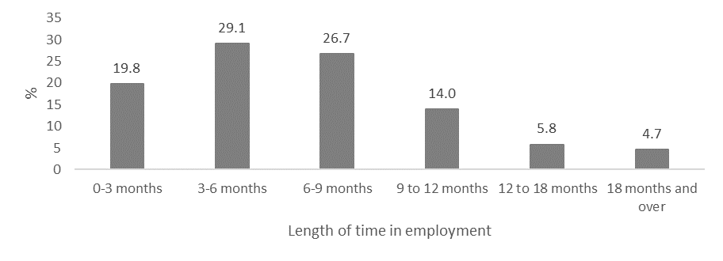
Figure 2.0. Length of time IPS service users have been in employment March 2020
Previously the NDA had recommended the importance of a concrete long term plan for the continuation of this model and sustainability planning is currently underway. The service has been collecting basic data since its rollout. However, since March 2020 the service has started to collect more rigorous, detailed data on service users, including data on education and employment histories and changes to social welfare benefits and income following employment. The NDA welcomes this and appreciates the service’s efforts to go beyond collection of service activity data to collecting outcome data which can show the impact of the service on service users. A recent review of fidelity to practice in the service found that 59% of sites had fair fidelity and 41% had good fidelity. The reviewers concluded that based on their experience in England, the fidelity scores were higher than expected at this early stage of roll-out. Again, the NDA welcomes the efforts to consider quality improvement and the effective implementation of this model, particularly when bringing it to a national scale.

2.6 Percentage of persons with disabilities using public transport services for journey to work vs non-disabled counterparts (Process) (R)
Census figures can show the means of transport to work for persons with and without a disability aged 15 and over. Public transport can be captured by those taking the ‘bus, minibus or coach’ or ‘the train, DART or Luas’ to work. However it should be noted that this information does not adequately address the accessibility of public transport services for persons with disabilities under the CES for the following reasons:
- a bus, minibus or coach could also refer to a private service,
- the train, DART and Luas excludes many rural areas, and
- this data includes those already in employment, and a lack of accessible transport is often cited as a barrier to employment and education for those with disabilities.
Figures from Census 2011 and 2016 show slight increases in the percentage of those with and without disabilities aged 15 and over taking public transport to work (see Figure 2.1). By 2016, 8.0% of those with disabilities who were working took a bus, minibus or coach to work, and this was higher than those without disabilities (5.4%). The proportion of persons with and without disabilities taking the train, DART or Luas to work was the same in 2011 at 2.9%, and this increased slightly to 3.2% of persons with disabilities and 3.1% of persons without disabilities in 2016.
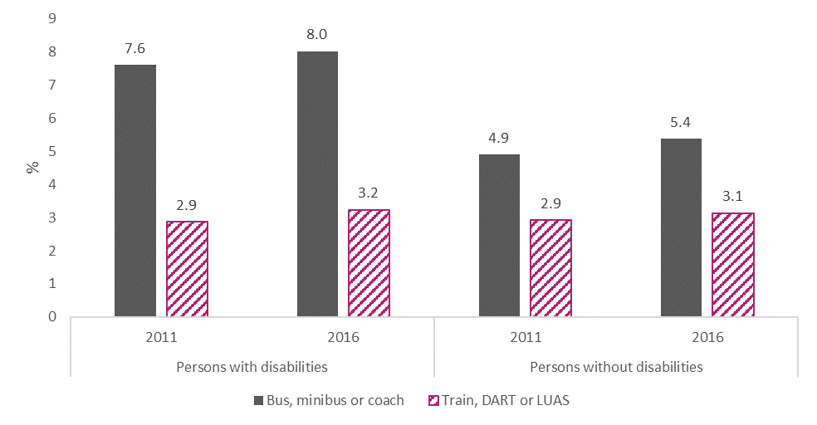
Figure 2.1. Means of public transport to work for persons with and without disabilities 2011 and 2016
The difference in proportions of persons with disabilities taking a bus, minibus or coach to work between 2011 and 2016 varied according to disability type (see Figure 2.2 below). There were slight increases in the proportions taking a bus, minibus or coach for persons with blindness or a serious vision impairment, with a condition substantially limiting one or more basic activities, those with a psychological or emotional condition, and those with another disability including chronic illness. There was a slight reduction in the proportion of those with deafness or serious hearing impairment and difficulties in learning, remembering or concentrating who took a bus, minibus or coach to work between 2011 and 2016. The largest change across the two timepoints was a 2.3% decrease in the proportion of those with an intellectual disability taking a bus, minibus or coach to work. There was a slight increase in the proportion of almost all disability types taking a train, DART or Luas to work between 2011 and 2016. The exception was for those with a condition substantially limiting one or more basic physical activities, which remained the same.
In 2016, persons with an intellectual disability accounted for the highest proportion of persons with disabilities travelling to work by a bus, minibus or coach (24.6%), while those with deafness or a serious hearing impairment had the lowest proportion travelling this way (5.4%). Those with a psychological or emotional condition had the largest proportion of persons at work travelling by train, DART or Luas (4.3%), while those with a condition substantially limiting one or more basic activities had the lowest proportion (1.8%).
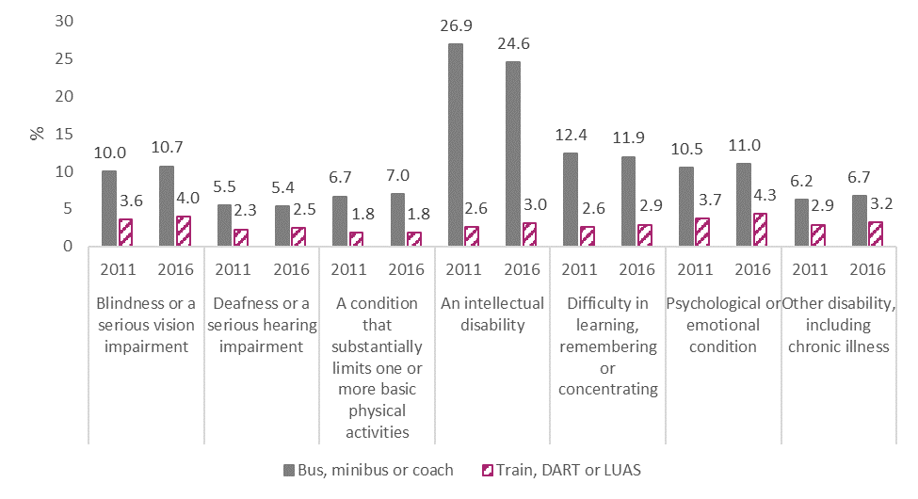
Figure 2.2. Means of public transport to work by disability type 2011 and 2016
Although this data suggests that higher proportions of persons with disabilities than persons without disabilities are taking public transport to work, as mentioned there are limitations to its interpretation. Geographical data would be of use here, to allow for analysis of regional differentiation, but it is not currently publicly available. This will however be sought by the NDA so as to provide greater insight.
Over the past few years there have been a number of improvements in public transport accessibility, the impact of which may be reflected in census 2021 figures including:
- The DART pilot project which was introduced in 2018 and is now completed, resulting in the reduction in advance notice from 24 hours to 4 hours. In addition, this reduced notice period has been extended to the commuter routes in the Greater Dublin Area and Cork commuter routes.
- Works on accessible bus bays at bus stations/train stations have been completed in Cavan, Monaghan and Drogheda stations in 2019 with works in Ballyshannon and Sligo stations underway and a number of tenders for other towns and cities underway.
- In 2019, Irish Rail began user testing a DART Disability App to help persons with disabilities pre-book assistance and to manage their journey. A new pilot application to assist customers arriving in major train stations was also being developed which was intended to be live in early 2020. The NDA has provided Irish Rail and the National Transport Authority (NTA) with guidance and advice that will help them to ensure that these apps are universally designed.
- The number of wheelchair accessible taxis in Ireland has increased from 2,220 wheelchair accessible vehicles (taxis and hackneys) in 2018 to 3,100 in 2020 (February). This corresponds to an increase in the overall fleet that is wheelchair accessible from 10% to 14.3%.
- There are currently 12,000 bus stops throughout the country. In 2018, the NTA conducted an accessibility audit of bus stops serviced by high floor coaches in towns with a population of over 5,000. This audit identified 43 towns requiring accessibility enhancements to accommodate 2 stops (one in each direction). The NTA estimates that work on these projects will be completed by the end of 2021 subject to funding.
- The NDA is developing new methods for monitoring the implementation of its statutory Code of Practice on Accessibility of Public Services and Information. The NDA has been working on the design of a monitoring mechanism and the development of structured indicators derived from this Code of Practice. The monitoring mechanism comprises of a multifaceted approach in order to evaluate the performance of public bodies against these indicators. It involves collecting feedback from persons with disabilities on their experience of the service and the collection of evidence from public bodies. Following which, the NDA will determine and report on the level of conformance of the public body with the Code of Practice. NDA intend to launch a pilot to test the monitoring mechanisms and indicators in 2020/21 focusing on public bodies who deliver transport services.

2.7 Numbers of persons with disabilities accessing Enterprise Ireland supports (Process)
The range of enterprise supports which are available either through Enterprise Ireland or Local Enterprise Offices are open and available to all and there are no statistics available in relation to the number of people with a disability who have accessed these supports. There are no supports that are aimed specifically at persons with a disability. The agencies may be generally aware that some of their clients have a disability but this would not have been considered relevant to their application for support and information on disability would neither have been sought nor recorded. The NDA advise that EI begin a process of data collection that measures both access to and completion of EI services and supports for people with disabilities. It has been proposed by NDA to EI that a simple data survey be completed by participants when commencing and when completing their EI experience.

2.8 Proportion of young persons with a disability who are NEET compared to young persons without a disability (Outcome) (N)
NEET is the term used to describe the status of a young person usually aged 15 to 24 who is "Not in Education, Employment, or Training". The definition of a ‘young person’ can vary depending on the study or country. The rate of NEET for both persons with and without a disability in Ireland dropped by approximately 6% between 2011 and 2016. In 2016, the proportion of persons aged 15 to 24 with a disability who were NEET was 23.0%, compared to 10.8% for young persons without a disability.
Figure 2.3 shows the percentage of persons who were NEET aged 15-24 between 2011 and 2016 according to disability type. In all cases, the proportion of persons who were NEET reduced between 2011 and 2016. The largest reduction was in those with a psychological or emotional condition (-12.8%) while the smallest reduction was in those with an intellectual disability (-4.2%). In 2016, the largest proportions of persons classified as NEET were those who had a condition substantially limiting one or more basic physical activities (42.3% of 15-24 year olds with such conditions), those with intellectual disabilities (32.8%) and those with psychological or emotional conditions (30.7%).
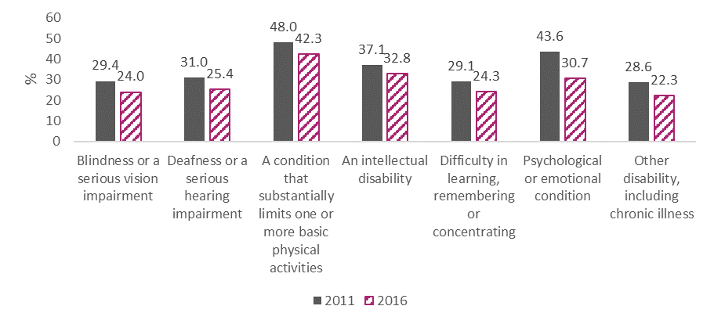
Figure 2.3. Percentage of persons aged 15-24 who were NEET by disability type 2011 and 2016
The NDA notes with concern that over twice the proportion of young persons with disabilities were NEET compared to those without disabilities. So too the proportions of those with different types of disabilities who were NEET, in particular the 4 in 10 of those young people who had a condition substantially limiting one or more basic physical activities. Time spent NEET can increase the likelihood of unemployment, low wages, or low quality of work later on in life. The NDA hope that delivery of actions under the CES will lead to improved figures in this regard in the next census.

Strategic Priority 3: Make Work Pay
The intention of this priority area is that “Work will pay, and will be seen to pay. People who get a job and have to leave it will have a streamlined return to disability payments.” It consists of 2 indicators.

3.1 Nos. of people accessing DEASP ready reckoner on roll-out (Process)
The DEASP developed on online Ready Reckoner to enable people to independently estimate the net benefits and financial implications of working. This indicator is included as it provides an indication of people considering work as an option. The data available however does not distinguish between persons with disabilities and those without. As repeated visits by the same person are counted the data should be treated cautiously. In the eight month period from May to December 2018 the Ready Reckoner had 10,458 users. Although a different recording period was used to track users in 2019 the numbers do seem to indicate an increase in numbers accessing the service. In the six months between January and June 2019, 9,865 people accessed the service. This increased to 10,777 for the second half of 2019.

3.2 Number of people with a disability on disability payments/benefits (Process) (R)
The number of recipients of DA has increased annually since 2015 and between 2015 and 2018 the numbers had increased by 18.3% (see Figure 3.0).
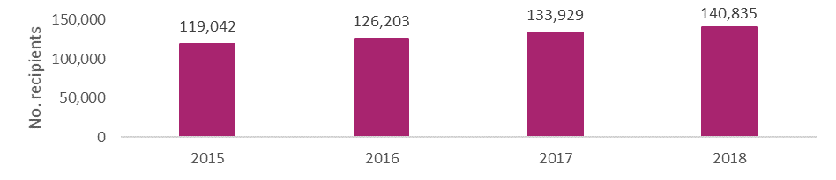
Figure 3.0. Total number of Disability Allowance recipients 2015-2018
As can be seen in Figure 3.1, the numbers on Partial Capacity Benefit increased between 2015 and 2016, then decreased substantially in 2017 and increased again to the highest number of the period by 2018. Numbers on Illness Benefit decreased from 2015, to 2016, to 2017, but again, increased to the highest number in the period in 2018. Numbers on Invalidity Pension have increased each year between 2015 and 2018.
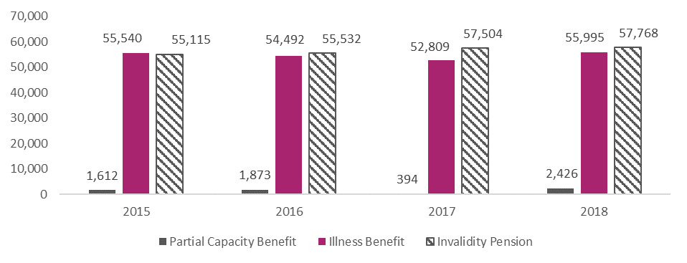
Figure 3.1. Recipients of Partial Capacity Benefit, Illness Benefit and Invalidity Pension 2015-2018
As noted earlier in indicator 1.9, a DEASP analysis of DA inflows and outflows conducted in 2018 found that the population within most age groups receiving any illness and disability payment is relatively stable over time. They also cautioned that any increases in one scheme should be viewed in the broader context. The report finds that the increases in illness and disability payments have largely been driven by demographics, and by an increased share of the working age population in the older age groups. A 2015 survey of DA recipients found that 43% of DA recipients who were not at work would like to work either part-time (35%) or full-time (8%). The NDA advises the need for more flexible work options for this group of people.
To make this indicator more useful the NDA will explore with DEASP regarding the availability of data on receipt of an allowance and employment status. This will allow us to see if the earnings disregard, introduced as part of the Make Work Pay report, has had an impact on the numbers of people in receipt of DA who are working. Figures available from DEASP indicate that approximately 3,189 people have taken up employment whilst on DA since the Make Work Pay Report was launched in April 2017. In the past, exits from DA were primarily due to transference to Old Age Pension. NDA would welcome the on-going monitoring of exits, in particular recording of where exits are being made to.

Strategic Priority 4: Promote job retention and re-entry to work
The intention of this priority area is that “Individuals who acquire a disability during their working years will be supported to obtain, retain or regain employment, as appropriate.” It consists of 5 indicators.

4.1 Number of persons in employment supported through the Wage Subsidy Scheme (Process) (R)
The Wage Subsidy Scheme (WSS) provides an employer with a general subsidy for any perceived productivity shortfall in excess of 20% for a person with a disability in comparison to a colleague without a disability. Table 4.0 shows that the number of persons in employment supported through the WSS increased each year between 2015 and 2017, dropped in 2018 and then increased to its highest figure over this period in 2019.,
Table 4.0. Number of persons in employment supported through the Wage Subsidy Scheme 2015-2019
Year | Number of people
2015 | 2,144
2016 | 2,482
2017 | 2,669
2018 | 2,525
2019 | 2,703
Issues have been identified with certain conditions pertaining to the WSS, which may dis-incentivise employers from providing certain forms of reasonable accommodations, such as part-time or reduced working hours. To avail of the WSS, an employee must work for at least 21 hours per week. Concerns have been raised that this threshold is too high and employers cannot access the scheme in respect of employees who are working part-time below 21 hours. In addition, employers are only provided with assistance under the WSS where the employee is less than 12 months in that employment. It has been suggested that the scheme could be made available for those who acquire a disability after 12 months in order to provide the employer with a financial incentive to retain the employee. The NDA advises that the scheme, in its current form, may mitigate against employers retaining employees who have acquired a disability after one year of employment.

4.2 Number of applications for Reasonable Accommodation Fund (Process) (R)
The Reasonable Accommodation Fund (RAF) consists of the Workplace Equipment and Adaptation Grant, the Job Interview Interpreter Grant, the Personal Reader Grant and the Employee Retention Grant. Table 4.1 provides the number of applications to each fund between 2015 and 2019. The highest number of applications over this period was 203 in 2015. This reduced to 116 in 2016, increased in 2017 to 134 applications, then reduced in 2018 and 2019 to 115 and 89 applications, respectively. Table 4.1 particularly highlights the limited update of the Employee Retention Grant. Between 2015 and 2019, 2018 was the first and only year in which an employer applied for this grant.
Table 4.1: Total applications for Reasonable Accommodation Fund 2015-2019
Type of Reasonable Accommodation Fund Grant | 2015 | 2016 | 2017 | 2018 | 2019*
Workplace Equipment and Adaptation Grant | 64 | 39 | 39 | 44 | 37
Job Interview Interpreter Grant | 63 | 26 | 28 | 36 | 28
Personal Reader Grant | 71 | 49 | 56 | 34 | 24
Employee Retention Grant | 0 | 0 | 0 | 1 | 0
Total | 203 | 116 | 134 | 115 | 89
*please note these figures are provisional and may be subject to change
There was a 63% increase in DEASP expenditure on the RAF between 2015 and 2018, and this fell to 35% in 2019., Although this overall increase is a positive and welcome development, a 2019 NDA review of Reasonable Accommodations identified areas where the scheme could be examined with a view to widening its benefits. This report found that there are low levels of awareness of the RAF amongst some employers, low levels of uptake and inconsistencies in processing times across areas. The report also highlighted concerns about issues and conditions associated with specific grants under the RAF. For instance, the Workplace Equipment Adaptation Grant is only available on a refund basis, thereby requiring employers to purchase equipment prior to receipt of funding. This can cause difficulties for smaller and medium sized employers. DEASP has committed to undertake a review of the RAF, and the NDA welcomes this. This indicator may need to be re-examined, pending the outcome of that review.

4.3 Number of people exiting disability payments/benefits into employment (Outcome) (R)
We know that the majority of people with a disability in the 15-64 age group acquire their disability during their working lives. An examination of changes in allowances could perhaps indicate the level of re-entry to the workforce and inform policies around return to work after acquiring a disability. To date, no data has been available to enable such an examination.

4.4 Percentage of persons with disabilities age 20-64 unemployed after having lost or given up previous job (Outcome) (R)
Originally, this indicator sought to use census data to examine the employment activity/inactivity of those with different disabilities, and in particular for this strategic priority, for those with an acquired disability. However, it is not possible to identify those with acquired disability from census figures. Instead, the percentage of persons with and without disabilities who are unemployed after having lost or given up their previous job will be examined. This is a simplistic analysis as it includes all persons with disabilities and does not take into account the contexts in which this unemployment has occurred. In the absence of any other data though, it may offer insight into changes in this kind of unemployment over time for persons with disabilities and identify any differences between persons with and without disabilities.
Figure 4.0 shows that for persons with disabilities in all age groups between 20 and 64, the rate of unemployment due to having lost or given up a previous job decreased between 2011 and 2016. For those without disabilities, the pattern was the same, except for those in the 60-64 age group, where rates of this unemployment had increased. What is clear in both years, is a higher rate of this unemployment for persons with disabilities in each age group up until the age of 54. In 2011, the rate of unemployment (for those who had previously worked) was higher for those without disabilities in the 55-59 and 60-64 year groups. In 2016, the rate for 55-59 year olds was still higher for persons without disabilities, and the rate of unemployment was identical for persons with and without disabilities aged 60-64. Of note is that the gap between persons with and without disabilities between 20 and 54 years old had widened between 2011 and 2016. The NDA advises the importance of monitoring this gap ongoing, with a view to narrowing it in future years.
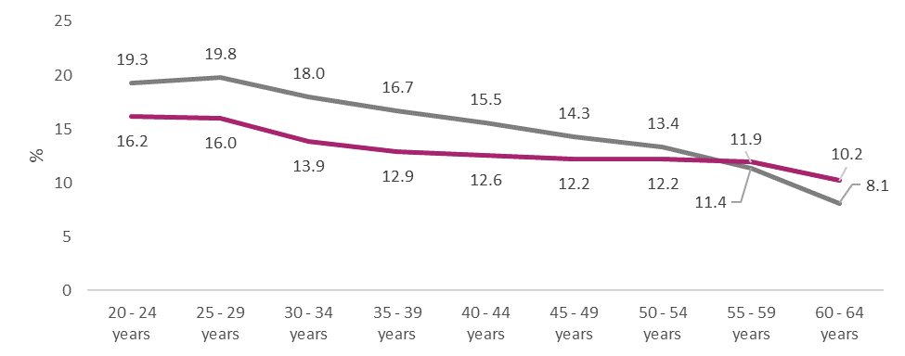
Figure 4.0. Percentage of persons with and without disabilities aged 20-64 who were unemployed after having lost or given up previous job 2011
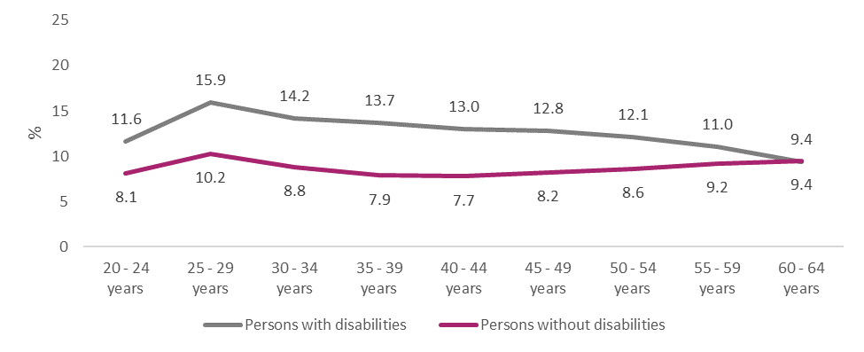
Figure 4.1. Percentage of persons with and without disabilities aged 20-64 who were unemployed after having lost or given up previous job 2016

4.5 Queries received by the Employer Disability Information Service on retention of employees with acquired disabilities (Process) (R)
The Employer Disability Information (EDI) service was launched in 2016 as part of the CES. It was managed by a consortium of employer organisations - Chambers Ireland, Ibec and ISME and funded through the NDA. It concluded its work in January 2020. In 2018, the EDI carried out a web audit and found that the top three pages accessed on the EDI website were: Advice on acquired disabilities; Hidden disabilities and Examples of reasonable accommodations.
An increase in traffic to the EDI website from organic search also indicated that employers were actively engaged and looking for resources and information to help guide them in the recruitment and retention of staff with disabilities. In 2016, organic search accounted for 33% of all website traffic while in 2018 organic search accounted for 67%. See indicator 6.3 for further detail on the EDI service.

Strategic Priority 5: Provide coordinated and seamless support
The intention of this priority area is that “The services provided by public bodies to support people with disabilities in their pathway to work and to sustain them in employment, will be both seamless and co-ordinated.” It consists of 4 indicators.

5.1 Evaluation of Ability programmes to provide innovative pre-activation approaches for persons with disabilities (Process)
The Ability programme provides funding to local, regional and national projects that focus on bringing young people with disabilities between the ages of 15 and 29 closer to the labour market. The aim of the programme is to support over 2,600 young people with disabilities as well as to build the capacity of employers and service providers to effectively engage young people with disabilities. The Ability programme will be evaluated to examine the extent to which the programme has met its stated policy objectives, but as it is still underway it is not yet possible to consider its impact on the employment outcomes of young persons with disabilities. However, the DEASP have provided some data on the programme between June 2018 and July 2019. Over this time:
- The programme was delivered by 27 community and voluntary groups from around the country
- 886 young people with disabilities were supported, reaching 33% of overall participant target
- 46% of participants had more than one type of disability
- 63% of participants were male, and 37% were female
- The highest level of education for 58% of participants was primary schooling
- 426 participants were placed on vocational, living skills, personal development and ICT courses
- The programme worked with 754 employers and 278 service providers across multiple sectors and industries.
While the number of young people with disabilities that have been supported falls short of the 2,600 target, the 886 that have been supported in one year – between 2018 and 2019, indicates a promising start. The NDA looks forward to the evaluation of the Ability programme which will be completed after the three year cycle of the programme ends in 2021, and understands that information from a mid-term review currently underway would also provide valuable learning. NDA advises the importance of the evaluation including consideration of the participants’ disability type or types when measuring the impact of the programme on young people.

5.2 Evaluation of pilot phase to provide complementary support services to persons with disabilities (5.1 implementation plan) (Outcomes)
This indicator originally sought to evaluate outcomes from the pilot phase of any demonstration projects arising from Action 5.1 in the CES: “To work together to develop an effective co-ordinated policy approach (and draw up an implementation plan based on that approach), to assist individuals with disabilities, including those who require a high level of support, to obtain and retain employment having due regard to the implementation of New Directions.” Although the cross-departmental working group for Action 5.1 has developed and agreed a coordinated policy, the mechanisms to implement this policy have not yet been agreed. As such, there are no demonstration projects underway to evaluate as yet and it is not possible to report on this indicator. However, this indicator will be retained and used as a placeholder for data on outcomes from activities under Action 5.1 on the supported employment of individuals with disabilities, including those who require a high level of support. NDA looks forward to progress in this regard over 2020 and 2021.

5.3 Nos. of persons with mental health difficulties benefiting from IPS model of supported employment (Process)
See indicator 2.5.

5.4 Development of protocols and MoUs for cross-departmental cooperation, at national and local level (Process)
Pathways to Work 2016-2020 sets out a number of actions in relation to protocols and Memoranda of Understanding (MoU). There are two strands within the programme that are of note in this regard:
- Strand 4 - Incentivising employers to offer jobs and opportunities to unemployed. Here there is an action to operate the joint governance structure which oversees the implementation of the protocol between DSP (now DEASP) and DJEI (now Department of Business, Enterprise and Innovation; DBEI) agencies.
- Strand 6 – Building Workforce Skills makes reference to protocols in actions 27.2 and 27.4 - to complete a review of inter-agency protocols between Intreo offices and DEASP and disseminate the results and to establish standing local arrangements to monitor the operation of the inter-agency protocols.
Published in 2019, Future Jobs Ireland is a whole-of-government framework which seeks to create a sustainable, resilient and future-oriented economy in Ireland over the years to 2025. One of the deliverables under the framework is to improve employment outcomes for people with disabilities, by:
- Publishing the results of the consultation exercise around the recommendations on early engagement and DA realignment from the Make Work Pay report.
- Developing an implementation and communications plan around applying the early engagement approach.
- Consulting with disability stakeholders about the implementation plan.
The National Skills Strategy 2025 – Ireland’s Future identifies Ireland’s current skills profile, provides a strategic vision and specific objectives for Ireland’s future skills requirements, and sets out a road map for how the vision and objectives can be achieved. The Strategy refers to the high number of people with disabilities who are unemployed and economically inactive, and contains two disability-specific commitments: to implement the NDIS and to phase in supports to enable children with disabilities to fully participate in pre-school care and education.
The NDA would welcome a review and reporting process whereby each of the above frameworks are measured in terms of performance. The development of key performance indicators for example would greatly assist in determining the success and failings of specific approaches.

Strategic Priority 6: Engage employers
The intention of this priority area is that “Employers will be supported and encouraged to employ people with disabilities, to support job retention and to facilitate return to work after the onset of a disability.” It consists of seven indicators.

6.1 Number of persons in employment supported through the Wage Subsidy Scheme (Process) (R)
See indicator 4.1.

6.2 Number of applications for Reasonable Accommodation Fund (Process) (R)
See indicator 4.2.

6.3 Employer engagement with EDI service (Process) (R)
The EDI service, which began operations as a pilot project in 2016, arose from this particular strategic priority. With the assistance of the NDA, the intention was to pilot an employer helpline to provide expert guidance, authoritative information and peer support to employers in relation to the employment of staff with disabilities. The service was managed by a consortium of employer bodies, the key aim of which was to provide peer-to-peer advice rather than it emanating from a disability body. The service included: a dedicated helpline giving advice and information to employers about recruiting and employing people with disabilities; a central web-based information resource incorporating guidance and a FAQ section, an outreach information service for employers; and an information and resource sharing service for participating organisations through the EDI employer peer network.
The number of calls to the helpline and the reasons for those calls were not collected or recorded. A web audit of the service was conducted in 2018 which offers some insight into web usage. It found that users increased by 42% between 2017 and 2018, bringing the total users to 9,763 by 2018. It found that by 2018, page views were up 11% on 2017 and 42% since 2016. However, a gradual increase in bounce from 2016-2018 was recorded, meaning people were increasingly leaving the site after arriving, rather than exploring further. The need to further develop the website, tools and content was highlighted and signalled as a priority for future development, but the pilot project came to its conclusion in January 2019.
Surveys were conducted by the EDI service in 2016 and 2018 on employers’ attitude to employing people with disabilities and the impact of the EDI service. In 2018, the survey found that 48% of the 250 respondents were aware of the EDI service, which was a 21% increase on 2016 levels. This is a positive reflection on the progress of the pilot programme. In 2016, just over one in three (38%) respondent enterprises had employed someone with a disability, while in in 2018 this had increased to 52% of respondents. Surveys in both years suggested that the larger the enterprise the greater the likelihood that they had employed someone with a disability (see Table 6.0 for 2018 figures).
Since the pilot project ended in January 2019 there has been a gap in the provision of peer-to-peer support to employers. The Department of Justice and Equality however are currently exploring options for addressing this gap from 2021. Consequently, this indicator will be kept under review pending any developments.
Table 6.0. Firm size and percentage of persons employed with a disability 2018
Firm size: | % of persons employed with a disability:
1-9 Employees (37% of respondents): | 38% employed someone with a disability
10-49 Employees (34% of respondents): | 45% employed someone with a disability
50-249 Employees (11% of respondents): | 52% had employed someone with a disability
250+ Employees (18% of respondents): | 88% employed someone with a disability

6.4 No. of employers in peer-to-peer networks (Process)
EDI launched the Employer Peer Network in 2018 to continue sharing best practice and address common fears about disability at work, such as employee performance, high cost of supports, poor attendance, retention difficulties and health & safety concerns. At the time of the conclusion of the pilot phase the online forum had 37 registered users and 80 members.

6.5 Principal economic status of persons with and without disabilities age 20-64 (Outcome) (R)
Between 2011 and 2016, the proportion of persons with disabilities in employment increased by 3.3% to 36.5%, the proportion of those unemployed decreased 1.8%, those in education and training increased 0.6%, those unable to work due to permanent sickness or disability decreased by 0.8% and those classified as other decreased by 1.3% (Figure 6.0). This pattern was similar to the changes in economic status of persons without disabilities, with the exception that the proportion of persons without disabilities in education and training had decreased between 2011 and 2016. Of note is that the increases in employment and decrease in unemployment for persons without disabilities (+6.4% and -4.8%) were larger than the same changes for persons with disabilities.
The 2016 census figures show that the ratio of employment among people with and without a disability aged 20 to 64 years was approximately 2 to 1. Almost 73% of people aged 20-64 without a disability were employed compared to 36.5% of persons without a disability aged 20-64. Just over 13% of those with a disability were unemployed, compared to 9.5% of those without a disability, and 4.7% of those with a disability were in education and training compared to 5.8% of those without a disability. Almost one third of those with a disability were unable to work due to permanent sickness or disability (32.4%) compared to 1.1% of those without a disability. Just over 13% of those without a disability had an ‘other’ principal economic status, compared to 10.8% of those with disabilities.
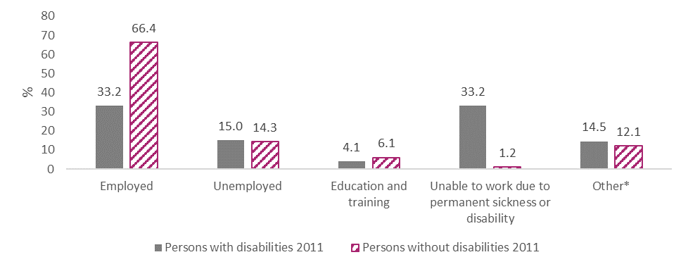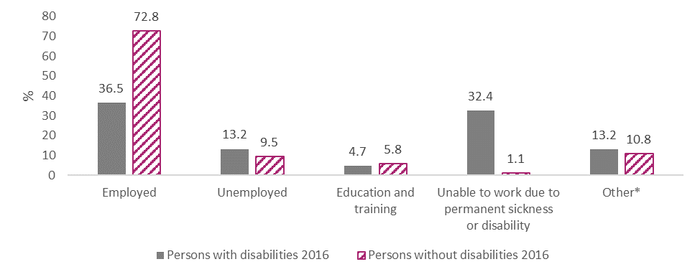
Figure 6.0. Percentage of persons aged 20-64 with and without a disability by principal economic status in 2011 and 2016
The figures show that by 2016 the 36.5% employment rate of persons with disabilities did reach close to the target of 38% which the CES aims to achieve by 2024. Although there was an improvement in employment and reduction in unemployment for those with disabilities between 2011 and 2016, it was to a lesser extent than for persons without disabilities. Furthermore, the gap between persons with and without disabilities in employment widened (+3.1%) as did the gap in unemployment (+3.0%). The recently published Roadmap for Social Inclusion 2020-2025 has a target of increasing the employment rate of persons with a disability aged 15 and over from the current level of 22.3% (census 2016) to 25% by census 2021 and 33% by census 2026. The NDA welcomes a commitment to a target but advises the low rate of employment among persons with a disability and the widening gap between those with and without disabilities requires ongoing focus. This is particularly important in the context of a post Covid-19 era as any employment initiatives need to take account of persons with disabilities.
Between 2011 and 2016, with the exception of persons with intellectual disabilities, the level of employment for all disability types increased over time (Figure 6.1). The largest increase in employment was found for those with deafness or a serious hearing impairment and those with a psychological or emotional condition (both had increased 4.7%). The rate of employment for persons with intellectual disability decreased very slightly by 0.1% between 2011 and 2016. The rate of unemployment for all disability types had decreased between 2011 and 2016, again with the exception of those with intellectual disability which increased by 0.5%. The largest decrease in unemployment rates was for those with deafness or a serious hearing impairment (decrease of 2.8%). The proportion of persons in education and training decreased slightly between 2011 and 2016 for those with deafness or a serious hearing impairment and those with a condition substantially limiting one or more basic physical activities. The levels increased for those with other disability types, with the highest increase of 1.5% found in those with a psychological or emotional condition. The rates of persons with intellectual disability, a psychological or emotional condition and other disability (including chronic illness) who were unable to work due to permanent sickness or disability decreased between 2011 and 2016 (with the largest decrease of 4.1% for those with a psychological or emotional condition). Proportions unable to work increased for the rest of the disability types, with the highest increase of 1.7% found for those with blindness or a serious visual impairment. The proportions of those classified as other (including retired, home duties, etc.,), decreased for all disability types between 2011 and 2016, aside from those with intellectual disability, where the rate stayed the same. The largest decrease of 1.7% was found for both those with blindness or a serious visual impairment and deafness or a serious hearing impairment.
In 2016, those with deafness or a serious hearing impairment had the highest level of employment of all disability types (47.3%), whereas the lowest rate was for those with intellectual disability (17.3%). The largest unemployment rate was for those with difficulty in learning, remembering and concentrating (16.0%) and the lowest was for those with another disability including chronic illness (11.0%). Those with difficulty learning, remembering and concentrating had the highest proportion of persons in education and training (7.5%) while those with a condition substantially limiting their daily activities had the lowest proportion in education and training of all disability types (1.6%). The highest rate of persons classified as unable to work due to permanent sickness or injury was for those with intellectual disability (57.3%), while the lowest rate was found for those with deafness or a serious hearing impairment (21.4%). Those with deafness or a serious hearing impairment had the highest proportion of those classified as ‘other’ (16.1%), while the lowest rate of 5.9% was for those with intellectual disability.
It is positive that the rate of employment had increased and the rate of unemployment had decreased for most disability types between 2011 and 2016. Of concern however, is that over half of those aged 20-64 with intellectual disability were classified as unable to work, and they were the only group where the rates of employment and unemployment had worsened slightly between 2011 and 2016. The implementation of the agreed programme of supports under Action 5.1 (see indicator 5.2) to help and assist those with higher support needs to access work would be of particular benefit to those with intellectual disability who want to work.
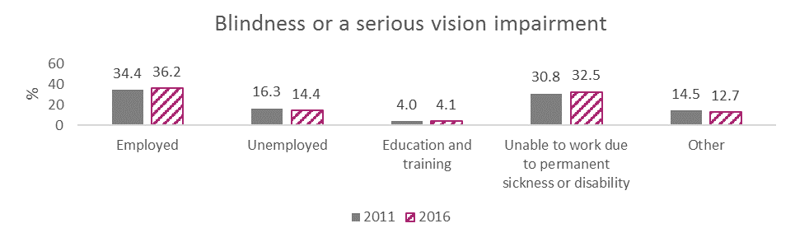
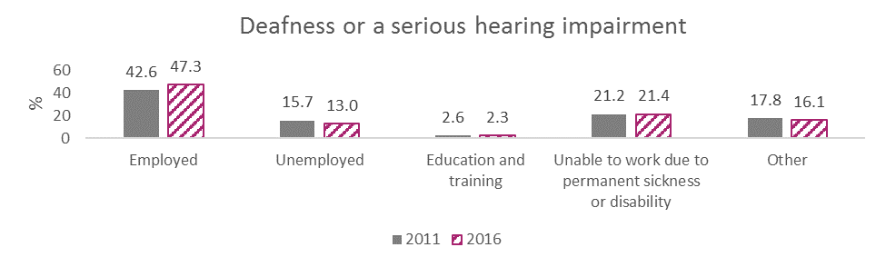
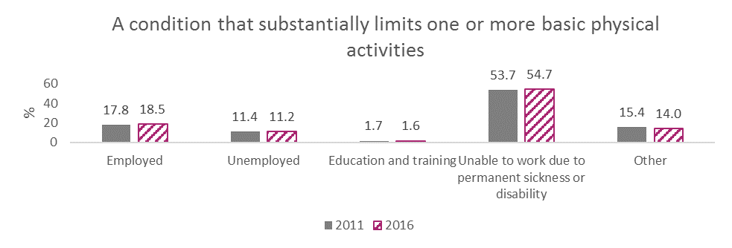
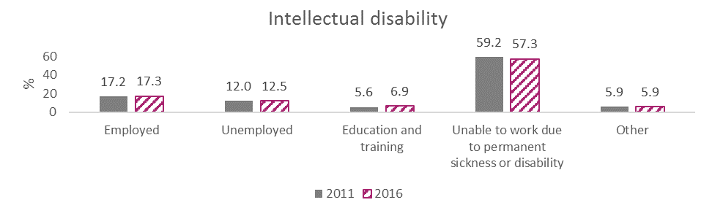
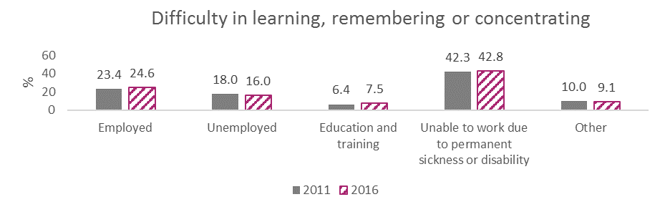
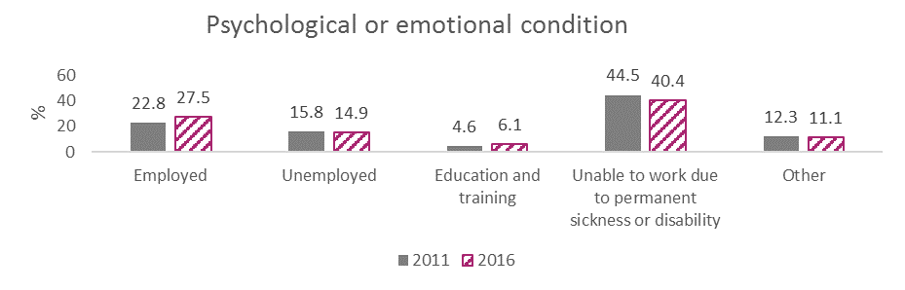
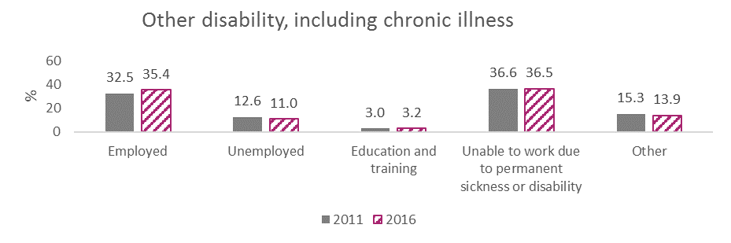
Figure 6.1. Percentage of persons with different disability types aged 20-64 by principal economic status in 2011 and 2016

6.6 Percentage of people with a disability employed in the public sector (Outcome)
For many years public bodies have pursued a positive action measure which set a 3% target for the employment of people with disabilities in the public service. The Disability Act Part 5 gives the 3% target legal status. Public bodies are obliged to report annually to the NDA on these figures. The percentage of employees in relevant public sector bodies reporting a disability has decreased over time from 3.6% in 2015 (n=7,245) to 3.3% in 2018 (n=7,585) (Figure 6.2). , The number of employees reporting a disability did increase 4.7% by 340 people over this time, however this was in the context of an overall 15.1% increase in public sector staff over the same period (201,341 in 2015 to 231,706 in 2018). However, the proportion of public bodies achieving the 3% target has increased over time, from 73.6% in 2015, to 77.5% in 2016, 84.4% in 2017 and 84.3% in 2018.
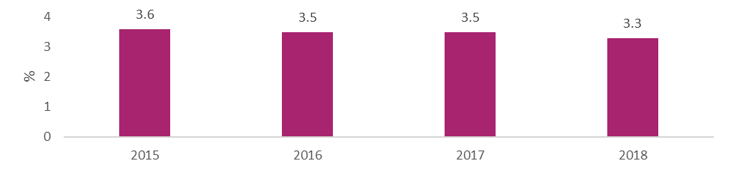
Figure 6.2. Percentage of public sector employees reporting a disability 2015-2018
The NDA understands that there are a number of factors that could have contributed to this slight decrease in the overall percentage of employees with disability in the public sector. A number of public bodies have continued to report that lack of disclosure by employees prevents them from getting an accurate count. Some public bodies also reported that a number of employees with disabilities have recently retired resulting in a decrease in the numbers. Under the CES the Government has committed to incrementally increasing the statutory employment target, so that by 2024, a minimum of 6% of employees in the public sector will be persons with disabilities. This will be put on a statutory footing once the Disability (Miscellaneous Provisions) Bill 2016 is passed by the Oireachtas. The NDA has consistently emphasised that the 3% is a statutory minimum compliance target and that it is important for public bodies to focus on exceeding this by creating inclusive workplaces. The NDA continues to work closely with and advise public bodies on measures they can implement to create an inclusive work environment that promotes and supports the recruitment and retention of persons with disabilities and one where employees feel supported and comfortable in disclosing a disability.

6.7 Percentage of persons with and without a disability who are self-employed (Outcome) (R)
The NDA emphasises the importance of self-employment as a route to positive employment outcomes for persons with disabilities as it allows for a greater degree of flexibility for the individual. This flexibility can include individual choice in terms of working hours and in terms of location. In 2011, 4.0% of persons with a disability aged 15 and over were self-employed (n= 21,619) compared to 9.3% of persons without a disability. The proportion of persons with a disability who were self-employed decreased very slightly in 2016 to 3.9% (although the actual number had increased to 22,634), while there was a similar 0.1% decrease in persons without disabilities.. There was a notable gender difference in the proportion of males and females with and without disabilities who were self-employed. In 2011, 6.7% of males with a disability were self-employed (n=17,200), whereas 1.5% of females with a disability were self-employed (n=4,419). This gap narrowed slightly in 2016, with 6.4% of males with a disability (n=17,578) and 1.6% of females with a disability (n=5,056) reporting they were self-employed. A similar pattern was apparent in those without disabilities: in 2011, 14.8% of males without a disability were self-employed, compared to 3.9% of females without a disability. In 2016, a slightly lower proportion of 14.3% of males without a disability were self-employed, compared to a slightly higher proportion of 4.1% of females without a disability.

Figure 6.3 shows that the proportion of persons with and without disabilities and with different disabilities who were self-employed did not vary much between 2011 and 2016. In both years, those with deafness or a serious hearing impairment were most likely to be self-employed (4.8% in 2011 and 2016) compared to persons with other disabilities while those with an intellectual disability were least likely to be self-employed (<1% in 2011 and 2016).
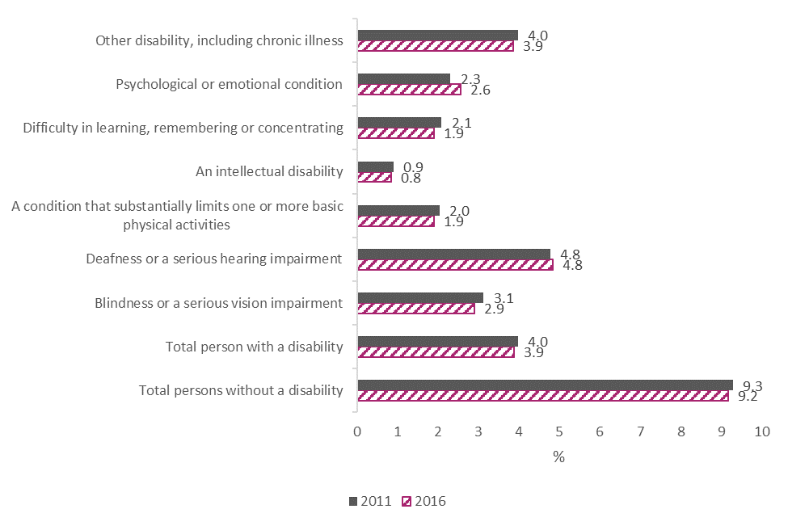
Figure 6.3. Proportion of persons with and without disabilities who were self-employed 2011 and 2016
As part of the CES, Enterprise Ireland (EI) are tasked with creating a strategy that promotes and supports entrepreneurship and self-employment for people with a disability. In 2019, EI reported on desk and commissioned research supported by a series of one-to-one interviews with entrepreneurs with disabilities. The NDA welcomes initial developments resulting from this work whereby EI is working with their network of mentors to increase their knowledge and competencies in supporting people with disabilities. NDA looks forward to continued progress in this area, noting the importance of self-employment to persons with disabilities, who by very nature of self-employment can benefit from greater opportunities for flexibility and control of hours to their own work. The NDA also notes that future efforts to promote self-employment may warrant different approaches for males and females (with and without disabilities).

Conclusion
This report has shown progress in many areas regarding the education, skills, and employment of persons with disabilities, the supports provided to facilitate them in transitioning to employment and supports provided to employers to enable them to recruit and retain employees with disabilities. The data presented has also shown areas where the gaps in employment outcomes between persons with and without disabilities have widened, where progress has perhaps stalled, and where there is room for improvement in the uptake of supports by employers. More data will be needed in order to fully consider the impact of the CES on the lives of those with disabilities, and this will be addressed in the recommendations section to follow.
The data has shown that there have been positive changes in the educational profile and participation of persons with disabilities over time. Between 2011 and 2016, the proportion of persons with disabilities whose highest level of education was primary school decreased, the proportion with FET and tertiary level education had increased, and the proportion of early school leavers had decreased. Furthermore, the participation by persons with disabilities in higher education has increased yearly since 2015. Of note, is that the gap between persons with and without disabilities lessened in relation to completing FET and early school leaving between 2011 and 2016. On the other hand, the gap between persons with and without disabilities who had completed higher education widened over the same period. By 2016, persons with disabilities were still more likely to have left school early, to have no formal education or have only completed primary school, and were less likely to have completed FET or tertiary level education than their non-disabled counterparts. By 2018, they were better represented in higher education than in FET and in FET than the apprenticeship population. However, persons with disabilities were still underrepresented in higher education, FET and most markedly so, the apprenticeship populations.
The overall number of Disability Allowance recipients increased each year between 2015 and 2018, and within that the young cohort of recipients aged 16-19 increased by number and proportion of total DA recipients. Between 2015 and 2018, the numbers of people on Partial Capacity Benefit, Illness Benefit and Invalidity Pension also increased. While the number of people receiving allowances/benefits is important information, it would be more useful to have data on changes in allowances and the movement of people to and from allowances and employment to examine the impact of the CES.
The Back to Education Allowance (BTEA) scheme provides income support to persons in receipt of certain social welfare payments, including disability payments, to undertake education or training. The numbers of BTEA recipients who had moved from disability payments reduced each year from 318 in 2015 to 199 in 2018, as did the overall number of BTEA recipients. Persons with disabilities made up very small proportions of BTEA recipients between 2015 and 2018, although these proportions did improve between from 1.8% in 2015 to 2.3% in 2018. The reason for diminishing transfers from disability payments to BTEA needs to be explored so that specific interventions to encourage or incentivise the return to education by persons with disabilities can be developed.
The introduction of the Access and Inclusion Model (AIM) has seen a sizeable increase in the number of children receiving targeted pre-school support between 2016 and 2018. Over the lifetime of the CES there have been a number of activities underway and resources made available to address transitions for children and young people with disabilities, noting that it is at key transition points that persons with disabilities can experience challenges in identifying or accessing the supports required to facilitate their move to the next phase. In 2018, the NCCA developed a general suite of supports for all children on the transition from pre-school to primary school and DCYA established a working group to address the issue of overage exemptions and transitions for children with disabilities in ECCE settings. In 2015, NEPs revised their existing materials on transitions from primary to post-primary and in 2016 the NCSE published a number of resources to support planning for effective transitions for those with special educational needs. A taskforce is being convened by the DES in 2020 to focus specifically on the issue of career guidance for those with special educational needs as children and young people in special schools are still unable to avail of this guidance. Work was commenced by NCSE and HSE in 2019 to consider transition arrangements between HSE-funded services and education, and vice versa. And in 2018, a pilot process was set up to enable school leavers with disabilities to defer their place in an adult day service or in RT in order to experience further education, training or employment first. All of these initiatives suggest progress is being made on transition planning, however there is no data available on the impact of these activities on the lives of children and young people with disabilities.
Under the New Directions policy for adult day services there is a commitment to ensuring persons with disabilities can transition out of sheltered employment, while recognising the need for coordinated and tailored supports to facilitate this process. The NDA advises the importance of continued focus on the work being progressed by the HSE to address sheltered work, as well as the necessity for collaborative approaches from other departments and agencies in this regard.
For those with disabilities who have undertaken RT, the figures show a notable increase in the proportion of exits into HSE-funded day services. While this increase is partly due to a concerning decrease exiting into employment, training and education, it is also due to a decrease in for example, exits due to illness or to no occupation.
The need for bridges and supports into education, training and employment is emphasised by the proportion of young persons with disabilities not in education, employment or training (NEET). Although the proportion of young people with disabilities who were NEET improved between 2011 and 2016, the same gap remained between those with and without disabilities. In 2016, almost one quarter of 15 to 24 year olds with disabilities were NEET. Positive impacts on persons with disabilities in this regard can be seen in the increases in the number of graduates on placements through the Willing Able and Mentoring programme each year since 2015 and on the introduction of the Oireachtas Work Learning (OWL) programme. After the first year of this programme, 7 out of the 10 OWL graduates had gained employment. The Youth Employment Support Scheme (YESS) which offers a way for young persons with disabilities aged 18-24 to gain work experience has had less of an impact given the uptake for those with disabilities has been extremely low. While the EmployAbility programme has consistently had approximately 30% of participants with disabilities exit into employment each year since 2014, as acknowledged previously, there is room for this figure to improve. Although data was not available for this report on the numbers of persons with disabilities receiving Intreo services to support them into employment, this indicator was retained as a placeholder for future consideration.
There have been a number of improvements in public transport accessibility in recent years, including the introduction of apps to make journeys for those with disabilities easier, improvements to the accessibility of transport stops, and an increase in the number of wheelchair accessible taxis. It is challenging to estimate the impact of such changes on the lives of those with disabilities using available data. Census data does indicate that in 2016, persons with disabilities were more likely to take a bus, minibus or coach to work than persons without disabilities and just as likely to take a train, DART or Luas. However, without geographical data it is not possible to establish the extent to which inequities in urban/rural provision of accessible transport remain, although NDA notes that it is an issue regularly raised by stakeholders. The census data also relates to the cohort of people already in work, and of particular interest is whether recent initiatives have improved the situation of those for whom a lack of accessible transport has previously been a barrier to employment. NDA advises this would require further exploration.
EI and Local Enterprise Offices provide a range of enterprise supports to individuals. Their impact on those with disabilities are unknown, as there are no supports aimed specifically at persons with a disability and information on disability is not sought or recorded for those using supports. NDA has indicated herein that it would welcome the collection of such data by EI/DBEI.
One of the outputs of the Make Work Pay report was the development of on online Ready Reckoner to enable people to estimate the net benefits and financial implications of working. This tool is available to those with and without disabilities and data on use of the Ready Reckoner by only those with a disability is not available. Use of this service increased from 2018 to 2019, and during the second half of 2019 10,777 people accessed the Ready Reckoner.
In general, increasing numbers of persons with disabilities have been supported through the WSS since 2015, while the numbers of applications to the RAF have mostly decreased between 2015 and 2019, peaking in 2015. It is unclear whether persons with disabilities who are supported by these schemes are being supported to enter, re-enter or retain employment. However, these supports are perhaps less likely about employee retention given that persons employed in the organisation over one year are not eligible for the WSS and that there has only been one application to the Employee Retention Grant of the RAF since 2015.
The original indicator set included an indicator on the employment situation of those with acquired disabilities. However, this is not possible to examine with available data. Instead, the percentage of persons with and without disabilities who were unemployed after having lost or given up their previous job was considered. There are of course many caveats with this analysis as it includes all persons with disabilities and does not take into account the contexts in which this unemployment has occurred. However, census data indicated that across all age groups between 20 and 54 years, there was a consistent gap between the proportion of persons with and without disabilities unemployed due to having giving up or lost their job. Figures were higher for those with disabilities, and although these figures did decrease for those aged 20-64 between 2011 and 2016, the gap between persons with and without disabilities widened. If there was no issue with the retention of persons with disabilities in employment, it is unlikely there would be such an obvious, consistent gap across age groups and across time between persons with and without disabilities in this type of unemployment. The NDA is to explore possible routes for gathering data.
Originally, the indicator set also included a placeholder for data on outcomes from the pilot phase of any demonstration projects arising from Action 5.1 in the CES. However, as noted, although a national programme of coordinated and comprehensive supports for persons with disabilities has been agreed, agreement on how best to test and scale both coordination and provision of these supports has not yet been achieved. The development of protocols and MoUs as outlined in Pathways to Work 2016-2020 will serve to improve and enhance a joint governance structure for paths to employment. Protocols between the DEASP and DJEI for example, and inter-agency protocols between Intreo offices and DEASP promise to provide a more coherent and collaborative approach on matters such as incentivising employers to offer jobs and opportunities to those unemployed. In addition, two promising approaches to the coordination of public services in helping persons with disabilities on the path to employment can be seen in the Ability Programme of projects for young people with disabilities and the IPS model for people with mental health difficulties. Although data is not yet available on the impact of the Ability Programmes, after one year in operation, 886 young people with disabilities were being supported across Ireland and the programme had worked with 754 employers and 278 service providers across multiple sectors and industries. Although this falls short of the targeted number of persons with disabilities to be supported (2,600), it is a promising position as this half way juncture. The limited data collection on the IPS programme means it is difficult to accurately consider its impact but we do know that in March 2020, 86 programme participants were in employment – and that this figure had fallen due to Covid-19. Learning from these programmes will be critical in helping to further understand how best to coordinate services for persons with disabilities. NDA welcomes the fact that, as the Ability Programme is being evaluated and as the IPS service has moved to a more robust data collection process, data will be available in future on the impact of this work on the lives of person with disabilities.
The ultimate goal of the CES is to improve the employment situation of persons with disabilities. Employment levels of persons with disabilities did improve from 2011 to 2016, when 36.5% of persons with disabilities of working age (20-64) were in employment. This is close to the 38% target which the CES aims to achieve by 2024. While this is positive news, the improvement in employment for those with disabilities was to a lesser extent than those without disabilities, meaning the gap between levels of employment and unemployment for those with and without disabilities had widened by 2016. In both 2011 and 2016, the proportions of persons without disabilities in employment were twice the proportions of those without disabilities. Another area of concern is that the percentage of employees in relevant public sector bodies reporting a disability has decreased over time from 2015 to 2018, from 3.6% to 3.3%. Although the numbers of persons with disabilities employed in this sector have increased over this time, it has been to a much lesser extent than the increase in the number of those without disabilities. The levels of self-employment of both persons with and without disabilities remained steady between 2011 and 2016. In both years, over twice the proportion of persons without a disability were self-employed compared to persons with a disability, and the proportion of males with disabilities who were self-employed was around four times higher than the proportion of self-employed females with disabilities.
The EDI service was piloted under the CES in 2016 as a way of supporting employers to employ and retain staff with disabilities. Despite the fact that the number and type of calls to EDI were not recorded, an audit of the EDI website conducted in 2018 indicated an increase in the number of employers seeking access to information and advice in relation to acquired disabilities, hidden disabilities and examples of reasonable accommodations. The 2018 EDI survey on employers’ attitudes to employing people with disabilities highlighted an increased awareness of the EDI service among employers since the previous 2016 survey. Further positive change was reflected in the increase in numbers of employers employing a person with a disability in the period 2016-2018. The Employer Peer Network launched by EDI in 2018 serves to support employers by creating a forum in which knowledge, experience and concerns can be shared. Growth of the forum is anticipated as is continued positive results in terms of employer attitude to and employment of persons with disabilities.
In some cases available data on those with disabilities is disaggregated by type of disability. The data has shown that the education and employment profiles of persons with intellectual disability is of particular concern. Almost three in 10 persons with intellectual disability had no formal education in 2016, they had the second highest proportion of young people with NEET status, over half of those with intellectual disability of working age were classified as unable to work due to permanent sickness or disability, and they were the only group whose employment situation had slightly worsened between 2011 and 2016. Also of note was that those with blindness/a serious visual impairment and deafness/a serious hearing impairment were the least likely groups to be in both the FET and higher education populations in 2017/2018. While this may be partly because these groups are the most likely to be in employment, it may still warrant further exploration. Finally, in 2016 those who have a condition substantially limiting one or more basic physical activities had the highest proportion of young people NEET, and one quarter of this group were early school leavers. Again, it is beyond the scope of this paper to consider the reasons and implications for these issues, but it does highlight the importance of collecting data on different types of disabilities in order to identify any gaps and address disability-specific barriers.
The recommendations below are primarily based on improving the availability of data and data sources for future iterations of this indicators report.

Recommendations

All Public Service Bodies
- Issues with disclosure of disabilities by employees and low response rates to surveys on the numbers of employees with disabilities have been cited as reasons for low and/or dwindling percentages of public service employees with disabilities. As such, in departments/bodies where these are problems, the NDA advises a concerted effort to encourage disclosure and response rates. This is particularly important given the statutory target of 3% is set to increase to 6% in the lifetime of the CES.

Comprehensive Employment Strategy Implementation Group
- Available data is limited on the employment pathways of those with acquired disability. The NDA advises the CESIG explore possible sources for such data in future.

National Disability Authority
- The NDA will review the indicator set used in this report and consider which indicators may need to be added, removed or amended for the next indicators report on the progress of the CES. This will involve the NDA liaising with relevant departments/bodies on data availability and plans for data collection.
- The NDA is currently exploring how to gather information directly from persons with disabilities on their lived experience in certain areas covered by the National Disability Inclusion Strategy and the United Nations Convention on the Rights of Persons with Disabilities. This information will also be critical to ensure the lived experience of those with disabilities is included in further examinations of the CES.
- The NDA is developing new methods for monitoring the implementation of its statutory Code of Practice on Accessibility of Public Services and Information. The NDA has been working on the design of a monitoring mechanism and the development of structured indicators derived from this Code of Practice. The monitoring mechanism comprises of a multifaceted approach in order to evaluate the performance of public bodies against these indicators. It involves collecting feedback from persons with disabilities on their experience of the service and the collection of evidence from public bodies. Following which, the NDA will determine and report on the level of conformance of the public body with the Code of Practice. The intention is to launch a pilot to test the monitoring mechanisms and indicators in 2020/21 focusing on public bodies who deliver transport services.

Department of Children and Youth Affairs (now Department of Children, Disability, Equality and integration)
- The NDA have previously advised that in relation to the Access and Inclusion model, it would be useful, where possible, if data was collected to monitor and report on unmet need, waiting lists, any impact of overage exemptions and general satisfaction with the programme by parents and carers of children.

Health Service Executive
- It would be beneficial if data was collected and published on the deferral process for school leavers, including data on numbers deferring and destination of same, and the numbers who subsequently take up a day service or RT place after deferral.
- It would also be beneficial to have access to timely annual data publically available, on those who exit rehabilitative training, and where those exits are to (employment, FET, etc.).

Department of Education and Skills
- Considering that persons with disabilities are more likely to leave school early, it would be of use if the DES reports examining cohorts of school leavers considered disability status of students to inform considerations for addressing this issue.
- The NDA has recommended that information on the numbers of students with disabilities accessing Transition Year and any associated work experience be collated, and that this data be utilised to highlight any gaps, and provide a baseline for further actions to be developed, given that access to work placements has been shown to lead to better employment outcomes.
- With regards, to the National Skills Strategy, the NDA would welcome a review and reporting process whereby actions are measured in terms of performance. The development of key performance indicators for example would greatly assist in determining the success and failings of specific approaches.

Department of Employment Affairs and Social Protection
- In the evaluation of the Ability Programme, the NDA advises the importance of ensuring the type of disability of participants is measured to understand the appropriateness of each activation programme for different young people with disabilities.
- Similarly, it would be of use if the type of disability for those participating in Youth Employment Support Service and the Employability programme was collated and reported on.
- It would be beneficial to know whether applicants for the Wage Subsidy Scheme and the Reasonable Accommodation Fund were applying for potential, new or existing employees (and if existing, how long have they been an employee).
- With regards, to the Pathways to Work and Future Job Ireland, the NDA would welcome a review and reporting process whereby actions are measured in terms of performance. The development of key performance indicators for example would greatly assist in determining the success and failings of specific approaches.

Department of Employment Affairs and Social Protection/GENIO/Health Service Executive
- The new data collected by the IPS service will be highly informative, but only if it is collected consistently and completely. Data collection in a busy service environment can be challenging and may not be considered a priority due to time and resource constraints. The NDA advises the importance of quality control checks for such data collection.

SOLAS
- The NDA encourages SOLAS to continue exploring and addressing barriers to disclosure for students with disabilities.
- The NDA looks forward to SOLAS continuing to report on the numbers of persons with disabilities in apprenticeships and in FET as per the 2018 reports and how they align with set targets.

AHEAD
- It would be of interest if the type of disability of those who have undertaken WAM placements was published in AHEAD’s annual report, as well as gender breakdown.

HEA
- The NDA advise the HEA collect data from the colleges involved in the Inclusive National Higher Education Forum (INHEF) on the access and participation of those with an intellectual disability in higher education courses.
- The NDA encourages HEA to continue exploring and addressing barriers to disclosure for students with disabilities.

Enterprise Ireland
- The NDA advise that EI begin a process of data collection that measures both access to and completion of EI services and supports for people with disabilities. It has been proposed by NDA to EI that a simple data survey be completed by participants when commencing and when completing their EI experience. Given the notably lower rates of females with disabilities being self-employed as per census figures, it would also be important to ensure the sex of those receiving supports is collected and analysed to explore this disparity further.

Appendix I. Amendments to original indicator set
Strategic Priority | Core Indicator of progress | Amended? | Reason for change
SP1: Building skills, capacity and independence | Proportion of people with disabilities achieving each educational attainment level (primary, secondary, tertiary, FET) by disability type. | No.
SP1: Building skills, capacity and independence | The ratio of people without a disability to people with a disability aged 15-65 in further education and training by disability type | Yes. Deleted. | The following indicator shows all people (of any age) accessing further education and training who have a disability.
SP1: Building skills, capacity and independence | Proportion of all people accessing higher education, further education and training who have a disability. | No.
SP1: Building skills, capacity and independence | Improved transition planning for children and young people with disabilities | Yes – the two indicators below on guidance counselling and deferral of school leavers have been subsumed into this indicator.
SP1: Building skills, capacity and independence | Number of children receiving targeted pre-school support (levels 4-7 of the AIMS model)
SP1: Building skills, capacity and independence | Expansion of guidance counselling to special schools and special classes within mainstream schools | Yes – moved under overarching indicator above “Improved transition planning for children and young people with disabilities”.
SP1: Building skills, capacity and independence | No. of deferrals of adult day services to take up further education and training | Yes – moved under overarching indicator above “Improved transition planning for children and young people with disabilities”.
SP1: Building skills, capacity and independence | Destination of persons existing Rehabilitative Training – i.e. to work, further education and training, or other | No.
SP1: Building skills, capacity and independence | Number of people with a disability on disability payments/benefits e.g. Disability Allowance, Illness payment/ Invalidity pension, by age and by disability type | Yes – to “Proportion of Disability Allowance recipients aged 16-19 years” | Under this strategic priority (SP), the rationale for this indicator originally was that as expectations are raised and supports provided for other activities, the nos. of people opting for Disability Allowance at age 16 should decrease. Hence, this indicator now focusses on the younger cohort taking up Disability Allowance.
SP2: Provide bridges and supports into work | Nos. of persons with disabilities in work situations not compatible with New Directions/ UNCRPD continue to decrease | Yes – “Nos. of persons with disabilities in sheltered work”. | Changed to reflect what the data will illustrate.
SP2: Provide bridges and supports into work | Nos. of persons with disabilities in:  - Work-placements  - Internships  - Apprenticeships | Yes. Work learning programmes added. | Changed to include ‘work learning programmes’.
SP2: Provide bridges and supports into work | No. of persons with disabilities in receipt of case management services through Intreo and broader public employment service | Awaiting data. Will hopefully also include data on outcomes of Intreo engagement.
SP2: Provide bridges and supports into work | Percentage of persons with disabilities able to access public transport services for journey to work vs non-disabled counterparts | Yes. Slightly rephrased to “Percentage of persons with disabilities using public transport services for journey to work vs non-disabled counterparts.”
SP2: Provide bridges and supports into work | Compared to the general population the % of people with disabilities age 15-65 in:  - Employment  - Unemployment  - Not active  - Education and training  by disability type | Yes. Removed from this SP. Retained in SP6. | To avoid repetition.
SP2: Provide bridges and supports into work | Percentage of people with a disability employed in the public sector | Yes. Removed from this SP. Retained in SP6. | To avoid repetition.
SP2: Provide bridges and supports into work | Nos. of persons with disabilities who are self-employed | Yes. Removed from this SP. Retained in SP6. | To avoid repetition.
SP2: Provide bridges and supports into work | Nos. of persons with disabilities accessing Enterprise Ireland supports (e.g. LEOs, entrepreneurship programme etc.)
SP2: Provide bridges and supports into work | Nos. of persons with disabilities increasing their level of participation in the work-force – e.g. increasing part-time hours etc. | Yes. Deleted. | At present there does not appear to be a national dataset available which could illustrate the original intention of this indicator.
SP3: Make work pay | Nos. of people accessing DEASP ready reckoner on roll-out
SP3: Make work pay | Number of people with a disability on disability payments/benefits e.g. Disability Allowance, Invalidity pension, by disability type | Yes. “Number of people with a disability on disability payments/benefits”. | Disability type not available.
SP3: Make work pay | Expenditure and Nos. of persons for whom wage subsidy scheme is paid, reasonable accommodation fund, back to education allowance, EmployAbility Service, any complementary support service | Yes. There have been a number of changes to this indicator. Each scheme now has its own specific indicator, and all have been removed from this SP, but moved to/retained in other SPs.  Wage subsidy scheme now “Number of persons in employment supported through the Wage Subsidy Scheme”. In SP4 and SP6.  Reasonable accommodation fund now “Number of applications for Reasonable Accommodation Fund”. In SP4 and SP6.  EmployAbility service: “Proportion of EmployAbility participants exiting into employment”. Moved to SP2.  Back to Education Allowance: “Numbers of Back to Education Allowance recipients with disabilities”. Moved to SP1. | Indicators were moved to/retained in the most relevant SPs.  The focus of the indicators is on persons with disabilities benefitting from the scheme, rather than the input of expenditure.  Indicator names were rephrased to reflect changes.
SP4: Promote job retention and re-entry to work | Expenditure and Nos. of persons for whom wage subsidy scheme is paid, reasonable accommodation fund, back to education allowance, EmployAbility Service, any complementary support service | Wage subsidy scheme now “Number of persons in employment supported through the Wage Subsidy Scheme”. In SP4 and SP6.  Reasonable accommodation fund now “Number of applications for Reasonable Accommodation Fund”. In SP4 and SP6.  EmployAbility service: “Proportion of EmployAbility participants exiting into employment”. Moved to SP2.  Back to Education Allowance: “Numbers of Back to Education Allowance recipients with disabilities”. Moved to SP1. | Indicators were moved to/retained in the most relevant SPs.  The focus of the indicators is on persons with disabilities benefitting from the scheme, rather than the input of expenditure.  Indicator names were rephrased to reflect changes.
SP4: Promote job retention and re-entry to work | Number of people with a disability on disability payments/benefits e.g. Disability Allowance, invalidity pension, by disability type if possible | Yes: “Number of people exiting disability payments/benefits into employment.” | Rephrased to reflect more specific data on those exiting out of disability payments. Availability of data TBC.
SP4: Promote job retention and re-entry to work | Compared to the general population the % of people with disabilities age 15-65 in:  - Employment  - Unemployment  - Not active  - Education and training  by disability type | Yes: “Percentage of persons with disabilities age 20-64 unemployed after having lost or given up previous job”. | This original indicator is still retained in SP6 but removed from here as it is not possible to examine the profiles of those with acquired disabilities using census data. Instead, this indicator is used to examine cohorts of people where employment retention and re-entry is of relevance.
SP4: Promote job retention and re-entry to work | Percentage of people with a disability employed in the public sector | Yes. Removed from this SP but retained in SP6. | This original indicator is retained in SP6 but removed from here as it is not possible to disaggregate data relevant to those with acquired disabilities.
SP4: Promote job retention and re-entry to work | Nos. of calls from employers regarding retention of employees with acquired disabilities | Yes. “Queries received by the Employer Disability Information Service on retention of employees with acquired disabilities”. | There was no available information on calls. Rephrased to reflect available data.
SP5: Provide coordinated and seamless support | Evaluation of Ability programmes to provide innovative pre-activation approaches for persons with disabilities | No.
SP5: Provide coordinated and seamless support | Evaluation of pilot phase to provide complementary support services to persons with disabilities (5.1 implementation plan)
SP5: Provide coordinated and seamless support | Nos. of persons with mental health difficulties benefiting from IPS model of supported employment | Yes. | Also relevant to SP2 so has been duplicated.
SP5: Provide coordinated and seamless support | Development of protocols and MoUs for cross-departmental cooperation, at national and local level
SP6: Engage employers | Nos. of people accessing wage subsidy scheme, reasonable accommodation fund, back to education allowance, EmployAbility Service, any complementary support service | Wage subsidy scheme now “Number of persons in employment supported through the Wage Subsidy Scheme”. In SP4 and SP6.  Reasonable accommodation fund now “Number of applications for Reasonable Accommodation Fund”. In SP4 and SP6.  EmployAbility service: “Proportion of EmployAbility participants exiting into employment”. Moved to SP2.  Back to Education Allowance: “Numbers of Back to Education Allowance recipients with disabilities”. Moved to SP1. | Indicators were moved to/retained in the most relevant SPs.  The focus of the indicators is on persons with disabilities benefitting from the scheme, rather than the input of expenditure.  Indicator names were rephrased to reflect changes.
SP6: Engage employers | Nos. of calls to EDI, disaggregated by call type | Yes: “Employer engagement with EDI service”. | There was no available information on calls. Rephrased to reflect available data.
SP6: Engage employers | No. of employers in peer-to-peer networks
SP6: Engage employers | Compared to the general population the % of people with disabilities age 15-65 in:  - Employment  - Unemployment  - Not active  - Education and training  by disability type | Yes: “Principal economic status of persons with and without disabilities age 20-64”. | Rephrase and change of age to 20-64 to represent the working age population.
SP6: Engage employers | Percentage of people with a disability employed in the public sector | No.
SP6: Engage employers | Nos. of persons with disabilities who are self-employed | Yes: “Percentage of persons with and without a disability who are self-employed.” | Rephrased to take into account proportion instead of numbers.
SP6: Engage employers | Nos. of persons with disabilities accessing Enterprise Ireland supports (e.g. LEOs, entrepreneurship programme etc.) | Yes. Deleted. | Data on persons with disabilities is not collected by EI. This indicator may be reinstated if this changes.

Appendix II. New indicators added to set
Strategic Priority | New Indicator of Progress | Reason for Inclusion
SP1: Building skills, capacity and independence | The proportion of persons with disabilities who are early school leavers compared to persons without disabilities | Persons with disabilities traditionally have higher than average early school leaving rates. This indicator offers another way to consider the inclusion of persons with disabilities in education. Data source is the census, meaning we can track change from 2011 and 2016, to 2021 and 2026.
SP2: Provide bridges and supports into work | Proportion of young persons with a disability who are NEET compared to young persons without a disability | This is a useful indicator as time spent NEET can increase the likelihood of unemployment, low wages, or low quality of work later on in life. Proportion of young people who are NEET highlights an important gap in education, training and employment and supports into same. Data source is the census, meaning we can track change from 2011 and 2016, to 2021 and 2026.

Government of Ireland. (2015) Comprehensive employment strategy for people with disabilities 2015-2024. Retrieved from http://www.justice.ie/en/JELR/Comprehensive%20Employment%20Strategy%20for%20People%20with%20Disabilities%20-%20FINAL.pdf/Files/Comprehensive%20Employment%20Strategy%20for%20People%20with%20Disabilities%20-%20FINAL.pdf
Government of Ireland. (2019) Comprehensive employment strategy: Phase two action plan 2019-2021. Retrieved from http://www.justice.ie/en/JELR/CES_Action_Plan_2019_to_2021.pdf/Files/CES_Action_Plan_2019_to_2021.pdf
NDA. (2019) Indicators for monitoring progress under comprehensive employment strategy for persons with disabilities 2015-2024. Unpublished report.
NDA. (2019) Indicators for monitoring progress under comprehensive employment strategy for persons with disabilities 2015-2024. Unpublished report.
United Nations Human Rights, Office of the High Commission. (2012) Human rights indicators. A guide to measurement and implementation. New York and Geneva: United Nations Human Rights, Office of the High Commission. Retrieved from https://www.ohchr.org/Documents/Publications/Human_rights_indicators_en.pdf
DES and HEA. (2015) National plan for equity of access to higher education 2015-2019. Retrieved from https://hea.ie/assets/uploads/2017/06/National-Plan-for-Equity-of-Access-to-Higher-Education-2015-2019.pdf
See https://www.hse.ie/eng/services/news/media/pressrel/transforming-lives-programme.html
DOH. (2018) Task force on personalised budgets. Retrieved from https://www.gov.ie/en/publication/4ea89a-task-force-on-personalised-budgets/
Department of Justice and Equality. (2017) National disability inclusion strategy 2017-2021. Retrieved from https://assets.gov.ie/18901/26182a87ecf84ddd8d60c215c0ce2520.pdf
NDA. (2019) Indicators for monitoring progress under comprehensive employment strategy for persons with disabilities 2015-2024. Unpublished report.
Government of Ireland. (2015) Comprehensive employment strategy for people with disabilities 2015-2024 p.14. Retrieved from http://www.justice.ie/en/JELR/Comprehensive%20Employment%20Strategy%20for%20People%20with%20Disabilities%20-%20FINAL.pdf/Files/Comprehensive%20Employment%20Strategy%20for%20People%20with%20Disabilities%20-%20FINAL.pdf
Data not publically available. Information obtained directly from correspondence with DYCA.
RSM Ireland. (2019) An end of year one review of the access and inclusion model (AIM). Department of children and youth affairs. Retrieved from https://aim.gov.ie/wp-content/uploads/2019/10/aim-end-of-year-one-review.pdf
CSO. Table E9019 Census 2016 Statbank. https://statbank.cso.ie/px/pxeirestat/Database/eirestat/Profile%209%20-%20Health%20Disability%20and%20Carers/Profile%209%20-%20Health%20Disability%20and%20Carers_statbank.asp?SP=Profile%209%20-%20Health%20Disability%20and%20Carers&Planguage=0
CSO. Table E9019 Census 2016 Statbank. https://statbank.cso.ie/px/pxeirestat/Database/eirestat/Profile%209%20-%20Health%20Disability%20and%20Carers/Profile%209%20-%20Health%20Disability%20and%20Carers_statbank.asp?SP=Profile%209%20-%20Health%20Disability%20and%20Carers&Planguage=0.
HEA. (2020) Student demographics 2018/19, Retrieved from https://hea.ie/statistics/data-for-download-and-visualisations/enrolments/student-demographics-2018-19/
SOLAS. (2019) This is FET. Facts and figures 2018. Retrieved from https://www.solas.ie/f/70398/x/6085857abc/this-is-fet-facts-and-figures-2018.pdf
AHEAD. (2017) Numbers of students with disabilities studying in higher education in Ireland 2015/16. https://ahead.ie/userfiles/files/shop/free/Rates%2015-16%20Online.pdf
AHEAD. (2018) Numbers of students with disabilities studying in higher education in Ireland 2016/17. https://www.ahead.ie/userfiles/files/shop/free/Rates%202016-17%20-%20ONLINE.pdf
AHEAD. (2019) Numbers of students with disabilities studying in higher education in Ireland 2017/18. https://www.ahead.ie/userfiles/files/shop/free/Numbers%20of%20Students%20with%20Disabilities%20Studying%20in%20Higher%20Education%20in%20Ireland%202017-18.pdf
S. Nic Fhlannchadha & IUA. (2018) DARE HEAR facts and figures report 2017-2018 summary. http://accesscollege.ie/wp-content/uploads/2017/02/DARE-HEAR-Facts-and-Figures-2017-2018-Summary-Report.pdf
DES & HEA. (2018) Progress review of the national access plan and priorities to 2021. Retrieved from https://hea.ie/assets/uploads/2019/01/HEA-Progress-Review-2021-NAP.pdf
Source information pending
SOLAS. (2019) FET in numbers 2018. Learners with disabilities. Retrieved from https://www.solas.ie/f/70398/x/ae0f704449/learners-with-disabilities-2018.pdf
SOLAS. (2018) Review of pathways to participation in apprenticeship. Retrieved from https://www.solas.ie/f/70398/x/fb640012f5/pathwaysapprenticeshipreviewnov18.pdf
O’Kane, M. (2016) Transition from preschool to primary school. Research report No. 19. NCCA. Retrieved from https://ncca.ie/media/1504/transition_to_primary_research_report_19.pdf
Smyth, E. (2017) Off to a good start? Primary school experiences and the transition to second-level education. Growing up in Ireland. Retrieved from https://www.growingup.ie/pubs/Off-to-a-Good-Start-Report.pdf
The range of most up to date resources are available here: https://www.education.ie/en/Schools-Colleges/Services/National-Educational-Psychological-Service-NEPS-/Model-of-Service.html
See https://ncse.ie/transitional-guidelines-for-parents-of-students-with-special-educational-needs-and-for-schools
Barnes-Holmes,Y et al. (2013) A study of transition from primary to post-primary school for pupils with special educational needs. NCSE research reports No. 12. Retrieved from https://ncse.ie/wp-content/uploads/2014/10/Transitions_23_03_13.pdf
DES. (2019) Indecon review of career guidance. Retrieved from https://www.education.ie/en/Publications/Education-Reports/indecon-review-of-career-guidance.pdf
2019 data from HSE Infographic – School Leaver /Rehabilitative Training Process 2019 www.hse.ie/newdirections
Unpublished data provided by HSE (Angela Moran)
DEASP. (2019) Annual SWS statistical information report. Retrieved from http://www.dsfa.ie/en/Pages/Annual-SWS-Statistical-Information-Report.aspx
DEASP. (2019) An analysis of disability allowance inflows and outflows. Retrieved from https://igees.gov.ie/wp-content/uploads/2019/01/An-analysis-of-Disability-Allowance-inflows-and-outflows.pdf
DEASP. (2019) An analysis of disability allowance inflows and outflows, p.22. Retrieved from https://igees.gov.ie/wp-content/uploads/2019/01/An-analysis-of-Disability-Allowance-inflows-and-outflows.pdf
See https://www.gov.ie/en/publication/5afe0f-operational-guidelines-back-to-education-allowance/
Data received from DEASP in 2020
DEASP. (2019) Annual SWS statistical information report. Retrieved from http://www.dsfa.ie/en/Pages/Annual-SWS-Statistical-Information-Report.aspx
CSO. Table E9018 Census 2016 Statbank. https://statbank.cso.ie/px/pxeirestat/Database/eirestat/Profile%209%20-%20Health%20Disability%20and%20Carers/Profile%209%20-%20Health%20Disability%20and%20Carers_statbank.asp?SP=Profile%209%20-%20Health%20Disability%20and%20Carers&Planguage=0
DES. (2019) Statement of strategy 2019-2021. Retrieved from https://www.education.ie/en/Publications/Corporate-Reports/Strategy-Statement/statement-of-strategy-2019-2021.pdf
DES. (2019) Action plan for education. Quarter 1 progress report. Retrieved from https://www.education.ie/en/Publications/Corporate-Reports/Strategy-Statement/action-plan-for-education-2019-quarter-1-progress-report.pdf
See https://www.education.ie/en/Publications/Statistics/Key-Statistics/education-indicators-for-ireland.pdf
Government of Ireland. (2015) Comprehensive employment strategy for people with disabilities 2015-2024 p.16. Retrieved from http://www.justice.ie/en/JELR/Comprehensive%20Employment%20Strategy%20for%20People%20with%20Disabilities%20-%20FINAL.pdf/Files/Comprehensive%20Employment%20Strategy%20for%20People%20with%20Disabilities%20-%20FINAL.pdfp16
National Rehabilitation Board. (1997) Employment Challenges for the Millennium: A Strategy for Employment for People with Disabilities in Sheltered and Supported Work and Employment. Dublin: NRB
NDA. (2009) Policy advice paper. From sheltered to open employment for people with disabilities in Ireland. To the department of enterprise, trade and employment. Retrieved from http://nda.ie/nda-files/NDA-s-2009-Policy-Advice-Paper-on-Sheltered-Employment-Services1.pdf
McConkey, R., Kelly, F., Craig, S. and Keogh, F., (2019) Changes in the Provision of Day Services in Ireland to Adult Persons with Intellectual Disability. Journal of Policy and Practice in Intellectual Disabilities, 16(1), pp.13-20. Retrieved from https://onlinelibrary.wiley.com/doi/epdf/10.1111/jppi.12261
HSE. (2012) New directions. Review of HSE day services and implementation plan 2012-2016. Personal support services for adults with disabilities. Working group report. Retrieved from https://www.hse.ie/eng/services/publications/disability/newdirections2012.pdf
McConkey, R., Kelly, F., Craig, S. and Keogh, F., (2019) Changes in the Provision of Day Services in Ireland to Adult Persons with Intellectual Disability. Journal of Policy and Practice in Intellectual Disabilities, 16(1), pp.13-20. Retrieved from https://onlinelibrary.wiley.com/doi/epdf/10.1111/jppi.12261
NDA. (2018) Comprehensive employment strategy 2017: National disability authority year-end review. Retrieved from http://nda.ie/Publications/Employment/Employment-Publications/Comprehensive-Employment-Strategy-2017-NDA-Review1.pdf
Figures from DEASP presented to CESIG in February 2020.
NDA. (2020) Mid-term review of progress. The national disability inclusion strategy indicators. Unpublished document.
AHEAD. (2016) Annual report 2015. Retrieved from https://www.ahead.ie/userfiles/files/shop/free/AHEAD-annual-report-2015-online.pdf
AHEAD. (2017) Annual report 2016. Retrieved from https://www.ahead.ie/userfiles/files/shop/free/Ahead-Annual-Report-2016-Online.pdf
AHEAD. (2018) Annual report 2017. Retrieved from https://www.ahead.ie/userfiles/files/shop/free/AHEAD-Annual-Report-2017-pages.pdf
AHEAD. (2019) Annual report 2018. Retrieved from https://www.ahead.ie/userfiles/files/shop/free/AHEAD_Report_2018_digital.pdf
AHEAD. (2018) The WAM programme. Key facts and figures from AHEAD. Retrieved from https://ahead.ie/journal/The-WAM-Programme-Key-Facts-Figures-from-AHEAD
Government of Ireland. (2018) Houses of the Oireachtas is the first Parliament to launch unique internship programme for people with intellectual disabilities. Retrieved from https://www.oireachtas.ie/en/press-centre/press-releases/20180925-houses-of-the-oireachtas-is-the-first-parliament-to-launch-unique-internship-programme-for-people-with-intellectual-disabilities/
Government of Ireland. (2019) First Oireachtas work learning (OWL) participants graduate from “life-changing” programme. Retrieved from https://www.oireachtas.ie/en/press-centre/press-releases/20190925-first-oireachtas-work-learning-owl-participants-graduate-from-life-changing-programme/
Crawley, M., Kelly, C., & Furlong, P. (2019) The story of OWL. Retrieved from https://www.ihrec.ie/app/uploads/2019/09/Workshop-1-Reimagining-Recruitment-Slides-1.pdf
See Action 6.2 of the Comprehensive Employment Strategy: Phase Two Action Plan 2019-2021. http://www.justice.ie/en/JELR/CES_Action_Plan_2019_to_2021.pdf/Files/CES_Action_Plan_2019_to_2021.pdf
NDA. (2020) Comprehensive employment strategy 2019: NDA year-end review. Unpublished document.
SOLAS. (2018) Review of pathways to participation in apprenticeship. 2018. Retrieved from https://www.solas.ie/f/70398/x/fb640012f5/pathwaysapprenticeshipreviewnov18.pdf
Minister of State at the Department of Employment Affairs and Social Protection, the Department of Justice and Equality and the Department of Health with special responsibility for Disability Issues, Finian McGrath TD, Parliamentary Question, 10 May 2018, 20678/18. Retrieved from https://www.oireachtas.ie/en/debates/question/2018-05-10/288/#pq_288
Indecon International Economic Consultants. (2016) Evaluation of employability (supported employment) service. Retrieved from http://www.dsfa.ie/en/downloads/IndeconEvaluationofEmployAbility.pdf
Mental Health Reform. (2018) Steps into work: Integrating employment and mental health supports project final report. Retrieved from https://www.mentalhealthreform.ie/wp-content/uploads/2018/02/Steps-into-work-FINAL.pdf
Data on this indicator received from HSE and Genio.
This may not be the first employment the individual has worked on as an IPS service user
NDA. (2020) Mid-term review of progress. The national disability inclusion strategy indicators. Unpublished document.
Report of the fidelity reviews of IPS services in Ireland, funded by the Social Reform Fund. Received from Sharon Lane, Genio. 2020.
CSO. Table E9021 Census 2016 Statbank. https://statbank.cso.ie/px/pxeirestat/Database/eirestat/Profile%209%20-%20Health%20Disability%20and%20Carers/Profile%209%20-%20Health%20Disability%20and%20Carers_statbank.asp?SP=Profile%209%20-%20Health%20Disability%20and%20Carers&Planguage=0
Department of Tourism, Transport and Sport. (2019) 2019 Work Programme (Q3 and Q4 Updates). Retrieved from file:///H:/Downloads/49487_6cd114e89ce3473a97d9678a7a5bbb49.pdf
Department of Tourism, Transport and Sport. (2019) 2019 Work Programme (Q3 and Q4 Updates). Retrieved from file:///H:/Downloads/49487_6cd114e89ce3473a97d9678a7a5bbb49.pdf
See https://www.irishrail.ie/travel-information/accessibility-onboard-trains/access-dart-app
NTA. (2019) Taxi Statistics 2018. Retrieved from https://www.nationaltransport.ie/wp-content/uploads/2019/10/Taxi_Statistics_Bulletin_2018.pdf
NTA. Vehicle licences by category website. https://www.nationaltransport.ie/taxi/publications-and-regulations/statistics-and-legislation/vehicle-licences-county-and-category-31st-january-2019/
CSO. Table E9009 Census 2016 Statbank. https://statbank.cso.ie/px/pxeirestat/Database/eirestat/Profile%209%20-%20Health%20Disability%20and%20Carers/Profile%209%20-%20Health%20Disability%20and%20Carers_statbank.asp?SP=Profile%209%20-%20Health%20Disability%20and%20Carers&Planguage=0
NDA. (2019) NDA Factsheet 3: NEET. Retrieved from http://nda.ie/Resources/Factsheets/NDA-Factsheet-3-NEET/NDA-Factsheet-3-NEET-Briefing-Information1.pdf
Government of Ireland. (2015) Comprehensive employment strategy for people with disabilities 2015-2024, p.18. Retrieved from http://www.justice.ie/en/JELR/Comprehensive%20Employment%20Strategy%20for%20People%20with%20Disabilities%20-%20FINAL.pdf/Files/Comprehensive%20Employment%20Strategy%20for%20People%20with%20Disabilities%20-%20FINAL.pdf
DEASP. (2019) Annual SWS statistical information report. Retrieved from http://www.dsfa.ie/en/Pages/Annual-SWS-Statistical-Information-Report.aspx
Partial Capacity Benefit is a social welfare scheme which allows you to return to work or self-employment (if you have reduced capacity to work) and continue to receive a payment from DEASP.
Illness Benefit is paid by DEASP to persons who cannot work due to illness. It is paid for a period of up to 2 years depending upon PRSI contributions. If after this time a person remains ill and is likely to be permanently incapable of work they may qualify for Invalidity Pension. If however a person has a disability that is expected to last for a year or more they may qualify for a means-tested Disability Allowance.
DEASP. (2019) An analysis of disability allowance inflows and outflows. Retrieved from https://igees.gov.ie/wp-content/uploads/2019/01/An-analysis-of-Disability-Allowance-inflows-and-outflows.pdf
Department of Social Protection. (2017) Make work pay for people with disabilities. Report to government 2017. Retrieved from https://assets.gov.ie/10940/c4c20348897148eb9a50ac2755fd680f.pdf
Government of Ireland. (2015) Comprehensive employment strategy for people with disabilities 2015-2024, p.19. Retrieved from http://www.justice.ie/en/JELR/Comprehensive%20Employment%20Strategy%20for%20People%20with%20Disabilities%20-%20FINAL.pdf/Files/Comprehensive%20Employment%20Strategy%20for%20People%20with%20Disabilities%20-%20FINAL.pdf
Minister of State at the Department of Employment Affairs and Social Protection, the Department of Justice and Equality and the Department of Health with Special Responsibility for Disability Issues, Finian McGrath TD, Parliamentary Question, 4 December 2018, 50427/18. Retrieved from https://www.oireachtas.ie/en/debates/question/2018-12-04/662/
2018 and 2019 data received from DEASP in 2020
According to the Minister for Employment Affairs and Social Protection, the rationale in relation to the Wage Subsidy Scheme having a minimum of 21 subsidised hours is to increase the likelihood of people with disabilities obtaining and sustaining employment in the open labour market. Minister for Employment Affairs and Social Protection, Regina Doherty TD, Parliamentary Question, 19 February 2019, 7896/19. Retrieved from https://www.oireachtas.ie/en/debates/question/2019-02-19/613/
NDA. (2019) Reasonable accommodations: Obstacles and opportunities to the employment of persons with a disability p.93. Retrieved from http://nda.ie/Publications/Employment/Employment-Publications/Reasonable-Accommodations-Obstacles-and-Opportunities-to-the-Employment-of-Persons-with-a-Disability1.pdf
NDA. (2019) Reasonable accommodations: Obstacles and opportunities to the employment of persons with a disability pp.93-94. Retrieved from http://nda.ie/Publications/Employment/Employment-Publications/Reasonable-Accommodations-Obstacles-and-Opportunities-to-the-Employment-of-Persons-with-a-Disability1.pdf
NDA. (2019) Reasonable accommodations: Obstacles and opportunities to the employment of persons with a disability p.94. Retrieved from http://nda.ie/Publications/Employment/Employment-Publications/Reasonable-Accommodations-Obstacles-and-Opportunities-to-the-Employment-of-Persons-with-a-Disability1.pdf
Minister of State at the Department of Employment Affairs and Social Protection, the Department of Justice and Equality and the Department of Health with Special Responsibility for Disability Issues, Finian McGrath TD, Parliamentary Question, 4 December 2018, 50434/18. Retrieved from https://www.oireachtas.ie/en/debates/question/2018-12-04/667/
2018 and 2019 data received from DEASP in 2020
Minister of State at the Department of Employment Affairs and Social Protection, the Department of Justice and Equality and the Department of Health with Special Responsibility for Disability Issues, Finian McGrath TD, Parliamentary Question, 4 December 2018, 50434/18. Retrieved from https://www.oireachtas.ie/en/debates/question/2018-12-04/667/
2018 and 2019 data received from DEASP in 2020
NDA. (2019) Reasonable accommodations: Obstacles and opportunities to the employment of persons with a disability p.93. Retrieved from http://nda.ie/Publications/Employment/Employment-Publications/Reasonable-Accommodations-Obstacles-and-Opportunities-to-the-Employment-of-Persons-with-a-Disability1.pdf
Employer Disability Information. (2019) Employer disability information – our journey so far 2016- 2018. The journey so far. Unpublished document.
Organic search indicates that people arrived to the site after discovering it through their general internet search terms (in Google for example), not due to paid marketing of the website
Government of Ireland. (2015) Comprehensive employment strategy for people with disabilities 2015-2024, p.20. Retrieved from http://www.justice.ie/en/JELR/Comprehensive%20Employment%20Strategy%20for%20People%20with%20Disabilities%20-%20FINAL.pdf/Files/Comprehensive%20Employment%20Strategy%20for%20People%20with%20Disabilities%20-%20FINAL.pdf
DEASP. (2016) Pathways to work 2016-2020. Retrieved from https://www.gov.ie/en/press-release/e07f10-taoiseach-tanaiste-and-education-minister-launch-pathways-to-work-20/
Government of Ireland. (2019) Future jobs. Ireland 2019. Preparing now for tomorrow’s economy. Retrieved from https://dbei.gov.ie/en/Publications/Publication-files/Future-Jobs-Ireland-2019.pdf
DES. (2016) National skills strategy 2025 – Ireland’s future. Retrieved from https://www.education.ie/en/publications/policy-reports/pub_national_skills_strategy_2025.pdf
Government of Ireland. (2015) Comprehensive employment strategy for people with disabilities 2015-2024, p.21. Retrieved from http://www.justice.ie/en/JELR/Comprehensive%20Employment%20Strategy%20for%20People%20with%20Disabilities%20-%20FINAL.pdf/Files/Comprehensive%20Employment%20Strategy%20for%20People%20with%20Disabilities%20-%20FINAL.pdf
Employer Disability Information. (2019) Employer disability information – our journey so far 2016- 2018. The journey so far. Unpublished document.
Employer Disability Information. (2016) Survey of private sector employer’s attitude to employing people with disabilities. Retrieved from http://www.employerdisabilityinfo.ie/_fileupload/Documents/EDI%20survey%202016%20report.pdf
Employer Disability Information. (2018) Employers attitude to employing people with disabilities. Survey results October 2018. Retrieved from http://www.employerdisabilityinfo.ie/_fileupload/Documents/EDI%20survey%202018%20report.pdf
Employer Disability Information. (2019) Employer disability information – our journey so far 2016- 2018. The journey so far. Unpublished document.
CSO. Table E9009 Census 2016 Statbank. https://statbank.cso.ie/px/pxeirestat/Database/eirestat/Profile%209%20-%20Health%20Disability%20and%20Carers/Profile%209%20-%20Health%20Disability%20and%20Carers_statbank.asp?SP=Profile%209%20-%20Health%20Disability%20and%20Carers&Planguage=0
Other refers to those who are looking after the home/family, retired, or are not in the labour force for another reason.
Government of Ireland. (2020) The Roadmap for Social Inclusion 2020-2025. Ambitions, Goals and Commitments. Retrieved from https://www.gov.ie/pdf/?file=https://assets.gov.ie/46558/5cea3d74aa934fe780cc521ddbe477a7.pdf#page=1
This 2016 figure of 22.3% is lower than the figure of 36.5% just reported as the former includes those aged 15 and over which can include school students and retirees, whereas the latter is of those aged 20-64 years old.
Relevant refers to the public bodies that report under Part 5 of the Disability Act 2005. Section (3) of Part 5 of the Act states that there are public bodies which Part 5 does not apply to.
NDA. (2016) Report on compliance with part 5 of the disability act 2005 for 2015. Retrieved from http://nda.ie/nda-files/Report-on-Compliance-with-Part-5-of-the-Disability-Act-2005-for-20151.pdf
NDA. Report on compliance with part 5 of the disability act 2005 for 2017. 2018. http://nda.ie/nda-files/Part-5-Forms/Report-on-Compliance-with-Part-5-of-the-Disability-Act-2005-for-201711.pdf
NDA. Report on compliance with part 5 of the disability act 2005 for 2018. 2019. Unpublished document.
Government of Ireland. (2015) Comprehensive employment strategy for people with disabilities 2015-2024. Retrieved from http://www.justice.ie/en/JELR/Comprehensive%20Employment%20Strategy%20for%20People%20with%20Disabilities%20-%20FINAL.pdf/Files/Comprehensive%20Employment%20Strategy%20for%20People%20with%20Disabilities%20-%20FINAL.pdf
Table E9011 Census 2016 Statbank. https://statbank.cso.ie/px/pxeirestat/Database/eirestat/Profile%209%20-%20Health%20Disability%20and%20Carers/Profile%209%20-%20Health%20Disability%20and%20Carers_statbank.asp?SP=Profile%209%20-%20Health%20Disability%20and%20Carers&Planguage=0
Data does not provide detail of whether employment took the form of internship or other

