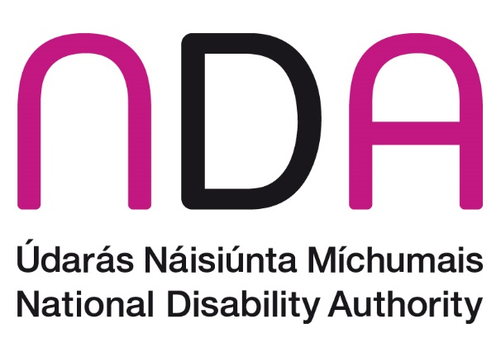

**Annual Conference 2024**

**‘Promoting the participation of disabled people in cultural life, recreation, leisure and sport in Ireland – UNCRPD Article 30’**

**Meet the Speakers**

Introduction and Opening Addresses

Dr Aideen Hartney – Director, National Disability Authority (NDA)

Dr Aideen Hartney became Director (Chief Executive) of the National Disability Authority (NDA) in mid-2020, having joined the organisation in 2016 as its Head of Policy, Research and Public Affairs.

Aideen has a long career in overseeing research for the public good, having managed several major funded research programmes in University College Dublin, before coming to the NDA. She also has private sector experience following 7 years as a market research consultant. Aideen holds a doctorate in Ancient History and lectured for a time at the University of Bristol.

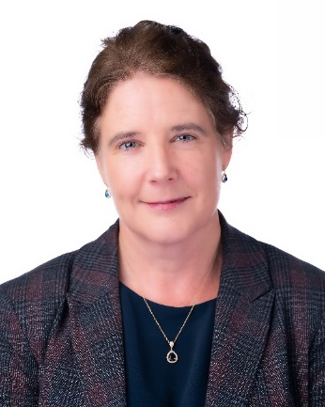

Kathryn O’Donoghue – Chairperson, National Disability Authority (NDA)

Kathryn was appointed as the Chair of the board of the National Disability Authority (NDA) in 2022. A member of the board since 2018, Kathryn was the Chair of the Finance Committee and a member of the Audit & Risk Committee.

Kathryn also served as the Chair of the Science Gallery Dublin Board from 2019 until 2022 having previously held roles as the Interim Director of Science Gallery Dublin during 2018 and as a Science Gallery Board member for 3 years until 2017.

Kathryn graduated from Trinity College Dublin in 1987 and completed a post-graduate course in Information Systems. Kathryn then started her career as a Management Consultant and spent 10 years between PriceWaterhouseCoopers and Ernst & Young specialising in Information Technology predominantly defining IT Strategies and designing, developing and implementing systems for Financial Services and Government organisations many of which were highly innovative and ground-breaking.

Kathryn joined General Electric in 1997 and working in the Financial Services division that became known as GE Money she successfully led several IT programs including the Y2K and Euro projects for 6 countries. She then moved to Italy to lead a project to fully replace the organisation’s systems there and once this was concluded she moved to the bank in Switzerland where she became the first female CIO for GE in Europe and the first female CIO of a bank in Switzerland. After 5 years she moved to Paris to become the Western Europe CIO for GE Money responsible for 10 countries.

Kathryn then moved back to Ireland and joined Google in 2009 and was a Director leading a number of multinational, multi-lingual teams across the sales and operations functions including being responsible for 44 countries in EMEA. She also led a global team responsible for data analytics & insights and spent 3 years as the EMEA Director of Trust & Safety for advertiser and publisher products.

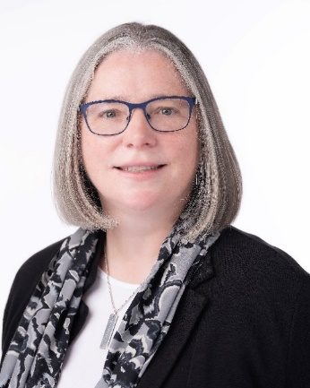

Anne Rabbitte T.D. – Minister of State with responsibility for Disabilities in the Department of Children, Disability, Equality, Integration and Youth

Hailing from Portumna, Co. Galway, Anne Rabbitte entered politics in 2014 when she was elected to Galway County Council for Fianna Fáil. Two years later, in 2016, she was elected to Dáil Éireann and was then appointed to the Fianna Fáil front bench as Spokesperson for Children & Youth Affairs. Re-elected to the 33rd Dáil in 2020, Deputy Rabbitte was subsequently appointed Minister of State with special responsibility for Disabilities by An Taoiseach Micheál Martin on the 1st July 2020. Before entering the political arena, Anne worked for a financial institution for 25 years and is a qualified financial adviser. For 3 years, Anne also ran a community childcare facility.

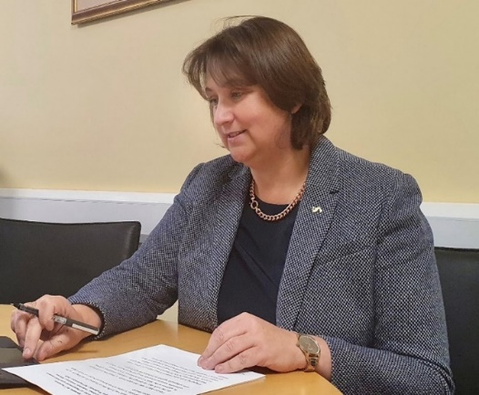

TBC, Department of Tourism, Culture, Arts, Gaeltacht, Sport and Media

Information forthcoming

Panel A: International and European Perspectives

Chair: Colm Ó Conaill – Assistant Secretary General, Department of Children, Equality, Disability, Integration and Youth

Information forthcoming

## **Jason Smyth – Strategy Manager, Paralympics Ireland**

Information forthcoming

Professor Delia Ferri – Professor of Law, Maynooth University

Delia Ferri is a Professor of Law at Maynooth University (MU) School of Law and Criminology and co-Director of the MU Assisting Living & Learning (ALL) Institute. Prof. Ferri is also affiliated researcher at Scuola Superiore Sant’Anna (Italy) within the research cluster on social rights, social inclusion and disability, and a fellow at the Burton Blatt Institute of Syracuse University (USA).

Prof. Ferri is a member of the RIA Ethical, Political, Legal and Philosophical Studies Committee. She is a senior member of the European Disability Expertise network funded by the European Commission. Since June 2023, she is a member of the Scientific Committee of the Fundamental Rights Agency of the European Union.

Prof. Ferri has authored several academic publications focusing on the rights of people with disabilities, participatory processes, and cultural diversity. She is currently Principal Investigator of the European Research Council (ERC) funded project ‘Protecting the Right to Culture of Persons with Disabilities and Enhancing Cultural Diversity through European Union Law: Exploring New Paths (DANCING)’. She has also taken part in several projects and EU-funded policy studies on disability rights. Among many others, in 2023, she authored a report on the European Disability Card for the European Parliament.

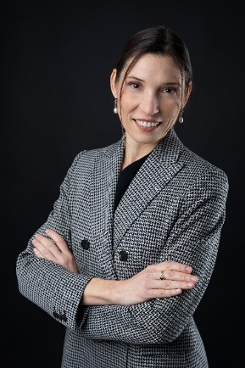

Ivor Ambrose – Managing Director, ENAT - European Network for Accessible Tourism

Ivor Ambrose co-founded ENAT, the European Network for Accessible Tourism non-profit association in Belgium in 2008 and has been its Managing Director since then, supporting its members and facilitating a wide range of projects and initiatives. With a background in Environmental Psychology, throughout his 40-year career he has been an advocate for the social integration of persons with disabilities and older people. He has worked in higher education as a lecturer and senior researcher specialising in user experience, accessibility and Universal Design in relation to buildings and environments, Information and Communication Technologies and service design. He participates in the development of European and International Standards on accessibility, and is a policy advisor on accessible tourism to the European Commission and UN Tourism. Through numerous projects and collaborations he has contributed to training curricula and provided strategic advice on accessibility and inclusion to tourism authorities, regions, cities, Destination Management Organisations and businesses. He is currently the lead expert on ‘Accessibility of the Built Environment’ at the AccessibleEU Resource Centre, an outreach initiative established by the European Commission running from 2023 to 2026.

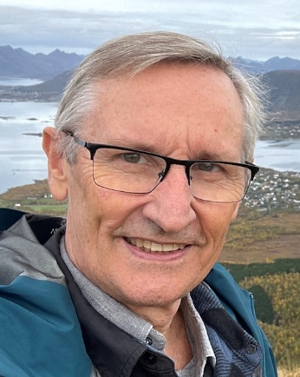

## **Antoine Fobe – Head of Advocacy and Campaigning, European Blind Union**

Antoine Fobe is the Head of Advocacy and Campaigning at the European Blind Union, which has a network of 42 national members. He previously worked for European Citizens’ Action Service, Amnesty International, the Council of Bars and Law Societies and the French data-protection authority.

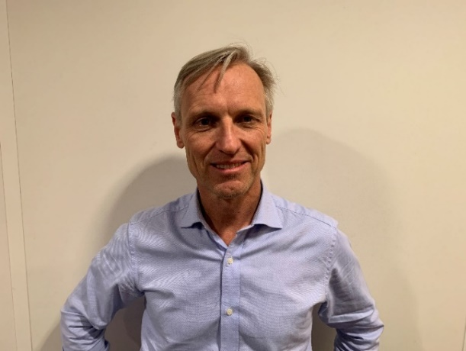

Panel B: Arts and Creativity

Chair: TBC

Information forthcoming

Pádraig Naughton – Executive Director, Arts & Disability Ireland

Pádraig Naughton became Executive Director of Arts & Disability Ireland in 2005. The national resource and development organisation for arts and disability, ADI champions the creativity of artists with disabilities and promotes inclusive experiences for audiences with disabilities. Activities include commissioning, providing audio description and captioning and support for artists in creating new work through funding, residency, mentoring and training opportunities.

In 2022 Pádraig graduated with an LLM in International & Comparative Disability Law & Policy from the University of Galway. He also holds a PGCE in Arts & Design Teaching, Bretton Hall College, University of Leeds (1998) and a Degree in Craft Design Ceramics, National College of Art & Design Dublin (1993). Pádraig established a studio practice focusing on tactile experimental sculpture and landscape drawing. Subsequently he became Artistic Director with Equata: Disability Arts Development Agency for Southwest England (2003).

Pádraig is the former Chair of the VSA Affiliate Council (2015-2018), a global network of arts and disability organisations. In 2022 The Kennedy Center recognized Pádraig’s lifetime achievement with an Excellence in Accessibility Leadership Award. Currently, Pádraig sits on the Night Time Culture Advisory Forum and Culture Night National Stakeholder Stewardship Group. He also represents Project Arts Centre as an Expert Collaborator on the Europe Beyond Access consortium 2024 – 2027.

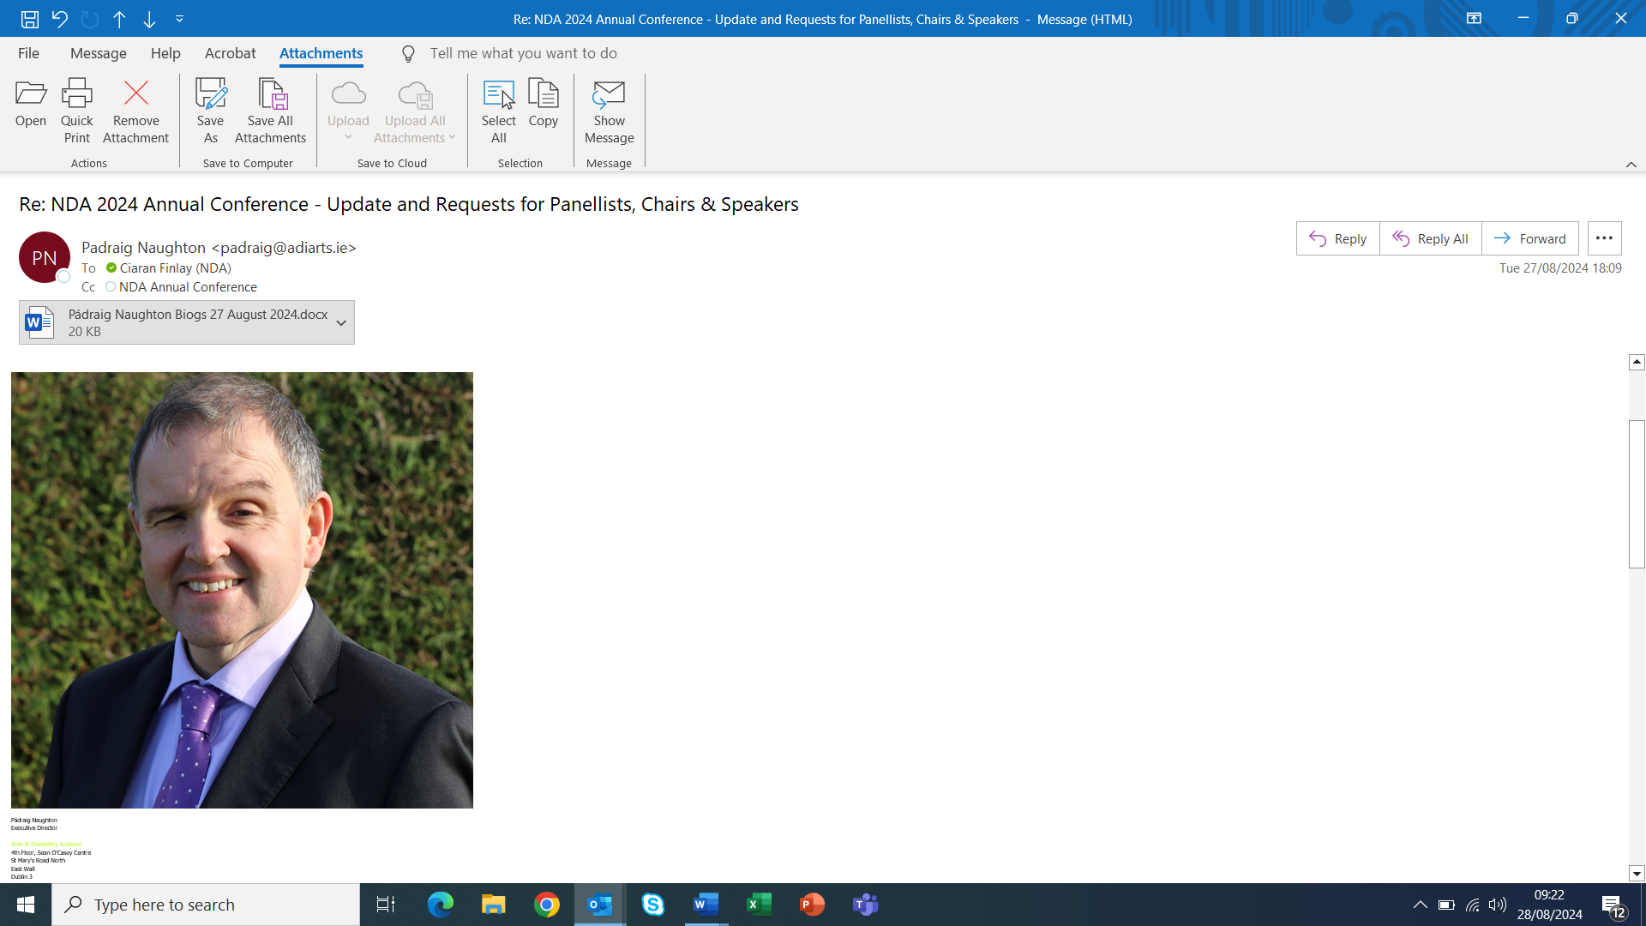

Petal Pilley – Artistic Director, Blue Teapot Theatre Company

Petal has a lifetime of experience in theatre having grown up in a travelling theatre company touring extensively throughout Europe.

In her role as Blue Teapot’s Artistic Director, she has extensive experience of commissioning new plays, theatre direction, selecting creative projects and people. Petal has clear vision, determination and flexibility in achieving goals and enjoys working in a collaborative team environment.

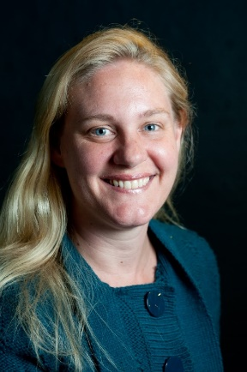

Kieran Coppinger – Actor, Blue Teapot Theatre Company

Kieran has been working on stage and screen for over 15 years. He was the lead in Sanctuary, an award-winning play and film that travelled the world. His credits include Lysander from Shakespeare’s A Midsummer Night’s Dream and Deagan from Into the Badlands on TV. He is currently in rehearsal with a new children’s play and will be leading inclusive theatre workshops in schools across Galway City and County.

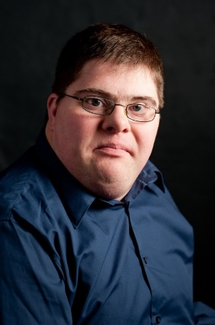

Emilie Conway – Artist and Founder, Disabled Artists and Disabled Academics

Emilie is an award winning vocal jazz artist, composer and lyricist. With music at the centre, Emilie's creative process is multi-disciplinary involving painting, writing, and dance. Her musical work has 3 areas of focus: on jazz and art/literature, jazz and disability and jazz and children.

Emilie was awarded a commission with the National Gallery to respond to the work of pioneering modern artist, Piet Mondrian. She created two podcasts, Music for Mondrian, and is in the final stages of production of her original compositions. This work attracted the attention from New York’s global centre for culture, The 92nd Street Y, and Emilie was invited to deliver a series of online lectures, entitled The Musical Art of Piet Mondrian in 2022. This in turn led to an invitation to deliver a set of performance lectures with the DLR Lexicon in 2023 entitled, Guiding Lights: Art and Music from Impressionism to Jazz.

Emilie has performed across Ireland the US, and Europe at festivals and venues including JJ Smyth’s Dublin, Carnegie Hall’s Migrations Festival NYC, The Village Trip Greenwich Village Festival, Sligo International Jazz Festival, The American Writers’ Museum Chicago, Ranelagh Arts Festival, The Bray Jazz Festival, Galway Jazz Festival, Copenhagen Jazz Festival, and many more.

Since Emilie has a disability, she is a passionate activist for equal and equitable participation of disabled people in arts and culture. She is highly in demand by Galleries, individual artists and cultural Institutions for her innovative and artistic expertise in creating and developing inclusive and aesthetic access experiences. In “Solid, Space & Sound” (TM) at the RHA Gallery and the National Gallery Emilie brings her musical, writing and artistic skills to the creation of innovative audio described, sensory, tactile, Braille and movement experiences of cultural space and visual art which are accessible to all, especially visually impaired and blind people.

In 2023 Emilie was commissioned by the Ark to adapt Solid, Space and Sound (TM) for disabled and visually impaired children from Child Vision - which was met with delight by the children. In July 2024, Emilie was awarded a Bursary from the Arts Council of Ireland to partner with the Project Arts Centre to develop an innovative aesthetic access experience for disabled audiences.

Emilie is a disability activist, consultant and advisor and is also the founder of DADA, Disabled Artists, Disabled Academics, whose focus is campaigning for the equitable participation and contribution by disabled artists to Ireland’s art and culture, in line with UNCRPD. Keeping music to the fore Emilie has sang her message at meetings and presentations to Oireachtas members. Since 2020 DADA has made several influential submissions on solutions to barriers facing disabled artists, which have resulted in inclusion in the publication of several policy documents by the Department of Tourism, Culture, Arts, Sport, Gaeltacht and Media (TCAGSM) including: A Safe and Respectful Working Environment in the Arts, ‘The Development of Local and Community Arts’. Emilie was an advisor on the recent report, AMPLIFY: A CALL FOR TRANSFORMATIVE ACTION from Safe to Create and the Irish Theatre Institute.

Emilie is also a fully accredited and practising art psychotherapist with the Irish Association for Counselling and Psychotherapy.

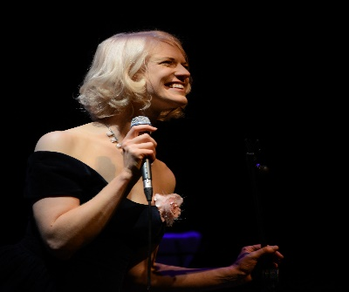

Peter Kearns – DPO Development Officer, Independent Living Movement Ireland

Peter started work with Independent Living Movement Irl. (ILMI) in 2019 as the EU cross border social inclusion Project Coordinator for ILMI and is currently the DPO Development Officer & Activist-Mentor. Peter graduated from Trinity College in the late 1980s with an English Honours degree and followed this with an MA in Film & TV Studies at DCU and a Higher Diploma in Adult & Community Education from Maynooth College. He also has higher Dips. in Disability Studies and Arts European Mentoring. Peter lectures at ATU St. Angela's College Sligo and has written-up over 15 QQ1-Level 8 & 9 Modules promoting a need for an Emancipatory-Advocacy way of thinking & practice for & with disabled people.

In the mid 1990’s Peter established THE WORKHOUSE, a disability consultancy company involved in equality/mentor/arts training in Ireland, Europe and Asia. As Development & Policy Worker with Forum of People with Disabilities, Peter worked in New York in early Noughties at the United Nations on developing NGO community development inputs into 2007 UN CRPD which now guide his work setting-up county Disabled Persons’ Org. (DPOs) throughout Ireland.

Peter’s associate residency at the Irish national Abbey Theatre facilitated the development of a disability access policy and promoted a vision for the National Cultural Institutes’ beginning of an ongoing relationship with disabled people as audience, creators and producers. Since leaving the National Theatre, he has produced & directed a series of touring adult cabaret shows with disabled performers. Critically recognised drama work has included Cork Year of Culture establishment of Forum Theatre groups at Cork Cheshire Homes, Firestation Artists Studio disability arts website, Dundalk Disability Forum Theatre and Dublin/Sligo/Galway Disability & Forum Theatre groups. Recently Peter co-produced, Disability-Dramaturge & acted in the critically acclaimed Irish Times Theatre Awards for best Audience-Choice play NO MAGIC PILL (NMP) at Galway and Dublin Theatre Festival. Peter was successfully involved in attracting the Irish Arts Councils largest Touring Grant for an 2024 autumn/winter national touring of NMP.

In terms of linking social model led disability equality with effective practice on the ground, Peter moved from Forum PwD to design and deliver nationwide mainstream programmes such as Making-Choices and Practical Self-Advocacy with Community Support Consultant with Disability Equality Specialist Support Agency (DESSA).

Peter is also a writer/dramatist, documentary & film maker. Peter also enjoys extreme trekking (K2 Stok Kangri 5,800-metres 2016 and Everest Basecamp 2019) and has two 'adult' children Deirbhile & Oisin and lives in Co. Leitrim, Ireland.

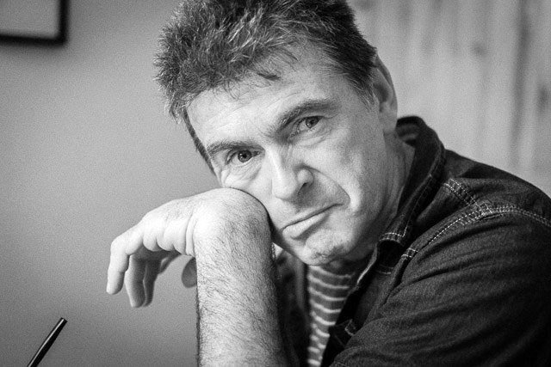

Panel C: Sports, Recreation & Leisure

Jack Kavanagh – Authority Member, National Disability Authority (NDA)

In 2012 Jack Kavanagh suffered a life changing spinal cord injury leaving him with 15% muscle function. In the years since Jack has challenged the perceived limitations of his situation. In 2014 Jack gave the acclaimed TEDx Talk "Fearless Like A Child, Overcoming Adversity", in 2019 was awarded as one of "Ten Outstanding Young People Of The Year" and has received several international awards for his documentary Breaking Boundaries.

Jack is a Pharmacist, Speaker and Non Executive Director. At present he runs Move The Needle a consultancy taking on select projects and sits on the board of directors of the National Disability Authority as well as leadership development organisation Common Purpose Ireland. He is engaged with the World Health Organisation in relation to digital and assistive technologies and is currently focused on tackling accessibility in aviation.

Something that has remained a constant in Jack’s life is a love of adventure. Jack is a keen hand cyclist, budding sailor and has taken up sit skiing over the past few winters. Last summer he set himself a “misogi” to cycle 100 km in a day to mark the anniversary of his injury. Successfully completing it is something he is particularly proud of over the past year.

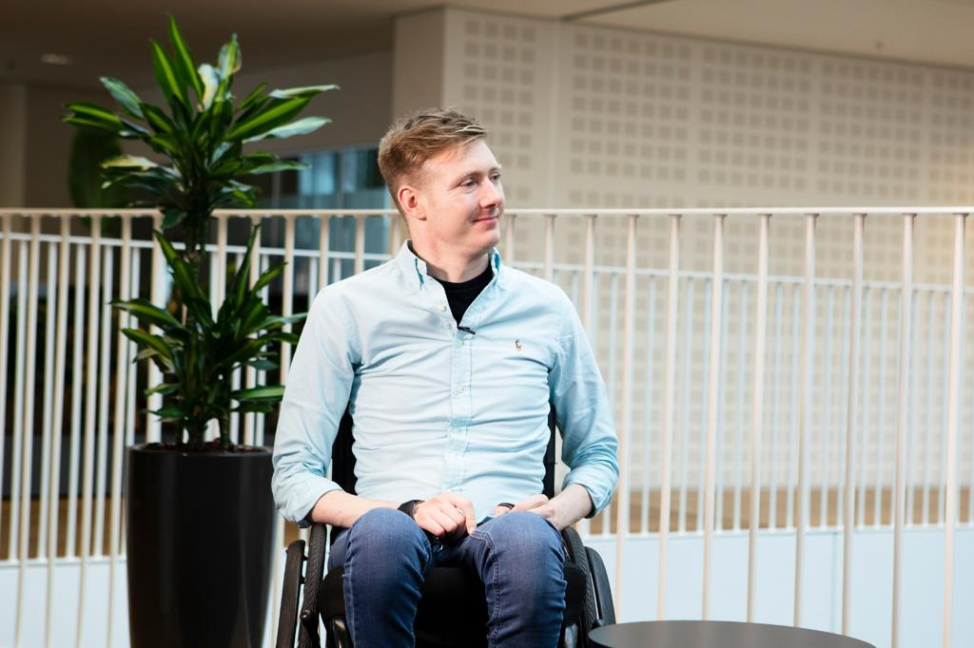

Stephanie Mac Sweeney – Strategic Operations Manager, Active Disability Ireland

Stephanie is the Strategic Operations Manager with Active Disability Ireland. Her role is focused on the strategic development of the organisation in helping to support others within the sport, health, education and community sectors to provide opportunities and choice for people with disabilities to participate in sport and physical activity.

With a background in the leisure, health and fitness sector and passion for sport and physical activity, Stephanie recognises how valuable and important it is to create equal participation opportunities for all.

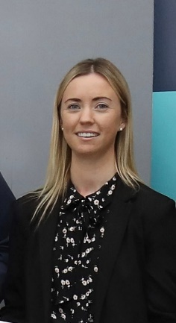

Sarah Kerrigan – Able Active Project Co-Ordinator, Surpass Sport Systems

Sarah Kerrigan, also known as troubleonapegleg, is a keen outdoor adventurer. She swims, hikes and more. She loves the freedom of the outdoors, it’s a freedom often difficult to attain if you’ve a disability. Sarah works to break down barriers to outdoor participation and strives to make it more accessible to others with disabilities by means of technology, initiatives and campaigns.

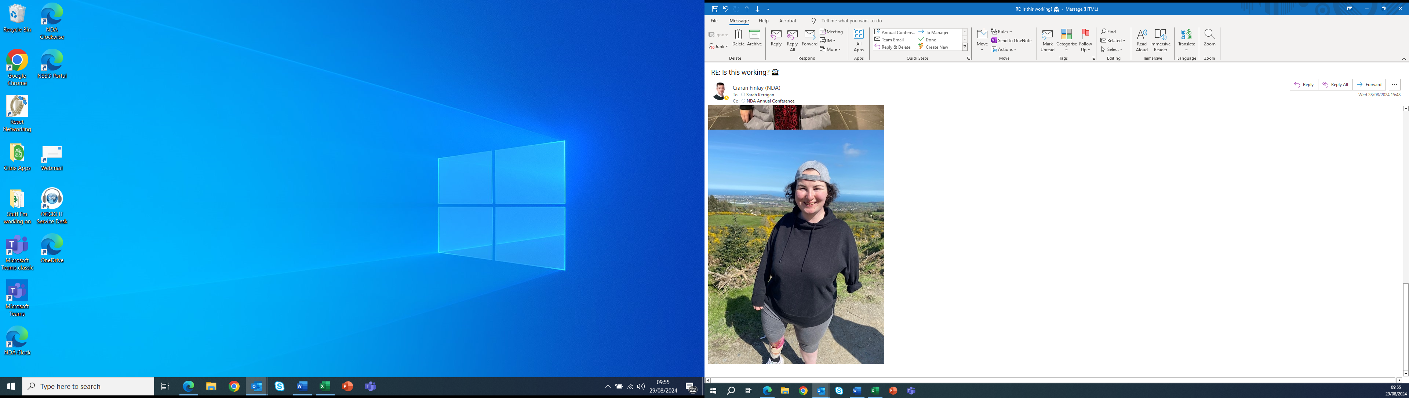

David McKay – Disability & Inclusion Officer, Irish Rugby Football Union (IRFU)

David McKay is a dedicated advocate for inclusivity and diversity within rugby, serving as the Disability & Inclusion Officer at the Irish Rugby Football Union (IRFU). In his role, David leads the strategic development of programs aimed at making rugby accessible to all, particularly those from marginalised communities. He oversees the implementation of disability and inclusion initiatives across Ireland's four provinces, ensuring they align with national objectives.

David’s commitment extends to providing essential support and training to the IRFU’s volunteers and staff, empowering them to foster an inclusive environment within the sport. A native of Ballymena, David brings over 28 years of playing experience to his role, coupled with 15 years of coaching players with range of different disabilities. He is an active player and coach with his local mixed ability rugby team Malone Tornadoes, and also coaches the Old Wesley Vision Impaired Rugby Team.

Before joining the IRFU, David made significant contributions to the community and voluntary sectors, specialising in helping adults and children with disabilities access employment and training opportunities. His passion for inclusion is deeply rooted in his family values, driving his dedication to creating a more inclusive rugby community.

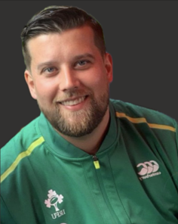

Laurence Colleran – Senior Executive Parks Superintendent, South Dublin County Council

Laurence works for South Dublin County Councils Public Realm Section. He has a background in landscape architecture and his work mainly focuses on environmental and green infrastructure projects. Laurence is also involved in the design and delivery of sports and recreational facilities within public parks. He notably managed a successful playspace programme that delivered over 40 natural and accessible playspaces throughout South Dublin. This initiative earned a special mention Award at the EU Access City Awards 2024 for its innovative approach to accessible play facilities. A strong advocate for universal design and consultation, Laurence is frequently invited to speak on natural play and accessible play at both national and international events and looks forward to sharing his experience of accessible play at the 2024 conference.

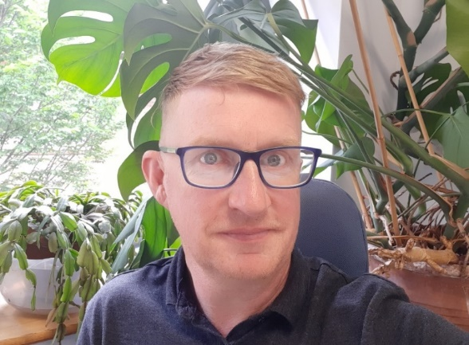

Louise Burke – Director of Participation, Sport Ireland

Louise Burke oversees the Outdoors, Partnerships and Cross Collaboration unit. Louise’s role is key to the implementation of Sport Ireland's Statement of Strategy 2023-2027 and its focus on participation and inclusion, as well as Sport Ireland’s involvement in delivering "Embracing Ireland's Outdoors," the National Outdoor Recreation Strategy. Through her work with Sport Ireland’s network of Local Sports Partnerships, Louise has developed a stronger network of 29 Sport Inclusion Disability Officers (SIDOs) to provide opportunities to be active in every community in Ireland for people with disabilities. Louise’s leadership is instrumental in driving initiatives that ensure that the benefits of participation and outdoor recreation are accessible to all. With a strong background in national governing bodies, Louise is dedicated to fostering collaboration and inclusion within the sports sector, thus ensuring Sport Ireland creates an active nation where all people are encouraged to start, continue to participate, progress and achieve in sport.

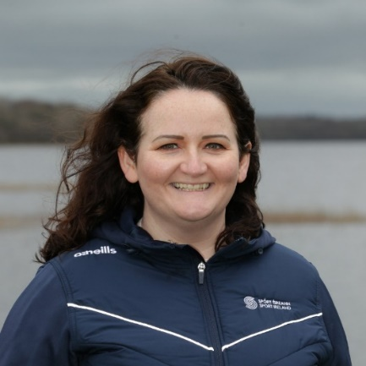

Panel D: Cultural Heritage, Identity and Tourism, Media and Film

Chair: Adam Harris – CEO, AsIAm

Adam Harris is the Founder and CEO of AsIAm, Ireland’s National Autism Charity. Adam founded the organisation based on his own experiences growing up on the Autism spectrum. Diagnosed with Asperger’s Syndrome from an early age, the condition was far less understood or even known as it is today. Having spent his initial school years within the special education stream, he moved to a mainstream school in Second Class and was supported by an SNA.

Today, AsIAm provides support to Autistic people and their families, advocates on behalf of the community, and works to support public and private sector organisations and communities in becoming inclusive and accessible. A Social Entrepreneurs Ireland Awardee, Adam is a frequent contributor to media and conferences in Ireland and overseas. He has also sat and advised on many government consultative and policy committees on disability rights and inclusion. From Greystones in Co Wicklow, Adam was appointed to the Irish Human Rights and Equality Commission in July 2020.

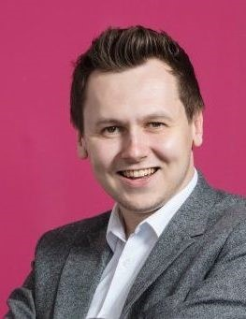

Niamh Daffy – Inclusive Tourism Manager, Fáilte Ireland

Embarking on a new opportunity in July of last year, Niamh joined Fáilte Ireland to lead the development of a new Inclusive Tourism team responsible for enhancing accessible and inclusive tourism provision across Ireland. Niamh, along with her colleagues in Fáilte Ireland are committed to supporting the development and delivery of exceptional and inclusive visitor experiences which meets the needs and expectations of all visitors, with a long-term vision for Ireland to be recognised by visitors (both domestic and international) as a leading accessible and inclusive destination.

With over 20 years’ experience in the disability and disability sport sectors, in her previous roles, Niamh was manager of an adult services organisation and subsequently led the establishment of a national charity tasked with increasing greater access and opportunities for people with disabilities in sport and physical activity overseeing the development of a national training framework, a co-designed charter for change along with the implementation of many national initiatives designed to deliver equality of access and opportunity within our communities.

Bringing her passion and expertise to her new role, Niamh is keen that we all work together to develop Ireland as a leading accessible and inclusive place for everyone.

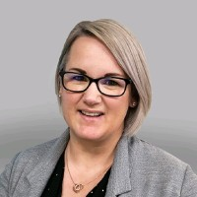

Elaine Grehan – Advocacy Services Manager, Irish Deaf Society

With over 20 years of experience in the Irish Deaf Society’s Advocacy Service, Elaine Grehan is a dedicated champion for the rights and access of Deaf people at local, national, and international levels. As the Advocacy Service Manager, Elaine leads the department in its daily efforts to empower the Deaf community, ensuring they are informed about their rights and have a strong voice representing them in governmental consultations. Elaine was a pivotal figure in the successful campaign for the Irish Sign Language (ISL) Act of 2017, which has significantly enhanced access and recognition for the Deaf community. Her unwavering passion for achieving equal access drives the Irish Deaf Society's mission to realise full inclusion for Deaf people across Ireland.

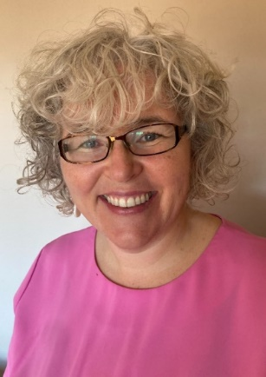

Terri Sweeney Meade – National Monuments, Historic Properties and Capital Works Delivery, Office of Public Works

Information forthcoming

Dan Airey – Presenter, Podcaster, Producer and Filmmaker

Dan Airey is a presenter, podcaster, producer and filmmaker. Dan is the co-producer and co-presenter of the award-winning Dan and Darragh Do Ability Podcast, talking to people with disabilities and trying to get people to see life through their eyes and so much more. He has considerable experience of the production process from beginning to end following a four-year degree in Creative Digital Media and a Masters in Broadcast Production for TV and Radio. He wrote and directed the short documentary L.I.F.E. (Live. It. Fully. Everyday.) as part of Virgin Media Sharp Shorts 2023. Dan has worked as a researcher in RTÉ on Angela Scanlon’s Ask Me Anything, The Late Late Show, The Late Late Toy Show and developed content for 2023 and beyond. He has produced films and documentaries such as A Deluge of Memories and Swim with Richard that focus on human stories. Dan has collaborated extensively with theIrish Wheelchair Association, National Youth Council of Ireland and Youth Work Ireland promoting disability rights through various speaking engagements, acting as an EU Youth Delegate for Ireland at the EU Youth Conference in Vienna, Austria. Dan has a unique set of skills and a different way of looking at the world.

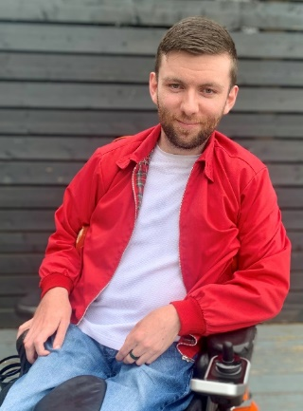

Louise McLoughlin – Director of Compliance & Complaints – Broadcasting and Video On-demand Services, Coimisiún na Meán

A Communications graduate and holder of a MSc in Equality Studies, Louise has worked in media regulation for over 17 years. Throughout her career, Louise has had significant roles in licensing independent broadcasters, developing codes and standards for broadcasters, funding programmes on Irish culture, heritage and experience, and supporting learning and skills development in the media sector.

Louise is now Director of Compliance & Complaints for broadcasting and video on-demand services. Her expertise plays a crucial part in ensuring a thriving, safe, trusted and accessible media landscape, balancing the right to freedom of expression and the need to protect the interests of audience, particularly children.

Louise's career is distinguished by her commitment to public service and putting people at the centre of media regulation in Ireland.

