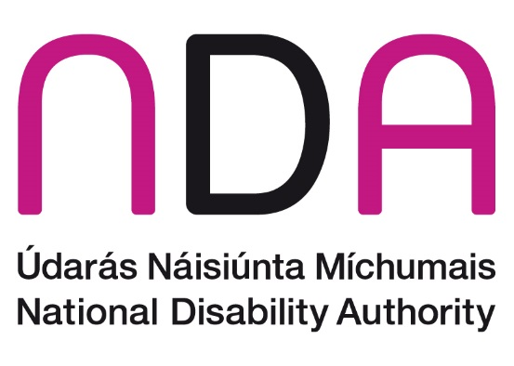

This is a Plain English Report

A monitoring report on the accessibility of public services and information in public bodies

2022

Who we are
The National Disability Authority, or NDA, is an independent organisation in Ireland.
Our job is to give the Government advice on things that are important to the lives of persons with disabilities.
We have a Centre for Excellence in Universal Design.
Universal Design means that buildings, products, services, and technology are designed so everyone can understand and use them easily.

Our monitoring responsibilities
The Disability Act is a law in Ireland. It is split into different parts called sections. The NDA has a role to monitor how some parts of this law are put into action.
A Code of Practice is a guide on the best way to do something. It can help public bodies to understand and follow the law.
There is a Code of Practice for accessible public services and information. This covers sections 26, 27, and 28 of the Disability Act.
The NDA checks if this Code of Practice is being followed by public bodies. We send a report to the Minister.
There is more information on the legal responsibilities of public bodies and the NDA’s monitoring responsibilities in the full report.
In 2022, we checked to see if public bodies were following certain information in the Code of Practice for accessible public services and information.
This monitoring activity was a desk based. We studied the websites of public bodies.

Access Officers
Section 26 of the Disability Act says that public bodies must have an Access Officer.
Some people with disabilities may need extra support to use a service. Public bodies must have at least one member of staff to organise this extra support. That member of staff is called an Access Officer.
We checked what information public bodies had on their website about Access Officers. We checked 3 different things:
1. We checked if the website said there was an Access Officer in the organisation.
2. We checked if the website had information about how to contact the Access Officer.
3. We checked if there were different ways to communicate with the Access Officer.

What we found
The NDA monitoring team looked at the websites of 292 public bodies, later changed to 281.
We put together a draft report. Our findings were communicated to Departments to share with the public bodies they support. Public bodies and Departments were given time to respond with updated information which was then included in the final report.
Our draft report showed that 47.7% of public bodies had Access Officer details on their websites while 52.3% of public bodies did not – see Chart 1.

Chart 1

When public bodies updated their information, our final report showed 68.3% of public bodies had Access Officer details promoted on their websites while 31.7% of public bodies did not – see Chart 2.

Chart 2

In our draft report, 34.9% of public bodies followed all 3 things about Access Officers on their website while 65.1% of public bodies did not.

Chart 3

When public bodies updated their information, our final report showed 58.7% of public bodies followed all 3 things about Access Officers while 41.3% of public bodies did not – see Chart 4.

Chart 4

Overall, since we shared the draft report, the NDA notes there has been a big improvement in the promotion of Access Officers on the websites of public bodies. For example, the promotion of the appointment of an Access Officer on public body websites has jumped from 47.7% of all public bodies monitored to 68.3% - see Chart 5

Chart 5

There was also a big improvement on Access Officers’ contact information and different ways to communicate with the Access Officer. More public bodies followed all 3 things about Access Officers on their website – see Chart 6.

Chart 6

How monitoring can help
Since the draft report came out, there has been a big improvement. There is more information about Access Officers on the websites of public bodies.
There is also better contact information for Access Officers on the websites. People can write or speak to Access Officers.
The Department of Justice set up a network for Access Officers in the justice sector. They will meet to share information and ideas.

What should happen next?
Public bodies need to do more to follow the Disability Act. They must make sure to give the right information to the public.
The NDA will keep giving advice to public bodies, so they have the right policies and people in place.
Public bodies must give their Access Officers the right training, resources, and information to do their job well.
Public bodies can read a guide from the NDA. It is about training and supporting Access Officers.

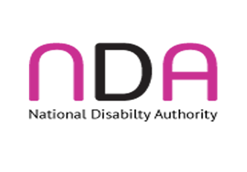
This report was put together by the National Disability Authority.

ACE Communication and Experts by Experience helped with this report.

