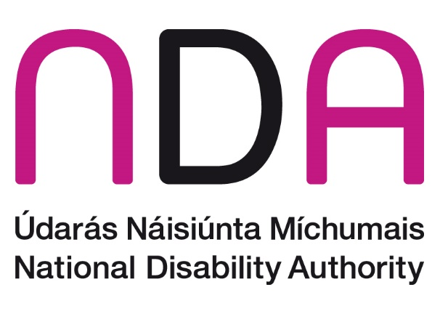

Annual Conference 2026

Disability inclusive responses to natural and man-made emergencies – Article 11 UNCRPD

Meet the Speakers

Introduction and Opening Addresses

Dr Aideen Hartney – Director, National Disability Authority (NDA)
Dr Aideen Hartney became Director (Chief Executive) of the National Disability Authority (NDA) in mid-2020, having joined the organisation in 2016 as its Head of Policy, Research and Public Affairs.
Aideen has a long career in overseeing research for the public good, having managed several major funded research programmes in University College Dublin, before coming to the NDA. She also has private sector experience following 7 years as a market research consultant. Aideen holds a doctorate in Ancient History and lectured for a time at the University of Bristol.
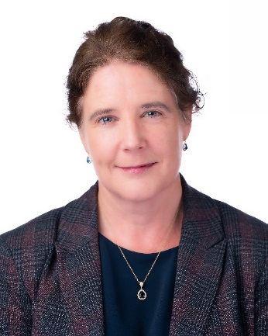

Kathryn O’Donoghue – Chairperson, National Disability Authority (NDA)
Kathryn was appointed as the Chair of the board of the National Disability Authority (NDA) in 2022. A member of the board since 2018, Kathryn was the Chair of the Finance Committee and a member of the Audit & Risk Committee.
Kathryn also served as the Chair of the Science Gallery Dublin Board from 2019 until 2022 having previously held roles as the Interim Director of Science Gallery Dublin during 2018 and as a Science Gallery Board member for 3 years until 2017.
Kathryn graduated from Trinity College Dublin in 1987 and completed a post-graduate course in Information Systems. Kathryn then started her career as a Management Consultant and spent 10 years between PriceWaterhouseCoopers and Ernst & Young specialising in Information Technology predominantly defining IT Strategies and designing, developing and implementing systems for Financial Services and Government organisations many of which were highly innovative and ground-breaking.
Kathryn joined General Electric in 1997 and working in the Financial Services division that became known as GE Money she successfully led several IT programs including the Y2K and Euro projects for 6 countries. She then moved to Italy to lead a project to fully replace the organisation’s systems there and once this was concluded she moved to the bank in Switzerland where she became the first female CIO for GE in Europe and the first female CIO of a bank in Switzerland. After 5 years she moved to Paris to become the Western Europe CIO for GE Money responsible for 10 countries.
Kathryn then moved back to Ireland and joined Google in 2009 and was a Director leading a number of multinational, multi-lingual teams across the sales and operations functions including being responsible for 44 countries in EMEA. She also led a global team responsible for data analytics & insights and spent 3 years as the EMEA Director of Trust & Safety for advertiser and publisher products.
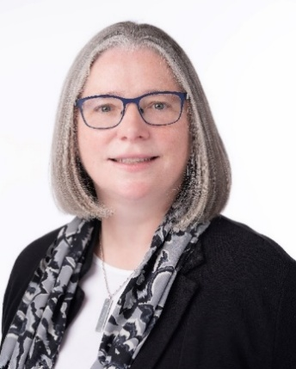

Kevin McCarthy – Secretary General, Department of Children, Disability and Equality

Kevin McCarthy is Secretary General of the Department of Children, Disability and Equality in Ireland. He took up his current role in January 2022.

As Secretary General, he has overall responsibility for the effective operation of the Department and for providing advice to the Minister in delivering on the Department’s mission and mandate to enhance the lives of people in Ireland by upholding rights, promoting equality of opportunity, recognising diversity and delivering supportive legislation, policies and services.

He previously served as Secretary General of the Irish Department of Rural and Community Development from 2017 and as an Assistant Secretary General in the Department of Education from 2008 to 2017, where he held a number of senior leadership roles.

In the earlier part of his career, he worked in a number of roles in Ireland’s Departments of Health and Finance and in the health sector.

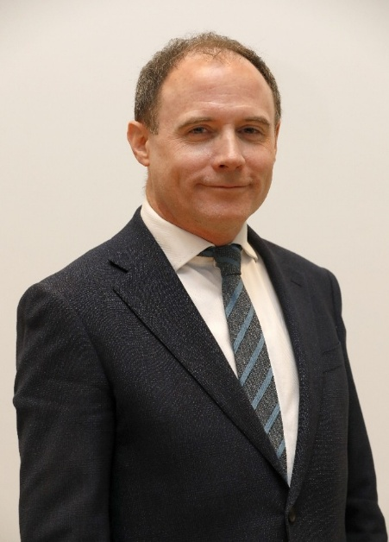

Keynote Address

Catherine Naughton – Executive Director, European Disability Forum
Catherine is Executive Director of the European Disability Forum, a European platform representing organisations of persons with disabilities. She has over 30 years’ experience in the field of disability, with a current focus on EU legislation and policy, accessibility, and the rights of persons with disabilities across Europe. She has worked at national, European, and international levels to advance the participation and inclusion of persons with disabilities.
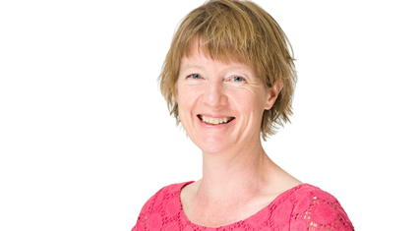

Session 1: Inclusive emergency responses in communities

Chair: Pauline Mulligan – Chief Executive Officer, Local Government Management Agency
Pauline Mulligan is Chief Executive of the Local Government Management Agency (LGMA) since January 2025. The LGMA provides a range of professional services for and on behalf of local authorities in Ireland supporting improved efficiency in delivery of services by the sector, sharing best practise and innovative approaches.
She was formerly on the Management Board of the Department of Enterprise, Trade & Employment with responsibility for the development of indigenous enterprise which included oversight of Enterprise Ireland, the 31 Local Enterprise Offices and 9 Regional Enterprise Plans.
Pauline has extensive experience across many policy and operational areas including developing Innovation 2020 Ireland’s previous national research and development policy and leading the Department’s response to Brexit and Covid. She led on embedding a culture of innovation in the public service and served as Industry Attaché in Brussels with the Department of Foreign Affairs.
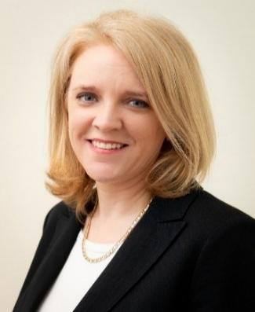

Laura O'Callaghan - Community Development Officer, Disability Federation of Ireland and Coordinator, Disability and Inclusion Steering Committee, Wicklow County Council
Laura has more than fifteen years' experience as a disability advocate. She began her career working with the Deafblind community, where she played a pivotal role in the campaign to have Deafblindness recognised as a distinct condition in Ireland.

Through a long-standing partnership with Disability Federation Ireland, Laura facilitates Wicklow County Council's Disability and Inclusion Steering Committee (DISC). The committee brings together council staff, elected members, community organisations and, most importantly, people with lived experience of disability to inform and strengthen policy and practice. This role has given Laura extensive expertise in the local implementation of the United Nations Convention on the Rights of Persons with Disabilities (UNCRPD). Drawing on this experience, she has contributed to national advocacy efforts calling for greater investment in disability rights and accessibility across local authorities.

Laura holds degrees in Social Science and in Counselling and Psychotherapy, as well as a Master's degree in Management and Leadership of Public, Community and Voluntary Organisations.

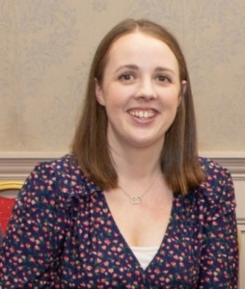

Dónal Rice - EAA Implementation Manager, Commission for Communications Regulation
Dónal Rice is the European Accessibility Act (EAA) Implementation Manager, at the Commission for Communications Regulation (ComReg), Ireland. He joined ComReg in 2025 to support establishment of the EAA function.

Previously, Dónal managed the National Monitoring Body under the EU Web Accessibility Directive at the National Disability Authority and the Public Sector Equality and Human Rights team with the Irish Human Rights and Equality Commission. Dónal has been an evaluator of accessibility projects on multiple EU research and innovation funding programs and is an associate lecturer on equality and human right at the Institute of Public Administration. He has advised the International Telecommunication Union Development Sector and the European Commission on accessibility policy.

Dónal volunteers as a trustee on the Board of Directors of the South Leinster Citizens Information Service.

Dónal holds a MSc in Computing and a Master of Laws (LLM).

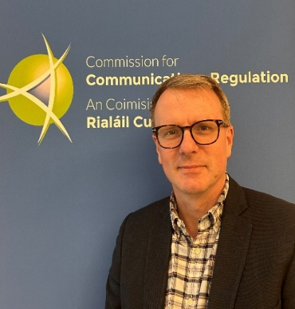

Lianne Quigley – Chair, Irish Deaf Society
Lianne serves as Chairperson of the Irish Deaf Society (IDS) Board. She has worked in the financial sector for 13 years. She holds a BA (Hons) in Business, Economics and Social Studies from Trinity College Dublin (TCD, 2006), as well as a Certificate in Equality Studies for Deaf People from University College Dublin (UCD, 2014).

She was Co-Chairperson of the ISL Recognition Campaign, which contributed to the achievement of the Irish Sign Language Act in 2017, and was involved in the Justisigns 2 Project. Lianne is a Deaf interpreter, having completed Continuing Professional Development (CPD) in Deaf Interpreting with the Centre for Deaf Studies at Trinity College Dublin (CDS) in 2021.

She is a member of the ISL Act Cross-Community Group and represents IDS on the Disabled Persons Organisations (DPO) Network. She also serves on the DPO Group for the National Human Rights Strategy for Disabled People 2025–2030. In addition, Lianne represents IDS on the ISL Working Group and chairs a subgroup under the ISL Working Group focused on access to emergency and essential services.

Lianne is also passionate about the arts and is a Deaf artist herself. She is a strong advocate for greater accessibility and inclusion within the arts and cultural sectors, promoting better access, opportunities and representation for Deaf artists and ensuring that Deaf audiences can fully participate in and enjoy the arts and cultural life.

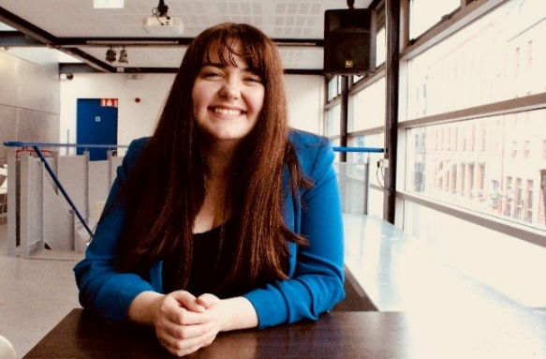

Lindsay Sharpe – Senior Manager for Customer Service & Experience, ESB Networks
Lindsay Sharpe leads the Customer Service & Experience team in ESB Networks. The Customer Service & Experience team drives customer-focused improvements across ESB Networks, using customer insights, innovation and collaboration to deliver better customer outcomes and experiences.

With over 20 years of experience spanning marketing, communications, strategy, and customer experience, Lindsay brings a deep understanding of how to align customer needs with strategic energy transformation. She holds a BA in Economics and an MSc in Marketing, and is committed to shaping a customer-centric, sustainable energy future.
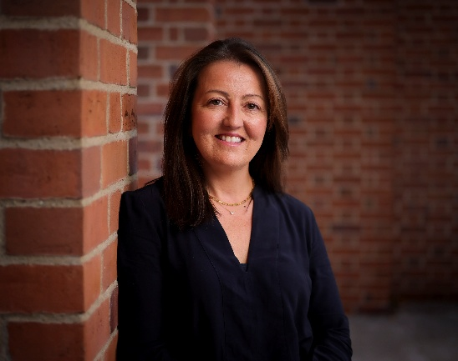

Sharon Commins, Head of National Services, Irish Red Cross
Sharon Commins is Head of National Services at the Irish Red Cross, where she leads the organisation’s Disaster Risk Management team. She brings more than 20 years of experience in the NGO sector, having held senior leadership positions across both domestic and international organisations.
She has extensive experience in community development, having served as CEO of a Local Development Company, where she oversaw a broad range of integrated programmes delivered in partnership with statutory, voluntary and community sector organisations. She has also held roles with Concern and GOAL, managing primary healthcare and community-based programmes in complex and insecure environments, including Sudan, the Democratic Republic of Congo and Uganda.
Throughout her career, Sharon has focused on delivering meaningful social impact for disadvantaged and marginalised communities. She holds an MBA from UCD Michael Smurfit Graduate Business School, a Master’s degree in International Relations, and a degree in Journalism and Communications.
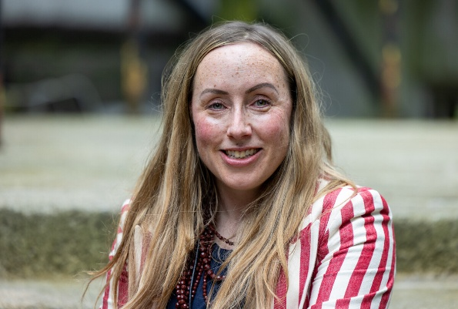

Session 2: Inclusive emergency responses in comparative contexts

Chair: Keith Leonard – National Director, National Directorate for Fire and Emergency Management, Department of Housing, Local Government and Heritage
Keith Leonard has over 30 years' experience in the Fire Service. A Computer Science graduate, he joined Dublin Fire Brigade in 1993 and was appointed Regional Control Centre Manager in 1997, leading the transition of Dublin Fire Brigade's Control Centre to the East Regional Communications Centre.
In 2006, Keith joined the National Directorate for Fire & Emergency Management (NDFEM) as Communications Advisor, representing the Fire Service on the Board of the National Digital Radio Project and working with the Department of Communications on the specification and procurement of the Emergency Call Answering Service (ECAS) for 999/112 call handling.
In 2010, he took on responsibility for Emergency Management within NDFEM, coordinating the Major Emergency Management National Steering Group and representing Ireland on EU Civil Protection matters. Keith chairs the National Emergency Coordination Group, which leads the whole-of-government response to major flooding and severe weather emergencies. He was appointed National Director of the NDFEM in 2021.
As National Director of the NDFEM, he leads fire service policy, preparedness and coordination, working across government, with local authorities and the principal response agencies to support fire services and emergency response.
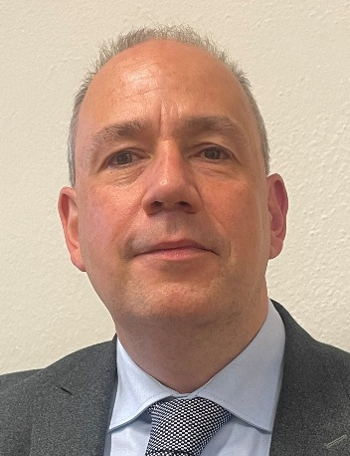

Andrea Podruski – Chief Operating Officer and Director General of Standards and Research, Accessibility Standards Canada
Andrea Podruski, currently the Chief Operating Officer and Director General of Standards and Research, has been with Accessibility Standards Canada since 2020 and is responsible for standards development and research funded by the grants and contributions program. Prior to joining the public service, she was a social worker and spent twenty years working in community and supporting the full inclusion of people with disabilities. She holds a Bachelor of Social Work and Masters in Philanthropy and Non-Profit Leadership. Andrea lives in Chelsea, Quebec with her husband and two teenage children, one of whom lives with multiple disabilities. As a parent to a child with disabilities, she dedicates her personal time to volunteering in various capacities in the education and disability communities.

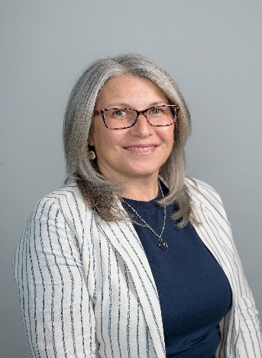

Lourdes González Perea – Head of Accessible Technologies, Fundación ONCE, Spain
Lourdes has been working in the field of accessibility since 2003, specialising in accessible technologies, inclusive education, and accessible communication. She also leads training initiatives aimed at improving assistance for people with disabilities in emergency situations. Academically, Lourdes holds a PhD in Education and Social Communication and has completed the Executive MBA programme at ESADE.

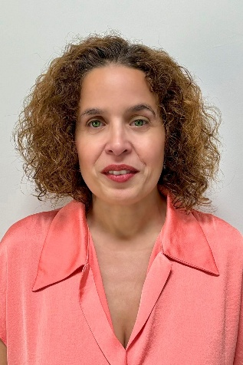

Kealan McMoreland – Head, Office of Emergency Planning, Department of Defence
Kealan is the Head of the Office of Emergency Planning. He leads this civil-military Branch of the Department of Defence in its function to support the work of the Government Task Force on Emergency Planning. He holds a MSc in Emergency Management from Dublin City University and a MA in Military History and Strategic Studies from Maynooth University, with undergraduates in Engineering from Sligo Institute of Technology. Over the last 25 years Kealan has worked with the Local Government, the Permanent Defence Forces, An Garda Síochána, Irish Aid and Civil Defence before taking up his current role in the Office of Emergency Planning.

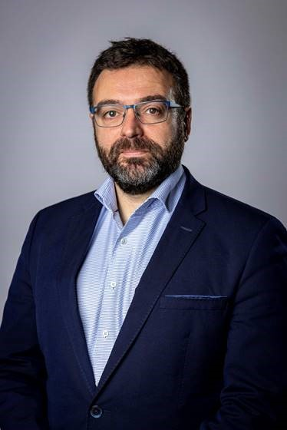

Professor Michelle Villeneuve – Deputy Director, Centre for Disability Research and Policy, The University of Sydney, Australia
Professor Michelle Villeneuve is a leading scholar and international advocate for disability-inclusive emergency management. She is Deputy Director of the Centre for Disability Research and Policy at the University of Sydney and an Australian Research Council Fellow. Michelle leads the Collaborating4Inclusion research program, which developed the Person-Centred Emergency Preparedness (P-CEP) approach and has influenced policy and practice change in Australia and internationally. Her work focuses on strengthening preparedness and resilience through collaboration between disability, health, community, government, and emergency management sectors.

Over the past two decades, she has worked across disaster and conflict contexts, including in Bosnia and Herzegovina, Sri Lanka, and Indonesia, advancing practical approaches to disability-inclusive disaster risk reduction. Michelle has led major research partnerships with governments, emergency management agencies, and community organisations, leading the development of the Disability-Inclusive Disaster Risk Reduction Framework and the nationally recognised Disability Inclusive Emergency Management (DIEM) Toolkit.
Her current Australian Research Council Fellowship focuses on strengthening evidence-informed preparedness decision-making by improving understanding of organisational capability, preparedness, and service continuity before emergencies occur. Michelle collaborates with partners across Australia, New Zealand, the United States, Türkiye, the Philippines, and Brunei to advance disability-inclusive emergency management practice and policy. She received the 2023 National Resilient Australia Award for the P-CEP Certificate Course, served as an advisor to UNESCAP's Disability-Inclusive Disaster Risk Reduction (DIDRR) eLearning program, and represents Australia on the World Rehabilitation Alliance Emergencies Committee.

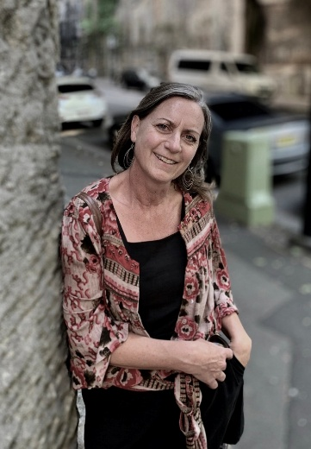

Ministerial Address

Emer Higgins T.D. – Minister of State with responsibility for Disability, Department of Children, Disability and Equality
Emer Higgins is Minister of State attending Cabinet at the Department of Children, Disability and Equality with special responsibility for Disability. She was appointed to this role on 18 November 2025. Before this, she served as Minister of State at the Department of Public Expenditure, Infrastructure, Public Service Reform and Digitalisation with special responsibility for Public Procurement, Digitalisation and eGovernment. She previously served as Minister of State with responsibility for Business, Employment and Retail.
She was elected Fine Gael TD for Dublin Mid-West in the 2020 General Election. Deputy Higgins served as a Councillor of South Dublin County Council from 2011-2020, representing the communities of Palmerstown, Lucan, Clondalkin, Newcastle, Saggart and Rathcoole. Previously, Deputy Higgins worked as Chief of Staff for PayPal’s Customer Service division in Europe, Middle East and Africa (EMEA), bringing over a decade of corporate expertise to the table working with both small and medium size businesses (SMEs) and multinational companies.
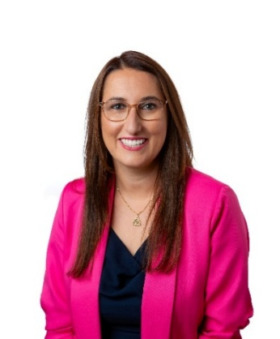

New Report

Dr Lorcan Kenny – Senior Research Officer, National Disability Authority (NDA)
Lorcan is a Senior Research Officer in the NDA. Since joining in 2024, Lorcan has led on a variety of projects including a review of workforce considerations for Children’s Disability Network Teams and an evaluation of therapists in special schools. Lorcan has also supported on several other NDA projects such as the updated disability terminology guidance and NDA actions from the Autism Innovation Strategy.
Prior to joining the NDA, Lorcan was the National Autism Research Lead in the National Learning Disability and Autism Programme in NHS England, was Head of Research for Autistica, the UK autism research charity and completed his PhD at the Centre for Research in Autism and Education (CRAE) at University College London (UCL).
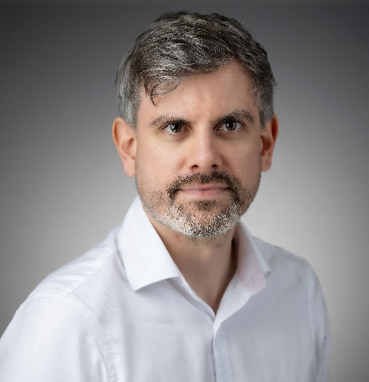

Dr Aoife O’Neill – Statistician, Central Statistics Office (CSO)
Aoife is a statistician working in the Children and Disability Division in the CSO. Since joining the CSO in 2021, Aoife has worked in the areas of survey design, sampling across all social surveys, the Labour Force Survey data processing. Aoife is now leading on the development of the new national survey on disability; the Irish Disability Survey (IDS).
For the past year, Aoife has been working with stakeholders from DCDE and other government Departments, the NDA, the DPO Network, and other sectoral stakeholders to design the upcoming survey. The IDS will be piloted at the end of 2026 and early 2027, before main data collection in 2028.
Prior to the CSO, Aoife was working as a postdoctoral researcher in the Ageing Research Centre, in the University of Ireland, with a focus on secondary data analysis of The Irish Longitudinal Study on Ageing.
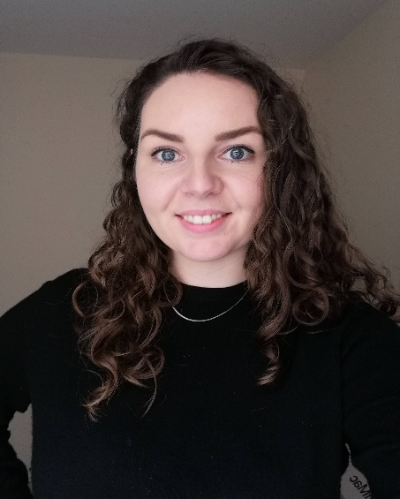

Session 3: Designing inclusive systems for future emergencies and crises

Chair: Jane Ann Duffy – Principal Officer, Disability Equality Policy, Department of Children, Disability and Equality
Jane Ann leads the Disability Equality Policy Unit (DEPU) of the Department of Children, Disability and Equality.

DEPU coordinates the National Human Rights Strategy for Disabled People which sets out the whole-of-Government approach to disability and to progressively realising the rights of disabled people under the United Nations Convention on the Rights of Persons with Disabilities.

DEPU also has responsibility for development of disability equality policy and for relevant legislation, including the Assisted Decision-Making Capacity Acts, the Disability Act and the Irish Sign Language Act.

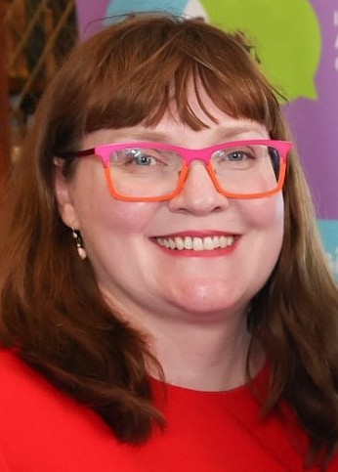

Gerry Tully – Assistant National Director for Disability Services for Adults, Health Services Executive
Gerry Tully is an Assistant National Director in the HSE, who works in specialist Disability Services in Access and Integration. He has thirty-six years’ experience in delivering supports from frontline to national services. Gerry chaired a national engagement between the HSE and the delivery system on a weekly basis throughout the Covid-19 Pandemic. While Covid was challenging for disabled persons as it was for many others, health outcomes were relatively positive across particularly residential services. The engagement is cited as an example of flexibility, innovation and collaboration by the National Economic and Social Council.
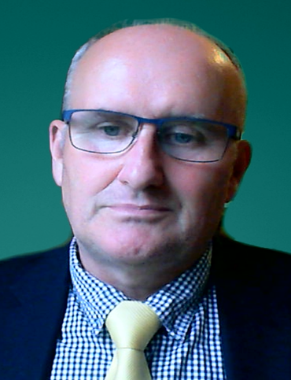

Boakai Abu Nyehn, Jr – Community Development Worker, Independent Living Movement Ireland
Boakai Abu Nyehn, Jr joined ILMI in September 2024 as community development worker on the Disability Participation Awareness Fund (DPAF) funding project “Engaging Disabled People in Direct Provision” which he led with Heylove Robert Mark Sr. Boakai has joined ILMI's ONSIDE Evolution project as a community development worker in August 2026.
He is a passionate advocate for disability rights, social inclusion, and development, with extensive experience in working to promote the rights and full participation of disabled people in Liberia. Boakai has served as a consultant on disability and social inclusion for numerous national and international agencies. He has also worked as a Research Assistant on multiple projects with organisations such as Leonard Cheshire Disability and Inclusive Development Centre at University College London, Talking Drum Studio, AIFO-Liberia, and UNMIL, ensuring that disabled people’s needs and perspectives are integrated into their programs.
As a disabled person, Boakai’s lived experience informs his leadership as Assistant Director for disabled people in Liberia. His role focuses on advocating for the inclusion of disabled people at all levels of society, promoting accessible development, and advancing the rights of the community. Boakai holds certifications in International Law and related fields and is a skilled Administrator and Assistive Technology Specialist, committed to using his expertise to create a more inclusive society for all.
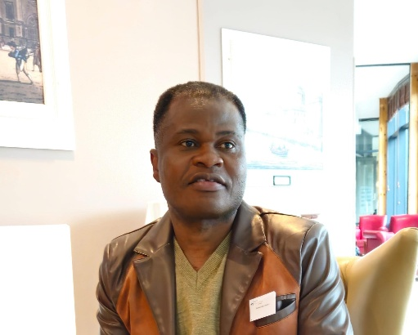

Dr Caroline Jagoe Sherman – Associate Professor, Clinical Speech & Language Studies, Trinity College Dublin and Co-Founder of the SADIE Network
Dr Caroline Jagoe Sherman is an Associate Professor in Clinical Speech & Language Studies, Trinity College Dublin and co-founder of the SADIE Network (Strengthening evidence-based Action on Disability Inclusion in Emergencies). Her work focuses on disability rights and inclusion in humanitarian action, informed by her clinical education in speech and language therapy and academic background in law. Caroline has collaborated with a range of UN agencies, International Non-Governmental Organisations and Organisations of Persons with Disabilities across various countries experiencing crises. She is a member of the Disability Advisory Committee of the Irish Human Rights and Equality Commission.

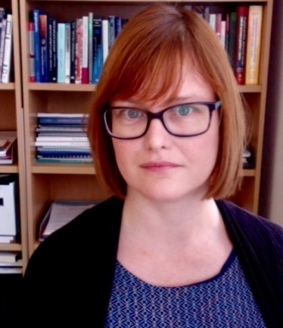

Dr Mary Keogh – Advocacy Director, Christian Blind Mission Global Disability Inclusion
Mary holds a PhD in Law and Public Policy and is an Adjunct Professor with the NUI Galway School of Law. Her PhD research focused the US, Finnish and Australian governments approach to including persons with disabilities in their development portfolios. This research interested was sparked by the opportunity to attend and observe the negotiations for the Convention on the Rights of Persons with Disabilities. Her other academic achievements include a master’s in international development, M.Sc. in Rehabilitation Management and a major in Economics. She also holds a diploma from the Chartered Directors programme with the Institute of Directors and she is a certified mediator.

For most of her 20-year career in international development, her mission has been to bridge the divide between siloed approaches to disability rights, human rights and development. She has held leadership advocacy and advisory roles on disability rights, intersectionality, and climate justice and her expertise encompasses research, policy analysis, strategic planning, and change management, supported by advanced training in mediation and conflict resolution.

As Advocacy Director at CBM Global Disability Inclusion, Mary works with global, national and local partners including organisation of persons with disabilities on the implementation of advocacy strategies and alliance building to bring about change. She passionately believes in the power of the collective.

She was elected chair of the board of the International Disability Development Consortium in 2024. She also is also a member of the Disability Rights and Climate Justice (DRCJ) Advisory Board at Global Greengrants Fund – a global board founded in 2022 that encourages intersectional connections between disability rights and climate justice movements through grant-making. In Ireland, she sits on the board of Áiseanna Tacaíochta (ÁT), an Irish independent living organisation.

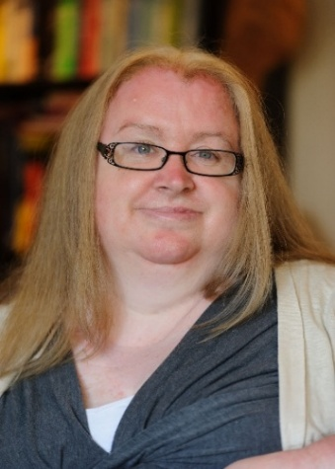

Sarah Bell – Senior Lecturer in Health and Disability Geography, University of Exeter
Dr Sarah Bell is a Senior Lecturer in health and disability geography at the University of Exeter. She uses qualitative and arts-based research approaches to examine the intersections between disability, well-being, social inequality and the changing environments encountered through the life course. Her current project, Sensing Climate, is exploring opportunities for responses to the climate crisis to build safe and fair communities that take into account the priorities and insights of people who are disabled, d/Deaf, neurodivergent and people with long-term health conditions.

