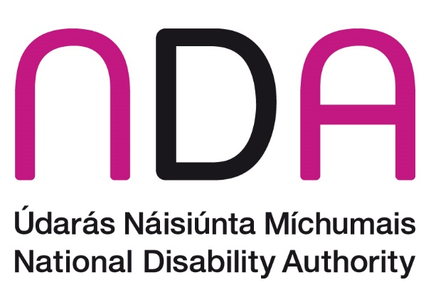

Annual Conference 2024

‘Promoting the participation of disabled people in cultural life, recreation, leisure and sport in Ireland – UNCRPD Article 30’

Conference Programme

**Thursday, 24 October 2024, Aviva Stadium and online.**

# Welcome and Registration

**9:30** Tea and coffee.

# Introduction and Opening Addresses

**10:00** Dr Aideen Hartney, Director, National Disability Authority.

**10:05 Welcome Address**  
Kathryn O’Donoghue,Chairperson, National Disability Authority.

**10:10** **Ministerial Address**  
Anne Rabbitte T.D., Minister of State with responsibility for Disability, Department of Children, Equality, Disability, Integration and Youth.

**10:20** TBC, Department of Tourism, Culture, Arts, Gaeltacht, Sport and Media.

# Session 1: International and Regional Perspectives

**10:30** **Chair:** Colm Ó Conaill, Assistant Secretary General, Department of Children, Equality, Disability, Integration and Youth.

* Jason Smyth, Strategy Manager, Paralympics Ireland.
* Professor Delia Ferri, Professor of Law, Maynooth University.
* Ivor Ambrose, Managing Director, ENAT – European Network for Accessible Tourism.
* Antoine Fobe, Head of Advocacy and Campaigning, European Blind Union.

**11:10 Q&A**

**11:30 Break**

# Exhibitions

**All Day** Feel free during the breaks and lunchtime period to browse the stands and exhibitions, including an arts exhibition entitled **‘Connecting Artists Collective’** from theConnections Arts Centre.

# Session 2: Arts and Creativity

**11:45** **Chair:** TBC.

* Pádraig Naughton, Executive Director, Arts & Disability Ireland.
* Petal Pilley, Artistic Director, Blue Teapot Theatre Company.
* Kieran Coppinger, Actor, Blue Teapot Theatre Company.
* Emilie Conway, Artist and Founder, Disabled Artists and Disabled Academics.
* Peter Kearns, DPO Development Officer, Independent Living Movement Ireland.

**12:25 Q&A**

# Performance

**12:45** **TBC**

**13:00 Lunch**

# Performance

**13:45** **Emilie Conway**

Vocal Jazz Artist, Composer and Founder, Disabled Artists and Disabled Academics.

# Session 3: Sport, Recreation and Leisure

**13:50** **Chair:** Jack Kavanagh, Authority Member, National Disability Authority.

* Stephanie Mac Sweeney, Strategic Operations Manager, Active Disability Ireland.
* Sarah Kerrigan, Able Active Project Co-Ordinator, Surpass Sport Systems.
* David McKay, Disability and Inclusion Officer, Irish Rugby Football Union.
* Laurence Colleran, Senior Executive Parks Superintendent, South Dublin County Council.
* Louise Burke, Director of Participation, Sport Ireland.

**14:30 Q&A**

# Recital

**14:50** **Jessica Keegan**

Poet, Author of ‘My Angels and Demons Through Poetry’ and Service Owner, Enable Ireland, Limerick.

**14:55 Break**

# Session 4: Cultural Heritage, Identity and Tourism, Film and Media

**15:00** **Chair:** Adam Harris, Chief Executive Officer, AsIAm.

* Niamh Daffy, Inclusive Tourism Manager, Fáilte Ireland.
* Elaine Grehan, Advocacy Services Manager, Irish Deaf Society.
* Terri Sweeney Meade, National Monuments, Historic Properties and Capital Works Delivery, Office of Public Works.
* Dan Airey, Presenter, Podcaster, Producer and Filmmaker.
* Louise McLoughlin, Director of Compliance and Complaints–Broadcasting and Video On-Demand Services, Coimisiún na Meán.

**15:40 Q&A**

**16:00 Conference Close**

Dr Aideen Hartney, Director, National Disability Authority.