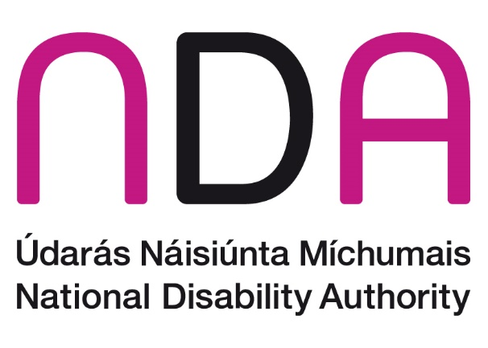

Literature review on the causes, prevention and management of crisis situations among young disabled people

Application Form

1. Introduction
Please read the accompanying Call for Proposals document along with this application form. In your application please:

- Answer all of the questions
- Sign the application form and keep a copy
- Return the completed application form by the deadline of:
17 November 2023 by 12 noon
- Applications should be marked Literature Review and submitted by email to: research@nda.ie

Please note that incomplete or unsigned applications cannot be processed.
Applications received after the deadline will not be processed

2. Applicant
Organisation name:
Address:
Project Manager, contact details (person who takes overall responsibility for project):
Name:
Position:
Email:
Phone:

3. Experience and qualifications of research team and appropriate supervisory arrangements (30%)

3a Project team
Details of the person in charge of the project and other members of the project team
For each key member of the team, list name, organisation, role and days assigned.
Person | Role | Total days
Attach a CV showing relevant expertise and experience of each member of the proposed team (2 pages maximum per team member).

3b Research support and advice
Give details of proposed arrangements for overseeing or advising on the review (where applicable). The NDA require an assurance that the details of qualified persons who are available and agreeable to serve in this capacity will be supplied should an award be made.
_______________________________________________________________________________________________________________________________________________________________________________________________________________________________________________________________________________________________________________________________________________________________________

3c Previous work
Please supply a web link to three pieces of relevant similar work carried out by the proposed team or lead researcher.

4. Quality and relevance of research proposal and methodology proposed (30%)
Please cover
- The broad parameters of the review, for example, time frame, language etc.
- Approach to the search including what databases will be included, how grey literature will be accessed (the actual search terms do not need to be included)
- The method of analysis and synthesis
- The approach to write up
Maximum 1,500 words

5. Cost (30%)
As a public body the NDA is required to seek value for money in its commissioned work. The lowest cost proposal received will be used as the baseline from which to judge other proposals. Any overheads included should be kept to a minimum. If VAT is applicable this should be stated and costs presented with and without VAT. A breakdown of costs is required in the table below.
Element | € Price (ex Vat) | Vat Amt. € | € Total incl. VAT
Total

6. Accessibility (10%)
Applicants should demonstrate experience of producing accessible reports. This relates to both the use of plain English and the translation of scientific findings that are suitable for non-technical audiences. Reports must be formatted correctly and be accessible to a range of users including those who use screen readers.
Accessibility can also be demonstrated through the inclusion of persons with disabilities in the research process.
_______________________________________________________________________________________________________________________________________________________________________________________________________________________________________________________________________________________________________________________________________________________________________

7. Referees
Please give the name, position and contact details of two referees for whom the lead researcher/team have conducted commissioned research.
Reference 1:
____________________________________________________________________________________________________________________________________________________________________________________
Reference 2: ___________________________________________________________________________________________________________________________________________________________________________________

8. Signature
Please sign 8.1 and 8.2 below. Unsigned applications cannot be processed. We will accept electronic signatures or signed scanned copies of this application form.

8.1 Freedom of Information Declaration
I understand that information about this process not identified as sensitive may be released in response to a request under the Freedom of Information Act 1997. The promoter is obliged under the Act to consult with this organisation prior to any decision to release such information
Failure to sign this section will result in an ineligible proposal
Signed:
On behalf of:
Date:

8.2 Disclosure of conflicts of interest, if any – sign A or B
A. There is no conflict of interest in relation to this application
Signed:
On behalf of:
Date:
B. The following interest(s) is/are declared in relation to this application:
________________________________________________________________________________________________________________________________________________________________________________________________________________________________________________
Signed:
On behalf of:
Date:

