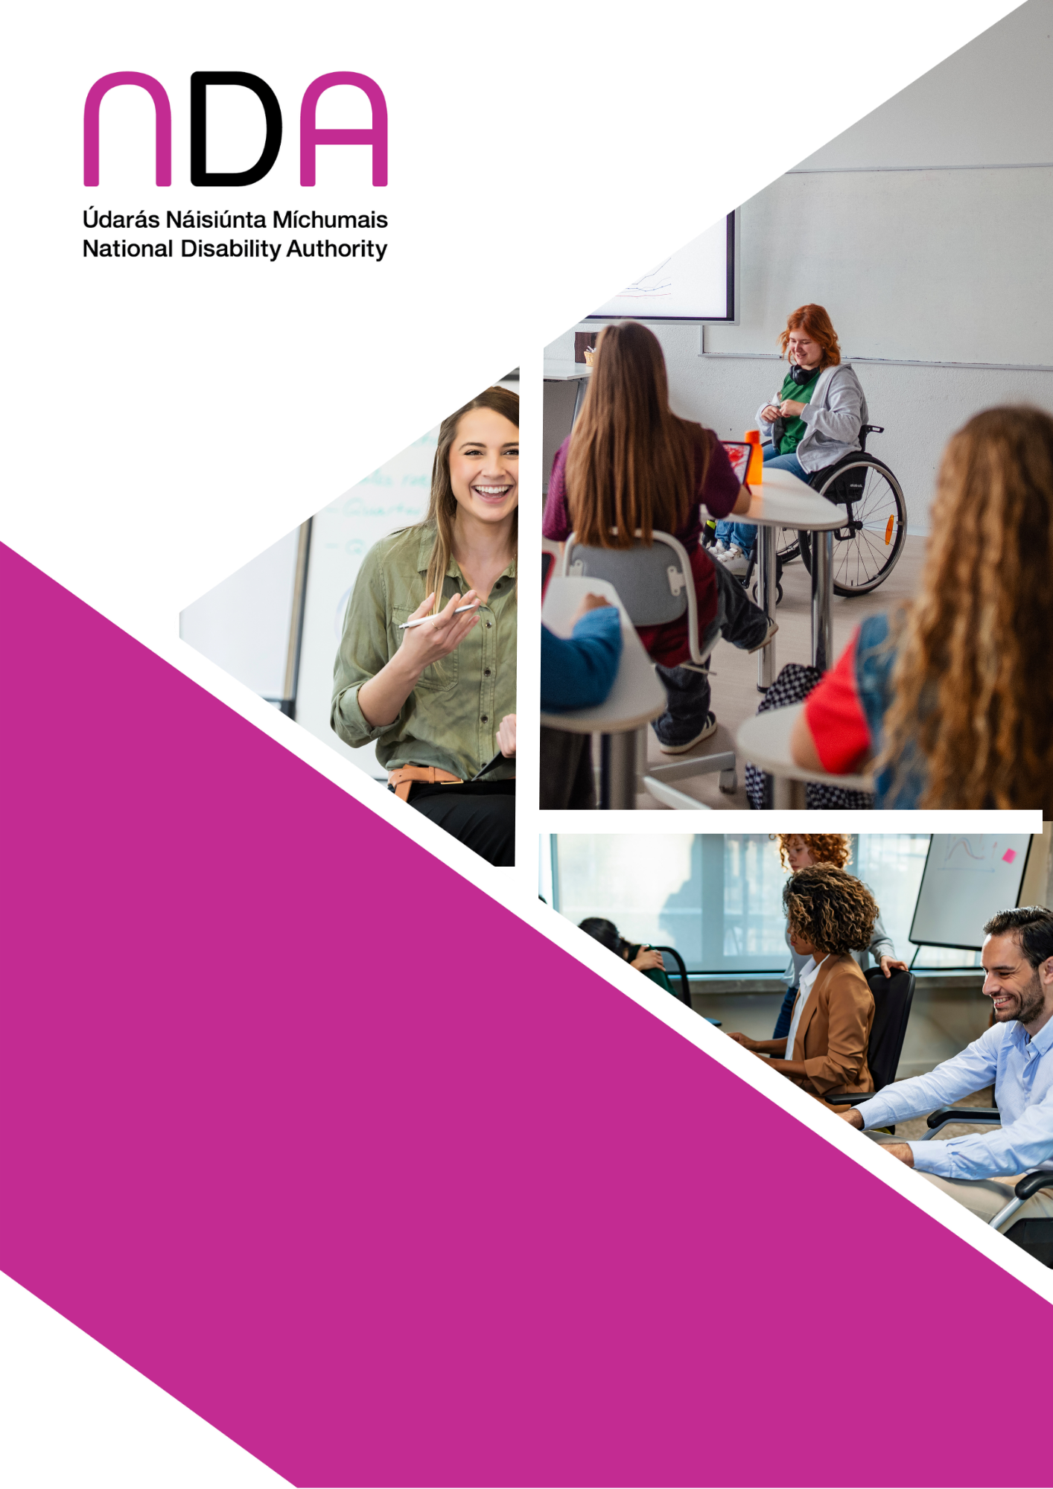
Good Practice Guidance
for Commissioners
of Disability
Training in
the Public Sector
February 2026

Good Practice Guidance for Commissioners of Disability Training in the Public Sector

Contents
Acknowledgments 1
Note on Language 2
Summary 3
Introduction 5
Purpose of disability training 6
Types of disability training 7
Disability awareness training 7
Disability competency training 8
Disability human rights training 8
Disability equality training 8
Selecting trainers 8
Including lived experience 8
Public procurement process 9
Accreditation/Certification 9
Knowledge of disability 10
Delivery of training 10
In-person training 11
Online training 12
Hybrid training 12
eLearning 13
Ensuring inclusive and accessible training 14
Evaluation and follow-up of training 15
Conclusion 15
Appendix 1: Text of UNCRPD Article 8 16
Appendix 2: Resources 17
Appendix 3: Suggested content for disability training 18

Acknowledgments
The National Disability Authority (NDA) wishes to acknowledge the contribution of the following Disabled Persons’ Organisations (DPOs) who contributed to this report.
- Voice of Vision Impairment
- Irish Deaf Society
- Independent Living Movement Ireland
- Irish Non-Neurotypical Disabled Persons Organisation
Comments from other DPOs related to the document Good Practice Guidance for Commissioners of Autism Training in the Public Sector also informed this report and we thank them for their input.

Note on Language
The language around disability continues to evolve and there is no universally agreed consensus on which terminology to use in relation to disability.
In this report, we use the terms ‘people/persons with disabilities’ and ‘disabled people’ interchangeably. Many people within the disability rights movement in Ireland, including some Disabled Persons’ Organisations consulted for this report, prefer the term ‘disabled people’ because it is considered to acknowledge the fact that people are disabled by barriers in the environment and society, and this aligns with the social and human rights models of disability. Identity first language is also used in the new Human Rights Strategy for Disabled People. However, we also recognise that others prefer the term ‘people/persons with disabilities’, because of the inherent understanding in this phrasing that they are first and foremost human beings entitled to human rights. Person-first language is used in the United Nations Conventions on the Rights of Persons with Disabilities (UNCRPD). We recognise that many people with an intellectual disability and people with a mental health difficulty or psycho-social disability prefer person-first language. We also acknowledge that some people to which information in this report may apply do not identify with either term.
The term ‘Disabled Persons’ Organisation (DPO)’ is used in this report to refer to organisations that are rooted in the principles and rights of the UNCRPD and are led by disabled people; however, we acknowledge that some organisations may prefer the term ‘Disabled Persons’ Representative Organisation (DPRO)’.

Summary
- This guidance updates a National Disability Authority (NDA) publication from 2005 entitled Guidelines for Purchasers of Disability Equality Training.
- Disabled people regularly report that they face barriers and challenges in their everyday lives, including in accessing public services.
- As training is one way that awareness, knowledge and understanding of disability can be improved, commissioning appropriate disability training is an important element in embedding inclusivity in a public body, its work culture and physical environment. It also assists in the provision of accessible and inclusive public services to people with disabilities.
- The aim of this guidance is to support commissioners of disability training across the public sector to procure appropriate training for their staff based on good practice. The training will support staff in their interactions with and understanding of disabled customers and in accepting and supporting disabled colleagues.
- This guidance is complemented by a companion publication called Good Practice Guidance for Commissioners of Autism Training in the Public Sector that has been produced under Action 6 of the Autism Innovation Strategy.
- It is important that commissioners understand the purpose of the training before procuring and decide, for example, if the training is to increase awareness for all employees, or to address a specific information or competency gap for certain staff.
- There are also different types of disability training that can be procured so it is important to decide which one is the most appropriate for your organisation.
- Selecting the right trainer is very important, and it is generally considered good practice that disability training is co-designed with disabled people and delivered, or co-delivered, by a disabled person. Disabled Persons Organisations (DPOs) can provide a lived experience perspective that is reflective of their membership.
- When considering and assessing the quality of a tender, organisations are advised to emphasise the incorporation of lived experience and to include a scoring criterion around this item.
- Where possible an individual, or company, delivering the training should be accredited or their training certified, to ensure that a course is high-quality, relevant, and meets specific standards. However, a balance needs to be struck between seeking certification and incorporating lived experience.
- There are a number of different ways that training could be delivered, such as through in-person, online, hybrid or eLearning. Each of these methods have their own benefits and challenges.
- It is important to note that the training should be developed using Universal Design principles meaning that the training must be accessible to all.
- An area that is often forgotten in relation to training is the evaluation of the training itself. Evaluation has benefits for the trainer, the participants and the organisation.
- Training should not be seen as a one-off event but rather as a step on a journey towards a more inclusive workplace, with commitments by senior management to a disability inclusion ethos in the organisation.
- This commitment to disability inclusiveness should be embedded in the public body’s strategic plan, objectives and goals and in their procurement policies and practices.

Introduction
Census 2022 found that approximately 22% of the population reported some form of disability. Disabled people regularly report that they face barriers and challenges in their everyday lives. These include environmental, communication, attitudinal and structural barriers. Any, or all, of these barriers can be encountered when interacting with public services.
One way that awareness, knowledge and understanding of disability can be improved is through training. Therefore, commissioning appropriate disability training is an important element in embedding inclusivity in a public body, its work culture and physical environment and in the provision of accessible and inclusive public services to people with disabilities. It can also be an important element in helping a public body comply with its statutory obligations.
This guidance updates a National Disability Authority (NDA) publication from 2005 entitled Guidelines for Purchasers of Disability Equality Training. There have been many developments in the disability landscape since 2005 that necessitated an update including:
- Ireland’s ratification of the United Nations Convention on the Rights of Persons with Disabilities (UNCRPD)
- the introduction of the Public Sector Duty
- the passing of the Irish Sign Language Act 2017
- the emergence of Disabled Persons’ Organisations (DPOs)
- the development of national disability strategies, the most recent being the National Human Rights Strategy for Disabled People 2025-2030
- the EU Web Accessibility Directive which requires all public bodies to have both their websites and mobile apps accessible as defined by WCAG 2.1 and EN301549 Standard
- the European Accessibility Act (EAA) which requires all public bodies to procure accessible digital products along with all online call services to be fully accessible
This guidance is complimented by a companion publication called Good Practice Guidance for Commissioners of Autism Training in the Public Sector that has been produced under Action 6 of the Autism Innovation Strategy.
The aim of the guidance is to support commissioners of disability training to procure appropriate training for their staff based on good practice. The training will support staff in their interactions with and understanding of customers and fellow staff with disabilities. This will help fulfil obligations such as:
- Article 8 of the UNCRPD which is concerned with awareness raising (see Appendix 1)
- The Public Sector Duty contained in Section 42 of the Irish Human Rights and Equality Commission Act 2014 which places a statutory obligation on public bodies to have regard to human rights and equality considerations in the performance of their functions, and
- Better Public Services: A transformation strategy to deliver for the public and build trust which requires a focus on better customer service.
It is important to remember that this is a guidance document. It should be used to complement your organisation’s own internal policies and goals. Please note that all procurement in the public sector should follow this document: Public Procurement Guidelines for Goods and Services.
While written for a public sector audience this guidance will also be valuable to private sector and community and voluntary sector employers.
This guidance has been informed by the views of several DPOs. Some additional resources are provided in Appendix 2.

Purpose of disability training
The NDA neither provides nor accredits disability training, neither do we promote any training provider.
It is important that commissioners understand the purpose of the training before procuring. They need to decide if it is to:
- Increase awareness and knowledge for all employees
- Support improved attitudes and behaviours
- Drive a disability inclusive ethos in the organisation
- Address a specific information or competency gap for certain staff
- Embed disability inclusion at a leadership level
Deciding who to train in an organisation will depend on the purpose of the training but also on the level of existing knowledge of staff. For example:
- Ideally all staff in a public body should receive disability equality training but at a minimum should receive disability awareness training (see further below on the distinction between the two). This will benefit both staff in customer facing and non-customer facing roles, as many people will have at least one disabled colleague. Ideally training should be conducted as part of induction or soon afterwards. This training should assume that people have minimal knowledge of disability.
- Some staff, because of their roles, will require more in-depth training such as disability equality training or disability competency training. For example, senior managers, HR/Corporate Services staff, access officers, disability liaison officers or customer facing staff.
Once the purpose of the training is known the type of training required becomes clearer. Typically training can be tailored to the needs of an organisation.

Types of disability training
Disability training has evolved over time, shifting the focus from just simply raising awareness around disability to promoting disability equality, changing attitudes and behaviours towards disabled people, and recognising the environmental, social and attitudinal barriers that people face.
Four broad categories of training are listed below. These are not mutually exclusive in terms of content but rather can build on each other with each one going into slightly more depth.
While all these types of training should lead to increased knowledge and each level increases the level of understanding, there is no guarantee that training will change people’s attitudes or behaviours. However, the deeper the understanding the more likely it is that attitudes and behaviours will improve. Disability training should be part of wider efforts in organisations to improve attitudes and behaviours and not a one-off action.

Disability awareness training
This training focuses on increasing the knowledge of participants about disability and aims to increase understanding, empathy, and confidence in interacting with and accommodating disabled people. It aims to break down barriers, combat unconscious bias, and provide practical skills for creating a more inclusive environment, by covering different types of disabilities, appropriate language and terminology, and interacting with disabled people. There has been a move away from this training in recent years to disability equality training as increasing knowledge without changing attitudes is not considered that useful.

Disability competency training
This training builds on disability awareness training. It can help individuals to improve their ability to work with and support disabled people by shifting their perspective and understanding about how to be more inclusive and effective in delivering services. This training focuses on developing skills in communication, assessment and collaboration, with the goal of providing high-quality, accessible and person-centred support or services. This type of training can also be covered as part of disability equality training.

Disability human rights training
This training focuses on upholding legal rights and ensuring access to the fundamental civil, political, social and economic rights of disabled people. It connects disability to legal frameworks and international conventions, like the UNCRPD. This training can incorporate elements of disability awareness and disability equality training.

Disability equality training
This training is concerned with changing attitudes to disability and emphasising the social model of disability, which is the understanding that disability is caused by environmental, social and attitudinal barriers and not the person’s impairment or difference (which is generally referred to as the medical model). Its aim is to create a more inclusive and respectful culture built on actively promoting equality and belonging and is sometimes called Disability Inclusion Training. It can promote proactive change by supporting employees and employers to remove barriers, promote inclusion and create equal opportunities. This training is becoming more common and can incorporate disability awareness, disability competency and disability human rights training.

Selecting trainers

Including lived experience
Identifying a trainer who can deliver high quality training is essential where training is in-person or online. It is generally considered good practice that disability training is co-designed with disabled people and delivered, or co-delivered, by a disabled person.
DPOs are organisations that are led, directed, and governed by disabled people. They believe that there is no greater qualification than the lived experience of a disabled person. Including disabled people as trainers, co-trainers, or co-facilitators, in the design of the training, offers authentic perspectives that challenge preconceptions. DPOs can provide a lived experience perspective that is reflective of their membership and can therefore be more valuable than a disabled person who is providing their unique perspective. Therefore, DPOs should be used where possible to deliver, or co-deliver/co-facilitate, training. While some DPOs have developed their own training, other DPOs are small and unfunded and may have limited capacity to provide training.
Where disabled people are involved in co-designing, co-delivering or co-facilitating of training, it is important that they are paid for their time.

Public procurement process
The Office of Government Procurement (OGP) develops public procurement policy in Ireland. The OGP’s Public Procurement Guidelines for Goods and Services emphasise the importance of selecting the most economically advantageous tender. This relates, primarily, to price and cost-effectiveness. In relation to quality the guidelines offer a menu of criteria including accessibility and design for all. In relation to two other criteria: delivery process and technical merit, organisations are advised to emphasise lived experience and course certification in any tender documents or request for quotes when commissioning training, and to include a scoring criterion around these items.

Accreditation/Certification
Where possible an individual, or company, delivering the training should be accredited or their training certified. This allows an organisation to verify that a course is high-quality, relevant, and meets specific standards. However, it can be difficult for individual trainers or DPOs to achieve such certification and a balance needs to be struck between seeking certification and incorporating lived experience.
Some commissioners of training may wish the training to be certified for Continuing Professional Development (CPD), which is often a requirement for maintaining licenses or certifications for some groups of staff. Some disability awareness training in Ireland is CPD certified by the CPD Certification Service in Ireland and the United Kingdom.
Some employers may wish to send some staff on more in-depth Disability Awareness courses that are certified as part of the National Framework of Qualifications under Quality and Qualifications Ireland (QQI).
The Department of Social Protection’s Work and Access scheme provides funding for training on disability equality and inclusion training. Although this is not available to public bodies, they provide slightly more funding (90% of costs) for courses certified by nationally recognised governing bodies and 80% if not certified. This is in acknowledgement of the limited number of courses that are certified.

Knowledge of disability
In general, trainers should have the knowledge and ability to deliver training that:
- promotes disability equality and inclusion
- increases awareness and understanding of disabled people, the social model of disability and the concept of disability equality
- provides employees with the understanding and skills to recognise disabled people as individuals, in their own right, with their own capacities and skills
- eliminates negative assumptions, stereotypes, and attitudes about people with disabilities in the workplace
- demonstrates knowledge of disability policy issues
The trainer also needs to have the ability to set learning objectives for the training.
Appendix 3 provides some examples of what could be included in disability training.

Delivery of training
How the training is delivered is a key decision that will be influenced by the training budget available, the number of staff to be trained and their location, and the ability of the participants to properly engage and really absorb the information. Access to technology is also important to consider for online or eLearning participation.
The following training options are generally available:
- In-person training
- Online training
- Hybrid training
- eLearning
The best training format depends on the learning style of the employees and the purpose of the training. Critical to providing accessible and inclusive training is ensuring that all the formats being delivered are universally designed. The NDA collaborated with the Department of Public Expenditure, Infrastructure, Public Service Reform and Digitalisation in producing Customer Communications Toolkit for Services to the Public – A Universal Design Approach as a useful resource in designing alternative formats covering spoken, signed, written and digital communication.
Organisations should consider these options and decide on the best method based upon the needs and capacity of the organisation. Participatory training tends to have better results than lecture style training but requires more time. Regardless of the format the trainer should be facilitated to use a variety of methods to suit the training including:
- Presentations
- Visual aids
- Case studies
- Practical Exercises
- Role Play

In-person training
In-person training in an organisation’s office or at an external location is the traditional approach to training. It offers direct interaction with the trainer and with peers. It works best for experiential learning such as role play and intensive, focused sessions.
The benefits of in-person training may include:
- The option to do practical activities such as role play
- Deeper engagement as participants can ask questions as they arise and participate in immediate, dynamic, and interactive discussions
- Stronger networking where face-to-face interaction can foster stronger connections, empathy, and collaborative learning among attendees
- Higher retention where direct, multi-sensory learning experiences often lead to better knowledge retention than passive online consumption
The challenges of in-person training may include:
- Less flexibility as it demands specific dates, times, and locations
- Higher costs including expenses for travel, venues, and materials
- Fewer participants as generally smaller numbers of staff participate in an in-person training session
- A lack of accessible transport options to and from the location
- Being more challenging for some participants, for example due to their neurodiversity

Online training
Online training provides maximum flexibility for staff and the trainer which is particularly important when many organisations may have hybrid working arrangements. It is a convenient method for large, dispersed teams.
The benefits of online training may include:
- Flexibility and convenience as participants can complete the training at their own pace and on their own schedule
- Cost-effectiveness where online courses eliminate travel, venue, and accommodation costs
The challenges of online training may include:
- Engagement, where it can be harder to maintain participant engagement and focus compared to live, interactive sessions (people may be distracted by their e-mails for example)
- Not being as easy to give and receive feedback on practical exercises such as role play
- Isolation brought about by the lack of personal interaction, where participants may feel isolated and miss networking opportunities and group discussions
- Certain meeting platforms being blocked by an organisation’s IT

Hybrid training
Hybrid training can be done in two ways. The first is where there are a few modules for the training: some where everyone attends in person; and some where everyone attends online. The second is where training can have some people attending in person and some online at the same time.
The benefits of hybrid training may include:
- The best of both worlds where the hybrid model leverages the convenience and reach of online delivery for some content while reserving in-person sessions for collaborative or practical workshops
- Increased accessibility, where hybrid allows participants who may be unable to attend, if all sessions were in-person, to participate
- Dynamic engagement, where through blending formats, the training experience can be more engaging and dynamic, accommodating a wider range of learning styles.
The challenges of hybrid training may include:
- The overall training, or module(s), may take longer to deliver which could be more costly and require more organisation
Regarding the hybrid training where some attendees are present and some online there may be several challenges including:
- Coordinating between in-person and virtual participants can be challenging and requires careful planning and robust technology
- Certain meeting platforms being blocked by an organisation’s IT
- Ensuring that online participants feel as engaged as their in-person counterparts requires an intentional and well-structured approach

eLearning
eLearning is a digital-based mode of learning, which uses various forms of electronic media. All eLearning services should be accessible for all users, for example people using a screen reader. For service providers under the scope of the EAA new eLearning services are required to be compliant with the accessibility provisions of the EAA and existing service providers must become compliant by June 2030.
The benefits of eLearning may include:
- Some ‘off the shelf’ training is already available and can be cost-effective to use particularly for large numbers of staff
- Self-paced learning means participants can do the training at their own pace and review materials as many times as needed. It offers greater autonomy and less social pressure for those who prefer to learn independently
- Taking a Universal Design approach to ensure that the eLearning covers multiple formats including videos, interactive elements and quizzes to make it both accessible and engaging
The challenges of eLearning may include:
- Being expensive and time consuming to develop
- A risk of becoming outdated and expensive to update
- A risk of isolation for remote learners as there are no in-person discussions and activities and there may not be an opportunity to ask for clarifications

Ensuring inclusive and accessible training
What follows is some brief guidance to ensure that the training is accessible to all including the trainer and the participants.
Section 3 of the NDA’s Participation Matters publication has more detailed advice in this area.
The training should be developed using Universal Design principles meaning that the training is accessible to all. Accessibility shouldn't be an afterthought and should be built into planning. While this approach should ensure that the training is accessible to most people, reasonable accommodations may have to be provided for individuals, for example, if someone requires Irish Sign Language interpretation or captioning to participate. Clear contact information should be provided so that participants can request accommodations if required.
The list below gives a quick summary of some steps you may wish to take to ensure inclusive and accessible training.
Provide reasonable accommodations when requested such as:
- A visual guide of the location/building in advance (this can be helpful to people who find going to new places challenging)
- Allowing a participant to bring their guide/assistance dog with them
- Including sensory-friendly zones for neurodivergent attendees
- Providing captioning
- Providing Irish Sign Language interpretation
- Frequent breaks
- Consulting with participants in advance to ensure communications and resources are accessible
- Using plain language and ensuring electronic information is screen-reader-accessible
- Ensuring ramps, lifts, wide doorways, and accessible toilets are available and clearly signposted
- Providing accessible parking and considering proximity to public transport where possible
- Ensuring evacuation plans include provisions for people with disabilities
- Allowing participants to share accessibility feedback post-event
Also consider the reasonable accommodations required for a disabled trainer.

Evaluation and follow-up of training
Evaluation of the training is as important as the training itself, but is an element frequently neglected by organisations. Evaluation has benefits for:
- The trainer – to assess their performance and their effectiveness in meeting the set objectives
- The participants – to assess their learning outcomes against the objectives and to gauge how accessible the training was
- The organisation – to assess the extent to which the training objectives and outcomes aligned with organisational goals, whether the approach worked and how accessible the training was

Conclusion
While knowledge can be tested pre- and post-training, measuring changes in behaviours and attitudes will be more difficult and therefore training should not be seen as a one-off event but rather as a step on a journey towards a more inclusive workplace and as an ongoing conversation.
Staff training will be more successful when there is a commitment by senior management to a disability inclusion ethos in the public body. Their understanding of the value of the diverse identities of its employees and customers can drive a higher quality of service to all stakeholders. This commitment to disability inclusiveness should be embedded in a public body’s strategic plan, objectives and goals. It also needs to be included in its procurement policies and practices.
It is important that once staff have received training, what they have learned is supported by the organisation’s strategic objectives and goals. These should operate independently of changes in management and should be adapted and updated as necessary to reflect current policy and practice.

Appendix 1: Text of UNCRPD Article 8
Article 8 of the UNCRPD, concerned with Awareness Raising is outlined below.
1. States Parties undertake to adopt immediate, effective and appropriate measures:
a) To raise awareness throughout society, including at the family level, regarding persons with disabilities, and to foster respect for the rights and dignity of persons with disabilities;
b) To combat stereotypes, prejudices and harmful practices relating to persons with disabilities, including those based on sex and age, in all areas of life;
c) To promote awareness of the capabilities and contributions of persons with disabilities.
2. Measures to this end include:
a) Initiating and maintaining effective public awareness campaigns designed:
i. To nurture receptiveness to the rights of persons with disabilities;
ii. To promote positive perceptions and greater social awareness towards persons with disabilities;
iii. To promote recognition of the skills, merits and abilities of persons with disabilities, and of their contributions to the workplace and the labour market;
b) Fostering at all levels of the education system, including in all children from an early age, an attitude of respect for the rights of persons with disabilities;
c) Encouraging all organs of the media to portray persons with disabilities in a manner consistent with the purpose of the present Convention;
d) Promoting awareness-training programmes regarding persons with disabilities and the rights of persons with disabilities.

Appendix 2: Resources
Here is a list of NDA resources that may assist you when looking to procure disability training:
- Customer Communications Toolkit for Services to the Public – A Universal Design Approach
- Participation Matters
- Advice Paper on Language and Terminology
- NDA’s Introductory eLearning module on disability equality

Appendix 3: Suggested content for disability training
- Evolution of the concept of disability with regard to social, educational and political factors
- Definitions of disability
- Overview of the models of disability, including the medical, social, biopsychosocial and human rights models
- Overview of the current legislation and policy including
  - United Nations Convention on the Rights of Persons with Disabilities
  - National Human Rights Strategy for Disabled People 2025-2030
  - Employment Equality Acts 1998 to 2015
  - Equal Status Acts 2000-2018
  - Public Sector Equality and Human Rights Duty
  - Disability Act 2005
  - European Accessibility Act
  - Irish Sign Language Act 2017
- Types of disability including non-visible disabilities and co-occurring disabilities or conditions
- Creating conditions where people are comfortable sharing their disability status
- Universally designed physical and digital spaces
- Overcoming communication barriers and promoting meaningful interactions and/or consultations with disabled people
- Practical strategies for support and inclusion
- Reducing stigma

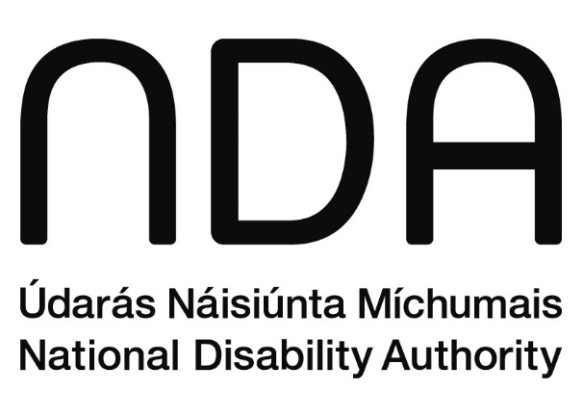

Údarás Náisiúnta Míchumais
25 Bóthar Chluaidh
Baile Átha Cliath 4
D04 E409
Teileafón: (01) 6080 400
Ríomhphost: info@nda.ie
Idirlíon: www.nda.ie/ga

National Disability Authority
25 Clyde Road
Dublin 4
D04 E409
Telephone: (01) 6080 400
Email: info@nda.ie
Web: www.nda.ie

Note that the NDA has developed a disability equality eLearning module for the public service.
For example, QQI Level 6 Component Certificate in Disability Awareness (6N1975). Certificate Specification
There are exemptions for small businesses. Service providers that fall under the EAA’s scope include businesses serving the EU market that have 10 or more employees and over €2 million in annual revenue.
Universal Design is the design and composition of an environment so that it can be accessed, understood and used to the greatest extent possible by all people, regardless of their age, size or disability.
If interpretation is required, it should be provided by an appropriately qualified person who is on the Register of Irish Sign Language Interpreters https://www.risli.ie/
The biopsychosocial model of disability proposes that disability is an interaction of health conditions, including impairments, and contextual factors such as environmental factors, that shape how disability is experienced by the individual.
See for example the Customer Communications Toolkit for Services to the Public – A Universal Design Approach

