NDA Public Sector Duty Action Plan

June 2024 – December 2025

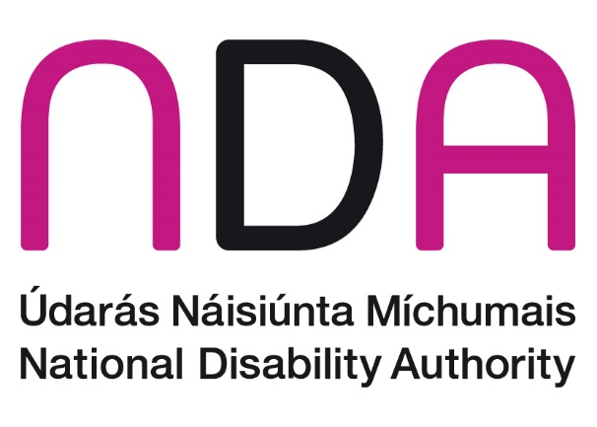

# Introduction

As a public body, the Irish Human Rights and Equality Commission Act 2014 requires the National Disability Authority (NDA) to conduct an assessment of the human rights and equality issues it believes to be relevant to the functions and purpose of the NDA; set out the policies, plans and actions in place or proposed to be put in place to address those issues and publish these in its strategic plan; and report on developments and achievements regarding the Public Sector Duty in its annual report.

The [NDA’s Strategic Plan 2025–2027](https://nda.ie/publications/nda-strategic-plans) explains that a new Public Sector Duty Action Plan was adopted in 2024, following a review of the first action plan.

This is the second NDA Public Sector Duty Action Plan. The NDA are committed to eliminating discrimination, promote equality of opportunity and protect the human rights of our staff and people we engage with in the delivery of our statutory functions. Our high-level actions are listed below. These are supported by a more detailed action plan with indicators of achievement, timelines and the responsible department within the organisation.

Progress will be reviewed frequently, with a final review conducted at the end of 2025 to inform a 2026-2027 action plan.

# Action Plan

1. Develop a consistent approach within the NDA to ensure that we apply a human rights and equality lens more explicitly to our work while maintaining a balanced approach and sound evidence informed advice
2. Continue to implement the advice in the [Participation Matters Guidelines](https://nda.ie/uploads/publications/NDA-Participation-Matters_Web-PDF_092022.pdf) in the NDA’s work and promote the use of the guidelines across the public sector.
3. Develop guidance for promoting good practice on accessibility and Universal Design for events for internal and external stakeholders
4. Ensure that the NDA provides a safe and accessible workspace
5. Proof the existing strategic plan and our statutory duties against the Public Sector Duty and embed the Public Sector Duty in the current and subsequent strategic planning cycles
6. Review procurement guidelines specifically looking at them with a HR&E lens and examine the understanding of, and compliance with, universal design requirements in the procurement guidelines.
7. Ensure the NDA is a welcoming safe and inclusive environment for all employees regardless of background or other characteristics.