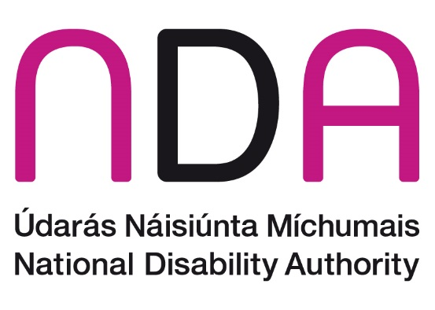

NDA Strategic Plan

2025 to 2027

# This is a Plain English version of the Strategic Plan

# Chairperson’s Foreword

On behalf of the National Disability Authority (NDA), I am delighted to present this Strategic Plan 2025-2027 to the Minister of Children, Equality, Disability, Integration and Youth.

The plan says how we will give advice to the Minister and government departments on disability policy. It says how we will encourage Universal Design.

To develop the plan, we spoke to many different people. This included persons with disabilities, the organisations that support them, government departments, professional bodies, and the public sector.

I would like to thank all those who gave their time and shared their ideas in interviews, focus groups, or in writing. We gathered a lot of information through the consultation. The NDA will review this information closely to see how it can be part of our annual work-plans.

This Strategic Plan sets out our goals for the next three years. There are many different groups working to support persons with disabilities. Each has its own part to play. This might be to advocate for the rights of disabled people, represent the views of particular groups, or voice the experiences and concerns of service providers.

The United Nations Convention on the Rights of Persons with Disabilities (UNCRPD) sets out goals for the participation of disabled people in policy making. The NDA will put this into action in its own work. We will also guide other public bodies on how to do this. During the lifetime of this plan, I hope we can help bring forward the vision of a fully inclusive Irish society.

I believe we are at an exciting time for this work. There is greater awareness and understanding of the importance of the UNCRPD across the public sector. A new National Disability Strategy is being developed. The NDA has particular skills to support this work. During the lifetime of this plan, we hope to do work that informs and guides policy making at national and local level. We want to keep adding to the knowledge base on disability.

I also welcome a greater awareness and use of Universal Design over the last number of years. I welcome the partnerships built by the Centre for Excellence in Universal Design at the NDA. I believe Universal Design benefits our whole society. I hope that under this Strategic Plan we can encourage more Universal Design. We want a human-centred approach to the development of physical and digital environments, services, and systems.

**Kathryn O’Donoghue, Chairperson of the NDA**

# Mission

To give independent advice to government on things that are important to persons with disabilities.

To check if new laws, policies, and plans are working and bringing good changes for persons with disabilities.

To encourage more people to understand and use Universal Design.

# Vision

An Irish society in which persons with disabilities are fully included, and where their rights are recognised and realised.

# Values

* **Independence:** We give independent advice and guidance. This comes from research and consultation.
* **Excellence:** We promise to do excellent work in a professional way.
* **Respect:** We show respect to each other and to everyone we work and communicate with.
* **Equality:** We promise to work to achieve equality and inclusion for all.
* **Effectiveness:** We deliver our work based on the beliefs of public service and teamwork. We encourage new thinking and ideas. We make the best use of the resources we have.
* **Engagement:** We work in partnership with persons with disabilities and those that support them. We listen to the views of persons with disabilities, and the individuals and organisations that support and represent them.

# Background

In 2025, the NDA will be 25 years old. Irish society has had a lot of changes during the last 25 years, in common with the rest of the world. We still feel the effects of the COVID-19 pandemic. For example, its impact on the world of work, social inclusion and participation, and the health and well-being of people at risk in our communities.

The pandemic also had a big effect on the economy. While the Irish economy seems to have recovered quicker than some, there are still pressures. Inflation has been made worse by war in Ukraine. We have not yet understood or felt the full impact of the conflict in Israel and Gaza. Rising energy costs have been felt by everyone, as have the effects of climate change.

We are not sure how to understand and prepare for future challenges, for example, the use of Artificial Intelligence (AI). The very opposing views in public debate can make it difficult to agree solutions to these challenges.

These challenges are in Irish society. We have experienced them less severely than some other countries. Our economy is strong, and we are at close to full employment. Not everyone experiences the challenges in the same way. There are groups in society that feel the impact of economic difficulties or lower employment rates more. Disabled people are one such group. Research has shown that economic and political shocks in the world are felt more by disabled people. It takes longer for disabled people to experience the recovery too. Research also shows that disabled and other marginalised groups are more likely to feel the impact of future changes. For example, the negative effect of climate change or the use of technology instead of people to do certain jobs.

These challenges are very real. However, this is also a time of great opportunity in Ireland. There is more awareness of the UNCRPD. Disabled Persons Organisations and others are working to make sure that decision makers at government level put these rights in place. This is best seen in the development of a new National Disability Strategy during 2024. This sets goals to move forward the delivery of the UNCRPD across government. The NDA will use our skills to give advice and guidance to support this. We will listen to and work with disabled people and their representative organisations, as well as other key stakeholders.

## The NDA’s focus

The NDA’s priority is to support and assist with the implementation of the National Disability Strategy. Implementation means putting into action. We will monitor and check on progress with the Strategy. We will develop data and statistics about disability. This will be important as Ireland prepares for its first State Party Dialogue with the UN Monitoring Committee. The State Party Dialogue is a discussion between Ireland and the UN. We expect it will take place in 2027.

The NDA will work closely with the Department of Children, Equality, Disability, Integration and Youth (DCEDIY). We will put information and data together to prepare for this Dialogue. We will give information to the independent monitoring body, the Irish Human Rights and Equality Commission. This will be part of our work in the coming years. We will make sure that our information is accessible, can be understood, and can be used by everyone interested in this process. This could be experts by experience or officials. We will keep adding to the knowledge that people have about disability and Universal Design. This will help policy makers and other audiences.

## The Equality agenda

There are a number of equality strategies being reviewed at the same time. This gives us a chance to make sure that disability is recognised in these. This is important as people are part of different identities in this country. Almost 22% of the population said they have some form of disability in Census 2022. It is important to recognise and respond to the challenges faced by such a large group. This cannot be done without thinking about all of the communities that people are part of.

There are more older people in Ireland now. The NDA’s work on universally designed services and supports will be more important. It will help us to have a society where people can live independently at all ages. It will help people to get the supports they need to have a life of their choosing. We know it is important to encourage government departments and organisations to work together on national strategies and action plans. For example, the National Housing Strategy for Disabled People, the Sharing the Vision Strategy for mental health, the Roadmap for Service Improvement 2023–2026 Disability Services for Children and Young People, and the Action Plan for Disability Services 2024–2026.

## Disability services and supports

In 2023, the Assisted Decision Making (Capacity) Act 2015 was put into law. This means the Decision Support Service can start its work. There will be a change in culture, where decisions were made ‘for’ people with disabilities to one where individuals are supported to make decisions based on their own will and preferences. We should feel this change over the lifetime of this NDA Strategy. We should see it during the process to discharge over 2,200 people who are currently Wards of Court. The NDA will continue its work to understand and document people’s experiences of this process. This will help us to say where improvements can be made in the future.

We look forward to supporting delivery of specialist disability services. We will do this by helping to evaluate some of these services. We will research good practice both nationally and internationally. This will guide us on a system that works with the UNCRPD.

Responsibility for disability services moved in 2023 from the Department of Health to DCEDIY. This is a chance for a coordinated approach to service provision that better reflects the social model of disability. This should be helped further during the ongoing restructuring of the HSE. We look forward to supporting the Department and the HSE during this Strategy.

## International strategies and directives

There are important international developments for how Ireland builds a fully inclusive society. In 2026, Ireland will hold the EU presidency. This will give us more opportunities to think about how inclusion and Universal Design can be promoted across Europe. It will help us think about how developments at European level can be used at national level.

Through our monitoring work, we have already seen the impact of EU regulations in Ireland. The introduction of the Web Accessibility Directive has increased focus on how to design and deliver accessible websites and mobile apps. This is important with the government focus on its ‘digital first’ agenda. The NDA has developed a way to check if organisations are following this law. We have a way to guide improvements across the public sector. During the lifetime of this Strategic Plan, the European Accessibility Act should be in place. This means that goods and services bought in the EU should have common standards of accessibility. The NDA will give advice and guidance. We will build knowledge and skills in accessibility and Universal Design across the various organisations. We will support the development of key EU standards.

## Digital and technological advances

Artificial Intelligence (AI) and Assistive Technologies (AT) can bring opportunities for new ways of working. They can support independent living. This works best when we think about Universal Design from the start. The NDA looks forward to advising and guiding on how this can be achieved, and how AI/AT can unlock possibilities for disabled and older people. Our work on Universal Design has developed valued resources for others to use as they try to remove barriers and challenges in society. We will continue this journey during this Strategic Plan. We will guide on how technology can be used in a way that is both creative and ethical. We will think about how technology can make our own work processes better.

## Meaningful engagement and the role of data

Understanding people’s experiences is key to designing solutions together. The NDA promises to keep working with disabled people through their representative organisations. We will also hear the views of other stakeholders in the disability area. We will continue to guide public bodies on how to engage with disabled people to develop policies and ways of working.

The role of data is important. We will explore the best ways to gather data to inform policy making. This includes new and different approaches to measuring outcomes for disabled people.

Over the lifetime of this plan, the NDA will give high quality research, advice, and guidance. This will help decision-making at both national and local levels. We can support and encourage policy makers and give helpful information to disability organisations. We will focus on clearly communicating our role. We will build relationships and work with other individuals and groups.

We know that current disability law in Ireland was developed before the UNCRPD. Therefore, it does not fully reflect the social and rights based model set out in the UNCRPD. We note suggestions at government level that an overall review of this law could happen. We will make sure our advice forms part of that process. This would include an examination of our own role and where we can best guide improvements in disability policy and ways of working.

We look forward to this next phase in our development. We have set out our commitments under the priority areas in the following pages.

# NDA’s Work to Date

During the 2022-2024 Strategic Plan, the NDA was proud to continue work to put the UNCRPD goals into action. We worked on different national strategies, policies, and programmes. We look forward to building on this work as we move into the next Strategic Plan.

Some of the highlights from the last 3 years include:

* 3 Annual Conferences on putting the UNCRPD into action. These conferences were on 3 different themes
* Support for the development of the National Disability Strategy
* Consultations with people with disabilities on topics that are important to the work of the NDA
* 3 independent assessments of progress under the National Disability Inclusion Strategy
* 3 independent assessments of progress under the Comprehensive Employment Strategy
* Participation Matters Guidance
* Partnership with the ESRI on new approaches to researching attitudes to disabled people
* Research on the process to discharge people from the Wards of Court system to new decision support structures
* Produced guidance with disabled people on doing research with disabled people
* Guidance on Changing Places toilets
* Code of Practice on Accessible Public Buildings
* Research on well-being and social inclusion of disabled people
* Support and guidance on supporting more disabled people to take part in higher education through the PATH 4 initiative
* Paid for research on experiences of assistive technologies
* Support and work on standards to put the European Accessibility Act into action
* Monitoring reports on compliance with Part 3 and Part 5 of the Disability Act. Compliance means if people are following the law
* Monitoring reports on compliance with the EU Web Accessibility Directive
* Publication of 3rd edition of Customer Engagement Toolkit for services to the public
* Redesign and relaunch of NDA and CEUD websites
* Sponsoring and running annual Universal Design awards for both student and industry awards programs
* Taking part at both national and international level in putting together accessibility standards.

# Strategic Priorities 2025 to 2027

## Strategic Priority 1

To give advice on and support the Government to put the UNCRPD and other national strategies into action.

We will do this by giving good advice and guidance based on research and consultation.

## Strategic Priority 2

To monitor, check, and guide government on the actions needed and the promises made to achieve inclusion for all.

## Strategic Priority 3

To encourage people to learn about and use Universal Design across Ireland.

## Strategic Priority 4

To talk and work with disabled people, their representative organisations, and others in the disability area. This will give us information for and improve our advice and guidance.

## Strategic Priority 5

To clearly communicate the value of our work. To be a well-run organisation that delivers our plan.

# Public Sector Duty

The Public Sector Equality and Human Rights Duty says that public bodies must treat people fairly and equally. They must protect the human rights of staff and of the people using their services.

The Duty could change how public bodies carry out their work. It could change how they engage with members of the public and their own staff.

The NDA is a public body. To follow the Duty, we must list any human rights and equality issues that are important to our work. We must put this list in our Strategic Plan and say how we will deal with any issues.

Promoting equality and human rights for persons with disabilities is a very important part of our work at the NDA. We do this through research and by giving advice.

The NDA developed its first action plan during 2019. There were 16 actions. A review in 2022 found that 9 were complete and 7 partly completed. The review recommended changing some actions and including some new actions. It suggested having a smaller number of more focused actions. This approach will be taken under this new Strategic Plan.

There is more staff turnover in the public sector workforce. The NDA will need to make sure that all staff understand the Public Sector Duty. We will make it part of our plans and activities. Our action plan will make sure that human rights and equality matters are part of the NDA’s culture and a key part of our Strategic Plan.

A number of actions will happen during this Plan. For example, putting together guidance for accessible events, and making sure that the working environment is safe and accessible.

# Finding out if things are working

The NDA will give independent research and guidance to the Government in order to bring meaningful improvements in the lives of persons with disabilities.

We also want a better awareness and understanding of Universal Design.

The NDA knows that to achieve our shared vision of an inclusive society, we need to talk to different people and organisations. Each one has a different role to play and work to do. The NDA will focus on areas where it can add value and do the best work. The amount of work we can do will depend on the resources made available to us.

We will check on how we are doing with this Strategy by:

* Putting the goals from the Strategy into annual work plans. These will say what we will deliver in project areas and how we will report progress
* Doing all the work that we must do by law in a timely manner and reporting on this
* Working with government departments to make sure we are getting the best opportunities to give advice and guidance
* Creating a place for safe and trusted engagement with the public sector. This will support ongoing improvements
* Making sure that relationships with the people and organisations we work with are strong. We will look for opportunities for more engagement with disabled people
* Reviewing and reporting on our work to the Minister and the Department of Children, Equality, Disability, Integration and Youth
* Regularly reviewing that the work we do to make sure we give information at the right time and in the right way. We will prepare accessible formats when they are needed.

# Resources

The NDA will deliver the priorities in this plan through our structures:

* The Policy, Research and Public Affairs Department
* The Standards and Monitoring Unit
* The Centre for Excellence in Universal Design
* The Corporate Services Department.

Across each of these units, staff have the right education and skills to carry out our work. This includes giving advice and guidance to government departments and others on different topics. This advice and guidance can lead to positive changes for persons with disabilities.

There is more demand for research, advice, and monitoring from the NDA. This is likely to continue over the lifetime of this Strategic Plan, for example to put the European Accessibility Act into action, and as IHREC monitors the UNCRPD in Ireland. The NDA will also need to give information and advice to Government for the first State Party Dialogue with the UN Monitoring Committee.

The NDA will have work to do for the new National Disability Strategy. We will need to monitor the progress on this. There is also a programme of work for us to do on the Autism Innovation Strategy. It will be important that the organisation has the resources to do this work well and help to deliver positive outcomes for disabled people in Ireland.

We will use the resources we have in the best way. This will make sure we can deliver on our work programme. We will get advice from outside experts when we need to. We will look for extra resources when we need them. If we have enough resources available, we can deliver research and policy advice and develop practical resources for different audiences.

We will build on our partnerships with key organisations outside of the NDA. This will help us do our work. We will look at how technology can help us to work better and more efficiently.

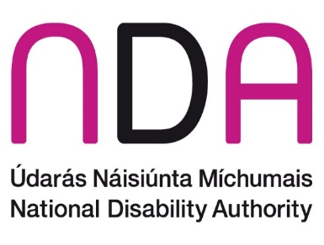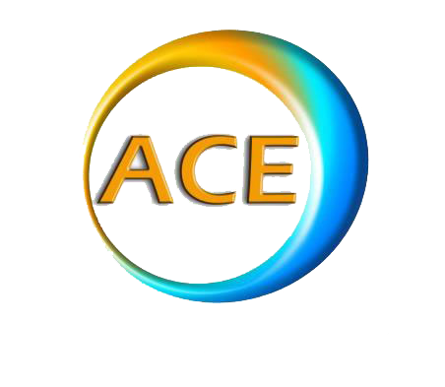

This Report was put together by the National Disability Authority.

01-6080400

www.nda.ie

NDA

25 Clyde Road

Dublin 4

ACE Communication helped with this Report.