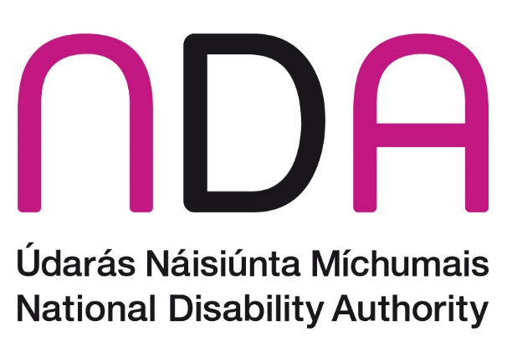

National Disability Authority submission to the Housing Policy for Older People Policy Group, Department of Housing, Local Government and Heritage.
May 2025

Introduction
The National Disability Authority (NDA) is the independent statutory body with a duty to provide evidence-informed advice to the Government on policy and practice relevant to the lives of persons with disabilities, and to promote the adoption and application of a Universal Design approach across all sectors. Our Senior Policy Advisor Ruth O’Reilly attended the stakeholder engagement workshop in the Custom House on 9 May and we welcome the opportunity to make this submission.

The intrinsic link between ageing and disability
There is an intrinsic link between ageing and disability. Figure 1 below (Housing Commission Report, page 213) shows that as age increases, the prevalence of disability increases. When we move into our 80’s, more than half of us will be affected by disability.
Figure 1: Prevalence of disability by age group, Census 2022
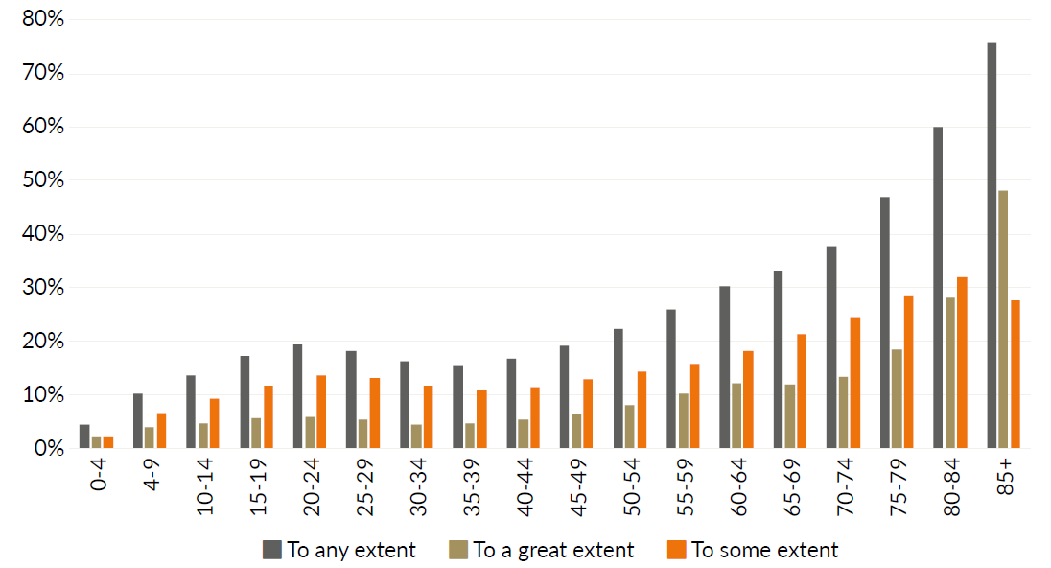
Figure 1: Prevalence of disability by age group, Census 2022
Source: CSO Census of the Population
Under CSO population projections for Ireland, the older population (those aged 65 years and older) is projected to increase very significantly from 2023 to 2057. In 2022, the older population accounted for 15.1% of the total population. This is projected to grow to between 27.8% and 31.6% of the total population by 2057 in the CSO population projections. These projections indicate that there will be significantly higher numbers of disabled people and significantly increased need for Universal Design over the coming decades, both in the public realm and in housing.

A Universal Design approach to housing
The NDA advises that taking a universal design approach in housing is important in relation to providing housing to accommodate the needs of Ireland’s ageing population. Universal Design Homes are both accessible and easily adaptable, designed to cater for a wide range of human diversity, reducing the need to undertake expensive and disruptive alterations. Integrating Universal Design in procurement, design, construction, and management provides dwellings that are accessible and usable for all and easily adaptable for changing requirements throughout the whole human life-cycle, therefore promoting social sustainability. This also supports economic and environmental sustainability by reducing the need for costly adaptation and minimising construction waste.

UN Convention on the Rights of Persons with Disabilities (UNCRPD)
Incorporating Universal Design principles into the planning and delivery of housing is important in light of the United Nations Convention on the Rights of Persons with Disabilities (UNCRPD). The Convention entered into force when ratified by Ireland in April 2018. Under Article 19, Ireland recognises the rights of persons with disabilities (including older people) to have the opportunity to choose their place of residence. Article 28 recognises the right of persons with disabilities to adequate housing. Articles 9, 19 and 28 respectively, recognise the rights of persons with disabilities to:
- ‘live independently and participate fully in all aspects of life’
- ‘live in the community, with choices equal to others’
- ‘an adequate standard of living and social protection’
In addition, Article 4, 1(f) specifically sets out, in relation to universal design that:
States Parties undertake to ensure and promote the full realization of all human rights and fundamental freedoms for all persons with disabilities without discrimination of any kind on the basis of disability. To this end, States Parties undertake: To undertake or promote research and development of universally designed goods, services, equipment and facilities, as defined in article 2 of the present Convention, which should require the minimum possible adaptation and the least cost to meet the specific needs of a person with disabilities, to promote their availability and use, and to promote universal design in the development of standards and guidelines;
The NDA advises that in order for disabled people (including older people) to have ‘choices equal to others’ in relation to where they live, it will be necessary for universally designed housing to be integrated into mainstream housing in Ireland, across both social and affordable and privately developed housing.
We welcome the emphasis on choice for older people at the stakeholder meeting in the Custom House on 9 May and advise that this remains central to housing policy for older people.

Policy Context

Planning to address ageing and disability
In this section, we highlight two key government policy documents that set out the need for an increase in the provision of accessible, lifetime adaptable Universal Design homes, to meet the needs of all people, including older and disabled people. This is important to address the needs of our ageing population. These policy documents are:
- The revised National Planning Framework
- Housing Options for our Ageing Population Policy Statement
The NDA advises that the commitments made in relation to Universal Design homes in these documents continue to be reflected in housing policy for older people and related actions under the new programme for government.

Revised National Planning Framework
The revised National Planning Framework acknowledges the intrinsic link between ageing and disability when it notes that:
“A significant proportion of the population will experience disability at some stage in their lives, particularly as the population ages. Many planning-related issues relevant to disabled people are similar to those that affect older people, including the need to facilitate independent living, access and mobility in relation to buildings and the environment and full integration with society generally.”
It further states that:
“Any new home will have to accommodate changing needs over its lifetime. A liveable and adaptable housing development or house is one that is able to respond effectively to these needs without requiring costly and energy intensive alterations. Our population is changing rapidly, with average households becoming both smaller in size and older as an increasing number of people live independently in their later years.”
We note that National Policy Objective 44 is:
“to support the provision of lifetime adaptable homes that can accommodate the changing needs of a household over time.”
Taking a Universal Design approach to housing to accommodate the neds of our ageing population is aligned with this policy objective. As noted above, Universal Design Homes are both accessible and easily adaptable, designed to cater for a wide range of human diversity, reducing the need to undertake expensive and disruptive alterations.

Housing Options for our Ageing Population: Policy Statement (2019)
This policy statement notes that:
“A key principle underpinning government housing policy is to support older people to live in their own home with dignity and independence for as long as possible”
Action 4.6 sets out a clear target for 30% of new homes to be built incorporating universal design principles:
“In partnership with industry, introduce measures to ensure that over a five year period delivery is increased to ensure that 30% of all new dwellings are built to incorporate universal design principles to accommodate our ageing population (Lead DPHLG).”
The NDA advises that working to achieve this target in Action 4.6 is imperative, given the demographic pressures in relation to ageing and disability that Ireland will experience in the coming years.

Key Considerations

County Development Plan Targets for Universal Design Homes
We welcome that the implementation of Universal Design in housing is becoming evident in the current planning system through local authority county development plans. Currently, thirteen local authorities in Ireland have objectives with specific percentage targets (ranging from 5 - 30%) for Universal Design Homes in new housing developments in their County Development Plans.
The NDA advises that all local authorities should include specific percentage targets for Universal Design Homes in new housing developments in their County Development Plans. There is an opportunity for variations in this regard to be integrated into the variations proposed in response to the revised National Planning Framework. As stated above, this would be aligned with policy objective 44 in the revised National Planning Framework.
County development plan objectives should specify that both UD Home and UD Home+ (wheelchair liveable) dwellings should be provided in new housing developments. For example, in Northern Ireland currently, 10% of all social homes are required to be wheelchair accessible and the remaining 90% are required to meet Lifetime Homes criteria, with a number of additional departmental requirements. In Ireland, Action 4.6 of the Housing Options for our Ageing Population Policy Statement sets out 30% as a specific target, which should be reflected in County Development Plans.

Promoting Universal Design Statements
We note that a Universal Design statement is a useful tool for assessing the integration of Universal Design into housing schemes at planning permission stage. A Universal Design Statement is listed in Appendix C of the Sustainable Residential Development and Compact Settlements Guidelines as supplemental information that may assist in the consideration of planning applications.

Data tracking to measure delivery
We understand that at present, local authorities do not track or measure the delivery of accessible lifetime adaptable Universal Design homes. It is important that when these new homes are delivered, they are recorded and tracked, including the address of these dwellings, so that a register of these dwellings can be maintained. This is particularly important in social housing, so that appropriate allocations are made, to meet disabled and older people’s needs and therefore maximising the benefits of these homes.

Building Capacity in local authorities
It is important that local authorities have the knowledge base, expertise and capacity to provide services and relevant information in relation to Universal Design Housing.
We are aware that each local authority has an Age-Friendly housing technical advisor with a role to provide specialist advice to the authority itself and to interested parties in relation to the provision of Age-Friendly housing. Under the National Housing Strategy for Disabled People, we understand that a Disability Friendly Technical Advisor has also been nominated in each local authority. However for both roles, we understand that this is an add-on responsibility to an existing post, rather than a full-time role. Given the extensive overlap between designing for disabled and older people, the NDA advises that a full-time role be established in each local authority with a technical advisor dedicated to advising on Universal Design Homes, covering both age-friendly and disability friendly housing.

Choice for older people living in family sized homes.
The rate of under-occupancy in Ireland is one of the highest in Europe. Addressing under-occupancy can have a benefit of increasing the supply of family-sized homes, as well as providing older people with choice and the opportunity to have a home to meet their changing needs as they age. It is important that Universal Design and accessibility are integrated into any policy developments in this area, as many people living in existing underoccupied homes will be older and disabled people with a wide range of needs. We would like to highlight two initiatives to be considered for support in relation to under-occupancy. We emphasise that all initiatives in this area should be voluntary and respect the wishes of people living in under-occupied homes.

Adapting existing family sized homes to create two one-bedroom dwellings
Ava Housing (previously the Abhaile Project) provides access to grants, project management and support services to older homeowners who wish to adapt their two-storey home to provide space for a rental capacity upstairs. This initiative was the winner of the Homes for Smart Ageing Universal Design Challenge in 2017. The Ava Housing design solution supports older homeowners to reconfigure their family-sized homes by creating an independent living area, bedroom and accessible bathroom, suitable for the older homeowner on the ground floor, eliminating the need to use the stairs; and creating an affordable one‐bedroom rental unit upstairs. Using a Universal Design approach, this promotes an efficient way to use our existing housing stock by developing much needed new one‐bedroom rental capacity in existing housing stock in mature urban areas. It allows the homeowner to live securely and independently downstairs, whilst promoting interaction with the person living upstairs, thereby reducing isolation. The NDA suggests that supports for this initiative be considered as part of Housing Policy for Older People in the new programme for government.

A national policy on right-sizing
The Irish Longitudinal Study on Ageing (TILDA) published a report on ‘Housing Conditions of Ireland’s older population: Implications for physical and mental health’ (2016), which indicated that 92% of middle-aged and older adults in Ireland live in an owner-occupied home, the majority of whom own their home outright. The report states that over half of adults aged 50 years and over experience some housing problems. Furthermore, the report emphasises that as people age, they are more likely to live alone which may affect their ability to maintain housing quality, ensure energy efficiency and manage their accommodation. Age Friendly Ireland research “A Study on the Awareness, Perceptions and Experiences of Older People of Rightsizing” recommends:
- Designation of County Development Plan objectives, specifically for accommodation suitable for the housing needs of older people
- The promotion of a greater awareness of right-sizing options
- The development of right-sizing incentives
- The publication of right-sizing guidelines
- The reconsideration of a Social Housing Passport Scheme
- The undertaking of post Covid-19 housing research
We understand the Department is developing a national policy on right-sizing and exploring options to support and incentivise right-sizing on a voluntary basis. It is important that universal design is central to this policy, ensuring that smaller homes provided for older people to right-size into incorporate universal design features that will enable older people to live independently at home for as long as possible. For example, homes suitable for right-sizing should meet the Universal Design checklist in Appendix C of the Irish Green Building Council Home Performance Index. Incentives could be considered including funding with favourable interest rates or other terms where Universal Design Homes are provided, for example focussing on infill or brownfield sites that would allow older people to relocate within their existing community.

Review Part M for Dwellings
The NDA advises that the current Part M for dwellings is inadequate to cater for the needs of our current and future population, including older and disabled people. We advise that Part M for Dwellings should be reviewed to move from a minimum standard of visitable housing towards liveable housing, taking a Universal Design approach, and including guidance on UD Home and UD Home+ (wheelchair liveable) dwellings.
We note that in England, Approved Document M for dwellings includes requirements for M(4)2 Accessible and Adaptable Dwellings and M(4)3 Wheelchair Dwellings. The number of accessible and adaptable and wheelchair dwellings in new housing developments is currently addressed through the planning system in England. The UK government has committed to changing the minimum requirement for all new dwellings from the current “visitable” standard to M4(2) Accessible and Adaptable.

Current developments in Universal Design Housing
We would like to highlight a number of current developments to inform the work of the Housing Policy for Older People Policy Group.

Integrating Universal Design into MMC and standard housing layouts
The Department of Housing has been promoting modern methods of construction and standard housing layouts to increase productivity and timely delivery of new housing generally. We acknowledge the engagement with our Centre for Excellence in Universal Design on the “Standardised Design Approaches Study”, noting that the study includes standard layouts for both UD Home and UD Home+ ground floor duplex apartments. We advise that universal design features and elements need to be continually integrated into all work to promote MMC, including the development of standardised 2D building components and standard housing layouts, to ensure that they meet the needs of older and disabled people in Ireland.

National Standard on Universal Design Dwellings
The NDA is currently supporting the National Standards Authority of Ireland to develop a new Irish standard on “Universal Design Dwellings, requirements and recommendations” that will support legislation, government policy and local authority objectives with a clear and consistent approach to the design of Universal Design Dwellings. It will set out requirements and recommendations for new dwellings that are accessible, easily understood, usable, adaptable and suitable for people to live in over their lifetime, following a Universal Design approach. A public consultation on the draft standard is expected in June 2025.

Universal Design Housing Cost Benefit Analysis
The NDA has appointed Indecon Economic Consultants to conduct a cost benefit analysis of Universal Design Housing, which is expected to be complete by the end of 2025.

Internal Layout Checklist for Universal Design Homes
The Centre recently co-published an “Internal Layout Checklist for Universal Design Homes” with Age Friendly Ireland. This checklist is a summary of guidelines from the Universal Design Guidelines for Homes in Ireland that impact on the internal layout of dwellings. The checklist is provided as a tool for designers to ensure that Universal Design is considered at the early stages of housing design. Five example floor plans are provided with the checklist, to demonstrate the checklist being applied in both UD Home and UD Home+ dwellings. It has been published on our website.

Conclusion
The NDA welcomes the opportunity to input on the consultation to inform the Housing Policy for Older People Policy Group. We would be happy to engage with the Department on any of the points raised in this submission.

County Development Plans use a range of different terminology in their objectives, including reference to the Universal Design Guidelines for Homes in Ireland, lifetime adaptable homes, Age-Friendly homes, homes suitable for older people / mobility impaired people.
Sustainable Residential Development and Compact Settlements Guidelines for Planning Authorities - Appendices

