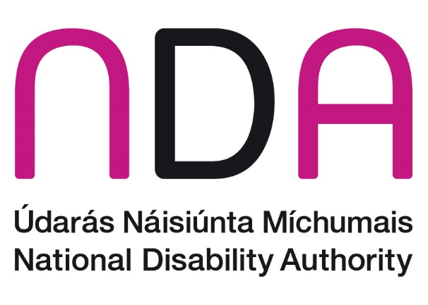

NDA Submission to Quality and Qualifications Ireland (QQI) in response to the Green Paper on QQI’s Access, Transfer and Progression Policy

**April 2025**

# Introduction

The National Disability Authority (NDA) is the independent statutory body with a duty to provide information and advice to the Government on policy and practice relevant to the lives of persons with disabilities, and to promote the adoption and application of a Universal Design approach across all sectors. We thank QQI for the opportunity to contribute to the consultation on the Green Paper on QQI’s Access, Transfer and Progression (ATP) Policy.

In this submission, we focus on aspects of the Green Paper related to the experiences of disabled people in education, as well as aspects related to universal design in education.

# Key Points for Consideration

## Emphasising Universal Design in Education (UDE) as an enabler of equity and social inclusion

Ireland has the widest disability employment gap in Europe and evidence indicates that the persistent disability employment gap is aligned with a persistent disability gap in education and skills. The NDA welcomes the statement in Section 3 (Overview of Access, Transfer and Progression) of the Green Paper which states that:

“The principles of equity and social inclusion are at the root of any ATP policy and should support lifelong learning. ATP should operate in such a way that it supports and facilitates widening participation initiatives (while being distinct from these initiatives). With this in mind, it is essential to consider the importance of universal design in the context of processes, systems and information with regards to ATP in order to support more accessible navigation of ATP processes for everyone.”

We advise that these principles of equity and social inclusion should be emphasised as underpinning the ATP policy and include a focus on Universal Design in Education (UDE). Universal Design and inclusion are key to achieving the right to education and training as enshrined in the UN Convention on the Rights of Persons with Disabilities (CRPD), the first legally binding instrument to contain a reference to the concept of quality inclusive education and training. This clearly articulates the importance of Universal Design as the preferred approach to an inclusive society. Our paper on [**Universal Design in Education and Training – policy landscape in Ireland**](https://universaldesign.ie/education/third-level-education) promotes Universal Design in Education (UDE) through a whole systems approach, so that the physical and digital environments, the educational services, and the teaching and learning can be easily accessed, understood and used, by the widest range of learners and by all key stakeholders, in a more inclusive environment. We would welcome an explicit reference to Universal Design in Education in the ATP policy to facilitate understanding and the need for implementation of this whole systems approach.

On page 23 of the Green Paper, (Supporting ATP) there is reference to incorporation of the Universal Design for Learning (UDL) framework and guidelines into programme design and administrative functions. We advise broadening the reference to incorporating Universal Design in Education as set out in the paper referenced above and the [National Charter for Universal Design in Tertiary Education](https://www.atu.ie/about/teaching-and-learning/altitude-charter). We would also welcome reference to the application of the [Design for All Standard (I.S. EN17161:2019)](https://universaldesign.ie/about-universal-design/products-and-services/standard-i-s-en-171612019-design-for-all) to the process of ensuring that all educational products and services are as inclusive as possible.

## Engaging with disabled learners to inform the ATP policy

The Green Paper lists a wide range of stakeholders to be engaged in the discussion on the proposed new APT policy, including the Union of Students in Ireland (USI) and other learner representative organisations. We advise that it is important that disabled learners are consulted with, to identify barriers to access, transfer and progression, so that the new policy can address these effectively. Hearing and acting on the lived experience of disabled students is essential to developing a more inclusive environment for all.

We wish to highlight our **Participation Matters guidelines**[1] as a useful resource to support public officials at national and local level to meaningfully consult with and actively involve disabled people and their representative organisations in policy development and other decision making processes to meet obligations set out under the United Nations Convention on the Rights of Persons with Disabilities (UNCRPD). For example, the National Disabled Postgraduate Advisory Committee was established in 2020 as a Disabled Person’s Organisation, which means that it is led by disabled people and is rooted in the principles of UNCRPD.

We note in the conclusion of the Green Paper that there is reference to including details of case studies and examples in order to detail common barriers experience by learners in navigating and understanding ATP pathways as well as highlighting examples of best practice across all principles. It is important that disabled and older learners are included in this case study approach and that the case studies are carried at an early stage in the policy development process, so that they can inform the policy development process effectively.

## Supports for Students with Disabilities

We note that the DARE scheme is available for post-primary students with special educational needs (SEN) progressing to Higher Education, but it is not available for a student with special educational needs progressing from Further Education and Training to Higher Education. This is an important issue to be addressed in relation to Access, Transfer and Progression for students with disabilities.

## CAO Route to Higher Education Entry for Holders of QQI Awards

The addendum to the Green Paper refers to the CAO route to Higher Education Entry for holders of QQI awards and the common points scale for QQI Awards, stating that the maximum common points scale that can be achieved by a relevant QQI award is 390. The NDA requests that as part of the development of the ATP policy, QQI consider whether this points ceiling is aligned with the Department of Further and Higher Education, Research, Innovation and Science Policy Platform, Progressing A Unified Tertiary System for Learning, Skills and Knowledge[2]. We note that this policy platform sets out objectives of a more unified system, including:

“A shared understanding of a unified but diverse tertiary system of education, skills, research and innovation that can meet the wide-ranging and distinct educational needs of individuals whereby every opportunity and pathway is valued equally in terms of the opportunity for learning and development that it offers.”

## A resource to support the provision of clear, accessible information to learners

On page 35 of the Green Paper, we welcome the emphasis on providing clear, accessible information to learners in relation to entry and exit routes, recognition of prior learning and access, transfer and progression procedures, including the commitment to accessible universally designed communications. A useful resource to be referenced in the policy to guide on this information provision is the [**Customer Communications Toolkit for Services to the Public – A Universal Design Approach**](https://www.gov.ie/en/department-of-public-expenditure-ndp-delivery-and-reform/publications/customer-communications-toolkit-for-the-public-service-plain-english-guide/), available from the Department of Public Expenditure, NDP Delivery and Reform.

# Conclusion

The NDA are happy to follow up with QQI on any of the issues raised in this submission.

1. [National Disability Authority (2022) Participation Matters guidelines.](https://nda.ie/about/engaging-with-disabled-people/guidance-on-consultations)
2. <https://www.gov.ie/en/department-of-further-and-higher-education-research-innovation-and-science/consultations/unified-tertiary-education-sector/>