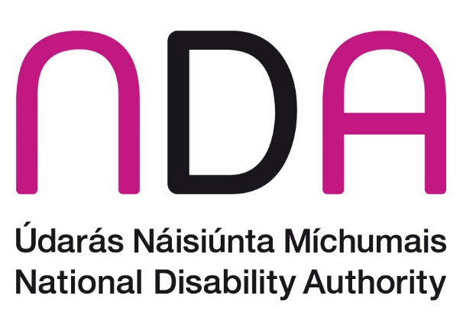

NDA Submission on the Draft Statutory Quality Assurance Guidelines on Programmes Involving Work-integrated learning

October 2025

Introduction
The National Disability Authority (NDA) is the independent statutory body with a duty to provide evidence-informed advice and guidance to Government on disability policy and practice and to promote adoption and application of a Universal Design approach across all sectors. The NDA welcomes the opportunity to take part in this consultation on Draft Statutory Quality Assurance Guidelines on Programmes Involving Work-integrated Learning.
The NDA outlines some areas to consider for the new guidelines below and is available for any follow up questions on the issues raised.

Universal Design in Education (UDE)
The NDA recommends a Universal Design in Education (UDE) approach is followed in relation to this program of “work-integrated learning”. UDE involves a whole systems approach where the entire educational ecosystem is considered, with every step of the student journey traced. Its goals move beyond facilitating access towards cultivating a sense of belonging and conditions to thrive for all learners. This whole systems approach looks at:
- the whole educational or training environment – this includes all levels of educational institutions, including the community and the wider public
- the whole person
- learning-friendly environments
It follows an educational ecosystem comprised of:
- The macro level, where directives, legislation and standards are set
- The meso level - this is the institutional level, which covers policies and governance, linking also to family and community
- The micro level, attending to individual needs and abilities
The NDA advises that the new guidelines support and promote this approach, which is articulated in the NDA’s Centre for Excellence in Universal Design paper. This paper outlines four pillars:
- physical environments,
- digital environments,
- educational services, and
- teaching, learning, assessment and curricula
It is only when these four pillars work in unison that a more inclusive environment can be created that can be easily accessed, understood and used, by the widest range of learners and by all key stakeholders. Work-integrated learning is an integral feature of many programmes and courses offered in the further and higher education system, therefore it is important that disabled people are facilitated to avail of this learning in an accessible manner.
The NDA therefore advises that physical and digital/online workplace-based learning environments are structured around Universal Design principles. Usability can be further supported through consultation with and testing by disabled learners. Such feedback may also, for example, prompt a re-imagining of traditional exams and assessments for greater flexibility and inclusivity.
This UDE approach is also central to the National Charter for Universal Design in Tertiary Education (ALTITUDE) and the PATH 4 Phase one Fund (see below). The charter’s focus is how the sector can work towards embedding a universal design approach across all sectors of the educational system.

Learner supports
While UDE will meet the needs of most students, some students will require specific supports to engage in their respective work-integrated learning placement. Therefore, the NDA advises that the new guidelines highlight the importance of being flexible and supportive of each individual. For example, one person may require information in a more accessible manner to participate effectively in their placement, another may simply need additional guidance at different points, while others may not need any additional support.
While some students may be able to advocate for themselves on the support requirements they need, others may need the assistance of their educational institution to liaise with employers regarding the placement and the supports they may require. The guidelines may also need to consider scenarios where students are to identify their own work placement and how this is facilitated. Therefore, it is also important that in advance of the person taking part in work-integrated learning, that the entity in question engages with the person and potentially the educational institution to identify any specific requirements they may have that will support and enable them to take part in the programme. Such an approach would also benefit the employers in question, so they are aware of the needs of the person and can support them in their roles.

Reasonable accommodations
Further to the importance of learner supports above, one of the most significant challenges people with disabilities face is the requirement for accommodations and flexibility in learning. The Quality Assurance (QA) guidelines could support this flexibility through promoting a Reasonable Accommodation Passport that can be used in their work-integrated learning and later during their career. These passports are used by many employers and are promoted by organisations such as Ibec, the Irish Congress of Trade unions and others. In a work experience setting, these passports could be designed for students who require adjustments or accommodations because of a disability and can be agreed between the student and the entity in question.
Ultimately, through a comprehensive and considered UDE approach, the need to have reasonable accommodations in the first place would be significantly reduced.

Consultation, participation and engagement with disabled people
Consultation and user-testing with people with disabilities is essential as it can often uncover exclusionary practices that had been overlooked. Article 4(3) of the UNCRPD requires all government departments and statutory agencies to ensure the effective participation of persons with disabilities in the creation and implementation of policies and legislation that impact their lives. The NDA strongly encourages effective and meaningful engagement with students with disabilities in relation to these guidelines, including through Disabled Persons Organisations so that the strategy can reflect an ability to be adaptive and responsive. The NDA wishes to highlight its Participation Matters guidelines as a useful resource in consulting with disabled people and we are happy to advise further.
It is important to note that all engagement, including learning and stakeholder communication, should be facilitated through alternative or accessible formats to ensure meaningful consultation with people with disabilities. The NDA wishes to highlight the Government’s Universal Design Customer communications toolkit as a useful resource in designing alternative formats and we are happy to advise further. The right to accessible communications is stipulated in the Disability Act (2005) and in the UNCRPD, which state that public bodies should ensure, as far as is practicable, that relevant information is provided in accessible formats and technologies.

Conclusion
People with disabilities are a group who can face additional barriers when it comes to accessing education. These new guidelines provide an opportunity to highlight ways to improve access to work-integrated learning for disabled students. This form of learning is an important part of many further and higher-level programmes so ensuring effective access and participation is an important part of providing an inclusive education system for all.
The NDA is available for follow-up on any of the issues raised in this submission.

https://www.gov.ie/en/department-of-public-expenditure-infrastructure-public-service-reform-and-digitalisation/publications/customer-communications-toolkit-for-the-public-service-plain-english-guide/

