NDA Submission to Department of Education and Skills Consultation on Review of Career Guidance
June 2018
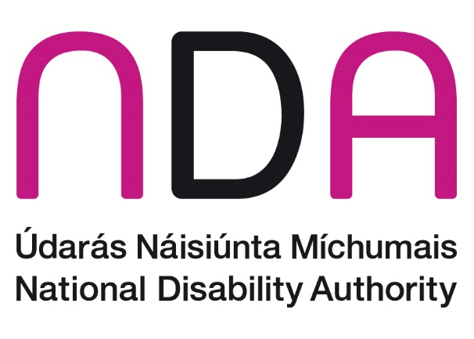

Introduction
The National Disability Authority (NDA) has a statutory duty to provide independent advice to the Minister on matters of policy and practice relevant to the lives of persons with disabilities, and to promote Universal Design. The NDA welcomes the opportunity to outline its advice in relation to the Review of Career Guidance being conducted by the Dept of Education and Skills, particularly in light of commitments it has made in the Comprehensive Employment Strategy for Persons with Disabilities to ensure the progression of training for Guidance Counsellors to support students with disabilities on the pathway to work.
The following is a summary of the main points in this:
- Career guidance for learners with disabilities should be delivered in an individually focused person centred way across the learner pathway. This will require knowledge and understanding of disability, training and employment options and any supports.
- Career guidance can assist students to plan for future careers, supported by tools, information material but also work experience and work sampling opportunities.
- Career guidance should be for all students including those in special education provision, who to date have not had access to career guidance that has assisted in the identification of work goals. There is therefore no such service in those schools which can be reviewed, but this further highlights the need develop appropriate career guidance models.
- Further work will be required to consider how career guidance in education can effectively support students with disabilities including the skills of the counsellor, knowledge of supports and options, the level of access required to a counselling service, and integrated working with between education levels and with employers.
- Career guidance tools, information delivery can benefit from the principles of Universal Design to ensure maximum accessibility and useability by all. However, the content is essential and should be relevant in terms of guiding on support options.
- The Department of Education and Skills should link the recommendations emerging from this review to its obligations with other government strategies most specifically the Departments obligations under the Comprehensive Employment Strategy for people with disabilities 2015 -2024
- We advise that career guidance for students with disabilities is not simply confined to the work of a career guidance practitioner, as it is also about the attitudes, aspirations and inclusion in career path activities such as Transition Year and other activities.
- The NDA advises that particular attention will need to be given to an effective model of career guidance for special education schools, and suggests that this may commence with a workshop looking at the learning from existing practice, including from other jurisdictions. The NDA would be happy to facilitate a workshop with officials in this regard.
- The DES review of career guidance and could learn from the CoP introduced in 2015 the UK Department of Education and the Department of Health
The issue of career guidance is highlighted in NDA research and consultation relevant to the questions posed by this review, and this is presented as appropriate throughout this submission.

Parameters of the DES Review on Guidance Provision

The NDA welcomes the commitment of the Department of Education and Skills to this review, recognising the importance of enhancing the alignment of career guidance information and tools with the National Skills Strategy and with other national policies regarding employment as well as further and higher education. The National Disability Authority advises the importance of including consideration of the provision of career guidance for all people with disabilities or special educational needs within the review, regardless of their educational setting.

In keeping with the national policy of mainstreaming, it is important that the whole of education provision from school to further education and training services reflect the diversity of the population served. Career guidance, therefore, should equally serve people with disabilities, across the spectrum of disability and learning style.

The NDA notes that the career guidance experiences of learners with special educational needs in mainstream schools is encompassed in this review, but is concerned that learners with educational needs in special schools appear to be excluded from the current terms of reference. This group of learners are also omitted when the list of survey recipients is examined. There may be no career guidance practice in special education schools to review, but it would be important to give due consideration to what an effective model of service would look like and to draw on the learning from other jurisdictions for example. It is noted that the UK has a Code of Practice for Special educational needs and disability for those aged 0 to 25 years, which refers to a statutory duty under section 42A of the Education Act 1997 to ensure pupils from Year 8 until Year 13 are provided with independent careers guidance. This duty also applies to schools and further education colleges. In they have a career guidance framework that supports the delivery of the Gatsby benchmarks on good career guidance. The NDA would be happy to engage with the Department on career guidance models, including for special education schools, and to facilitate a workshop for officials as a first step in exploring the issues involved.

NDA research and consultation on supporting people with disabilities to make informed choices regarding their career pathway shows the importance of:
- Ensuring high quality, impartial career information, advice and guidance for young people with disabilities and outlining how this can be built into the curriculum
- Working towards a career pathway by using an individual education plan (IEP) to become an individual training plan (ITP) with identified career / skills attainment goals
- Understanding the use and importance of vocational profiles as means of capturing information about skills, capacity and educational attainment, including how to include their development in classroom or tutorial time and how to ensure they inform a vocational curriculum
- Developing work experiences in real work settings in line with aspirations
- Creating more work opportunities through traineeships, supported internships and apprenticeships
The availability of appropriately trained career guidance counsellors is significant in realising these objectives, as is the availability of career guidance materials that are universally designed and disability proofed. However career guidance can be offered in a number of ways and the NDA recommend that creative ways of embedding career guidance are considered in this review.
The next section of this document highlights some further considerations in this regard.

Career Guidance for persons with disabilities

Raising expectations
The Comprehensive Employment Strategy for Persons with Disabilities 2015-2024, hereafter CES, highlights the importance of raising expectations with regard to the employment opportunities for persons with disabilities. This ranges from the expectations of the individuals themselves, to those of their families, educators and support workers. As part of this, it has been demonstrated that consideration of employment goals and aspirations should begin at the earliest stage possible. Having strong and appropriate career guidance provision in all school settings in which students with disabilities are educated is a critical aspect of this work. Good practice from other jurisdictions indicate that career advice and guidance for students with disabilities should commence at age 12/13 to improve the chances of achieving good employment outcomes.

Supporting learners to make informed choices
The Terms of Reference set out a clear remit for this review, which is to describe and review existing career guidance tools and career information for post-primary/further education/higher education students and adults, currently in place across the education and training system in Ireland. The additional task is to assess how learners form their opinions around career choice including when, who and what influences these choices is of particular importance for learners with disabilities.
The NDA recently conducted a mapping of post-school options for learners with special educational needs which demonstrated the post-school options and support structures for young adults with disabilities are fragmented and provision often localised. The mapping exercise noted that individual Career Guidance Counsellors may support people with particular disabilities only a few times in their careers, highlighting the need to build capacity in this regard. This is one of the reasons why the CES includes the Action 1.7 for delivery by the Department of Education and Skills. The Action provides that the Dept, NCSE and Schools will work together to consider how Guidance Counsellors can effectively support students with disabilities in guiding them on further education, training and career options. Also that guidance and training would be provided for Guidance Counsellors and that Counsellors would be provided with the skills to develop individual FET options.
This requires a specific action plan in terms of how the needs of those with disabilities will be addressed and as to how the guidance service would be available and operate in schools, and also for special education schools. This requires particular attention to the information and tools involved, design of training for career guidance counsellors, ensuring a service that is effective for students with disabilities and tailored as appropriate. It would be helpful to see this action also linked and carried through to the Whole School Guidance Framework in 2017, developed by the National Centre for Guidance in Education.

Whole of school approach
The Whole School Guidance Framework is intended to assist schools in planning and delivering a comprehensive whole school guidance programme that meets the needs of all students. The NDA welcomes the commitment of the DES to implementing this Framework but notes that it has no explicit reference to special education provision or to the individual needs of learners with special educational needs, which means that the specific needs of these students can be overlooked.
This Framework is intended to be a resource for schools to support the planning, design and delivery of the whole school guidance programme in line with the requirements of The Education Act (1998), that schools provide students with “access to appropriate guidance to assist them in their educational and career choices” (section 9c). The Framework identifies three areas of learning to facilitate students’ development in eight areas of competence including: learning relating to oneself (personal/social development), educational opportunities (educational development) and career decision making (career development). Research has shown than additional training and resources may be required to support the development goals of students with disabilities in this regard, and that this should be explicitly targeted within the objectives of the Framework.

Further education & training and transitions from school
Further education and training play a key role in providing a pathway for people with disabilities into employment. This includes providing effective bridges for young people with disabilities from school into further education or training, and providing opportunities to the many people with disabilities who have left the workforce, so they can re-engage and acquire skills that can lead to work.
Previous NDA-funded research (2014) indicates the challenges around key transition points in the life of a person with a disability, noting that it is at these points that gaps in support can occur which may create additional barriers in the pathway to employment. In 2017, Dublin City University (DCU) conducted a study on supporting young people with Intellectual Disabilities transition from school to work. This work was conducted with assistance from the Walkinstown Association for people with Intellectual disabilities. The PASTE project made a number of recommendations, including:
- Dedicated transition planning for every student which should take place at least two years prior to leaving school, including discussion between the student, parents or carers, teachers, guidance professionals, and key workers, to ensure that young people are at the centre of the decision process.
- A Personal Transition Plan setting out the specific pathways that have been planned, and those which are realistically available.
- Access to career guidance professionals in special schools to organise, manage and facilitate supported transition planning.
- A staged transition programme in Rehab and Adult Services that recognises current levels of achievement and experience in the work environment and progresses these forward to real and permanent employment opportunities.
- The development and enactment of a national framework for facilitating transition from formal education to further education and training, and employment for young people with disabilities.
The NDA advises that the role of suitably trained guidance counsellors and staff with support roles within schools and further education settings will be significant in achieving any of these recommendations.

Address education and skills deficits that are holding people back
Between a third and a half of people with disabilities who are not employed would wish to work, and among the obstacles they identify are lack of education or training. The employment rate of people with disabilities is directly proportional to the highest level of education received. Recent research conducted by the NDA to support departments in delivery of actions under the Comprehensive Employment Strategy found that for some young people leaving special education, they exit with a QQI level 3 qualification and have no progression routes available, as in their region there is no access to QQI level 4 & 5 courses. However, this level of qualification is generally a minimum requirement for employers.
There is also evidence that some young people with disabilities have underachieved relative to their peers when they leave school, and access to further education and training is essential to develop their talents and capacities to the full. It would be important to consider what effective and appropriate career guidance for this population looks like in such further education settings in order to manage the next transition in the person’s employment journey.

Career Guidance delivered in a person-centred way
For learners with disabilities, it is important that training and education are designed around the individual and their learning style, rather than a one size fits all approach.
It is also important that delivery of career planning is flexible to the learner’for example learners with intermittent health problems who may need to start and stop and pick up again.
A continuum of support model for the school guidance programme, similar to the school support model of the National Educational Psychological Service (NEPS), is presented in the Whole School Guidance Framework discussed earlier in this document. The continuum encompasses guidance for all, guidance for some and guidance for a few. It comprises a whole school approach to guidance through guidance-related learning to individualised supports for students. The NDA notes that individualised, person-centred supports will be most relevant to students with disabilities and would welcome further detail from the DES on how it intends to achieve this in the context of the Framework.

Accessibility and Universal Design in the context of Education and Career Guidance

The NDA suggests that career guidance tools and resources can be designed to meet the needs of those with disabilities, regardless of the educational setting. Particular attending is required in relation to how they are designed, not just in terms of accessibility and ease of use, but also in terms of how they best assist students with different needs to identify career options and pathways. The NCSE has developed very helpful suite of materials on options post school, which would be a helpful part of the suite of materials required.

Effective career planning and guidance can be especially helpful in opening up opportunities for young adults with disabilities rather than the alternative of costly adult day services, yielding long term individual benefits.

Relevant national policies and strategies
This review is clearly described in terms of the current Skills Strategy with a key question asking ‘what measures could be designed and what framework created to enhance enterprise engagement with the education and training system in relation to providing information on career pathways for students and adults’. The NDA believes that thorough appropriate career guidance provision and utilisation of transition year, as well as taster courses for apprenticeships, internships and work placements, can be provided to learners with disabilities, including those in special education provision. Engagement by employers is a core element of the Comprehensive Employment Strategy (CES), including roles for the employer engagement unit within the Dept of Employment Affairs and Social Protection and the role of the Intreo service in supporting persons connect with work.
Career guidance developments are an essential element to supporting the effective implementation of the Comprehensive Employment Strategy. The CES is the whole-of-government commitment to achieving higher employment levels for persons with disabilities and clearly identifies the importance of effective and early career guidance for students with disabilities as part of this pathway.
The next 3 year action plan under the CES is due to be produced shortly, and there is an opportunity to build in the next phase of work in relation to career guidance implementation including to enhance enterprise engagement with the education and training system for students with disabilities. It will be important to ensure that the guidance is connected to and informed by future skills need for the labour market, particularly given the varied career opportunities that are opening up in a changing market place. Review of likely skills needs and demands by the ETBs to inform future training should also inform career guidance awareness and relevance.
Equally we note the relevance of the Pathways to Work strategy as a joint initiative between Department of Employment Affairs and Social Protection and DES to identify ways of ‘activating’ those who are considered long-term unemployed as part of delivering on the overarching goals within the national Action Plan for Jobs.
The National Skills Strategy is part of the government’s economic plan to restore full employment and build a sustainable economy. The Strategy is presented as an important step in the development of the education system to one which supports lifelong learning and one which is responsive to the needs of all (DES, 2016e, pg. 7).
The Strategy identifies the need for information that is accessible to all who are making educational and career choices and to those who are supporting them including guidance counsellors (ibid; pg. 37). Due to the changing nature of work, job roles and required skills, career guidance and information is identified as essential in supporting individuals in making appropriate choices and in improving retention on courses. Better career guidance and career information are linked to appropriate study choices and course retention and in turn contributing to an increase in the return in public investment (pg. 70).
It is also important for the Department of Education and Skills to link its own internal strategies for delivery of improved employment outcomes for all students. For example, the NDA suggests that if the Department’s targets for the uptake of apprenticeships are to be realised then accommodations and guidance counselling to include people with disabilities must be built into the system. Apprenticeships have been shown to be a valuable model for mentoring and training persons with disabilities in specific job skills, thereby introducing them to the jobs market. The right preparation and support to avail of apprenticeship opportunities is key, however. For example Killester College of Further Education is currently designing pre- apprenticeship courses to support learners who are not ‘apprenticeship ready’. Effective and integrated guidance counselling also has relevance in this regard.

In conclusion
The importance and value of good career guidance provision in achieving employment outcomes, available at an early stage in the schooling of a student with a disability, is clear. Since the review by DES of current career guidance provision does not explicitly consider guidance for all settings in which a student with a disability might be educated, the NDA believes there will be students with disabilities who will miss out on this vital support and opportunity to break the cycle of dependency on costly State funded services and income support schemes.
The NDA has set out key points to consider with a review of guidance counselling and how to ensure this is an effective support to students with disabilities. We also suggest that action is required to consider an effective model of guidance support for special education schools, and would be happy to work with officials to access learning from other jurisdictions and to consider what might be for an appropriate career guidance framework.
It is important that the review and learning from it is connected to and built into other related strategies.

References
Valuing People Now: a three-year strategy for people with intellectual disabilities. UK Department of Health (2009)
http://www.gettingalife.org.uk/
https://www.ndti.org.uk/uploads/files/How_to_Support_Young_People_With_Special_Educational_Needs_into_Work.pdf

The Gatsby Benchmarks
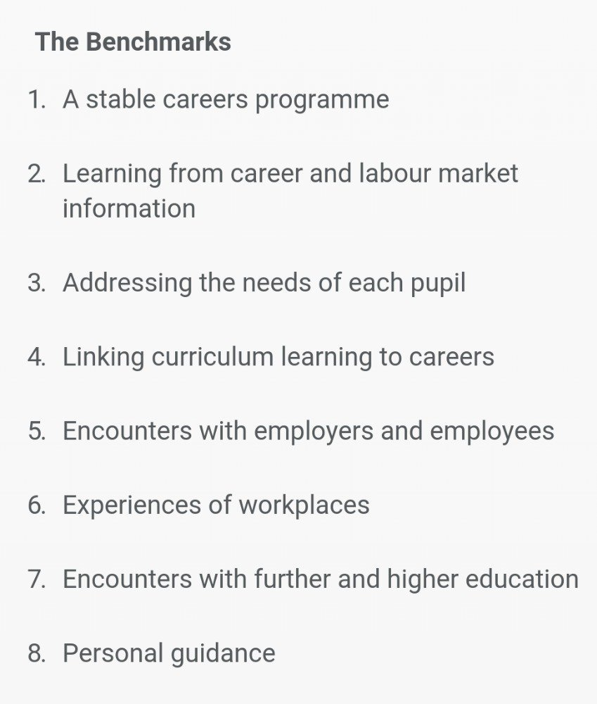

Special educational needs and disability code of practice: 0 to 25 years.
http://www.thecdi.net/write/Careers_guidance_and_access_for_education_and_training_providers.pdf
NDA, 2017, Supports available for adults with disabilities after leaving school
https://www.ndti.org.uk/uploads/files/How_to_Support_Young_People_With_Special_Educational_Needs_into_Work.pdf
The Progressing Accessible Supported Transitions to Employment (PASTE) project investigated the concept of supported transition for school leavers with intellectual disabilities, as a means of accessing mainstream opportunities in further / higher education, training, and employment (FETE).
Ireland’s National Skills Strategy 2025 (DES, 2016)

