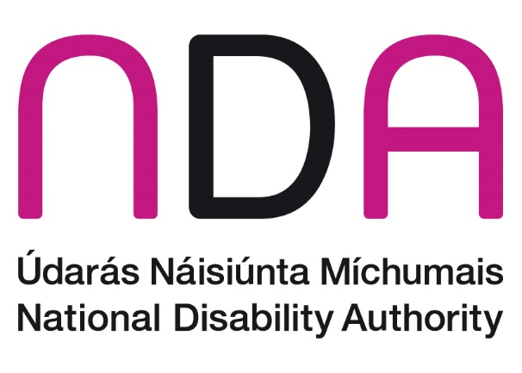

NDA Submission to the Department of Health on their consultation on the Suicide Reduction Policy[1]

**April 2025**

# Introduction

The National Disability Authority (NDA) is the independent statutory body providing evidence-based advice and research to Government on disability policy and practice and promoting Universal Design. We welcome the opportunity to input to this important consultation. The survey format did not allow us to comment on the areas within our competency, so we have taken the liberty of outlining some key issue in this written submission.

The NDA recognises the value of the previous suicide reduction policy and the subsequent work undertaken to progress the agenda of suicide reduction in Ireland. Below, we provide details about both (a) the increased risk of suicide and non-suicidal self-injury in disabled people and (b) some potentially modifiable risk factors for these groups. The below information is provided in the hope it is useful in ensuring disabled people’s needs are adequately represent in the forthcoming strategy.

# Suicide and disability

A growing body of international evidence shows that disabled people and people with long-term conditions are at an increased risk of suicidal ideation and dying by suicide (Fässberg et al., 2016). Physical, intellectual, progressive and functional disabilities have each been shown to carry suicide risk (Giannini et al., 2010). Risk factors for disabled people can also be linked to, for example, increased rates of mental ill-health, un- and under-employment, loneliness, stigma, perceived burdensomeness, and degree of functional limitation (Kumar et al., 2024; Marlow et al., 2021).

Evidence also exists in relation to some specific groups of the disability community. For instance, autistic people, including autistic children and young people (O’Halloran et al., 2022), are at a higher risk of thinking about, attempting and dying by suicide compared with those who are not autistic (Hedley & Uljarević, 2018). Undiagnosed or late-diagnosed autism, (Cassidy et al., 2022) traumatic, painful life experiences (Pelton et al., 2020), barriers accessing effective mental health treatment (Brede et al., 2022; Camm-Crosbie et al., 2019), and pressure to conceal autistic traits, known as masking or camouflaging, (Cassidy et al., 2020) are known risk factors for autistic people. Some of these risk factors can be acted on to reduce the risk. This evidence and the need for policy action has been recognised nationally by the HSE’s national clinical programme for self-harm and suicide-related ideation (HSE, 2022), and there are several commitments to include autistic people in suicide reduction policy articulated in the Autism Innovation Strategy (Government of Ireland, 2024). International recognition has also grown, including from the International Society for Autism Research (INSAR, 2021) and the inclusion of autistic people in England’s national suicide prevention policy (England’s Department of Health and Social Care, 2023). The NDA is in the process of commissioning a review of literature related to causes of early mortality in autistic people that may be of interest.

People diagnosed with attention deficit hyperactivity disorder (ADHD) have been found to be at an increased risk of suicidal ideation and suicide attempts (Oh et al., 2024). Comorbid mental ill health is a factor in suicidal ideation among people with ADHD, but ADHD has been shown to be an independent risk factor, although this risk is reduced with ADHD medication (Huang et al., 2018). Therefore, access to, and treatment for both mental health and inattention/impulsivity symptoms in people with ADHD are risk factors that can be acted on and are worth pursuing in the aim of suicide reduction in Ireland.

Chronic pain, as is experienced by many disabled people, is a well established risk factor for suicidality (Balit et al., 2024; Racine, 2018). The Census of Population in Ireland 2022 found the most common type of long-lasting condition experienced by people in Ireland is ‘difficulty with pain, breathing, or any other chronic illness or condition’, which is reported by 8.5% of the total population and 39.7% (n=440,090) of all those reporting a disability. Of these, approximately 33% (n~14,500) reported a difficult with pain, breathing, or any other chronic illness or condition to a great extent. Specifically, there is a clear relationship with chronic pain, clinical depression and suicidal behaviours. Therefore, effective management of chronic pain and both preventive and reactive intervention to psychiatric conditions in people with chronic pain can contribute to suicide reduction.

It is well documented that members of the Travelling Community in Ireland have a higher rate of suicide than the rest of the population. (All Ireland Traveller Health Study Team, 2010). They also experience a higher level of disability than the rest of the population (26% of Travellers reported a disability in Census of Population 2022 compared to 21.5% of the general population). It is likely therefore that the suicide rate of disabled Travellers is also disproportionately high.

There is a growing recognition that family carers of people with long-term conditions or disabilities are at increased risk of mental ill health and suicidality (Huang et al., 2018; O’Dwyer et al., 2021). For instance, a prospective study of young carers, conducted in Australia, found the pressures and personal costs of caring led to an increased likelihood of self-harm and suicidal behaviours over time (King et al., 2023).

Research has found associations between social media and internet use and suicide and suicidal thoughts and behaviours (Sedgwic et al, 2019, Macrynikola et al, 2021). Whether this association also holds and to what extent, for disabled people is not clear but particular strategies may be required in relation to improved content moderation, public health led digital monitoring and education on safe social media use. For example, education should be accessible to disabled people.

# Consultation with disabled people

Article 4(3) of the United Nations Convention on the Rights of Disabled Persons requires all government departments and statutory agencies to ensure the effective participation of persons with disabilities in the creation and implementation of policies and legislation that impact their lives. The NDA strongly encourages the Department to effectively and meaningfully engage with Disabled Persons’ Organisations and disabled people as part of this consultation process. The NDA wishes to highlight its [**Participation Matters guidelines**](https://nda.ie/about/engaging-with-disabled-people/guidance-on-consultations) as a useful resource in this regard and we are happy to advise further.

# Conclusion

The NDA would be happy to provide further information up on any of the issues raised, including a fully list of references if required. We would welcome a specific emphasis on disabled people in the new policy with accessible and targeted strategies as appropriate. We will share relevant findings from our forthcoming literature review on premature mortality among autistic people.

1. <https://ec.europa.eu/eusurvey/runner/4b66d611-a5bc-a3a6-daa1-de2f3e4baf50>