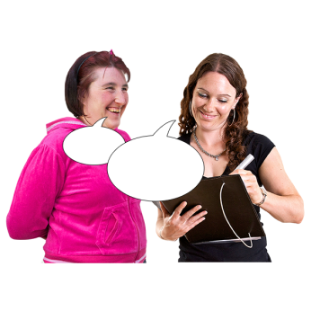

**Have your say on the draft Code of Practice on Accessible Public Buildings**

|  |  |
| --- | --- |
| NDA logo | The National Disability Authority has put together a draft Code of Practice on Accessible Public Buildings. |
| Two people with disabilities speaking up. | A draft means there might be changes to the Code before it is finished.  We would like to get your views on this draft Code of Practice. |
| Draft Code of Practice document. | Please read the draft Code of Practice. |

|  |  |
| --- | --- |
| **Question marks.** | Answer the five questions in this form.  Tell us your views and ideas. |
| One person. Group of people. | You do not have to give your name or contact information.  You can answer as an individual, or for a group or organisation. |
| Email | You can email your form to nda@nda.ie |
| A post box. | You can post your form to:  Code of Practice Public Consultation National Disability Authority, 25 Clyde Road, Ballsbridge, Dublin 4, D04 E409 |
| Date Jun 26 | Send the form to us by 26th June 2023. |

**Question 1**

Is the information in the draft Code of Practice clear?



**Question 2**

Are all the important things about access in public buildings in the draft Code of Practice?

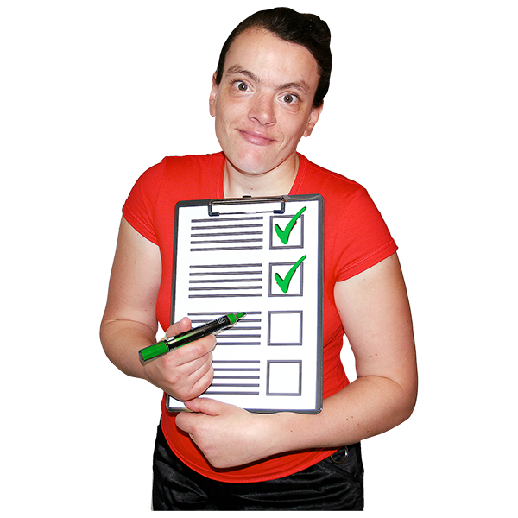

**Question 3**

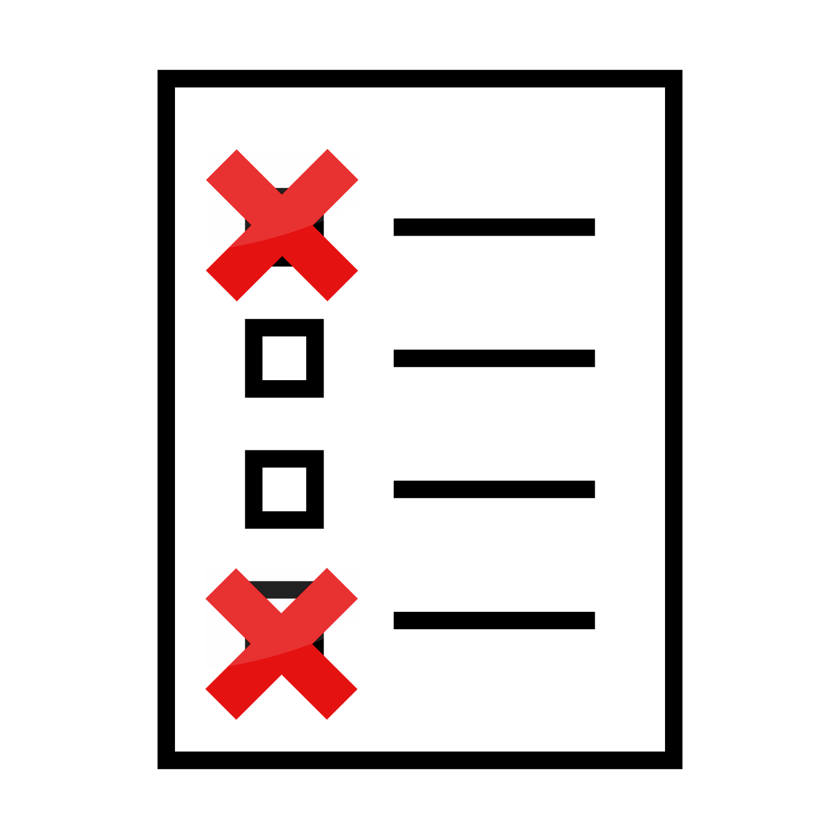

Is there anything that you think should be taken out of the draft Code of Practice?

**Question 4**

Do you have any ideas to make the Code of Practice better?



**Question 5**

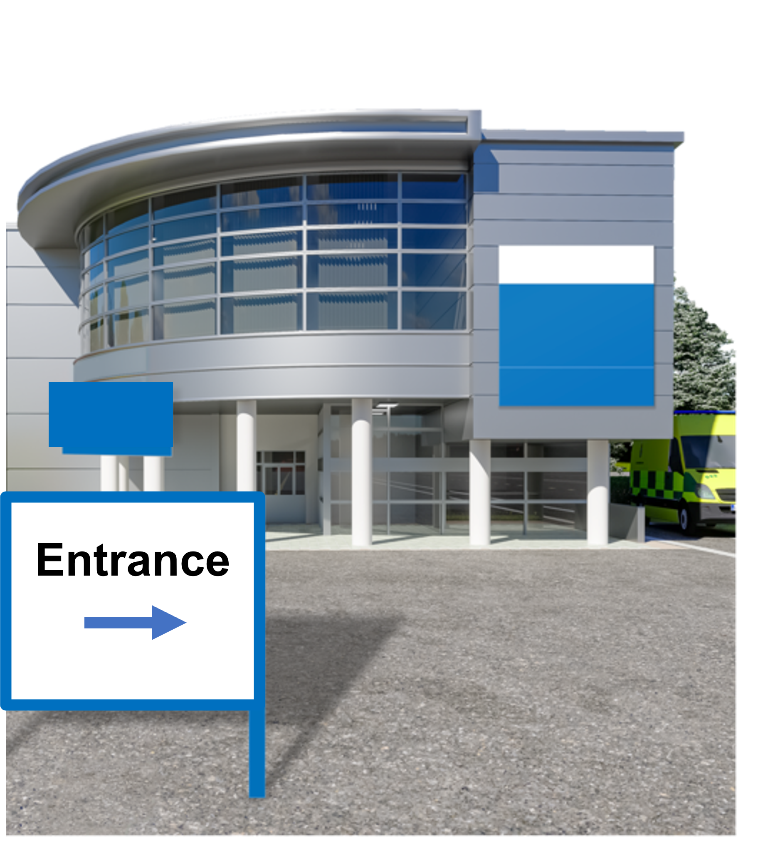

Do you have any examples of good access in a public building?