National Disability Authority Resource Allocation Feasibility Study phase 2

Final Report

December 2014

Key findings

Strong correlation between all four tools
- There was a very strong overall correlation between the four assessment tools, FACE, interRAI, RAS 5 and Support Intensity Scale® (SIS) for individual service users
- All four tools correlate well with underlying need
The strength of the correlation between the scores suggests that any of the tools would give very similar assessment results. Therefore a standardised framework based on any of the four tools could allow resources to be targeted towards those with the greatest needs, and enable supports and services to be aligned with needs. While one of the questionnaires (RAS 5) was noticeably shorter and covered issues in less depth than others, it arrived at a similar ranking of needs to the more detailed ones.
Thus, the decision on which assessment tool to rollout nationally is likely to be driven by the ease and accuracy in deriving costs of services from the assessment of need, the usefulness in performing other tasks, the cost of adoption and operation, and the acceptability to users and interviewers of each tool.

What support needs and costs may not be captured

Quantum of therapy support
Each of the tools is capable of assessing the degree of need for care support, but none of the tools are designed to predict the quantum of therapy or other clinical services required. However, some of the tools can point to likely needs for therapy or clinical input. The scale of such inputs required would need separate clinical assessment.
That suggests that resource allocation for therapy supports would need to be addressed outside of the allocation of resources.

Irregular intermittent support needs and complex circumstances
All tools work for regular support needs but are not geared towards identifying needs and costs where people have irregularly intermittent needs or conditions
No tool was effectively able to capture need in all circumstances. For instance, the tools were not intended to capture the range of support needs in complex situations such as where a service user is themselves providing care to a child with a disability. It would be important to have protocols to highlight those cases where assessments might need to extend beyond standard tools.
All tools gave people with complex disabilities similar scores. However, feedback was that people with complex or multiple disabilities felt that the interRAI tool did not fully capture their needs. This reflected the particular configuration of the interRAI tool that the NDA used, where filter questions were used to direct respondents to particular suites of questions, focusing on either physical or intellectual disability. This highlights the need for an adequately integrated tool which accommodates different types of disabilities rather than different tools for different disabilities.

Support available from family and friends
The support available to a person from family and friends is a key factor in assessing the kind and scale of support they need from the state, whether this should be day support or a residential service. Of the four assessment tools, SIS does not explicitly collect information on the supports available from the family or others.

Feedback from participants in the trials
Service users generally felt that the acceptability of all four tools was good, with the exception, as noted above, that people with multiple forms of impairment did not feel that the configuration of interRAI used by NDA fully captured their needs.
Service users, key workers and family members did not clearly identify a preference for one tool over any other tool. Interviewers had a clear preference for the SIS assessment tool which they perceived to be more comprehensive, and reported their view that the interRAI tool did not give a holistic sense of the person.

Cost of implementing specific tools
While the National Disability Authority has not yet been able to cost the different tools in detail, there are some general indications:
- Administration time is shortest for RAS 5, and roughly equivalent for the other three tools
- With more time taken to administer comes a more in-depth profile of the individual, which may be helpful for purposes other than resource allocation
- InterRAI comes at no or nominal cost for licensing. FACE is cheap to licence, and the FACE tool licence also includes supply of a web-based hosted centralised data collection and cost calculation service, covering the cost of computerised implementation. RAS 5 is cheap to licence. SIS is more expensive to licence
- Data processing for interRAI is done through dedicated commercial software companies for which there are additional charges. SIS has an online data processing system SIS Online, for which there is a charge
- Training for FACE and RAS 5 is shorter and less expensive than training for interRAI or SIS.

Strengths, weakness, similarities of the 4 tools
In summary, all four assessment tools are good predictors of need and there is a strong overall correlation between assessment tools scores for service users. This remains when correlating scores by age and gender with a small exception for disability type. Service users report high satisfaction levels and were generally happy with the length of interviews. Therefore, with appropriate amendments or additions, and with accurate algorithms to convert assessment scores into costs, in principle it would be possible to use any of the tools to generate a fair resource allocation mechanism that would map well onto individual need in most circumstances. A key difference between the systems is the ready availability of accurate algorithms to convert assessment results into care and support hours or budgets.
The following table sets out how each of the four systems meets key features
Comparison of the four assessment tools
Feature | FACE | interRAI | RAS 5 | SIS
Correlates well with need | Yes | Yes | Yes | Yes
No clear bias | Yes | Yes | Yes | People with physical disabilities tend to score slightly lower on SIS
Collects info on family support available | Yes | Yes | Yes | No
Addresses sustainability of family support | Yes | Yes | No | No
Scores can be readily converted into costs | Yes. Package to convert data to cost figure comes with the licence, giving costs/care hours based on UK data. | Yes. Based On international data – Irish data would take time. | Flaws in standard methods. Alternative methods to convert scores to costs would need to be devised | Would require a statistical exercise to develop a formula to link current costs to scores on individual elements.
Accuracy of cost figures | High | High consistency across jurisdictions. | Problematic. UK case law has successfully challenged accuracy and consistency | Additional factors need to be added into model to predict costs – family support, challenging behaviour
Can be used for case mix straight away | Yes, using support hours generated from UK data | Yes, using support hours generated from international data | Would need new algorithm developed | Would need new algorithm developed
Acceptable to service users in NDA trial | Yes | To all but one (out of 40) | Some service users in NDA trial felt complexity of their needs not fully covered | Generally yes, but some service users with physical disabilities felt some parts not relevant to them, others felt some relevant areas were missed
Acceptable to interviewers, NDA trial | Yes | Interviewers expressed view it did not adequately assess need | Not considered as comprehensive as other tools | Interviewers felt it was very comprehensive. Their preferred system
Psychometric tests show reasonable consistency across interviewers, and over time | Yes | Yes | No extensive tests | Yes, in intellectual disability
In widespread use | Used in UK across wide range of disabilities. Standard tool for assessment of ID in about half of English councils | Eldercare version in widespread use. Disability versions under trial | Variations of this in widespread use in England across adult social care groups | In widespread use in US for ID. Some use in Netherlands for people with physical disabilities
Easy to understand | Yes | Yes | Yes | Yes, but some ambiguity
Quick to complete | Yes | Yes, with gateways (which proved problematic in NDA trial where someone had multiple disabilities) | Quickest of the 4 | Yes
Assessment template can be readily modified | Some flexibility | Up to 5% of ‘’local’ questions can be added | Yes | Limited capacity to edit the tool. New questions would be outside SIS scoring system
System tried in Ireland | Some use in mental health services | Selected as single assessment tool for eldercare | No | Some disability organisations have invested in SIS training and are applying it in a number of areas
Rollout costs | Modest, and includes data processing in licence | Licensing nominal. Cost of data processing unknown | Modest | Appears highest of all four (licensing, IT)
Training time | Less intensive | More intensive | Less intensive | More intensive

Other issues
Several other issues related to resource assessment tools and the assessment process arose during the course of the first field trial and the current one:

What is appropriate or sustainable support from the family/community
In a situation where there is no unpaid family or community support available or obtainable, the level of support needs that would fall to be funded by the state is reasonably clear cut. In situations where there is some family or community support available, there is a degree of judgment to be exercised about whether that support is sustainable, and the scale of residual needs that would fall to the state. Appropriate guidance as to policy and practice in this respect would be needed to complement the assessment tools, as this is an issue that assessment tools in themselves do not fully resolve.

Ambiguity about assessing present capacity or capacity with support
In replying to questions on the different forms, interviewers and interviewees were not clear as to whether specific questions related to what a person can currently do, or what they could do in future with support, with the result that some responses were ambiguous. Whatever tool is adopted, there would need to be clear guidelines and appropriate training to ensure that a consistent approach would be taken to how questions should be interpreted, to ensure that everyone is assessed on a similar basis.

Respondents giving conflicting answers on different tools
The trials showed that occasionally the factual answers given were different for the same individual in successive interviews using different tools. This highlights the need to have input from a second informant in situations where that is a potential issue.

Assessing people with intermittent needs
All of the resource allocation tools are framed primarily around current needs. The assessment of people with intermittent needs will pose a challenge, particularly where those needs are irregular or unpredictable. In a resource allocation model focusing on the case mix of service providers, it is easier to forecast aggregate annual demands arising from intermittent needs across a population. This becomes much more difficult where the focus of the resource allocation model becomes individualised needs or individualised budgets.

Frequency of review or reassessment
In designing an assessment process, the question of when and in what circumstances complete reassessments or partial reviews might be required should be considered. The design of the assessment process should provide mechanisms for people with disabilities, their families, support staff or professionals to trigger a request for reassessment or review.

Background to resource allocation project
The Irish Government is committed to introducing greater transparency in the disability budget. The Government is also committed to moving towards individualised budgets for some proportion of public expenditure on disability services. Both commitments are to promote the goals of better quality services and outcomes for people with disabilities. For these commitments to be fulfilled, a systematic, transparent and fair assessment of need is required.
One of the important building blocks of the reform programme for disability services is the development of new resource allocation to provide a basis upon which the transition from a block funding to more individual costing approaches can take place.
The National Disability Authority has been engaged in a programme of research to inform its advice to the Department of Health and the HSE on the optimum tool to guide individualised budgeting ^{[1]} for people with disabilities. Following the Value for Money and Policy Review of Disability Services, the focus has also been extended to look at how to ensure that resource allocation between different service providers is better matched to need.
During 2011 and 2012 the National Disability Authority (NDA) conducted a Resource Allocation Feasibility Study (hereafter the first study). The objective of this study was to examine the appropriateness of the Support Intensity Scale® (SIS) and InControl as resource allocation tools for disability services in Ireland. The research was an evaluation of the acceptability of these two established tools to an Irish context.
Subsequent to the first study, the NDA received a formal request from the Department of Health to widen the original consideration of assessment tools to include other two assessment tools (interRAI and FACE) which had been used for assessment of need in Ireland. As the ultimate purpose of the studies is to examine how a common needs assessment tool could be used to guide allocation of resources, it was viewed as prudent to test the FACE and interRAI assessment tools before committing to the introduction of any one assessment tool.
This second tranche of research tested FACE and interRAI with 40 participants, 39 of whom had been involved in the first study.
Each tool had a different genesis in terms of the group it set out to cater for and what it was originally designed to do. RAS 5 was designed as a summary way to capture information to guide resource allocation. The other tools began as multi-faceted assessments of support needs, with application to resource allocation added on at a later stage. FACE and interRAI developed originally to aid care planning and person-centred planning, and SIS to capture support needs in key life domains.
RAS 5 was designed to capture the need for adult social care support across a range of care groups including elderly people and people with disabilities, SIS was originally developed for adults with intellectual disabilities, and a subsequent child version was developed, however it has also been used for people with physical disabilities. InterRAI was originally developed in the context of eldercare and nursing home care, and then a wider suite of interRAI tools was developed for other care groups. FACE was used initially with people with mental health conditions, and then developed and applied for a wider range of care groups.
This paper reports on the results of the second tranche of research, but does not deal with how need is translated into costs. It also compares results across all four assessment tools examined from the two phases of field trials.
A further paper will provide a wider assessment of the four tools, looking at core questions of how well they match assessments and costs of service, and how consistent are they when administered by different interviewers, as well as how well they would serve other assessment, planning and management purposes. An extensive programme of needs assessment is likely to be resource intensive, and greater value could be achieved from such an exercise if the assessment can contribute towards other tasks, such as person-centred planning, aggregate service planning, statutory needs assessment, monitoring outcomes, or functioning as a core record of needs to guide assessment of eligibility for other services.
This paper summarises the learning to date about the wider characteristics of the different assessment tools and associated resource allocation models, while a fuller analysis and discussion of these issues will be undertaken in the next paper.

Background to Phase 2 Feasibility Study
After the completion of the evaluation of the first field trial, which involved comparing RAS 5 and the Supports Intensity Scale, the National Disability Authority was requested by the Department of Health and the HSE to test two other resource allocation systems, Functional Analysis of Care Environments (FACE) and interRAI. Both tools had been used in Ireland to assess need and both seemed to offer potential as the preferred resource allocation systems.

InterRAI
InterRAI had been developed by academics in the US as an assessment and resource allocation system, initially in the eldercare sector, and then a wider family of interRAI tools was developed. InterRAI has been selected by the HSE to be the single assessment tool for older people.
The potential for using the same family of tools for assessment and resource allocation for both eldercare and disability support services clearly warranted examination.
The National Disability Authority worked with the interRAI organisation to develop a tool for assessing the needs of people with a disability (interRAI had several tools for assessing different aspects or sub-groups but at the time none of their tools was a broad-based disability tool). However, as the resulting tool was very long the NDA suggested putting ‘gates’ into the tool. Therefore, after some initial questions, people answered a slightly varied version of the tool depending if they had an intellectual disability, mental health difficulty or a physical disability. These gates did serve to shorten the length of the interview but proved unpopular with people who had more than one disability as they felt the complexity of their needs were not captured (see discussion later).

FACE
FACE was developed in the UK to support the ‘single assessment process’ for older people and was accredited by the Department of Health in 2003. It is now widely used in England as the standard needs assessment for all disability care groups, including older people, intellectual disability, physical disability and mental health, and used routinely for allocating personal budgets to people with intellectual disabilities in over 20 councils in England. FACE is already used by some HSE and other mental health service providers in Ireland. Evidence as to the accuracy of FACE for resource allocation is published in a paper in the journal Research, Policy and Planning in 2013.

Conduct of Field Trial 2 – FACE and interRAI
As an extension of the previous feasibility study, the National Disability Authority tested FACE and interRAI during 2013. The NDA invited a subset of the participating organisations and their service users from the first study to take part in the new study. As the first study did not find that location was an important variable, mainly Dublin-based services were selected for ease of logistics. One Kerry based organisation was included to ensure complete coverage of all disability groups. These service providers represented 50 people who had participated in the first study and who had a spectrum of disability, support needs and living arrangements. Of these service users, 39 agreed to participate in the new study and one was a substitute with characteristics similar to one of the service users who declined to participate.

Characteristics of service users in this study
The service providers were chosen because they provided a balanced coverage of people with different disabilities and different service delivery modalities. The 40 interviewees’ main disabilities are characterised as follows:
- 9 with mild or moderate intellectual disability
- 8 with severe or profound intellectual disability
- 6 with neurological disabilities
- 13 with physical disabilities
- 4 with sensory disabilities
In addition 17 of the 40 above could be characterised as ‘complex cases’. For the purpose of this study, the definition of a complex case is someone with a dual diagnosis or with significant co-morbidities that therefore result in the person needing much more support or multiple complex interventions. In addition nine of those in the study potentially could have been listed under a different disability category (for instance a wheelchair user with a significant visual impairment could be classified as either having a physical disability or having a sensory disability). These nine people are defined in this study by their service provider’s categorisation. However, the effect of defining them by their second form of impairment was tested and found not to change the results.

Service settings
The type of service provision accessed by service users in the study can be categorised as follows:
- Congregated care settings – residential service with a home accommodating ten people or more
- Group home – residential service with homes accommodating four to six people.
- Day services – these can either be agency based or non-agency based.
The 40 participants have the following types of service provision:
- 7 use day services on site
- 7 live in congregated settings
- 8 live in a group home
- 18 use agency-based day services

Other characteristics of service users in study
- 23 women and 17 men
- 23 people aged 18 to 40 and 17 aged 41-65.
- 5 people with mental health difficulties
- 2 people with challenging behaviour
- 4 of the service users had dependent children and 2 of these were single parents

Assessment instruments
The NDA worked with both the FACE and interRAI organisations to produce tools that were relevant to the Irish context. In addition, as mentioned above, the NDA worked with the interRAI team to produce a ‘disability’ tool and, further, to produce gateways within this tool so that people were only asked relevant questions. These gateways meant that everyone interviewed was asked general questions and then, depending on the answer to these questions, they answered the questions on one of three interRAI questionnaires:
- Mental health
- Physical disability
- Intellectual disability

Study process
As in the first field trial, participants were interviewed by someone from outside their own service. Each participating service provider offered experienced staff to act as interviewers for people in another service.
The FACE and interRAI interviews were conducted by a team of eight interviewers, all of whom had extensive experience of working in the provision of supports to people with disabilities. Five of these interviewers were involved in the first study and therefore had experience of all four tools.
A team of ten project liaison officers in the participating services recruited service users who had participated in the first study to participate in the second study, obtained their consent and co-ordinated the timetabling of interviews. The project liaison officer was also a key contact point for service users and their families, dealing with any queries or concerns regarding participation in the study.
Ethical protocols were similar to the first study and ethical oversight was provided by Dr Ron Iphofen AcSS (an independent consultant, and adviser to the Ethics Sector of DG Research and Innovation, European Commission). All comments from the adviser were attended to promptly, lessons learned from the first phase were applied and no serious issues emerged during the conduct of the study.
Training in the two supports needs assessment tools was provided to interviewers by the interRAI and FACE organisation. The actual interviews, with two exceptions, were delivered by individuals that had no prior knowledge of the service user and their support needs (in two instances due to unavoidable timetabling issues, the interviewer had interviewed the service users during the first study a year previously). The interviews were timetabled to take place in the course of a single day and the interRAI tool was undertaken first followed by FACE tool. Service users had the option of being accompanied by a family member or key worker. Service users with cognitive impairments or intellectual disabilities were routinely joined by a key worker.
Service users were interviewed at the service provider’s premises.

Data for analysis
Similar to the process involved in first study, data was collated and analysed from different key sources:
- Monitoring sheet – this was developed by the National Disability Authority and was designed to capture anonymised data on the characteristics of the service users, as well as coding to record the interviewer conducting each assessment, the date of the assessment, and who was present.
- Quick response sheets – feedback was captured from all participants (interviewers, service users, key workers and family members) immediately after each interview was completed. This captured data on satisfaction with the interview process and the assessment tools.
- FACE/ interRAI assessment results - The completed anonymised FACE interviews were scanned to the FACE organisation. FACE returned an indicative budget for each person. In addition information from each person’s FACE assessment was collected in order to be able test scores against the other tools scores. During the interRAI interview information was collected on the number of hours of care (formal and informal) the service user received in the last week, results were recorded in paper form by interviewers who then sent this on to the NDA. The output from interRAI is based on weighted answers to questions which have been normalised on a US population
- Focus group – a focus group was held with the interviewers involved in present study, giving them an opportunity to reflect upon and share their experiences of the FACE, interRAI, SIS and tools. In addition, two interviewers who could not make the focus group submitted written submissions. The focus group information and written submissions were written up and circulated to all interviewers for approval.
The National Disability Authority conducted the evaluation of the study in-house, using the methodology from the first study with extra statistical tests on the data for individuals who had been interviewed on all four tools.

Results
The results of the present research are combined with the results from the first study for the forty individuals involved in trials of all four instruments. This means that the results reported for RAS 5 and SIS vary from those in the first study’s final report which covers all 112 participants rather than the 40 individuals who participated in the both studies. Results are given under the following sub-headings:
- Interview length
- Acceptability (feedback from quick response sheets)
- Correlation with need
- Cost implications

Interview length
Table 2 reports on the average time interviews took on each tool. RAS 5 was the shortest average interview at 32.6 minutes, FACE, SIS and interRAI took similar amounts of time at 57 minutes, 59.8 minutes and 60.7 minutes respectively. For each tool, there was wide dispersion in the length of time it took for different individuals. Note that the time for RAS 5 and FACE is based on the time taken for the 40 service users included in present study and therefore the average time taken is different than that reported in the first study.
Table 2: Average length of interviews in minutes
 | RAS 5 | SIS | FACE | interRAI
Mean | 32.6 | 59.8 | 57.0 | 60.7
Source: NDA
In addition to the length of time the interview took, interviewers also spent time after the interview coding the tools – interviewers commented that the interRAI and FACE tools took a long time to code. Typically the interviewers reported that they spent as long filling in the coding as they did in the interview. As this was a small scale study, where individual interviewers conducted a small number of interviews each, this finding could be different with practised interviewers doing these assessments regularly. The use of laptops loaded with the questionnaire to record information at interview could also save time – interRAI report that experienced assessors with laptops typically take about an hour for both assessment and data entry.
Graph 1: length of FACE and interRAI interviews
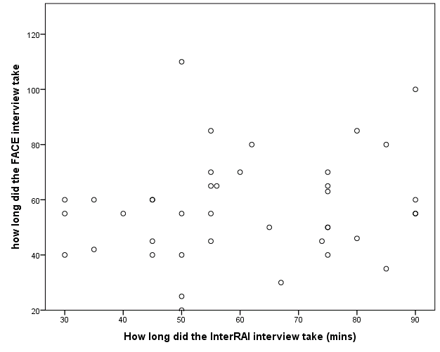
Source: NDA
Analyses of the results show that there is no correlation between the lengths of time each tool took for the same individual. Graph 1 shows the length of the FACE interviews against the length of the interRAI interviews. No clear pattern emerges which suggests that it is not interviewee characteristics, nor tool (beside the much shorter time for RAS 5) which is driving the length of the interviews.
Finally it is not clear that the length of time an interview takes is a crucial metric to use when choosing between the tools. If these interviews are to determine a person’s supports and care plan it is important that the service user does not feel rushed and has time to explain their total support needs.

Acceptability of the four support needs assessment tools
The following table (table 3) summarises some of the responses to the questions on the interviewer and service user quick response sheets.
The acceptability of all assessment tools was generally good. Service users were generally happy with the length of interviews and they did not identify one tool as being better than any other tool in allowing them to describe their needs.
Table 3: responses to selected quick response sheet questions
 | FACE | RAS5 | SIS | interRAI
Acceptability
Interviewer felt that service users was dissatisfied with the interview and the process involved | - | - | 3% | -
Service users disliked certain questions | 3% | 3% | 5% | 5%
Interviewers thought that the interview was too long for the service user | 0 | 3% | 10% | 0
Relevance
Interviewers thought very much relevant | 63% | 48% | 48% | 45%
Interviewers: Do you feel that any of the questions were irrelevant [for the service user]? | 8% | 15% | 33% | 28%
Service users thought missed points | 15% | 26% | 10% | 8%
Do you feel that the questions explored issues that are relevant to the service user's needs in their day to day life? Very much so | 63% | 48% | 48% | 45%
Service users: Did the questions help you to say what support you need in your day to day life? % reporting very much so or in part | 70% | 65% | 60% | 60%
Interviewers: Did the service user make any points about their support needs and outcomes they hoped for, that could not be/ were not captured through the interview? | 18% | 18% | 8% | 20%
Source: Quick response sheets
On the measures of relevance, the FACE tool scored more highly than the other 3 tools.
While service users did not single it out, interviewers identified SIS as the tool that best captured service users’ support needs. Interviewers support for SIS was underlined in the focus group – where they highlighted it as the tool which gave them the best sense of the person. At the same time they felt that that in a third of cases some of the SIS questions were irrelevant to the service users.
There were two areas in which service users did differentiate more clearly between the tools (and which were statistically significant):
- service users with a physical disability were more likely to say that there were parts of the SIS questionnaire which did not apply to them, compared to service users with mild to moderate intellectual disabilities. This may well be a reflection of the fact that the SIS needs assessment tool was specifically developed for service users with intellectual and related disabilities
- service users with multiple disabilities were likely to highlight that interRAI did not capture all of their needs
The implication from the findings was that any of the assessment tools could be rolled out nationally and would be acceptable to service users. As yet, no tool has been used to undertake resource allocation in Ireland, and the overall acceptability of any tool may be affected in the longer term by the extent to which service users feel the tool results in them being allocated a budget which they regard as acceptable in meeting their support needs.

Complex disability
There was a feeling among service users with more complex disabilities that some of the complexity of their condition was missed. However an analysis of those with complex disabilities or those with more than one form of impairment shows that they scored similarly under all tools (appendix 1). However, people with complex disability were less likely to report that they felt that the interRAI was relevant to them.

Comparison of need
Analysis of four tools shows that they are correlated with each other (table 4). All Pearson correlations are significant at the 0.01 level and are high.
Table 4 Pearson correlation of the four tools
 | FACE score | interRAI | RAS 5 | SIS
FACE score | 1
interRAI | .765** | 1
RAS 5 | .787** | .632** | 1
SIS | .718** | .574** | .727** | 1
Source: NDA ** Correlation is significant at the 0.01 level (2-tailed).
Note: The interRAI measure in this table is derived from outcomes of a fully trialled care assessment in another jurisdiction. These numbers may then alter when a fully-developed case mix system is developed for Ireland. Note that raw scores were used for FACE, whereas FACE usually is used to generate weighted scores
As analysis showed that all four tools were measuring the same thing, a variable was created from the four tools called ‘average need’. Analysis of this variable shows that it is correlated well with the four tools (table 5). All are statistically significant at the 0.01 level and with high coefficients.
Table 5: Average need correlation with the four tools
 | Average need
FACE | .92**
interRAI | .83**
RAS 5 | .90**
SIS | .86**
Source: NDA
Just because the four measures are well correlated at the global level it does not follow that they are well correlated at subcategory level. The next eight graphs look at how different subgroups are treated by each tool in turn. In each case, the diagonal line separates those who have more points under the tool compared to the average of all tools, from those who have lower points on this tool.
Disability type and service provision were chosen as these demonstrate statistically significant differences between tools at the subgroup level. Other breakdowns which were not statistically significant are shown in appendix 1. However, due to the very small sample size, care must be exercised in deciding that these other breakdowns are not of interest as a larger sample size may indicate significance.

Disability type
Graph 2: Comparison of FACE with the average of all assessment tools by disability type
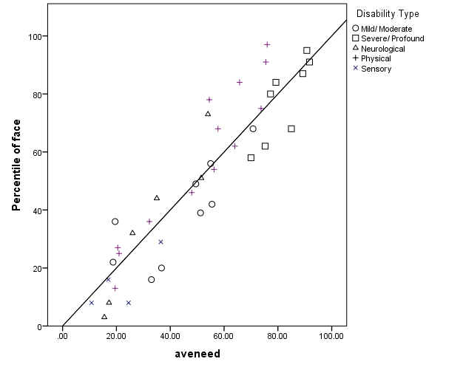
Source: NDA
FACE gives slightly higher scores to those who have a physical disability relative to other tools (graph 2). With one exception all those with physical disabilities are on the right hand side or very close to the diagonal line indicating that they would have slightly more points on the FACE tool than on the other tools. Those with a severe and profound disability at the very top of the distribution have the same points on the FACE tool as the other tools but relatively lower scores if they are not close to the top of the distribution. People with sensory disabilities would lose a little under FACE. Apart from these patterns there are no other clear patterns as there are people with mild/moderate and neurological disabilities on both sides of the diagonal line.
Graph 3: Comparison of interRAI with the average of all assessment tools by disability type
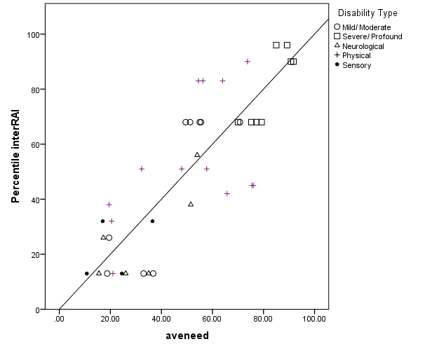
Source: NDA
Overall people with mild or moderate intellectual disabilities score similarly under interRAI compared to the other tools; however people with few support needs generally score less on interRAI (graph 3). People with a severe or profound intellectual disability, sensory disability or neurological disability generally score similarly on the interRAI tool than they do on the average of the tools.
Graph 4: Comparison of RAS 5 with the average of all assessment tools by disability type
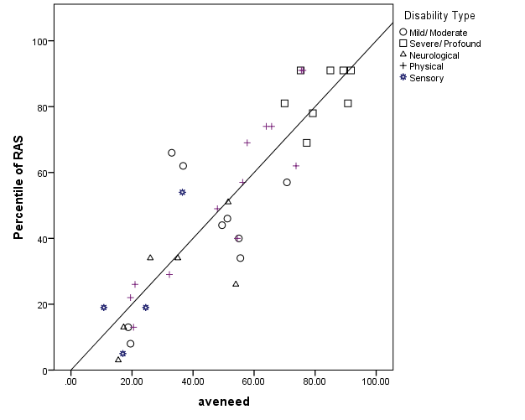
Source: NDA
RAS 5 (graph 4) does not demonstrate any systematic pattern compared to the average of the four tools. There are people with each type of disabilities on both sides of the line. This indicates that scores all groups similarly to the average score of all tools.
Graph 5: Comparison of SIS with the average of all assessment tools by disability type
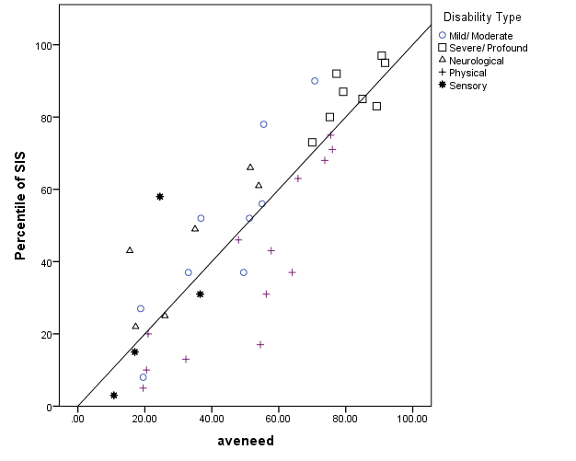
Source: NDA
SIS compared to the other tools provides lower relative scores for people with physical disabilities and over scores people with neurological disabilities and intellectual disabilities.
The next table (table 6) compares the average score on each tool broken down by disability type. This allows a comparison of how the different disability groups compare under each tool.
Table 6: Comparison of means of all assessment tools by disability type
 | Nos. | FACE | RAS | SIS | interRAI | Average of  four tools
Mild/ Moderate ID | 9 | 38.7 | 41.1 | 48.6 | 45.0 | 43.3
Severe/ Profound ID | 8 | 78.1 | 84.1 | 86.5 | 80.5 | 82.3
Neurological | 6 | 35.2 | 26.8 | 44.3 | 26.5 | 33.2
Physical | 13 | 58.2 | 53.6 | 38.4 | 34.4 | 51.1
Sensory | 4 | 15.3 | 24.3 | 26.8 | 22.5 | 22.2
Total | 40 | 50.0 | 50.0 | 50.0 | 50.1 | 50.0
Source: NDA
Some of the cell sizes are very small however it does seem that SIS, in comparison to other tools, scores people with a physical disability relatively lower. An examination of the individual cases listed in appendix 2 highlights some of the reasons why individuals with physical disabilities, but without an intellectual disability, score higher on the other tools than on SIS.

Service type
Now we turn to looking at how each tool does, on the basis of where people live and the type of service they receive.
The second category where there are statistically significant differences between subgroup is in service provision. The service provision accessed by service users was categorised as follows: congregated setting, group home, day services that were centre-based (site) or day services that were not centre-based (non-site). Each tool is examined in turn to see how each tool scores people in different types of service provision.
Graph 6: Comparison of FACE with the average of all assessment tools by service type
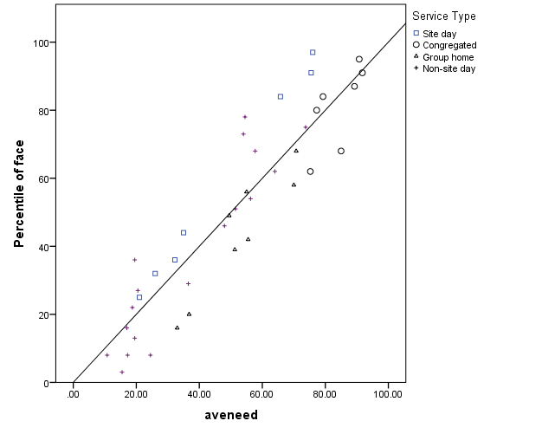
Source: NDA
FACE, compared to the average of all tools, gives higher scores to the users of site-based day services and gives relatively lower scores to group homes. However, there is a more mixed pattern for people who receive non-site day support, or who live in congregated settings, as here there are people on either side of the line. This indicates that, compared to the average FACE scores, some score slightly higher and some slightly lower than the average.
Graph 7: Comparison of interRAI with the average of all assessment tools by service type
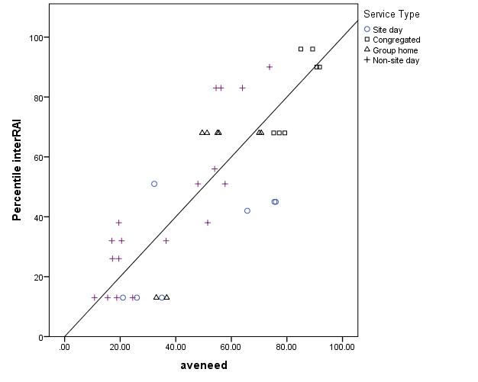
Source: NDA
InterRAI gives lower scores on average to on-site day service users than the other tools and higher scores, on average, to those supported by non-site-based services. People who live in congregated settings and those group homes score similarly on interRAI in comparison to the average of all tools.
Graph 8: Comparison of RAS 5 with the average of all assessment tools by service type
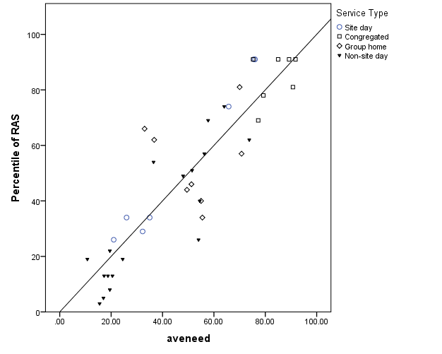
Source: NDA
RAS 5, compared to the average of all tools, does not display a very clear pattern: all four categories of service provision are represented on both sides of the line, indicating that scores are independent of service provision.

Graph 9: Comparison of SIS with the average of all assessment tools by service type
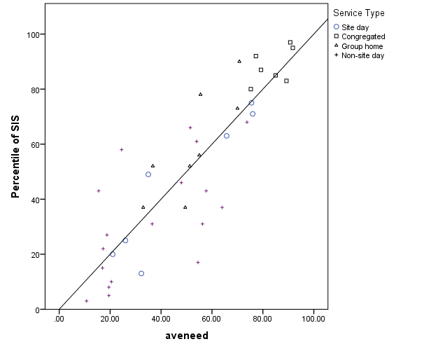
Source: NDA
While there is no strong pattern for SIS compared to the average of the four tools, SIS on average gives higher scores to people living in congregated setting and those in group homes relative to the average of all tools.
The following table (table 7) summarises the mean score of each tool by service type. SIS scores people who live in congregated settings and group homes the highest of any of the tools. FACE scores site day users relatively high and interRAI scores non-site day users relatively high. InterRAI scores group homes the highest and FACE scores these the lowest. FACE scores agency service off-site the highest and interRAI scores these the lowest and RAS 5 has no consistent deviations from the average by service type.
Table 7 comparison of the means of all assessment tools by service provision
Service Type | Nos. | FACE | RAS 5 | SIS | interRAI | Average of four tools
Site-based day | 7 | 58.4 | 54.1 | 45.1 | 31.7 | 47.9
Congregated | 7 | 81.0 | 84.6 | 88.4 | 82.3 | 81.3
Group home | 8 | 43.5 | 53.8 | 59.4 | 54.3 | 53.3
Non-site day | 18 | 37.6 | 33.2 | 32.8 | 43.0 | 37.2
Total | 40 | 50.0 | 50.0 | 50.0 | 50.1 | 50.0
Source: NDA from QRS
Appendix 1 has other breakdowns by gender, challenging behaviour and mental health status – none of these breakdowns are statistically significant.
In conclusion, all four tools are highly correlated with each other so therefore could be said to reflect underlying need. However, some tools show small differences based on disability or the type of current service received. To that extent, the choice of tool may make a difference as to how an individual will be scored.

Cost of introducing an assessment tool
The cost of administering any of the assessment tools includes various factors such as:
- The staff time to administer the assessment tool. Staff time will obviously vary depending on whether the tool is administered by staff external or internal to the service provider, whether it is integrated into existing assessment practices or is a stand alone exercise. The pricing of staff time in doing the assessments will vary depending on the grade and pay rate of the staff conducting the assessments.
- Licensing costs for the assessment tool. These might include direct costs of licensing the tool or indirect licensing costs through having to use a preferred supplier for IT software and/or hardware.
- Training costs
- Travel costs for staff to travel to assessment
- Hardware and software costs
Many of these costs are dependent on decisions about how the tool is to be used, for instance how many people are to be assessed, how often individuals are reassessed and which staff do the assessment. Other costs are dependent on the tendering process. Finally some costs are dependent on the particular configuration of the tool: is it copyrighted, does it need special software or hardware and so on.
Table 8: Relative costs associated with each tool
Cost source | FACE | RAS 5 | SIS | interRAI
Staff time – average length of interview | 57.03 | 32.55 | 59.79 | 60.73
Number of assessments | Same | Same | Same | Same
Travel costs for staff to travel to assessment | Same | Same | Same | Same
Licensing costs | Low | Minimal | High | None
Per user cost | None | Low | High | Unclear
Training costs | Low | Low | High | High
Ongoing support costs | Low | Low | None | None
Specialist software | None | None | High | High
Specialist hardware | Same | Same | Same | Same
Source: NDA
There are many unknowns in table 8 and therefore it is not possible to give a definitive costing for the tools. However, RAS 5 is likely to be the cheapest followed by FACE with SIS and interRAI more expensive.
The dominant cost is likely to be hardware if data were to be collected using laptops. Any laptops or tablets bought for this purpose could of course have many other possible uses. FACE and RAS 5 lend themselves more readily to paper-based data collection with subsequent transcribing, while SIS and interRAI are optimised for direct data entry.

Strengths and weaknesses of all four tools

FACE
The FACE scores generated through the pilot correlated well with average need of all four tools. Furthermore, FACE does not have any obvious biases and was found to be acceptable to service users. Both interviewers and service users ranked it as the most relevant tool for identifying support needs amongst service users and both groups said they found it easy to understand. FACE explicitly explores what support is available to service users from family and friends. The time the FACE assessment takes to complete compares well with the other three tools.
FACE is a family of care assessment and planning tools that is used extensively across the UK for resource allocation and for service planning for people with a range of disabilities and it is used in some mental health contexts in Ireland. FACE has undertaken extensive internal testing to confirm its reliability and validity.
The FACE system has an algorithm to calculate care hours and associated costs, and the FACE licence includes the generation of budgets from the data inputted. This means that case mix estimates for different service providers could be established quickly. The FACE answers may be entered into an Excel spreadsheet and do not require specialised software.

InterRAI
InterRAI correlates well with underlying need as defined as the average of all tools and it does not have any clear biases. Service users on the whole found it acceptable but people with multiple and complex disabilities did not feel that the complexity of their situation was adequately captured. As discussed elsewhere in this paper, this was as result of the particular configuration used by the NDA and therefore the interRAI tool would need to be changed to overcome this problem. Furthermore, some of the questions were judged to be inappropriate in a disability service context (e.g. the question on tea and coffee consumption), and might need to be dropped or amended in any future iteration.
Overall service users thought the length of time the interRAI took was acceptable though this was on the interRAI tool that filtered respondents to one sub-tool or another using ‘gates’ – a reconfigured tool might take longer.
InterRAI was developed for use in elder care in the USA and has been extended out to many countries for resource allocation in elder care and, more recently it has been extended to other care domains. InterRAI has developed an entire range of instruments and screeners to support assessment in a wide array of community and institutional contexts – this could mean that in future interRAI would be used across the life cycle and in different contexts in Ireland. The interRAI elder care tool has had extensive psychometric testing and it has a good track record in allocation of resources in elder care. As the roll-out to other domains is more recent, the testing of questions and resource allocation in those domains is not as yet highly developed. The development of an appropriate tool for people with disabilities in Ireland and its testing would mean that it would be some time before an appropriate case-mix based on interRAI would be ready to use.
If interRAI were adopted there would be a need to source an IT supplier with interRAI software for data entry and to convert the tool via an algorithm into an indicative budget. These issues would have to be dealt with at the tendering stage.
Other potential sources of delay are the development of an integrated disability assessment tool and the development of appropriate resource allocation algorithms based on that tool. Work is ongoing on this issue in other jurisdictions. The IT tender for a software supplier to generate results could add a small level of delay.

RAS 5
RAS 5 correlates well with underlying average need and was the tool that was least likely to show a bias. The tool measures what support is available to the service user. The tool was acceptable to service users although some service users felt that the complexity of their needs was not covered. Although acceptable to interviewers, they thought it would have limited application outside the resource allocation context unlike other tools that collected more comprehensive information on service users’ support needs. However, service users did not express that concern.
The RAS 5 tool does ask about resources available to the service user and it can be modified and probably could be altered to enable it to capture other information.
RAS 5 has an existing track record in being used for resource allocation for people with a range of disabilities in the UK, though there have been legal challenges to it implementation. Case mix estimates could be established quickly. However, algorithms for turning data into case-mix estimates have been proving problematic in the UK under pressure from operational issues and from 0 challenges. Testing is not publicly available to confirm the reliability and validity of the In Control RAS 5 as a measure of need, nor to determine the predictive power in determining cost.
Of all the tools, RAS 5 was the quickest to complete (average 32.6 minutes) and its national rollout costs are the lowest.

SIS
SIS correlates well with underlying need but people with physical disabilities did score slightly lower on SIS compared to the other tools. This could reflect the fact that SIS was developed for use in intellectual disability although more recently being applied in other disability contexts. This would mean that any SIS tool adopted would have to be altered to eliminate any such bias. However, as a standardised copyrighted tool, the ability to modify SIS is limited.
While the quick response data found that SIS was acceptable to service users, service users were most likely to identify SIS as the tool that missed points relevant to them. Interviewers in nearly a third of cases felt that there were some irrelevant questions. At the same time interviewers felt that the SIS was very comprehensive in gathering information on service users’ support needs (although service users did not make this distinction). Service users with a physical disability were significantly more likely to state that parts of the SIS questionnaire were not relevant to them and a more general concern was raised by interviewers as to the applicability of all SIS questions for service users with physical disabilities.
SIS has been used widely both within the US and internationally and it has been tested to see how valid and reliable it is. However it has not been used extensively for case-mix allocation outside of intellectual disability and this element of the tool would need to be developed and tested through a separate statistical exercise. A supplementary suite of questions would need to be developed to ascertain the degree of family and community support available and whether it was sustainable.

Some additional issues
Some additional issues emerged in the course of the research which would need to be considered in introducing any resource allocation system in Ireland.

Current versus potential capabilities
It is essential to be clear and consistent about whether individual questions are assessing someone’s current capabilities or their capabilities given appropriate support.

Answers that are mutually inconsistent
As highlighted in the first study, occasionally people give different answers to similar questions. There are many causes of this: tiredness, forgetfulness, social desirability response bias, acquiescence bias, or the effect of a cognitive disability such as acquired brain injury. This factor underscores the need for assessments to be checked and triangulated to improve confidence in the results.

Flexible responses to intermittent or changing needs
While some people have fairly stable circumstances or support needs, others may have needs that are intermittent and are inherently more difficult to predict. People with progressive conditions or who otherwise have changing support needs over time will need to have their needs assessed periodically as circumstances change. It would be important to develop protocols that set out what might trigger a reassessment.
Some of the personal circumstances of individual interviewees in the study highlighted the importance of a resource allocation system that could respond flexibly to intermittent needs. For instance one interviewee who was deaf, and a parent, needed intermittent help because of his family circumstances. While all the tools were good at identifying his routine everyday needs, none of the tools could predict the need for intermittent help in this role as a father.
All the tools were good at predicting need when a person was in a very stable, predictable environment (for instance when a person was living in a group home). However the tools had difficulties (conceptual at least) where there was a much more individualised service (see examples in appendix 2). For instance one person with a disability lived with another person with a disability. All the tools rated the individual’s needs not the couple’s needs, where they could share some support resources. This means that the tools can not completely replace professional judgements in the assessment of need.

Translating assessments into budgets
FACE (for social care generally) and interRAI (for eldercare) have developed systems for predicting cost that are reasonably applicable in an Irish context, and those algorithms could be further refined after fuller-scale testing in Ireland. Further work would be needed to develop sound systems for converting SIS or RAS 5 scores into costs.

Conclusion and next steps
Resource allocation tools have the potential to better match funding to needs in Ireland in a way that is both transparent and fair. The four tools examined in the two research projects predicted need well and all four tools were generally acceptable to people with disabilities in Ireland.
This paper has presented the evidence from the field trials conducted by the National Disability Authority as to how well the individual resource allocation systems studies performed at the needs assessment stage.
A further National Disability Authority paper reviews wider aspects and possible applications of each resource allocation system, including how needs assessments might be translated into costs.
Following the selection by the Department of Health and HSE of the final resource allocation system, it is recommended assessments using the chosen tool would be trialled on a larger scale in a defined geographical area with a comprehensive cohort of service users, to model the feasibility of large scale application, the resource implications of a fuller-scale assessment exercise, and to examine what ‘shadow’ budgets would be generated.

Appendix 1: Summary of tools by different breakdowns
This appendix examines the mean scores on each tool for different sub-categories. None of these breakdowns showed statistically significant differences between the tools. However, with a small sample size this is not surprising.
Table 8: mean score by gender by tool
Gender | FACE | interRAI | RAS 5 | SIS | Average of tools
Male n=17 | 40.6 | 42.1 | 37.6 | 38.1 | 39.5
Female n=23 | 57.0 | 56.0 | 59.1 | 58.9 | 57.8
Total N=40 | 50.0 | 50.1 | 50.1 | 50.0 | 50.0
Source: NDA
Table 9: mean score by age group by tool
Age | FACE | interRAI | RAS 5 | SIS | Average of tools
18-40 n=23 | 52.0 | 45.7 | 54.7 | 54.3 | 51.7
41-65 n=17 | 47.4 | 56.2 | 43.5 | 4.2 | 47.8
Source: NDA
Table 10: mean score by challenging behaviour by tool
 | FACE | interRAI | RAS 5 | SIS | Average of tools
Challenging behaviour n=2 | 63.0 | 82.0 | 86.0 | 82.0 | 77.5
Other n=36 | 49.3 | 48.5 | 48.1 | 48.5 | 48.6
Source: NDA
Table 11: mean score by mental health difficulties by tool
 | FACE | interRAI | RAS 5 | SIS | Average of tools
Mental health difficulties n=5 | 45.4 | 48.2 | 49.2 | 57.6 | 50.1
Other n=35 | 50.7 | 50.4 | 50.1 | 48.9 | 40.0
Source: NDA
Table 12 mean score by complex disabilities behaviour by tool
 | FACE | interRAI | RAS 5 | SIS | Average of tools
Complex disability n=15 | 51.0 | 50.8 | 55.6 | 50.0 | 51.9
Other n=25 | 49.4 | 49.7 | 46.7 | 50.0 | 48.9
Source: NDA
Table 13 mean score by parental status by tool
 | FACE | interRAI | RAS 5 | SIS | Average of tools
Dependent children n=4 | 25.5 | 33.25 | 20.0 | 22.8 | 25.4
Other n=36 | 52.8 | 52.0 | 53.3 | 53.1 | 52.8
Source: NDA
Table 14 mean score by single parent status by tool
 | FACE | interRAI | RAS 5 | SIS | Average of tools
Single parent=2 | 8.0 | 19.5 | 16.0 | 12.5 | 14.0
Other=38 | 52.2 | 51.74 | 51.7 | 52.0 | 51.9
Source: NDA

Appendix 2: Differences in ranking
While the study showed strong similarities in how the different tools ranked the whole sample, and that there was little discernible systematic bias, this does not mean that there were no differences in how individuals were assessed. This section looks at those individuals to whom some tools awarded very different rankings.
The above analysis demonstrated that subgroup treatment was similar for all four tools (with the exceptions noted) however this does not mean that individuals get similar treatment under all four tools. To examine this issue, individuals were ranked using all tools and a value for the difference between highest ranking and lowest ranking was calculated. Table 15 gives the five most extreme differences in values.
Table 15 rank of individual scores by tool
Identifier | FACE | RAS 5 | SIS | interRAI | highest-lowest ranking
A | 32.0 | 16.5 | 7.0 | 34 | 27.0
B | 6.5 | 27.0 | 15.0 | 5 | 22.0
C | 22 | 23.5 | 12.5 | 34 | 34
D | 40 | 37.5 | 29 | 18.5 | 40
E | 3.0 | 7.5 | 24.0 | 5 | 21.0
Source: NDA Note: this is based on raw scores for FACE, but weighted scores are used in its cost algorithm
The following are pen pictures of the five cases with enough detail to illustrate the different weightings – to aid anonymity some of the peoples genders have been changed.
- A has a degenerative disorder and lives with a live in PA in A’s own house. A uses an electric wheelchair and can not raise his hands above his waist therefore A’s PA cooks, cleans, dresses and feeds him. Therefore, both interRAI and FACE score him as having high support needs. However, A is articulate, intelligent and has no challenging behaviours therefore SIS scores him lower.
- B has Down syndrome and a mild intellectual disability. Partly the difference in B’s rankings reflects different answers to similar questions across tools. In FACE, B said she lives at home with parents but for interRAI she said she lives in group home (latter is correct). B can do all the activities of daily living herself. B scored higher on RAS 5 because she said she needed help to do these things. This example underscores the need for triangulation.
- C has a degenerative condition and has a high level of disability and that is why FACE, RAS 5 and interRAI all score him highly – however as he is verbal and is able to direct his own care he is scored lower by SIS. InterRAI score him particularly highly because he middle aged.
- D is a young woman with cerebral palsy who lives at home. Her parents support and care for her including turning her four times a night. As she is very physically disabled FACE, RAS 5 and SIS give her high marks. Although interRAI classify D as having the highest functional needs possible, because she has never left the family home, has no outburst of anger and is young they award her less funding that other people with the same level of needs.
- E is deaf person, has a mild intellectual disability and lives in a group home. E is completely independent in personal care and can manage public transport alone therefore FACE and RAS 5 rank this person as having low needs. However E needs help to socialise, plan and budget therefore SIS ranks the person higher.

This issue was particularly dealt with in the first report http://www.nda.ie/cntmgmtnew.nsf/0/8A76108C3F4680E88025795A003BAE74?OpenDocument
See http://per.gov.ie/wp-content/uploads/ProgrammeforGovernmentFinal.pdf, p30
See final report at http://www.nda.ie/cntmgmtnew.nsf/0/8A76108C3F4680E88025795A003BAE74?OpenDocument
HSE Northern Area, HSE Southern Area, HSE South Western/East Coast Area, Clare Mental Health Services, HSE Mid Western Area, West Clare Community Mental Health Team, West Galway Mental Health Services, St Loman’s
Clifford, Saunders and Gibbon (2013). Modelling the relationship between needs and costs: how accurate resource allocation can deliver personal budgets and personalisation. Research, Policy and Planning (2013) 30(2), 107-120. http://ssrg.org.uk/wp-content/uploads/2012/01/CLIFFORD-et-al-7Jan14.pdf
The service provider from Kerry was included to ensure that sufficient people with sensory disabilities were included. In addition to this two of the interviewees were based in Limerick.
The service providers approached represented 50 service users who participated in the first study. Of these 48 were approached to participate in the present study. One service user was no longer with the service and one service provider preferred we did not re-contact the service user. Of the 48 approached, 39 agreed to participate in the present study giving a response rate of 79%. As we wanted to have 40 participants one service provider agreed to recruit a service user based on the characteristics of one of the non-respondents. The characteristics were type and level of disability, gender, age and challenging behaviour. Though this introduces a bias in the ability to test-re-test it was felt that it was more important to maintain a reasonable sized sample.
None of the participants lived with 6-9 others.
In the first study the sequencing of interviews (i.e. whether the RAS or SIS was undertaken first or second) was rotated but analysis showed that this was not an important issue.
A factor analysis indicated one underlying factor which explained 71.1% of underlying variance. Though based on only 40 cases, this points to all four tools measuring the same thing. Extraction indicated that all four tools are well represented in the common factor space.
Percentage scores on all four tools were added and then divided by 1.6 so that average need potentially varied between 0 and 100.
Further statistical analysis controlling for other factors highlights that SIS has a very small but statistically significant bias towards lower scores for people with physical disabilities
Though there are statistically significant differences by service provision, further analysis showed that this was largely driven by disability type, as there were differences between where people with different disabilities lived.
The NDA was supplied with copies of these results.

