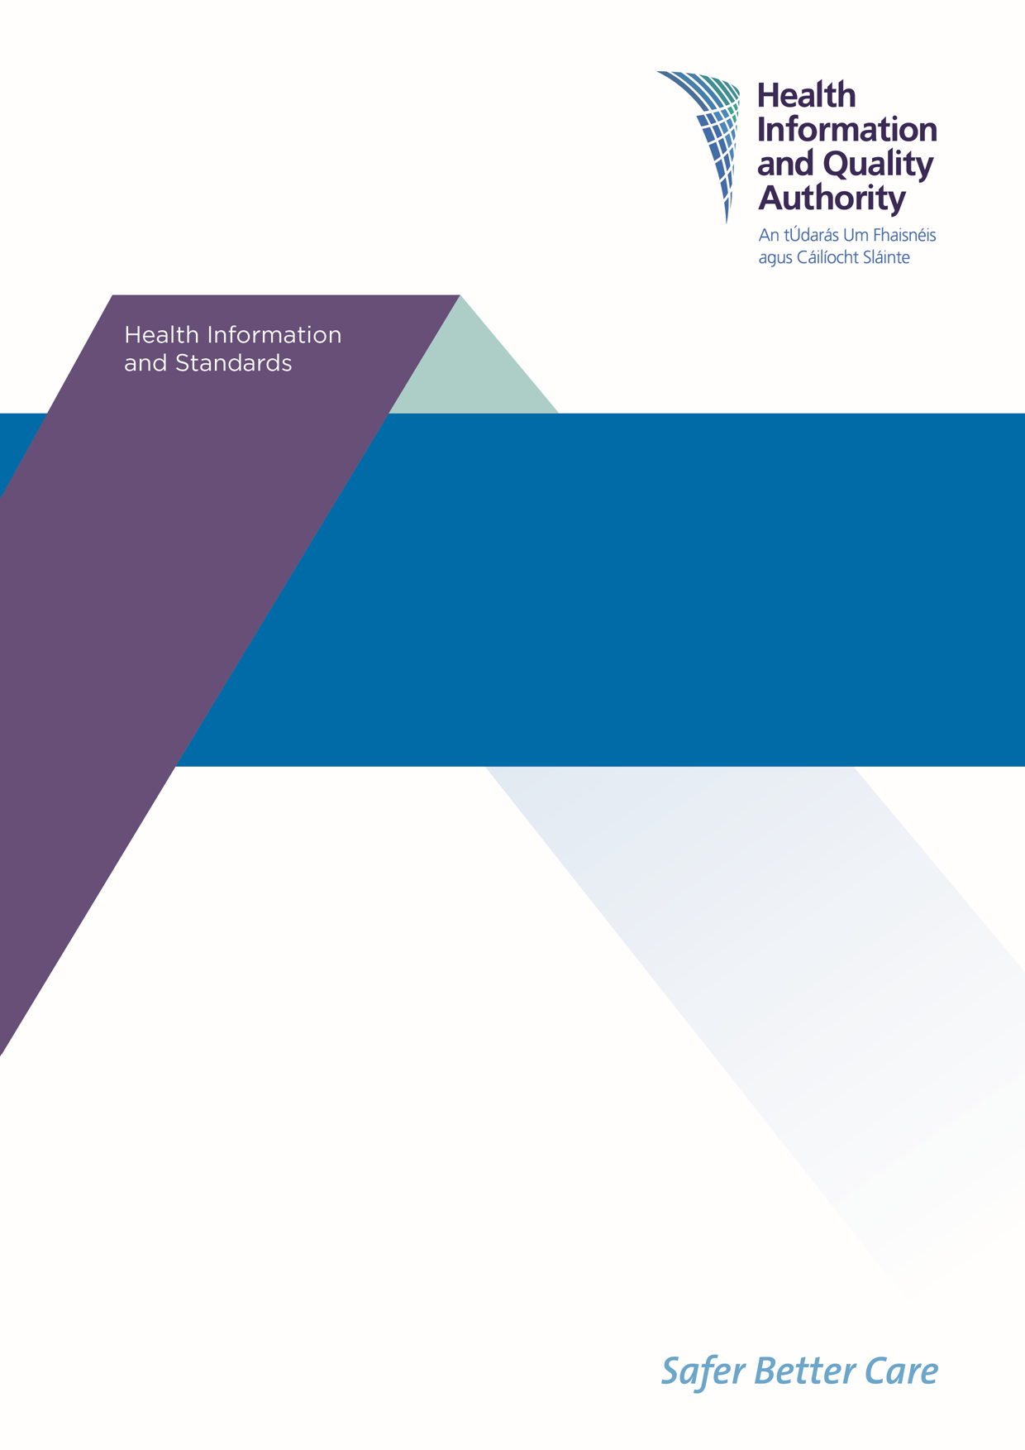

Draft National Standards for Information Management in Health and Social Care
Public Consultation Feedback Form
October 2022

The Health Information and Quality Authority (HIQA) is holding a public consultation to give people an opportunity to provide feedback on the Draft National Standards for Information Management in Health and Social Care (referred to in this document as the draft standards).
Your views are very important to us, and we will carefully assess all feedback received and use it to help develop the final standards which will be submitted to the Minister for Health for approval.
Please note: the focus for this consultation is the content and structure of the draft standards. The final design and layout of the standards will be developed after the public consultation.
We welcome responses to all questions, and there will be an opportunity at the end of the survey to provide any additional general comments.

The feedback from your consultation form will be used to develop the Draft National Standards for Information Management in Health and Social Care, for research purposes and to inform further reports. Any information you provide will be held securely and will not be published, subject to legal requirements under Freedom of Information (FOI) legislation or where you are responding on behalf of an organisation, in which case the name and type of organisation will be published in Summary of Stakeholder Involvement Report.
The closing date for the public consultation is:
5pm, 19th December 2022.

Instructions for submitting feedback
- The draft standards document is available at www.hiqa.ie.
- If you are commenting in a personal capacity, there is no need to provide your name or any other personal information. However, if you would like to be contacted to take part in future stakeholder engagement, there is an option to provide your name and contact number.
- If you are commenting on behalf of an organisation, please combine all feedback from your organisation into one submission. In this case, we will request a name and contact number for a designated representative from your organisation in case we need to verify the authenticity of your contribution.
- When referring to a specific section of the standards document, please include the section and page number that you are commenting on.
- Do not paste other tables into the boxes already provided — type directly into the box as the box expands.
- Please spell out any abbreviations that you use.
You can email or post a completed form to us. You can also complete and submit your feedback on www.hiqa.ie.

Data Protection and Freedom of Information

- HIQA will only collect personal information during this consultation for the purposes of verifying your feedback or where you have indicated that you would like to be contacted to partake in future stakeholder engagement. If you have any concerns regarding your data, please contact HIQA’s Information Governance and Assurance Manager on infogovernance@hiqa.ie.
- Please note that HIQA are subject to the Freedom of Information (FOI) Act and the statutory Code of Practice in relation to FOI. Following the consultation, we will publish a stakeholder involvement report summarising the responses received, which will include the names and types of organisations that submitted feedback to us. For that reason, it would be helpful if you could explain to us if you regard the information you have provided to us as being confidential or commercially sensitive.
- If we receive a request for disclosure of the information under FOI, we will take full account of your explanation, but we cannot give you an assurance that confidentiality can be maintained in all circumstances.

About you

Are you providing feedback as:

☐ an individual
(If you would like to be contacted to participate in future stakeholder engagement, please provide your name and contact number below. Otherwise, please move on to the next question.)
Click here to enter text.

☒ on behalf of an organisation
(If you are responding on behalf of an organisation, please provide your organisation’s name and contact details below for verification purposes.)
National Disability Authority

Are you commenting:

☒ In a professional capacity
(Please use the box below to specify your role in the organisation you currently work for.)
Director

☐ As a member of the public / user of health and social care services
(If you would like to provide any additional details, please share in the box below.)
Click here to enter text.

Your feedback on the draft standards

In this section, we would like to find out what you think of the content of the Draft National Standards for Information Management in Health and Social Care. This section focuses on the three principles, standard statements and features presented in the draft standards. Taken together, the principles, standard statements, and the features provide a common language to describe what good information management practices in health and social care should look like.

The draft national standards are underpinned by three principles:
- A rights-based approach
- Accountability
- Responsiveness.

The questions in this section are not intended in any way to limit your feedback, and other comments relating to the draft national standards are welcome.

Please consider the following questions as part of your review of the draft standards:
- Do you think all important areas have been covered in each standard statement or are there any areas that should be included or excluded?
- Are the features listed sufficient to assist staff working in organisations that process health and social care information?

Please provide your feedback on the standard statements and features set out under Principle 1: A rights-based approach

Feature 1.1.1 refers to the process by which a person can get their personal information from an organisation needing to be "accessible and timely" and refers to the need for information to be provided in formats that can be re-used. However, it doesn't appear to require organisations to provide people with their personal data in an appropriate accessible format. The NDA advises that it would be important that people are asked about what format they wish to receive data in and are offered support where appropriate to understand the data.
Feature 1.2.3 refers to organisations requiring appropriate policies and procedures for sharing information with other 'organisations'. The NDA is aware of service providers who have developed processes and infrastructure to share relevant data with individuals who are involved in providing natural supports or who are part of a person's circle of support. Therefore, the NDA advises that consideration be given to whether Feature 1.2.3 should refer to organisations requiring appropriate policies and procedures for sharing information with other organisations and individuals.
The NDA welcomes Feature 1.3.4's reference to relevant stakeholders being involved in the development of new health and social care information initiatives. The NDA advises that where appropriate disabled persons should be consulted through their representative organisations (Disabled Persons Organisations or DPOs) in order to comply with Articles 4.3 of the UN Convention on the Rights of Persons with Disabilities . Also, for some people involvement will require that appropriate accommodations and supports are built into the design of the consultation process. We note the reference to "co-design of new health information initiatives or systems". The NDA notes that "co-design" is one approach to facilitating participation in the design process but we would suggest that perhaps the method of participation should be linked to the particular context. So for example the method of facilitating participation in a decision around what data to gather may be different to the method used to design a database.
The NDA has recently published guidelines on consulting with people with disabilities which may be useful in relation to the points made above in Feature 1.3.4. https://nda.ie/publications/participation-matters-guidelines-on-implementing-the-obligation-to-meaningfully-engage-with-disabled-people-in-public-decision-making

Please provide your feedback on the standard statements and features set out under Principle 2: Accountability

'Consent' is defined in the terminology section and there are references to consent in the preamble text for Principle 2: Accountability but consent and considerations around consent are not explicitly addressed in any of the Standards or Features. While consent may not be the basis for processing some health and social care data it is likely to be required in certain circumstances (for certain categories of data and certain processing activities). The NDA advises that a Feature related to consent, and in particular relating to those who will require support to consent or who cannot consent, be added to the Features under Principle 2: Accountability.

Please provide your feedback on the standard statements and features set out under Principle 3: Responsiveness

Feature 3.2.1 makes reference to "equity stratifiers". The NDA strongly supports the concept of including markers of inequality in health data to inform health policy and research. We note that in the definition of "equity stratifiers" that disability is not one of the suggested markers. However, we know that disability does have significant inpact on people's health outcomes (for example we note that people with a disability had a standardised death rate more than four times that of those without a disability CSO, 2019, Mortality differentials in Ireland 2016–2017). The NDA advises that futher discussion of and work on equity stratifiers in health data is required and that a health equity stratifier framework would need to be developed in the coming years if the concept is to remain in the Standards.
In this context it may be worth noting that the CSO and Department of Children, Equality, Disability, Integration and Youth are developing a Equality Data Strategy and that work on the health equity stratifiers could potentially link in with that broader Equality Data Strategy.

Are there any other comments or suggestions on the draft standards that you would like to make?

As noted in the preamble to the Draft Standards, Irish healthcare data is very fragmented. In the disability sector the issue of fragmented data collection has been highlighted in a number of reports (Value for Money and Policy Review of Disability Services in Ireland, 2012; Report of the Independent Review Group established to examine the role of voluntary organisations in publicly funded health and personal social services, 2019). The draft Standards provide a valuable guide for organisations to be more strategic about their approach to collecting and processing data through all stages of the information cycle. However, in the absense of more direction from the funder / commissioner of services there remains the risk that while individual organisations will adhere to the Draft Standards the approach by individual organisations to collecting and processing data will remain separate and fragmented. Therefore, there is a question as to whether the Draft Standards should place a greater emphasis (or a more explicit emphasis) on the need for greater alignment between funder / commissioner health / social care information strategy and individual organisation's strategy.

General Feedback

Do you think the language used in the draft standards is clear, easy to follow and easy to understand?

☒ Yes
☐ No

Do you think the content and structure of the draft standards is clear, easy to follow and easy to understand?

☒ Yes
☐ No

Please provide any additional comments on the language, content and structure of the draft standards.

As these Standards apply to both health and social care the use of the term "patient" in certain contexts is inappropriate. The term "patient" is used 23 times in the Draft Standards. Most of those 23 times the context is related to healthcare but there are instances where the term patient is used when it seems to be referring to people who use health and social care services.
The NDA has developed a paper on disability language and terminology which may be useful to your considerations. While the paper will not give you a substitute term for "patient" it does suggest how you may go about adressing such issues through engaging with relevant stakeholders. https://nda.ie/publications/nda-advice-paper-on-disability-language-and-terminology

Having read the draft standards, do you have a better understanding of what good information management looks like for organisations that process health and social care information?

☒ Yes
☐ No

Comments:
Click here to enter text.

If you work in an organisation that processes health and social care information, having read the draft standards, do you intend to make changes to your work practices?

☐ Yes
☐ No

Can you describe what these changes may be?
(If this question is not relevant to you, please move on to the next question.)

Click here to enter text.

What is needed to support the implementation of these standards in the organisation that you work in?
(If this question is not relevant to you, please move on to the next question.)

Click here to enter text.

Are there any other comments that you would like to make about these draft standards?

The Draft Standards don’t mention the Web Accessibility Directive (WAD). While not all information system will be covered by WAD all websites and mobile applications (apps) of public sector bodies are. The National Disability Authority is the monitoring body for the WAD. You can read more about our work on WAD here
https://nda.ie/monitoring/eu-web-accessibility-directive/eu-web-accessibility-directive-monitoring-reports
It should be noted that while at present only the websites and mobile applications (apps) of public sector bodies are being monitored that in time this will need to be expanded to organisations substantially funded by the State and therefore many of the organisations to whom the Draft Standards apply will in time be covered by the WAD.
If you would like to discuss the WAD and the NDA's role in monitoring compliance please feel free to get in touch with me (Ms. Jacinta Byrne - webaccessmonitor@nda.ie).

Thank you for taking the time to give us your views on the Draft National Standards for Information Management in Health and Social Care.

Please return your form to us by email or post.

You can download a consultation feedback form at www.hiqa.ie and then email the completed form to: healthinformation@hiqa.ie

or

Print the consultation feedback from and post the completed form to:

Health Information Quality Team,
Health Information and Quality Authority,
Unit 1301,
City Gate,
Mahon,
Cork
T12 Y2XT

You can also complete an online consultation form at www.hiqa.ie

If you have any questions on this document, you can contact the HIQA Health Information Quality Team by:

Phone: 021 240 9300 or Email: healthinformation@hiqa.ie

Please ensure that you return your form to us by 5pm on 19 December 2022.

