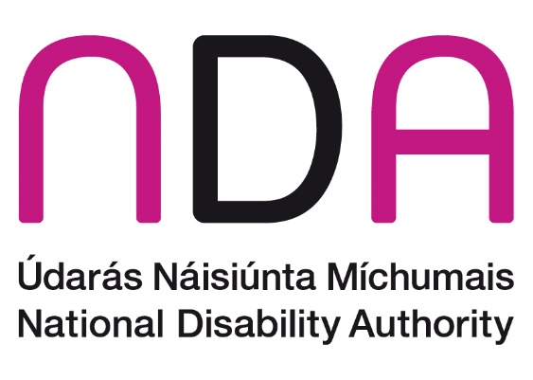

NDA submission to National Transport Authority regarding Public Consultation on Proposals for SPSV Fines for the Non-Compliant - Focus on Safety, Consumer Protection and Services for Users with a Disability

September 2022

Introduction
The National Disability Authority (NDA), as the independent statutory body, provides information and advice to the Government on policy and practice relevant to the lives of persons with disabilities. We have a role to assist the Minister for Children, Equality, Disability, Integration and Youth in the co-ordination of disability policy. We work through our Centre for Excellence in Universal Design to promote the universal design of the built environment, products, services and information and communication technologies so that they can be easily accessed, understood and used by everyone, including persons with disabilities.
The NDA wishes to make a submission with regards to the proposed SPSV ( Taxis, hackneys and limousines) fines for non-compliance proposed by the National Transport Authority (NTA).

Importance of transport for persons with disabilities
The importance of integrated universally designed public transport services is underpinned by Article 9 of the UN Convention on the Rights of Persons with Disabilities. Ireland ratified the UN Convention in 2018. Article 9 states that in order for persons with disabilities to live independently and fully participate in all aspects of life, they need to have access not only to accessible transportation but also to the wider infrastructure, the built environment, information and communication processes and technologies and to other public facilities and services.
Section 6.3 of the National Planning Framework for Project Ireland 2040 also identifies universally designed transport services, in addition to housing, education, and health services, as key areas that need to be developed to facilitate the development and progression of diverse and inclusive communities.

The importance of transport in the lives of persons with disabilities and the necessity for transport services that are accessible to everyone is also highlighted in The Comprehensive Employment Strategy 2015 – 2024; National Disability Inclusion Strategy 2017 – 2021.
Small public service vehicles (SPSVs) form an integral part of the transport infrastructure for everyone, including persons with disabilities. SPSVs offer more flexibility in terms of transport provision and also provide transport to persons who may not be served by public transport routes or are unable to easily access public transport.

Proposed changes to fines for non-compliant SPSVs
As the NTA is aware, despite current requirements and associated fines for non-compliance, persons with disabilities regularly report being refused journeys by SPSV operators. The NDA therefore welcomes recognition by the NTA in the public consultation report of the greater protection needed for SPSV passengers with a disability and the associated proposals of increased fines for SPSV operators who refuse to carry passengers with disabilities, in particular those who travel with guide/assistance dogs and wheelchair users. The NDA would support the maximum fine (€250) now being imposed on these grounds, the NDA is particularly supportive of the increase from €80 in the case of refusal to carry passengers with guide/assistance dogs.
The NDA notes as well that a lack of accessible taxis has been highlighted as a real issue and a barrier to transport for persons with disabilities. The NDA notes that there has been an increase in the wheelchair accessible taxi fleet (from 4% in 2014 to 17.4% in 2022) , however this is still a low percentage of the total fleet. Increased fines and enforcement will address some accessibility barriers, sufficient availability of accessible taxis is key to ensuring wide access for all.
The NDA also advises that clear and universally designed communication on this matter is key, as it is important that all passengers, in particular older people and passengers with disabilities are informed of their rights, and about complaints and enforcement mechanisms. In particular, it is vital that complaints mechanisms are accessible. The NDA recognises that efforts have been taken to reach out to disability groups by the NTA as part of this consultation, however, the NDA notes that on the consultations website there is no clear method to request available documentation in any alternative formats other than those available on the website. The NDA Code of Practice on Accessibility of Public Services and Information provided by Public Bodies states that public bodies should have a procedure in place for processing requests for accessible formats that may be provided as far as practicable including providing for a dialogue with the customer in order to ensure that they are compliant with Section 28 of the Disability Act, 2005. The NDA also notes that only written submissions are being considered. The NDA would advise that channels should be provided which allow for spoken comments and submissions to be taken in addition to the written channels available. The NDA would suggest consultation with our newly published guidelines Participation Matters: Guidelines on implementing the obligation to meaningfully engage with disabled people in public decision making which provides context on the requirements for engaging with Disabled Persons Organisations (DPOs), the importance of engagement with DPOs and how to gain meaningful engagement and input from engagement with DPOs and persons with disabilities.
All information (written, spoken, signed and digital) delivered by a public transport services provider (which includes consultation information), should be universally designed. The NDA suggests that the NTA should use the Customer Communications Toolkit for the Public Service - A Universal Design Approach which will help to produce universally designed written, verbal and digital communications that can be easily accessed, understood and used by everyone.

Conclusion
Transport plays a crucial role in empowering people with disabilities to participate in everyday life and the activities of their communities. Approximately one in ten people with disabilities said that inadequate/inaccessible transport systems prevented them from participating in social events. About one in six people with a disability are not in work who would be interested in a job, cite transport or parking as an issue for them. Those with sight, mobility or intellectual disabilities are most likely to cite transport as an issue for employment.
In this context therefore, the NDA advises that the proposed increase in fines is adopted and that universally designed communications publicise this change to operators and the general public. The NDA also advises the need for disability awareness training for providers of transport services for the public, it is vital that those who are providing services to persons with disabilities are trained on communicating and interacting with persons with disabilities.
The NDA is happy to meet with the NTA to discuss this submission.

Scheme 2040 is the Government’s long-term strategy to make Ireland a better country for all of its people by investing in its public infrastructure.
https://www.thejournal.ie/lift-out-pt1-5502428-Aug2021/
https://www.thejournal.ie/lift-out-pt1-5502428-Aug2021/
DoT accessibility Work Programme 01 March to 25 May 2022
National Disability Survey (2006) Vol. 2, Table 7.30
National Disability Survey (2006) Vol. 2, Table 7.30

