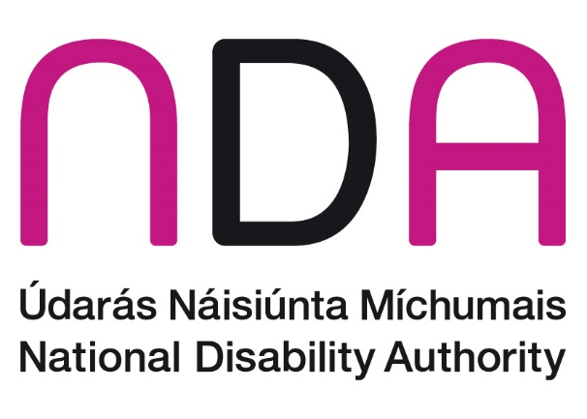
31st May 2023

NDA Submission to the Department of Enterprise, Trade and Employment on proposals to enhance the Companies Act 2014

Introduction
The National Disability Authority (NDA) is the independent statutory body with a duty to provide information and advice to the Government on policy and practice relevant to the lives of persons with disabilities, and to promote Universal Design. The NDA welcomes the opportunity to make a submission on proposals to enhance the Companies Act 2014. We have responded to one of the four consultation questions outlined by the Department in relation to Corporate Governance, and have included an additional point in relation to alignment of the Companies Act 2014 with the UN Convention on the Rights of Persons with Disabilities.

Corporate Governance
The NDA supports the suggestion to include provisions in the Act which would allow for the holding of virtual and hybrid meetings by establishing the temporary provisions introduced in the Companies (Miscellaneous Provisions) (Covid-19) Act 2020 in response to the COVID-19 pandemic on a permanent basis. An NDA report, ‘Lockdowns Unlock Innovations” found that changes to a hybrid model of working, where there is a mix of physical attendance and remote working enabled by digital connectivity can remove some of the barriers to entry and retention in the workplace for persons with disabilities. The opportunity provided by remote or hybrid working should therefore be considered as a key element of supporting disability inclusion through enhancements to the Companies Act 2014.

Other considerations

Alignment of the Companies Act 2014 with Article 29 of the UN Convention on the Rights of Persons with Disabilities
Ireland ratified the UN Convention on the Rights of Persons with Disabilities (UNCRPD) in March 2018. The UNCRPD provides the framework to promote, protect and ensure the rights of all persons with disabilities and promotes equal rights in all areas of life.
Article 29 of the UNCRPD, ‘Participation in political and public life’, outlines that States Parties shall undertake to promote actively an environment in which persons with disabilities can effectively and fully participate in the conduct of public affairs, without discrimination and on an equal basis with others, and encourage their participation in public affairs, including participation in non-governmental organizations and associations concerned with the public and political life of the country.
The Department of Justice published its ‘Roadmap to Ratification’ in 2019 which set out the legislative measures needed to meet the requirements of UNCRPD upon ratification. The Roadmap outlines a recommendation to amend section 188.4 (a) and (c) of the Companies Act 2014 to remove references to “unsound mind”. The report stated that an amendment of the Companies Act would be undertaken by the Department of Jobs, Enterprise and Innovation in the Accounting Bill 2015, with enactment of same intended by end of 2015. However, this amendment did not take place and the references to “unsound mind” remain within the Act. We therefore recommend that amendments are made to sections 188.4 (a) and (c) as a matter of priority and that language in line with the terminology progressed in the Assisted Decision-Making (Capacity) Act 2022 is inserted in place of the term “unsound mind”.
The Department may also be interested in reading the NDA’s paper on Disability Language and Terminology.

Conclusion
The NDA welcomes the consultation on the Companies Act 2014. We are happy to advise further on any of the issues raised in this submission.

gov.ie - Public consultation on proposals to enhance the Companies Act 2014 (www.gov.ie)
NDA (2021) “Lockdowns Unlock Innovations”
UNCRPD, Article 29 ‘Participation in public and political life’.

