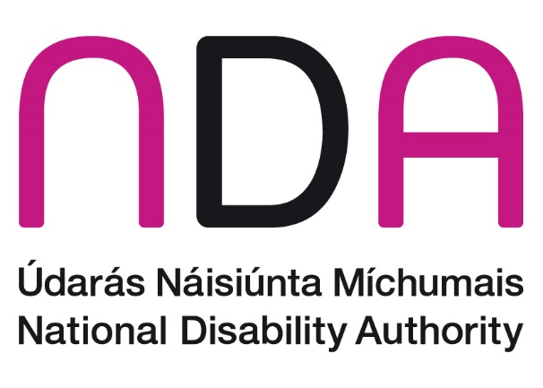

**July 2024**

NDA Submission to the Department of Children, Equality, Disability, Integration and Youth on the successor to the National LGBTI+ Inclusion Strategy

# Introduction

The National Disability Authority (NDA) is the independent statutory body with a duty to provide information and advice to the Government on policy and practice relevant to the lives of persons with disabilities, and to promote Universal Design. The NDA welcomes the opportunity to input on the Department of Children, Equality, Disability, Integration and Youth’s public consultation on the successor to the National LGBTI+ Inclusion Strategy.

# Theme 4 – Treated Equally

## What is working well?

People with disabilities comprise a large group in Ireland, with almost 22% of the population reporting that they have some form of disability in Census 2022. This group is not a homogenous one, with disabled people reflecting the diversity of Irish society in terms of sexual orientations, gender identities and sexual characteristics. However, the duality of these identities – as LGBTI+ and disabled – can result in unique challenges and barriers.

Recognising and responding to the specific difficulties experienced by LGBTI+ disabled people requires a joined up, coordinated and intersectional approach. This point is echoed in a recent study by the Centre for Effective Services, which evaluated the implementation of three national equality strategies, finding that the development and implementation of equality policies would not be complete without adequate responses to intersectional discrimination and inequality.

The NDA welcomed the references to the intersectionality of people with disabilities and diverse sexual orientation and gender identity within both the previous LGBTI+ and disability inclusion strategies. Action 13 of the previous National LGBTI+ Inclusion Strategy 2019-2021 committed to providing supports to those at higher risk of multiple discrimination and double marginalisation including people with disabilities. In this regard, the Department of Children, Equality, Disability, Integration and Youth (DCEDIY) (and formerly the Department of Justice and Equality) undertook to ‘design and implement programmes and measures to address intersectional discrimination in partnership with NGOs and target communities’.

Similarly, Action 125 of the National Disability Strategy 2017-2022, as revised following the 2020 mid-term review, committed to developing links with other equality strategies aimed at identifying intersectional issues for people with disabilities relating to, *inter alia*, their gender identity or sexual orientation.

## What needs to improve change?

The actions designed to address intersectional discrimination were not meaningfully advanced during the lifetime of the previous LGBTI+ and disability inclusion strategies. The NDA therefore advises that the successor to the National LGBTI+ Inclusion Strategy identify specific and tailored actions to address intersectional issues experienced by LGBTI+ persons, including LGBTI+ persons with disabilities. The NDA further recommends that there is alignment between the new LGBTI+ strategy and the forthcoming National Disability Strategy.

## Are there any specific gaps?

The NDA has assisted DCEDIY with the development of a new National Disability Strategy by undertaking a comprehensive public consultation initiative. The public consultation was broad and wide-ranging, including focus groups with disabled LGBTI+ persons.

Some of the concerns highlighted by LGBTI+ persons with disabilities included:

* Multiple or intersectional discrimination experienced by LGBTI+ people with disabilities
* Challenges connected to accessibility, discrimination, and understanding when accessing healthcare
* Dearth of mental health supports, particularly for trans people, with some having to obtain care abroad
* Lack of inclusive sex education, which predominantly focuses on heterosexual and non-disabled experiences
* Paucity of accessible LGBTI+ community spaces, lack of inclusive activities by LGBTI+ community groups and a lack of social groups for disabled LGBTI+ people over 35 years old living outside of Dublin

Disabled LGBTI+ persons recommended the following actions to address some of these challenges:

* Recognise the unique mental health challenges faced by disabled LGBTI+ individuals and prioritise mental health supports for them, particularly for the trans community
* Allocate resources for the provision of targeted mental health support services that address the intersectionality of disability and LGBTI+ identity, such as counselling services, peer support groups, and awareness campaigns
* Provide training to healthcare staff on LGBTI+ and intersectional issues
* Deliver inclusive sex education in schools that centres on lived experience and includes discussions around consent and ways of making intimacy and sex accessible to all
* Provide funding to make LGBTI+ resource centres and community spaces accessible
* Provide appropriate training and resources to counter violence, abuse and bullying against LGBTI+ disabled people, including anti-homophobia training to professionals in care settings

## What three priority actions would you like to see progressed under this theme?

### Tailored actions to address intersectional issues and meet UNCRPD and international human rights law requirements

The NDA advises that the successor to the National LGBTI+ Inclusion Strategy identify specific and tailored actions to address intersectional issues experienced by LGBTI+ persons, including LGBTI+ persons with disabilities. Some of the recommendations received from disabled LGBTI+ persons during the consultation on the new National Disability Strategy are detailed under the “Are there any specific gaps?” heading above.

Separately, the NDA wishes to draw the Department’s attention to requirements under the UN Convention on the Rights of Persons with Disabilities and international human rights law. The UN Committee on the Rights of Persons with Disabilities regularly highlights the discrimination experienced by disabled LGBTI+ persons in its Concluding Observations, recommending action such as broadening equality legislation to recognise multiple and intersectional discrimination.

Additionally, in 2023, the UN Independent Expert on Protection Against Violence and Discrimination Based on Sexual Orientation and Gender Identity, and the UN Special Rapporteur on the Rights of Persons with Disabilities issued a statement on ‘LGBT Persons with Disabilities’.[1] The statement highlighted challenges experienced by LGBTI+ persons, including violence, unnecessary medical interventions and lack of supports for intimate relationships and sexual health.

### Mental health and wellbeing

In early 2023, the NDA published the results of the **Wellbeing and Social Inclusion Survey of 2022**. The objective of the survey was to explore whether disabled people feel that they belong and feel valued and respected in their communities and to determine how they evaluate their own sense of wellbeing. It also sought to assess how a combination of marginal identities affects wellbeing and social inclusion. The findings indicate that disabled people experience poorer mental wellbeing and social inclusion compared to non-disabled people. The findings further highlight that identifying as a member of more than one marginalised group, such as being disabled and a member of the LGBTQI+ community, increases the risk of social exclusion and poorer wellbeing.

Additionally, the NDA welcomes the recent publication of the **‘Being LGBTQI+ in Ireland’** study by Belong To and Trinity College Dublin School of Nursing and Midwifery. Key findings from the study indicate that mental health and wellbeing amongst the LGBTI+ population have declined since 2016, with significant challenges experienced by younger age groups and the transgender and gender non-conforming communities. The NDA advises that the provision of mental health supports for LGBTI+ persons be prioritised in the new strategy.

### Consultation, data and research

The NDA is aware that the Department is undertaking a series of targeted focus group discussions to ensure that the voices of more marginalised members of the LGBTI+ community are adequately heard in the strategy consultation process. We advise that these targeted focus groups should include engagement with disabled LGBTI+ persons and there should be proactive consultation with people with disabilities, through their representative organisations. Disabled people should also have a role in the implementation and monitoring of the strategy.

Furthermore, participants in the recent consultation on the new National Disability Strategy drew attention to the lack of data on the intersection between disability and LGBTI+ persons. The NDA recommends that this issue be afforded adequate attention in the new strategy, with data key to evidence informed policymaking. In addition, the NDA understands that Belong To and Trinity College Dublin will soon publish a study on disability in the LGBTI+ population, and we hope that the findings of this report will also inform the development of the new strategy.

1. The statement is available at the following link: <https://www.ohchr.org/en/press-releases/2023/10/un-experts-issue-guidance-relation-lgbt-persons-living-disabilities>