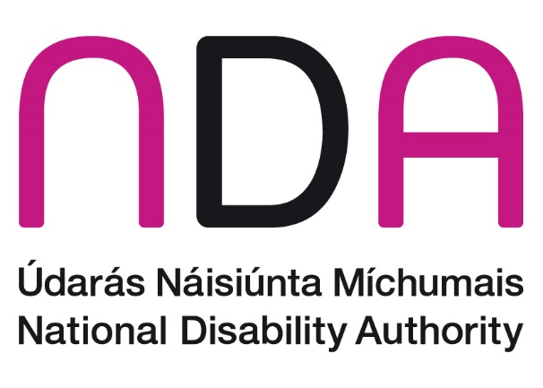
April 2023

NDA Submission to the Housing Commission Public Consultation
The National Disability Authority (NDA) has answered selected questions in line with our competency areas.

1. In your opinion, what can the Government do to improve the supply of housing as to better meet the needs of first-time buyers, existing owner-occupiers and renters?
Given the significant shortage of appropriate housing options for disabled and older persons, as well as Ireland’s longer term demographic trend towards an older population, there is a societal need for UD Homes.
The Government could improve supply by providing grants and other financial incentives to support the delivery of Universal Design (UD) Homes. Providing financial supports to drive the delivery of UD Homes could result in savings in areas such as home adaptation, residential care and health services costs. In addition, such supports would be beneficial to the construction industry by absorbing some or all of the cost uplift associated with building UD Homes.
As UD Homes provide enhanced accessibility, their construction can result in significant benefits ranging from improved quality of life outcomes for dwellers and the avoidance of some costs which would arise in the absence of such housing. UD Homes allow older persons to live in their home and age in place, this can result in cost savings by avoiding the need for long-term residential care.
The Croí Cónaithe grant scheme provides a useful template for State intervention to incentivise appropriate design and planning outcomes while addressing viability concerns. A similar grant scheme to incentivise the construction of UD Homes, or the inclusion of UD Home design as a qualifying criteria within the Croí Cónaithe scheme, would be an effective means of driving the delivery of UD Homes while addressing viability concerns. By resulting in potential cost savings in later years, the Exchequer funding allocated to subsidise the construction of UD Homes could be a cost-effective intervention in the longer-term while also resulting in maintaining independence for disabled and older persons. As the construction industry is experiencing significant sectoral inflation, the case for a State intervention to ensure viability is strong.

2. In your opinion, what measures interventions are needed to improve the affordability of private rental accommodation?
N/A

3. In your opinion, what measures / interventions are needed to improve the affordability of housing for first-time buyers?
N/A

4. In your opinion, what is required to address the costs of construction of housing in order to improve the affordability of housing in the longer term?
N/A

5. In your opinion, what changes to building standards and regulations, if any, are required to address the quality of housing?
Part M of the building regulations sets out the minimum requirements for housing design, which is that new dwellings are visitable by disabled people. As most housing is built to the minimum requirements, this means that there is a lack of accessible housing, that disabled people can live in, in Ireland.
Part M was last revised in 2010. The NDA has advised that Part M should be reviewed, with priority given to a review of Part M for Dwellings, to ensure that new homes are required to be liveable by all people, including disabled people and older people, to enable ageing in place and to provide for persons using a wide variety of mobility aids, including power wheelchairs.

6. In your opinion, what actions can be taken to increase capacity in the construction sector to better meet the increasing demand for housing?
The NDA has advised the Department of Housing, Local Government and Heritage to consider the introduction of incentives for the provision of Universal Design Homes. These include:
- Universal Design mortgages for new homes where more favourable terms could be offered when Universal Design features are included in new homes
- a time-limited VAT reduction in order to encourage builders to build Universal Design Homes
- extending the existing practice of waivers from local authority development contributions to developments – or part of developments – that are planned, designed and built following a Universal Design approach
The Norwegian State Housing Bank (NSHB) is working towards increasing the amount of housing using a Universal Design approach. This work is based on Norwegian government policy set out in Norway universally designed by 2025. The NDA suggests that rather than creating a specific bank, there are existing institutions that could be used for a similar purpose in Ireland.
NDA advises that homes that are to be planned, designed and built following a Universal Design approach could be prioritised for investment by Home Building Finance Ireland as an incentive for builders/developers. In addition, there may be resources available via the Land Development Agency that could attract Universal Design planning, design and building criteria as conditions for funding.
The Housing Finance Agency already lends to Approved Housing Bodies, who are themselves now regulated by the Approved Housing Bodies Regulatory Authority.
Finally there may also be surplus monies to be tapped from the profits that NAMA has made managing its various portfolios. As NAMA is due to be wound down would there be scope for a Dormant Accounts-style block of funding that could be made available for Universal Design homes.

7. In your opinion, what measures / interventions are needed for the development of rural housing, including one-off housing (a house built outside of a town / village that is not part of a group of houses / estate), in an environmentally and socially sustainable manner?
N/A

8. In your opinion, what measures, if any, are needed in order to regulate local authority provided social housing in Ireland?
It is critically important that a share of local authority provided social housing is built in accordance with UD principles, with particular emphasis on developing homes that are liveable for persons with disabilities and older persons.
The 2019 inter-Departmental policy statement Housing Options for our Ageing Population outlines a range of actions, including the aim that within five years 30% of new builds in Ireland should incorporate UD principles to accommodate Ireland’s ageing population. On foot of this document, the NDA is in the process of developing an economic and social evaluation of UD homes through the performance of a Cost Benefit Analysis in accordance with the Public Spending Code. We would advise local authorities, where practicable, to gradually work towards this target. The delivery of UD Homes should be coordinated at a national level, and the delivery and monitoring of same should be formalised and standardised.
At present, many personnel working in local authorities may not be fully clear on the various features and technical specifications associated with UD Homes. The NDA published Universal Design Guidelines for Homes in Ireland in 2015. The Irish Green Building Council’s Home Performance Index also includes content on UD Homes.
The NDA has now commenced work with the National Standards Authority of Ireland on the development of an Irish standard for Universal Design Dwellings, to support delivery in both the public and private sectors.

9. What do you believe is the optimum role of Approved Housing Bodies (AHBs), including their role regarding the housing needs of vulnerable groups? AHBs are independent, not-for-profit organisations that provide affordable rented housing for people who cannot afford to pay private sector rents or buy their own homes (examples of AHBs include Clúid, Respond and Threshold).
Approved Housing Bodies (AHBs) are already the leading sector in the building industry for providing Universal Design homes for disabled and older people. They should be incentivised to increase the amount of these homes that they could be reasonably expected to build.
The financial measures that AHBs use to fund their projects e.g. CAS and CALF, need to be more dynamic and responsive to their needs.
No group in society is inherently vulnerable, but they can be placed in situations of vulnerability. It’s important not to depict disabled or older people as inherently vulnerable.
People with disabilities become vulnerable because of the disabling barriers in society, rather than because of an individual’s ‘impairment’. This approach shifts the perspective from paternalism and protection towards empowerment and the recognition of disabled people as rights-holders. We advise against the use of vulnerable as blanket term as it does not align with the new approach to capacity adopted in the Assisted Decision-Making (Capacity) Act 2015 and the new Assisted Decision-Making (Capacity) (Amendment) Act 2022.
Disabled people are not a homogenous group and may choose to identify in various ways. Disabled Persons Organisations (DPOs) are the organisations best placed to advise about the most up to date language. The views of some DPOs may differ from others. A flexible approach which is respectful to all can be adopted. The NDA recognises both ‘person with a disability’ and ‘disabled person’ as valid and legitimate terms. The NDA paper on Disability Language and Terminology expands on this issue.
The NDA has recently published Participation Matters: Guidelines on implementing the obligation to meaningfully engage with disabled people in public decision making. These guidelines support officials to take a Universal Design approach to all public consultation and participation processes so that disabled people can participate on an equal basis with others.

https://www.gov.ie/en/consultation/7d325-the-housing-commission-public-consultation/
https://www.regjeringen.no/globalassets/upload/bld/nedsatt-funksjonsevne/norway-universally-designed-by-2025-web.pdf
https://www.gov.ie/pdf/?file=https://assets.gov.ie/9398/ca553fa753b64f14b20e4a8dcf9a46ab.pdf#page=null

