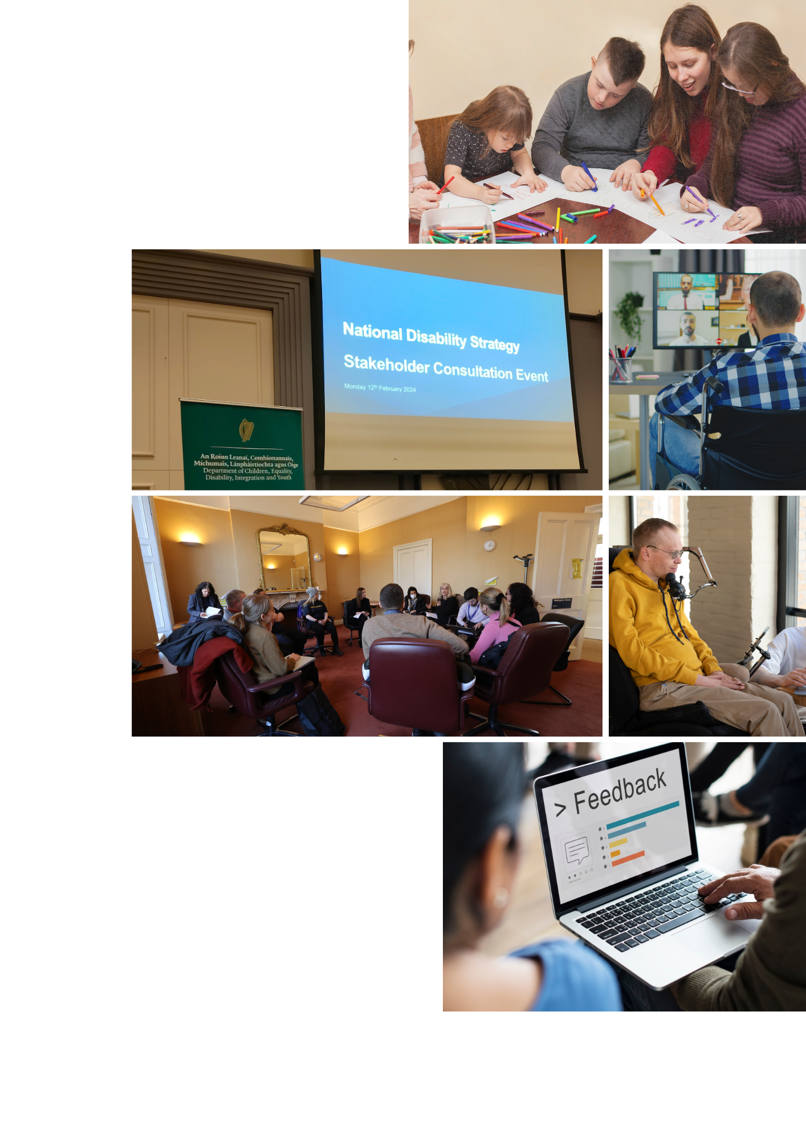Report Title

Report on the public consultation for the National Disability Strategy – Executive summary

May 2024

Report on the public consultation for the National Disability Strategy – Executive summary

**May 2024**

Cover images (Top to bottom, L-R): Images 1, 3, 5 and 6 via Freepik; Image 2 and 4 via National Disability Authority.

Table of contents

Statement on language 5

Executive summary 6

ES1 - Introduction 6

ES2 - Methodology 6

ES3 - Survey findings on quality of life and disability awareness 7

ES4 - Feedback on strategy development, implementation, and monitoring 8

ES4.1 Stakeholder engagement 8

ES4.2 Strategy development 8

ES4.3 Strategy implementation, monitoring, oversight, and accountability 9

ES5 - Challenges and proposed solutions 10

ES5.1 - ‘Nothing About Us, Without Us’ 10

ES5.2 - Awareness, attitudes, and discrimination 11

ES5.3 - Accessibility 11

ES5.4 - Health and social care services 12

ES5.5 - Independent living 13

ES5.6 - Housing 13

ES5.7 - Education and training 14

ES5.8 - Employment 15

ES5.9 - Financial independence and security 15

ES5.10 - Transport and mobility 16

ES5.11- Culture, recreation, leisure, and sport 16

ES5.12 - The justice system 17

ES5.13 - Abuse and violence 17

ES5.14 - UNCRPD implementation and disability legislation 18

ES5.15 - Data and research 18

ES5.16 - Climate justice, situations of risk and humanitarian emergencies 18

ES5.17 - International co-operation 18

ES6 - Caring for and supporting people with disabilities 18

ES7 - Conclusion 19

Statement on language

In this report, we use the terms ‘people/persons with disabilities’ and ‘disabled people’ interchangeably. Many people within the disability rights movement in Ireland prefer the term ‘disabled people’ because it is considered to acknowledge the fact that people with an impairment are disabled by barriers in the environment and society and therefore aligns with the social and human rights model of disability. However, we also recognise that others prefer the term ‘people/persons with disabilities’, because of the inherent understanding in the term that they are first and foremost human beings entitled to human rights and this reflects the language used in the United Nations Conventions on the Rights of Persons with Disabilities (UNCRPD). We recognise that many people with an intellectual disability, people with a mental health difficulty or psycho-social disability prefer person-first language. We also acknowledge that some people do not identify with either term.

In this report, the term ‘Deaf’ with an uppercase ‘d’ is used when referring to those who are Deaf or hard-of-hearing who identify culturally and linguistically as part of the Deaf community and who use Irish Sign Language as their first or preferred language. A lower case ‘d’ is used to refer to those who are deaf or hard-of-hearing and who do not identify culturally and linguistically as a member of the Deaf community. The term ‘d/Deaf’ is used to refer to both groups.

The term Disabled Persons’ Organisation (DPO) is used in this report, but we acknowledge that some DPOs may prefer the term Disabled Persons’ Representative Organisation (DPRO).

For further information on disability-related language and terminology, please refer to the NDA’s [Advice Paper on Disability Language and Terminology](https://nda.ie/publications/nda-advice-paper-on-disability-language-and-terminology) on nda.ie.

Executive summary

# ES1 - Introduction

This report presents the findings from the public consultation for the new National Disability Strategy which took place from November 2023 to February 2024. The Department of Children, Equality, Disability, Integration and Youth (DCEDIY) requested support from the National Disability Authority (NDA) to carry out a comprehensive public consultation to inform the new strategy. The National Disability Strategy is the successor strategy to the National Disability Inclusion Strategy 2017-2022.

Ireland ratified the UN Convention on the Rights of Persons with Disabilities (UNCRPD) in 2018, committing to promote the human rights of all disabled people in Ireland. The new National Disability Strategy will seek to provide a blueprint for further realisation of the UNCRPD. In line with the ethos of the UNCRPD, the consultation focused on identifying actions and solutions to address challenges and barriers to participation in society faced by disabled people.

Throughout the course of the consultation, the NDA regularly shared emerging findings with DCEDIY to help inform the ongoing development, approach and content of the new National Disability Strategy.

# ES2 - Methodology

The consultation was underpinned by principles of participation and aimed to be a genuine, accessible, and transparent process which meaningfully engaged with disabled people. During the consultation the NDA and DCEDIY proactively sought and gave due consideration and priority to the opinions and views of DPOs. Specific DPO contributions are noted in this report for easy identification and consideration by policy makers as part of the strategy development process.[1] Issues and areas identified as key priorities by DPOs and other disability stakeholders during engagements with DCEDIY in 2023 were used to inform, facilitate, and guide the consultation questions.

In addition to DPOs, people with disabilities and other disability stakeholders including families, parents, carers, and disability organisations were targeted and actively encouraged to participate in the consultation. Marginalised and seldom heard-from groups, such as disabled children and people with significant support needs were specifically included. Acknowledging the intersectionality of disability with other identities[2], women, migrants, Travellers, and members of the LGBTQI+ community were specifically targeted for consultation. A range of consultation activities were organised to allow different stakeholders choice in how they could engage. Consultation events were held at various times of the day, and during weekdays and the weekend.

Disability stakeholders engaged in consultation activities including:

* 34 focus group discussions involving 211 participants,
* 18 interviews with disabled individuals,
* Four large consultation meetings in Dublin, Cork, Galway, and online, including 166 attendees,
* 81 written and 4 video submissions from DPOs, disability organisations, individuals, and other interest groups,
* A national survey completed by 484 disabled people or carers, family members and supporters of people with disabilities.

Qualitative and quantitative data were collected across consultation activities. Data were analysed to identify the challenges, barriers, actions, and solutions raised by consultation participants.

# ES3 - Survey findings on quality of life and disability awareness

The consultation survey aimed to identify the issues most important to disabled people’s quality of life and to explore how people with disabilities feel they are treated. The three issues rated as important to their quality of life by the highest proportion of respondents were:

* getting health or social care services and supports,
* having enough money to cover the extra costs related to their disability,
* being able to get and use public or private transportation easily.

Respondents reported that family and friends were the groups most likely to be reported as having enough disability awareness, whereas the general public were reported as least likely to have enough disability awareness. Of concern is that 62% of disabled survey respondents felt that health and social care staff were not aware enough of their disability. In addition, people providing public services such as social protection, local authority, and public transport staff were most likely to be identified as treating people negatively because of their disability.

There was general alignment between the issues most commonly rated as important to disabled people’s quality of life by survey respondents and the frequency with which these issues were raised across other consultation activities. The survey findings indicate that there is a need for impactful, widespread awareness raising campaigns on disability, as well as targeted disability competence training for public service staff, employers, and health and social care staff.

# ES4 - Feedback on strategy development, implementation, and monitoring

Consultation participants provided a wealth of feedback and recommendations about ongoing stakeholder engagement in the strategy, as well as strategy development, implementation, and monitoring.

## ES4.1 Stakeholder engagement

Participants suggested that the strategy needs:

* to put disabled people and DPOs at the centre of any engagement structure or monitoring structure from the beginning,
* accessible information and communication regarding engagement,
* regular, genuine, and transparent engagement between government departments and disabled people throughout the lifetime of the strategy,
* to support and build the capacity of people with disabilities to engage,
* a flexible, proactive and grassroots approach to engagement.

## ES4.2 Strategy development

### Strategy vision

Participants emphasised that the vision of the strategy should be underpinned by a social model orientation and human rights approach, should use active language and Plain English, and should not rely on what some felt were ‘buzzwords’ like ‘inclusion’ and ‘diversity’. There was a sense that these terms can be used as a ‘catch-all’ without any clarity as to what they translate to in reality, and that they are used so often they may have lost some of their original meaning and power.

### Values underpinning the strategy

Participants called for the strategy to be underpinned by the values of respect, dignity, collective empowerment, collaboration, innovation, accountability, empathy, affirmation, autonomy, sustainability, flexibility, belonging and inclusion.

### Principles underpinning the strategy

They felt that the strategy should retain the principles from the UNCRPD (Article 3) to demonstrate a commitment to the UNCRPD framework. In addition to considering the merits of these principles, they felt the strategy should also be underpinned by principles of ‘Nothing About Us, Without Us’ and Accountability.

### Pillars of the strategy

Participants were asked whether they felt the following five original draft pillars of the strategy were appropriate:

* employment and anti-poverty,
* transport and mobility,
* independent living in the community,
* wellbeing and social care services,
* education and training.

In response, consultation participants:

* Expressed a preference for placing the disabled person at the centre of the pillars, rather than designing the pillars around the structure of government departments;
* Generally felt that ‘employment and anti-poverty’ should be separated into two pillars particularly as a person could be employed and living in poverty;
* Were confused as to what the ‘independent living in the community’ pillar would include;
* Raised concerns regarding the wording of ‘wellbeing and social care services’, in particular the paternalistic connotations of the word ‘care’;
* Queried where issues they deemed important, such as health, mental health, and housing would sit; and
* Queried where cross-cutting issues would sit within the original draft pillars, such as accessibility, communication, disability equality training, human rights, and Universal Design.

## ES4.3 Strategy implementation, monitoring, oversight, and accountability

Participants expressed disappointment at the implementation of previous national strategies, which they felt had over-promised and under-delivered, and for which there was a perceived lack of transparency and accountability. To counter this for the National Disability Strategy, participants called for:

* A whole-of-government approach to strategy development and delivery;
* A focused list of measurable and achievable actions, with clear timelines and ownership;
* Prioritisation of actions to be determined by disabled people;
* A sustained focus on implementation;
* Realistic targets and defined indicators of progress;
* Strategy alignment with other relevant strategies and policies;
* Appropriate monitoring and oversight mechanisms which involve disabled people; and
* High-level accountability where implementation stalls.

# ES5 - Challenges and proposed solutions

Across all the consultation activities, consultation participants discussed challenges that disabled people face in society, and proposed actions and solutions to address these challenges. The following is a summary of the main challenges and key actions proposed by participants in a number of topic areas. Please note the full report covers these challenges and their related proposed actions in greater detail.

## ES5.1 - ‘Nothing About Us, Without Us’

Participants called for disabled people and their representative organisations to have more control in the decisions that affect their lives. They raised challenges including limited funding and resourcing to facilitate DPO involvement in decision-making processes, and that not all disabled people can self-advocate or have access to appropriately resourced DPOs to promote their interests. Linked to these issues, there were calls to address barriers for people with disabilities in political life.

Key proposed actions and solutions to address challenges include:

* Build DPO capacity by supporting and funding DPOs;
* Establish DPOs for people with more significant support needs and for children with disabilities;
* Prioritise and distinguish views of DPOs (over non-DPOs) through creating a DPO register;
* Include DPOs in the consultative process from the outset of any new policies being introduced in Ireland;
* Ensure transparency from government departments about how consultations impact their decision-making processes; and
* Ensure all government departments have disability representation.

## ES5.2 - Awareness, attitudes, and discrimination

Many participants spoke of their experiences of prejudiced attitudes and discrimination and how this can have a profound negative impact on the well-being of disabled people. They explained how these attitudes arise from lack of visibility and understanding of disability in society and how particular disability experiences are being omitted from awareness campaigns.

Key proposed actions and solutions to address these challenges include:

* Actively tackle inadequate disability awareness and ableism through public awareness campaigns;
* Deliver disability equality training to anyone delivering mainstream and disability-specific services to disabled people;
* Promote the visibility of disabled people in public life and in communities;
* Deliver disability equality training to children and young people in schools; and
* Ensure positive representation of disabled people on radio, television, podcasts, and in newspapers that challenges stereotypes, guarding against ‘pity’ narratives and ‘toxic positivity’.

## ES5.3 - Accessibility

The importance of accessibility for equality, realisation of rights, independence, community participation, and belonging were emphasised. Participants cautioned against narrow understandings of ‘access’, and advocated for a holistic approach that addresses not only physical barriers but also communication, information, and digital access barriers. They also referred to the critical importance of assistive technology (AT) in facilitating their access to education, employment, and independent living. AT was characterised as a human right and a precondition for community participation, supporting communication, rehabilitation, independence, and improved quality of life.

Key proposed actions and solutions to address these challenges include:

* Make all public buildings accessible (to people with physical, sensory and psychosocial disabilities), regardless of cost;
* Fund businesses and community groups to make premises accessible;
* Develop accessible cities, towns and villages, and a focus on accessibility in rural areas;
* Create more accessible public toilets and increase availability of Changing Places toilets;
* Clear paths, roadways, car parks from street furniture and other obstacles and impose penalties for those causing obstructions;
* Provide more accessible information, websites and services (easy read, video, ISL, braille) across a range of areas;
* More access to and increase in availability of ISL interpreters;
* Invest significantly in assistive technology, both in the technologies themselves and the services/supports to ensure that those who need them can get them in a timely manner; and
* Provide AT to individuals, not organisations.

## ES5.4 - Health and social care services

Health and social care services was by far the most common topic raised throughout the consultation. Participants reported challenges and barriers to accessing assessments, services and supports, including a failure to deliver or a lack of availability of services, long waiting lists, and geographic variations in the provision and quality of services. Many of these difficulties were attributed to a lack of adequate funding and staffing, including a lack of multi-annual funding for voluntary organisations providing services on behalf of the state. A range of cross-cutting issues were identified including difficulties accessing information and signposting on services, supports and entitlements, lack of forecasting and planning for future care needs, and lack of understanding of disabled people amongst health and social care professionals. Some of the primary concerns raised during the consultation process related to barriers to early intervention services, multidisciplinary supports, children’s therapies, and respite services for both children and adults with disabilities. Participants also drew attention to insufficient services and supports in other areas, including adult and children’s mental health services, adult therapies, residential care, day services, assistive technology, and home care.

Key proposed actions and solutions to address these challenges include:

* Ensure that all disabled people have equal and consistent access to and are provided with health and social care services in a timely manner.
* Eliminate any geographic disparities in the provision of care and services;
* Provide health and social care services based on assessed current and future needs;
* Foster a joined-up approach across health and social care services to ensure that disabled people do not fall between the cracks;
* Ensure that all health and social care services are fully accessible to disabled people and are universally designed;
* Provide more accessible information regarding health and social care services and better signposting towards supports;
* Ensure that health and social care professionals understand and are aware of the diverse needs of disabled people;
* Increase funding for health and social care services to ensure disabled people have timely and equal access to supports;
* Provide multi-annual funding to organisations providing health and social care services on behalf of the State;
* Increase staffing within health and social care services, specifically day, residential, respite and children’s disability services, to meet needs;
* Increase the provision of respite services for both adults and children with disabilities;
* Ensure disabled people have regular, consistent, and adequate access to home care support;
* Ensure that children’s disability services are adequately resourced;
* Improve early intervention services and supports for disabled children;
* Provide timely access to therapies and services to all children who require them on an ongoing basis;
* Provide more mental health and counselling supports to children and ensure access to Child and Adolescent Mental Health Services (CAMHS) for all children and young people with disabilities, including those with intellectual disabilities and/or who are autistic; and
* Address mental health issues within the Traveller Community e.g., ensure quicker referrals to CAMHS for Traveller children.

## ES5.5 - Independent living

Consultation participants emphasised choice, control, and support as key factors in achieving independence and community participation. The main challenges to independent living included barriers to accessing personal assistance, control of one’s own finances and inaccessible environments. Participants urged the government to listen to people with disabilities about where and with whom they wish to live.

Key proposed actions and solutions to address these challenges include:

* Implement and fund a proper personal assistance service;
* Introduce personalised budgets to individuals on a national, permanent basis;
* Improve access to home help or care services to promote independence and reduce reliance on family member for personal care;
* Plan and fund the exit strategy for young people (<65 years) in nursing homes;
* Increase access to a range of in-home, residential and community supports; and
* Develop a national plan to realise the right to independent living as part of the over-arching policy framework.

## ES5.6 - Housing

Major challenges raised concerned barriers to available, accessible, and affordable housing as well as the impact this has on the wellbeing of people with disabilities. Challenges related to housing applications, grants, benefits, and entitlements were also raised.

Key proposed actions and solutions to address these challenges include:

* Build more universally designed housing stock;
* Update minimum requirements for accessibility in rented accommodation;
* Widen the income threshold eligibility cut-off point for social housing;
* Prioritise the availability and allocation of different housing options for persons with disabilities on the basis of need;
* Implement joined-up services with HSE and local authorities to ensure social care needs are provided for in tandem with housing needs; and
* Plan for the long-term housing needs for people with complex needs rather than waiting for emergencies to happen.

## ES5.7 - Education and training

The major issue raised by participants about education and training concerned the need for more support and resources for inclusive education practices. Consultation participants reported low expectations for students with disabilities, different standards of inclusive practices, and a lack of teachers with appropriate support and training for inclusive educational practices. Participants also stressed the challenges and barriers that disabled people face transitioning within and between educational, training and employment settings. Participants reported unique challenges for different disability groups such as Deaf people, those with intellectual disabilities, neurodivergent people as well as women, Travellers, and asylum seekers with disabilities.

Key proposed actions and solutions to address these challenges include:

* Employ a child-centred, rights-based, inclusive educational model underpinned by the ethos of the UNCRPD to adapt educational environments to people’s needs rather than expect disabled people to adapt to fit the environment;
* Improve supports and resources for inclusive education practices including specialists, information, funding, and appropriate spaces;
* Highlight and share examples of good inclusive education practices;
* Ensure every student (disabled or non-disabled) in special school or mainstream settings receives tailored career guidance;
* Ensure continuity of accommodations for students with disabilities;
* Embed disability awareness/equality training in schools;
* Deliver inclusive sex education in schools;
* Create more places for autistic and neurodiverse children in mainstream schools; and
* Ensure every Deaf child has a fully qualified ISL special assistant teacher.

## ES5.8 - Employment

Across the consultation, the importance of employment for inclusion, independence, and social and economic well-being was emphasised. The importance of recognising that some disabled people will not be able to work and must not be pressured to do so was also stressed. Consultation participants described general barriers to employment for disabled people in Ireland, and how challenges specific to different groups should be addressed in the strategy. Challenges on the side of employers included inaccessible recruitment processes, lack of reasonable accommodations and discriminatory attitudes. Other barriers to employment included lower educational attainment, issues with social welfare services and schemes, and returning to sustainable employment after leaving as a result of acquiring a disability.

Key proposed actions and solutions to address these challenges include:

* Develop accessible recruitment processes;
* Improve disability competence among employers;
* Produce more incentives for employers to hire disabled people;
* Improve access to reasonable accommodations and a more flexible Reasonable Accommodations Fund;
* Develop an easier route back to Disability Allowance (DA) if employment does not work out for people with disabilities;
* Retain secondary benefits such as the medical card and free travel pass for disabled people who move from DA to employment;
* Create specific, measurable targets for the employment of disabled people;
* Improve employment supports, including support to find suitable employment and in-work supports such as personal assistance and ISL interpretation;
* Introduce a national policy and system for vocational rehabilitation; and
* Raise the public sector minimum employment target and extend this target to NGOs and the private sector.

## ES5.9 - Financial independence and security

The main challenges relating to financial independence and security were the extra cost of disability and increased risk of poverty for disabled people. Participants deemed social protection measures as inadequate for a decent standard of living, with some noting their frustration that Disability Allowance (DA) is less than the initial Pandemic Unemployment Payment. Means-testing supports was felt to be punitive to families with disabled family members.

Key proposed actions and solutions to address these challenges include:

* Introduce a permanent, non-means-tested, non-taxed cost of disability payment (separate to social welfare payments);
* Increase social protection payments;
* Abolish means-testing of benefits and entitlements;
* Give automatic entitlement to the medical card for all people with a disability;
* Make eligibility criteria for benefits and entitlements more inclusive; and
* Improve applications, appeals and reviews processes to make the process more accessible.

## ES5.10 - Transport and mobility

Transport was seen as a key enabler of independence, social inclusion and access to employment and education, particularly for people with disabilities living in rural areas. The main challenges raised included insufficient and inaccessible forms of public and private transport, and a failure to include DPOs and disabled people in decisions about transport.

Key proposed actions and solutions to address these challenges include:

* Make more accessible, affordable, and available public and private transport;
* Improve joined-up thinking within transport services;
* More wheelchair spaces on buses;
* Remove requirement to pre-book public transport;
* Provide accessible communications on public transport;
* Increase the number of accessible taxis;
* Consider views of disabled people when designing active travel infrastructure and prioritize safety for all;
* Reinstate the Motorised Transport Grant and the Mobility Allowance and make mobility schemes more flexible; and
* Amend the requirements for the Disabled Drivers and Passengers Scheme including the appeals process.

## ES5.11- Culture, recreation, leisure, and sport

It was evident during discussions that opportunities for leisure, recreation, sport, and access to the arts and culture had a positive impact on people’s quality of life. Barriers to participation in culture, recreation, leisure, and sport included inaccessible facilities and transportation to, for example, sports clubs, entertainment venues, bars and hotels. Specific challenges for LGBTQI+ disabled communities and d/Deaf communities were also highlighted by participants.

Key proposed actions and solutions to address these challenges include:

* Encourage social venues to offer more accessible services, information and spaces;
* Provide Changing Places toilets in shopping centres, hotels, cinemas, and swimming pools;
* Support the establishment of more community groups to enable people with disabilities to meet like-minded individuals who share similar hobbies/interests;
* Introduce a transport allowance to facilitate access to social communities and health and fitness initiatives/centres;
* Provide funding to make LGBTQI+ resource centres and community spaces accessible; and
* Continue the ISL voucher scheme which provides free access to ISL interpreters for a variety of events, services, and activities.

## ES5.12 - The justice system

Consultation participants noted challenges related to the accessibility of the legal, international protection and prison systems for disabled people and highlighted the importance of diverting people with mental health issues away from the criminal justice system.

Key proposed actions and solutions to address these challenges include:

* Ensure the courts system is accessible to all, by providing reasonable accommodations and assistive technology, appointing intermediaries or court mentors, and nominating access officers;
* Provide training to legal professionals on disability awareness and rights, and effective communication with disabled people;
* Support and gather accurate and timely data on the nature and prevalence of disability among people in custody;
* Ensure the rights of disabled asylum seekers to access and participate in all asylum proceedings, including the international protection determination process, and provide any necessary reasonable accommodations; and
* Introduce legislation and other initiatives that support the effective diversion of people with severe mental health issues from the penal system.

## ES5.13 - Abuse and violence

Consultation participants noted that disabled people can experience higher levels of abuse and violence due to factors like financial barriers to leaving abusive situations. Other challenges related to hate crime and sexual violence.

Key proposed actions and solutions to address these challenges include:

* Ensure accessible supports for disabled victims of abuse and violence;
* Enhance cooperation between victim support and disability organisations; and
* Enact effective hate crime legislation.

## ES5.14 - UNCRPD implementation and disability legislation

Consultation participants highlighted concerns regarding the lack of effective implementation of the UNCRPD, with many referencing the ongoing delay in ratifying the Optional Protocol and divergences between disability-related legislation and UNCPRD standards. Proposed actions include to ratify the Optional Protocol and review all legislation concerning disability rights to ensure full alignment with the UNCRPD.

## ES5.15 - Data and research

Participants stressed that more high-quality disability data needs to be collected that can be disaggregated to develop targeted and effective policies that consider the multiple identities of different groups.

Key proposed actions and solutions to address these challenges include:

* Fully resource the Central Statistics Office (CSO) to collect relevant, disaggregated, and timely data to inform future policy development;
* Include the lived experience of people with disability in data collection through funding for inclusive research initiatives; and
* Ensure data collection on disability takes an intersectional approach, specifically for Travellers, LGBTQI+ people, children, and the prison population.

## ES5.16 - Climate justice, situations of risk and humanitarian emergencies

Several consultation participants referred to issues of climate justice for disabled people. They referenced the negative consequences of the climate crisis for disabled people and were conscious of the risks facing people with disabilities during situations of risk and humanitarian emergencies. Participants recommend that any climate adaptation and mitigation, and disaster preparedness approaches include the views of people with disabilities and their representative organisations at a local level.

## ES5.17 - International co-operation

Participants wanted Ireland to demonstrate commitment to disability inclusion in its overseas development work and engage on global issues such as the Global Disability Summit and Inclusive Humanitarian Charter.

# ES6 - Caring for and supporting people with disabilities

During the consultation, participants emphasised the importance of acknowledging families and carers in the new National Disability Strategy. There was a clear message from the consultation that carers feel unsupported by the State. Carers noted that they feel invisible, and their value is not acknowledged, particularly when they are not paid for their caring role or are paid a small amount due to means testing and taxing of financial support. The main challenges raised for carers included the lack of respite available nationwide and the lack of any mechanism to enable parent carers to plan for their children’s futures. In addition, many participants referred to the financial challenges of caring for someone with a disability in Ireland and some highlighted specific issues related to the Travelling Community such as a gender imbalance in the burden of care.

Key proposed actions and solutions to address these challenges include:

* Recognise care and support provided by including families, carers and supporters within the language of the strategy;
* Improve provision of respite for disabled children and adults;
* Develop a mechanism to plan for future care including discussions with people with disabilities and carers and joined-up thinking to plan clear pathways to address future needs;
* Reform the current system of benefits and entitlements for carers by increasing the level of financial support to carers (e.g., Carer’s Allowance) and removing means testing and taxing of financial supports;
* Improve supports for carers by providing targeted and tailored family support packages for parents and carers of those with disabilities to support resilience and wellbeing;
* Provide a service for carers which includes counselling and advocacy training; and
* Include a consideration of intersectionality – for example, the likelihood that a higher proportion of female Travellers are carers than settled females.

# ES7 - Conclusion

The purpose of this report was to summarise the breadth of the contributions made and the solutions suggested by a wide range of disability stakeholders. Unfortunately, it will not be possible for all contributions to be included in a new strategy. However, this report is an extremely valuable record of the concerns and suggestions of Disabled Persons’ Organisations, disabled people, their families, service providers, civil society organisations, advocacy bodies and carers. While the key purpose of this document is for use in developing the new NDS, we encourage stakeholders to use this report to inform reporting ahead of Ireland’s first examination under the UNCRPD, to shape the national disability research agenda and government policies, and to inform other government strategies and action plans more generally. When considering the recommendations in this report, we encourage people to be inclusive of children, young people and adults with disabilities, and those with intersectional identities. We look forward to the new NDS, informed by this report, that will promote the human rights of all disabled people in Ireland.

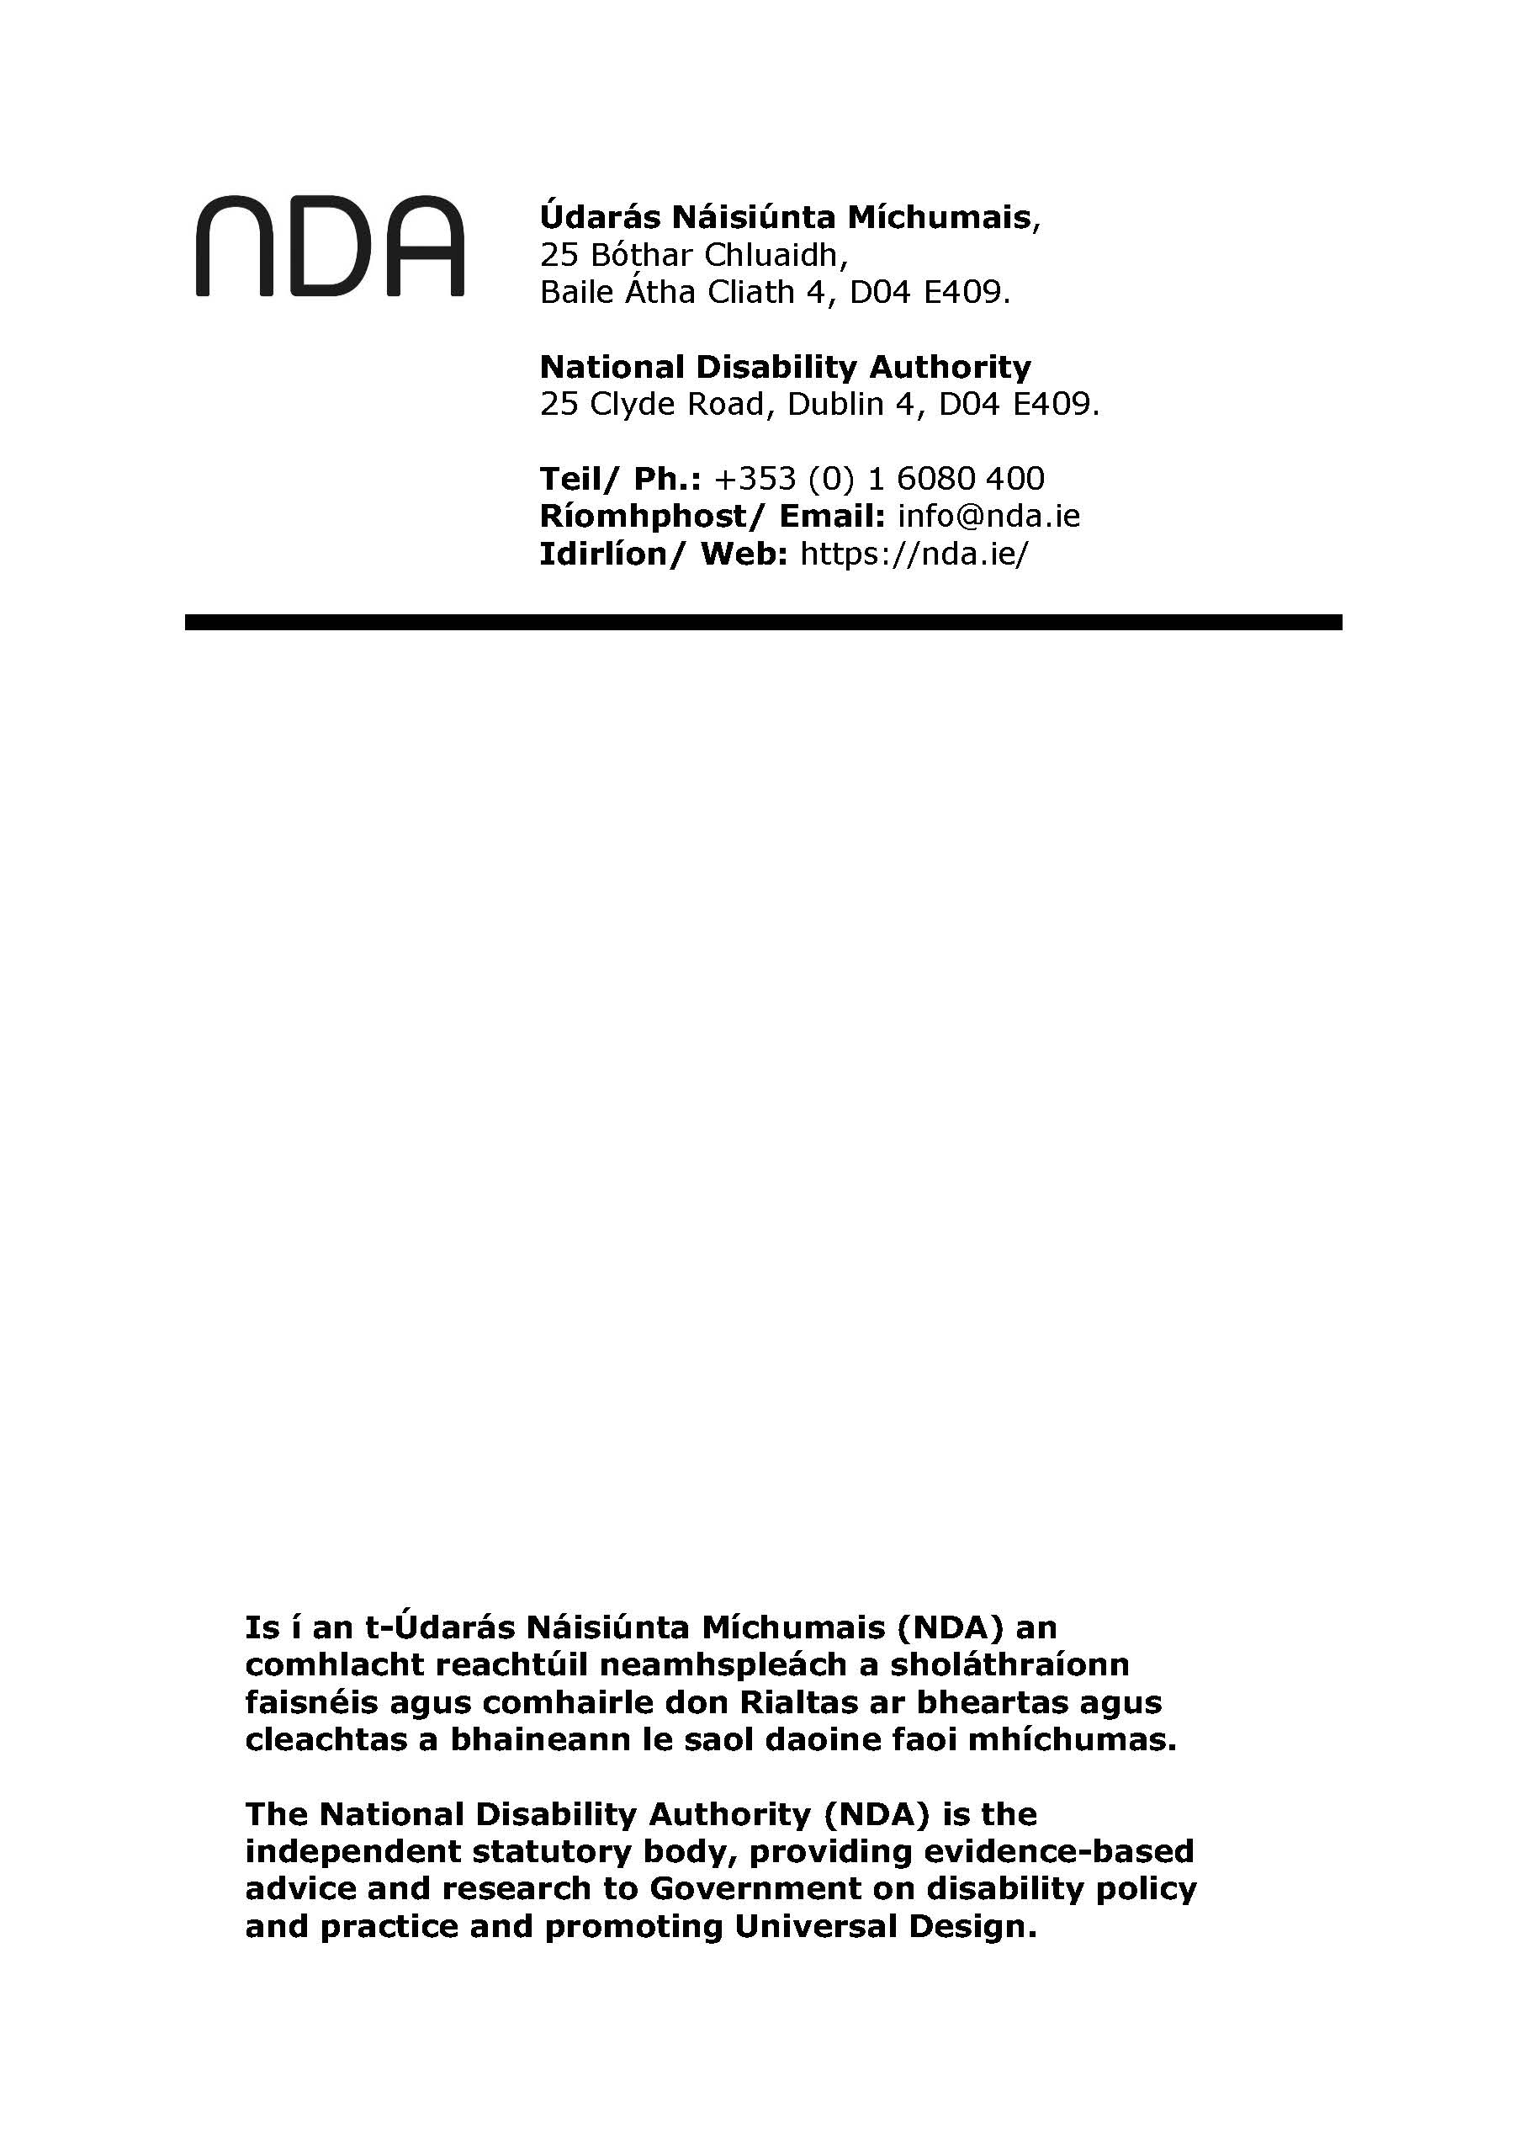

1. Please note that in addition to this national consultation there was ongoing direct consultations between DCEDIY and DPOs that are not captured in this report.
2. Individuals with disabilities may belong to multiple different racial, ethnic, gender, or socioeconomic backgrounds. These intersecting identities can influence their experiences and the types of challenges and barriers they encounter.