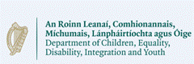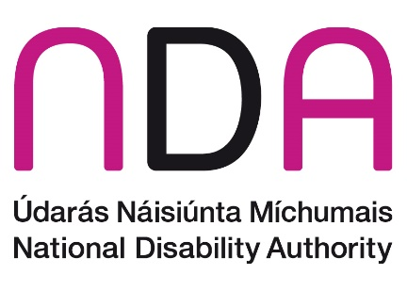

National Disability Strategy call for written submissions
The Department of Children, Equality, Disability, Integration and Youth are leading the development of a new National Disability Strategy. They have requested the National Disability Authority to lead on certain elements of the consultation.
The consultation consists of a number of strands including online thematic focus groups, a national questionnaire and town hall style in person meetings. There will be more information here in the coming weeks. There is also an option to make a video submission – see here for an ISL video on how to make a submission.
Disability organisations and in particular Disabled Persons Organisations (DPO), are invited to make a written submission. The national questionnaire will be available for individuals but if you are not part of an organisation and would like to make a written submission you are welcome to do so.
We ask that in your responses you focus on solutions and tangible actions that can be done to improve the lives of persons with disabilities.
Please answer the questions below and submit to nda-events@nda.ie by Friday 2 Feb 2024.
We ask that you please adhere to the word counts provided. An A4 page with single spaced text font 12 is between 400 and 500 words.
You can also post your submission to
NDS Consultation,
National Disability Authority,
25 Clyde Road,
Dublin 4.

What will happen to your submission
The written submissions will be summarised and included in a consultation report that will also include summaries from the national survey, video submissions and focus group discussions. The key themes emerging from all the consultation strands will continually be fed into the strategy development process. The consultation report will be published along with the strategy.
Views shared by DPOs will be distinguished from the views of others during the analysis process and the consultation report will summarise the findings of DPOs separately and highlight any unique views or particular emphasis of DPOs.
The consultation report will not identify any organisations or individuals but will use phrases such as …a DPO suggested…, …a disability organisation said…, …. a submission from an individual highlighted that…

Please go to the next page to start your submission

About you

Please respond to one of the options below.

I am responding as:
- A representative of a Disabled Persons Organisation
If yes, please specify your name and the name of the organisation:

- A representative of another disability organisation
If yes, please specify your name and the name of the organisation:

- An individual with a disability
If yes, please provide your name (your name will not be included in the consultation summary):

- An individual who is a carer
If yes, please provide your name (your name will not be included in the consultation summary):

- Other
Please specify:

Questions
The vison of the United Nations Convention on the Rights of Persons with Disabilities (UNCRPD), which Ireland has ratified, is that disabled people can exercise their human rights like everyone else in society and have an equal opportunity to live their lives with dignity, respect, and equality.

Question 1: What changes do you see as important to ensure that disabled people in Ireland are fully included in society in line with the vision of the UNCRPD? (Maximum 500 words)

Question 2: What needs to happen for these changes to be achieved? (Maximum 500 words)

Question 3: What would a successfully implemented strategy look like? For example, how do you think life should have improved for disabled people in Ireland at the end of a five-year strategy? (Maximum 500 words)

Question 4: If you have any other views that are relevant to the new National Disability Strategy please tell us? (Maximum 300 words)

We recognise that some DPOs prefer the term Disabled Persons Representative Organisations (DPRO)
Please note that the length of the strategy has not yet been confirmed.

