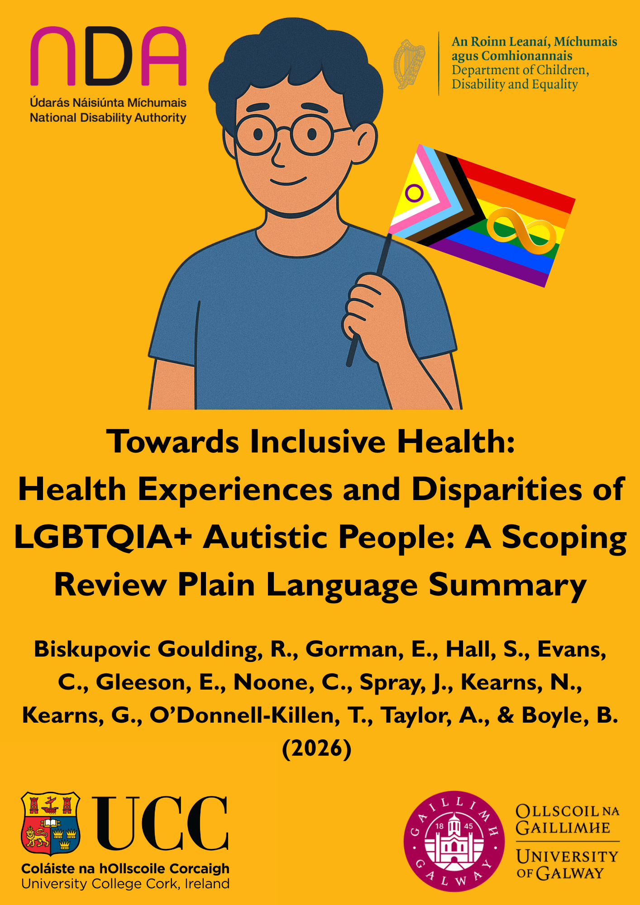

Table of Contents
Why LGBTQIA+ Autistic Healthcare Matters 3
How we looked for evidence 3
What we found 3
Barriers to good healthcare 4
What helps 5
Health disparities and outcomes 5
What this means 6
What should happen next 6
What we could not do 7
Conclusion 7

Why LGBTQIA+ Autistic Healthcare Matters
In this report, we use a capital “A” when we write Autistic. We do this to show respect to how some Autistic people see themselves.
We also use the term LGBTQIA+. This is a broad term. It includes people whose gender is different from the sex they were given at birth. It also includes people who are attracted to someone of the same sex, more than one sex, or a different sex.
Autistic people and LGBTQIA+ people often have worse health than people who are not Autistic or LGBTQIA+. They may also have harder experiences when they use healthcare. Many face unfair treatment. Healthcare systems are not always built to meet their needs. For example, staff may not understand them. Some places may feel hard to use or unsafe.
Very little research has looked at people who are both Autistic and LGBTQIA+. Having both identities can make healthcare even harder. Autism can be part of who someone is. It can also be something a doctor diagnoses. Being LGBTQIA+ is about who someone is, not a medical diagnosis. Healthcare services usually treat these differently.
In this work, we looked at what is known about the health and healthcare experiences of people who are both Autistic and LGBTQIA+. We also looked at what helps and what makes getting care harder.

How we looked for evidence
We searched for research about the health and healthcare of people who are both Autistic and LGBTQIA+. We then wrote a summary of what we found. We included studies that used surveys, interviews, or both. We also included community reports and policy papers.
Our team worked closely with two groups: Neuro Pride Ireland and Thriving Autistic. People from these groups shared their views based on their own lives as Autistic LGBTQIA+ people. We included studies written in English that looked at any part of Autistic LGBTQIA+ identity in any healthcare setting.
We then looked at all the findings together. We looked at survey answers, interview answers, and studies that used both. We did this to understand what makes healthcare harder or easier. We also looked at whether Autistic LGBTQIA+ people have different health experiences than people who are not both Autistic and LGBTQIA+.

What we found
What we found shows that Autistic LGBTQIA+ people face many problems in healthcare. These problems often build up and make things even harder.
These problems can happen when people talk to healthcare staff, when they use healthcare services, or because of bad experiences they have had before. Some things can help. These include healthcare staff who are kind and understanding, services that can change to meet people’s needs, and rules that protect Autistic LGBTQIA+ people. These supports are not always in place, but they make a big difference when they are.
Because of these problems, Autistic LGBTQIA+ people often have poorer mental and physical health. This means healthcare needs to become more supportive and more understanding of Autistic LGBTQIA+ people as soon as possible.

Barriers to good healthcare
Across 32 studies, Autistic LGBTQIA+ people said they faced many big problems in healthcare.
Many people said healthcare workers did not know enough about people who are both Autistic and LGBTQIA+. People working in healthcare sometimes found it hard to change how they talked and communicated. They did not always understand why some Autistic people plan what to say before an appointment or use movements or actions (stimming) to help them stay calm. Because of this, many people felt like healthcare workers did not understand them. Some also said they could not get the care they needed or had to wait a long time.
Non-binary and transgender people (people whose gender is different from the sex they were given at birth) said their gender identities (how you feel and think about your gender) were sometimes not taken as seriously as their autism diagnosis. Many felt they were treated like children or ignored when they shared that they were Autistic. This happened especially when they were trying to get care that helps them change their name, body, or how they live so it matches their gender (gender-affirming care).
Many people also spoke about problems in the healthcare system. Services were not always well connected. People often had to wait a long time for care. The ways to send people to other services were often strict and hard to change. Because of this, healthcare workers often treated only one part of who they are, not both.
Some healthcare places were also hard to use. Waiting rooms were often too bright, too noisy, or too busy. Money problems also made care harder. Some people could not pay for tests or a doctor to confirm they had autism. Their health insurance did not always pay for this care. These problems were even greater for non-binary people and for Autistic women.
Because of bad past experiences, many Autistic LGBTQIA+ people expect to be judged or not understood in healthcare. Some do not use healthcare because of this. Others feel very tired because they always have to explain themselves. Some Trans Autistic people hide that they are Autistic so they will not be denied care that helps them live as their true gender. This can be very upsetting and allows the same problems to keep happening.

What helps
Even though there were many problems, some things helped people get better care.
Support from other Autistic and LGBTQIA+ people helped a lot. Autistic and LGBTQIA+ people made groups that also helped by sharing advice and information. Family members, close friends, and healthcare workers they trusted also helped people.
Small changes helped a lot. People found it easier when they could use email instead of phone calls. It also helped when they could choose times that worked for them. Calm spaces that were not too bright or noisy also made care easier. These changes made healthcare less stressful and easier to use. When a doctor confirmed that they have autism, it helped some people. It helped them feel believed, helped others understand what they need, and allowed them to get extra support.
When healthcare workers were kind, used respectful words, and wanted to learn, people felt safe and understood. Rules that stop people from being treated badly also helped. For example, in places with these rules, more people got the care they needed. People with less money sometimes found it easier to get care because some services were free or cheaper. This shows that strong support can help more people get the care they need.

Health disparities and outcomes
The research showed that Autistic LGBTQIA+ people often have poorer health than other people who were not Autistic or LGBTQIA+. Many also do not get the healthcare they need.
More than 3 out of 4 people said they had a health problem that was not getting help. This was highest for non-binary Autistic people. About 9 out of 10 non-binary Autistic people said they were not getting help. About 8 out of 10 Autistic cisgender (people whose gender is the same as the sex they were given at birth) women said this, and about 7 out of 10 Autistic cisgender men said this.
Trans Autistic people were much more likely than trans non-Autistic people to say they had problems with their mental or physical health. They were also much more likely to have mental health problems. This included anxiety, depression, stress after scary events, eating problems, and problems with alcohol or drugs
Many people said they felt very stressed. Some said they had thoughts about suicide. Some also used alcohol or drugs to help them deal with being left out or treated badly.\
Trans and non-binary people were told by doctors they have autism later than other people. Most were told they have autism about 4 to 6 years later than cisgender people. This may be because they were treated badly or because healthcare was hard to understand.
Being treated badly in healthcare was common for Trans Autistic people. About 1 in 5 Trans Autistic people said healthcare workers used the wrong name or words for their gender, like “he,” “she,” or “they.”. For non-Autistic trans people, it was about 1 in 8. Many people also had to wait longer to get care that helps them live as their true gender or could not get this care at all. This often happened because staff did not understand autism.

What this means
Autistic LGBTQIA+ people are often treated unfairly in healthcare. This is not only because of problems with healthcare workers or services. It also happens because people with both identities are often not thought about enough.
In Ireland, plans talk about Autistic people and LGBTQIA+ people individually. There is very little advice about people who are both. Some other countries, like the UK, Canada, and Australia, are starting to see how gender, sexuality, and autism are linked.
Real change needs better information and fairer ways for people to get an autism diagnosis. It also needs rules that understand and support both people who have a diagnosis and people who believe they are Autistic. Most importantly, Autistic LGBTQIA+ people need to be included in decisions about healthcare. This will help make services fairer, more flexible, and more supportive.

What should happen next
From what we learned, here are 7 main ideas to help Autistic LGBTQIA+ people get better healthcare and stay healthier:
- Help healthcare workers learn and understand more
  - Give training taught by Autistic and LGBTQIA+ people. This training should include both identities together.
  - Give simple advice on how to talk with people, how to support gender care, and how to ask people what they need instead of guessing.
  - Teach staff to notice and stop unfair treatment, like refusing care, talking down to people, or treating people unfairly because of their identity.
  - Make sure staff keep learning so they treat people kindly and listen well.
- Make services easier to use and more welcoming.
  - Make spaces calm, not too bright, or noisy. Let people choose appointment times. Give different ways to communicate, like email, text, or in person.
  - Show that everyone is welcome. For example, use forms that include all people, display LGBTQIA+ pride and autism symbols, and give easy-to-read information. Make it easier for people to find help, know where to go, and understand what to do.
- Make it easier to get care and pay for it.
  - Make sure people can get both gender care and autism care without being blocked.
  - Reduce waiting times by helping services work together and by supporting both people with a diagnosis and people who believe they are Autistic.
  - Offer public autism testing for adults across Ireland that is respectful and understands gender needs.
  - Check rules to make sure they stop unfair treatment and talking down to people.
- Collect better information.
  - Collect information about how many people in healthcare are Autistic and LGBTQIA+
  - Use this information to find unfair differences and improve services.
  - Keep people’s information private and always ask for clear permission before collecting it.
- Listen to Autistic LGBTQIA+ people.
  - Ask Autistic LGBTQIA+ people to help design and improve healthcare.
  - Learn from people’s real-life experiences so services meet their needs.
  - Involve them to help fix past problems and make healthcare feel safer.
- Make sure rules include both groups.
  - Make health plans clearly include people who are both Autistic and LGBTQIA+
  - Remember that some people are both Autistic and LGBTQIA+, not just one.
  - Learn from other countries where this has helped people get fairer care.
- Learn more about Autistic LGBTQIA+ people.
  - Study what helps improve healthcare for Autistic LGBTQIA+ people.
  - Do not just look at problem. Look at what works and what makes good care for Autistic LGBTQIA+ people.

What we could not do
Most studies were done in English-speaking countries that have a lot of money. Many looked mostly at white transgender people, so other people’s experiences may be missing.

Conclusion
We found that Autistic LGBTQIA+ people do not have worse health because they cannot find their way through healthcare. They have worse experiences because healthcare is not made for them.
To make things better, the government needs clear rules that remember some people belong to more than one group. Healthcare needs to be planned with Autistic LGBTQIA+ people, not just made for them. When healthcare makes room for everyone, it helps fix problems and makes people feel safe
When healthcare is changed to give people the help they need, it works better for everyone. This means a place where Autistic LGBTQIA+ people are listened to and get the help they need.

