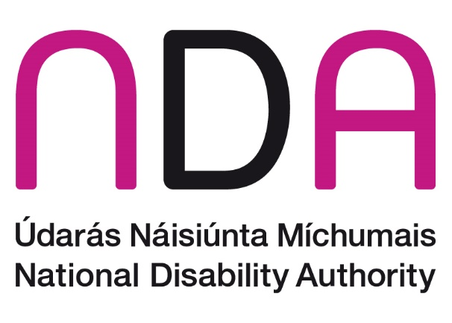

Draft Code of Practice on Accessible Public Buildings
The National Disability Authority (NDA) has developed a draft Code of Practice on Accessible Public Buildings. We are inviting you to submit your feedback on this draft Code of Practice.
This Code of Practice has been developed under Section 25 of the Disability Act which states that:
“public bodies shall ensure that its public buildings are, as far as practicable, accessible to persons with disabilities.”
The purpose of this Code of Practice is to guide public bodies on how to make their public buildings accessible to people with disabilities. Public bodies will be obliged to meet the requirements and fulfil the recommendations set out within this Code. The NDA has the power to monitor public bodies against monitoring indicators on the implementation of this Code and publish a report on how well they are doing.
This Code will not provide technical detail such as the dimensions of toilets, the gradient of ramps, the width of doors because this detail is already found in the technical guidance document for Part M of the Building Regulations.
The preferred mode for providing feedback is through the online survey found at https://www.surveymonkey.com/r/code_of_practice, but we will accept the completion of this form instead.
A completed form should be returned by email to nda@nda.ie or by postal mail to:
Code of Practice Public Consultation
National Disability Authority
25 Clyde Road,
Ballsbridge, Dublin 4
D04 E409
We welcome submissions from individuals, organisations and public bodies.
It is not intended that you provide personal or confidential information as part of the submission process.
Please ensure that you return this form to us by 5pm on 26th June 2023.

Consultation questions for members of the public, organisations and public bodies

Draft Code of Practice on Accessible Public Buildings
We would like to learn your thoughts on the draft Code of Practice on Accessible Public Buildings.
Consultation questions
- Do you think the language used in the draft Code of Practice is clear and easy to understand? Yes/No
If no, please explain.

- Do you think the structure of the draft Code of Practice is clear and easy to understand? Yes/No
If no, please explain.

Please reflect on the following points when answering the questions that follow:
- The clarity of the Code of Practice
- What might be added to the Code of Practice
- What might be removed from the Code of Practice
- Any improvements that could be made
- Examples of good practice

- Please provide your feedback on Section 1-3: Introduction; Scope and definitions of the Code of Practice; Other mandatory requirements to be aware of when using the Code of Practice (word limit 400 words)

- Please provide your feedback on the Core Elements of the Code Section 4.1: Planning for Accessibility (word limit 400 words)

- Please provide your feedback on the Core Elements of the Code Section 4.2: Pre-visit information (word limit 400 words)

- Please provide your feedback on the Core Elements of the Code Section 4.3: Building approach and entry (word limit 400 words)

- Please provide your feedback on the Core Elements of the Code Section 4.4: Way finding (word limit 400 words)

- Please provide your feedback on the Core Elements of the Code Section 4.5: Circulation within the buildings and its environs (word limit 400 words)

- Please provide your feedback on the Core Elements of the Code Section 4.6: Internal environment (word limit 400 words)

- Please provide your feedback on the Core Elements of the Code Section 4.7: Facilities (word limit 400 words)

- Please provide your feedback on the Core Elements of the Code Section 4.8: Programmes, meetings, exhibitions and events (word limit 400 words)

- Please provide your feedback on the Core Elements of the Code Section 4.9: Emergency egress (word limit 400 words)

- Please provide your feedback on the Core Elements of the Code Section 4.10: Management and maintenance (word limit 400 words)

- Are there any other comments or suggestions on the draft Code of Practice you would like to make?

Additional consultation questions

Draft monitoring indicators
We welcome your thoughts on the draft monitoring indicators.
An indicator is a metric by which compliance with a particular requirement can be determined. It also offers a way of tracking and measuring progress over time. The NDA monitors a public body's compliance with Codes of Practices by assessing the extent to which the agreed indicators are achieved. The NDA reports and publishes the findings. It is important to note that even where an indicator can be assessed as achieved using objective appraisal, the subjective experience of individuals in real-time may differ from this.
We have produced draft indicators derived from the draft Code of Practice on Accessible Public Buildings. These indicators are preliminary. The NDA proposes to monitor these a number of ways including requesting public bodies to complete survey questions and provide information and evidence.
These indicators are subject to change based on the feedback we receive from this consultation. There will be further consultation on these indicators after we consolidate the Code of Practice on Accessible Public Buildings for submission to the Minister.
If you wish, we would like to learn your thoughts on the draft monitoring indicators.
Consultation questions
- Do you think the language used in the draft monitoring indicators is clear and easy to understand? Yes/No
If no, please explain.

- Please provide your feedback on the draft monitoring indicators (word limit 400 words)

Thank you for taking the time to give us feedback on the draft Code of Practice on Accessible Public buildings.
Name of Organisation or Public Body (if applicable)

Next steps
Once the period for receiving feedback has ended, the NDA will review and analyse the responses. The feedback will inform further development of the draft Code of Practice on Accessible Public Buildings and the monitoring indicators. The draft Code of Practice and the monitoring indicators will be presented to the NDA Board for sign off. The Code of Practice on Accessible Public Buildings will then be provided to the Minister for Children, Equality, Disability, Integration and Youth for approval as a statutory instrument, after which it will be published.
Following publication, the NDA will commence monitoring of this new Code of Practice.

