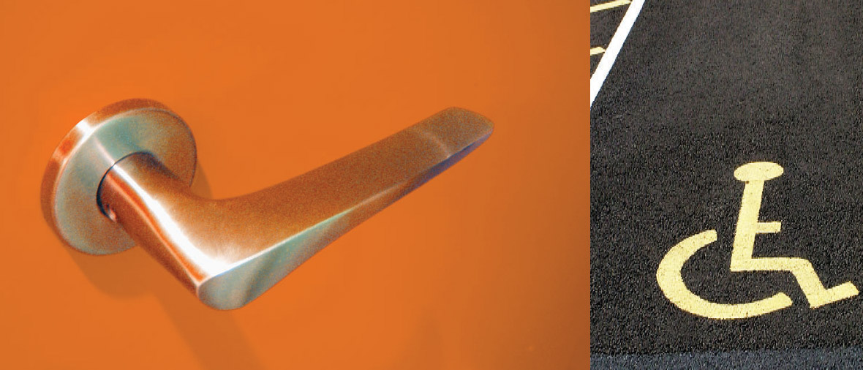
Access Handbook Template:
A Tool to Help Manage Accessibility
of the Built Environment

Access Handbook Template:
A Tool to Help Manage Accessibility
of the Built Environment

Eoin O’Herlihy
September 2005

Contents

1 Introduction 5
1.1 Purpose of access handbook 5
1.2 Why accessibility? 5
1.3 Barriers faced by people with disabilities 6
1.4 Access and the legislative context 6
1.5 Introduction to the building 8
2 Location and Transport 9
3 Layout of Building 10
4 Accessibility Features of the Building 11
5 Management Responsibility 12
6 Maintenance Audit 14
6.1 Externally 14
6.2 Entrances 14
6.3 Horizontal circulation within the building 15
6.4 Vertical circulation 15
6.5 Signage 16
6.6 Sanitary facilities 16
6.7 Furniture 16
6.8 Communication devices 16
6.9 Cleaning and maintenance work 17
6.10 Staff training 17

7 Signage 18
7.1 Comparison of good versus bad signage 19
7.2 Examples of good sign design 20
8 Emergency Equipment and Evacuation 21
8.1 Fire exits 24
8.2 Emergency equipment 24
8.3 Important safety issues 25
8.4 Steps to Produce Personal Emergency Egress Plans (PEEP) 26
9 Conclusion 28
10 Resources 29
10.1 Important Websites on Accessibility 29
10.2 Literature on Accessibility of the Built Environment 30
11 References 32
12 Records 33

Foreword

An access handbook is an internal document for the use of management, maintenance personnel and new staff; and which all staff should be aware of. Its purpose is to provide a simple way of listing and explaining the features and facilities of a building, which must be maintained and/or improved in order to ensure access for everyone.

This template has been designed to allow managers to design an access handbook for their organisation with simplicity and ease. The template contains an introduction to accessibility in section one which can be used or altered by the user to suit their organisation’s needs.

Sections two to four and section eight requires the organisation to fill in details on how to get to the building, the building layout, and the accessibility features of the building and emergency equipment and evacuation. To help the user complete these sections the template highlights what is required (this information is highlighted in red and is underlined) and gives examples of what content should be contained in each section.

As management is a key feature in ensuring the day-to-day accessibility of a building, section five gives a brief overview of management responsibilities and section six highlights what needs to be carried out in a maintenance audit. The maintenance audit identifies items, which management must ensure are maintained, but it must be noted that it is not an exhaustive list and will vary depending on the nature and size of the building.

Section seven provides information on the design of accessible signage and highlights examples of well versus badly designed signs. Finally, section nine identifies some useful websites and available literature in the area of accessibility.

Introduction

Purpose of access handbook
This access handbook has been designed as an internal document for the use of management, maintenance personnel and new staff; and which all staff should be aware of. The purpose of the access handbook is to provide a simple way of listing and explaining the features and facilities of a building, which must be maintained and/or improved in order to ensure access for everyone.

Management and maintenance personnel can use this handbook to ensure that a high standard of accessibility is maintained throughout day-to-day running of the building. For all new staff, the access handbook can be a useful document to familiarise people with the building and the structures of their organisation.

The National Disability Authority states, ‘Good management can improve the accessibility of even a badly designed building’ and if management or maintenance personnel use the access handbook, this principle will become a reality. The access handbook highlights:
- Background information on access;
- How to get to the [insert building name] building using various modes of transport;
- Areas that need to be kept clear to ensure maximum accessibility;
- Guidelines for accessible signage;
- Management responsibilities;
- How to Carry out a Maintenance Audit;
- Means of escape.

Why accessibility?
We live in a diverse society, where social inclusion is becoming a worldwide issue and the demographics are changing; in particular the population is ageing and there is increased immigration. A report entitled “2010: A Europe Accessible for All” highlighted that accessibility is a key to autonomy, inclusion and sustainable development (http://www.socialdialogue.net/en/en_lib_170.htm). Sustainability is now high on the agenda for all and accessibility is a major factor in the delivery of a more sustainable environment. An accessible building has benefits for all. It is safer, healthier, more comfortable and easily adapted to changing needs.

Barriers faced by people with disabilities
Everyone requires equal consideration from those who commission, design, construct or manage buildings and the external environment, for example:
- Someone who is short of breath or has a broken ankle will find stairs difficult or impossible;
- A smooth circular doorknob will be very difficult to use if a person has poor grip;
- Street furniture or bollards that is poorly sited and/or does not contrast with the background, are a hazard for people with poor vision;
- Even a single step can deny entry to a person pulling a suitcase on wheels, or a person using a wheelchair.

Access and the legislative context
Access varies depending on disability and goes well beyond the physical type alone. Darcy (1998) has characterised access from four main dimensions:
- Physical access, which involves people with physical disabilities requiring the use of wheelchairs or walking aids and requires the provision of, for example, handrails, ramps, lifts and lowered counters;
- Sensory access, which involves people with hearing or vision impairment requiring the provision of, for example, tactile markings, signs and labels, hearing augmentation-listening systems and audio cues for lifts and lights;
- Communication access, which involves people who have difficulty with the written word, vision, speech, and language problems.
- Cognitive access, which involves people who have impaired awareness, perception, reasoning and judgement.

Accessibility of the built environment for people with disabilities in Ireland is mainly controlled by Part M of the Building Regulations (2000) entitled “Access for People with Disabilities”. The underlying philosophy of Part M is to ensure that as far as is reasonable and practicable, buildings should be usable by people with disabilities. A Technical Guidance Document for Part M is also provided in three sections, which include access and use; sanitary conveniences; and audience/spectator facilities. The first part of section one deals with buildings other than dwellings and the second part of section one deals solely with dwellings. Areas covered in the document include approach; access; circulation; hotel and guest rooms; and use of facilities in a building. The Building Regulations (2000) apply to construction of new buildings after 1st January 2001 and any extension work or renovations carried out after this date.

In addition, certain parts of the regulations apply to existing buildings where a material change of use takes place. Otherwise, the Building Regulations do not apply to buildings constructed prior to 1st June 1992.

There are also a number of Acts that provide a legislative framework for organisations to ensure that premises and services comply with minimum accessibility requirements. These include the Safety Health and Welfare at Work Act 1989, the Employment Equality Act 1998/2004, the Equal Status Act 2000/2004, the Disability Act 2005 and Safety, Health and Welfare at Work Act 2005. Also, key national plans such as the Programme for Prosperity and Fairness 2000, and Sustaining Progress 2003 have promoted accessibility.

While legislation provides for minimum standards in accessibility, universal accessibility takes this one step further. It is a key concept that states that all environments should be accessible by everyone, regardless of ability. Everybody is different and there is no ‘average’ person.

As a result, universal accessibility will benefit all because people with disabilities, people of small or tall stature, parents with buggies, delivery persons and so forth will have greater access to the built and external environments.

Examples of how to design with universal accessibility in mind:
- If tactile indicators are used on landings and the first and last step in a flight of stairs is clearly marked, a person with impaired vision will find a stairs easier to use;
- An induction loop fitted in a busy-noisy environment will enhance communication for people with hearing aids;
- If colour contrast is used on fixtures and fittings and tactile indicators are used on controls (e.g. in lifts) they will be easier to use for people with vision impairments;
- Clearly legible, well-designed and placed signage will help everyone to find their way around in an unfamiliar building and are vital for people with learning and speech difficulties;
- A threshold with no step provides access for everyone.

To ensure accessibility of the built environment is of the highest standard, there are a number of essential criteria that need to be met. These are highlighted below with a brief description of some of their influencing factors:

- Management - Access handbook, access and safety, management responsibilities;
- External Environment - car parking, routes, ramps, steps and doors;
- Vertical and Horizontal Circulation - steps and stairs, lifts, corridors and internal doors;
- Facilities - reception, toilets, seating areas, changing rooms, restaurants and refreshment machines;
- Interior Design - lighting, colour and contrast, fixtures;
- Evacuation - emergency equipment, alarms, signage, evacuation equipment, evacuation plans;
- Communication Facilities - signage, telephones, tactile features, acoustics.

Introduction to the building
In this section, provide a general introduction to the building, including information about the user groups of the building (public/staff) and their number. Also describe the main functions of the building and any events that are held.

Example:
Both employees and members of the public use the building. Approximately 80 staff members use the building on a daily basis. The building is also used for public conferences, seminars and meetings and, therefore, is used by a wide range of people with various abilities on a regular basis. The library is also open to members of the public from Monday to Friday. As the organisation’s main focus is on disability/equality related issues it is expected that many visitors and guests with disabilities will be using the building.

Location and Transport
This section should provide information on the exact whereabouts of the building, with detailed information on how to get there from the major arrival points in the city, town or area. This should include:
- The use of maps;
- Details on arrival by car, taxi, bus, train, and from the nearest airport;
- Accessibility information on the transport routes; for example whether the bus service is wheelchair accessible;
- Pricing and contact details.

Example:
Getting to the [Name building Here] by Bus
Dublin bus offers many routes that pass close to the [Name building Here]. The buses which stop in Ballsbridge include the 5, 7, 7A, 18, 27X and 45 (100% wheelchair accessible) and the buses which stop in Donnybrook are the 7B, 7D, 10 (100% wheelchair accessible), 10A, (100% wheelchair accessible), 15X, 25X, 27X, 32X, 39X, 46, 46A (80% wheelchair accessible), 46B (80% wheelchair accessible), 46X, 49X, 50X, 58X, 66X, 70X, 116, 117 and 746 (100% wheelchair accessible). For the latest route details and timetable information see www.dublinbus.ie.

Layout of Building
This section should describe, in detail, the physical layout of the entire premises and the classification of use as described in the provided introduction. Descriptions should include information on the use of the different areas and where the toilets, stairs, lifts, and any other facilities are situated. Building plans should be provided in conjunction with written explanations.

Bright and Di Giulio (2001) and Bright and Sawyer (2004) describe building types in four distinct building categories/classification of use. These are complete freedom of movement, controlled entry/freedom of movement, free entry/controlled movement and controlled entry/ controlled movement.

Complete freedom of movement: A building or area in this classification would be one where the user or visitor is free to enter, wander around, probably in no particular sequence and leave without the need to make any contact with potential assistance points such as reception/information desk or security point (Shopping centre, non paying museums etc.).
Controlled entry/freedom of movement: There will be some point of control usually a payment desk or security point, but, after passing that point, users will be allowed the type of free, usually unrestricted, movement described above.
Freedom of entry/controlled movement: This type of environment will usually have a central entrance through which the visitors enter, but once inside, movement around the building will be restricted (post offices, bus and railway stations etc.).
Controlled entry/controlled movement: In this type of environment, security will usually be a major issue and the type of visitor will be restricted (Bank, research laboratories, some schools etc.).

Accessibility Features of the Building
All key accessibility features of the building should be described in this section. The different areas of the building should be analysed and reported on, in terms of accessibility and recommended management practices to prevent the area becoming inaccessible. These areas may include:
- Parking bays and external areas;
- Entrances and exits;
- Reception and lobby areas;
- Circulation routes, both horizontal (corridors) and vertical (stairwells);
- Toilets;
- Meeting and conference rooms;
- Offices;
- Facilities (vending machines, canteen facilities, telephones etc.);
- Provision of means of escape.

Example:
Entrances – Access to the front door is provided by both steps and a ramp. The front door automatically opens and reception is immediately through the entrance. Both entrances need to be kept clear and well maintained at all times. It is important to note that seasonal change (e.g. falling leaves) can cause difficulty or risk of injury and management must ensure that the effects of seasonal change are minimised

Management Responsibility
In order to maximise accessibility for all, management must ensure that:
- Circulation routes and spaces are kept free of obstruction;
- Facilities are kept clean and function properly;
- Lighting levels are adequate;
- Spaces primarily intended for people with disabilities, including safety zones and wheelchair accessible toilets, are properly maintained, not used as storage spaces or locked-off during business hours;
- Equipment such as platform lifts and induction loops are maintained in good working order;
- Safety and orientation features to assist people with disabilities, e.g. colour contrasting door furniture, tactile surfaces on floors and colour contrasting strips, are present and renewed when necessary;
- Signage is clear, legible and is consistent throughout the building, and is revised after any modification to building use or layout;
- Staff are aware of how best to facilitate users with disabilities;
- Carpets and soft furnishings are kept free of dust;
- Filters are replaced in mechanical ventilation systems;
- Smoking restrictions are enforced.

A management template and audit sheet has been provided to assist in this process (page 33-35). This needs to be signed off by management on a regular basis e.g. every six months or in light of significant changes (whichever is sooner).

Other issues that need to be considered by management include:
- Reviewing the access plan/strategy to ensure positive changes take place on a regular basis.
- Consultation with users. This may include:
  - Consulting users throughout the design process of any building works (either on a new building or material changes to an existing building);
  - Consulting users when developing access strategies/plans;
  - Consulting users in the development of any access literature;
  - Getting feedback from users of the building to highlight what worked well and not so well.
- Ensuring an internal working/cross functional team of staff responsible for accessibility matters is developed.
- Publishing information regarding accessibility. This should highlight where a good level of access has been achieved (either in a new building or following access improvements to an existing building).
- Providing training for all staff. Topics to be covered include: disability awareness training, guiding people through the building, sign language etc.
- Ensuring all maintenance and refurbishment processes consider accessibility. General maintenance should also consider accessibility (see above).
- Considering accessibility from the beginning of all new building designs or extensions. The first step in this process would be to produce an ‘access statement’. An access statement demonstrates the organisation’s/designer’s commitment to take the issue of inclusive design seriously at the earliest stages.
- Ensuring all procured services (security, catering etc.) are aware of access policies and procedures and their staff receive the relevant training to undertake their duties.
- Ensuring that facilities management companies that carry out work within an organisation have training in accessibility.

For further information on management responsibilities and access statements see:
- Building for Everyone (see references)
- The Access Manual (see references)
- http://www.drc-gb.org/businessandservices/bizdetails.asp?id=97&title=bs [Update 2011: This link should now be http://www.equalityhumanrights.com/uploaded_files/PSD/40_planning_building_roads_ded.pdf]
- http://www.sheffield.gov.uk/index.asp?pgid=24694 [Update 2011: This link should now be http://www.sheffield.gov.uk/planning-and-city-development/planning-documents/disability-access/access-statements]²

Maintenance Audit
To ensure that the accessibility features of the building (discussed above) are kept up to standard a maintenance audit could be carried out. The following section is a maintenance audit checklist, which identifies items that management/maintenance personnel must ensure are maintained. A maintenance template and audit sheet has been provided to assist in this process (page 36-38).

Externally
Check that:
- Designated parking bays are reserved for the use of drivers and passengers with disabilities and parking restrictions are strictly enforced;
- Ramps and circulation routes are free from parked bicycles and other obstructions;
- Circulation routes and escape routes from buildings to places of safety are on safe surfaces, free of obstruction and well lit;
- Areas being serviced or repaired are adequately protected, and alternative routes are provided as necessary and clearly marked;
- Route surfaces are well maintained, clean, free of gravel, grit, mud, ice, snow and moss;
- Battery supplies to platform lifts are permanently charged;
- Aids to evacuation are in place, clearly visible and access to them kept clear.

Entrances
Check that:
- Turning space at the top of ramps is kept free of obstruction;
- Approach to bells, letterboxes, door handles etc. is free of obstruction;
- Doors are easy to open and closing devices are set at the minimum force needed to open and shut the door;
- Entrance lobbies are free of obstruction, both permanent and temporary, e.g. delivered goods.

Horizontal circulation within the building
Check that:
- Door mats are recessed (with the top of the mat flush with the floor) and, along with rugs, are securely fixed so as not to cause tripping;
- Slip resistance of floor finishes is maintained, spillages cleaned up promptly and appropriate cleaning agents and polishes used;
- Worn floor finishes are replaced;
- Artificial lighting is at adequate levels;
- Doors are easy to open and door closers are set at the minimum force needed to open and shut the door;
- Doors are kept closed when not in use;
- Wheelchair spaces in waiting rooms and elsewhere are kept free of obstruction;
- Both temporary and permanent circulation routes are free of obstruction, e.g. toolboxes, boxes of files, vending machines, photocopiers;
- Safety zones are kept free of obstructions;
- Adequate headroom is maintained throughout the building, with no trailing cables on floors or at heights below 2200mm;
- Approach to and egress from all lifts and stairs are kept free of obstruction.

Vertical circulation
Check that:
- Stairways and ramps are free of obstruction, whether permanent or temporary, particularly on landings and at the tops and bottoms of ramps;
- Stairway finishes are maintained clean and slip-resistant and are replaced when frayed or worn;
- Stairway handrails are securely fixed;
- Visual strips on stairways nosings are clearly distinguishable from adjacent surfaces;
- Tactile areas at stairs and the colour contrasting strips of the first and last steps are maintained;
- Stairways are adequately lit, without confusing shadows adjacent to or on the stairs;
- Lifts are serviced and lift car floors align with finished floor levels;
- Lift controls are free of obstruction.

Signage
Check that:
- Signage is clear and legible, and revised on foot of any alterations to building layout;
- Signs are replaced after redecoration;
- Bulbs in illuminated signs are replaced when performance is reduced, rather than when they fail;
- Access to tactile signs is maintained.

Sanitary facilities
Check that:
- Toilet transfer areas are kept free of obstruction;
- Alarm facilities are maintained and any pull cords extend to within 100mm of the floor;
- Toilets used by people with disabilities are kept particularly clean, as these users depend on the WC surfaces for support;
- Sanitary disposal bins are provided, emptied regularly and positioned within reach of the toilet.

Furniture
Check that:
- Loose furniture and fittings are placed so as not to obstruct circulation routes;
- Safety zones and emergency escape routes are free of obstacles;
- Seats have good back and arm support;
- Storage units are accessible and securely fixed;
- Items in storage or on furniture are not at risk of being easily knocked over and heavy items are stored at lower levels.

Communication devices
Check that:
- Induction and counter loop systems are kept in good working order and their locations indicated;
- Communications systems (e.g. queuing systems and alarms) are both audio and visual, and in full working order.

Cleaning and maintenance work
Check that:
- Cleaning and maintenance work are carried out during off-peak periods or while the building is closed;
- Wet floors and similar hazards are cordoned off and/or indicated by warning signs;
- Equipment, trailing cables etc. do not cause obstruction or hazard during cleaning operations;
- Polish applied to floor surfaces does not reduce slip resistance;
- Polishing of surfaces does not present glare and reduce contrast;
- Windows, lamps and lighting diffusers are cleaned regularly;
- Cleaning agents and applications are non-toxic and air fresheners are not of a type that aggravates respiratory difficulties.

Staff training
Check that:
- Everyone understands their role in ensuring that the building operates efficiently, both on a day-to-day basis and in an emergency;
- Appropriate skills and disability/equality training are included in staff induction training;
- Training is updated routinely;
- Contract workers are appraised of their safety duties and responsibilities in advance of commencing any work;
- High temperature surfaces (e.g. open fires, radiators, portable heaters, hot plates, cookers etc.) are protected;
- General staff: Fire alarms, visual alarm indicators and emergency evacuation equipment and facilities are kept unobstructed;
- Maintenance staff: Both visual and audio fire alarms are operative;
- Hazardous areas, such as plant and machine rooms, are kept locked.

Signage
The information in this section is excerpted from Building for Everyone, Inclusive Buildings: Designing and Managing an Accessible Environment and The National Council for the Blind of Ireland Guidelines
(http://www.ncbi.ie/information/access_and_awareness/signage.php)

The majority of signs can be divided into four functional groups:
Information signs – to identify sites, areas, buildings etc;
Directional signs – to direct and would usually have arrows;
Identification/Location signs – numbering or room naming;
Fire safety and mandatory signs – usually taken from the appropriate standard.

The information provided on signs needs to consider typeface; symbols; colour and contrast; background; lettering and directional arrows. It is clear that the design of signage is a complex issue and to help assess whether the signs used in a building are accessible a checklist has been attached.

For additional information on good sign design the following textbooks may be relevant (available in NDA library):
- Sign Design Guide - a guide to inclusive signage. Published by JMU Access Partnership, 224 Great Portland St., London W1N 6AA;
- Building Sight, by Barker, Barrick and Wilson, Published by HMSO and RNIB;
- A Design Guide for the Use of Colour and Contrast to Improve the Built Environment for Visually Impaired People, (This book is a design guide, based on research, that would enable a sign maker to use colour and contrast to maximum effect. Particularly useful for buildings requiring access for the general public.) Contact ICI Paints, Wexham Road, Slough SL2 5DS, Tel: 0044 1753 691690;
- Building for Everyone (see references).

Comparison of good versus bad signage
Sign A Sign B

Feature | Sign A | Sign B
Contrast wall and sign background | Good | Poor
Contrast text and sign | Good | Very poor
Text font | Good (Arial) | Good (Arial)
Text size | Good | Too small

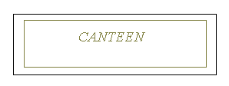
Sign A Sign B
Feature | Sign A | Sign B
Contrast wall and sign background | Good | Poor
Contrast text and sign | Good | Very poor
Text font | Good (Arial with upper and lower case) | Poor (Times New Roman, italic and all caps)
Text size | Good and good weighting | Too small weighting

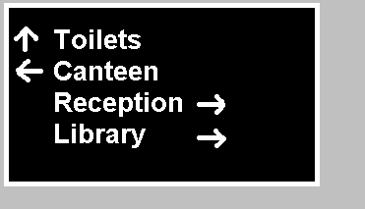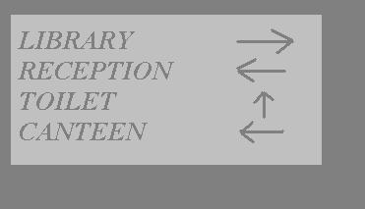
Sign A Sign B

Feature | Sign A | Sign B
Contrast wall and sign background | Good | Poor
Contrast text and sign | Good | Very poor
Text font | Good | Poor
Text size | Good and good weighting | Too small
Arrows | Correct, Arrows placed on the side of the side of the sign to which change of direction applies | Arrows on wrong side and confusing.

Examples of good sign design

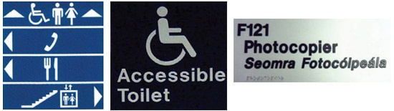

Signage Checklist

1 | Location | Yes | No
1.1 | Locate signs where they are clearly visible.
1.2 | Signs should be placed at eye level. The optimum height for viewing at eye level is 1400 - 1700mm above floor level.
1.3 | Position signs where the reader will not obstruct circulation paths.
1.4 | Signs that are projecting or being suspended from the ceiling must be positioned above head height at 2200mm from floor level.
1.5 | Position room number signs and names on the wall adjacent to the door handle and not on the door to avoid the door being opened whilst being read by touch.

2 | Surface finish/colour and contrast/background | Yes | No
2.1 | The surface of the sign should have a matt finish to  reduce reflection and glare.
2.2 | Black on white or white on black are good contrasting colours. Light coloured characters on dark backgrounds are preferred.
2.3 | For very large text - negative text is best
2.4 | The illumination of a sign should be considered.
2.5 | Avoid busy backgrounds. The background should  enhance the visibility of the sign.
2.6 | Letters and symbols should contrast with the signboard and the signboard should contrast with the background it is being attached to.

 |  | Yes | No
2.7 | Use as few colours as possible and avoid colours that may be traditionally used in fire and safety signs (red/yellow/green).
2.8 | In existing situations, if the colour of the signboard is similar to that of the background provide a contrasting border on the sign (25-50mm).

3 | Typeface | Yes | No
3.1 | Sign Lettering should use upper and lower case letters.
3.2 | Letters used should be plain (Sans Serif) for example, Arial and Helvetica.
3.3 | Never use italics on signs and the number of different typefaces and font sizes should be kept to a minimum.
3.4 | Justified text in signage should be avoided.
3.5 | Symbols should be placed on signs to enhance the sign.

4 | Size of Typeface | Yes | No
4.1 | Character height on internal signs should be at least 37mm for direction signs, and 25mm for information and identification signs. Characters of these dimensions are legible at up to 5.0m approximately.
4.2 | External directional signs should be at least 75mm high.
4.3 | In general, a minimum letter height of 150mm is  recommended at building entrances or for house numbers.

5 | Tactile Finish | Yes | No
4.1 | If a wall mounted sign has raised letters or Braille that are to be read, the tactile letters should be placed at a height of 1400 - 1700mm.
4.2 | The letters should be raised 1.5mm and the edges of the raised characters should be slightly rounded. The recommended stroke width of each character is 1.5 - 2mm for a 15mm letter.
4.3 | Embossed signs should only use a simple Sans Serif font
4.4 | Braille should be incorporated onto signs that are designed to be read at close distance.
4.5 | Braille should enhance the embossed information but not replace it.
4.6 | The use of embossed symbols at the beginning and end of Braille messages is important (e.g. arrows).

6 | Directional Arrows | Yes | No
4.1 | Directional arrows should be placed on the side of the sign to which change of direction applies.
4.2 | Direction arrows indicating the need to go straight ahead should be placed on the top of the sign.
4.3 | Arrows that are angled should be avoided.

Emergency Equipment and Evacuation

Fire exits
This section should provide detailed information on all of the emergency escape exits in the building, covering specific escape routes from the different areas within the building. The use of building plans to identify escape routes and fire and safety equipment, and alarms is recommended.

Example:
There are a number of fire exits located throughout the building. Staff should familiarise themselves with all fire exits throughout the building even if they don’t work in a particular section of the building. Staff should also consider the closest exits to public areas such as all meeting rooms, the conference centre, training rooms and the library, as these are the areas where members of the public will be in an emergency situation. Staff also need to know how best to get members of the public safely from various parts of the building in an emergency situation. For example, which is the quickest way to exit the building from the meeting rooms on the first floor if there is a fire at Reception?

Emergency equipment
Details on the location and use of the emergency equipment should be provided here.
Example:
There are a number of exits located near the sports hall. The nearest exit is the back door, which is located in the corridor adjacent to the sports hall. A second exit is through the back corridor and out through the emergency exit door, which is straight ahead. In the sports hall there are two emergency exit doors, which lead onto the main car park. There are also a number of fire extinguishers, break glass units etc located throughout the sports hall and a first aid room is located next to the main entrance.

Important safety issues
Building for Everyone highlights the following important issues to ensure the safety of all building users:
- Encourage people with disabilities to make themselves known, if their impairment could compromise their response to a fire alarm.
- In a public building, an emergency egress plan should be drawn up for all people with disabilities, formed on the basis of the general need associated with a broad range of impairments. There should be a written and practiced procedure on how to locate and assist people with disabilities. Fire wardens should be appointed to locate people who may not be alerted by an alarm and to check out toilets, stores and other areas where there may not be any visual/audio alarms;
- A personal emergency egress plan should be established for all regular building users, these include; members of staff, contract staff and regular visitors (clients) with disabilities. This should be more specific than the general plan and can include the appointment of a specific staff member to ensure that people with disabilities are aware of the emergency and to assist them out of the building if necessary (see section 8.4 for further details);
- Include all emergency egress plans in the general building safety statement;
- Fire drills should be practiced regularly and should include people with disabilities;
- Fire alarms must be combined audio and visual two-stage systems, and visual alarms must be free of obstruction (consider the specification of visual alarms as some can induce the symptoms of epilepsy in some people. Also, do not over prescribe);
- Staff must be trained in the safe transportation of people in wheelchairs (and where necessary ‘evac-chairs’) in an emergency. Set up a ‘buddy’ system so it can be guaranteed that one person per disabled person who is trained in the safe transportation of disabled people is on site at all times.
- Ask people with disabilities for their guidance on how best to assist them.

Steps to Produce Personal Emergency Egress Plans (PEEP)
- Identify all employees who may have difficulty during an emergency egress of the building.
- Consult with these staff to determine their requirements for emergency egress:
  - Which areas of the building(s) do you use?
  - What is your current awareness of emergency evacuation procedures and equipment?
  - Can you hear/see the alarm and raise the alarm from the manual set off points?
  - Do you require assistance to evacuate any parts of the building in an emergency situation?
  - What current assistance procedures are you aware of?
  - Can you evacuate the building quickly in an emergency?
  - Is a ‘buddy’ or ‘buddies’ required?
- Assess building to determine individual procedures for emergency evacuation, taking into account:
  - Availability of assistance and what happens if assistance is not available.
  - How do the building’s features and design affect the person’s ability to evacuate in an emergency?
  - How will smoke, heat, confusion, darkness, noise and fire affect the individual’s ability to orientate themselves, use equipment, and follow the signs to an emergency exit?
  - Can the individual open the emergency exit doors?
  - Are there any barriers that could prevent the individual from reaching the assembly point?
  - Current training and awareness of designated assistants.
- Produce PEEP document.
- Provide relevant staff with PEEP and commence training of any staff designated as assistants.
6. PEEPs should be reviewed and updated regularly; every six months, when there are staff changes, if an employee’s requirements change or when there are changes to the physical environment (whichever is sooner).

Template:
Personal Emergency Egress Plan
Name: | Enter Your Name Here | Date: | Enter The Date Here
Position: | Enter Your Position Here
Designated Assistance:
Enter Your Response Here
Assistance methods/techniques:
Enter Your Response Here
Equipment provided:
Enter Your Response Here
Emergency Evacuation Procedure(s): (A step-by-step guide, from alarm safety, of the evacuation procedures from different floors/buildings)
Enter Your Response Here
Evacuation Route(s): (preferably with diagram)
Enter Your Response Here

Adapted from The Northern Officer Group, 1993.

Conclusion
An accessible built environment is a key element for the realisation of a society based on equal rights, and provides its citizens with autonomy and the means to pursue an active social and economic life (EC Group of Experts, 2003). Lack of access to the built environment is one of the greatest barriers to participation faced by people with disabilities from all manner of activities throughout society. This handbook has highlighted a broad range of issues that will make the [insert building name] building more accessible for all its users.

Accessibility of the building should be reviewed every six months or in the light of changes (whichever is sooner), to ensure that the building is managed and maintained to the highest possible accessibility standard. This may lead to the inclusion of further sections to this handbook, relating specifically to the [insert building name] building and its functions.

Resources

Important Websites on Accessibility
- www.nda.ie The National Disability Authority Homepage.
- http://www.nda.ie/NDAlinks.nsf
Links to a number of Irish Disability Organisations.
- http://www.environ.ie/DOEI/DOEIPol.nsf/wvNavView/wwdConstruction?OpenDocument&Lang=en#I13
Technical Guidance Documents for the Building Regulations 2000.
- www.idd.ie The Institute for Design and Disability Homepage who offer professional services on design for all, disability advocacy and consultancy.
- www.eca.lu The European Concept for Accessibility Homepage.
- www.accessibility.lexir.net European Disability Forum universal access website on disability issues.
- http://www.design.ncsu.edu/cud/ The Centre for Universal Design US is a national research, information, and technical assistance centre that evaluates, develops, and promotes universal design in housing, public and commercial facilities, and related products.
- http://www.design.ncsu.edu/cud/resources/resources.htm The Centre for Universal Design resource page.
- http://www.accessibility.lexir.net/?dokId=64 Built environment links
- www.cae.org.uk The Centre for Accessible Environments (CAE) is an information provider and a forum for collaborative dialogue between providers and users on how the built environment can best be made or modified to achieve inclusion by design.
- www.jrf.org.uk The Joseph Rowntree Foundation is one of the largest independent social policy research and development charities in the UK.
- www.jmuaccess.org.uk The JMU Access Partnership is a not-for-profit pan disability access consultancy (specialising in buildings, transport and the street environment) supported by the Royal National Institute for the Blind.
- www.access-association.org.uk The Access Association’s aim is to improve access and facilities for people with disabilities and consequently for all people who would benefit from an accessible environment.
- http://www.sustainable-design.ie/index.htm Sustainable Design International Limited.

Literature on Accessibility of the Built Environment
The National Disability Authority (NDA) has published a best practice guideline entitled Building for Everyone, which aims to promote universal access to buildings and the environment. Building for Everyone (NDA, 2002) shows how to design, make and manage buildings and external environments for the inclusion, access and use of everybody.

Inclusive Buildings: Designing and managing an accessible environment is a CD ROM publication (Bright and Di Giulio, 2002) giving an extensive insight in how to design and manage the built environment. The CD is arranged under the following headings: user needs, building categories, functional elements, access audits and way guidance systems.

Universal Design (Goldsmith, 2000) calls on designers and lawmakers to embrace access “for everyone” rather than looking at people with disabilities in isolation. Goldsmith discusses making buildings safe and convenient for all their users, including people with disabilities and provides a comprehensive list of guidelines for making these buildings accessible.

Access Audits has been published by the Centre for Accessible Environments (2004) as a guide and checklist for auditing the accessibility of public buildings. It provides the background data to ensure the auditor understands what details need to be considered in carrying out an audit and illustrates how to carry out an audit.

Building Sight (Barker et al.,1995) published to address the needs of people with vision impairments in the built environment. It is a handbook of building and interior design solutions to include the needs of vision impaired people and highlights their needs in a simple and practical way.

The Access Manual (Bright and Sawyer, 2004) covers the design, improvement, maintenance and management of accessible environments. As a building designer or manager, it will show you how to provide and run buildings and services, and employment facilities to enable independent and convenient use by everyone.

The list above only indicates some of the texts that are available for accessibility and the built environment. The NDA Library has an extensive range of other publications. You can view the NDA library catalogue online at www.nda.ie. If you require a book on loan please do not hesitate to contact the NDA Library at 01-6080400.

References

Barker, P., Barraick, J. and Wilson, R. (1995) Building Sight. Royal National Institute for the Blind, London.

Bright, K. and Di Giulio, R. (2002) Inclusive Buildings: Designing and Managing an Accessible Environment. Blackwell Science, London.

Bright, K. and Sawyer A. (2004) The Access Manual: auditing and managing inclusive built environments. Blackwell Publishing, London.

Centre for Accessible Environments (2004) Access Audits: A guide and checklists for appraising the accessibility of public buildings. Centre for Accessible Environments, United Kingdom.

Darcy S. (1998) Anxiety to access: tourism patterns and experiences of NSW people with physical disability, Tourism NSW, Sydney, Australia.

EC Group of Experts (2003) 2010: A Europe Accessible for All. European Commission for Employment and Social Affairs, Brussels.

Goldsmith, S. (2000) Universal Design Architectural Press, London.

NDA (2002) Building for Everyone. The National Disability Authority, Dublin.

Records
Management Audit
Enter Your Name Here
Date:
Enter The Date Here
Date | Records Attached | Inspected by

Management Audit
Enter Your Name Here
Date:
Enter The Date Here
Carried out by
Date
Changes from previous audit

Future Changes
Enter Your Name Here
Date:
Enter The Date Here
Short Term Changes | Medium Term Changes | Long Term Changes

Maintenance Audit
Enter Your Name Here
Date:
Enter The Date Here
Date | Records Attached | Inspected by | Signed off by

Maintenance Audit
Enter Your Name Here
Date:
Enter The Date Here
Carried out by
Date | dcsdcdsc
Changes from previous audit

Future Changes
Enter Your Name Here
Date:
Enter The Date Here
Short Term Changes | Medium Term Changes | Long Term Changes

Staff Training

Name of Trainee | Date | Training | Training Company | Name of Trainer | Trainee Signature
Examples of training include correct use of evacuation chair, safe transportation of people in wheelchairs, Health and Safety Officer training and Occupational First Aid.

Notes

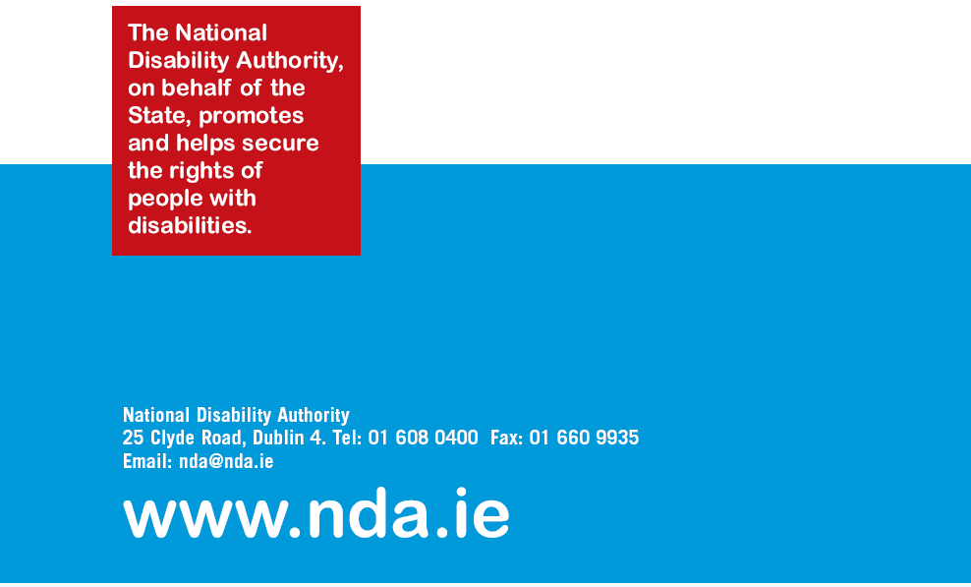

The Access Statement offers an additional opportunity to improve quality of buildings and spaces. By considering at the very earliest stages, and throughout the project the proposed use of the building, who will use it and how it will be managed in terms of the needs of its users, the Statement will assist in achieving the highest quality outcome for everyone.
Both websites relate to UK Regulation and users should note that the English and Welsh Part M Regulations differ from Irish Part M. However, users should note it is the principles that attention is being drawn to.

